ZeroG's GIS to GAME
Converter (GTG)
User manual · version 1.1.5 · November 2026
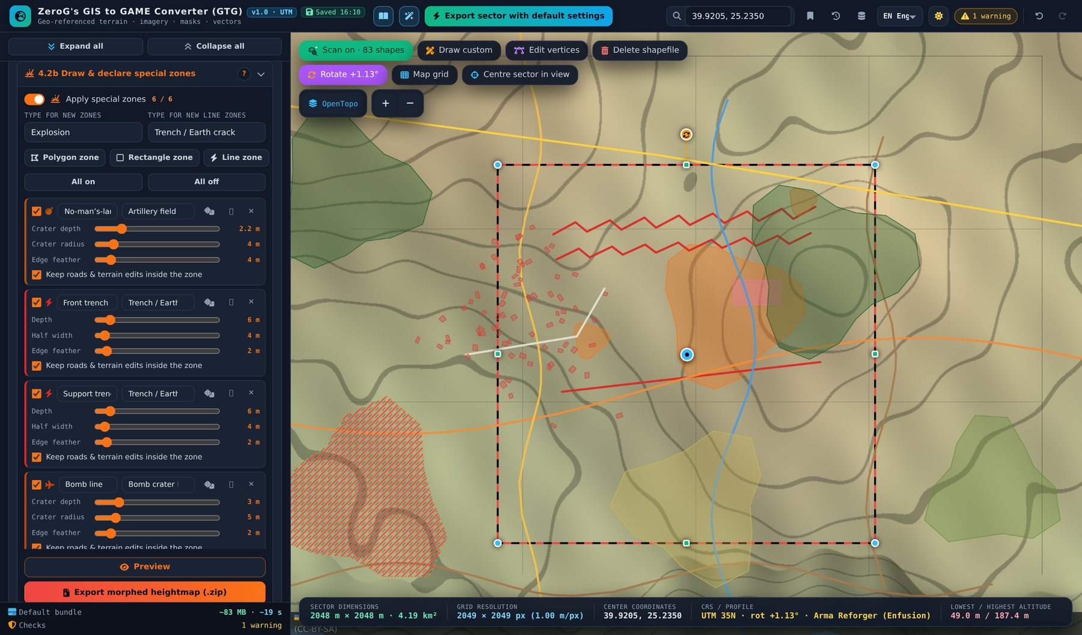
Real-world terrain for game engines – heightmaps, satellite maps, surface masks with colour legend, shapefiles and terrain shaping, georeferenced in UTM and ready for Arma Reforger, Arma 3, Unreal Engine and Unity.

Contents
Preface 3
Core facts at a glance 3
How this manual is organised 4
Part 1 – Getting started 5
1.1 Starting the tool 5
1.2 The screen at a glance 5
1.3 Header bar 6
1.4 Fold and unfold the sections 6
1.5 Map controls 6
1.6 Concepts used everywhere 7
Part 2 – Tutorial: a WW1 front line on Lemnos for Arma Reforger 9
Step 1 – Find the place 9
Step 2 – Choose the engine profile and size 10
Step 3 – Align the sector to the map grid 11
Step 4 – Look at the terrain on the map 12
Step 5 – Check the satellite image 13
Step 6 – Scan the public shapefiles 14
Step 7 – Declare the special zones 15
Step 8 – Morph the terrain 16
Step 9 – Generate the surface masks and the colour legend 17
Step 10 – Export 19
Importing the result into Arma Reforger 20
Part 3 – Feature reference 21
3.1 Section 1 – Map sector dimension & resolution 21
3.2 Section 2 – Height map 24
3.3 Section 3 – Satellite map 27
3.4 Map controls in detail 27
3.5 Section 4.1 – Public shapefiles (OpenStreetMap) 31
3.6 Section 4.2 – Custom shapefiles 32
3.7 Section 4.2b – Special zones 34
3.8 Section 4.3 – Heightmap morphing 36
3.9 Section 4.4 – Surface masks 38
3.10 Preview window 39
3.11 Project management 40
3.12 Language and theme 40
Part 4 – Reference 42
4.1 Keyboard and mouse 42
4.2 Engine import notes 42
4.3 Limits and formats 42
4.4 Troubleshooting 42
4.5 Credits and licences 43

Preface
ZeroG’s GIS to GAME Converter (GTG) turns any place on Earth into game-ready terrain data. You pick a sector on a map, and the tool produces a georeferenced heightmap, a satellite image, surface masks with a colour legend for material painting, shapefiles of roads, rivers, forests and buildings, and a reshaped (“morphed”) heightmap in which roads are graded, rivers are carved and buildings stand on smoothed ground. Optional special zones add craters, trenches, berms, dams, pits, dunes and other features on top.
The tool targets map makers for Arma Reforger (Enfusion), Arma 3 (Terrain Builder), Unreal Engine and Unity, and anyone who needs real-world terrain in a metric grid. Everything runs inside your web browser: there is nothing to install, no account and no server of its own. Data is loaded directly from public services (OpenStreetMap, AWS Terrain Tiles, Sentinel-2 cloudless, OpenTopoMap) or from your own files and WMS servers.

Core facts at a glance
Topic | Fact
Delivery | One HTML file, opens in Chrome or Edge. Internet access is needed for map data.
Start state | English interface, map name “MyMap”, 4,096 × 4,096 m sector at latitude 52, longitude 9, all sections folded. Your last session is restored automatically.
Coordinate system | WGS84 / UTM (zone of the sector centre). The south-west corner of the sector is game origin 0,0.
Sector size | 128 m up to 65,536 m per side; square or rectangular; optional rotation against the UTM grid.
Heightmap | Cell size 0.25–8 m, max 8,192 px per side. Formats .asc, 16-bit .png, 16-bit .raw, 32-bit .r32, float GeoTIFF.
Elevation sources | AWS Terrain Tiles (global), custom elevation WMS, local DEM file (.tif / .asc).
Imagery sources | Sentinel-2 cloudless (2016 = commercial use allowed), OpenTopoMap, custom XYZ tiles, custom WMS.
Map backgrounds | OpenTopoMap, Sentinel-2 cloudless (always the newest year), Hybrid (Sentinel-2 + OpenTopoMap) and AWS Terrain Tiles as shaded relief – plus any custom WMS on top.
On the map | Shapefile scan that follows the sector; heightmap and surface mask drawn on the map without a preview window, with a compare slider; DEM / WMS extents; rotation handle; map grid.
Vectors | OpenStreetMap scan in 8 categories / 33 subtypes, plus your own drawn, imported or colour-generated shapes (from a land-cover WMS or the background map) with own surface names and place-based names. Shapefile and GeoJSON.
Terrain shaping | Water carving, road and rail grading, building smoothing, flatten areas, 19 special-zone types.
Surface masks | Colour-coded mask with colour legend (picture and PDF), grayscale splat masks per subtype, RGBA splatmap, Enfusion block check.
Engine profiles | Unreal Engine 5, Unity, Arma 3, Arma Reforger – one click sets grid, formats and resolutions.
Languages | English (default), German, French, Spanish, Italian, Polish, Danish, Swedish, Norwegian, Czech, Ukrainian, Russian.
Storage | Session, bookmarks, history (20 versions) and tile cache are kept in the browser. Projects can be saved as .json.

How this manual is organised
- Part 1 – Getting started: the screen layout, the header, the side-panel tools, the map controls and the concepts that apply everywhere (Basic / Advanced, messages, help).
- Part 2 – Tutorial: a complete project from an empty map to the exported bundle, step by step with pictures.
- Part 3 – Feature reference: every section and every control, grouped like the side panel, plus a chapter on the map controls.
- Part 4 – Reference: keyboard shortcuts, engine import notes, limits, troubleshooting, credits and licences.
Note Screenshots in this manual were taken with a sample terrain near Lemnos (Greece). Colours of map tiles may differ from what you see with live data; the controls are identical.

Part 1 – Getting started

1.1 Starting the tool
- Open the HTML file in a current Chrome or Edge browser (double-click or drag it into a browser window).
- The tool starts in English with all sections folded and a 4,096 × 4,096 m sector named “MyMap” at latitude 52, longitude 9 and 1 m cell size.
- Your last session is restored automatically on the next start (“Restored” in the header). The shapefile scan always starts switched off.
- A private window starts clean – useful for a fresh project or for testing.

1.2 The screen at a glance
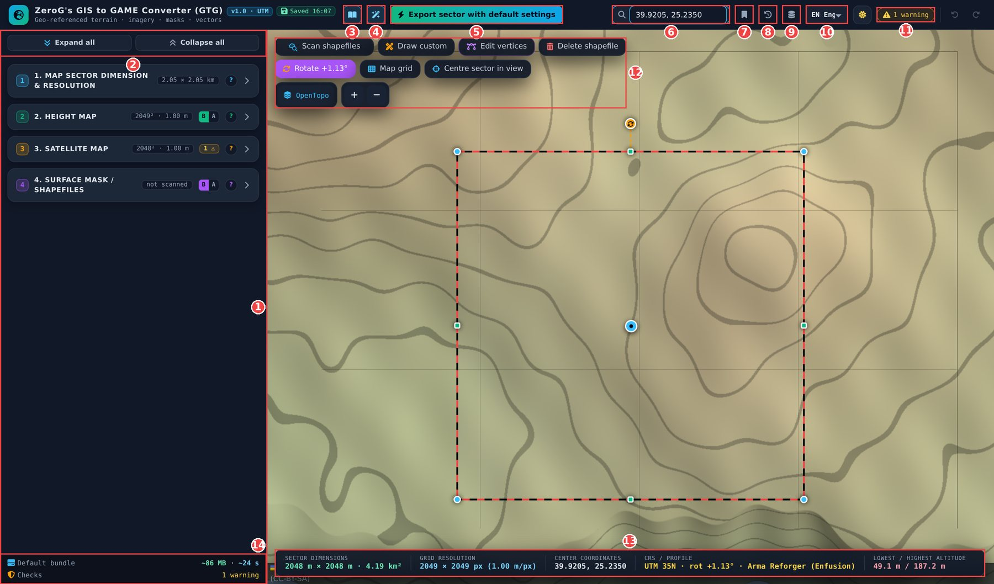
Figure 1 – Main screen with the numbered areas explained below
No. | Area | Purpose
1 | Side panel | Sections 1–4 with all settings, previews and exports. Click a header to fold or unfold it.
2 | Expand / collapse | Two buttons at the top of the side panel: open or fold every section at once.
3 | Manual | Opens the built-in manual (can be printed or saved as PDF).
4 | Wizard | Step-by-step tour that highlights every visible control.
5 | Default export | One-click ZIP with heightmap, satellite map, masks (with legend), shapefiles and morphed heightmap.
6 | Search | Enter coordinates “lat, lon” and press Enter – the sector jumps there.
7 | Locations | Bookmarks and recently used sectors.
8 | History | Saved project versions; one is stored with every export.
9 | Data cache | Tile and OpenStreetMap cache, size limit and clearing.
10 | Language | Interface language (12 languages).
11 | Messages | Number of errors and warnings; click to see all and jump to the setting.
12 | Map controls | One block at the top left of the map: shapefile row, sector row and map row (see 1.5).
13 | Status bar | Sector size, grid, centre, CRS / profile / rotation, lowest and highest altitude.
14 | Footer | Expected size and time of the default bundle and the overall check status.

1.3 Header bar
Figure 2 – Header bar
- Version and save tag – shows “Saved hh:mm” after each automatic save.
- Undo / Redo – right end; reverses shape edits, deletions and on/off changes (Ctrl+Z / Ctrl+Y).
- Bright / dark – sun icon switches the colour theme; the choice is saved.

1.4 Fold and unfold the sections
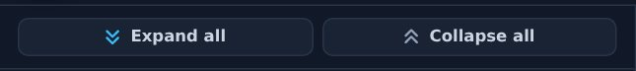
Figure 3 – Expand all / Collapse all at the top of the side panel
- The two buttons sit at the top of the side panel and stay visible while you scroll through the sections.
- Expand all opens every section and subsection; Collapse all folds them again. A single section is opened or folded by clicking its header.

1.5 Map controls
All map controls sit together in one block in the top-left corner of the map, in three rows. The status bar is an information display and stays at the bottom left.
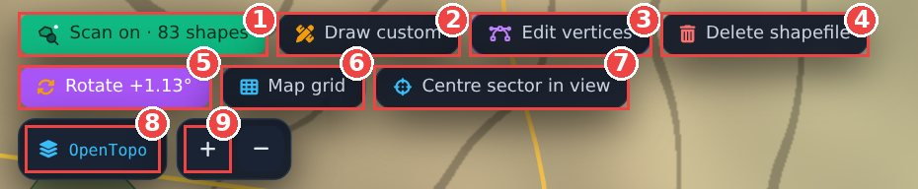
Figure 4 – The map-control block (scan switched on). Labels fold into icons on narrow windows
No. | Row · button | What it does
1 | Shapefiles · Scan | Switch on to load the OpenStreetMap shapes and keep them shown; they follow the sector. Click again to switch off.
2 | Shapefiles · Draw custom | Panel with class list and Polygon / Line / Rectangle tools.
3 | Shapefiles · Edit vertices | Move, add (+) or delete (Del) vertices of any shape. Key E.
4 | Shapefiles · Delete | Delete mode: every clicked shape is removed (Undo works).
5 | Sector · Rotate sector | Angle input, slider, “Align to map grid” / “Align to UTM grid”.
6 | Sector · Map grid | UTM, lat / lon or sector grid overlay (display only).
7 | Sector · Centre in view | Moves the sector to the map centre; size and settings stay.
8 | Map · Background map | OpenTopoMap, Sentinel-2 (latest), Hybrid, AWS relief and a custom WMS on top. The menu opens downwards.
9 | Map · Zoom + / − | Zoom in and out.

1.6 Concepts used everywhere

Basic and Advanced
- Sections 2 and 4 have a small B | A switch next to the “?” button.
- Basic shows the essential controls; hidden settings keep their values and are summarised in one line.
- Advanced shows every option. In section 4, subsections 4.2, 4.2b and 4.3 appear only in Advanced.
- Sections 1 and 3 always show all options.

Messages and checks
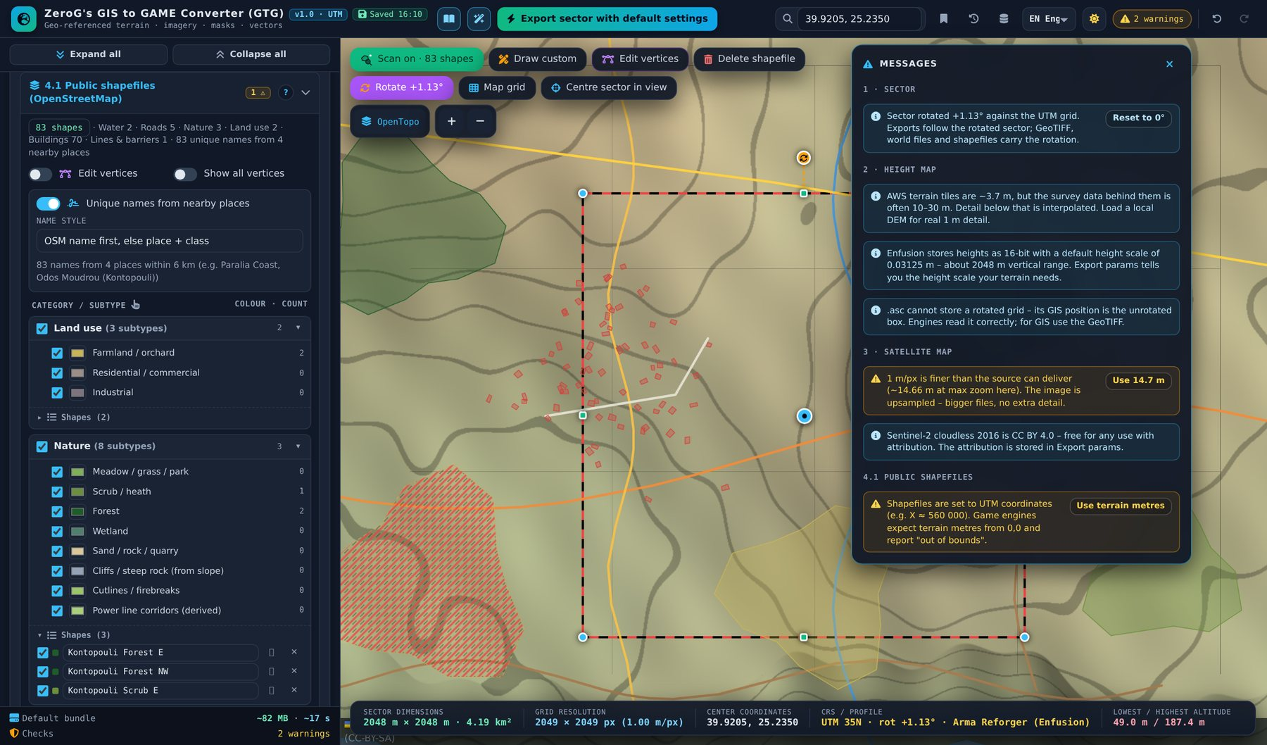
Figure 5 – Message list – click a message to jump to the setting, use the button for a one-click fix
- Every change is checked live. Red = error (blocks the export), amber = warning, blue = tip.
- The header button shows the count; the coloured badges on section headers open the same list.
- Clicking a message opens the section, scrolls to the setting and highlights it – messages about the shapefile scan jump to the scan icon on the map.
- Many messages offer a fix button (e.g. “Scan on”, “Use terrain metres”, “Use 2016”, “Make square”).

Help, wizard and built-in manual
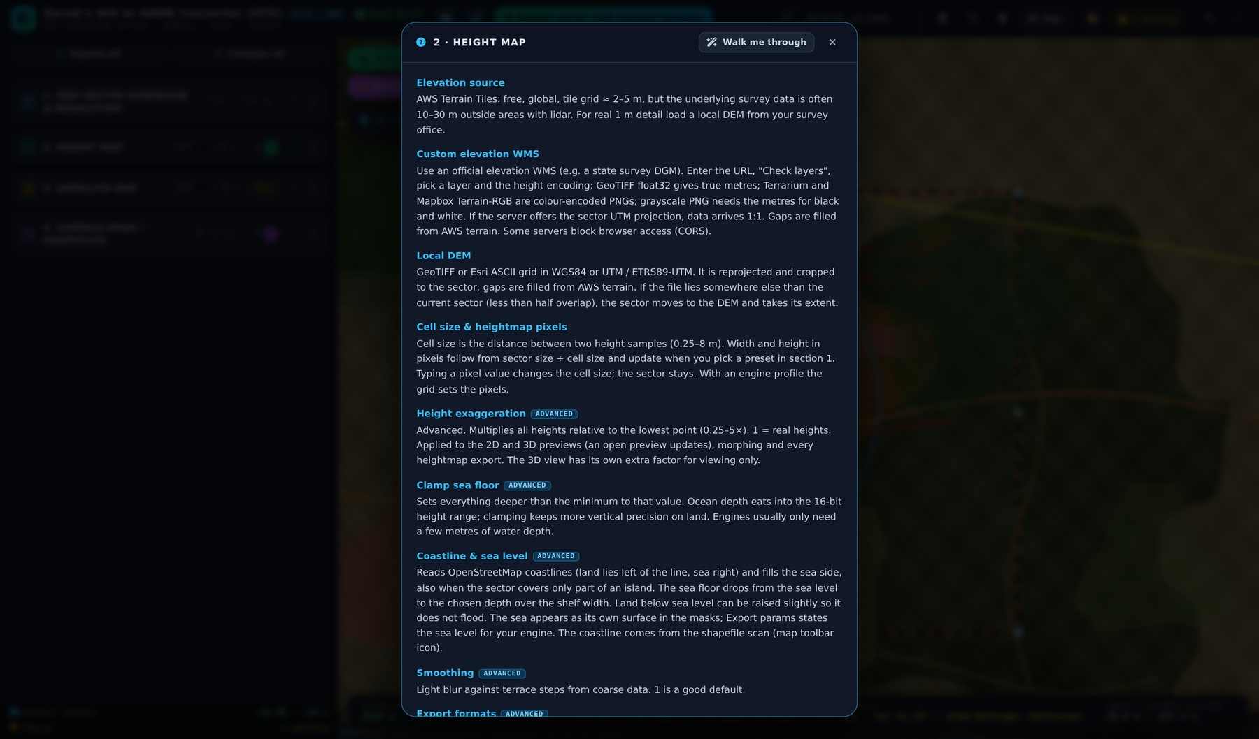
Figure 6 – Section help (“?”) with the “Walk me through” button
- “?” on a section – explains every control of that section; “Walk me through” starts the wizard there.
- Wizard – black panel at the right, ← / → to move; jumps between chapters with the drop-down. It follows the Basic / Advanced state of each section.
- Tooltips – hover any control for a one-line explanation.
- Built-in manual – the Manual button opens every chapter with illustrations; it includes the chapter “Map controls”. It can be printed or saved as PDF.
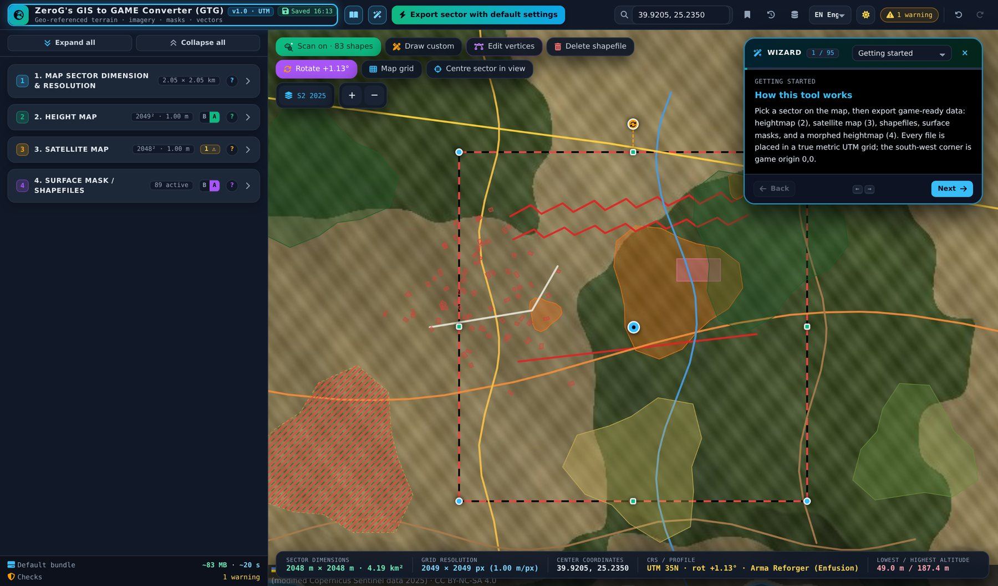
Figure 7 – Wizard highlighting a control

Part 2 – Tutorial: a WW1 front line on Lemnos for Arma Reforger
Goal: a 2 × 2 km Arma Reforger terrain of a coastal hillside, aligned to the map grid, with real roads, forests and buildings, a shelled no-man’s-land, two trench lines, a bomb crater line, a machine-gun nest and a mine crater. At the end you export one ZIP with everything the Enfusion Workbench needs, including a colour legend for the surface mask.
Note Time needed: about 10 minutes. Result: heightmap, morphed heightmap, satellite map, surface masks per surface with colour legend, shapefiles in terrain metres and the import values in params.json.

Step 1 – Find the place
- Type the coordinates “39.9205, 25.2350” into the search box and press Enter.
- The red-black dashed frame (the sector) jumps there. Rename the map to “Lemnos_Front” in section 1 – this becomes the prefix of all files (the default is “MyMap”).
- Alternatives: drag the blue centre marker, pan the map and click “Centre sector in view”, or enter four coordinates.
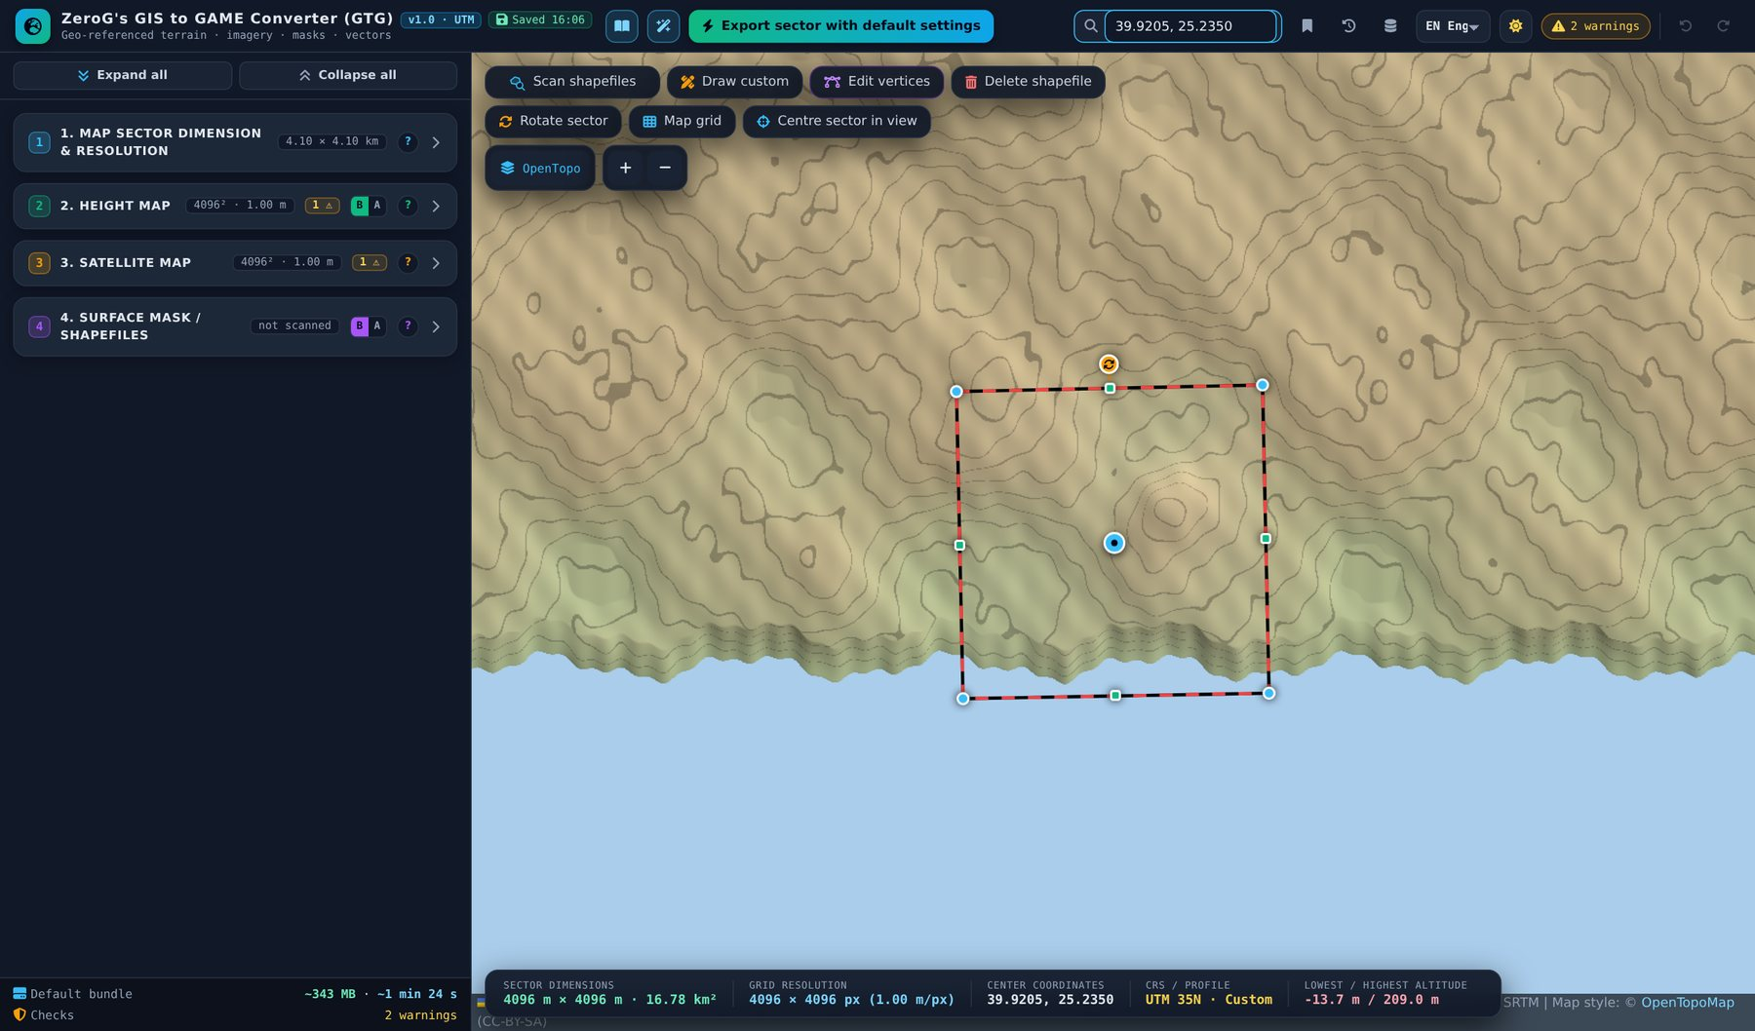
Figure 8 – Sector placed via coordinate search

Step 2 – Choose the engine profile and size
- Open section 1. Set Target to “Arma Reforger (Enfusion)” and Grid to “2049 × 2049”.
- The profile sets the heightmap formats (.asc + 16-bit .png), per-subtype splat masks, the block check and terrain-metre coordinates.
- With a 1 m cell size the sector becomes 2,048 × 2,048 m (2049 vertices = 2048 faces = 64 blocks of 32 faces).
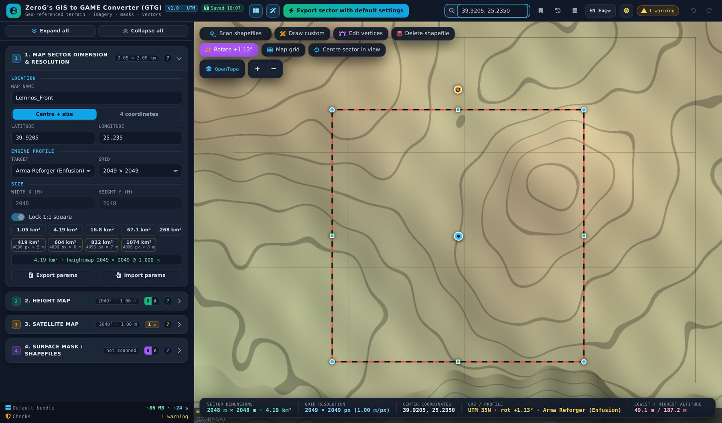
Figure 9 – Arma Reforger profile with a 2049 grid

Step 3 – Align the sector to the map grid
- Click “Rotate sector” in the sector row of the map controls and then “Align to map grid”.
- The sector turns by the grid convergence (+1.13° here), so its edges run exactly north–south and east–west on the map.
- Switch on “Map grid → Sector” to see the game grid from the south-west corner (0,0). It is display only.
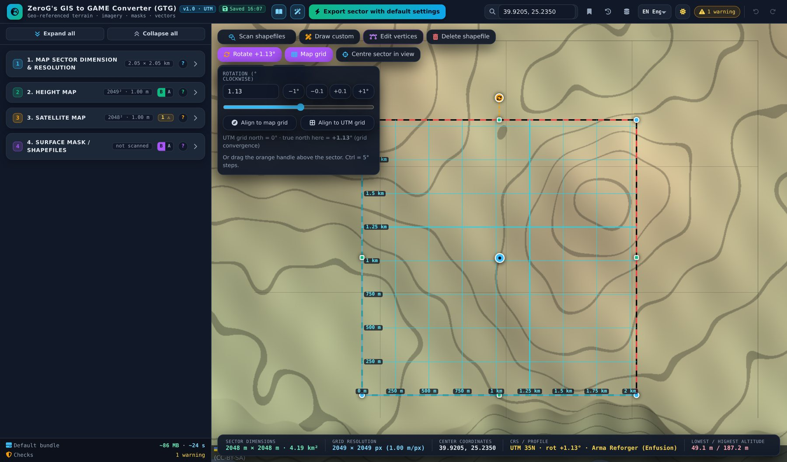
Figure 10 – Rotation panel and sector grid

Step 4 – Look at the terrain on the map
- Open section 2 and switch on “Show heightmap on map”. The relief of the sector is drawn on the map – no preview window needed. Switch on “Compare slider” and drag the orange handle to compare it with the background map.
- Choose a shader (Relief, Elevation, Slope, Contours, Clay, Grayscale) and an opacity. The status line shows the elevation range – important for the Enfusion height scale.
- For a larger view use Preview, which also compares the terrain with the satellite image (see the figure after the steps).
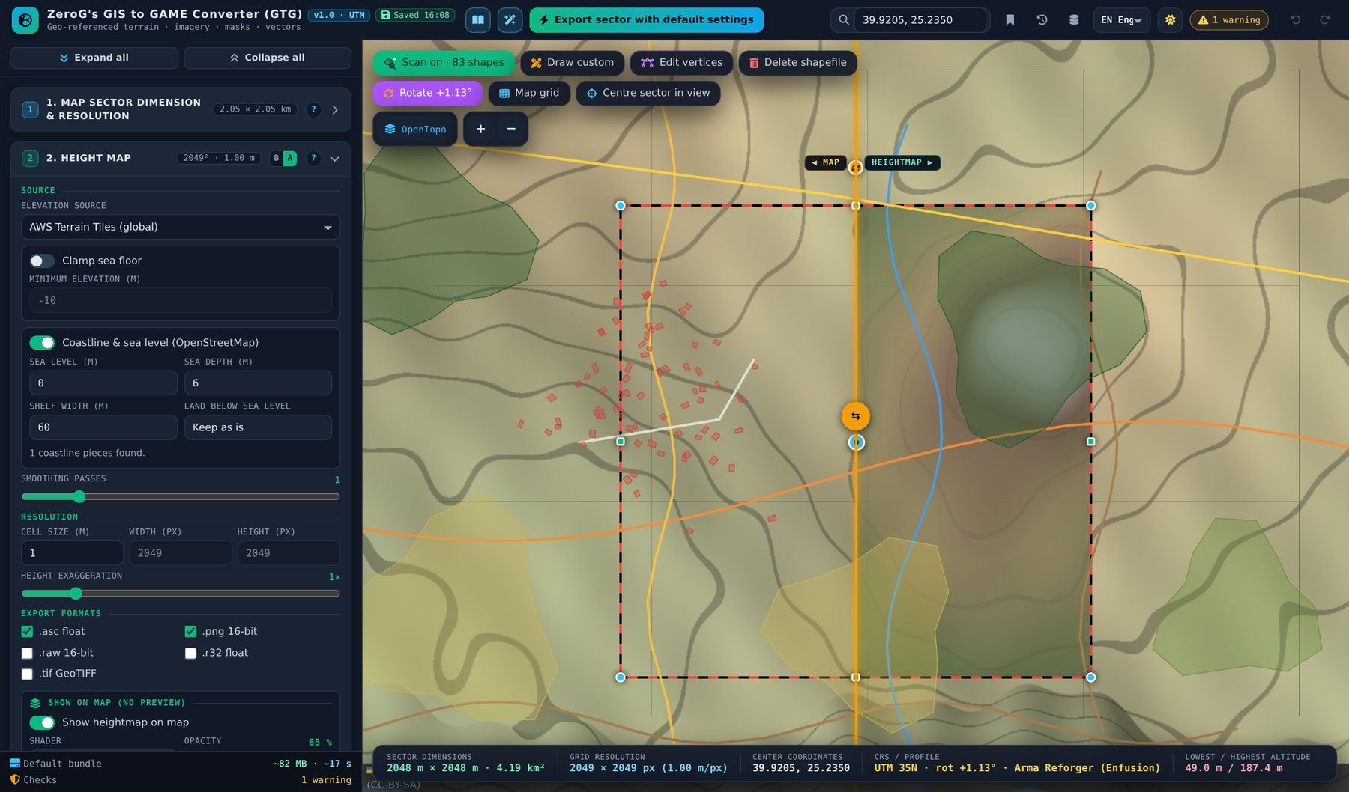
Figure 11 – Heightmap on the map with the compare slider (map on the left, relief on the right)
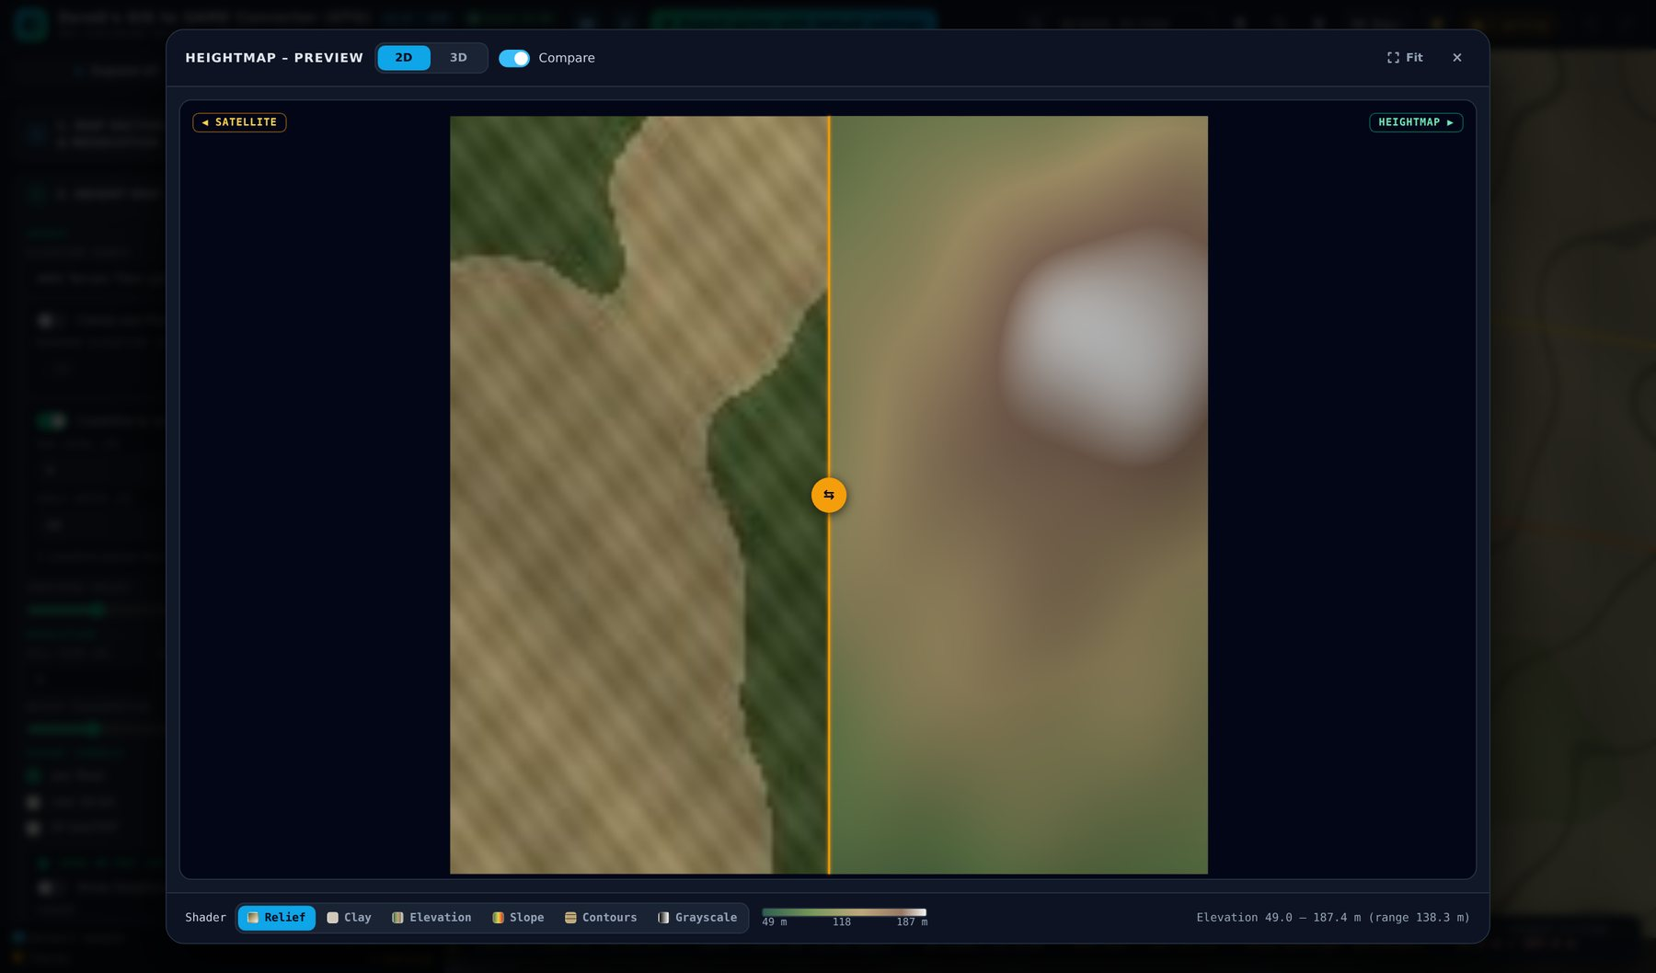
Figure 12 – Heightmap preview window with compare slider against the satellite image

Step 5 – Check the satellite image
- Section 3: keep “Sentinel-2 cloudless 2016” (commercial use allowed with attribution). Years from 2018 on are non-commercial.
- Preview shows the image against the terrain relief. A finer resolution than the source only makes files bigger.
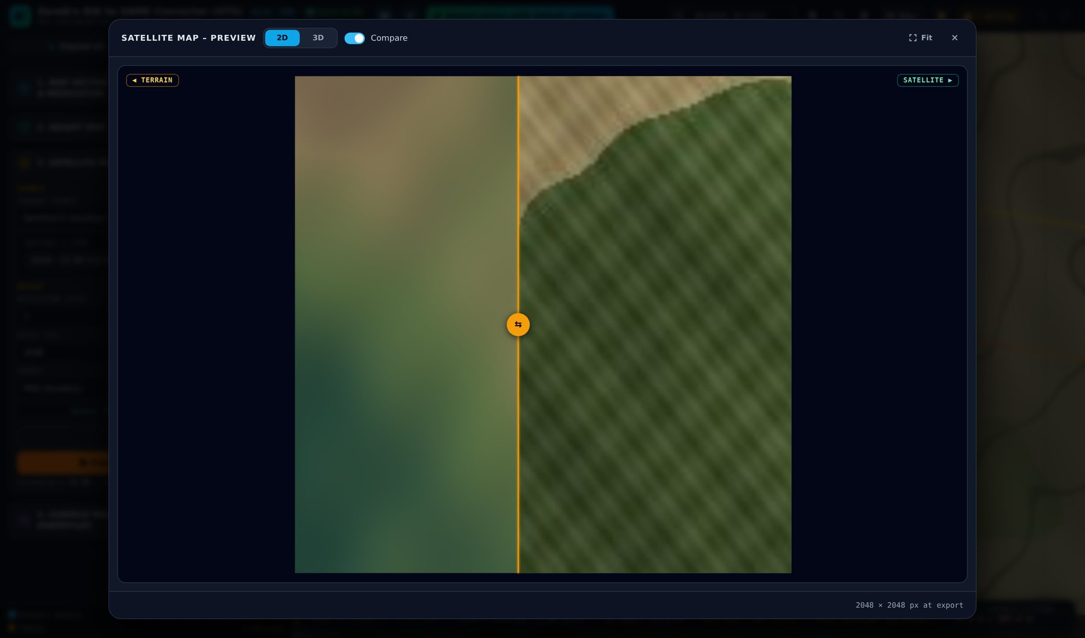
Figure 13 – Satellite preview

Step 6 – Scan the public shapefiles
- Click the scan icon, the first button of the shapefile row on the map. It pulses while it works, then turns green and reads “Scan on · N shapes”. Roads, rails, water, land use, forest, buildings and power lines appear on the map.
- While the icon is on, the shapes follow the sector: after every move, resize or rotation the sector is rescanned automatically. Click the icon again to switch it off (the shapes are hidden; exports still scan by themselves when they need shapes).
- Click a field you do not want: it gets red diagonal bars and is excluded from all exports. Section 4.1 lists the shapes per category.
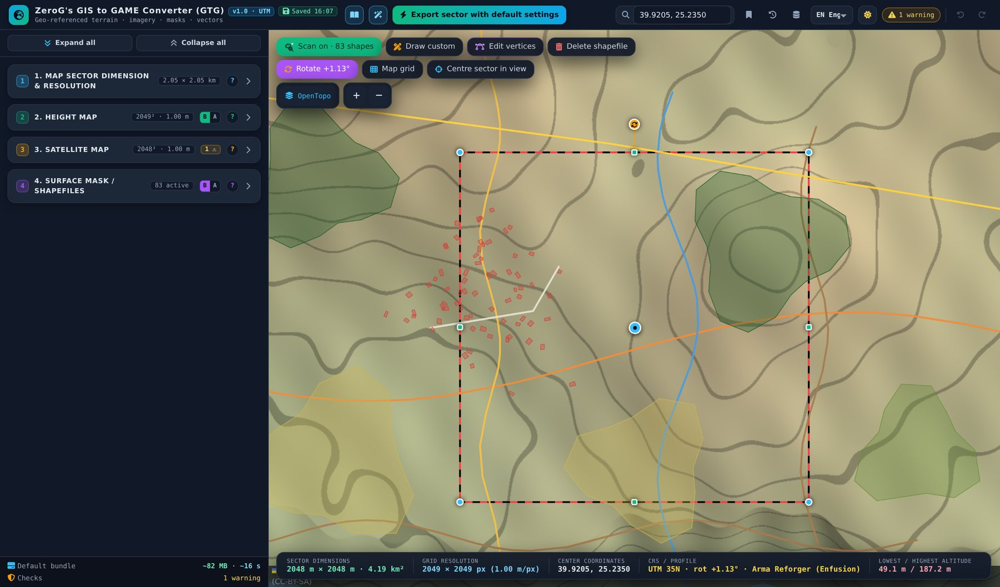
Figure 14 – Scan switched on: shapes follow the sector
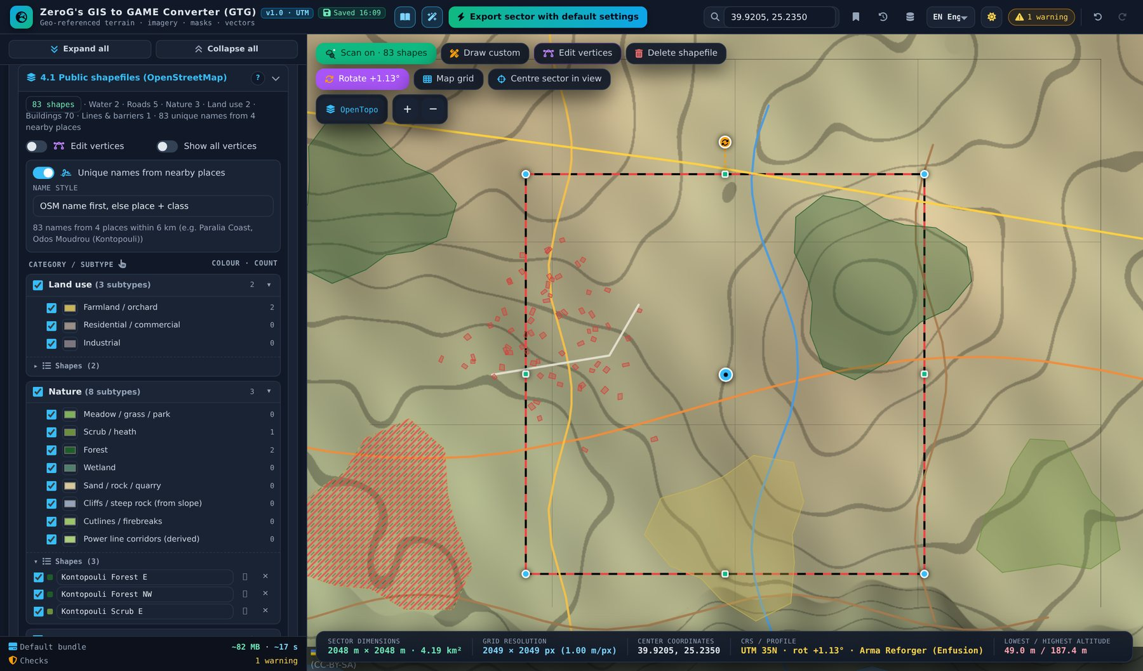
Figure 15 – Section 4.1 open; the excluded farmland shows red bars

Step 7 – Declare the special zones
- Switch section 4 to Advanced (A) and open 4.2b. Draw a polygon zone over no-man’s-land and set its type to “Artillery field”.
- Draw two line zones as “Trench / earth crack”, one as “Bomb crater line”, a small polygon as “Firing position / revetment” and one as “Explosion”.
- Each zone has its own card with intensity, radius, edge feather, “Keep roads & terrain edits” and a dice for a new random layout.
Figure 16 – Special zones on the map and their cards in 4.2b

Step 8 – Morph the terrain
- Open 4.3 and click Preview. Left = original, right = morphed: roads graded, buildings smoothed, craters and trenches cut.
- Switch to the Slope shader to judge steep edges, or to Clay for the pure shape.
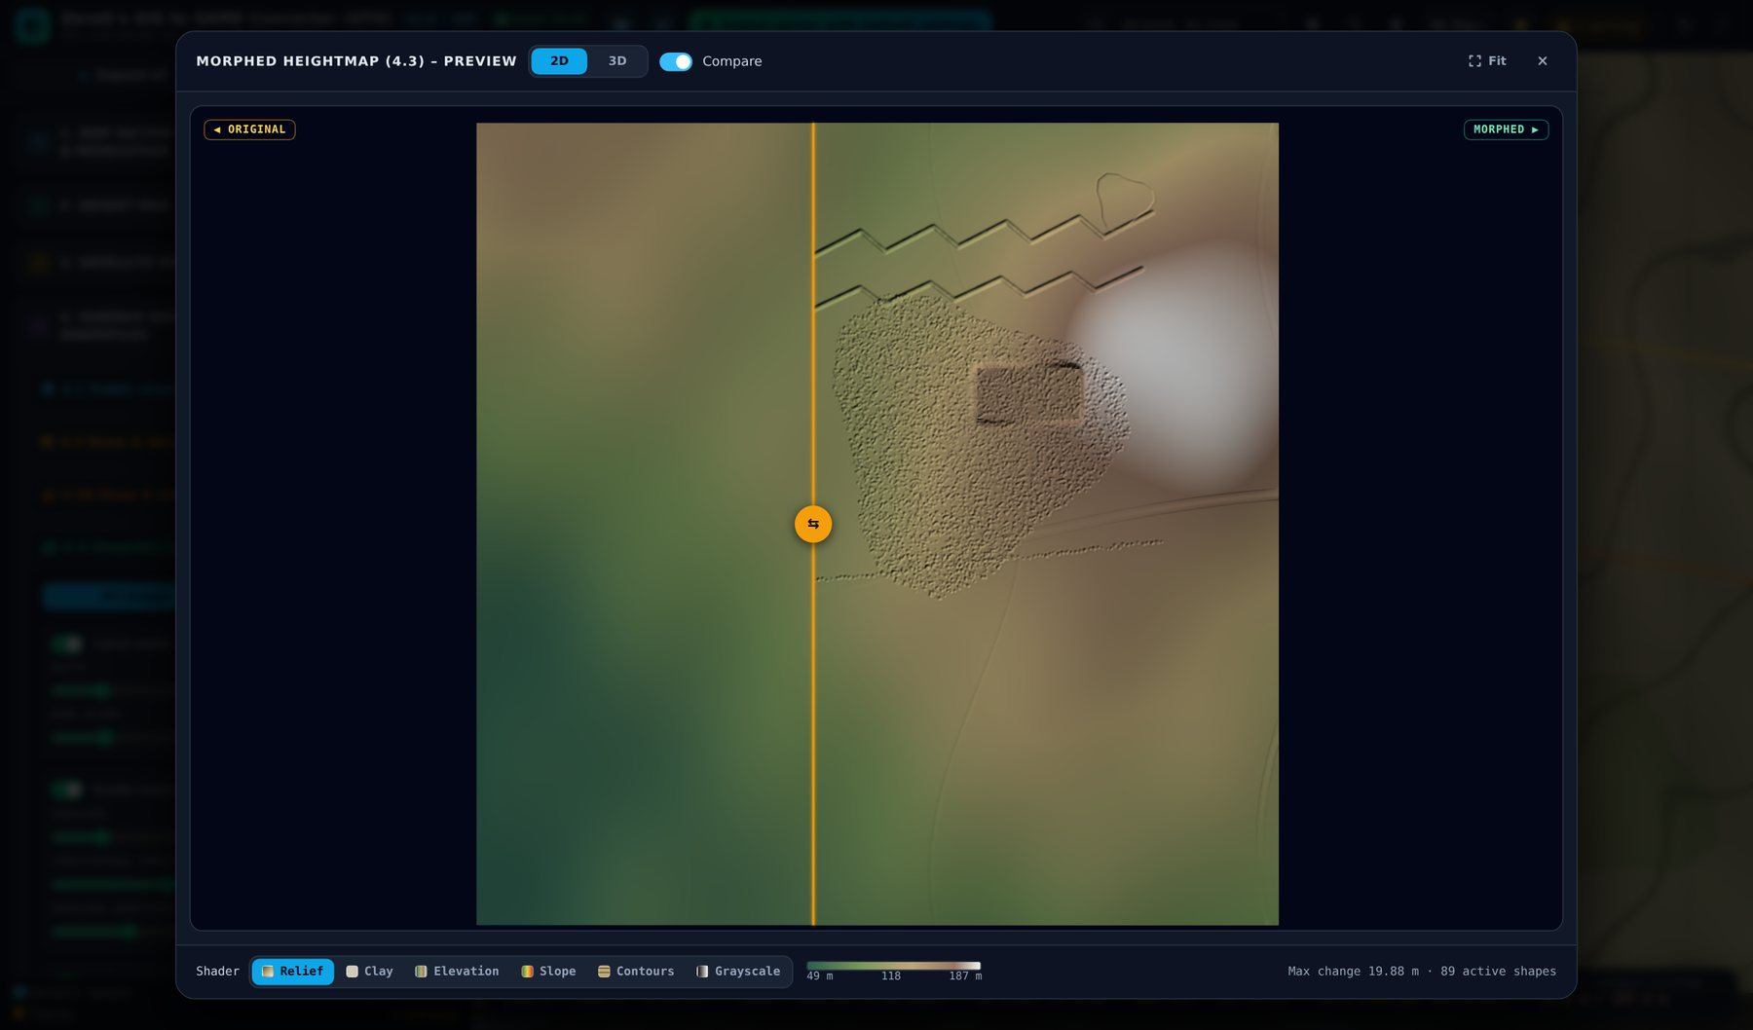
Figure 17 – Before / after preview of the morphed heightmap
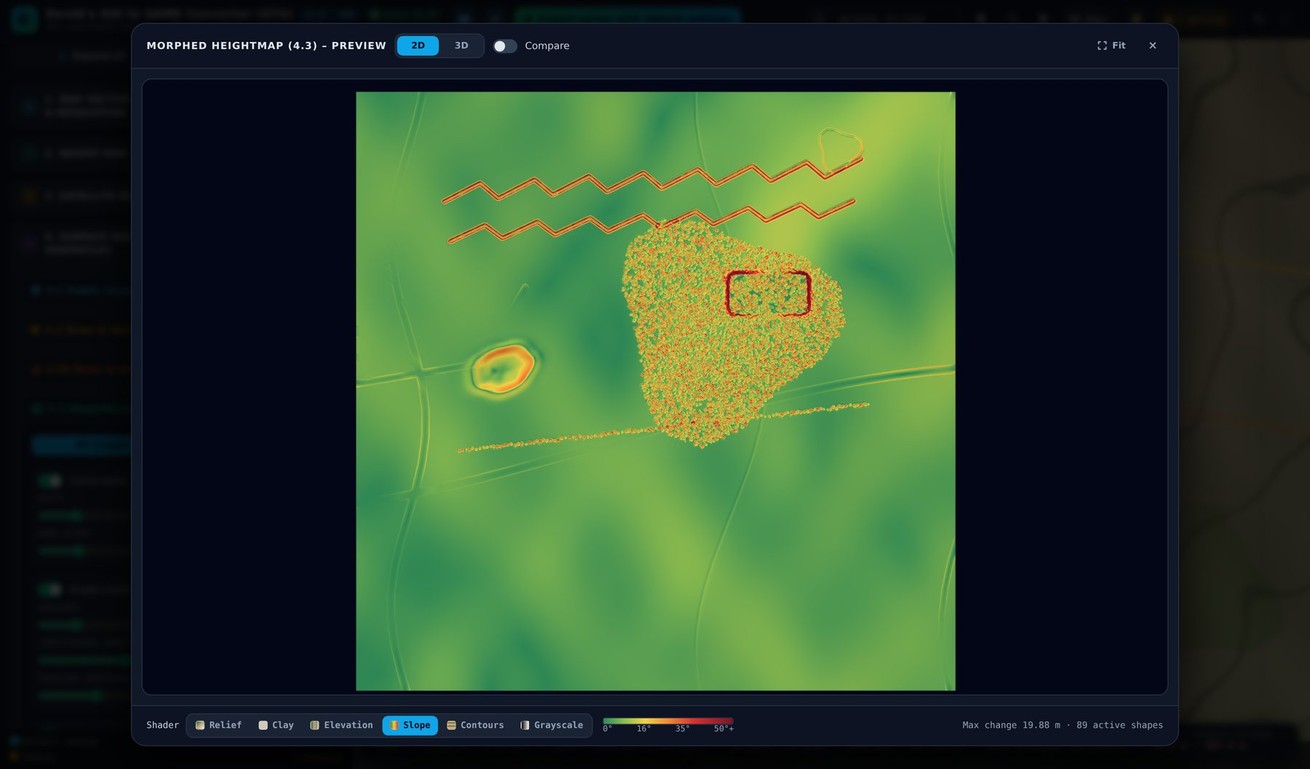
Figure 18 – Slope shader: crater rims and trench walls in red

Step 9 – Generate the surface masks and the colour legend
- Open 4.4. With the Reforger profile the splat masks are written per subtype and the Enfusion block check is on.
- Switch on “Slope & cliff auto-masking” to add rock on steep slopes. “Show surface mask on map” draws the colour-coded mask over the background map (transparent background, opacity and compare slider) so you can check it without a preview window.
- “Colour legend” (Picture + PDF by default) makes the export contain a legend of the colour-coded mask – see the next two figures.
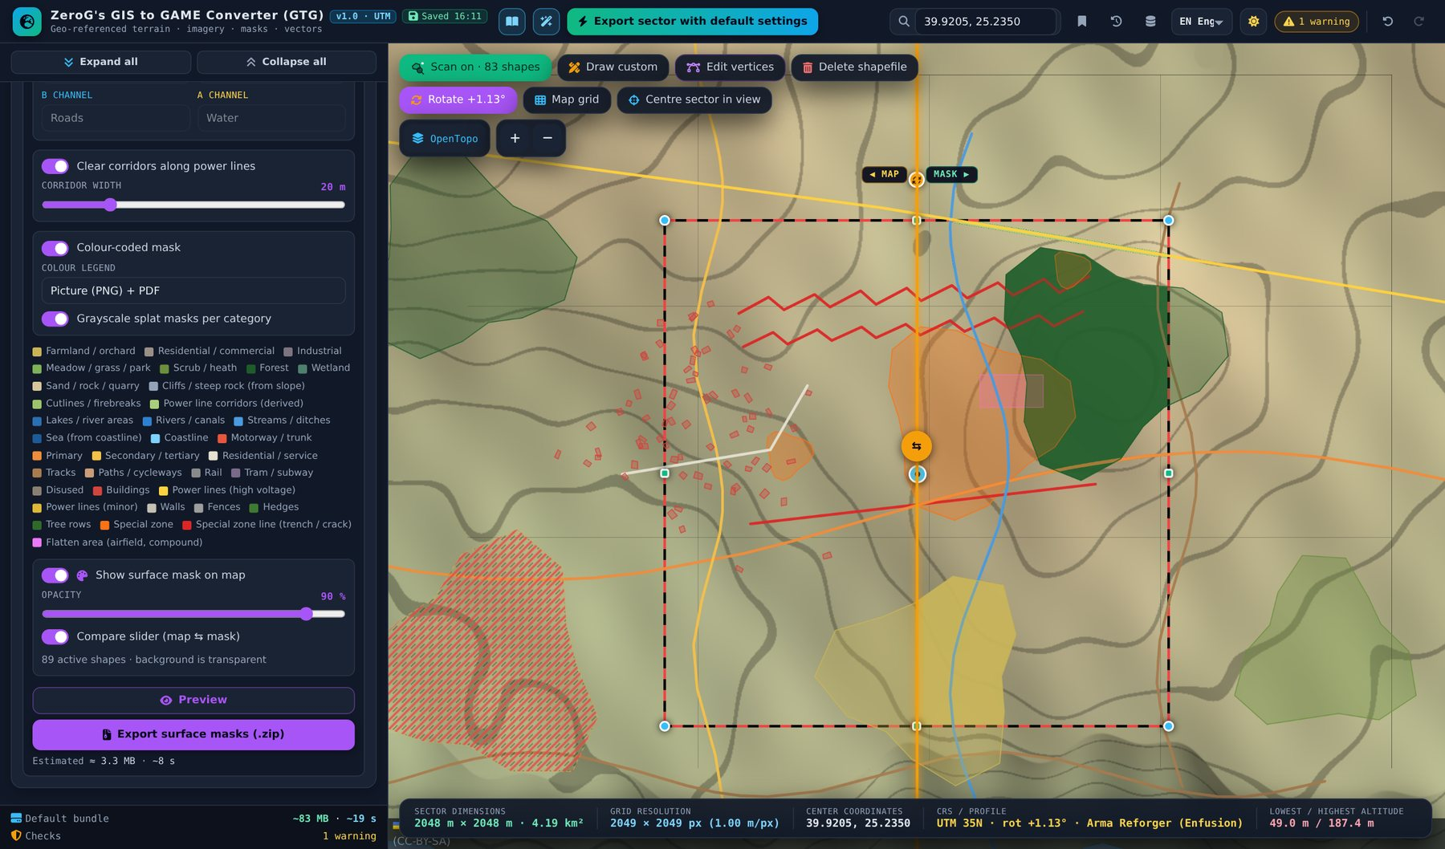
Figure 19 – Surface mask on the map (right of the compare handle)
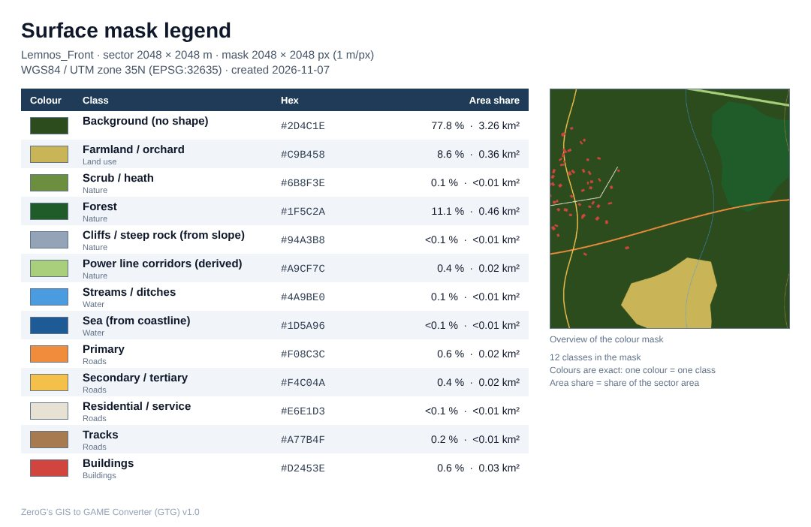
Figure 20 – Exported legend picture: only classes that appear in the mask, with hex colour and share of the area
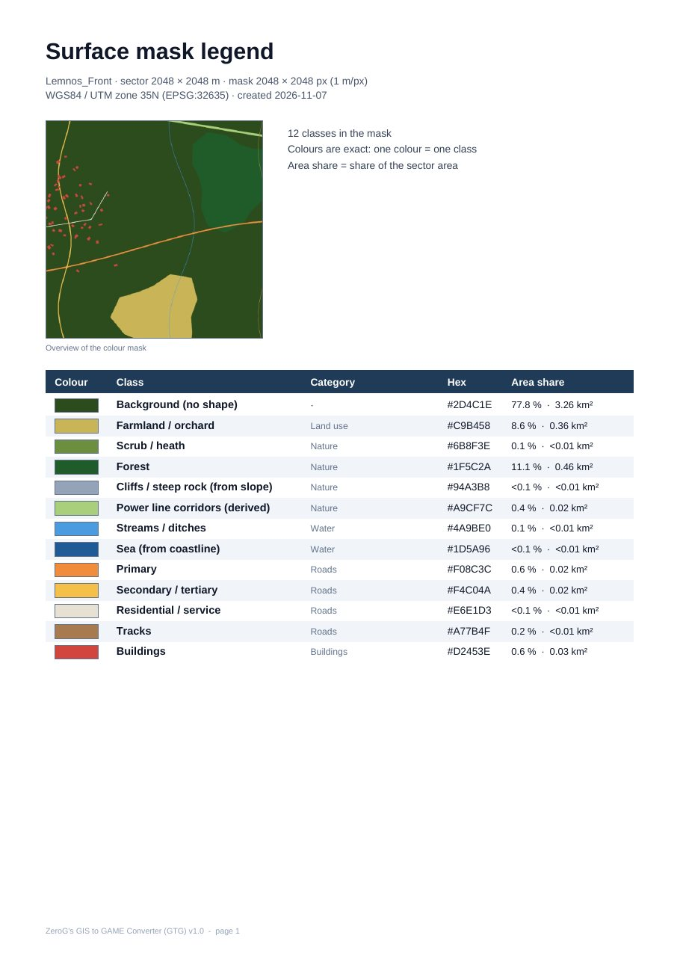
Figure 21 – The same legend as PDF (A4, text stays selectable)

Step 10 – Export
- Click “Export sector with default settings” in the header for one ZIP with everything, or use the export button of each section for single parts.
- Large exports show an estimate first; a progress panel with Cancel follows.
- Use “Export params” in section 1 for the import values (height scale, grid, min / max height) – Arma Reforger needs them in the terrain import dialog.
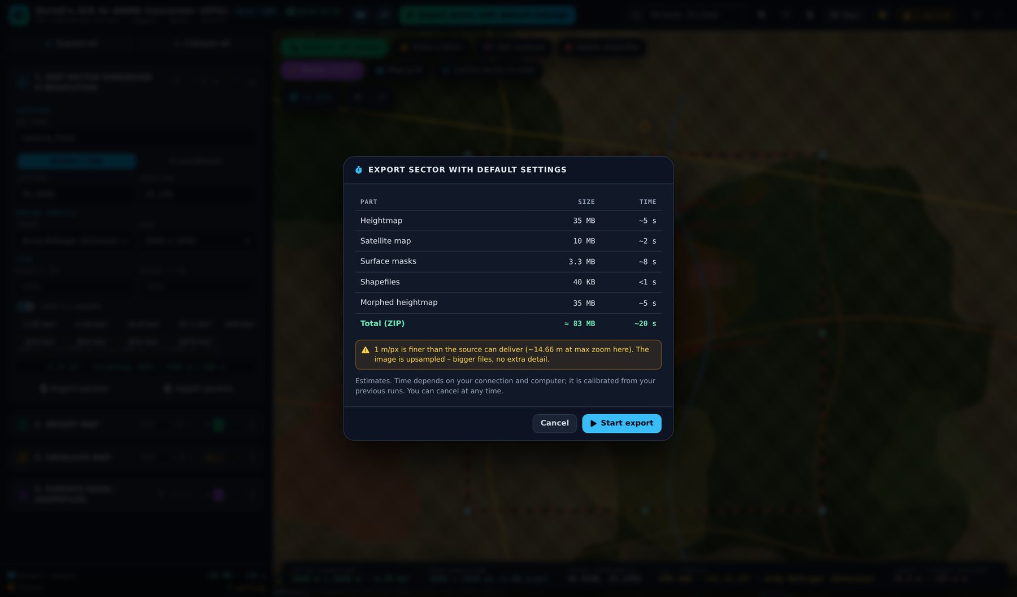
Figure 22 – Export estimate before a large export
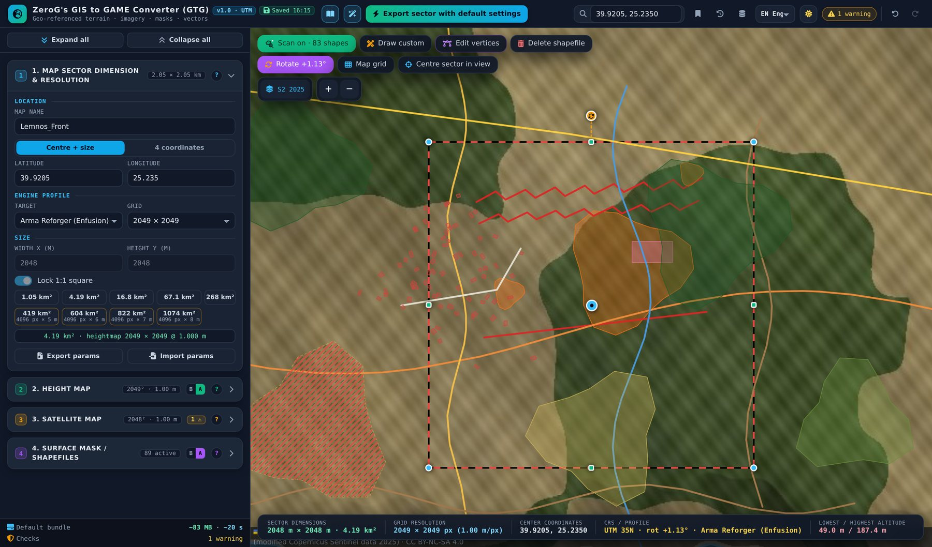
Figure 23 – Progress panel with elapsed / remaining time and Cancel

What the default bundle contains
Folder | Size | Examples
1_Heightmap | 7 files, 52.1 MB | , GTG_Lemnos_Front_2048x2048m_Heightmap.asc, GTG_Lemnos_Front_2048x2048m_Heightmap.prj, GTG_Lemnos_Front_2048x2048m_Heightmap_16bit.png, GTG_Lemnos_Front_2048x2048m_Heightmap_16bit.pgw, GTG_Lemnos_Front_2048x2048m_Heightmap_16bit.prj, …
2_Satellite | 4 files, 2.3 MB | , GTG_Lemnos_Front_2048x2048m_Satellite.png, GTG_Lemnos_Front_2048x2048m_Satellite.pgw, GTG_Lemnos_Front_2048x2048m_Satellite.prj
3_SurfaceMask | 32 files, 2.0 MB | , GTG_Lemnos_Front_2048x2048m_SurfaceMask.png, GTG_Lemnos_Front_2048x2048m_SurfaceMask.pgw, GTG_Lemnos_Front_2048x2048m_SurfaceMask.prj, GTG_Lemnos_Front_2048x2048m_SurfaceMask_legend.csv, GTG_Lemnos_Front_2048x2048m_SurfaceMask_legend.png, …
4_Shapefiles | 48 files, 58 KB | , , GTG_Lemnos_Front_road_primary.shp, GTG_Lemnos_Front_road_primary.shx, GTG_Lemnos_Front_road_primary.dbf, GTG_Lemnos_Front_road_primary.cpg, …
5_Heightmap_Morphed | 7 files, 52.1 MB | , GTG_Lemnos_Front_2048x2048m_Heightmap_Morphed.asc, GTG_Lemnos_Front_2048x2048m_Heightmap_Morphed.prj, GTG_Lemnos_Front_2048x2048m_Heightmap_Morphed_16bit.png, GTG_Lemnos_Front_2048x2048m_Heightmap_Morphed_16bit.pgw, GTG_Lemnos_Front_2048x2048m_Heightmap_Morphed_16bit.prj, …
(root) | 2 files, 9 KB | GTG_Lemnos_Front_2048x2048m_params.json, ATTRIBUTION.txt

Importing the result into Arma Reforger
- Create a terrain entity at 0, 0, 0 with grid size 2048 × 2048 faces and cell size 1 m.
- Import the heightmap .asc (true metres) – or the 16-bit PNG with “Resample heights” and the min / max values from params.json.
- Import the satellite map and the grayscale surface masks (Surfaces_order.csv lists the stack order, 01 = bottom). The colour legend in 3_SurfaceMask shows which colour of the colour-coded mask means which surface.
- Import the shapefiles from 4_Shapefiles/shp – they are in terrain metres, so they fit without offsets.

Part 3 – Feature reference

3.1 Section 1 – Map sector dimension & resolution
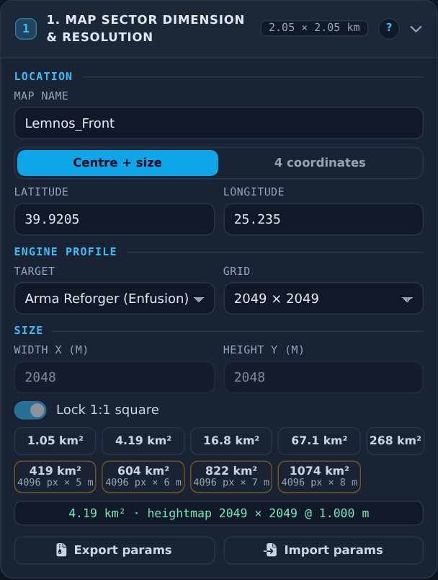
Figure 24 – Section 1

Location
- Map name – prefix of every exported file and ZIP (default “MyMap”).
- Centre + size – latitude / longitude of the sector centre (WGS84; default 52, 9). Same as dragging the blue marker.
- 4 coordinates – enter north, south, west, east or paste them (also four “lat, lon” corner lines from Google Maps or QGIS). The sector becomes the UTM rectangle that encloses them.

Engine profile
- Target – Custom, Unreal Engine 5, Unity, Arma 3, Arma Reforger. Sets grid, heightmap formats, satellite / mask resolution, vector format and coordinates.
- Grid – heightmap samples per side. Unreal / Unity / Reforger use vertex counts (2ⁿ+1); Arma 3 uses cell counts (2ⁿ). The sector size is (grid − 1) × cell size.

Size and presets
- Width / height – sector size in metres (fixed by the grid when a profile is active).
- Lock 1:1 – keeps the sector square.
- Presets – 1.05 km² up to 1,074 km². The large presets use a 4,096 px heightmap at 5–8 m cell size.
- Export / import params – saves or loads the whole project as .json, including all engine import values.

Direct manipulation on the map
- Blue centre marker: move the sector.
- Round corner handles: resize freely to any rectangle; hold Ctrl (or Alt) to keep it square.
- Green edge handles: change only width or height.
- Orange handle above the north edge: rotate (Ctrl = 5° steps).
- “Centre sector in view” (sector row of the map controls): moves the sector to the middle of the current map view; size, cell size and profile stay.

Rotation and map grid
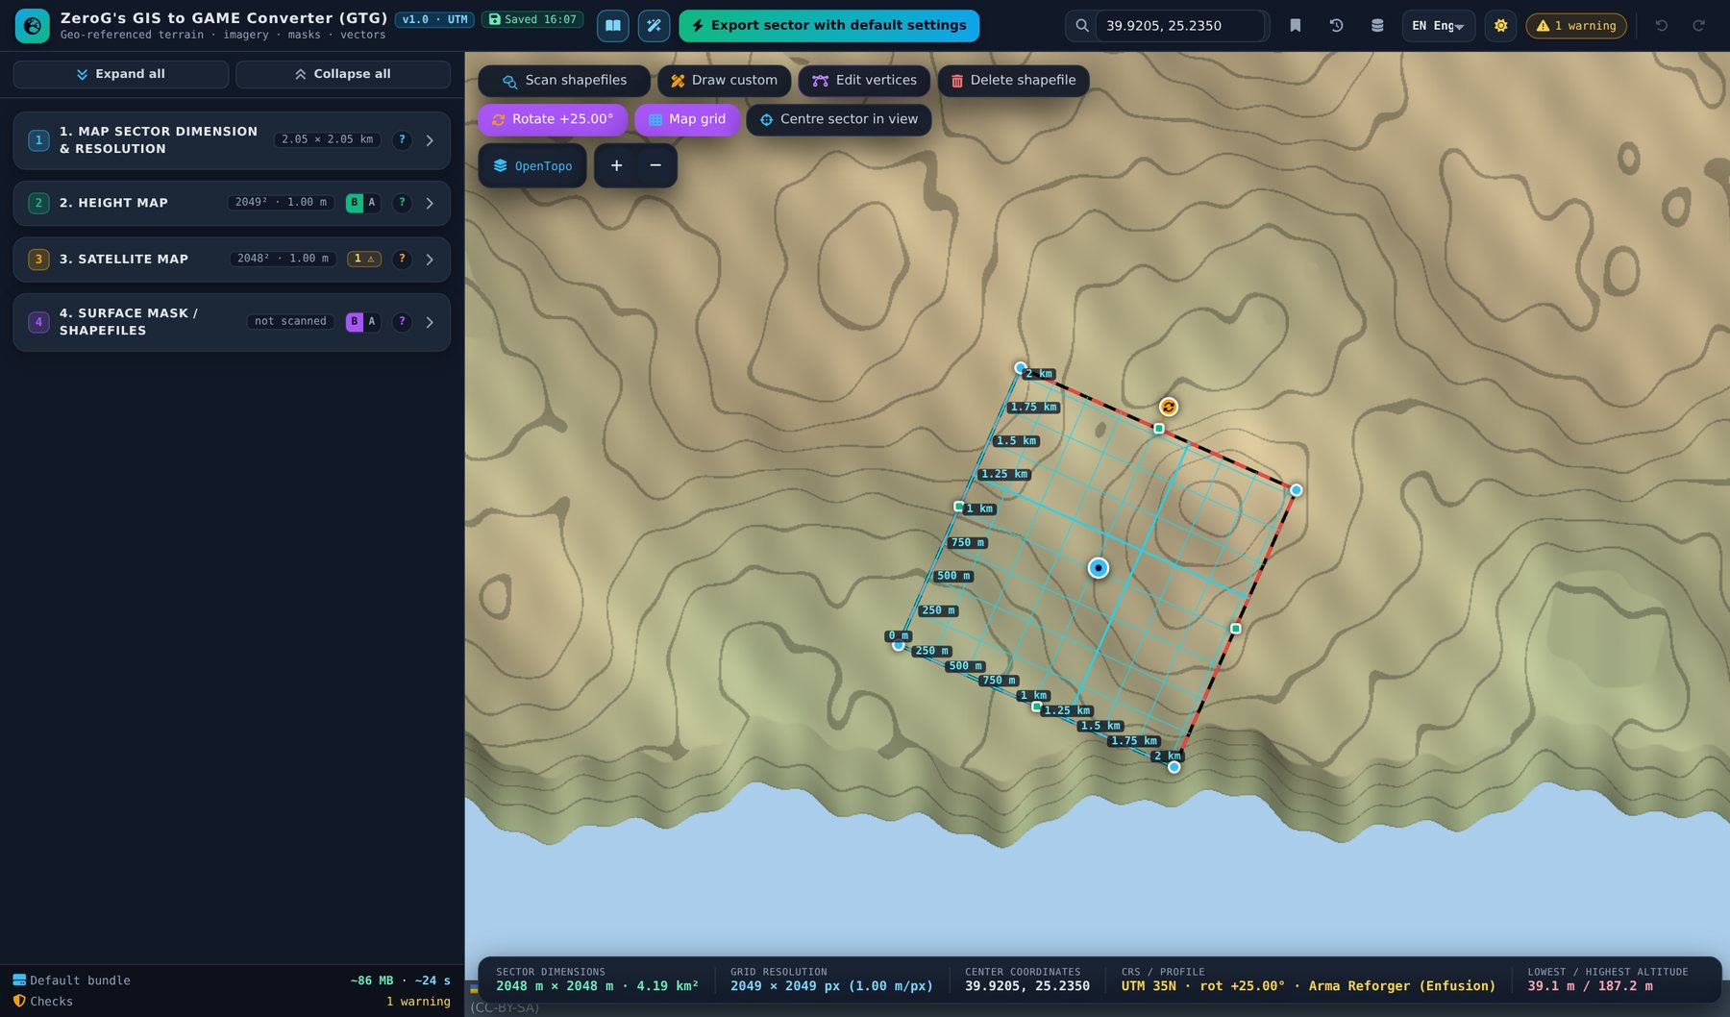
Figure 25 – Sector rotated by 25°: the frame, the handles and all exports follow the rotation
- Rotate sector – angle in degrees clockwise against UTM grid north; slider; ±0.1° / ±1° steps.
- Align to map grid – compensates the grid convergence so the edges run true north–south / east–west.
- Align to UTM grid – back to 0°.
- Effect on exports – heightmap, imagery and masks are resampled into the rotated grid; shapefiles in terrain metres follow the rotated axes; GeoTIFF and world files carry the rotation; .asc cannot store it (a message explains this).
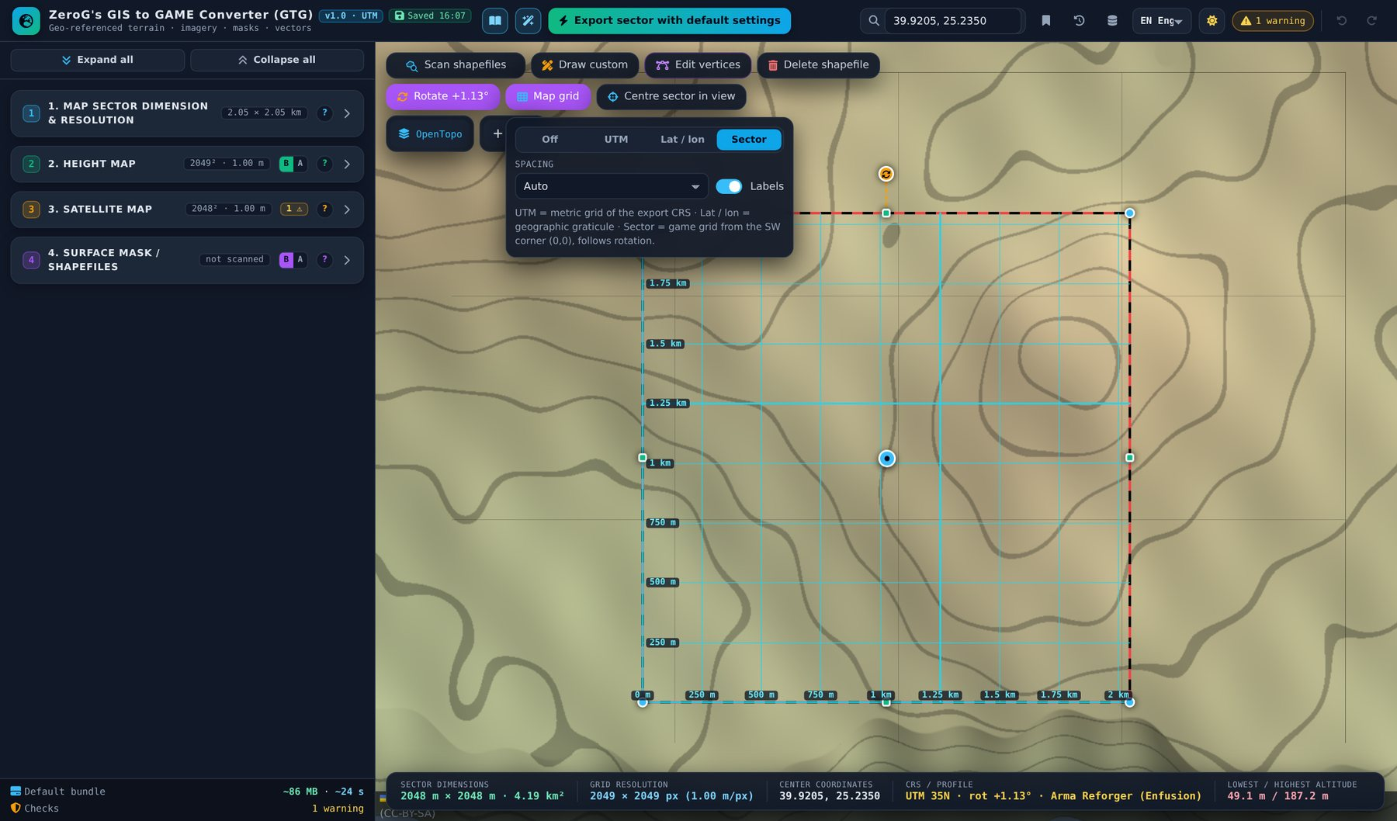
Figure 26 – Map grid panel: Off, UTM, Lat / lon, Sector; spacing and labels
- UTM – metric grid of the export CRS; every 10th line bold.
- Lat / lon – geographic graticule.
- Sector – game grid from the south-west corner (0,0); rotates with the sector.
- Spacing – Auto adapts to zoom or sector size; fixed 10 m – 10 km.

3.2 Section 2 – Height map
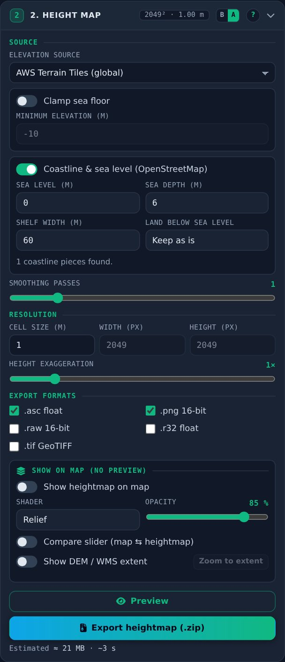
Figure 27 – Section 2 in Advanced mode

Elevation source
- AWS Terrain Tiles – free, global; tile grid ≈ 2–5 m, but survey data behind it is often 10–30 m outside lidar areas.
- Custom WMS (elevation) – official DEM servers; encodings GeoTIFF float32, Terrarium, Mapbox Terrain-RGB or grayscale with min / max. Gaps are filled from AWS.
- Local DEM – GeoTIFF or Esri ASCII in WGS84 or UTM. If it lies elsewhere (less than half overlap), the sector moves onto it automatically.

Sea and coast
- Clamp sea floor – limits depth to save 16-bit range for land.
- Coastline & sea level – fills the sea side of OpenStreetMap coastlines (read from the shapefile scan); sea level, depth, shelf width; option to raise land below sea level.

Resolution and formats
- Cell size – 0.25–8 m. Width / height in px follow from sector ÷ cell size; typing pixels changes the cell size.
- Smoothing passes – light blur against terrace steps (1 is a good default).
- Height exaggeration – 0.25–5×, scaled from the lowest point; applies to previews, the map overlay and exports.
- Formats – .asc (true metres), .png 16-bit, .raw 16-bit (Unity / Unreal), .r32 float, .tif GeoTIFF (QGIS).

Show on map (no preview)
- Show heightmap on map – draws the heightmap of the sector on the map with the same data as the export (AWS terrain, local DEM or elevation WMS incl. smoothing, exaggeration and sea shaping). It follows the sector when you move, resize or rotate it.
- Shader and opacity – Relief, Elevation, Slope, Contours, Clay or Grayscale; opacity 10–100 %.
- Compare slider – adds an orange handle on the map: the background map stays visible on the left, the heightmap on the right.
- Show DEM / WMS extent – outlines the area covered by the local DEM file or the elevation WMS layer (taken from the server’s capabilities); “Zoom to extent” jumps there. AWS terrain covers the whole globe.
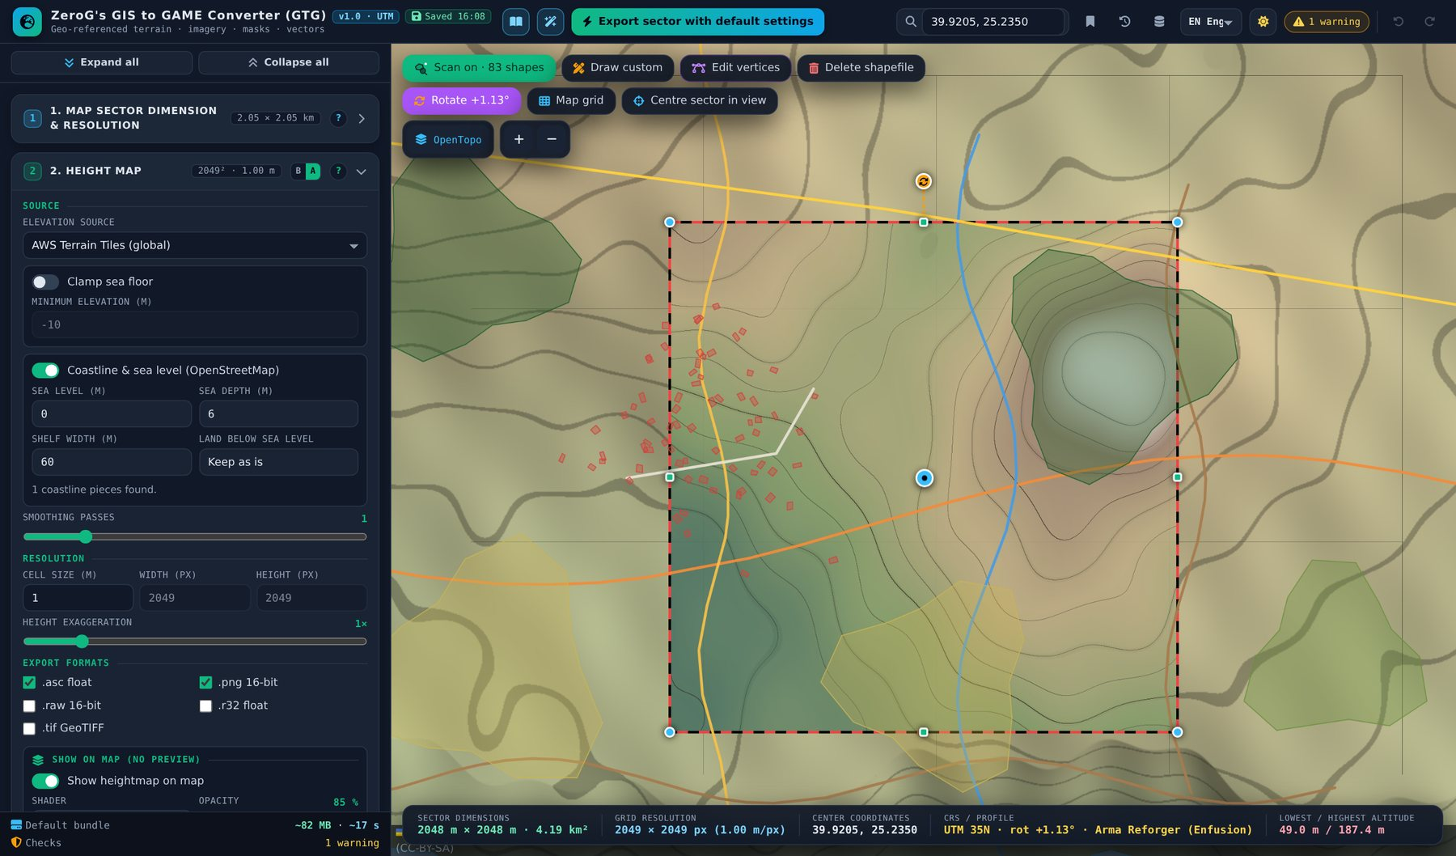
Figure 28 – Heightmap on the map with the Contours shader
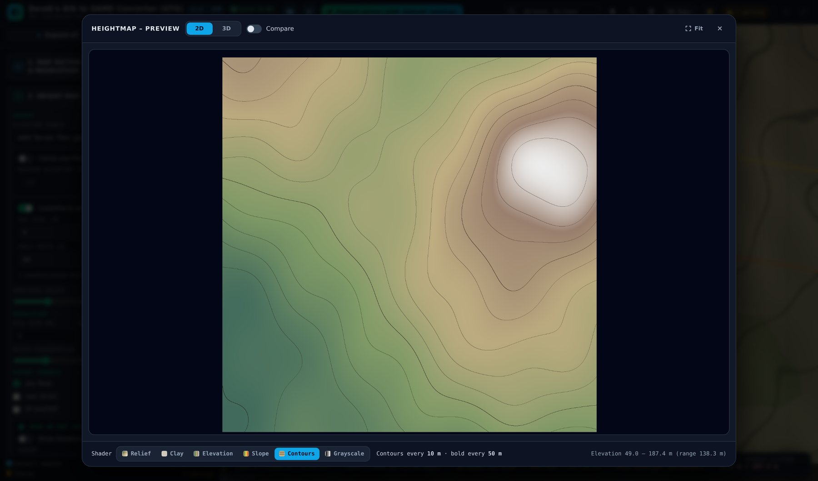
Figure 29 – Preview window, Contours shader – every 5th line bold, interval shown in the legend
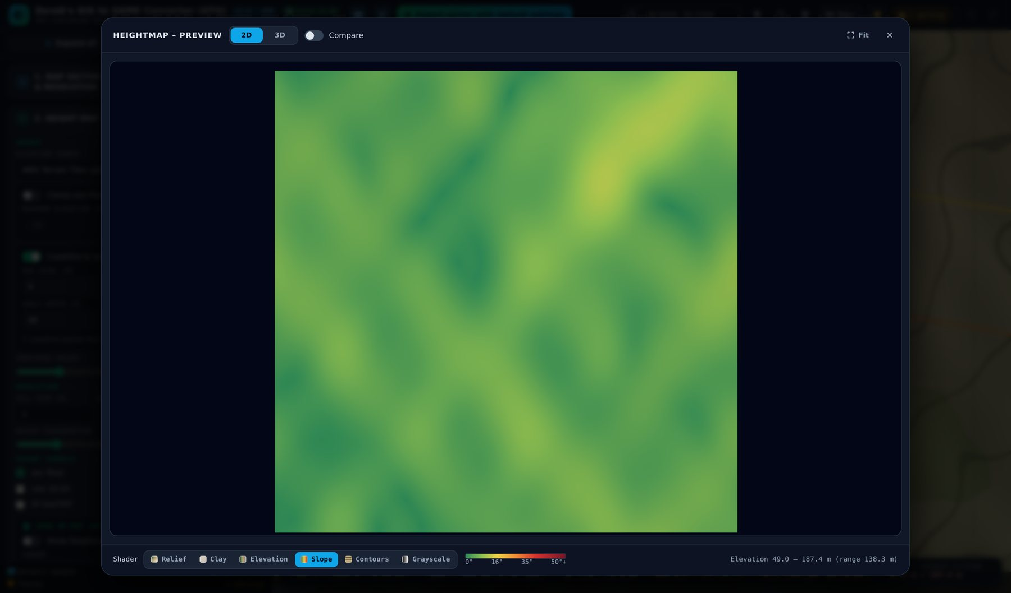
Figure 30 – Preview window, Slope shader – green flat, yellow ~16°, red > 35°

3.3 Section 3 – Satellite map
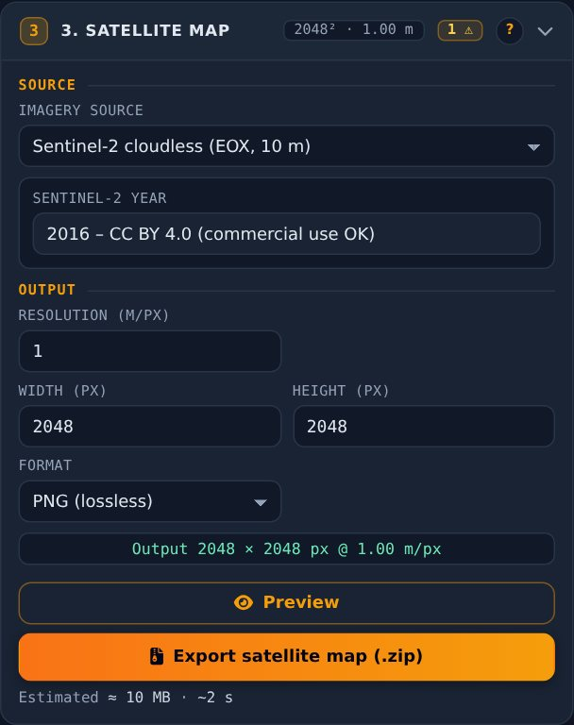
Figure 31 – Section 3
- Imagery source – Sentinel-2 cloudless (10 m colour; 2016 = CC BY 4.0, 2018 to 2025 = non-commercial), OpenTopoMap (rendered map), custom XYZ, custom WMS.
- Sentinel-2 year – the export default stays 2016 because it is the only year free for commercial use. The background map in the map controls always uses the newest year.
- Resolution – metres per pixel; a warning appears if you go finer than the source.
- Width / height (px) – linked to the sector size; typing pixels changes the resolution.
- Format – PNG (lossless) or JPG (about 5× smaller).

3.4 Map controls in detail
The block in the top-left corner of the map has three rows (see 1.5). This chapter explains the buttons; Part 3.1 covers rotation, grid and centring in context.

Shapefile row
- 1 Scan – switch on to load the public shapefiles of the sector (OpenStreetMap: roads, rails, water, land use, nature, buildings, power lines, coastline) and keep them shown. While it is on, the sector is rescanned automatically about a second after every move, resize or rotation; sectors above 64 km² are not rescanned automatically (a message offers “Rescan now”). Click again to switch off: the shapes are hidden, scanned data stays available, and exports scan by themselves when they need shapes. Shift+click forces a fresh download instead of the 7-day cache. The icon pulses while scanning and then reads “Scan on · N shapes”. After a reload it starts switched off.
- 2 Draw custom – opens a panel: pick the class, then Polygon, Line or Rectangle and draw on the map. Same tools as in 4.2.
- 3 Edit vertices – click a shape, drag a vertex to move it, click + to add one; click a vertex (it turns red) and press Del to remove it; right-click also removes. Esc deselects, Done ends.
- 4 Delete – delete mode (red): every clicked shape – OpenStreetMap or custom – is deleted. Esc ends it; Undo brings shapes back.
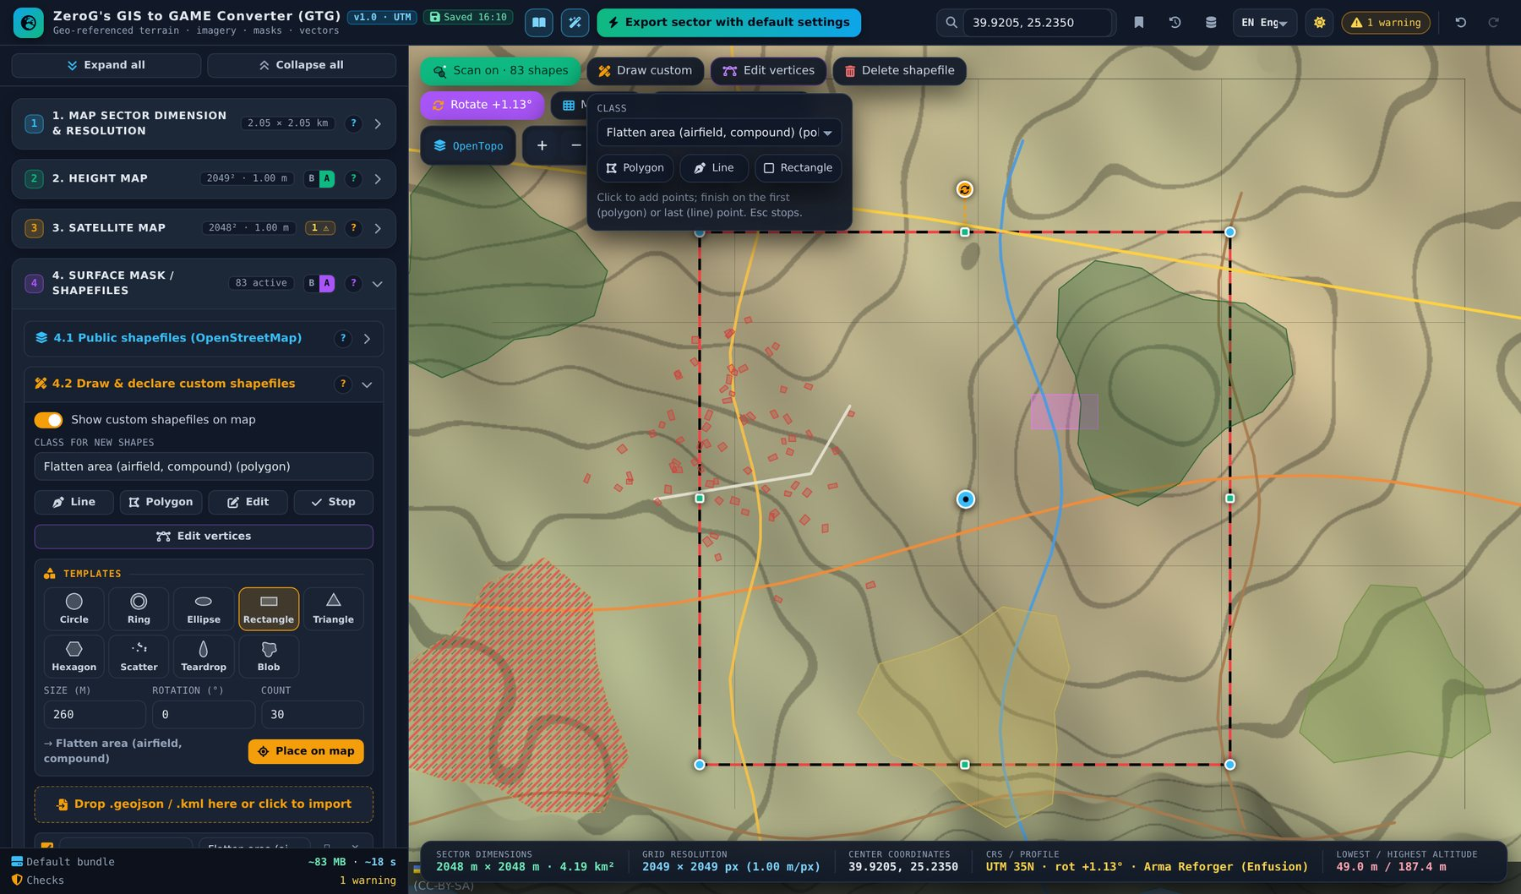
Figure 32 – Draw panel below the “Draw custom” button
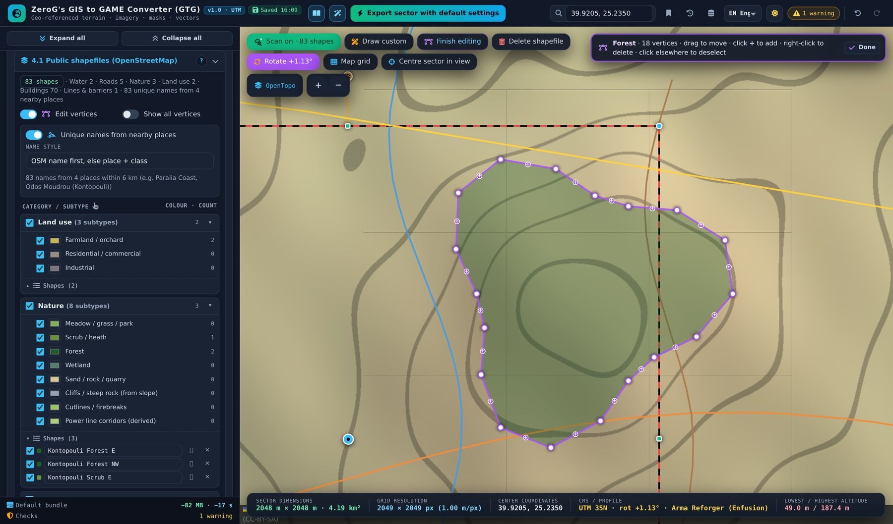
Figure 33 – Edit vertices: drag a vertex, click + to add one, select and press Del to remove

Background map
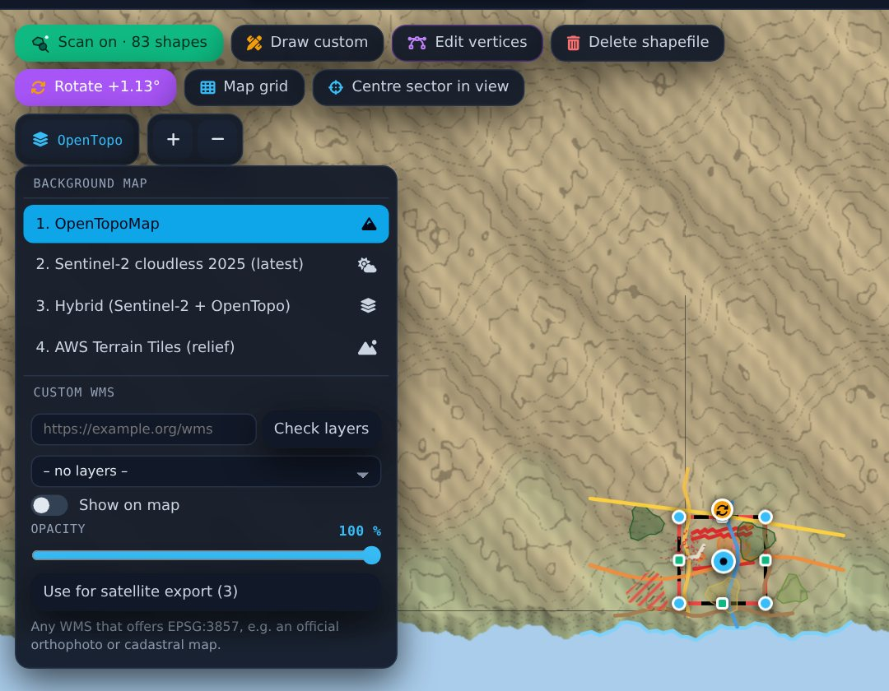
Figure 34 – Background menu with the custom WMS block (it opens downwards from the button)
Background | What it shows
OpenTopoMap | Rendered topographic map with contours, roads and names.
Sentinel-2 cloudless (latest) | Cloud-free satellite colour. The newest year offered by EOX is detected automatically (checked at start, remembered for 7 days); the button shows it, e.g. “S2 2025”. 2018 and later are free for non-commercial use only.
Hybrid (Sentinel-2 + OpenTopo) | The newest Sentinel-2 imagery with OpenTopoMap drawn over it. The slider “Map layer strength” (10–100 %, default 50 %) sets how strongly contours, roads and names show.
AWS Terrain Tiles (relief) | The elevation tiles behind the heightmap, drawn as shaded relief (lowlands green, highlands brown to white, sea blue) – a quick look at the terrain of a place before you set the sector. A shader selector offers Relief, Clay, Elevation, Slope and Contours; the sea stays blue.

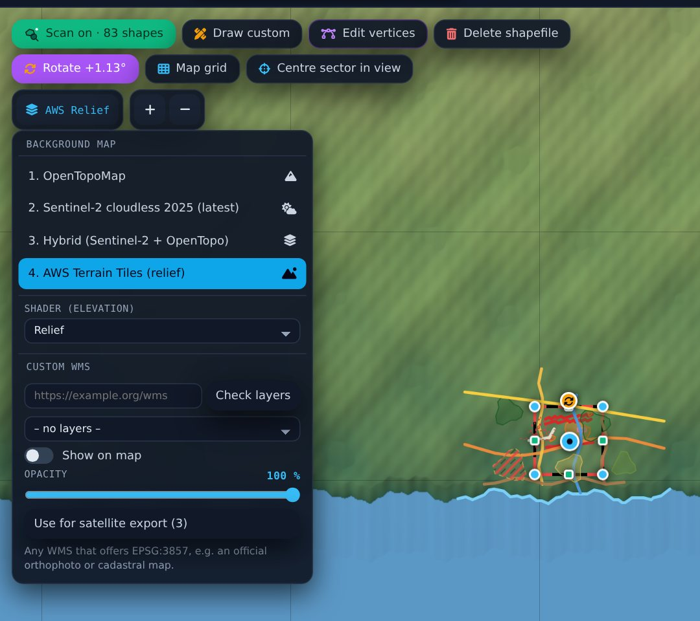
Figure 35 – AWS Terrain Tiles as background with the shader selector
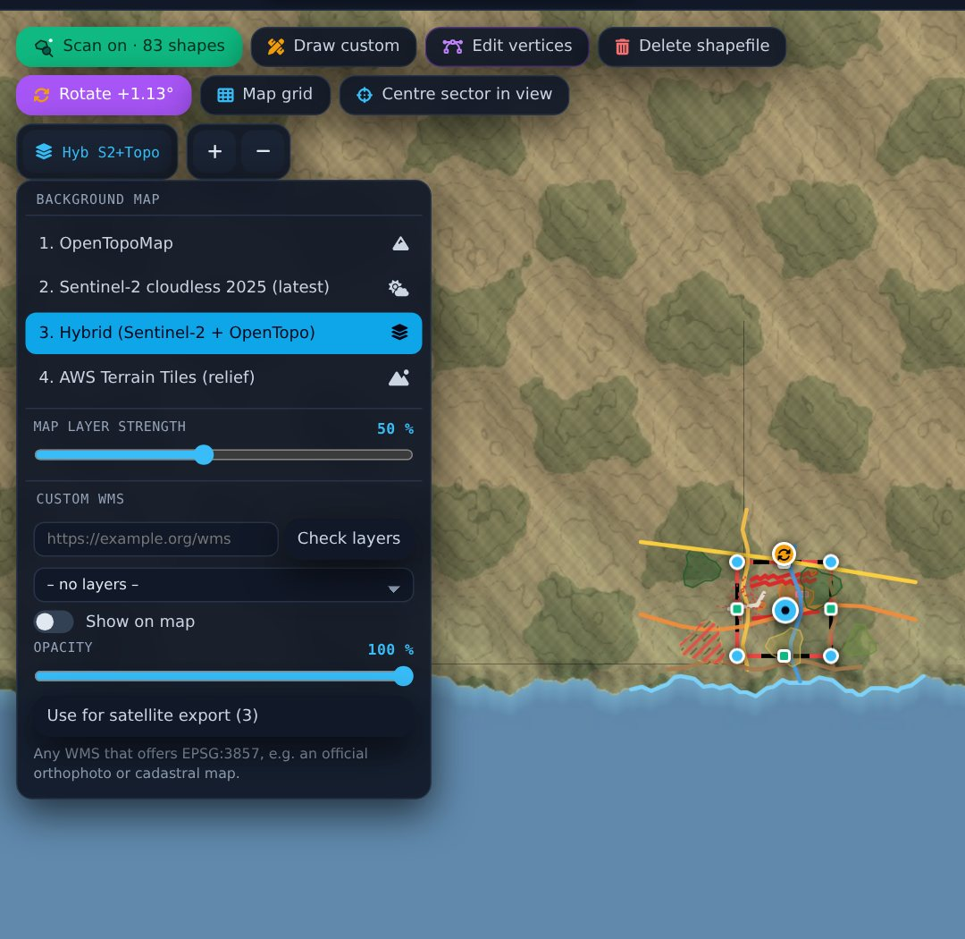
Figure 36 – Hybrid map with the “Map layer strength” slider
- Custom WMS – below the list: enter a URL, “Check layers”, pick a layer. It is drawn on top of the background; the opacity slider blends it (100 % covers the background). “Use for satellite export (3)” copies URL and layer to section 3. The server must offer EPSG:3857; some servers block browser access (CORS). URL, layer and opacity are saved with the session.
- Zoom – plus and minus next to the background button.

3.5 Section 4.1 – Public shapefiles (OpenStreetMap)
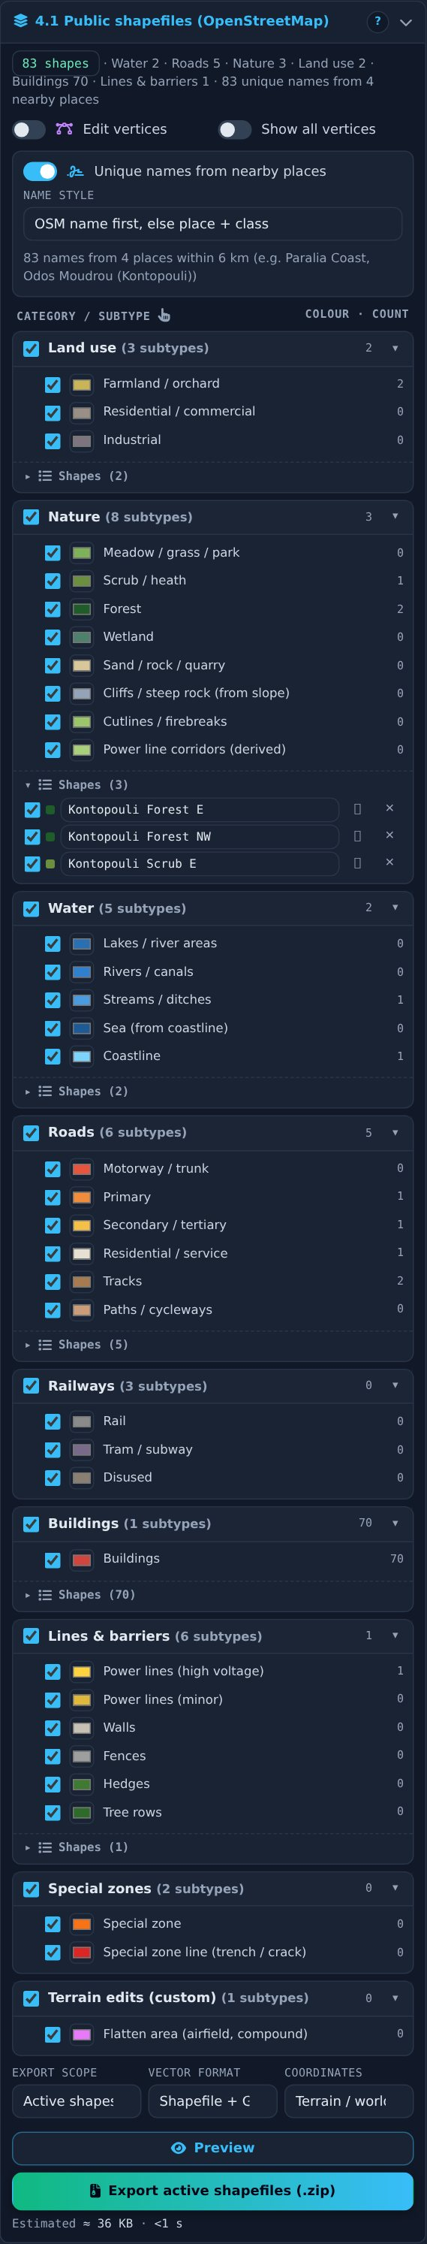
Figure 37 – Section 4.1 with category tree and shape list

Scan status and names
- Scan – the scan itself is switched on and off with the scan icon on the map (see 3.4). The status line in 4.1 shows the result: shapes per category and whether it came from the cache (with a link to download fresh data).
- Unique names – every shape gets a name from the nearest place, its class and direction (e.g. “Kontopouli Forest NE 02”). Written to NAME, OSM_NAME, PLACE, PLACE_DIR, PLACE_DIST and SURFACE (custom shapes with a surface name).

Category tree and shape lists
- Tick categories / subtypes to show and export them; the colour sets map and mask colour.
- “Shapes (n)” lists every shape: include checkbox, name field, ⌖ zoom, ✕ delete. With 4.3 “Selected only” a target button picks shapes for morphing.
- Clicking a shape on the map excludes it (red diagonal bars); Ctrl+click selects it for 4.3.

Export
- Export scope – active shapes only, or all shapes (deleted shapes never).
- Vector format – Shapefile + GeoJSON, Shapefile, GeoJSON.
- Coordinates – Terrain / world (metres from the south-west corner; use for engines) or UTM (for GIS). Shapes are cut to the terrain and kept 1 cm inside.

3.6 Section 4.2 – Custom shapefiles
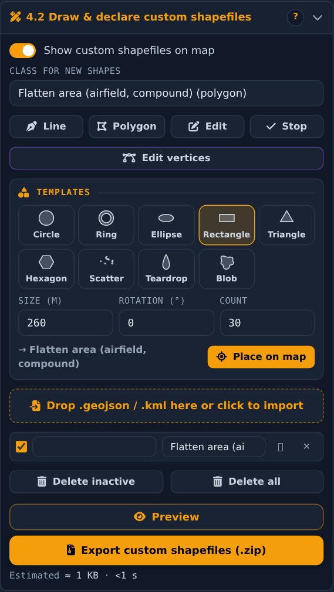
Figure 38 – Section 4.2 with templates and shape list
- Show custom shapefiles on map – shows or hides your own shapes; hidden shapes are still exported.
- Class for new shapes – all OSM classes plus “Flatten area” (airfields, compounds).
- Draw tools – Line, Polygon, Edit, Stop – or “Draw custom” on the map (also Rectangle).
- Templates – circle, ring, ellipse, rectangle, triangle, hexagon, scatter, teardrop, blob; size, rotation and count; Shift+click places copies.
- Import – drop GeoJSON (WGS84, UTM, terrain metres) or KML; a “class” property is used when it matches.
- Shape list – include, rename, change class, zoom, delete; “Delete inactive” / “Delete all”. Names are filled in from nearby places (see below).

Shapes from map colours
Turns the colours of a map into custom shapefiles. Use it where OpenStreetMap has little detail – for example different kinds of forest inside one nature area. The colours come from the custom WMS overlay of the background-map menu (e.g. an official land-cover map) or from the background map itself (Sentinel-2 or OpenTopoMap). The box sits in 4.2, so section 4 must be in Advanced mode.
- Colour source – Map overlay (custom WMS) or Background map. The AWS relief background has no image colours; the box says so.
- Detail (m/px) – pixel size of the colour image. 0 = automatic (about 1,600 px along the longest side). Smaller values give more detail but take longer; at most 4,096 px per side.
- Detect colours in sector – loads the picture inside the sector and groups its colours into classes. Each colour shows its share of the sector and a suggested class (dark green → Forest, blue → Lakes, yellow → Farmland …). The suggestion is an assumption – check it. White and black are ignored by default.
- Class per colour – choose any shape class or “Ignore”. Polygon classes (forest, grass, farmland, water …) become areas, including holes such as clearings. Line classes (track, stream, hedge …) become the centre lines of thin features.
- Colour tolerance and Max colours – how different two colours may be and still count as one class; the maximum number of classes. Earlier class choices are kept for matching colours.
- Min area (m²), Min line (m) – smaller areas are merged into their neighbour (removes specks and anti-aliased borders); shorter lines are dropped.
- Outline smoothing – 0 = exact pixel outline, higher = fewer vertices and rounder shapes.
- Preview colour classes on map – draws the classes over the map the way they will be traced, so you can tune the settings before generating.
- Generate shapes – creates the shapes as normal custom shapefiles: edit vertices, rename, change class, use them in morphing and masks, export them. Ctrl+Z undoes the whole run; “Delete generated” removes all generated shapes later. At most 3,000 shapes per run; the smallest are skipped and you are told.

Surface names and groups
- Own surface names – every colour has a name field next to its class. The suggestion comes from the class (e.g. “Forest”); type your own, e.g. “Pine forest” or “Beech forest”. Two forest colours with different names become separate surfaces; both keep the class Forest.
- Colour groups – the colour list is grouped by surface name, so similar colours with the same name sit together. One switch per group turns all its colours on or off before generating.
- Generated surface groups – after generating, one row per surface: the switch activates or deactivates all shapes of the group at once (exports, masks, morphing; Ctrl+Z works); the name field renames the whole group including the shape names; ⌖ zooms; ✕ deletes the group.
- Export – the surface name is written to the SURFACE field of the shapefile and to “surface” in GeoJSON.

Names from nearby places
- Every custom shape – drawn, imported or generated – is named after the nearest town, village or locality, its surface name or class and the direction, e.g. “Kiefernhain Pine forest S 01”. Duplicates are numbered from north to south.
- The places are looked up on their own, so naming also works while the shapefile scan is off. The lookup is cached for 7 days.
- The names appear directly in the custom shape list. A name you type yourself always takes priority.
Note Generated shapes are only as accurate as the picture. A WMS served in the sector’s UTM projection is used 1:1; a rotated sector is read via lat / lon. The masks still colour by class, so two forest surfaces share one mask colour.

3.7 Section 4.2b – Special zones
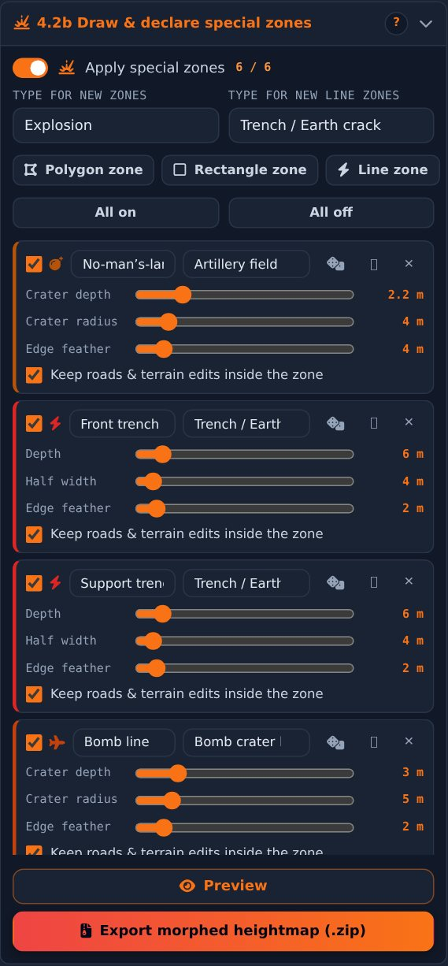
Figure 39 – Section 4.2b: zone cards with individual settings
- Apply special zones – master switch with active / total counter.
- Type for new zones / line zones – type given to the next drawn polygon or line.
- Polygon zone, Rectangle zone, Line zone – start drawing directly.
- Zone card – on/off, name, type, dice (new random layout), zoom, delete; sliders Intensity, Radius, Edge feather; “Keep roads & terrain edits inside the zone”.
Zone type | Shape | Effect
Explosion | Polygon | Single irregular crater with rim and one-sided ejecta.
Artillery field | Polygon | Many overlapping irregular craters – WW1 style.
Meteor impact | Polygon | Large crater with central peak and raised rim.
Sinkhole | Polygon | Steep-walled collapse.
Volcano | Polygon | Cone with crater; wipes roads (keep off).
Erosion | Polygon | Gullies, stronger on steep slopes.
Firing position / revetment | Polygon | Dug-in pad with earth wall.
Dam / reservoir | Polygon | Raises a dam where the edge lies below the water level.
Open-pit mine / quarry | Polygon | Stepped benches down to a flat floor.
Mound / spoil heap | Polygon | Rounded dome with surface roughness.
Subsidence field | Polygon | Undulating sinking.
Dune field | Polygon | Asymmetric dunes; dice changes wind direction.
Rockfall / boulder field | Polygon | Scattered boulders.
Terraced fields | Polygon | Steps following the contours.
Trench / earth crack | Line / polygon | Narrow cut with noisy depth.
Bomb crater line | Line | Craters along the line.
Earthworks / berm | Line | Raised wall.
Anti-tank ditch | Line | Ditch with spoil berm on the right of the drawing direction.
Riverbed / dry wadi | Line | Meandering channel.

3.8 Section 4.3 – Heightmap morphing
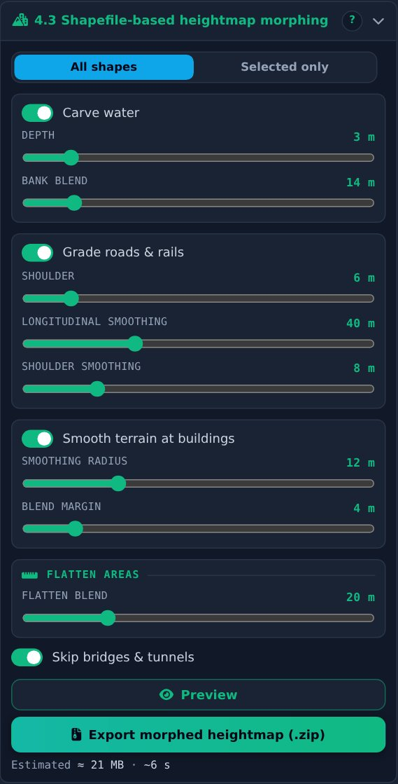
Figure 40 – Section 4.3
- All shapes / Selected only – apply shaping to everything or only to selected shapes.
- Carve water – flattens water to bank level, lowers it by Depth, blends over Bank blend.
- Grade roads & rails – flat cross-sections and smooth gradients; Shoulder, Longitudinal smoothing, Shoulder smoothing.
- Smooth terrain at buildings – smoothing radius and blend margin; slopes stay, bumps disappear.
- Flatten areas – each “Flatten area” polygon is levelled to its mean height.
- Skip bridges & tunnels – no dammed rivers, no cut hills.
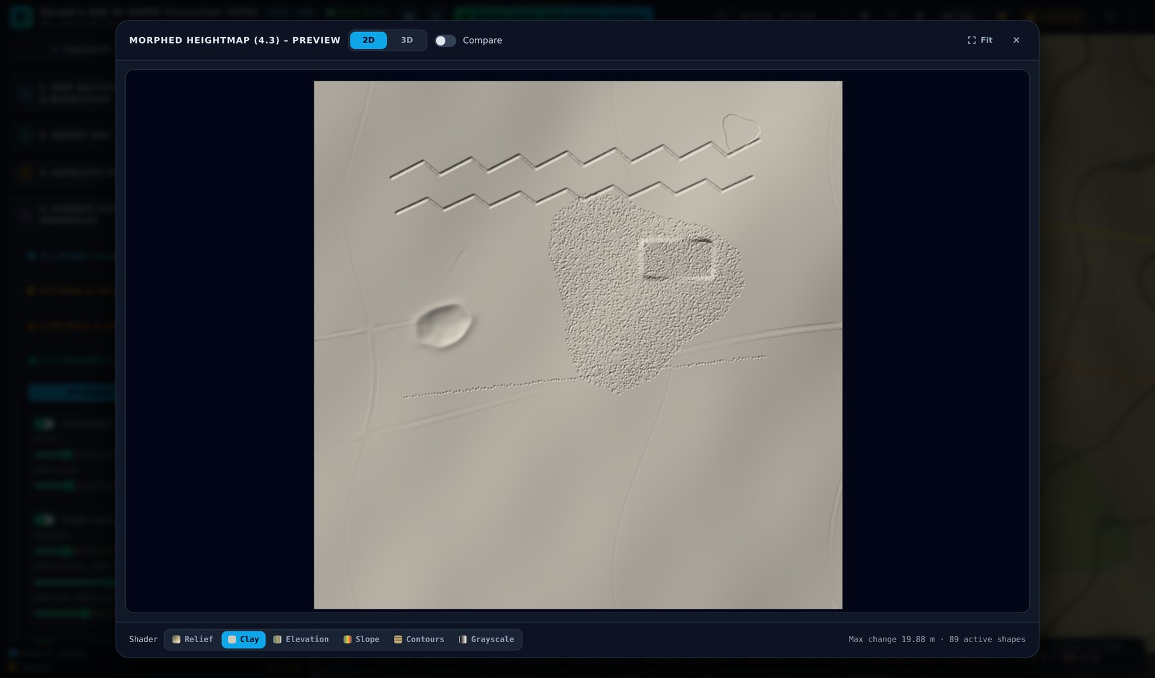
Figure 41 – Clay shader – neutral model to judge the morphed shape

3.9 Section 4.4 – Surface masks
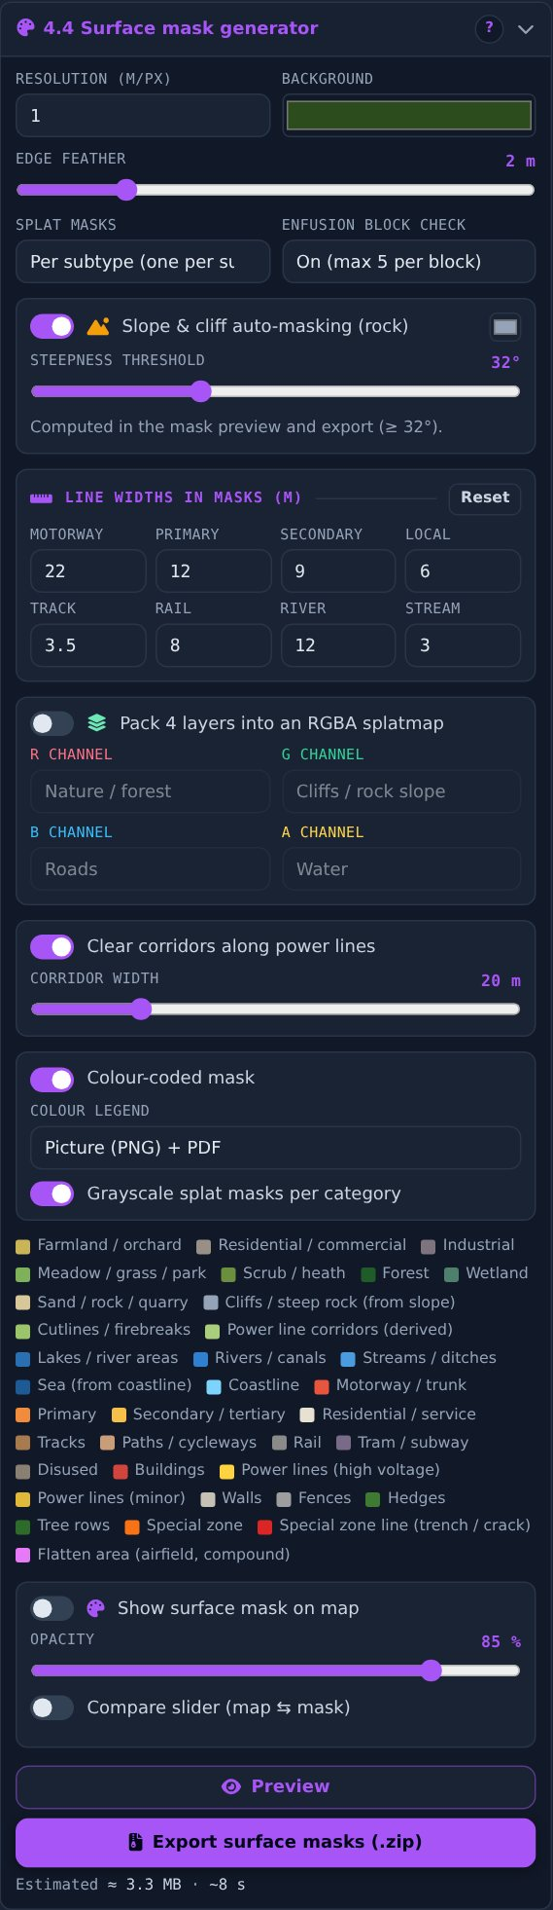
Figure 42 – Section 4.4 with the colour-legend selector
- Resolution & background – metres per mask pixel and colour of empty pixels.
- Edge feather – soft edges for grayscale splat masks (colour mask stays hard).
- Splat masks – always per subtype: one grayscale PNG for every marked (active) subtype, never merged into the top category; numbered in stack order and listed in Surfaces_order.csv.
- Enfusion block check – marks 32 × 32-face blocks with more than 5 surfaces; exports BlockCheck.png / .csv.
- Slope & cliff auto-masking – rock surface on slopes above the threshold (30–35° typical).
- Line widths – widths of roads, rails and rivers in masks and morphing.
- RGBA splatmap – four layers in one 8-bit PNG for Unity / Unreal.
- Clearings – corridors along power lines.
- Outputs – colour-coded mask with legend and / or grayscale splat masks.

Colour legend
- The colour-coded mask is exported together with a colour legend: as a picture (PNG), as PDF, or both (default). The selector “Colour legend” in the outputs box has the options Picture + PDF, Picture, PDF and None; it is available while the colour-coded mask is on.
- The legend lists only the classes that really appear in the mask – colour swatch, class name, category, hex colour and share of the sector area in percent and km² – plus a small overview of the mask. The background colour is the first entry. The numbers are counted from the exported mask itself.
- Colours are exact: one colour equals one class. Anti-aliased edge pixels are snapped only to classes that are really drawn, so no stray colours appear.
- Files: <map>_SurfaceMask_legend.png and <map>_SurfaceMask_legend.pdf, next to the legend CSV with all classes. The default bundle contains both.

Show surface mask on map (no preview)
- Draws the colour-coded mask over the background map; the background colour is transparent. Opacity and a compare slider work as in section 2.
- The overlay updates when you change shapes, colours, slope masking or the sector.

3.10 Preview window
- Mouse wheel zooms, drag pans, double-click fits; the orange handle moves the compare split.
- “Compare” switches the before / after view on or off.
- 3D tab: orbit with the mouse, extra height factor for viewing only.
Shader | Shows
Texture (3D) | Preview image draped over the terrain.
Relief | Coloured hillshade.
Clay | Neutral grey model – best for judging shape.
Elevation | Colour bands from low to high.
Slope | Green (flat) to red (> 35°).
Contours | Lines at an automatic interval, every 5th bold.
Grayscale | Heightmap values as the engine reads them.
Wireframe / Normals (3D) | Mesh density / surface direction.

3.11 Project management
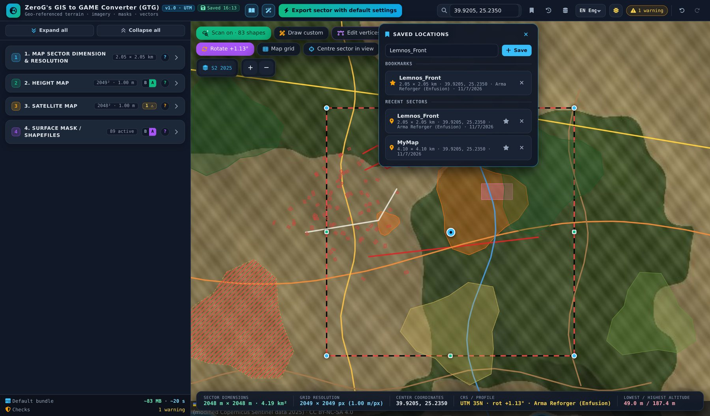
Figure 43 – Locations: bookmarks and recent sectors
- Locations – bookmark the current sector; recent sectors are recorded after each scan and export.
- History – last 20 versions: restore, compare with now, download as .json.
- Data cache – tiles and OpenStreetMap scans are kept between sessions; size limit and clearing.
- Auto-save – settings and shapes are saved while you work.

3.12 Language and theme
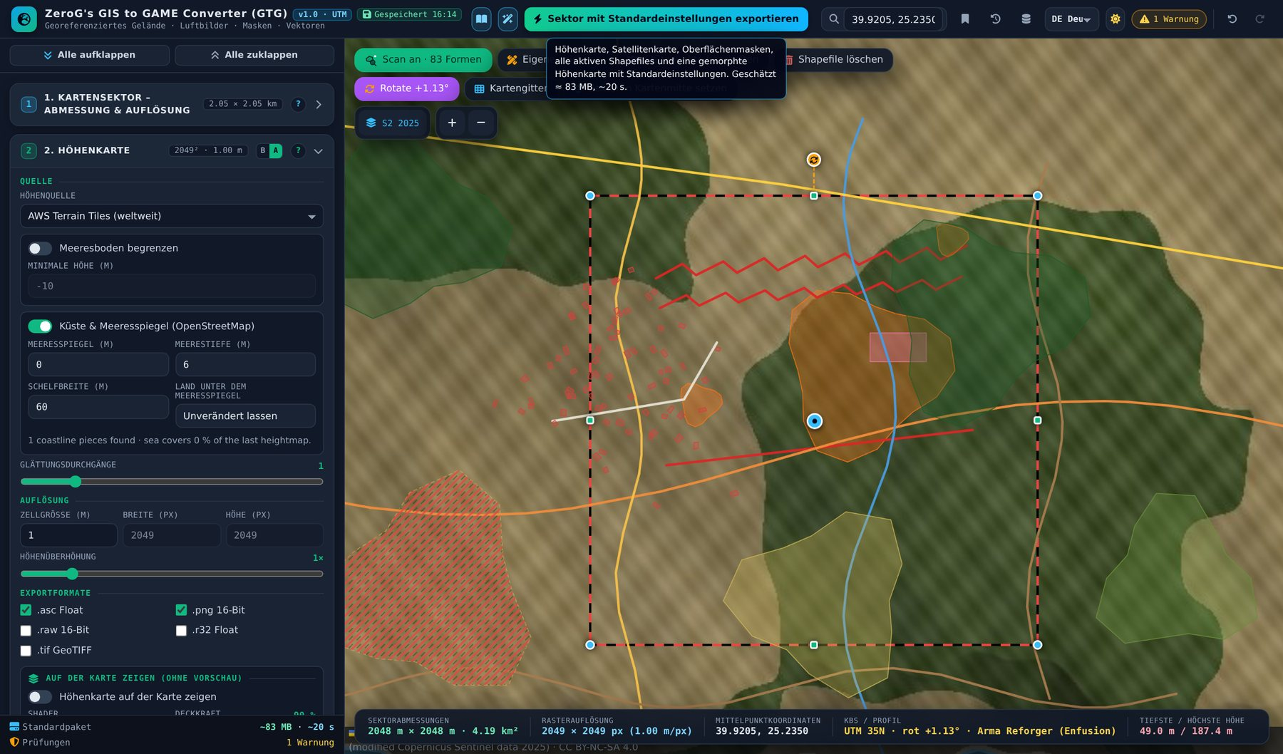
Figure 44 – German interface
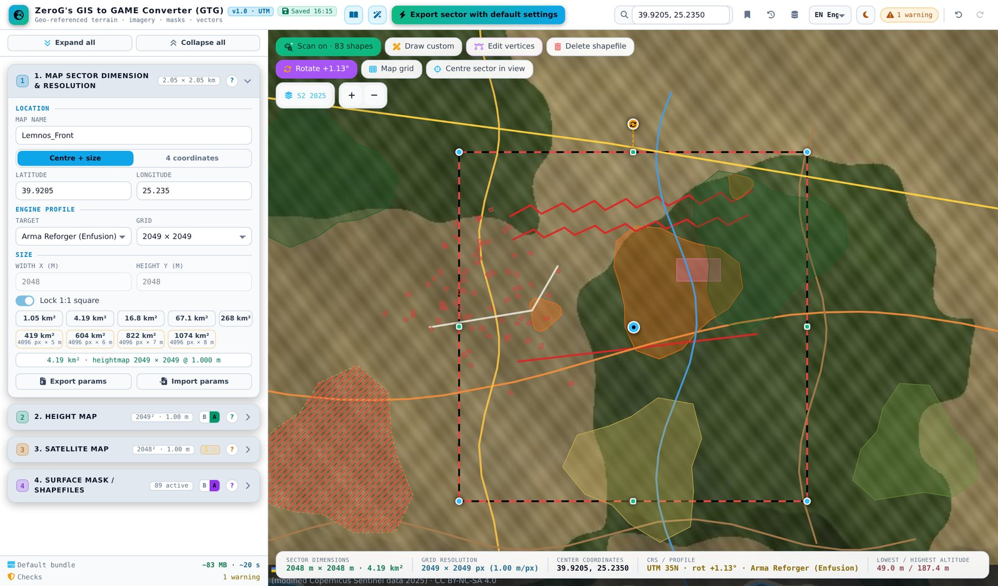
Figure 45 – Bright theme

Part 4 – Reference

4.1 Keyboard and mouse
Key / action | Function
Ctrl+Z / Ctrl+Y | Undo / redo
E | Edit vertices on / off
Del | Remove the selected vertex
Esc | Close dialog, cancel template, finish editing or delete mode
Click shape | Exclude / include in export
Ctrl+click shape | Select for 4.3 “Selected only”
Ctrl + drag corner | Keep the sector square
Ctrl + drag rotation handle | Rotate in 5° steps
Shift+click scan icon | Force a fresh OpenStreetMap download
Shift+click map (template) | Place several copies
← / → | Wizard steps

4.2 Engine import notes
Engine | Key values
Arma Reforger | Terrain at 0,0,0; grid − 1 faces; .asc in true metres or 16-bit PNG with “Resample heights” (min / max in params). Height scale 0.03125 m = 2048 m range – params tells you if you need more. One grayscale PNG per surface; max 5 surfaces per block. The colour legend explains the colour-coded mask.
Arma 3 | .asc heightmap, satellite and colour-coded mask with legend (picture / PDF / CSV), UTM shapefiles.
Unreal Engine 5 | 16-bit PNG or RAW; X/Y scale = cell size × 100; Z scale from params.
Unity | RAW 16-bit, Windows byte order; terrain size and height from params.

4.3 Limits and formats
- Cell size 0.25–8 m; heightmap and images at most 8,192 px per side; sector at most 65,536 m.
- UTM is defined between 80° S and 84° N.
- OpenStreetMap scans above ~64 km² may time out at the Overpass servers; the automatic rescan is paused above 64 km².
- Many WMS servers block browser access (CORS) – the tool shows a message.

4.4 Troubleshooting
Problem | Solution
Shapes do not show on the map | Switch on the scan icon at the top left of the map – scanned shapes are shown only while it is on. Your own shapes follow the switch “Show custom shapefiles on map” in 4.2.
“Out of bounds” on shapefile import | Set 4.1 → Coordinates to “Terrain / world”.
The legend is missing in the mask export | Switch on “Colour-coded mask” in 4.4 and choose a format for “Colour legend” (picture, PDF or both).
WMS does not load | Server blocks browser requests (CORS) or lacks EPSG:3857 – try another server or a local file.
Special zone has no effect | “Apply special zones” on, zone ticked, section 4 in Advanced, preview the morphed heightmap (4.3).
Export is slow | Larger cell size, smaller sector; the estimate under every export button shows size and time.
Drawing does not start | The drawing library loads from unpkg.com – check internet access.
Rotated sector looks unrotated in GIS | Use the GeoTIFF; .asc cannot store rotation.
Generated shapes are blocky or full of specks | Raise “Min area” and “Outline smoothing” in “Shapes from map colours”, or use a finer “Detail (m/px)”. Check the result with “Preview colour classes on map”.
Two forest types end up in one group | Give the colours different surface names in the colour list (e.g. “Pine forest”, “Beech forest”). Colours with the same name form one group.

4.5 Credits and licences
- OpenStreetMap – © OpenStreetMap contributors, ODbL 1.0. Derived published data must stay under ODbL.
- Mapzen Terrain Tiles on AWS – USGS 3DEP, GMTED2010, SRTM; NOAA ETOPO1; EU-DEM (Copernicus) and regional sources.
- Sentinel-2 cloudless – cloudless.eox.at / s2maps.eu by EOX IT Services GmbH; 2016 CC BY 4.0, 2018+ CC BY-NC-SA 4.0.
- OpenTopoMap – map data © OpenStreetMap contributors, SRTM; style © OpenTopoMap (CC-BY-SA).
- Software – Leaflet (BSD-2), Leaflet-Geoman Free, JSZip, geotiff.js, three.js (MIT); Font Awesome Free; Inter and JetBrains Mono (OFL).
- Every export ZIP contains ATTRIBUTION.txt with the required credit text.

