Data Structure: Hashtable

Database scheme design:

1. ForwardWordTable(**word**, wordId)

Provide the **word** to retrieve its **wordId**

1. InvertedWordTable(**wordId**, word)

Provide the **wordId** to retrieve its **word**

1. ForwardPageTable (**url**, pageId)

Provide the **url** to retrieve its **pageId**

1. InvertedPageTable (**pageId**, PageInfo)

Provide the **pageId** to retrieve its **PageInfo**

1. PageInfo(**url**, title, lastModificationDate, size, partentLink, list of childLinks)

Provide the **url** to retrieve the **page’s information, including its title, lastModificationDate, size, partentLink and list of childLinks**

1. ForwardIndexTable(**pageId**, DocInfo (list of <**wordId**, frequent >) )

Provide the **pageId** to get the list of **wordId** with its **frequent**



structure of table 6

1. InvertedIndexTable(**wordId**, IndexInfo (list of <pageId, postingList>) )

Provide the **wordId** to get the list of **pageId** and the corresponding **posting list**

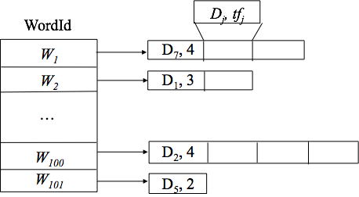

structure of table 7