**Experiment No 2**

**AIM : Design dimensional modelling (creation of star and snowflake schema) for the given case study.**

**Theory:**

**Star Schema:**

A data warehousing schema that consists of a central fact table connected to multiple dimension tables. The structure resembles a star, with the fact table at the center and dimension tables radiating outward. It’s simple and optimized for query performance.

**Snowflake Schema:**

An extension of the star schema where the dimension tables are normalized into multiple related tables. This results in a more complex structure that resembles a snowflake. It reduces data redundancy but can make querying more complex.

**Fact Constellation Schema:**

A more complex schema that includes multiple fact tables sharing dimension tables. It represents multiple star schemas and is also known as a galaxy schema. It’s used when different types of facts (e.g., sales, shipping) need to be analyzed together.

**Star Schema for E-commerce DW** 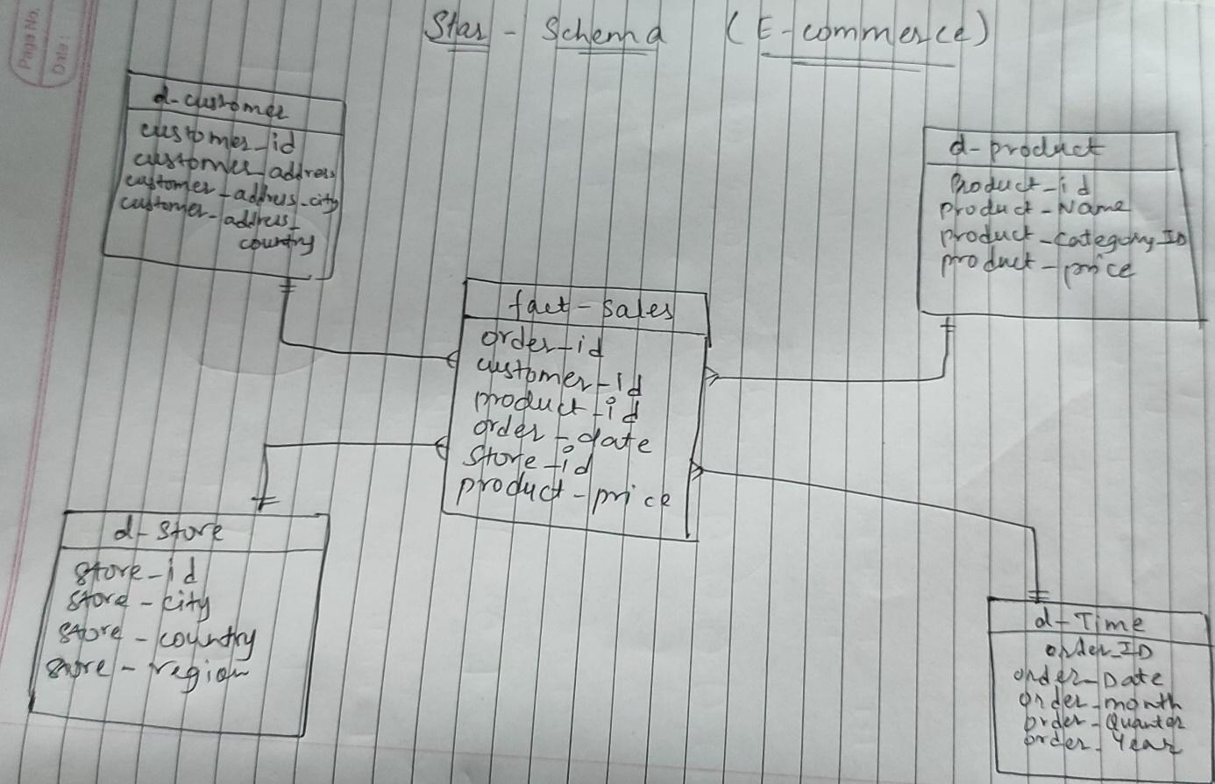

**Snowflake Schema for E-commerce DW**

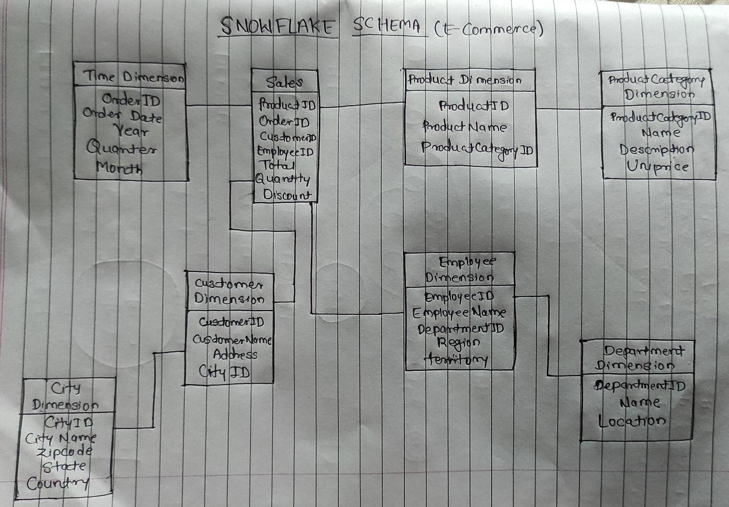

**Fact Constellation Schema for E-commerce DW**