**Shaikh Zaid Muddaris Husain 23DCO06 Batch 03**

**Experiment No 02**

**Aim: To apply the traditional process model for an E-commerce System.**

**Theory:**

The traditional process model for an E-commerce System involves defining system requirements, designing the system architecture, implementing the software, and rigorously testing it to ensure functionality and reliability. This sequential approach ensures comprehensive planning and systematic development, enhancing the system's efficiency and effectiveness.The traditional model that will be used for creating this project is the Waterfall Model.

**Waterfall Model:**

The waterfall model, also known as the 'linear-sequential model' or 'classic life cycle model,' is a structured approach to software development. The process begins with the requirements gathering phase and progresses through analysis, design, coding, testing, and maintenance in a sequential manner.

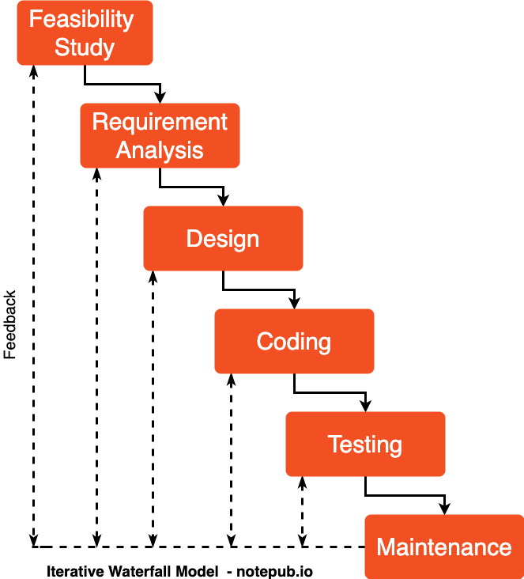

**Advantages:**

1. Simple to understand and implement.
2. Effective for smaller projects where requirements are well understood.

**Disadvantages:**

1. Not suitable for large, complex projects.
2. Difficult to accommodate changes in requirements once the process is underway.
3. Not ideal for projects where requirements may evolve during development.

**Phases of Waterfall Model for E-commerce System:**

1. **Communication:**

Engage with stakeholders, including business owners, users, and developers, to gather detailed requirements. This includes understanding the features needed for the e-commerce platform, such as product listings, user accounts, shopping carts, payment processing, and order tracking.

1. **Planning:**

Develop a project plan outlining the timeline, resources, and tasks required for the system's development. This phase also includes setting milestones and deliverables to ensure progress is tracked effectively.

1. **System Design:**

Create detailed design documents specifying the system architecture, database schemas, interface designs, and algorithms to be used. The design phase ensures that all requirements are addressed and that the system will function as intended.

1. **Implementation:**

Code the system according to the design specifications. This phase includes developing the various modules of the e-commerce platform, such as the product catalog, user authentication, shopping cart, checkout process, and order management.

1. **Integration and Testing:**

Combine the modules and rigorously test the entire system to identify and correct any bugs or issues. Testing ensures that the system meets all specified requirements and functions smoothly, including performance, security, and usability testing.

1. **Deployment:**

Install the completed system in the production environment, configuring it as needed and ensuring all components are operational. This phase may also involve migrating existing data, setting up hosting environments, and launching the website for public access.

1. **Maintenance:**

Provide ongoing support, including regular updates, bug fixes, and improvements based on user feedback and evolving business needs. Maintenance ensures the system remains functional, secure, and up-to-date with the latest features and technologies.

**Conclusion:**

The implementation of the traditional waterfall model for developing an E-commerce System has provided a structured and methodical approach to the software development process. Each phase, from communication through to maintenance, has been meticulously followed, ensuring that all requirements are clearly defined, system designs are well-structured, and the final product is both functional and reliable. While the waterfall model offers simplicity and ease of understanding, it also has limitations, particularly in its rigidity and difficulty in accommodating changes mid-process. However, for the development of this E-commerce System, the waterfall model has proven effective, resulting in a system that meets the needs of the business and its customers efficiently.