**Experiment No 3**

**Name : Shaikh Zaid Muddaris Husain Roll No.: 22CO56 Batch : 3**

**Aim : Application of the Agile Process Models(Using Jira)**

**1. Introduction to Agile Process Models**

Agile process models are a group of methodologies that encourage flexible responses to change, iterative progress through small increments, and collaborative efforts among cross-functional teams. Unlike traditional project management approaches, Agile allows teams to deliver portions of the project incrementally, ensuring continuous delivery of value and quick adaptation to any changes or feedback.

**2. Backlog Creation**

Backlogs are a crucial component of the Agile process, particularly in Scrum. The backlog is essentially a prioritized list of tasks or features that need to be completed for a project. Each backlog item is typically a small, manageable chunk of work, such as a new feature, bug fix, or enhancement.

**Steps Taken:**

1. **Identification of Key Features**: The first step involved identifying the key features and functionalities required for the e-commerce website. This includes aspects like Product Catalog Management, Shopping Cart, Checkout Process, Payment Gateway Integration, User Authentication, etc.
2. **Creating Backlog Items:** Each feature was broken down into specific tasks and added as individual backlog items. For example, "Product Catalog Management" and "Payment Gateway Integration" were created as separate backlog items.
3. **Prioritization:** The backlog items were then prioritized based on their importance to the overall project goals, with high-priority tasks like "User Authentication" being addressed first.

**Screenshots Reference**: The first screenshot shows the backlog items created for the e-commerce project. These include tasks like "Scrum Sprint 3" and "Backlog".

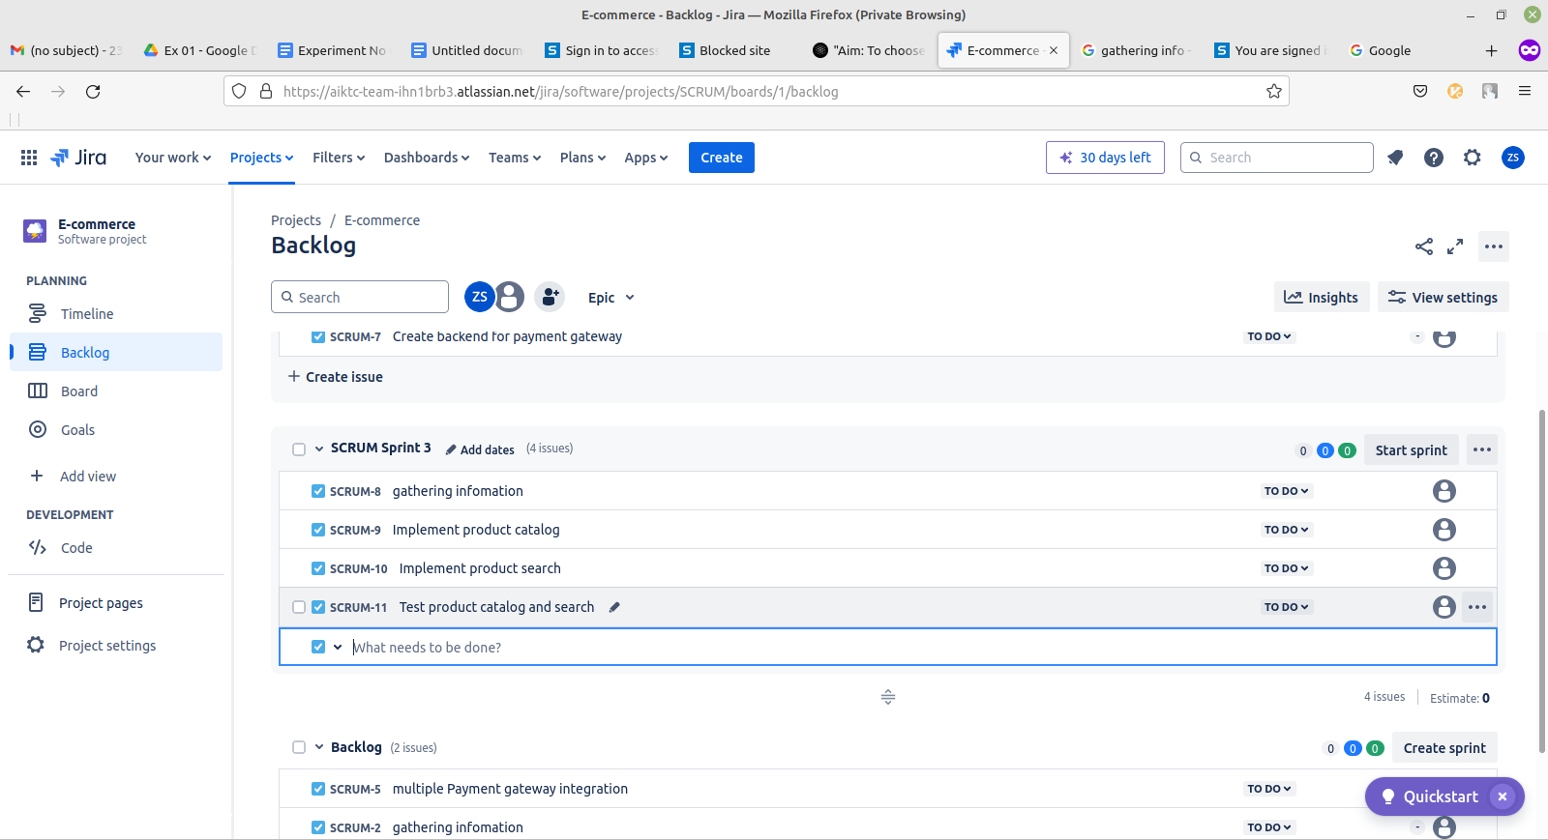

**3. Sprint Planning**

Once the backlog was established, the next step was to plan the sprints. In Scrum, a sprint is a time-boxed period during which a specific set of backlog items are completed.

**Steps Taken:**

1. **Sprint Duration:** A sprint duration of two weeks was chosen, allowing enough time to focus on the selected backlog items while keeping the iteration short enough to allow for frequent reassessment.
2. **Selection of Backlog Items for Sprint:** Based on the prioritization, high-priority tasks like “User Authentication” and “Product Catalog Management” were moved into the sprint. This decision was based on the necessity to get key features functional early in the development process.
3. **Assigning Tasks:** Each task within the sprint was assigned to team members based on their expertise and workload.

**4. Execution and Progress Tracking**

The execution phase involves working on the tasks selected for the sprint. As work progresses, tasks move through different stages, such as "To Do," "In Progress," and "Done."

**Steps Taken:**

1. **Task Execution:** Team members began working on their assigned tasks. As tasks were completed, they were marked as "Done." For example, "Gathering Product Information" was successfully completed and marked as done in the Jira board.
2. **Tracking Progress:** Progress was tracked in real-time using Jira’s board view, where tasks move across different columns based on their status.
3. **Ongoing Work:** Some tasks, such as “Implementing Product Search,” were still in progress at the time of documentation. This ensures that team members are aware of which tasks are being actively worked on and which are pending.

**Screenshots Reference:** The second screenshot shows the progress of tasks in the SCRUM Sprint 1, with "Gathering Product Information" marked as "Done," and "Implementing Product Search" as "In Progress."

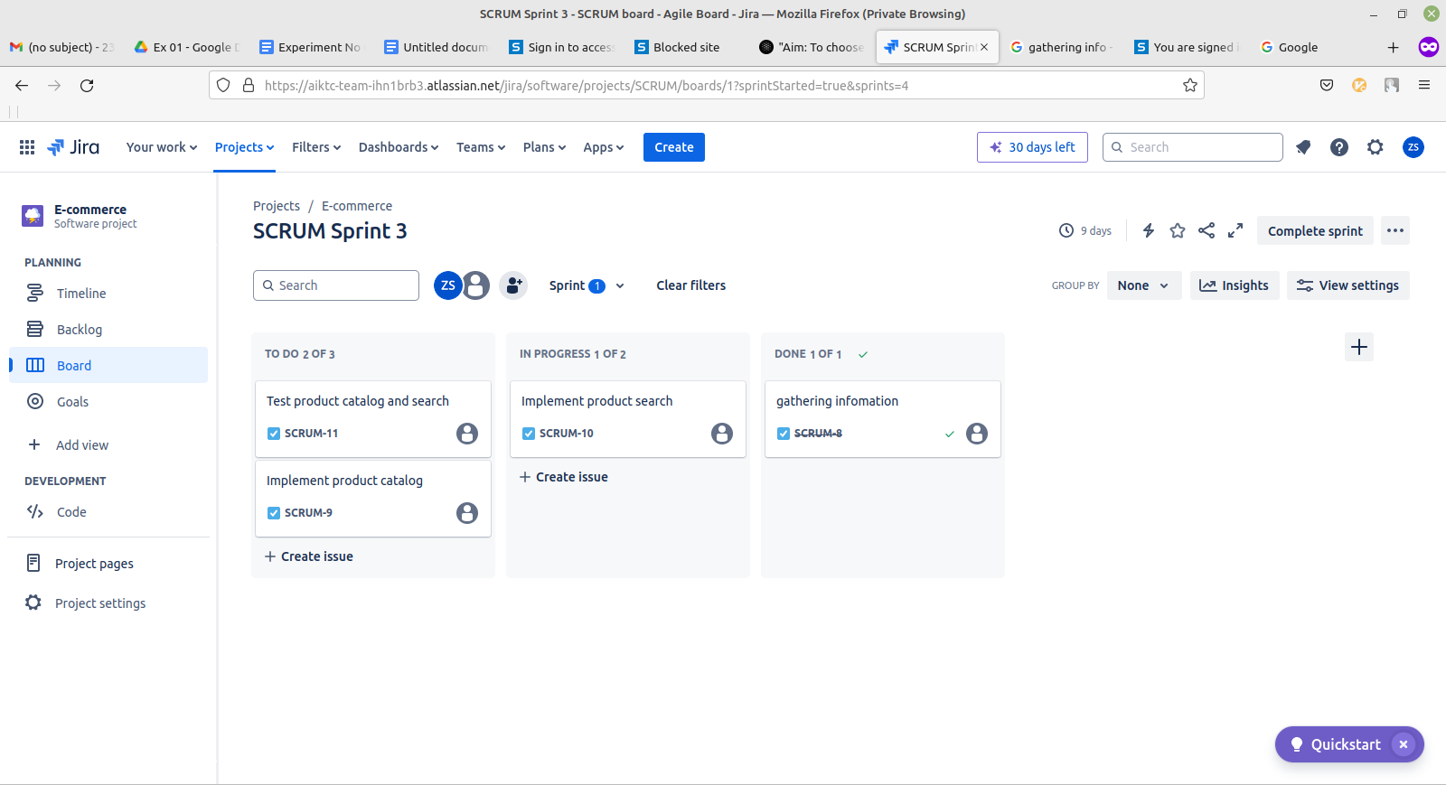

**5. Conclusion**

The application of the Agile process model, specifically Scrum, facilitated a structured yet flexible approach to managing the e-commerce project. The creation of backlogs allowed for a clear prioritization of tasks, and the sprint planning enabled focused work on the most critical features. The real-time tracking of progress ensured that the team remained aligned and could quickly adapt to any changes or challenges that arose during the development process. This iterative approach is expected to continue delivering value as the project progresses through subsequent sprints.