**Shaikh Zaid Muddaris Husain 23dco06 Batch-03**

**Experiment No 10**

**Aim:** To write test cases for black box testing.

**Theory:**

Black Box Testing is a software testing method in which the functionalities of software applications are tested without having knowledge of internal code structure, implementation details and internal paths. Black Box Testing mainly focuses on input and output of software applications and it is entirely based on software requirements and specifications. It is also known as Behavioral Testing. Test cases are created considering the specification of the requirements. These test cases are generally created from working descriptions of the software including requirements, design parameters, and other specifications.

For the testing, the test designer selects both positive test scenario by taking valid input values and adverse test scenario by taking invalid input values to determine the correct output. Test cases are mainly designed for functional testing but can also be used for non-functional testing. Test cases are designed by the testing team, there is not any involvement of the development team of software.

Testing techniques:

| Decision Table Technique | Decision Table Technique is a systematic approach where various input combinations and their respective system behavior are captured in a tabular form. It is appropriate for the functions that have a logical relationship between two and more than two inputs. |
| --- | --- |
| Boundary Value Technique | Boundary Value Technique is used to test boundary values, boundary values are those that contain the upper and lower limit of a variable. It tests, while entering boundary value whether the software is producing correct output or not. |
| State Transition Technique | State Transition Technique is used to capture the behavior of the software application when different input values are given to the same function. |
| Cause-Effect Technique | Cause-Effect Technique underlines the relationship between a given result and all the factors affecting the result. It is based on a collection of requirements. |
| Equivalence Partitioning Technique | Equivalence partitioning is a technique of software testing in which input data divided into partitions of valid and invalid values, and it is mandatory that all partitions must exhibit the same behavior. |

**Procedure:**

1. Create at least 3 test cases for your selected project in the prescribed format:

**Output:**

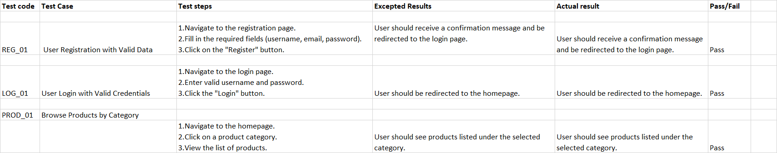

### **Conclusion:**

In conclusion, comprehensive testing of an e-commerce website is crucial to ensure its effectiveness in facilitating online shopping, enhancing user experience, and managing transactions securely. By validating key features such as user registration, product browsing, shopping cart functionality, and the checkout process, we can confirm that the website meets users' needs and fosters customer satisfaction. Thoroughly executed tests guarantee that the site is user-friendly, functional, and reliable, ultimately contributing to successful sales and timely order fulfillment. A well-tested e-commerce platform minimizes errors, boosts customer trust, and supports effective online retail operations.