SOFTWARE ENGINEERING LAB
Project Report

Mark-Matrix
Online Result Processing System
Submitted by
Team-Tractor
Team Members
1. Pranit Rane (Roll No.: 424167)
2. Y. L. Vardhan (Roll No.: 424192)
3. N. Venkata Sai Yadav (Roll No.: 424159)

Department of Computer Science and Engineering
Academic Year 2026

Table of Contents
1. Requirement Identification and Feasibility Study 3
1.1 Aim 3
1.2 Problem Statement 3
1.3 Stakeholders 3
1.4 Functional Requirements 3
1.5 Non-Functional Requirements 4
1.6 Feasibility Study 5
1.7 Requirement Validation 5
2. Software Requirements Specification (SRS) 6
2.1 Introduction 6
2.2 Overall Description 7
2.3 Specific Requirements 8
2.4 Other Non-Functional Requirements 10
3. Use Case Diagram 11
3.1 Aim 11
3.2 Actors Identified 11
3.3 Use Case Diagram 11
3.4 Use Case Descriptions 12
4. Class, Activity, Sequence and Collaboration Diagrams 15
4.2 Class Diagram 15
4.3 Activity Diagram 17
4.4 Sequence Diagram 19
4.5 Collaboration Diagram 20
4.6 Summary 20

1. Requirement Identification and Feasibility Study

1.1 Aim
The aim of this phase is to systematically identify, analyze, and document the requirements of the Mark-Matrix Online Result Processing System, and to evaluate the technical, operational, economic, and schedule feasibility of building the proposed system before committing engineering effort to its design and implementation.

1.2 Problem Statement
Academic institutions traditionally manage attendance, marks entry, grade computation, and result publication through manual registers, spreadsheets, or fragmented tools. This approach is time-consuming, error-prone, difficult to audit, and provides no structured, role-based control over who may enter, approve, or view academic data. There is a need for a centralized, secure, web-based system that allows faculty to record attendance and marks, allows an administrator to review, approve, and lock results before they are published, and allows students to view their own academic performance data — all while maintaining a full audit trail of every change.
Mark-Matrix addresses this problem by digitizing the entire result-processing lifecycle — from attendance capture through marks entry, grade/SGPA/CGPA computation, administrative approval and locking, to final gradesheet publication and transcript generation — within a single, role-based, auditable platform.

1.3 Stakeholders
Stakeholder | Role in the System | Primary Interest
Administrator | Configures the academic structure; approves, locks, and publishes results; manages users and audits the system. | Data integrity, correctness, and traceability of published results.
Faculty | Records attendance and enters/submits marks for assigned courses. | A fast, reliable way to record and submit academic data.
Student | Views attendance, marks, gradesheets, SGPA/CGPA, and downloads transcripts. | Timely, accurate, and easily accessible result information.
Institution / Department | Owns the academic process and data; relies on the system for compliance and record-keeping. | A dependable, auditable system of record.

1.4 Functional Requirements
The system shall provide the following core functional capabilities, grouped by module:
- FR-1: The system shall allow users to securely authenticate and shall restrict access based on role (Admin, Faculty, Student).
- FR-2: The system shall allow the Admin to create and manage the academic hierarchy — batch, program, semester, and course.
- FR-3: The system shall allow the Admin to assign faculty to courses and enroll students into a batch/program/semester.
- FR-4: The system shall allow Faculty to record attendance for students in a course session, and allow all roles to read attendance according to their scope.
- FR-5: The system shall allow Faculty to enter and submit marks for students in an assigned course, with validation against the course's maximum marks.
- FR-6: The system shall allow the Admin, and only the Admin, to approve and lock submitted marks.
- FR-7: The system shall automatically compute grades, SGPA, and CGPA using a configurable grading scheme once marks are locked.
- FR-8: The system shall allow the Admin, and only the Admin, to compile, lock, and publish a semester gradesheet.
- FR-9: The system shall allow Students to view their own attendance, marks, gradesheet, SGPA, and CGPA once published, and to download a transcript in PDF format.
- FR-10: The system shall provide analytics and reports (pass percentage, toppers, attendance shortage) scoped to the requesting user's role.
- FR-11: The system shall maintain an immutable audit log of every write action performed on attendance, marks, approvals, locks, and gradesheet publication.

1.5 Non-Functional Requirements
Category | Requirement
Security | All access must be role-based and enforced at both the API layer and the database layer (Row-Level Security). Passwords/sessions are never handled or stored insecurely.
Reliability | Locked marks and published gradesheets must be immutable except through an explicit, logged Admin unlock action.
Auditability | Every sensitive write operation must produce a corresponding audit log entry with before/after values.
Performance | Core pages (dashboards, marks entry, gradesheet view) should load within 2 seconds under normal load; bulk operations (CSV upload) should process a class-sized roster (≈300 records) in under 5 seconds.
Scalability | The system should support concurrent use by an entire institution (multiple batches/programs/semesters) without architectural change, leveraging edge-deployed compute.
Usability | Faculty and student workflows should be achievable in a minimal number of steps, with clear validation feedback on marks/attendance entry.
Availability | The system should target high availability using managed, edge-distributed infrastructure.
Maintainability | The codebase should be modular (by academic hierarchy and by role) to allow independent evolution of attendance, marks, and grading logic.

1.6 Feasibility Study

1.6.1 Technical Feasibility
The proposed stack — React for the frontend, the Hono framework running on Cloudflare Workers for compute, and Supabase (Postgres) for database, authentication, and session management — is composed of mature, well-documented, and widely adopted technologies. Role-based access can be enforced both at the API middleware layer and at the database layer using Postgres Row-Level Security, giving the system a proven, technically sound security model. The team has access to all necessary tools (Claude Code as the development agent, Cloudflare and Supabase platforms) making the project technically feasible within the lab timeframe.

1.6.2 Operational Feasibility
The system directly mirrors the real-world academic result-processing workflow already followed by institutions (attendance → marks → approval → publication), so end users (faculty, students, administrators) require minimal retraining. The role-based interface ensures each user only interacts with functionality relevant to them, further easing adoption.

1.6.3 Economic Feasibility
Cloudflare Workers/Pages and Supabase both offer generous free/low-cost tiers suitable for an academic lab project and small-to-medium scale institutional deployment, keeping infrastructure cost low. Development cost is limited to engineering time, as no proprietary or licensed software is required.

1.6.4 Schedule Feasibility
The project has been broken down into nine development cycles (Cycle 0 through Cycle 8), each independently scoped with development and testing phases, allowing incremental delivery and validation within a typical semester-length lab schedule.

1.7 Requirement Validation
Requirements were validated against the following criteria to ensure they are appropriate for design and implementation:
- Completeness — every stakeholder role (Admin, Faculty, Student) has explicit read/write capabilities defined for every data entity in the hierarchy.
- Consistency — no requirement contradicts another (e.g., only Admin can approve/lock, consistently enforced across marks and gradesheets).
- Verifiability — each functional requirement (FR-1 to FR-11) can be directly mapped to a test case in the corresponding development cycle.
- Traceability — each requirement traces to a specific module in the Software Requirements Specification (Section 2) and to a use case in Section 3.
- Feasibility — each requirement was checked against the chosen technology stack to confirm it can be implemented without unproven technology.

2. Software Requirements Specification (SRS)

2.1 Introduction

2.1.1 Purpose
This Software Requirements Specification (SRS) defines the functional and non-functional requirements of the Mark-Matrix Online Result Processing System. It is intended for use by the development team (Team-Tractor) to guide design and implementation, and by evaluators to assess the completeness and correctness of the proposed system.

2.1.2 Scope
Mark-Matrix is a web-based application that manages the complete academic result lifecycle: academic structure configuration, attendance tracking, marks entry, grade/SGPA/CGPA computation, administrative approval and locking, gradesheet publication, transcript generation, reporting/analytics, and audit logging. The system is organized around a data hierarchy of batch → program → semester → course, with attendance and marks scoped per course, and gradesheet/SGPA/CGPA scoped per semester.

2.1.3 Definitions, Acronyms, and Abbreviations
Term | Definition
RBAC | Role-Based Access Control — restricting system actions based on a user's assigned role.
RLS | Row-Level Security — a Postgres/Supabase feature restricting which rows a query may access based on policy.
SGPA | Semester Grade Point Average — the weighted average grade point for a single semester.
CGPA | Cumulative Grade Point Average — the weighted average grade point across all completed semesters.
Gradesheet | The compiled, per-student, per-semester record of course grades, SGPA, and status.
Admin | The institutional administrator role, with exclusive authority to approve, lock, and publish results.

2.1.4 References
- IEEE Std 830-1998 — Recommended Practice for Software Requirements Specifications (structure reference).
- Mark-Matrix High-Level Project Plan (internal project document, Team-Tractor).
- Mark-Matrix Cycle-Based Execution Plan, Cycles 0–8 (internal project document, Team-Tractor).

2.1.5 Overview
The remainder of this SRS describes the overall product context (Section 2.2), the specific functional requirements grouped by role and module (Section 2.3), and additional non-functional requirements not already captured in Section 1.5 (Section 2.4).

2.2 Overall Description

2.2.1 Product Perspective
Mark-Matrix is a new, self-contained system rather than a modification of an existing one. It consists of a React frontend deployed on Cloudflare Pages/Workers, a Hono-based API layer deployed on Cloudflare Workers (edge compute), and a Supabase-managed Postgres database that also provides authentication and session management. Access control is enforced redundantly at the API middleware layer and via Postgres Row-Level Security policies.

2.2.2 Product Functions
At a high level, the product allows: (a) Admin configuration of the academic hierarchy and user roles; (b) Faculty entry of attendance and marks for assigned courses; (c) Admin-controlled approval, locking, and publishing of results; (d) automatic computation of grades, SGPA, and CGPA; (e) Student access to their own academic records and transcripts; and (f) system-wide analytics, reporting, and audit logging.

2.2.3 User Classes and Characteristics
User Class | Characteristics
Admin | Institutional staff responsible for academic administration; requires full configuration, approval, and audit capability; assumed to be a trusted, trained user.
Faculty | Teaching staff who record attendance and marks for their assigned courses only; require a simple, low-friction data entry workflow.
Student | End consumers of result data; require read-only, self-scoped access with no ability to modify any record.

2.2.4 Operating Environment
The system operates as a browser-based web application (desktop and mobile browsers) served from Cloudflare's global edge network, with all persistent data stored in a managed Supabase Postgres instance. No native client installation is required.

2.2.5 Design and Implementation Constraints
- The frontend must be implemented in React and deployed via Cloudflare Pages/Workers.
- The backend API must be implemented using the Hono framework and deployed to Cloudflare Workers.
- All persistent data, authentication, and session management must use Supabase (Postgres).
- Only the Admin role may approve, lock, unlock, or publish marks and gradesheets — no other role may perform these actions under any circumstance.

2.2.6 Assumptions and Dependencies
- Users have a modern web browser and internet connectivity.
- The institution provides accurate initial data for batches, programs, semesters, and courses.
- Cloudflare Workers and Supabase services remain available per their published SLAs.

2.3 Specific Requirements

2.3.1 Authentication and Access Control
ID | Requirement
SRS-AUTH-01 | The system shall authenticate users via Supabase Auth (email/password) and issue a session used for all subsequent requests.
SRS-AUTH-02 | The system shall assign every user exactly one role: Admin, Faculty, or Student.
SRS-AUTH-03 | The system shall reject any API request to a route not permitted for the requester's role with an HTTP 403 response.
SRS-AUTH-04 | The system shall enforce access restrictions redundantly via Postgres Row-Level Security policies, independent of API-layer checks.

2.3.2 Academic Structure Management
ID | Requirement
SRS-ACAD-01 | The system shall allow only the Admin to create, update, and delete batches, programs, semesters, and courses.
SRS-ACAD-02 | The system shall allow only the Admin to assign Faculty to a course and to enroll Students into a batch/program/semester, including via bulk CSV import.
SRS-ACAD-03 | The system shall prevent duplicate student enrollment and prevent faculty assignment to a non-existent course.

2.3.3 Attendance Tracking
ID | Requirement
SRS-ATT-01 | The system shall allow Faculty to record attendance (present/absent/late) for students in a course session, limited to courses they are assigned to.
SRS-ATT-02 | The system shall allow all roles to read attendance data according to scope: a Student may read only their own records; Faculty/Admin may read the full course roster.
SRS-ATT-03 | The system shall compute an attendance percentage per student per course.

2.3.4 Marks Entry
ID | Requirement
SRS-MRK-01 | The system shall allow Faculty to enter marks for students in an assigned course, validated against the course's maximum marks.
SRS-MRK-02 | The system shall support a draft → submitted status workflow for marks, with edits disallowed by Faculty once submitted.
SRS-MRK-03 | The system shall support bulk marks upload via CSV with row-level validation and error reporting.

2.3.5 Grade Calculation
ID | Requirement
SRS-GRD-01 | The system shall compute a letter grade and grade point for each student's marks using a configurable grading scheme.
SRS-GRD-02 | The system shall compute SGPA per student per semester from course-level grade points and credit weights.
SRS-GRD-03 | The system shall compute CGPA per student as a cumulative aggregate of SGPA across completed semesters.
SRS-GRD-04 | The system shall snapshot the grading scheme used at computation time so future scheme changes do not retroactively alter past results.

2.3.6 Approval, Locking, and Publishing
ID | Requirement
SRS-APR-01 | The system shall allow only the Admin to approve submitted marks and to lock approved marks.
SRS-APR-02 | The system shall allow only the Admin to compile a semester gradesheet, which requires all courses in that semester to have locked marks.
SRS-APR-03 | The system shall allow only the Admin to lock and subsequently publish a gradesheet.
SRS-APR-04 | The system shall reject any write to locked marks or a locked/published gradesheet except through an explicit, reason-logged Admin unlock action.

2.3.7 Result Access and Transcripts
ID | Requirement
SRS-RES-01 | The system shall allow Students to view their own attendance, marks, gradesheet, SGPA, and CGPA once the relevant gradesheet is published.
SRS-RES-02 | The system shall generate a downloadable PDF transcript from a published gradesheet.
SRS-RES-03 | The system shall prevent access to unpublished gradesheet data by Students.

2.3.8 Reporting, Analytics, and Audit
ID | Requirement
SRS-RPT-01 | The system shall provide pass-rate, toppers, and attendance-shortage reports scoped to the requester's role and course/semester access.
SRS-RPT-02 | The system shall log every sensitive write action (attendance, marks, approval, lock, unlock, publish, enrollment/assignment changes) to an immutable audit log with before/after values.
SRS-RPT-03 | The system shall allow only the Admin to view and filter the audit log.

2.4 Other Non-Functional Requirements
- Portability: the web application shall function correctly on the latest versions of major browsers (Chrome, Firefox, Safari, Edge).
- Data Integrity: locked and published records shall be immutable outside the explicit unlock workflow, enforced at the database level.
- Security: all traffic shall be served over HTTPS; secrets (service keys) shall never be exposed to the client bundle.
- Compliance: the audit trail shall be sufficient to reconstruct the history of any result, supporting institutional academic-integrity requirements.
- Recoverability: database migrations and backups (via Supabase) shall allow recovery to a known-good state in case of failure.

3. Use Case Diagram

3.1 Aim
The aim of this section is to identify the actors that interact with Mark-Matrix and to model, through a use case diagram and accompanying descriptions, the primary interactions each actor has with the system.

3.2 Actors Identified
Actor | Description
Admin | The institutional administrator; the sole authority for academic-structure configuration, approval, locking, and publishing of results.
Faculty | Teaching staff who record attendance and enter/submit marks for their assigned courses.
Student | The end user who views their own attendance, marks, gradesheet, SGPA/CGPA, and downloads transcripts.

3.3 Use Case Diagram
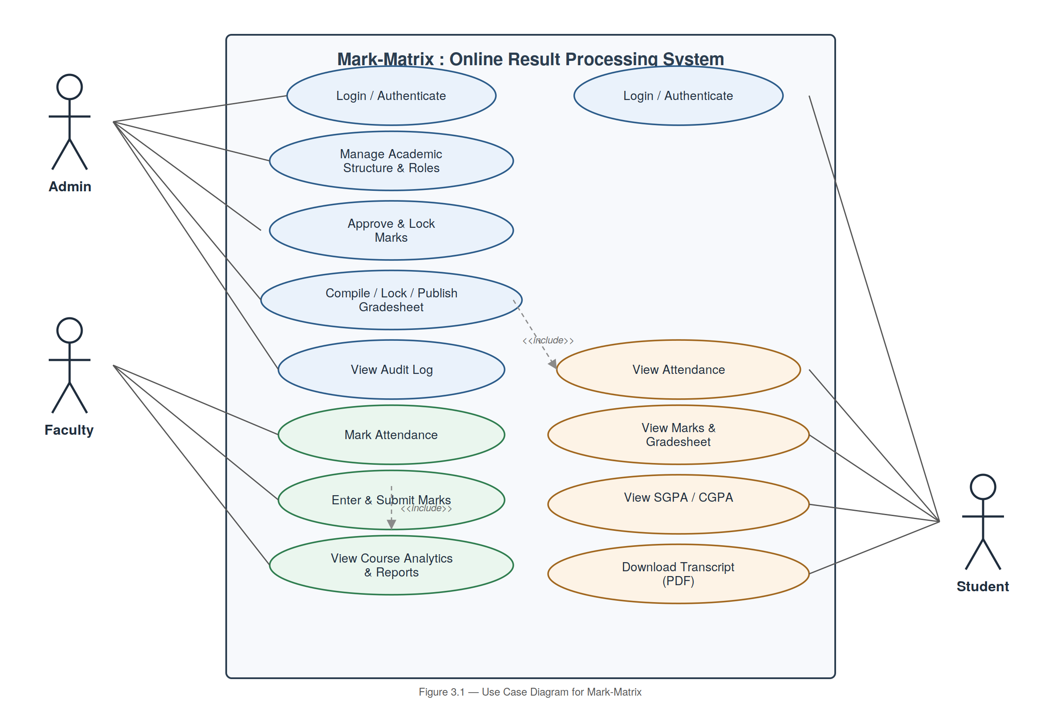
Figure 3.1 — Use Case Diagram for Mark-Matrix
The diagram groups use cases by actor: Admin-centric use cases (blue) cover configuration, approval, locking, and auditing; Faculty-centric use cases (green) cover attendance and marks entry; and shared/Student-centric use cases (amber) cover read access to attendance, marks, gradesheets, and transcripts. The «include» relationships indicate that gradesheet compilation depends on attendance data being available, and that submitting marks depends on marks having first been entered.

3.4 Use Case Descriptions

UC-01 — Login / Authenticate
Use Case ID | UC-01
Use Case Name | Login / Authenticate
Primary Actor | Admin, Faculty, Student
Description | A registered user authenticates to gain role-scoped access to the system.
Preconditions | The user has a valid account provisioned by the Admin.
Main Flow | 1) User submits email and password. 2) System verifies credentials via Supabase Auth. 3) System establishes a session and routes the user to their role-specific dashboard.
Postconditions | The user has an active, authenticated session.

UC-02 — Manage Academic Structure
Use Case ID | UC-02
Use Case Name | Manage Academic Structure
Primary Actor | Admin
Description | The Admin creates and maintains batches, programs, semesters, and courses, and assigns faculty/enrolls students.
Preconditions | Admin is authenticated.
Main Flow | 1) Admin navigates to academic structure management. 2) Admin creates/edits a batch, program, semester, or course. 3) Admin assigns faculty to a course or enrolls students (single or bulk CSV). 4) System validates and persists changes.
Postconditions | The academic hierarchy reflects the Admin's changes; affected faculty/students gain corresponding access.

UC-03 — Mark Attendance
Use Case ID | UC-03
Use Case Name | Mark Attendance
Primary Actor | Faculty
Description | Faculty records attendance for students in a course session.
Preconditions | Faculty is authenticated and assigned to the course.
Main Flow | 1) Faculty selects a course and session date. 2) Faculty marks each student present/absent/late. 3) Faculty submits the attendance record. 4) System validates and persists the data, scoped to that course.
Postconditions | Attendance is recorded and readable by the student, faculty, and Admin per access rules.

UC-04 — Enter and Submit Marks
Use Case ID | UC-04
Use Case Name | Enter and Submit Marks
Primary Actor | Faculty
Description | Faculty enters marks for students in an assigned course and submits them for review.
Preconditions | Faculty is authenticated and assigned to the course.
Main Flow | 1) Faculty selects a course and exam type. 2) Faculty enters marks per student (validated against max marks). 3) Faculty saves as draft or submits for Admin review.
Postconditions | Marks exist in draft or submitted status, pending Admin approval.

UC-05 — Approve and Lock Marks
Use Case ID | UC-05
Use Case Name | Approve and Lock Marks
Primary Actor | Admin
Description | The Admin reviews submitted marks, approves them, and locks them to prevent further edits.
Preconditions | Marks for the course have status = submitted.
Main Flow | 1) Admin reviews submitted marks for a course. 2) Admin approves the marks. 3) Admin locks the marks once satisfied. 4) System marks the course's marks as locked and immutable.
Postconditions | Marks are locked and eligible for inclusion in gradesheet compilation.

UC-06 — Compile, Lock, and Publish Gradesheet
Use Case ID | UC-06
Use Case Name | Compile, Lock, and Publish Gradesheet
Primary Actor | Admin
Description | The Admin compiles a semester gradesheet once all courses are locked, then locks and publishes it.
Preconditions | All courses within the target semester have locked marks.
Main Flow | 1) Admin triggers gradesheet compilation for a semester. 2) System computes grade, SGPA, and CGPA per student via the Grade Calculation Engine. 3) Admin locks the compiled gradesheet. 4) Admin publishes the gradesheet, making it visible to students.
Postconditions | The gradesheet is published; students can view their results and download a transcript.

UC-07 — View Marks, Gradesheet, SGPA/CGPA
Use Case ID | UC-07
Use Case Name | View Marks, Gradesheet, SGPA/CGPA
Primary Actor | Student
Description | A student views their own academic performance once results are published.
Preconditions | Student is authenticated; the relevant gradesheet has been published.
Main Flow | 1) Student opens their gradesheet view. 2) System retrieves the student's own published gradesheet, SGPA, and CGPA (RLS-scoped). 3) Student reviews results.
Postconditions | The student has viewed their up-to-date academic results.

UC-08 — Download Transcript (PDF)
Use Case ID | UC-08
Use Case Name | Download Transcript (PDF)
Primary Actor | Student
Description | A student downloads a PDF transcript generated from their published gradesheet.
Preconditions | The relevant gradesheet is published.
Main Flow | 1) Student requests a transcript download. 2) System generates a PDF from the published gradesheet and score data. 3) System returns the PDF file to the student.
Postconditions | The student has a downloadable transcript matching their published results.

4. Class, Activity, Sequence and Collaboration Diagrams
This section presents the structural and behavioral UML models for Mark-Matrix: a class diagram capturing the static data structure, an activity diagram capturing the end-to-end result-processing workflow, a sequence diagram capturing a representative marks-to-publication interaction, and a collaboration diagram capturing the same interaction from an object-collaboration perspective.

4.2 Class Diagram
The class diagram models the core entities of Mark-Matrix and their relationships, directly reflecting the batch → program → semester → course hierarchy and the role hierarchy (Admin, Faculty, Student inheriting from a common User class).
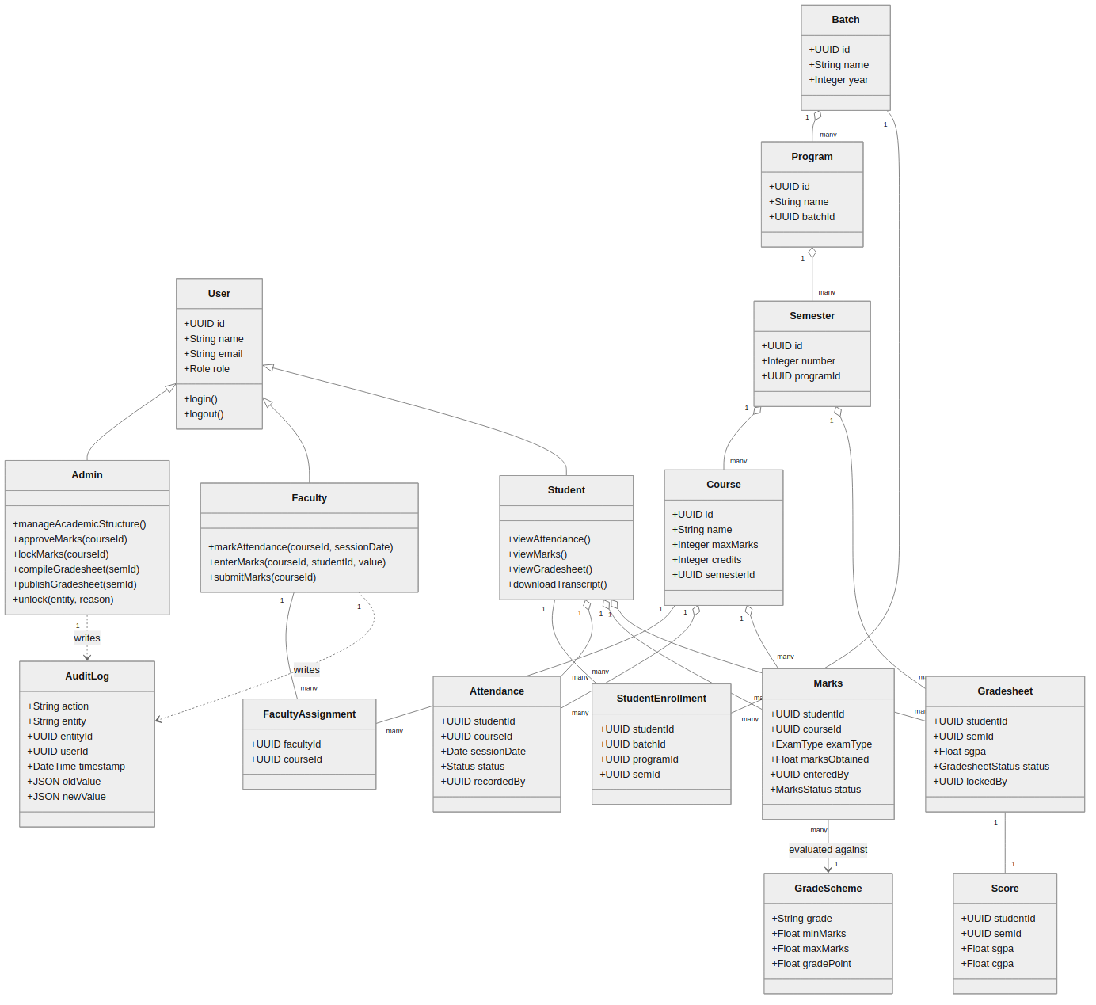
Figure 4.1 — Class Diagram for Mark-Matrix
Key relationships: a Batch contains many Programs, which contain many Semesters, which contain many Courses. Faculty are linked to Courses via FacultyAssignment, and Students are linked to Batches via StudentEnrollment. Attendance and Marks are recorded per Student per Course; Marks are evaluated against a GradeScheme to produce a Gradesheet and Score (SGPA/CGPA) per Student per Semester. Admin and Faculty actions that write data also produce AuditLog entries.

4.3 Activity Diagram
The activity diagram models the complete result-processing workflow, from attendance capture through marks entry, Admin approval and locking, gradesheet compilation, and final publication to students.
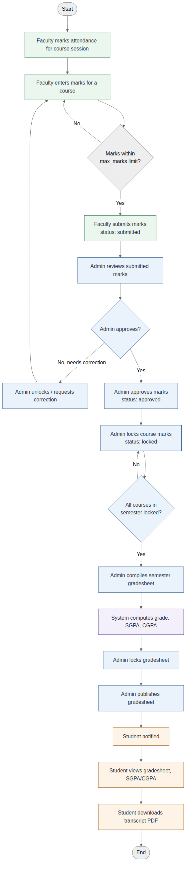
Figure 4.2 — Activity Diagram: End-to-End Result Processing Workflow
The workflow highlights the decision points that enforce the system's core policy: marks must pass validation before submission, and a semester gradesheet cannot be compiled until every course within that semester has locked marks — ensuring results are only ever published from a fully verified state.

4.4 Sequence Diagram
The sequence diagram illustrates a representative end-to-end interaction: Faculty entering and submitting marks, Admin approving, locking, compiling, locking, and publishing the gradesheet, and a Student subsequently viewing results and downloading a transcript — across the React frontend, the Hono API on Cloudflare Workers, and the Supabase (Postgres) backend.
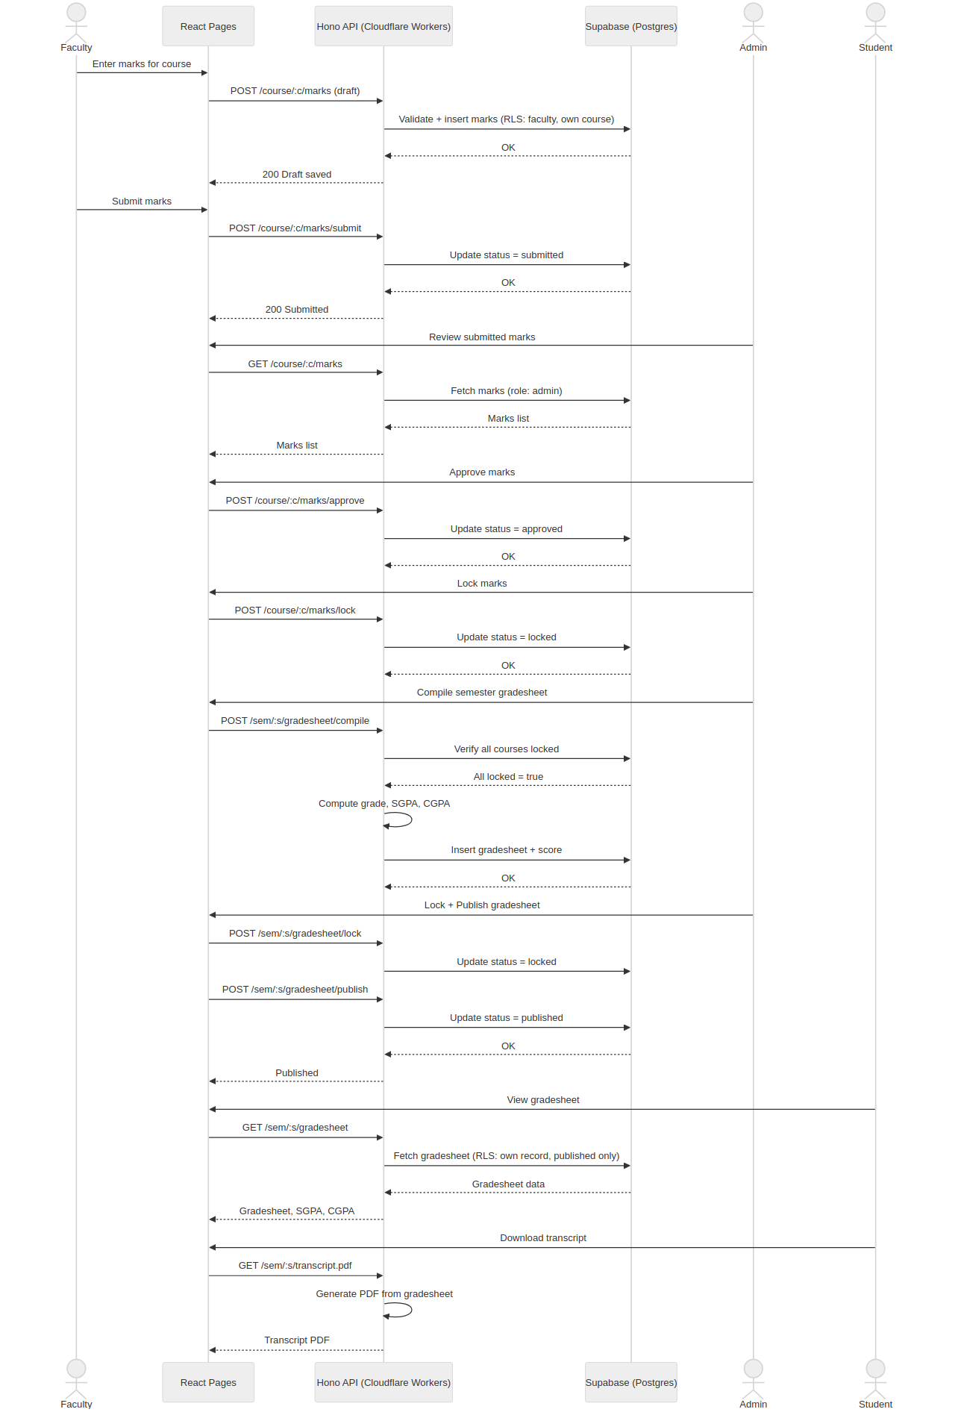
Figure 4.3 — Sequence Diagram: Marks Submission Through Result Publication
This diagram makes explicit that every state transition (draft → submitted → approved → locked, and compiled → locked → published) is mediated by the API layer and persisted in Supabase, with the Grade Calculation Engine invoked only at gradesheet-compile time.

4.5 Collaboration Diagram
The collaboration diagram models the same interaction as Figure 4.3, but emphasizes the objects involved and their links, with numbered messages indicating the sequence of collaboration rather than a time axis.
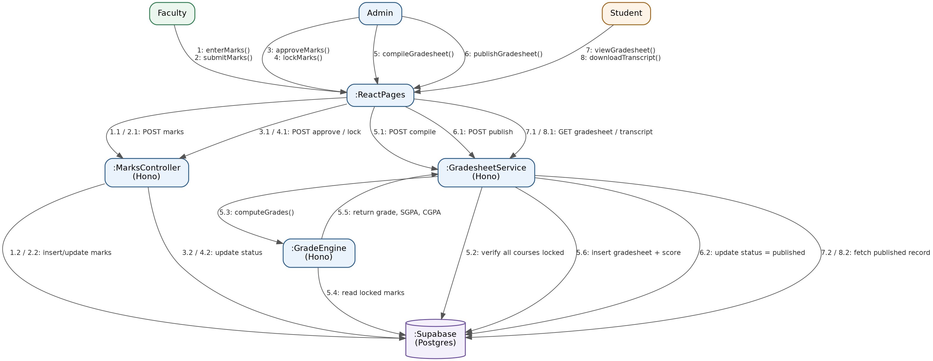
Figure 4.4 — Collaboration Diagram: Marks Submission Through Result Publication
Messages 1–2 originate from Faculty and flow through the MarksController; messages 3–4 originate from Admin for approval and locking; message 5 (with sub-messages 5.1–5.6) shows the GradesheetService collaborating with the GradeEngine and the database to compile results; message 6 publishes the gradesheet; and messages 7–8 show the Student reading the finished, published record.

4.6 Summary
Together, these four diagrams provide a complete structural and behavioral model of Mark-Matrix. The class diagram establishes the persistent data structure and role hierarchy; the activity diagram captures the governing business process and its control logic; and the sequence and collaboration diagrams provide two complementary views — time-ordered and object-collaboration-ordered — of how the system's components interact to move a result from initial entry to a published, student-visible outcome. Consistently across all four models, two architectural principles hold: (1) only Faculty may write attendance and marks, scoped to their assigned courses, and (2) only Admin may approve, lock, or publish results, ensuring a single, auditable point of control over what is ultimately released to students.

