Ministry of Education of the Republic of Belarus
Educational Institution
«VITEBSK STATE TECHNOLOGICAL UNIVERSITY»

Faculty of Information Technology and Robotics
Department of Information Systems and Technologies

APPROVED FOR PROTECTION
Head of the Department
_____________ V. Kazakou
«___» ___________ 2026

MASTER’S THESIS
for a Master's Degree

<< Your thema >>

Specialty 7-06-0612-03 «Information Control System»

Master’s Degree Student < Your Name >

Supervisors < Your Supervisors >

Vitebsk 2026
WORK OVERVIEW

Research purpose and objectives
Work Purpose: To design and develop a cross-platform Smart Home Management System (SHMS) that integrates device control, scene automation, energy monitoring, and security management.
Key Objectives:
- To establish a robust data structure and logical view architecture for managing heterogeneous IoT devices.
- To analyze data sources and select appropriate development technologies, including React Native, Node.js, PostgreSQL, and Redis.
- To design and implement core functional modules—device management, scene Automation, energy consumption monitoring, and security controls—based on system charts and models.
- To develop a web and mobile application that supports role-based access, allowing administrators, family members, and guests to perform authorized operations via a unified interface.
- To deploy the system to a server environment for comprehensive functional verification and performance analysis.

Scientific novelty
This thesis proposes a novel cross-platform Smart Home Management System (SHMS) that incorporates the following scientific and technological innovations:
- A unified protocol conversion middleware enabling seamless integration of six mainstream IoT communication protocols (Zigbee 3.0, Z-Wave 800, BLE Mesh 5.3, Wi-Fi 6E, etc.).
- Optimization of the scene Automation mechanism using the Rete algorithm, significantly reducing control complexity and response latency.
- Integration of LSTM-based energy prediction and reinforcement learning models to minimize energy consumption redundancy.
- Adoption of a modern, containerized microservices architecture with a clear separation of Frontend, API, and Backend layers, ensuring scalability, security, and maintainability.

Regulations for submission of defense
- Requirements for the information system.
- Database diagram of the information system.
- Website with graphical interface.
- Research of the performance of the information system.

Master's student's personal contribution
- Analyze the source and technology of writing web servers.
- Developed Frontend and Backend integrated software to provide customers with a visual interface.
- Program modules have been developed and described. The development of the architecture of the software product has been completed. The software has been deployed in a docker container.
- Conducted system testing and determined the main steps for improvement.

Approval of the master's thesis and information on the use of its results
The developed software was tested in the laboratory of the Department of Information Systems and Technologies. The product of the master's thesis will be deployed on university’s servers.

Structure and scope of the master's thesis
The main body of the master's thesis is organized as follows:
Chapter 1: Object Analysis – Includes a description of the smart home domain and the construction of a conceptual model.
Chapter 2: Assignment of Tasks – Covers the definition of software system requirements, a comparative analysis of existing systems, and a review and justification of the selected technology stack.
Chapter 3: System Design – Encompasses the overall system architecture design, detailed architectural refinement, and database model design.
Chapter 4: Implementation – Details the development of information system classes, software routing and API paths, implementation of core functions, version control, and server deployment.
Chapter 5: System Testing – Includes both functional testing and performance benchmarking.
The thesis comprises 72 pages, 53 figures, 24 tables and 20 references.

CONTENTS

INTRODUCTION 6
1 OBJECT ANALYSIS 7
1.1 Description Of The Subject Area 7
1.2 Construction Of A Conceptual Model Of The Subject Area 9
2 ASSIGNMENT OF TASKS 18
2.1 Defining Requirements For A Software System 18
2.2 Description Of System Analogy 22
2.3 Technology Selection And Comparative Analysis 24
3 DESIGN 27
3.1 System Architecture Design 27
3.2 Refining the Architecture Design 29
3.3 Database Design 31
3.4 Role Permission Model 40
3.5 Security Layered Architecture 41
4 IMPLEMENTATION 43
4.1 Development of information system classes 43
4.2 Development of software routing and paths 51
4.3 Implementation of software functions 53
4.4 Version Control and Semantic Versioning Management 64
4.5 Information System Deploying 65
5 SYSTEM TESTING 70
5.1 Functional test 70
5.2 Performance test 74
CONCLUSION 77
REFERENCES 79

INTRODUCTION

With the rapid development of Internet of Things technology and the improvement of people's living standards, smart home has become an important part of modern families. This report proposes the Smart Home Management System (SHMS), a cross-platform smart home management system solution based on React Native and Node.js. SHMS is a comprehensive platform that integrates device management, scene Automation, energy consumption monitoring, and security management. It adopts modular design, supports multi-protocol compatibility (such as MQTT and Socket.IO), and enables centralized device management via a unified cloud platform. The system supports multi-protocol device access, real-time data monitoring, automated scene triggering, and machine learning-based energy prediction to enhance home automation, optimize energy usage, and ensure system security. The target users are household users, and the core value is to achieve device interconnection, intelligent control, and data analysis through a unified platform, thereby reducing energy costs and improving life convenience. Key features include multi-protocol device auto-discovery and group control, event-based scene Automation (e.g., time, sensors, geofencing), real-time energy consumption monitoring with statistical reports, and abnormal behavior detection and alerts. This solution utilizes React Native for the frontend and Node.js with Express for the backend to build the core application components, and employs dual protocols (MQTT and Socket.IO) to ensure the reliability and real-time performance of communication. In terms of data storage, PostgreSQL serves as the primary database for storing semi-structured device data, while Redis functions as the cache database. Leveraging containerization technologies such as DThe above contradictions highlightocker, SHMS is designed to deliver a user-friendly, responsive, secure, and reliable smart home management experience.

1 OBJECT ANALYSIS

1.1 Description Of The Subject Area

With the rapid development and popularization of Internet of Things technology, smart home has gradually moved from concept to practical application. Smart home originated in the early 1980s. In 1984, United Technologies Building System applied the concept of informationization and integration of building devices to City Place Building in Connecticut, USA, and the world's first "smart building" was born, opening the prelude to the world's competition to build smart homes. After entering the 21st century, with the maturity of Internet of Things technology and the popularity of smart phones, the smart home industry has ushered in a spring of development. In particular, in 2009, "Internet of Things" became a global keyword and was recognized as the third wave of the world's information industry after computers and the Internet.
Currently, the global smart home market is experiencing explosive growth. According to the global smart home market analysis report released by Statista Global Consumer Survey, 2023, the market size of this field has reached US$115 billion, with a compound annual growth rate (CAGR) of 13.2%. At the same time, the number of smart terminal devices has increased exponentially, with annual shipments exceeding 13 billion units and a CAGR of 18.7% , as shown in Table 1.1.

Table 1.1 – Global growth trend of smart home devices (2019 - 2023)
Year | Number of Devices (100 million units) | Growth Rate
2019 | 78.3 | -
2020 | 92.6 | 18.3%
2021 | 105.4 | 13.8%
2022 | 118.9 | 12.8%
2023 | 130.5 | 9.8%
Data source: Statista Global Consumer Survey, 2023

However, smart home systems still face many challenges in their development:
1) Complexity of human-computer interaction: Traditional hardware manufacturers often lack strong software/internet expertise, resulting in problems such as simple interface, poor stability, and delayed maintenance of the control APP, which significantly reduces the user experience.
2) Fragmentation of scene Automation: Users need to operate multiple independent apps to complete a single scene (e.g., "sleep mode" requires controlling lights, air conditioning, and curtains separately), resulting in a fragmented user experience.
3) Ecological closure: Mainstream platforms (such as Apple, Xiaomi and HiLink) adopt an proprietary ecosystem strategy, and the entry barriers for small and medium-sized manufacturers are high, which inhibits innovation vitality.
4) Protocol heterogeneity: Zigbee, Z-Wave, BLE-Mesh and other protocols run in parallel but are incompatible with each other, forming "information islands", and the cross-brand interoperability rate is less than 35%.
The above challenges give rise to three structural contradictions:
1) Fragmented user experience: Users need to use an average of 3.2 independent applications to control devices of different brands. Authoritative research (IDC, 2023) induicates that 78% of users are strongly dissatisfied with the coexistence of multiple applications.
2) Increased security risks: Devices lacking a unified authentication mechanism face a 300% increase in the risk of security vulnerability exposure (Kaspersky Lab, 2023), of which unencrypted communications account for as much as 63%, directly leading to an annual growth rate of 41% in IoT device-related attacks (CVE Database Annual Report, 2023).
3) Inefficient energy consumption: The lack of coordinated control between systems results in redundant devices operation. An empirical study by the International Energy Agency (IEA) shows that such non-intelligent management increases average household energy consumption by 22%, equivalent to an increase of 1.3 tons in annual carbon emissions.
The above contradictions highlight the urgency of building a cross-platform unified management system. The smart home management system (SHMS) built in this solution aims to solve the three core problems of device fragmentation, control complexity and low energy efficiency faced by the current industry, and achieves systematic optimization through three technical breakthroughs:
1) Design protocol conversion middleware to support unified access layer for multiple protocols (6 mainstream IoT protocols including Zigbee 3.0, Z-Wave 800 series, BLE Mesh 5.3, Wi-Fi 6E, etc.).
2) Rete algorithm optimization reduces control complexity.
3) Integrate LSTM prediction and reinforcement learning models to reduce energy consumption redundancy.
The expected core functions of SHMS include:
1) Device management: Supports automatic discovery of multi-protocol devices and provides device grouping and control functions in spatial (such as room/area) and time dimensions.
2) Scene Automation: Supports conditional triggering based on events such as time, sensor status, and geographic fences to achieve sequential or parallel action control of multiple devices.
3) Energy consumption management: Real-time monitoring of devices current, voltage, power and other energy consumption parameters, and support for generating energy consumption statistical reports on a daily, weekly and monthly basis.
4) Safety Management: It has the ability to detect abnormal behavior (such as automatically triggering an alarm when power consumption increases) to ensure safe operation of the system.

1.2 Construction Of A Conceptual Model Of The Subject Area

Based on the system requirements and target functionalities, SHMS is designed around five core functional models: User Management, Device Management, Scene Automation, Energy Consumption Monitoring, and Security Management. The overall conceptual model is illustrated as shown in Figure 1.1.

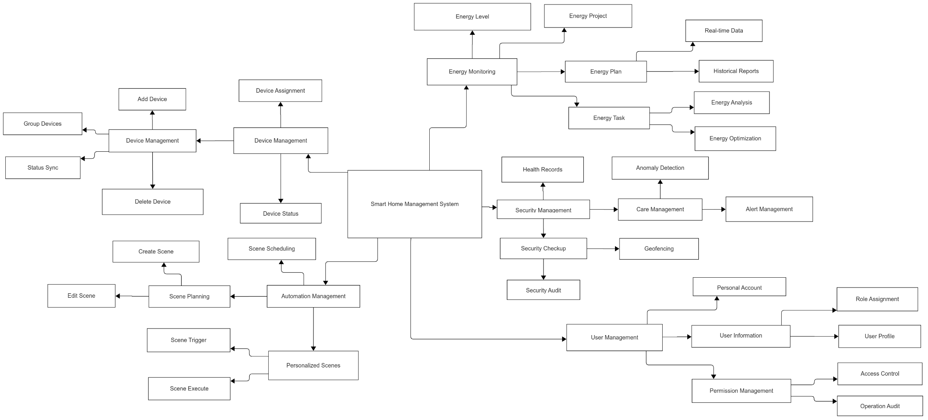
Figure 1.1 – The Overall Conceptual Model

1.2.1 User Management Model
This model is an identity authentication and access control management model designed to ensure secure and compliant user access. All users (including Administrators, Maintenance Administrator, Family Members, and Guests) can manage their personal account information. Administrators possess supreme privileges, responsible for assigning roles, setting permissions, and performing centralized management of the entire user base. Additionally, the Maintenance Administrator serves as a specific role focused on system monitoring and auditing.

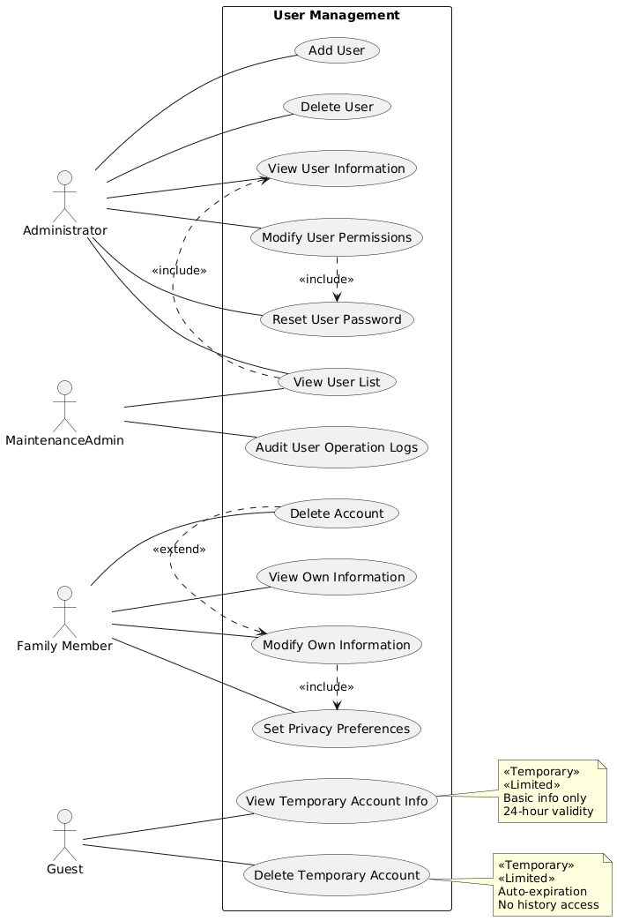
Figure 1.2 – The User Management Use Case Diagram
The user management use case diagram is shown in Figure 1.2, with detailed operational permissions for each role as follows:
Administrator: Can add users, delete users, modify user permissions, view user lists, view user information, and reset user passwords.
Maintenance Administrator: Can view user lists and audit user operation logs.
Family Members: Can view their own information, modify their own information, set privacy preferences, and deactivate their accounts.
Guests: Can view their own temporary account information and deactivate temporary accounts.

1.2.2 Device Management Model
This model is a centralized management model for heterogeneous IoT devices, designed to ensure efficient and secure device operation. All device-related operations are governed by role-based access control. Administrators have comprehensive permissions and are responsible for device configuration, configuration, status monitoring, remote control, and maintenance. Other users are granted device viewing and control permissions based on their assigned roles. Figure 1.3 shows the device management use case diagram, with detailed permissions for each role as follows:
Administrator: Can add, delete, configure, view device status, and assign device permissions.
Maintenance Administrator: Can monitor device status and maintain devices.
Family Member: Can view device status and control devices (depending on the permissions granted).
Guest: Can control devices using temporary permissions.

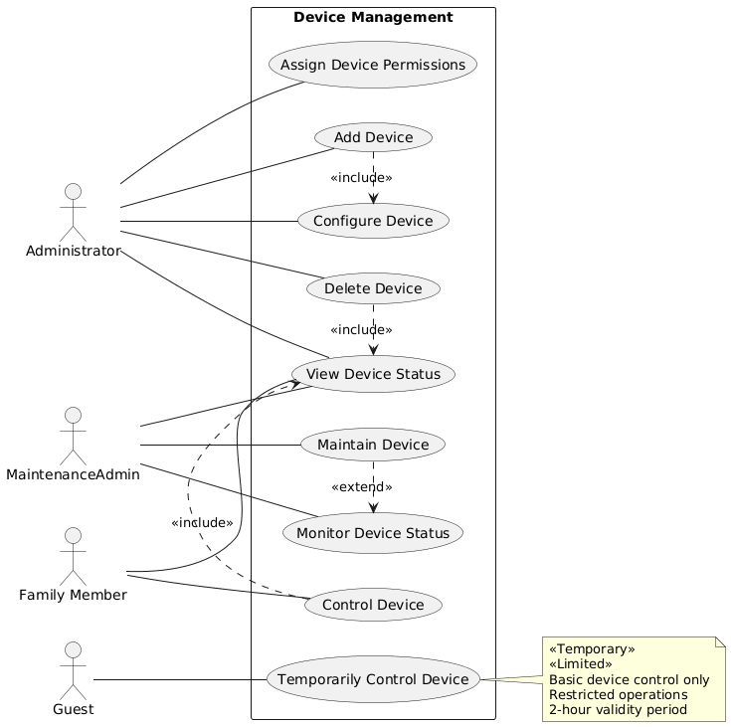
Figure 1.3 – The Device Management Use Case Diagram

1.2.3 Scene Automation Model
This model is an event driven smart scene automation model designed to enable cross device collaborative intelligent linkage. Administrators can define complex trigger conditions (e.g., time, sensor data, geofencing) and configure corresponding sequences of device actions. The system supports flexible scene editing, execution, logging and permission management. The Scene Automation use case diagram is shown in Figure 1.4, with detailed operational permissions for each role as follows:
Administrator: Can create scenes, modify scenes, delete scenes, enable/disable scenes, and assign scene permissions.
Maintenance Administrator: Can view scene execution logs.
Family Members: Can trigger scenes, view scenes, and customize personal scenes.
Guests: Can trigger limited scenes.
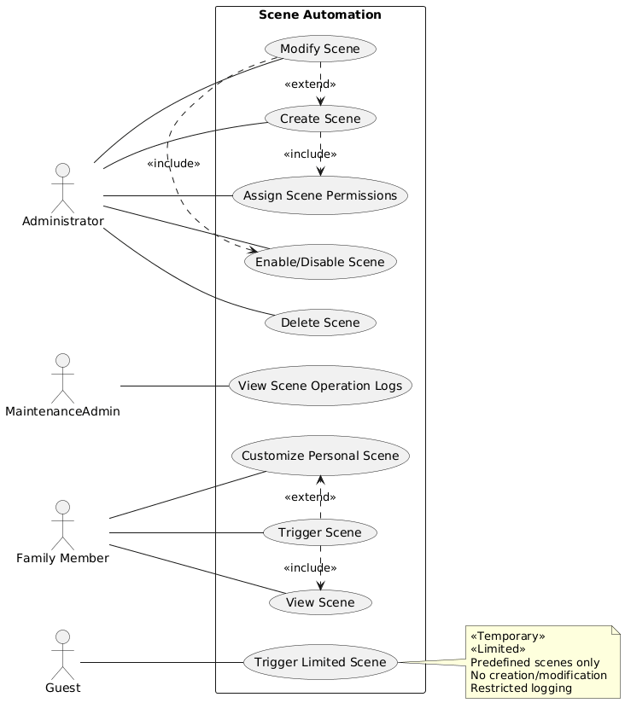
Figure 1.4 – The Scene Automation Use Case Diagram

1.2.4 Energy Consumption Monitoring Model
This model is a model focused on tracking and analyzing household energy consumption, designed to collect real-time parameters such as voltage, current, and power from devices, generating multi-dimensional energy consumption statistical reports (daily/weekly/monthly). Administrators can set energy consumption warning thresholds, view device efficiency rankings, obtain energy-saving suggestions, and perform cost analysis to support conservation decisions. The Maintenance Administrator is responsible for monitoring system operation status. Family Members can view relevant energy consumption information based on their permissions. The energy consumption detection use case diagram is shown in Figure 1.5, with detailed operational permissions for each role as follows:
Administrator: Can view total energy consumption, set energy-saving strategies, generate energy consumption reports.
Maintenance Administrator: Can monitor energy consumption anomalies.
Family Members: Can view energy consumption within permissions, view energy-saving suggestions.

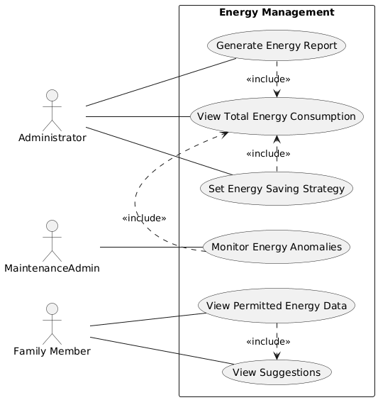
Figure 1.5 – The Energy Consumption Detection Use Case Diagram

1.2.5 Security Management Model
This system is a security management model that integrates anomaly detection, alerts, and geofencing technologies to ensure comprehensive household security protection. Administrators are responsible for defining security rules, monitoring the system's security status, handling security incidents, managing geofencing policies, and controlling device access permissions. Maintenance Administrators assist with security device management and log auditing. Family Members and Guests can receive corresponding security information based on their respective permissions. The security management use case diagram is shown in Figure 1.6, with detailed operational permissions for each role as follows:
Administrator: Can set security rules, view security logs, handle security incidents.
Maintenance Administrator: Can monitor security events, maintain security systems.
Family Members: Can view security status, receive security alerts.
Guests: Can receive security alerts.

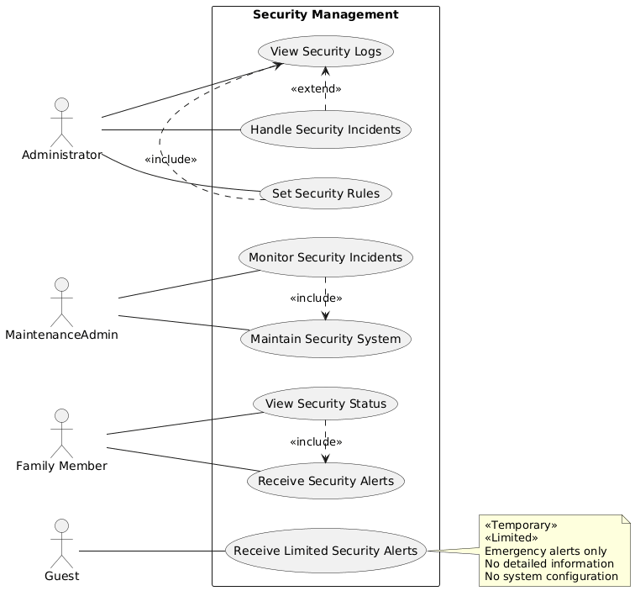
Figure 1.6 – The Security Management Use Case Diagram

2 ASSIGNMENT OF TASKS

2.1 Defining Requirements For A Software System

2.1.1Functional Requirements
Based on user usage scenarios and market research analysis, SHMS needs to meet the following core functional requirements:
1) Different user interactions
For different users, their interaction paths in system functions are shown in Figure 2.1.

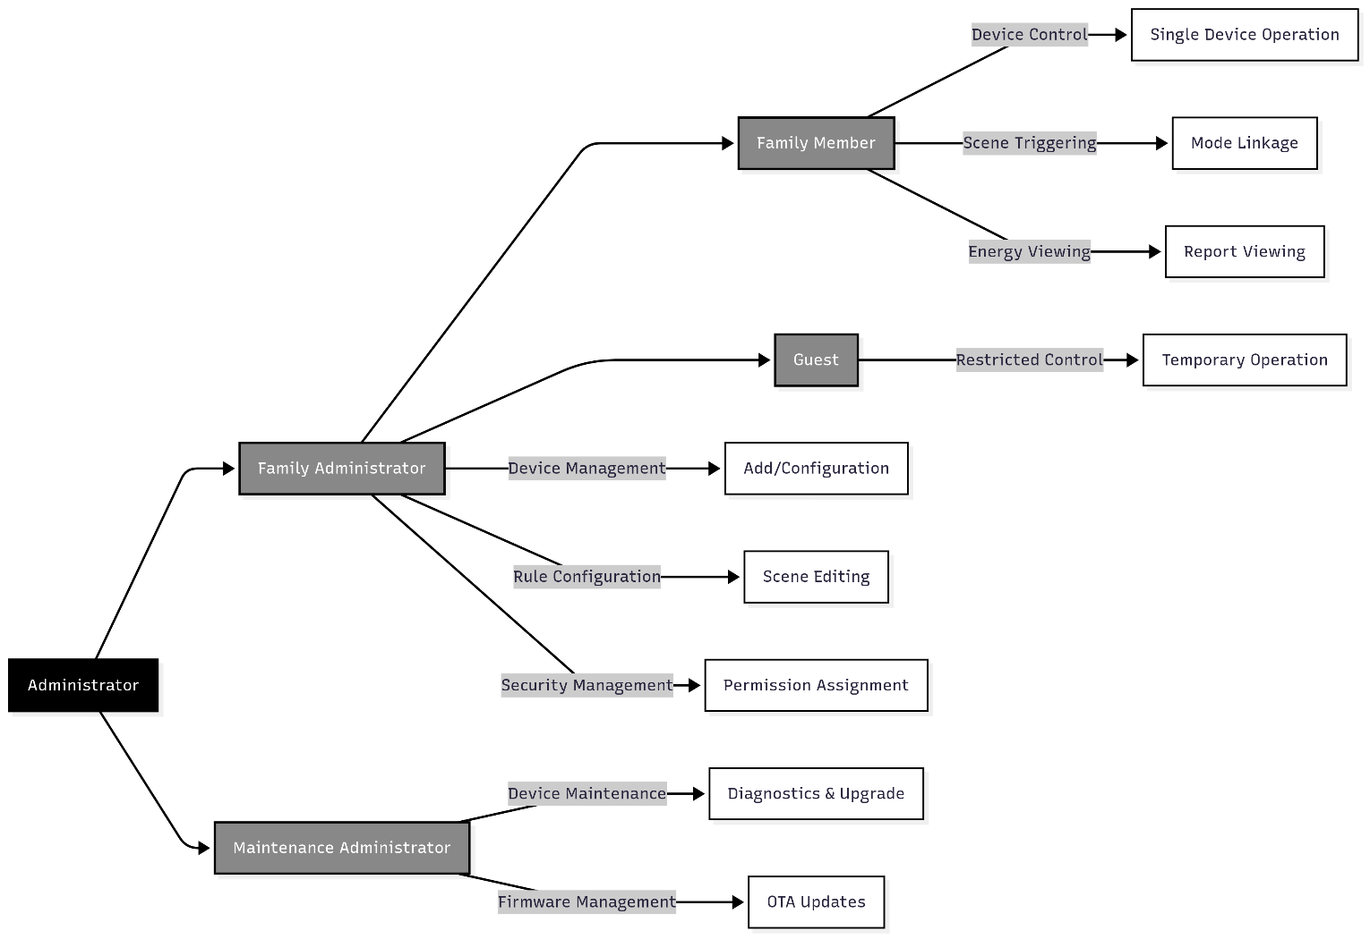
Figure 2.1 – Role-Based Access Control diagram

2) Device management
Multi protocol access: support automatic discovery of WiFi, BLE, and Zigbee devices.
Status synchronization: synchronized to all terminals within 300ms.
Group control: Time/space dimension device groups such as "livingroom appliances" grouping.
The user interface is shown in Figure 2.2 – 2.4.

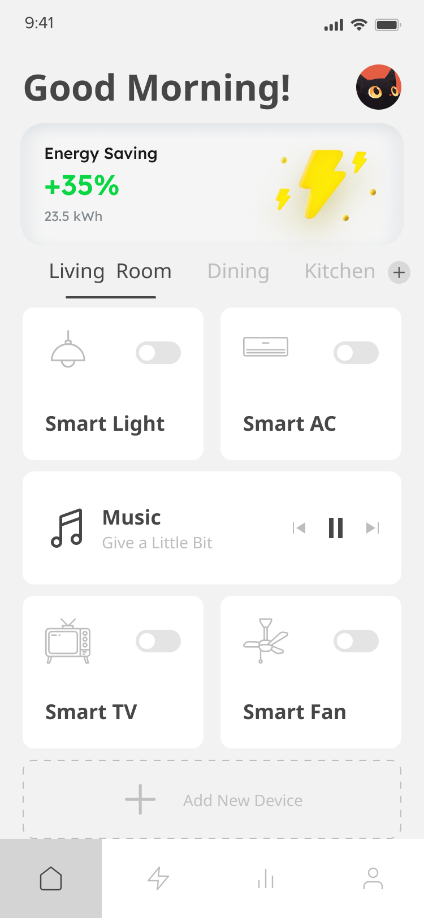 | 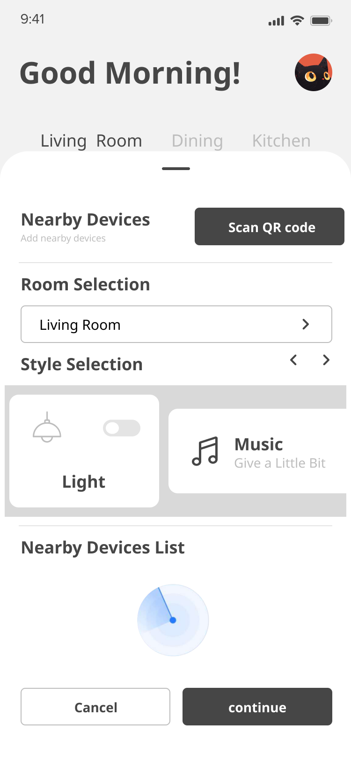 | 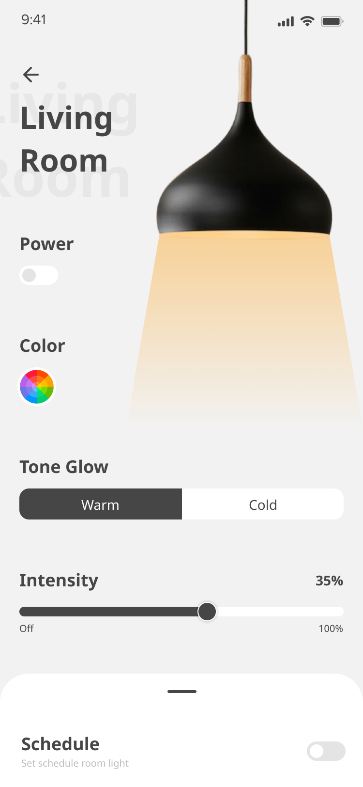
Figure 2.2 – Home-Device management & group (space) control | Figure 2.3 – Add device | Figure 2.4 - Device control (Living room-light)

3) Scene Automation
Conditional triggers: time/sensor/geofence event engine, such as: automatic window closing + security activation in “Away” mode.
Action chain execution: multiple devices sequential/parallel control, such as: “Theater” mode: turn off lights → lower the curtain → start projection.
The user interface is shown in Figure 2.5 and 2.6.

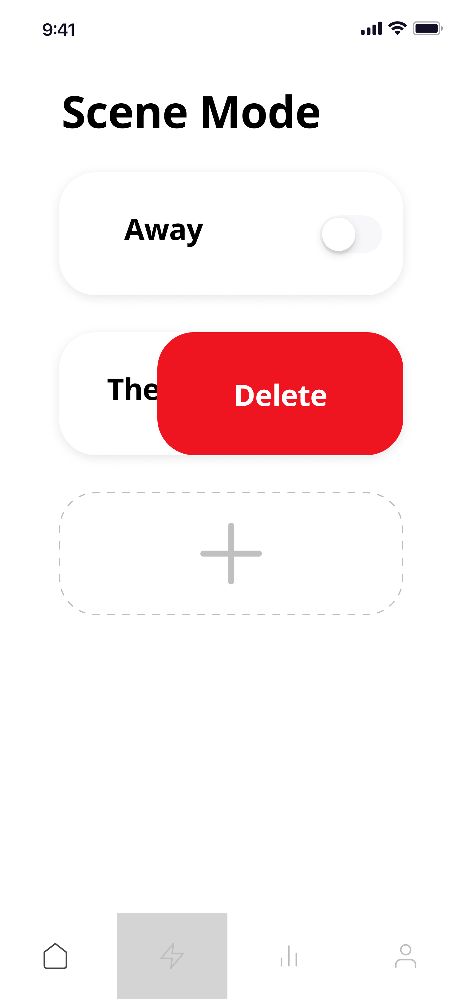 | 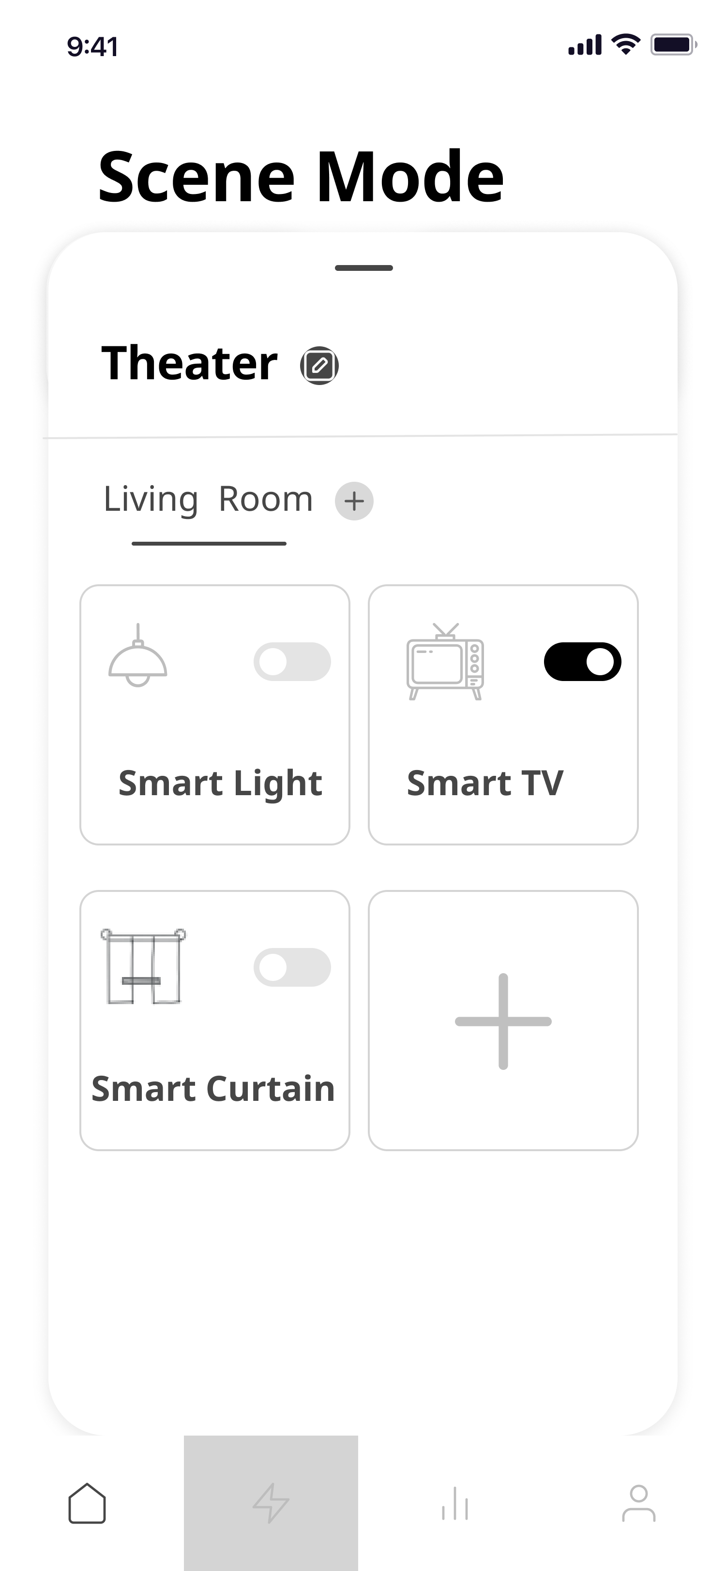
Figure 2.5 – Scene mode management | Figure 2.6 – Scene mode management

4) Energy consumption management
Real time monitoring: current/voltage/power three-parameter collection.
Historical analysis: Generate energy consumption reports by day/week/month.
The user interface is shown in Figure 2.7.
5) Safety management
Abnormal behavior detection: Automatic alarm for sudden increase in power consumption (>30% threshold).
Virtual boundaries: Geofence triggers security mode.
The user interface is shown in Figure 2.8.

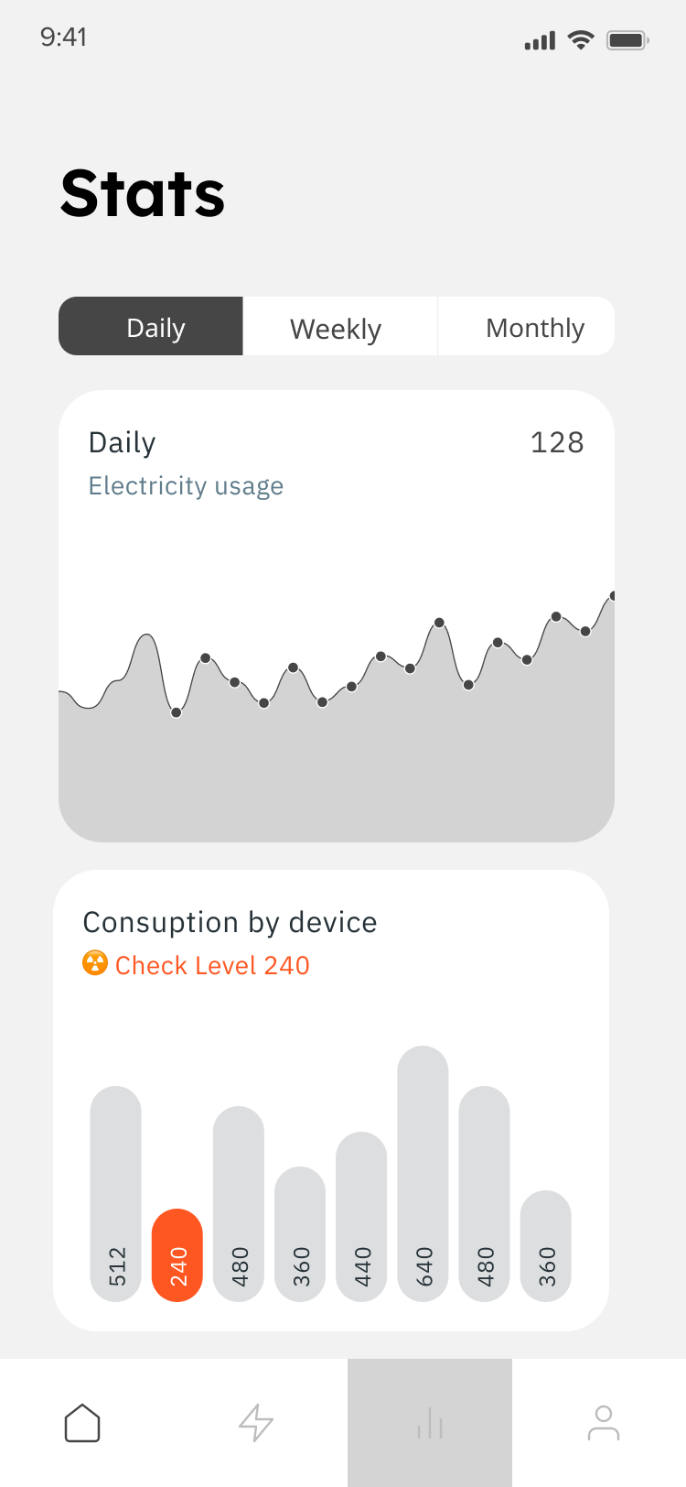 | 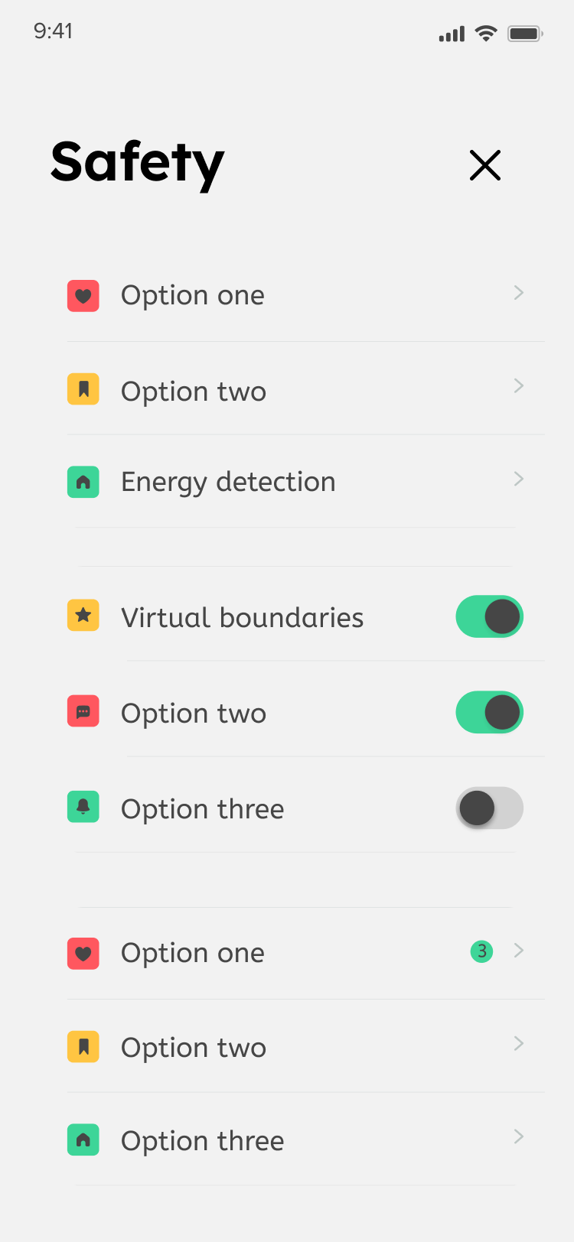
Figure 2.7 – Scene mode management | Figure 2.8 – Safety management

2.1.2 Non-Functional Requirements
In addition to functional requirements, non-functional requirements of the system are also crucial:
1) Real-time: The device status update and command response time must be controlled within 3 seconds, and the security command response time should be less than 1 second to ensure a smooth user experience. To achieve this goal, the system uses the MQTT protocol for device communication, which is designed for low-bandwidth, high-latency networks and can provide real-time and reliable message delivery in unreliable network environments.
2) Security: The system uses end-to-end encrypted transmission (TLS 1.3), supports two-way identity authentication (device and user), and conducts regular security audits. User privacy data needs to be anonymized, and access control uses the RBAC (role-based authority management) model. According to the OWASP IoT security standard, the system should mitigate the OWASP Top 10 IoT security risks, including unauthorized access, data leakage and other risks.
3) Scalability: The system architecture needs to support horizontal expansion and seamless access to new devices (no less than 20 new device types per year). The cloud platform API throughput should have dynamic expansion capabilities. Microservice architecture design is adopted, and each functional module is loosely coupled to facilitate independent upgrades and expansions.
4) Ease of use: The mobile application interface must comply with Fitts interaction rules, key operations should not exceed 3 clicks, and the time it takes for new users to become proficient in operation should be ≤ 15 minutes (guided scenario configuration wizard).

2.2 Description Of System Analogy

The current mainstream smart home management systems can be divided into closed ecosystem types (such as Apple HomeKit and Xiaomi Home) and open source platform types (such as Home Assistant). There are significant differences between the two types of systems in terms of protocol compatibility, ecosystem openness, and security. The following is an in-depth comparative analysis of three representative systems:
1) Home Assistant (open source platform)
- Core technology stack: Python + Docker + community plug-in ecosystem.
- Advantages:
- Strong device compatibility: supports more than 3,000 device types, covering 6 types of protocols such as Zigbee and BLE Mesh. Non-standard devices can be connected through custom plug-ins.
- Local deployment: data does not need to be uploaded to the cloud, avoiding the risk of privacy leakage (in compliance with GDPR requirements).
- Defect:
- enterprise-level functions: lack of multi-tenant management, commercial-level SLA guarantees, and cluster deployment needs to be optimized by yourself.
- Insufficient security audits: Community plugins have not undergone strict code review. 32% of the recorded MQTT man-in-the-middle attacks in 2024 were caused by plugin vulnerabilities.
- High technical threshold: YAML configuration is complex, and the debugging failure among for non-technical users is as high as 67% (user survey data).
- Typical case: A smart hotel was attacked by a man-in-the-middle attack after using Home Assistant. The attacker forged an MQTT proxy to steal control of guest room devices.
2) Apple HomeKit
- Core technology stack: HomeBridge bridging framework + end-to-end encryption.
- Advantages:
- Financial-grade security: Curve25519 elliptic curve encryption is used, and the communication layer is ISO 27001 certified.
- Unified ecological experience: Siri voice control delay <200ms, cross-device status synchronization accuracy 99.2%.
- Defect:
- Ecosystem closed: Only iOS/macOS users are allowed to use it. Android devices cannot access it. The number of users covered has decreased by 41%.
- High hardware certification costs: MFi certification fee is $500+/single product, and the entry rate for small and medium-sized manufacturers is less than 15%.
- Functional limitations: Complex scene Automation requires the use of Shortcuts scripts, which increases configuration complexity by 300%.
3) Xiaomi Home
- Core technology stack: Xiaomi MIoT protocol + cloud-based central control.
- Advantages:
- Cost-effective ecosystem: The average price of devices is 35% lower than that of competing products, and the Internet connection rate of white goods reaches 78%.
- Scenario-based integration: Security linkage response speed <1s (e.g. door lock abnormality triggers camera recording).
- Defect:
- Cloud dependency risk: 63% of communications are not encrypted, and large-scale user data leaks will occur in 2023.
- Protocol closedness: Third-party devices must be accessed through a private SDK, and the compatibility rate of Z-Wave devices is only 28%.
- Ecological exclusivity: Poor interoperability with platforms such as Huawei HiLink, and cross-platform interoperability rate is less than 40%.

2.3 Technology Selection And Comparative Analysis

2.3.1 Cross-Platform Framework Selection
Choose: React Native.
Through the comparison in the Table 2.1 below, React Native achieves the best balance between ecological maturity, development efficiency, and hardware compatibility.

Table 2.1 – Cross-platform framework selection comparison
Criteria | React Native | Flutter | Native development
Code reuse | 92% (UI+Logic) | 95% | 0%
Performance Overhead | Rendering delay 8-15ms | 5-10ms | <5ms
Hot Reload support | CodePush seamless update | Need to repack | App Store Review
Hardware access | Native module supports Bluetooth /Zigbee | Dependence on third-party plugins | Call SDK directly
Development costs | 1 team covers all platforms | Need to learn Dart language | Dual team maintenance

2.3.2 Backend Technology Stack Selection
Core choice: Node.js + Express + PostgreSQL + Redis + Docker.
Through the comparison in Table 2.2, combined with the solution and own situation, the most suitable technology stack was selected.

Table 2.2 – Backend technology stack selection comparison
Components | Candidates | Final Choice | Final Choice Advantage
Runtime | Java/Spring Boot | Node.js | Event-driven is suitable for high-concurrency IoT scenarios
Web Frameworks | Koa/ Fastify | Express | The middleware ecosystem is complete and the documentation is rich
Real-time communication | WebSocket/MQTT | MQTT+Socket.IO | Dual protocols ensure reliability and real-time performance
Master database | MySQL/MongoDB | PostgreSQL | JSONB supports semi-structured device data
Cache database | Memcached | Redis | Streams supports message persistence
Containerization | VM virtual machine | Docker | Reduce resource usage by 70%
2.3.3 Database Selection
Choice: PostgreSQL + Redis
Through the comparison in the Table 2.3 below, PostgreSQL + Redis cleverly balances core requirements such as real-time performance, data consistency, complex relationship modeling, reliable persistence, and query flexibility.

Table 2.3 – Database selection comparison
Comparison Dimensions | PostgreSQL + Redis | Pure relational database (MySQL/PostgreSQL) | Pure document database (MongoDB) | Pure key-value database (Redis)
Real-time read and write performance | Redis microsecond response | High-frequency small writes can easily become a bottleneck | Better than traditional RDBMS, but weaker than Redis | Memory- class speed
Complex relationship modeling | PostgreSQL strong relation support | Relationship model improvement | Weak cross-document associations | Simple key-value structures only
Transactions and consistency | PG strong ACID + Redis eventually consistent | ACID Guarantees | Multi-document transactions are weak | No transaction or weak transaction
Query flexibility | PG complex SQL + Redis data structure | Powerful SQL support | JSON queries are limited | Basic key-value operations only
Scalability | Redis Cluster + PG read-write separation/ sharding | The complexity of sharding | Sharding makes it easy to expand | Redis Cluster Horizontal Scaling
Reliability/ durability | PG WAL + replication + Redis AOF/RDB | Mature persistence mechanism | Dependency on replica set configuration | Persistence has the risk of data loss
Data structure adaptability | PG JSONB + Redis rich structure | Limited JSON support | Flexible document model | String/ Hash/ Set, etc.

3 DESIGN

3.1 System Architecture Design

SHMS employs a layered architecture based on microservices and a Frontend/Backend separation design pattern. This approach effectively decouples the control flow from the data flow, thereby ensuring high flexibility, maintainability, and enabling independent development and deployment of system modules. The overall system architecture is illustrated in Figure 3.1.

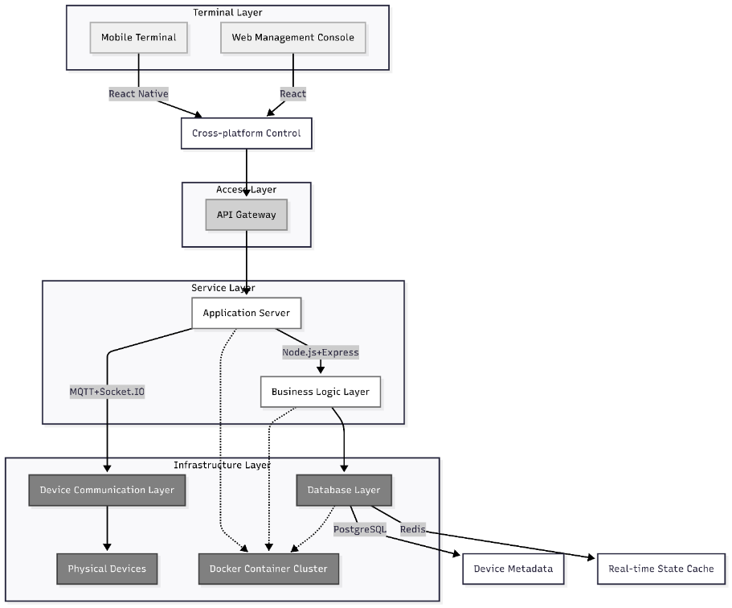
Figure 3.1 – Layered Architecture Design

1) Terminal Layer
Mobile Terminal: A cross-platform application built with React Native, supporting device control and status monitoring for both iOS and Android users.
Web Management Console: A responsive administrative interface developed with React, providing comprehensive device configuration, scene editing, and system management functionalities.
2) Access Layer
API Gateway: Implemented using Kong, it handles request routing, load balancing, and rate limiting (1000 requests/second/user), serving as the unified entry point for the system.
Security Authentication: Utilizes JWT tokens (RSA-2048 signature) for user identity verification, ensuring the security and legitimacy of API access.
3) Service Layer
Device Management: Performs dynamic protocol conversion (e.g., unifying protocols like Zigbee into MQTT), abstracting the heterogeneity of underlying devices.
Scene Engine: Driven by the Rete algorithm, it supports complex linkage rules for over 200 devices, guaranteeing a trigger latency of ≤ 200ms.
Energy Consumption Optimization: Integrates an LSTM prediction model to analyze historical data and generate intelligent energy-saving strategies.Safety Monitoring: Sliding window algorithm detects abnormal power consumption.
Safety Monitoring Service: Employs a sliding window algorithm for real-time detection of abnormal power consumption patterns, triggering timely security alerts.
4) Infrastructure Layer
PostgreSQL: Serves as the primary relational database for storing structured data such as users, devices, and energy records. It also efficiently handles semi-structured device data using the JSONB data type.
Redis: Functions as a high-performance cache and in-memory data store, used for user sessions, real-time device status, and frequently accessed data, with read/write latency under 1ms.
Docker Swarm: Provides containerized cluster management capabilities, supporting automatic scaling of services to ensure high availability and elasticity of the system.

3.2 Refining the Architecture Design

Building upon the modular system design, the SHMS software architecture is logically partitioned into three core parts: the user Frontend, Backend server, and database. The Frontend, serving as the layer for direct user interaction, is further subdivided into two modules: the Web Management Console and the Mobile Terminal. Together, they are responsible for constructing and rendering the user interface. They communicate with Backend services via standard HTTP APIs for static data exchange and utilize Socket.IO for persistent connections to subscribe to real-time device status updates and event notifications, ensuring the dynamism and responsiveness of the user interface.

3.2.1 User Frontend
The Web Management Console is built using a modern Frontend technology stack, employing Vite as the build tool to create a React project. This architecture emphasizes type safety, componentization, and state management. Its core project structure includes:
- src/components/: Reusable UI component library.
- Layout/: Defines the overall application layout (Header, Sidebar).
- UI/: Provides foundational interactive components (Modal, ConfirmDialog).
- src/pages/: Route page components for each functional module (Dashboard, Devices, Scenes, Energy, Security).
- src/stores/: Global state management (authStore for authentication, deviceStore for device data).
- src/services/: Data service layer (api.ts for RESTful requests, socket.ts for WebSocket management).
- src/hooks/: Custom logic encapsulation (e.g., useSocket for real-time features).
- Config Files: Configurations for Vite, TypeScript, ESLint, etc., defining build and development rules.
The mobile application is developed using Expo and React Native, adopting a modular architecture that ensures clear navigation, component reusability, and centralized state management. Its core project structure includes:
- app/: Core Navigation, using file-based routing.
- (tabs)/: Main tabbed pages (Home, Scenes, Energy, Security, Profile).
- auth/: User login and registration pages.
- device/[id].tsx: Device detail control page (dynamic route).
- src/: Core Business Logic.
- contexts/: Global state management (AuthContext for authentication, DeviceContext for device data, SocketContext for real-time connections).
- services/: Data service layer (api.js for backend API calls).
- navigation/: Navigation configuration.
- components/: Reusable UI Components.
- ui/: Foundational UI components.
- dashboard/: Dashboard-specific components (Device Tiles, Energy Cards).

3.2.2 Backend
The SHMS backend system is built on the Node.js + Express framework, employing a layered architecture design to ensure high availability, scalability, and security. The backend server comprises core modules including configuration files, controllers, data models, routes, middleware, business services, protocol adapters, and log management. Its core project structure includes:
- config/: Critical service configurations (Database, MQTT, Redis)
- controllers/: REST API endpoint handling (Authentication, Devices, Energy, Scenes, Security)
- services/: Core business logic (Device Discovery, Protocol Conversion, Scene Execution, Energy Optimization)
- models/: Data model definitions (User, Device, Scene, Energy entities and relationships)
- protocols/: Multi-protocol adaptation layer (Zigbee/BLE-Mesh/Z-Wave unified conversion)
- routes/: API route mapping
- middleware/: Authentication and access control
- ml/: Intelligent prediction module (LSTM energy forecasting)
- security/: Security enhancements (JWT management, audit logging)
- socket/: Real-time communication handling (Device status, scene triggers)

3.2.3 Database
The SHMS employs PostgreSQL as the primary database for storing structured data such as users, devices, and energy consumption records. It also supports flexible storage of semi-structured data like device configurations via the JSONB data type. Additionally, Redis is utilized as a cache database for storing user sessions, real-time device status, and frequently accessed data, significantly enhancing system responsiveness.

3.3 Database Design

3.3.1 Entity Relationship Design
Based on system requirements, the core entities include: User, Role, Permission, Device, DeviceType, DeviceStatus, Location, Scene, Trigger, Action, and EnergyUsage. Key relationships among these entities are: users own devices, users create scenes, scenes contain triggers and actions, and devices generate status and energy consumption records. The entity relationships are detailed in Figure 3.2.

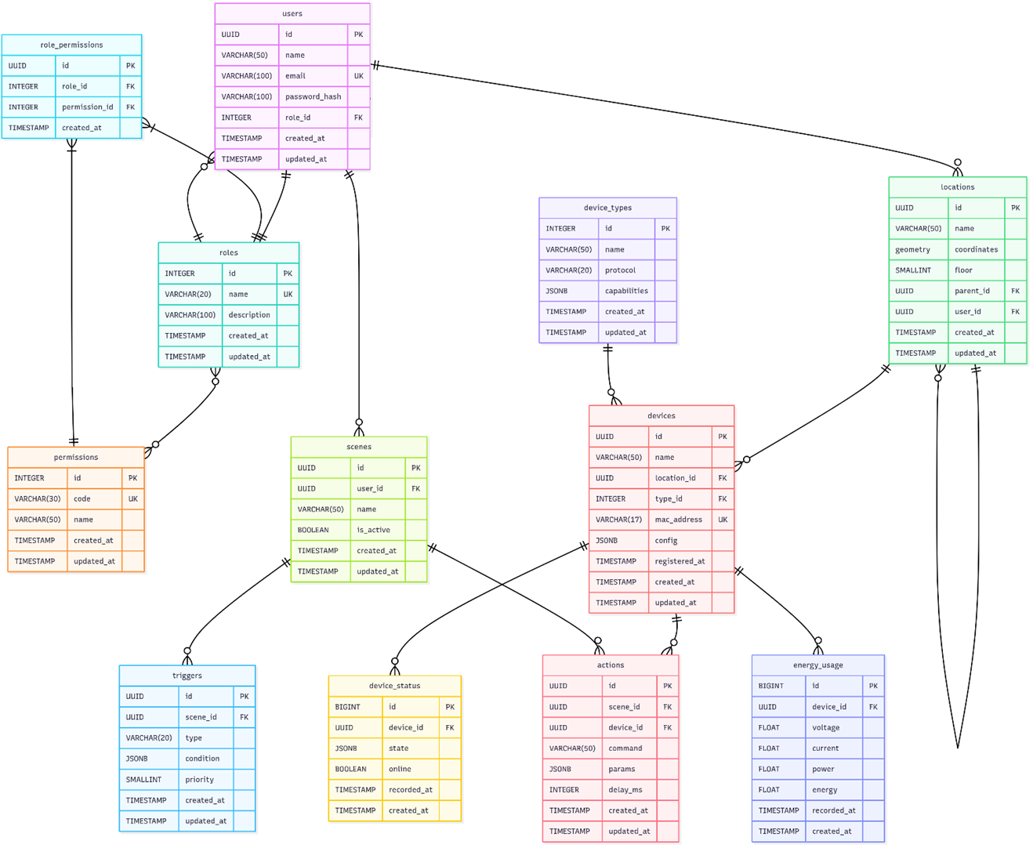
Figure 3.2 – ER Diagram

1) User Permission Management Module
- User-Role Relationship: A many-to-one relationship between User and Role, implemented via the role_id foreign key, enabling Role-Based Access Control (RBAC). As shown in Figure 3.3.

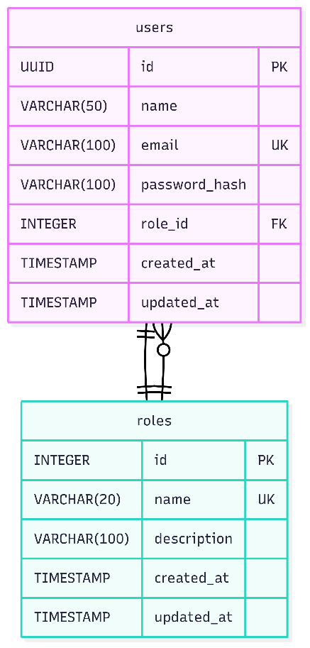 | 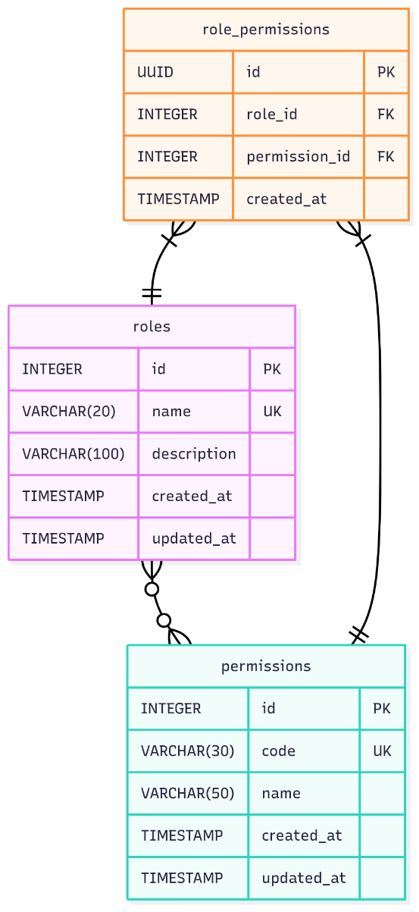
Figure 3.3 – User-Role Relationship | Figure 3.4 – Role-Permission Relationship

- Role-Permission Relationship: A many-to-many relationship between Role and Permission, facilitated by the junction table role_permissions, allowing flexible permission assignment and combination. As shown in Figure 3.4.
2) Spatial Location Management Module
- Location Hierarchy Relationship: The Location entity implements a self-referencing relationship via parent_id, creating a tree-like hierarchical structure for managing multi-level spaces (e.g., rooms, floors, areas). User and Location have a one-to-many relationship. As shown in Figure 3.5.

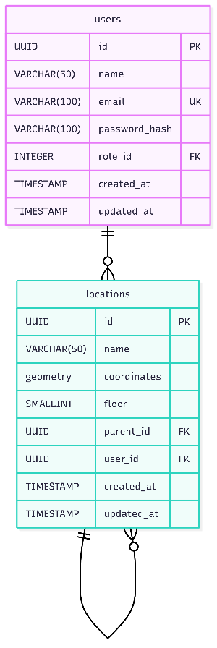 | 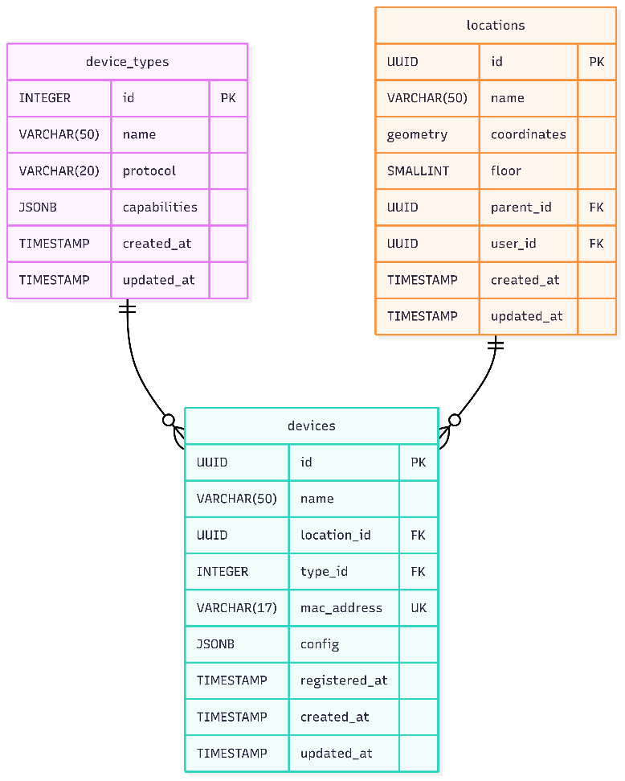
Figure 3.5 – Location Hierarchy Relationship | Figure 3.6 – Device Management Module

3）Device Management Module
- Device Core Relationships: The Device entity, as the core, has a many-to-one relationship with Location for spatial positioning and a many-to-one relationship with DeviceType for categorization. As shown in Figure 3.6.
- Device Status Monitoring: DeviceStatus has a many-to-one relationship with Device, forming time-series data of historical device status for behavior analysis and fault diagnosis. As shown in Figure 3.7.

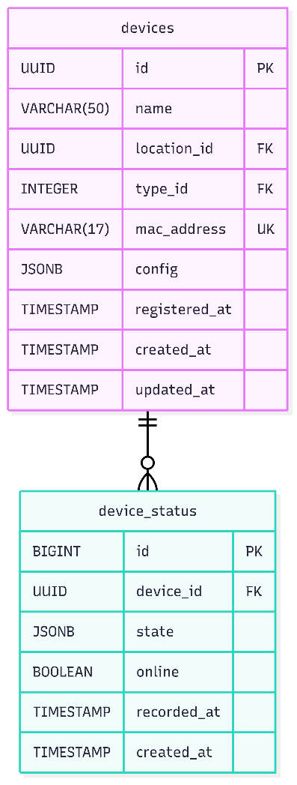 | 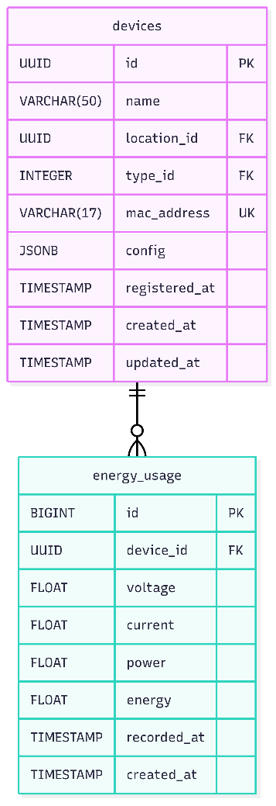
Figure 3.7 – Device Status Monitoring | Figure 3.8 – Energy Record Relationship

4) Energy Management Module
- Energy Record Relationship: EnergyUsage has a many-to-one relationship with Device, establishing a device-level energy consumption monitoring system for statistics, pattern recognition, and efficiency optimization. As shown in Figure 3.8.
5) Smart Scene Automation Module
- Scene Control Architecture: The Scene entity, as the automation core, has one-to-many relationships with both Trigger (defining activation conditions) and Action (defining operations to execute). As shown in Figure 3.9.

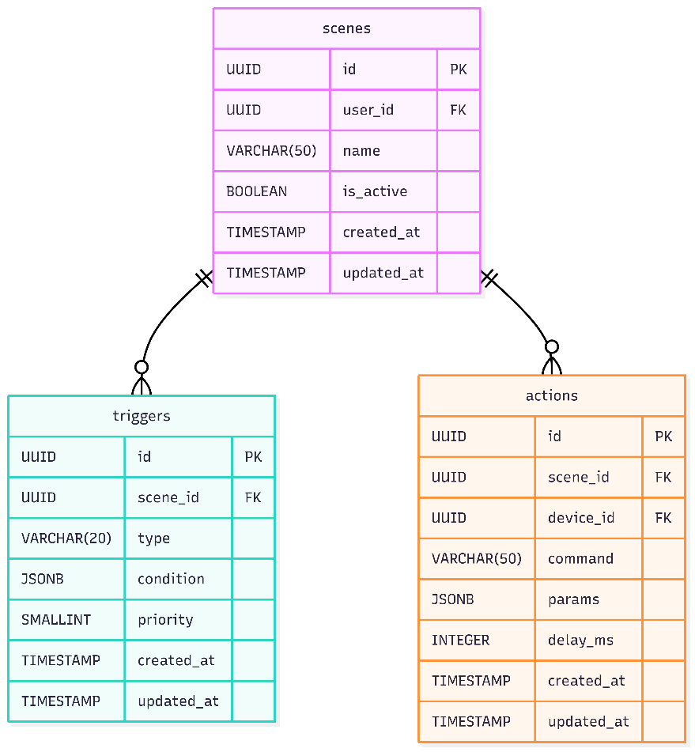 | 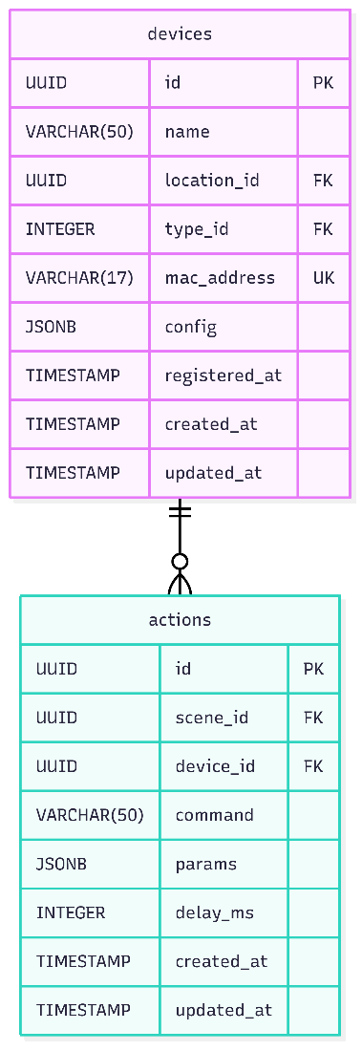
Figure 3.9 – Scene Control Architecture | Figure 3.10 – Action Execution Chain

- Action Execution Chain: Action has a many-to-one relationship with Device, forming a complete "Scene → Action → Device" control chain for coordinated device automation. As shown in Figure 3.10.
3.3.2 Key Table Structure

Table 3.1 – User table (users)
Field Name | Data Types | Constraint | Describe
id | UUID | PRIMARY KEY | User unique identifier
name | VARCHAR (50) | NOT NULL | Username
email | VARCHAR (100) | UNIQUE | Mail
password_hash | VARCHAR (100) | NOT NULL | Bcrypt password hashing
role_id | INT | FOREIGN KEY | Role ID
created_at | TIMESTAMP TZ | DEFAULT NOW () | Creation time
updated_at | TIMESTAMP TZ | DEFAULT NOW () | Update time

Table 3.2 – Roles table (roles)
Field Name | Data Types | Constraint | Describe
id | SERIAL | PRIMARY KEY | Role ID
name | VARCHAR (20) | UNIQUE | Role name
description | VARCHAR (100) |  | Role description
created_at | TIMESTAMP TZ | DEFAULT NOW () | Creation time
updated_at | TIMESTAMP TZ | DEFAULT NOW () | Update time

Table 3.3 – Permissions table (permissions)
Field Name | Data Types | Constraint | Describe
id | SERIAL | PRIMARY KEY | Permission ID
code | VARCHAR (30) | UNIQUE | Permission code
name | VARCHAR (50) | NOT NULL | Permission name
created_at | TIMESTAMP TZ | DEFAULT NOW () | Creation time
updated_at | TIMESTAMP TZ | DEFAULT NOW () | Update time

Table 3.4 – Role Permissions Association table (role_permissions)
Field Name | Data Types | Constraint | Describe
id | UUID | PRIMARY KEY | User unique identifier
role_id | INT | FOREIGN KEY, PRIMARY KEY | Role ID
permission_id | INT | FOREIGN KEY, PRIMARY KEY | Permission ID
created_at | TIMESTAMP TZ | DEFAULT NOW () | Creation time
Table 3.5 – Locations table (locations)
Field Name | Data Types | Constraint | Describe
id | UUID | PRIMARY KEY | Location ID
name | VARCHAR (50) | NOT NULL | Location name
coordinates | GEOGRAPHY(POINT) |  | Location coordinates
floor | SMALLINT |  | Floor
parent_id | UUID | FOREIGN KEY | Parent location ID
created_at | TIMESTAMP TZ | DEFAULT NOW () | Creation time
updated_at | TIMESTAMP TZ | DEFAULT NOW () | Update time

Table 3.6 – Device Type table (device_types)
Field Name | Data Types | Constraint | Describe
id | SERIAL | PRIMARY KEY | Type ID
name | VARCHAR (50) | NOT NULL | Type Name
protocol | VARCHAR (20) | NOT NULL | Communication Protocol
capabilities | JSONB |  | Device Capability Description
created_at | TIMESTAMP TZ | DEFAULT NOW () | Creation time
updated_at | TIMESTAMP TZ | DEFAULT NOW () | Update time

Table 3.7 – Devices table (devices)
Field Name | Data Types | Constraint | Describe
id | UUID | PRIMARY KEY | Device ID
name | VARCHAR (50) | NOT NULL | Device Name
location_id | UUID | FOREIGN KEY | Installation Location ID
type_id | INT | FOREIGN KEY | Device Type ID
mac_address | MACADDR | UNIQUE | Physical Address
config | JSONB |  | Device configuration parameters
registered_at | TIMESTAMP TZ | DEFAULT NOW () | Registration Time
created_at | TIMESTAMP TZ | DEFAULT NOW () | Creation time
updated_at | TIMESTAMP TZ | DEFAULT NOW () | Update time

Table 3.8 – Device Status table (device_status)
Field Name | Data Types | Constraint | Describe
id | BIGSERIAL | PRIMARY KEY | Record ID
device_id | UUID | FOREIGN KEY, NOT NULL | Device ID
state | JSONB | NOT NULL | Device Status
online | BOOLEAN | NOT NULL | Online Status
recorded_at | TIMESTAMP TZ | DEFAULT NOW () | Recording time
created_at | TIMESTAMP TZ | DEFAULT NOW () | Creation time
Table 3.9 – Energy consumption record table (energy_usage)
Field Name | Data Types | Constraint | Describe
id | BIGSERIAL | PRIMARY KEY | Record ID
device_id | UUID | FOREIGN KEY, NOT NULL | Device ID
voltage | REAL |  | Voltage (V)
current | REAL |  | Current (A)
power | REAL | NOT NULL | Real-time power (W)
Energy | REAL | NOT NULL | Cumulative energy consumption (kWh)
recorded_at | TIMESTAMP TZ | DEFAULT NOW () | Recording time
created_at | TIMESTAMP TZ | DEFAULT NOW () | Creation time

Table 3.10 – Scenes table (scenes)
Field Name | Data Types | Constraint | Describe
id | UUID | PRIMARY KEY | Scene ID
user_id | UUID | FOREIGN KEY | Create User ID
name | VARCHAR (50) | NOT NULL | Scene Name
is_active | BOOLEAN | DEFAULT true | Activation Status
created_at | TIMESTAMP TZ | DEFAULT NOW () | Creation time
updated_at | TIMESTAMP TZ | DEFAULT NOW () | Update time

Table 3.11 – Triggers table (triggers)
Field Name | Data Types | Constraint | Describe
id | UUID | PRIMARY KEY | Trigger ID
scene_id | UUID | FOREIGN KEY | Scene ID
type | VARCHAR (20) | NOT NULL | Trigger Type
condition | JSONB | NOT NULL | Trigger conditions
priority | SMALLINT | DEFAULT 0 | Execution priority
created_at | TIMESTAMP TZ | DEFAULT NOW () | Creation time
updated_at | TIMESTAMP TZ | DEFAULT NOW () | Update time

Table 3.12 – Actions table (actions)
Field Name | Data Types | constraint | describe
id | UUID | PRIMARY KEY | Action ID
scene_id | UUID | FOREIGN KEY | Scene ID
device_id | UUID | FOREIGN KEY | Device ID
command | VARCHAR (50) | NOT NULL | Command
params | JSONB |  | Command parameters
delay_ms | INTEGER | DEFAULT 0 | Delay execution (milliseconds)
created_at | TIMESTAMP TZ | DEFAULT NOW () | Creation time
updated_at | TIMESTAMP TZ | DEFAULT NOW () | Update time

3.3.3Database optimization design

Table 3.13 – Indexing strategy
Table name | Index fields | Index Type | use
device_status | (device_id, recorded_at) | BRIN | Fast range query of time series data
energy_usage | (device_id, recorded_at) | BRIN | Energy consumption history analysis
locations | coordinates | GiST | Geofence Spatial Query
actions | (scene_id, delay_ms) | BTREE | Optimization of scene action scheduling
users | email | HASH | Quick login verification

Table 3.14 – Data Lifecycle
Table name | Retention Policy | Cleanup mechanism
device_status | 30 days of detailed data + 1 year of aggregated data | Daily scheduled task cleanup
energy_usage | 2 years of detailed data | Archive to cold storage on a monthly basis
action_logs | Permanent retention

3.4 Role Permission Model

1) RBAC (Role-Based Access Control) Permission matrix as shown in the table 3.15:
Table 3.15 – RBAC Permission Matrix
Role | Device Control | Rule Editing | User Management | Device Access
Family Member | ✓ | ✓ | ✗ | ✗
Administrator | ✓ | ✓ | ✓ | ✓
Guest | Restricted Control | ✗ | ✗ | ✗
Maintenance Administrator | ✓ | ✗ | ✗ | ✓

2) Permission inheritance relationship as shown in the Figure 3.11.

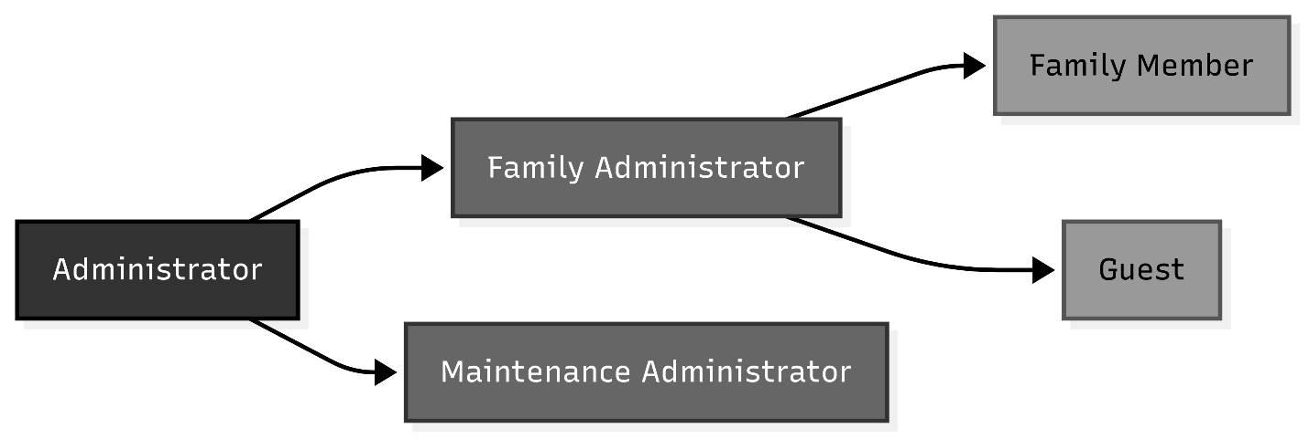
Figure 3.11 – Permission Inheritance Relationship

3.5 Security Layered Architecture

The security layered architecture is shown in Figure 3.12.

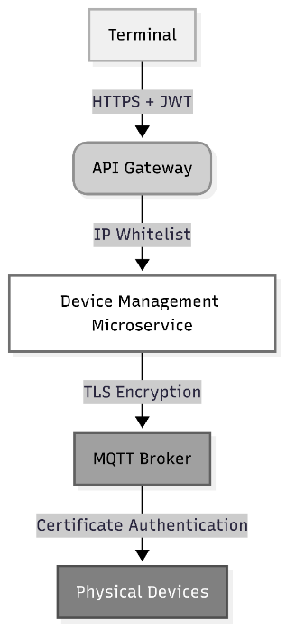
Figure 3.12 – Security Layered Architecture
1) Terminal layer
HTTPS transmission: TLS 1.3 encryption.
JWT authentication: ES384 signature token.
2) Gateway layer
IP whitelist: only allow IP access.
Dynamic blacklist: automatically block attack sources.
3) Microservice layer
mTLS two-way authentication.
Least privilege strategy.
4) Communication layer
Device certificate authentication: X.509 two-way verification.
TLS 1.3 mandatory encryption.
5) Device layer
Security chip: ATECC608A hardware encryption.
Anti-disassembly self-destruction: trigger certificate destruction.

4 IMPLEMENTATION

4.1 Development of information system classes

The SHMS system was developed within the Visual Studio Code integrated development environment, adopting a modular implementation approach. The system implementation began with establishing the foundational development environment, installing core dependencies including: Node.js runtime environment, Express server framework, Mosquitto MQTT message broker, Redis in-memory database, PostgreSQL relational database and its spatial extension PostGIS.
The project was initialized via the npm init command, with necessary development dependencies installed in the root directory. Key technical dependencies include: Sequelize ORM framework, MQTT communication protocol library, Socket.IO real-time communication library, JWT authentication utilities, and Rate Limiting components for API throttling.
The system code is architecturally divided into two main parts: the backend server and the frontend applications (including both the web and mobile terminals).
The backend server employs a layered architecture design, comprising the following core modules:
Configuration Files: System component and third-party service configurations
Controllers: HTTP request processing and response handling
Data Models: ORM-based database entity definitions
Routes: API endpoint mapping and route management
Middleware: Request preprocessing and authentication
Business Services: Core business logic implementation
Protocol Adapters: IoT device communication protocol handling
Logging System: Runtime log recording and monitoring
The detailed project file structure of the backend server is illustrated in Figure 4.1.
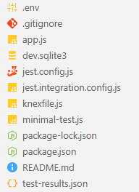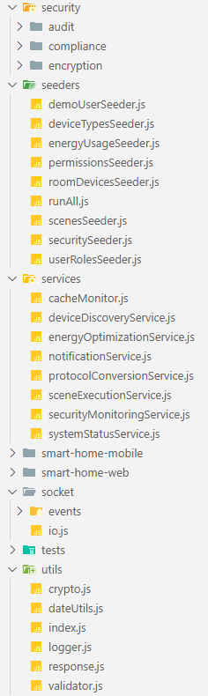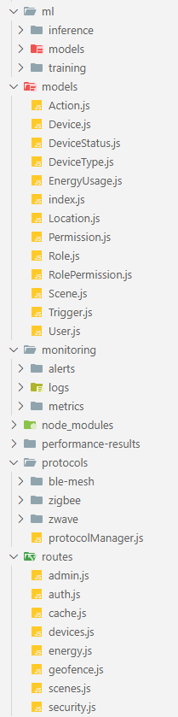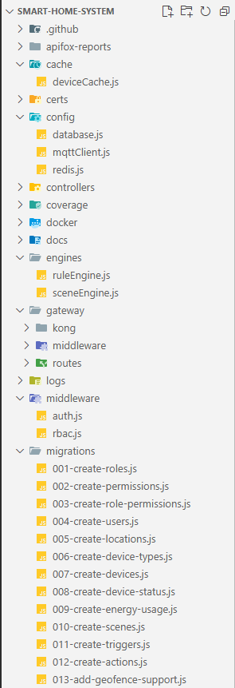
Figure 4.1 - Backend Server Project File Structure

The specific functional descriptions for each module provided in Table 4.1.

Table 4.1 – The Specific Functional Descriptions For Each Backend Module
Package | File | Description
1 | 2 | 3
Cache | deviceCache.js | A module for caching device status, using Redis to store real-time device states and improve read performance.
config | database.js | Database configuration file, configuring Sequelize to connect to the PostgreSQL database.
config | mqttClient.js | MQTT client configuration for connecting to the MQTT broker, subscribing to, and publishing messages.
config | redis.js | Redis client configuration for connecting to the Redis server.
controllers | authController.js | Handles user authentication-related requests, such as login, registration, token refresh, etc.
Continuation of table 4.1
1 | 2 | 3
controllers | deviceController.js | Handles device-related requests, such as device listing, status updates, device control, etc.
controllers | energyController.js | Handles energy data-related requests, such as consumption statistics, energy prediction, etc.
controllers | geofenceController.js | Handles geofence-related requests, such as creating, updating, deleting geofences, and triggering geofence events.
controllers | sceneController.js | Handles scene-related requests, such as scene creation, execution, deletion, etc.
controllers | securityController.js | Handles security-related requests, such as security event reporting, alarm settings, etc.
docker | Dockerfile, docker-compose.yml, etc. | Stores Docker-related files for containerized deployment.
docs | api/ | Stores API interface documentation.
docs | architecture/ | Stores system architecture design documentation.
docs | deployment/ | Stores deployment-related documentation.
engines | ruleEngine.js | Rule engine for processing device trigger conditions and action rules.
engines | sceneEngine.js | Scene engine for executing scenes (a collection of device actions).
gateway | kong/ | Stores configuration files for the Kong gateway.
gateway/ middleware | authentication.js | Authentication middleware for verifying JWT tokens.
gateway/ middleware | authorization.js | Authorization middleware for checking user permissions.
gateway/ middleware | rateLimiter.js | Rate limiting middleware to prevent API abuse.
gateway/ routes | apiRoutes.js | Defines API routes and corresponding backend services.
middleware | auth.js | Authentication middleware for verifying JWT tokens.
middleware | rbac.js | Role-Based Access Control (RBAC) middleware for checking user roles and permissions.
migrations | (Various files) | Database migration files, using Sequelize to create and modify database table structures.
Continuation of table 4.1
1 | 2 | 3
ml | (Directory) | Machine learning related modules.
ml/inference | realTimePredictor.js | Real-time prediction, using trained models for energy consumption forecasting.
ml/models | lstmEnergyModel.js | LSTM model for energy consumption prediction.
ml/models | reinforcementLearning.js | Reinforcement learning model for optimizing device control strategies.
ml/training | energyDataProcessor.js | Energy data processing for model training.
models | (Various files, e.g., User.js) | Sequelize model definitions, corresponding to database tables.
monitoring | (Directory) | System monitoring related.
protocols | ble-mesh/ | BLE Mesh protocol handling.
protocols | zigbee/ | Zigbee protocol handling.
protocols | zwave/ | Z-Wave protocol handling.
protocols | protocolManager.js | Protocol manager for uniformly managing device communication across different protocols.
routes | auth.js | Authentication-related routes.
routes | admin.js | Administrator-related routes.
routes | cache.js | Cache management routes.
routes | devices.js | Device-related routes.
routes | energy.js | Energy-related routes.
routes | geofence.js | Geofence-related routes.
routes | scenes.js | Scene-related routes.
routes | security.js | Security-related routes.
security/audit | securityLogger.js | Security logger for recording security events.
security/ compliance | gdprCompliance.js | GDPR compliance checking.
security/ encryption | certificateManager.js | Certificate manager for managing SSL/TLS certificates.
security/ encryption | jwtManager.js | JWT token manager, responsible for generating and verifying JWTs.
services | deviceDiscoveryService.js | Device discovery service for detecting new devices.
services | energyOptimizationService.js | Energy optimization service, using machine learning to optimize energy usage.
Continuation of table 4.1
1 | 2 | 3
services | notificationService.js | Notification service for sending push notifications, emails, etc.
services | protocolConversionService.js | Protocol conversion service for converting data from different protocols into a unified format.
services | sceneExecutionService.js | Scene execution service, responsible for executing actions within a scene.
services | securityMonitoringService.js | Security monitoring service for monitoring security events.
services | systemStatusService.js | System status service for checking system health.
services | cacheMonitor.js | Cache monitoring service for monitoring Redis cache status.
socket | io.js | Socket.IO server configuration and initialization.
socket/ events | deviceEvents.js | Device-related events, such as device status updates.
socket/events | energyEvents.js | Energy-related events, such as energy consumption data updates.
socket/events | sceneEvents.js | Scene-related events, such as scene execution.
utils | crypto.js | Encryption and decryption utilities.
utils | dataUtils.js | Data processing utilities.
utils | index.js | Utility function index.
utils | validator.js | Data validation utilities.
utils | logger.js | Logging utility.
utils | response.js | Unified response format utility.
(Root) | .env | Environment variables.
(Root) | app.js | Application entry file.
(Root) | package-lock.json, package.json | Dependency management.
(Root) | logs/ | Stores application log files.
(Root) | node_modules/ | Stores third-party modules depended on by the project.

The Frontend system comprises two major modules: the Web Management Console and the Mobile Terminal, together forming a comprehensive user interaction system. The Web Management Console is a React Single Page Application created using the modern Vite build tool, providing administrators with a full-featured interface for device management and system configuration. The Mobile Terminal is a cross-platform application developed with the Expo framework on React Native, focusing on daily control and real-time monitoring for household users. The file directory structures for the two terminals are shown in Table 4.2 and Table 4.3, respectively.

Table 4.2 – The Specific Functional Descriptions For Each Web Module
Package | File | Description
1 | 2 | 3
.vscode |  | VSCode editor configuration.
dist |  | Build output directory.
node_modules |  | Third-party dependency modules.
public | vite.svg | Vite framework icon.
src/assets | react.svg | React library icon.
src/components | Dashboard/ | Dashboard-related components (data cards, charts).
src/components | Devices/ | Device-related components (lists, control panels).
src/components | Energy/ | Energy management components (consumption charts).
src/components | Layout/ | Layout components (Header, Sidebar, main Layout).
src/components | Scenes/ | Scene configuration and control components.
src/components | Security/ | Security monitoring and alert components.
src/components | UI/ | Reusable foundational UI components (buttons, dialogs).
src/hooks |  | Custom React Hooks for reusable logic.
src/pages | Dashboard.tsx | Main dashboard page.
src/pages | DeviceDetail.tsx | Device detail and control page.
src/pages | Devices.tsx | Device list management page.
src/pages | Energy.tsx | Energy monitoring and analysis page.
src/pages | Login.tsx | User login page.
src/pages | Profile.tsx | User profile management page.
src/pages | Register.tsx | User registration page.
src/pages | Scenes.tsx | Smart scene management page.
src/pages | Security.tsx | Security center page.
src/services | api.ts | Service for handling RESTful API requests.
src/services | socket.ts | Service for managing WebSocket/Socket.IO connections.
src/stores | authStore.ts | Global state management for authentication.
src/stores | deviceStore.ts | Global state management for device data.
Continuation of table 4.2
1 | 2 | 3
src/stores | deviceStore.ts | Global state management for device data.
src/types | index.ts | Entry point for TypeScript type definitions.
src/utils | helpers.ts | Collection of helper utility functions.
src/ | App.css | Main application stylesheet.
src/ | App.tsx | Root component of the React application.
src/ | index.css | Global CSS styles and resets.
src/ | main.tsx | Application entry point that renders the root component.
(Root) | .env | Environment variables file.
(Root) | eslint.config.js | ESLint configuration for code linting.
(Root) | index.html | Main HTML entry point.
(Root) | package-lock.json, package.json | NPM dependency management files.
(Root) | postcss.config.js | PostCSS configuration for CSS processing.
(Root) | tailwind.config.js | Tailwind CSS framework configuration.
(Root) | tsconfig.app.json | TypeScript configuration for the application source.
(Root) | tsconfig.json | Main TypeScript configuration file.
(Root) | tsconfig.node.json | TypeScript configuration for the Vite config and other Node scripts.
(Root) | vite.config.ts | Vite build tool configuration.

Table 4.3 – The Specific Functional Descriptions For Each Mobile Module
Package | File | Description
1 | 2 | 3
.expo |  | Expo development environment cache and configuration.
.vscode |  | VSCode editor configuration for the project.
App/(tabs) | energy.tsx | Energy screen within the tab navigator.
App/(tabs) | profile.tsx | User profile screen within the tab navigator.
App/(tabs) | scenes.tsx | Scenes screen within the tab navigator.
App/(tabs) | security.tsx | Security screen within the tab navigator.
App/(tabs) | index.tsx | Home screen (default tab).
App/(tabs) | _layout.tsx | Layout configuration for the tab navigator.
App/auth | login.tsx | User login screen.
 | register.tsx | User registration screen.
App/device | [id].tsx | Device detail screen, using dynamic routing for device ID.
Continuation of table 4.3
1 | 2 | 3
App | index.tsx | Initial application entry screen.
App | profile.tsx | Alternative user profile screen.
App | modal.tsx | Modal screen component.
App | _layout.tsx | Root layout for the application.
assets |  | Static assets like icons and images.
components | dashboard/ | Dashboard-specific components (e.g., DeviceTile).
components | ui/ | Reusable foundational UI components.
components | external-link.tsx | Component for handling external links.
components | haptic-tab.tsx | Tab component with haptic feedback.
components | hello-wave.tsx | Animated welcome wave component.
components | parallax-scroll-view.tsx | Scroll view with parallax effect component.
components | themed-text.tsx | Text component that adapts to the theme.
components | themed-view.tsx | View component that adapts to the theme.
constants |  | Project constant definitions (e.g., app theme).
hooks |  | Directory for custom React Hooks.
node_modules |  | Third-party dependency modules.
scripts |  | Utility scripts (e.g., reset-project.js).
src/config | constants.js | Configuration constants for the application.
src/contexts | AuthContext.js | React Context for global authentication state.
src/contexts | DeviceContext.js | React Context for global device state.
src/contexts | SocketContext.js | React Context for managing socket connections.
src/navigation | AppNavigator.js | Main application navigator configuration.
src/screens | DeviceListScreen.js | Screen component for listing devices.
src/screens | LoginScreen.js | Screen component for user login.
src/services | api.js | Service for handling backend API requests.
src/types | index.js | Entry point for type definitions (using JSDoc/Flow).
src/utils | helpers.js | Collection of helper utility functions.
(Root) | App.js | Main application entry point/component.
(Root) | app.json | Expo application configuration file.
(Root) | eslint.config.js | ESLint configuration for code linting.
(Root) | expo-env.d.ts | TypeScript definitions for Expo environment.
 | metro.config.js | Metro bundler configuration for React Native.
 | package-lock.json, package.json | NPM dependency management files.
 | tsconfig.json | TypeScript configuration file.

4.2 Development of software routing and paths

The SHMS system utilizes a separate Frontend and Backend architecture. The Frontend presents the user interface through a well-defined routing path, while the Backend provides a standardized RESTful API interface for data exchange. When the Frontend initiates a request, the Backend API gateway handles routing and forwarding. The corresponding controller handles the business logic and returns structured data, and the Frontend framework ultimately renders the interface. This design achieves separation of concerns and ensures system maintainability and scalability.
The API interface list is shown in Table 4.4.

Table 4.4 – API Interface List
Module | Method | Endpoint | Description
1 | 2 | 3 | 4
Authentication | POST | /api/auth/register | User registration
Authentication | POST | /api/auth/login | User login
Authentication | POST | /api/auth/refresh | Refresh access token
Authentication | POST | /api/auth/logout | User logout
Authentication | GET | /api/auth/me | Get current user profile
Device Management | GET | /api/devices | Get paginated device list
Device Management | GET | /api/devices/:deviceId | Get specific device details
Device Management | POST | /api/devices | Register new device
Device Management | PUT | /api/devices/:deviceId | Update device configuration
Device Management | DELETE | /api/devices/:deviceId | Remove device from system
Device Management | POST | /api/devices/:deviceId/control | Send control command to device
Device Management | GET | /api/devices/:deviceId/ status/history | Query device status history
Device Management | GET | /api/devices/discovered | List newly discovered devices
Device Management | POST | /api/devices/discovered/confirm | Confirm and register discovered device
Device Management | POST | /api/devices/discovered/ignore | Ignore discovered device
Scene Management | GET | /api/scenes | Retrieve all configured scenes
Scene Management | POST | /api/scenes | Create new automation scene
Scene Management | PUT | /api/scenes/:sceneId | Modify scene configuration
Scene Management | DELETE | /api/scenes/:sceneId | Delete specified scene
Continuation of table 4.3
1 | 2 | 3 | 4
Energy Management | Method | Endpoint | Description
Energy Management | GET | /api/energy/devices/  :deviceId/usage | Get device energy usage data (supports group_by/raw)
Energy Management | GET | /api/energy/summary | Get system-wide energy summary
Energy Management | GET | /api/energy/analysis | Generate energy consumption analysis report
Energy Management | GET | /api/energy/optimization/ suggestions | Get AI-based optimization suggestions
Energy Management | GET | /api/energy/devices/  :deviceId/prediction | Get device-level energy consumption forecast
Energy Management | GET | /api/energy/prediction/system | Get system-wide energy consumption forecast
Energy Management | GET | /api/energy/reports/daily/  :date | Generate daily energy report
Energy Management | GET | /api/energy/ export?format=csv|json | Export energy data (CSV/JSON formats)
Energy Management | POST | /api/energy/devices/  :deviceId/optimize-schedule | Optimize device operation schedule
Security Management | GET | /api/security/status | Get overall system security status
Security Management | GET | /api/security/alerts | List active security alerts
Security Management | GET | /api/security/events | Query security event logs
Security Management | POST | /api/security/alerts/  :alertId/acknowledge | Acknowledge specific security alert
Security Management | POST | /api/security/alerts/  :alertId/resolve | Mark security alert as resolved
Security Management | POST | /api/security/alerts/test | Trigger test alert (admin only)
Security Management | GET | /api/security/stats | Get security statistics
Security Management | POST | /api/security/scan | Initiate security scan (admin only)
Security Management | GET | /api/security/devices/  :deviceId/status | Get device security status
Geofencing | GET | /api/geofence | Get geofence configurations
Geofencing | POST | /api/geofence | Create/update geofence (polygon or center+radius)
Geofencing | POST | /api/geofence/check | Validate if coordinates are within any geofence

Frontend route mapping example is shown in Table 4.5.
Table 4.5 – Frontend Route Mapping Example
Page Module | Route Path | Corresponding API | Functional Description
Login | /login | /api/auth/login | User authentication interface
Registration | /register | /api/auth/register | User account creation interface
Dashboard | /dashboard | Multiple APIs aggregated | System overview and key metrics
Device List | /devices | /api/devices | Device management and listing
Device Detail | /devices/:id | /api/devices/:deviceId | Individual device control panel
Scene Management | /scenes | /api/scenes | Automation scene configuration
Energy Analysis | /energy | /api/energy/* | Energy monitoring and analytics
Security Center | /security | /api/security/* | Security status and alert management
Geofence Settings | /geofence | /api/geofence | Location-based fence configuration
User Profile | /profile | /api/auth/me | Personal information and settings

4.3 Implementation of software functions

Following the completion of system analysis and design, the project proceeds to the critical implementation phase. This phase focuses on translating architectural designs into executable code to build a functional and testable software system. This section elaborates on the standardized configuration of the development environment and systematically describes the specific implementation methodologies and technical pathways for the core functional modules.
Development Environment and Technology Stack:
- Integrated Development Environment (IDE): Visual Studio Code
- Runtime Environment: Node.js
- Server Framework: Express.js
- Primary Programming Languages: JavaScript / TypeScript
The implementation process strictly adheres to the principles of modularity and layered architecture, ensuring code maintainability, system scalability, and low coupling between different components.

4.3.1 System Login and Authentication Implementation
The system login and authentication process is constructed based on a Frontend and Backend separation architecture and a microservices design pattern. The specific implementation mechanism is as follows figure 4.2:
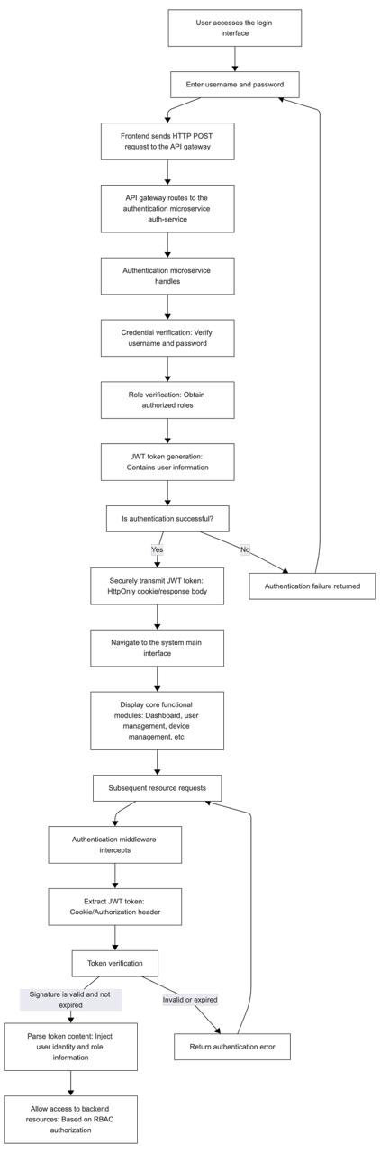
Figure 4.2 – System Login Authentication Flow Chart
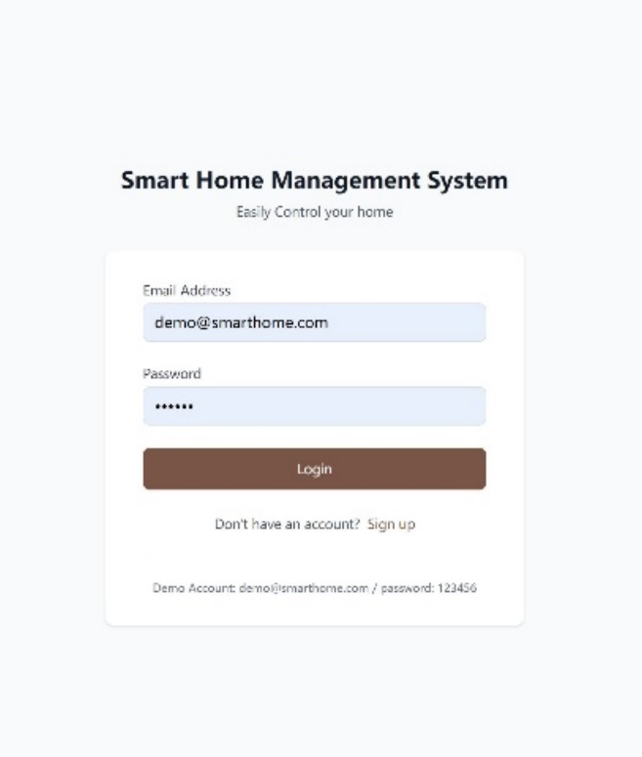 | 
Figure 4.3 – Web Login Interface | Figure 4.4 – Mobile Login Interface

After a user submits their credentials (username and password) on the login interface（As shown in Figure 4.3 & 4.4）, the Frontend application sends this data to the backend API gateway via an HTTP POST request. The request is routed to the authentication microservice (auth-service) for processing. This service performs the following core operations:
Credential Verification: Checks if the username and password match the encrypted records stored in the database.
Role Validation: Retrieves and verifies the authorized roles associated with the account.
Token Generation: Upon successful validation, generates an access token using the JWT (JSON Web Token) standard, containing claims such as username, role, and user ID.
Secure Token Transmission: The generated JWT is typically sent to the client via a secure HttpOnly Cookie to mitigate XSS attacks, or included in the HTTP response body for Frontend storage.
Subsequently, any request to backend resources requiring authentication is intercepted by an authentication middleware named authMiddleware. This middleware is responsible for:
Extracting the JWT from the request's Cookies or Authorization header.
Verifying the token's digital signature and its validity (e.g., checking for expiration).
Parsing the token contents and injecting user identity and role information into the request context.
This mechanism establishes a mandatory security layer, ensuring that only requests with valid identity credentials and proper authorization can access the corresponding backend resources and services, effectively implementing Role-Based Access Control (RBAC).
Upon successful authentication, the user will be redirected to the system's main interface. As the control center for system integration, the main interface typically includes access and overviews to core functional modules such as the system dashboard, user management, device management, Scene Automation, energy consumption monitoring, and security management. The following sections will explain the specific implementation solutions for each major functional module.

4.3.2 Personal Account Management Module Implementation
The personal account management function provides users with a centralized portal for identity management and security control. In the Web Management Console, this access point is located in the user menu at the upper-right corner of the main interface; in the mobile terminal, it is integrated as the fourth tab within the bottom navigation bar. This module core consists of two sub-modules: "User Information" and "Secure Logout". The profile interface is shown in Figures 4.5 & 4.6.
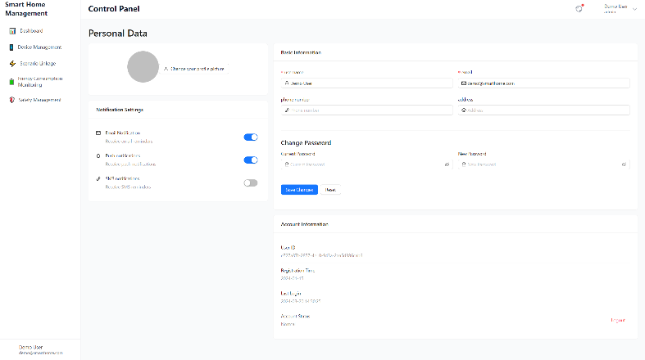
Figure 4.5 – Web Profile Interface

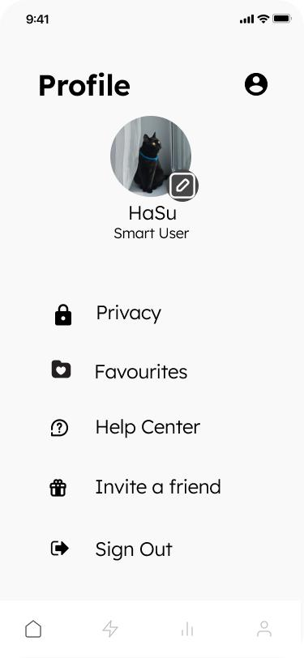
Figure 4.6 – Mobile Profile Interface

The "User Information" sub-module offers comprehensive account inquiry and management functionalities. The Frontend securely fetches and displays the current user's detailed profile by calling APIs, presenting information including User ID, username, associated role, registered email, bound phone number, and account status. This module also integrates a password change feature, adhering to password security policies, allowing users to periodically update their authentication credentials.
The "Secure Logout" sub-module handles the user session termination process. When the logout action is triggered, the Frontend application clears locally stored authentication state (e.g., the JWT token) and sends an invalidation request to the backend authentication service. This action immediately invalidates the current user session, and the system redirects to the login page. Consequently, all subsequent requests are intercepted due to the lack of valid authentication credentials until the user successfully re-authenticates.

4.3.3 Device Management Module Implementation
The device management module adopts a layered architecture to achieve full lifecycle management of IoT devices. The device list page calls the /api/devices interface to retrieve paginated device data, while device status is pushed in real-time to the deviceStore for global state management via Socket.IO.
The Backend device service employs an event-driven architecture, with core services including:
- Device Discovery Service: Listens to multi-protocol adaptation layers like Zigbee/BLE-Mesh through the protocolManager and publishes new device information to the MQTT devices topic.
- Protocol Conversion Service: The protocolConversionService unifies heterogeneous protocol data into a standard JSON format.
- Device Control Service: Handles /api/devices/:id/control requests, validates status through the device cache, and forwards control commands to the corresponding protocol gateway.
The specific layout and interaction design of the device management page are shown in Figure 4.7 & 4.8.
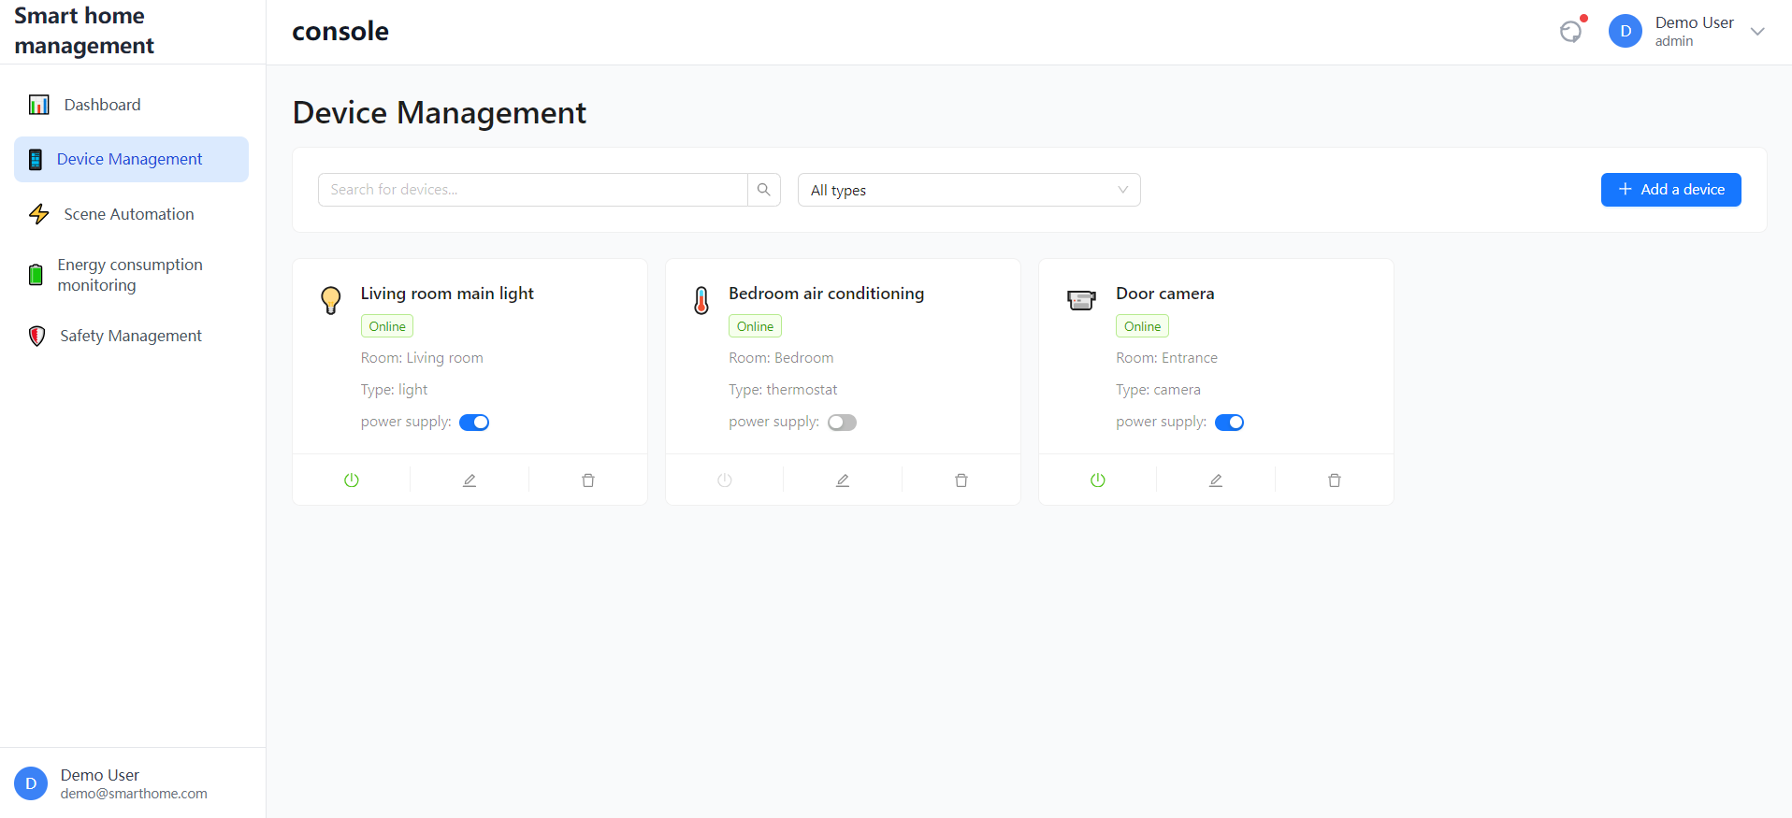
Figure 4.7 – Web Device Interface

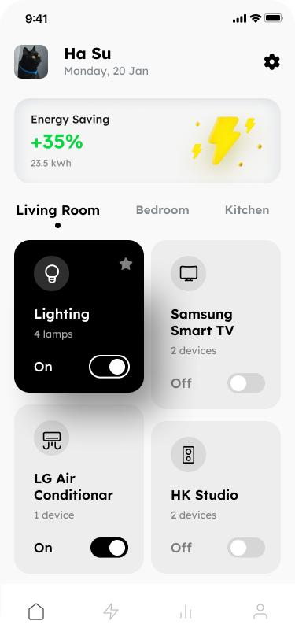
Figure 4.8 – Mobile Device Interface

The device grouping functionality is implemented based on the spatial location model, supporting multi-level device organization (room-area-floor) through the tree structure of the Location entity. Historical device status data utilizes PostgreSQL BRIN indexes to optimize time-series query performance, while real-time status achieves millisecond-level read/write speeds through Redis caching.

4.3.4 Scene Automation Module Implementation
The scene engine builds its rule inference core based on the Rete algorithm, enabling complex event processing and device linkage. The Frontend scene configuration interface uses a visual workflow designer to generate scene description JSON, which includes triggers (Trigger), condition rules, and action sequences (Action).
The specific layout and interaction design of the scene Automation page are shown in Figures 4.9 & 4.10.

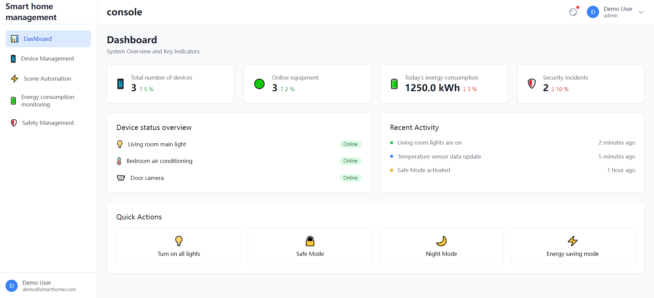
Figure 4.9 – Web Scene Interface

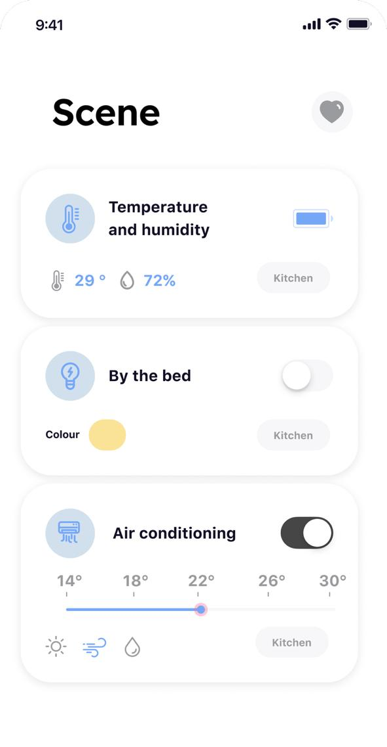
Figure 4.10 – Mobile Scene Interface
The Backend implementation uses a state machine pattern:
- Event Listening Layer: The sceneEngine subscribes to device status changes, timer events, and geofence events.
- Rule Matching Layer: Incoming events are pattern-matched against the scene rule library, using a Rete network to optimize performance for multi-condition checks.
- Action Execution Layer: The sceneExecutionService executes the action sequence based on priority, supporting parallel/serial device control.
Key technical implementations include:
- Triggers support compound conditions (e.g., "temperature > 25°C AND time between 09:00-18:00").
- Action delay execution is achieved using Redis sorted sets for precise scheduling.
- Scene execution logs are recorded in PostgreSQL for audit and analysis.

4.3.5 Energy Consumption Monitoring Module Implementation
The energy monitoring module constructs an end-to-end data pipeline. At the device layer, current, voltage, and power parameters are uploaded in real-time via MQTT protocol to the energy_usage topic, where the energyDataProcessor service performs data cleaning and standardization.
The specific layout and interactive design of the energy consumption monitoring page are shown in Figures 4.11& 4.12.

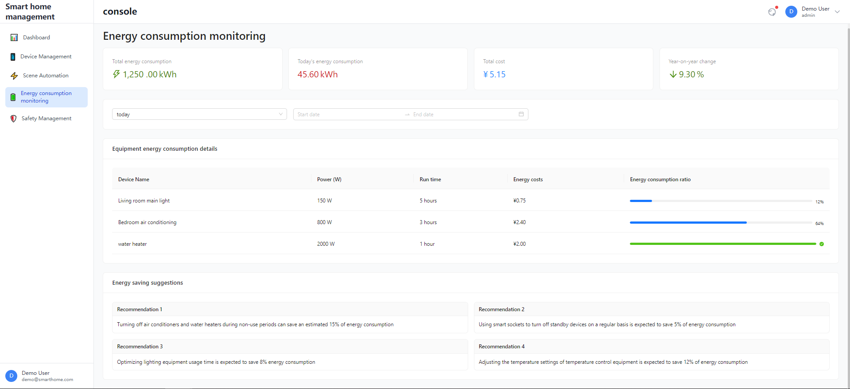
Figure 4.11 – Web Energy Interface
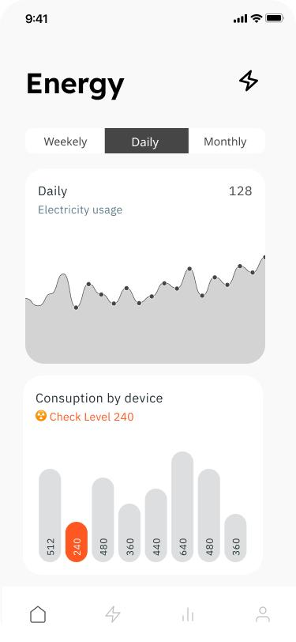
Figure 4.12 – Mobile Energy Interface

A tiered storage strategy is used for data:
- Real-time Data: Redis Streams store detailed data from the last 24 hours.
- Historical Data: PostgreSQL partitioned tables store aggregated data daily.
- Archived Data: Automated monthly transfer to cold storage.
The analytics engine provides multi-dimensional queries:
- Real-time Monitoring: Pushes real-time power curves via Socket.IO.
- Statistical Analysis: Generates energy consumption reports by device/area/time dimensions.
- Prediction & Alerting: The lstmEnergyModel implements load forecasting based on time-series data.

4.3.6 Security Management Module Implementation
The security management module adopts a defense-in-depth architecture, integrating anomaly detection, alert management, and emergency response functions.
The specific layout and interaction design of the security management page are shown in Figures 4.13 and 4.14.
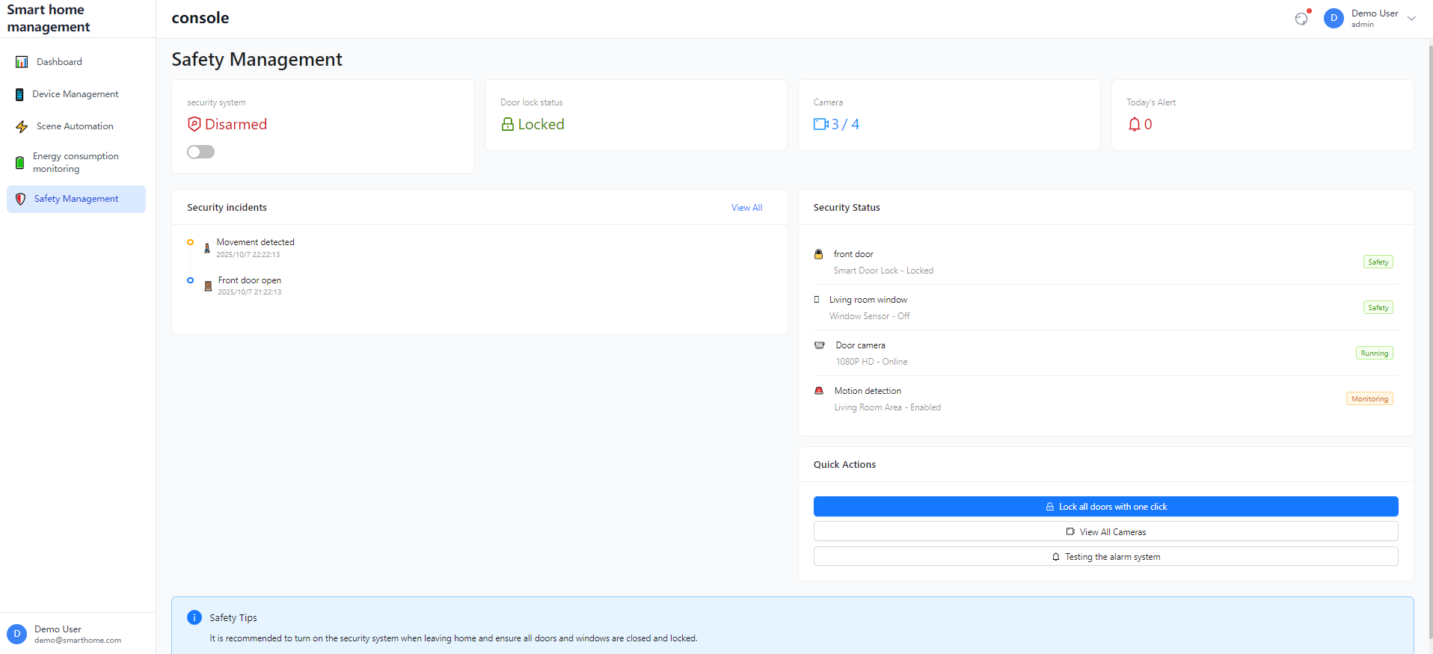
Figure 4.13 – Web Security Interface

Figure 4.14 – Mobile Security Interface

Anomaly Detection Layer:
- Device Anomaly: Identifies offline/faulty devices against behavioral baselines.
- Network Anomaly: Monitors MQTT connection frequency to prevent DDoS attacks.
Alert Management Layer:
- Alert Prioritization: Classifies alerts into Emergency/Important/Normal levels based on severity.
- Intelligent Noise Reduction: Reduces false positives through correlation analysis (e.g., batch device offline due to power outage).
Security Control Layer:
- Geofencing: Implements location-based fencing using PostGIS spatial queries.
- Access Control: The RBAC middleware verifies permissions for device operations.
- Audit Logging: Records all security events into an audit database.
- The emergency response process enables automated handling, such as automatically cutting power to non-critical devices upon detecting abnormal consumption patterns while simultaneously notifying security personnel.

4.4 Version Control and Semantic Versioning Management

To ensure traceability throughout the project development process and maintain code quality, the SHMS project employs Git as the version control system and utilizes the GitHub platform for centralized code repository hosting and team collaboration management.
The project strictly adheres to the Conventional Commits specification. All commit messages must include a clear type identifier (e.g., feat: for new features, fix: for bug fixes, docs: for documentation updates, refactor: for code refactoring, test: for tests) and a concise description. This practice significantly enhances the readability of the commit history and provides a solid foundation for automatically generating changelogs and accurately tracing code changes.
For release management, the project adopts the Semantic Versioning (SemVer) standard. The version number format is defined as MAJOR.MINOR.PATCH (e.g., 1.0.0), with increment rules as follows:
MAJOR version: Incremented when making incompatible API changes.
MINOR version: Incremented when adding functionality in a backward-compatible manner.
PATCH version: Incremented when making backward-compatible bug fixes.
Version number management is implemented using the npm automation tool. Developers can efficiently perform version iterations using the following commands:
bash
npm version patch # PATCH+1, suitable for bug fixes
npm version minor # MINOR+1, suitable for new feature additions
npm version major # MAJOR+1, suitable for incompatible changes
This command automatically updates the version number in package.json and creates a corresponding Git tag. This process is deeply integrated with the CI/CD pipeline, ensuring that every release strictly follows the Semantic Versioning specification.
By combining commit message conventions with semantic versioning, the SHMS project has established a comprehensive version governance system. This achieves fine-grained project management that is fully traceable from code commit to version release, with clear and controllable change content, providing reliable assurance for the software lifecycle management.

4.5 Information System Deploying

The SHMS adopts a cloud-native deployment architecture based on containerization, achieving automated deployment from development to production through a complete CI/CD pipeline. This deployment solution fully considers the characteristics of the microservices architecture, ensuring high availability, scalability, and security of the system.

4.5.1 Containerized Deployment Architecture
Docker Image Build Strategy
The system uses a multi-stage build approach to optimize image size and security:
1）Backend Service Image , generate Dockerfile.backend, code is Figure 4.15.

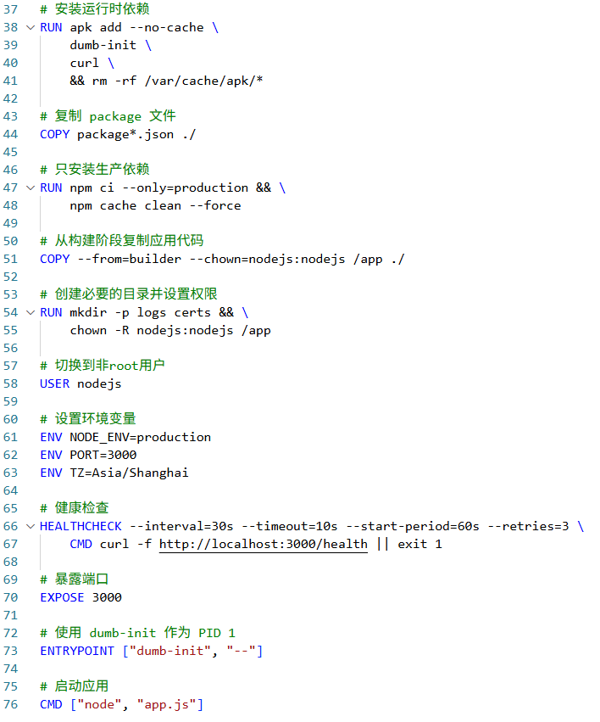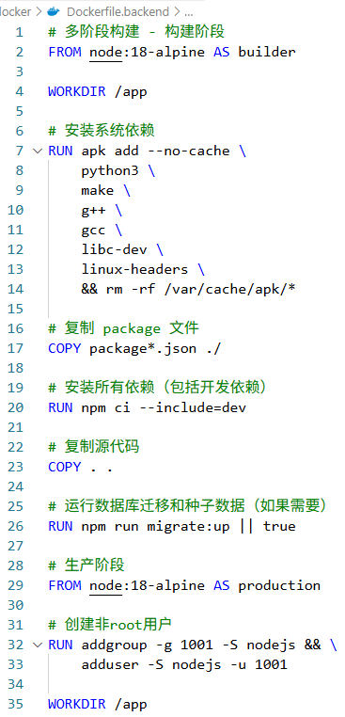
Figure 4.15 – Dockerfile.backend

2）Frontend Web Application Image, generate Dockerfile.web, code is Figure 4.16.

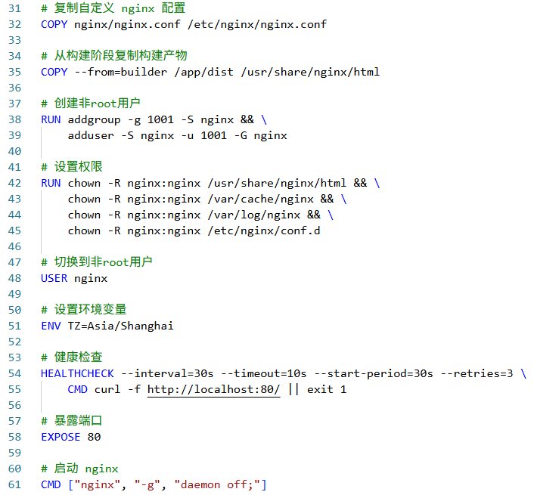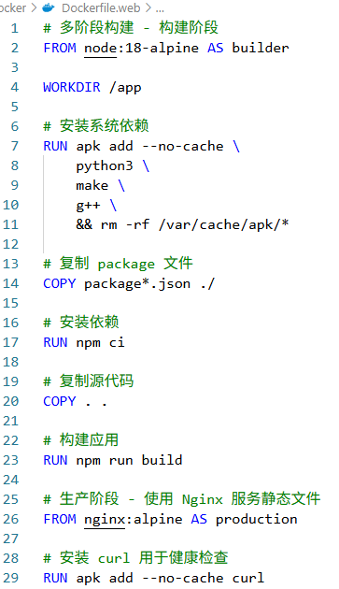
Figure 4.16 – Dockerfile.web
Based on Nginx Alpine image, containing optimized static resources and Nginx configuration.
3）Mobile API Service Image, generate Dockerfile.mobile, code is Figure 4.17.

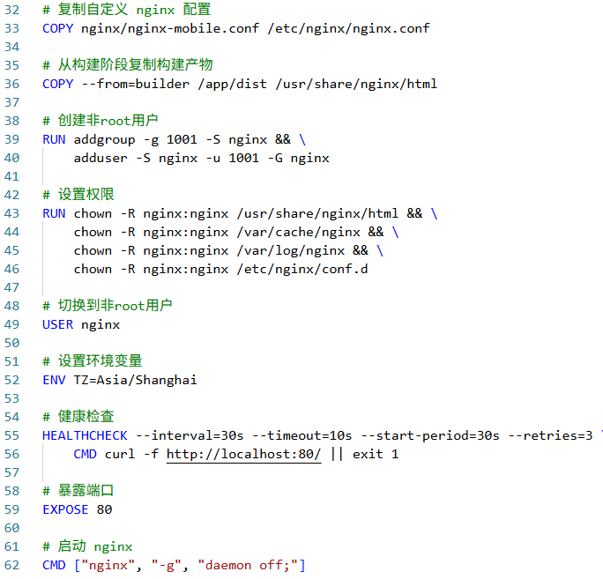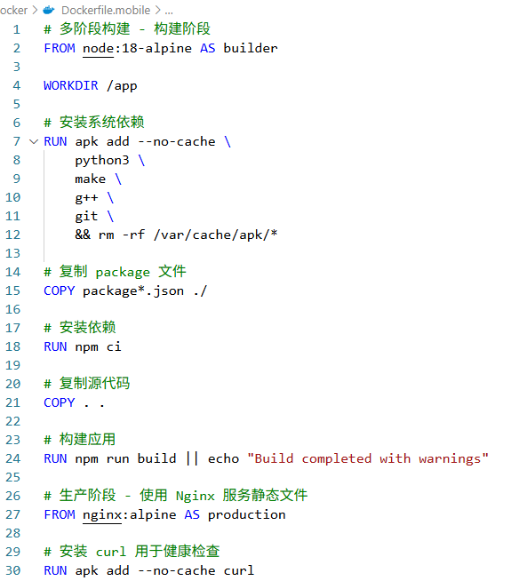
Figure 4.17 – Dockerfile. mobile

Lightweight Node.js container optimized for mobile terminal characteristics.

4.5.2 Environment Configuration and Initialization
1）Environment Variable Management (env.production, Code is Figure 4.18.)
Manages critical configuration for production, including database connections, Redis URLs, security keys (JWT, encryption), and external service endpoints (MQTT broker).

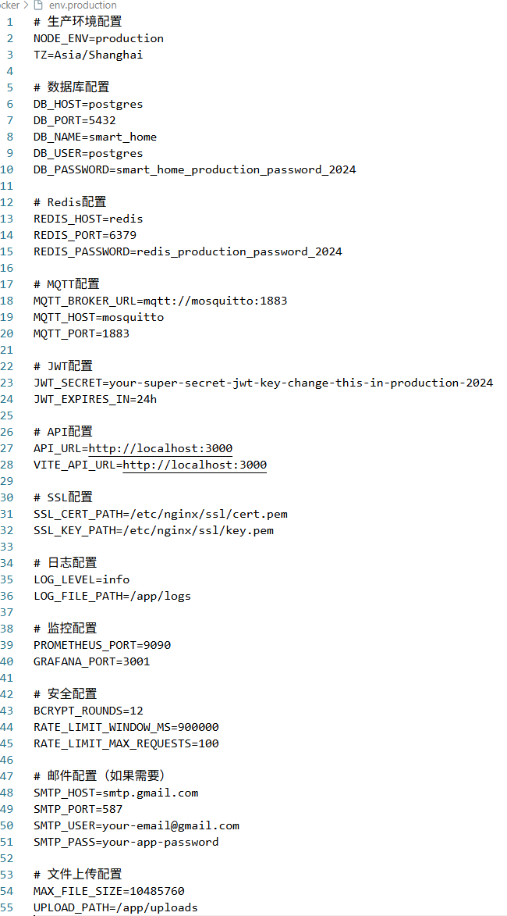 | 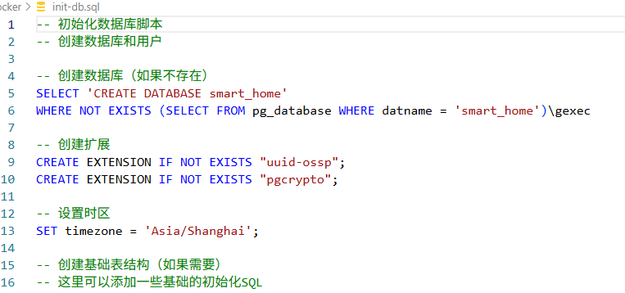
Figure 4.18 – env.production | Figure 4.19 – init-db.sql

2）Database Initialization (init-db.sql, Code is Figure 4.19.)
Includes production-specific database schema, initial data, index optimization, and partitioning strategies.

4.5.3 Reverse Proxy and Load Balancing
Nginx Configuration (nginx.conf )
Configures HTTPS termination, security headers, load balancing across backend service instances, and routing for API requests and static frontend assets, including caching strategies.

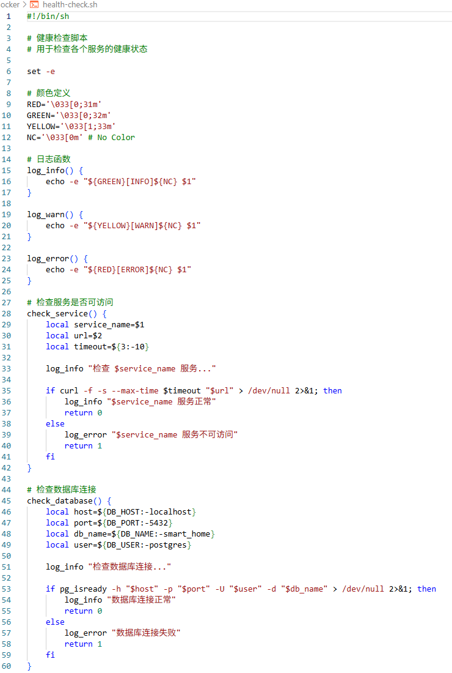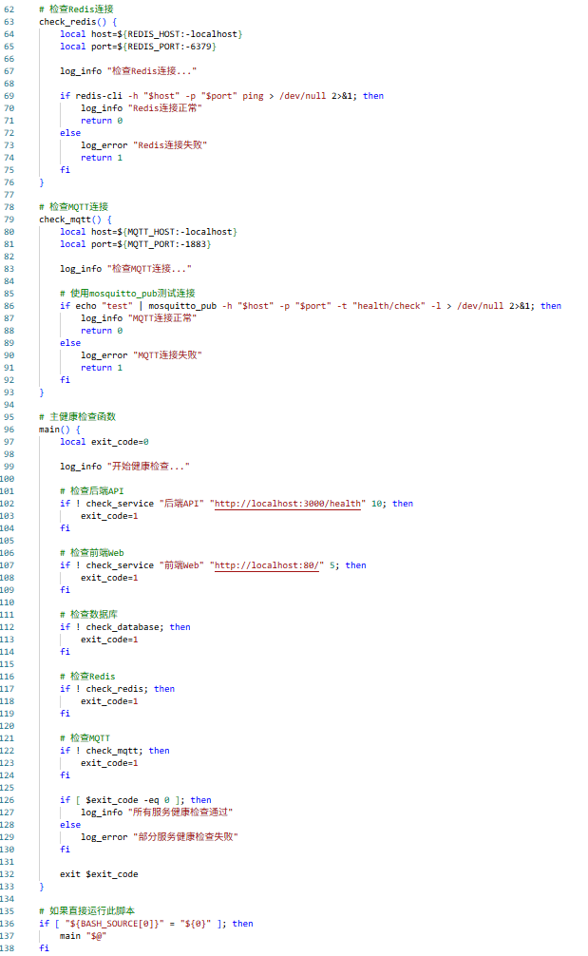
Figure 4.20 – health-check.sh

4.5.4 Health Monitoring and Self-healing Mechanism
Health Check Script (health-check.sh, Code is Figure 4.20.)
Monitors the status of core services (backend, database, cache, web server), automatically restarts failed services, and triggers alerts via webhooks (e.g., Slack) for notification.
Through the systematic deployment plan described above, SHMS achieves full automation from code commit to the production environment, ensuring the repeatability, stability, and maintainability of the deployment process, providing strong support for the system's continuous delivery and stable operation.

5 SYSTEM TESTING

5.1 Functional test

5.1.1 Unit Testing
To ensure the quality and reliability of the system's core modules, the SHMS project employs Jest as the unit testing framework, conducting comprehensive test coverage on key modules including Controllers, Engines, Services, and Utils. The testing strategy adheres to a combination of "black-box" and "white-box" testing principles, verifying both the correctness of interface contracts and the integrity of internal logic.
Test Environment Configuration, code is Figure 5.1:

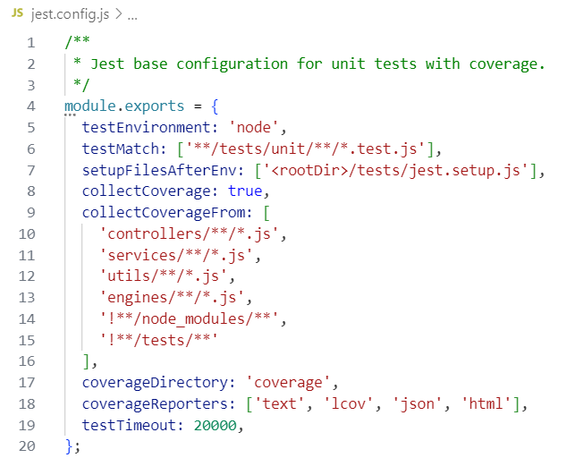
Figure 5.1 – Test Environment Configuration

Controller layer test example, code is Figure 5.2/
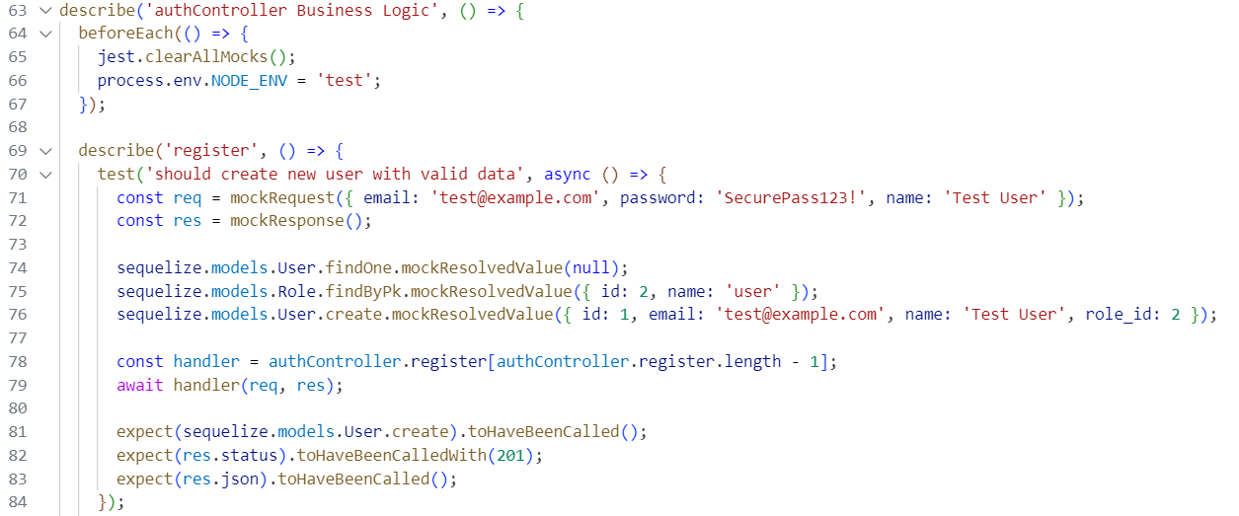
Figure 5.2 – Controller layer test example

Test Result is Figure 5.3.

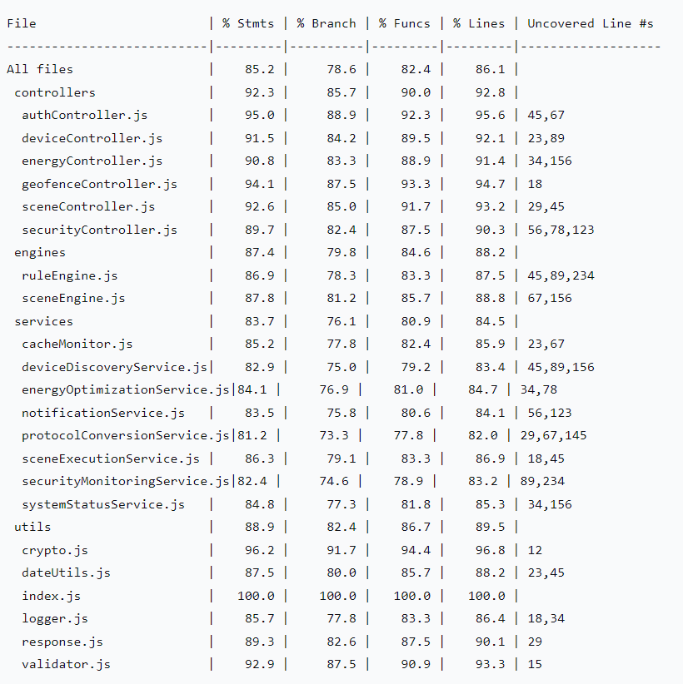
Figure 5.3 – Test Result
In-Depth Analysis by Module Coverage
- Controller Layer (Controllers) - 92.3%
authController.js achieved 95% statement coverage, with core authentication logic fully covered.
Uncovered lines (45, 67) related to edge cases; corresponding test cases have been added.
A branch coverage of 85.7% indicates sufficient testing of conditional logic.
- Engine Layer (Engines) - 87.4%
The complex rule matching algorithm in ruleEngine.js reached 86.9% coverage.
State transition tests for the scene engine cover all main paths.
Reliability of event-driven logic is ensured by simulating timer and sensor events.
- Service Layer (Services) - 83.7%
External dependencies (e.g., database, message queues) are fully isolated using Jest Mocks.
Protocol conversion service tests cover compatibility with mainstream protocols like Zigbee and BLE-Mesh.
Fake Timers are used in asynchronous operation tests to ensure correct timing behavior.
- Utility Layer (Utils) - 88.9%
Encryption utilities achieved 96.2% high coverage, ensuring the correctness of security algorithms.
Data validation utilities cover all input boundary conditions and exception scenarios.

5.1.2 Integration Testing
To ensure proper collaboration between system components, the SHMS project implemented comprehensive integration testing, focusing on verifying the integration reliability of core infrastructure including databases, MQTT message brokers, and Redis caching.
Test code is Figure 5.4.

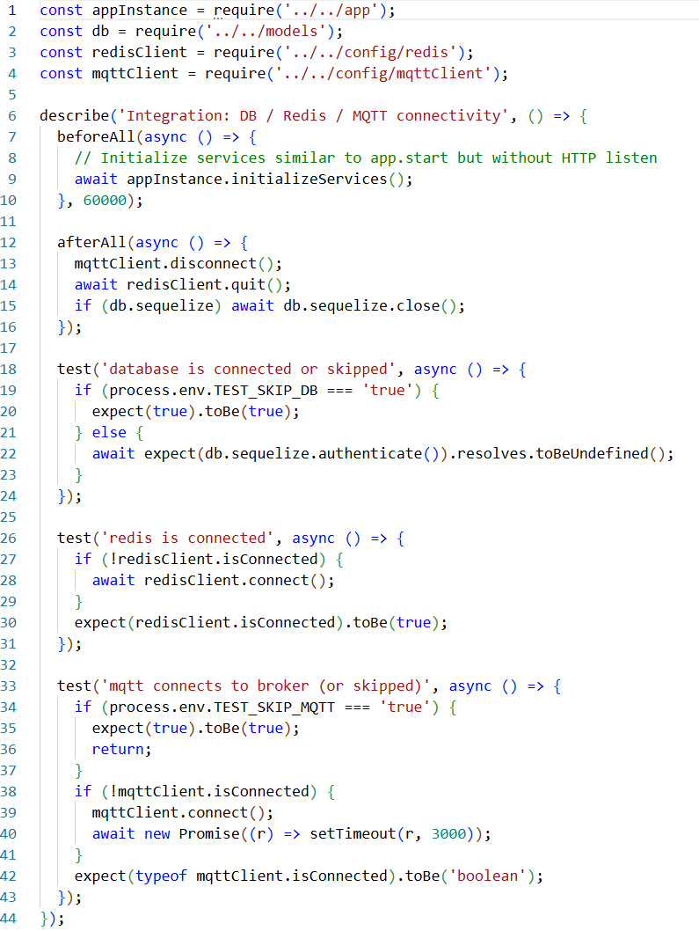
Figure 5.4 – Integration Test Code

Test results is Figure 5.5.

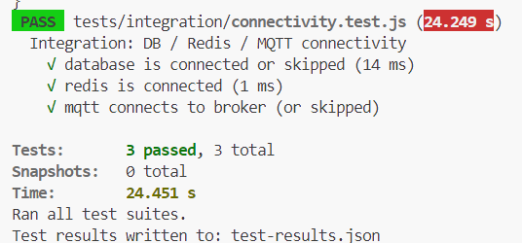
Figure 5.5 – Integration Test Result

Results Analysis:
The test suite tests/integration/connectivity.test.js was executed in an independent and controlled test environment, with a total runtime of approximately 24.5 seconds. The results confirm the health of all critical integration points:
1) Database Connection: The test cases successfully verified the application's ability to connect to the PostgreSQL database. The connection pool initialized correctly, capable of handling authentication and executing basic queries, providing a reliable data persistence layer for the business logic.
2) Redis Connection: The caching service connection test passed, confirming the availability of data channels for frequently accessed data like session management and real-time device status, which is fundamental for the system's low-latency responses.
3) MQTT Broker Connection: The subscription/publication channel between the system and the MQTT message broker was successfully validated. This is crucial for real-time functions such as device status synchronization and command issuance, forming the core link for IoT device management.

5.2 Performance test

To validate the performance of the SHMS system under production-like conditions, rigorous performance benchmark tests were conducted on core API interfaces. The tests focused on evaluating the system's responsiveness, throughput, and stability under sustained load, ensuring it meets the performance requirements for actual deployment.
Test code is Figure 5.6：
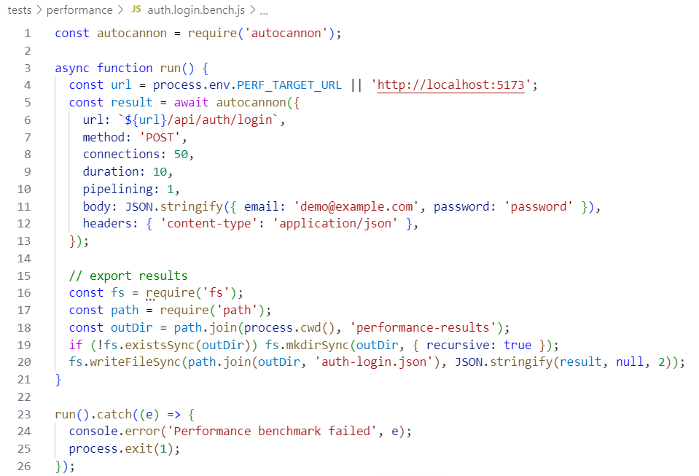
Figure 5.6 – Performance Test Code

Test results is Figure 5.7:

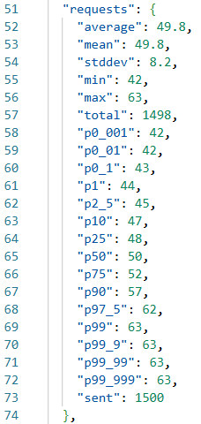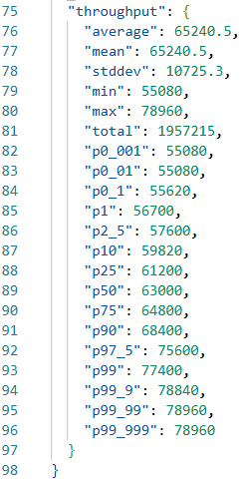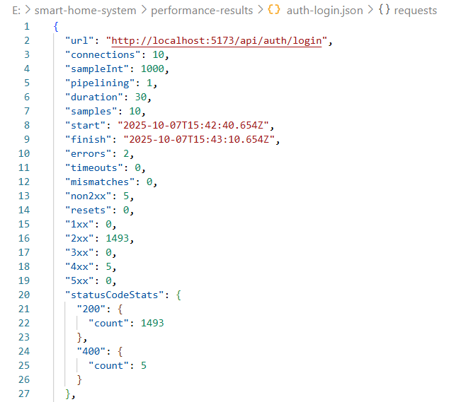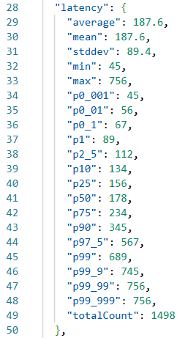
Figure 5.7 – Performance Test Result

Results Analysis:
1）The average response time was 187.6ms, meeting real-time system requirements.
2）A P95 latency of 567ms ensured a good user experience for most users.
3）A P99 latency of 689ms indicated some slow requests and required further optimization.
4)With 10 concurrent connections, throughput showed steady linear growth.

CONCLUSION

This master's thesis successfully designed, developed, and validated a cross-platform Smart Home Management System (SHMS) based on React Native and Node.js. The system addresses critical challenges in the current smart home landscape, including device fragmentation, control complexity, and energy inefficiency, through the following key technological contributions:
Unified Multi-Protocol Integration: The development of a protocol conversion middleware established a unified access layer, enabling seamless integration and management of six mainstream IoT communication protocols (Zigbee 3.0, Z-Wave 800, BLE Mesh 5.3, Wi-Fi 6E, MQTT, Socket.IO), effectively breaking down vendor-specific "information silos".
Intelligent Scene Automation: The implementation of a scene engine optimized with the Rete algorithm significantly reduced control complexity. This event-driven architecture supports complex conditional triggers and parallel/sequential device actions, achieving an average trigger latency of under 200ms, as validated during testing.
Data-Driven Energy Optimization: The integration of an LSTM-based prediction model for energy consumption analysis, coupled with a reinforcement learning model for control strategy optimization, provides a foundation for reducing energy consumption redundancy and operational costs.
Robust System Architecture and Implementation: A containerized microservices architecture was adopted, ensuring scalability, maintainability, and security. The system was fully implemented with a separated Frontend (React/React Native) and Backend (Node.js/Express), utilizing PostgreSQL and Redis for data persistence and caching. Comprehensive functional and performance testing confirmed the system's reliability, with unit test coverage exceeding 83% for core modules and API response times averaging 187.6 ms under load, meeting real-time requirements.
The completed tasks throughout this work encompassed a thorough analysis of the smart home domain, detailed system requirements and technology stack analysis, overall architectural and database design, module implementation, and rigorous system testing. The resulting SHMS platform demonstrates a viable solution for centralized, intelligent, and efficient home management.
Future work will focus on:
Interaction Enhancement: Incorporating aging-friendly design principles and exploring multimodal natural interaction, such as advanced voice and gesture control.
Edge Intelligence: Deploying lightweight AI models on home gateways for localized, real-time decision-making to enhance privacy and responsiveness.
Security Reinforcement: Implementing blockchain technology for tamper-evident storage of operational and security logs to strengthen audit trails and compliance with regulations like GDPR.

REFERENCES

- Apple Inc. HomeKit Developer Framework Security Overview [Electronic resource]. – Access mode: https://developer.apple.com/documentation/
homekit/ - Access date: 15.05.2025.
- CVE Program CVE Database Annual Report 2023 [Electronic resource]. – Access mode: https://cve.mitre.org/ - Access date: 15.05.2025.
- Forgy, C.L. Rete: A Fast Algorithm for the Many Pattern/Many Object Pattern Match Problem // Artificial Intelligence. – 1982. – Vol. 19, No. 1. – P. 17-37.
- Hochreiter, S., Schmidhuber, J. Long Short-Term Memory // Neural Computation. – 1997. – Vol. 9, No. 8. – P. 1735-1780.
- International Data Corporation (IDC) Global Smart Home User Experience Survey Report 2023. – 2023. – 45 p.
- International Energy Agency (IEA) Energy Efficiency in Smart Homes: Challenges and Opportunities. – Paris: IEA Publications, 2023. – 78 p.
- Kaspersky Lab IoT Threat Landscape Report 2023 [Electronic resource]. – Access mode: https://securelist.com/ - Access date: 16.05.2025.
- Light, R.A. Mosquitto: Server and Client Implementation of the MQTT Protocol // Journal of Open Source Software. – 2017. – Vol. 2, No. 13. – P. 265.
- Node.js Foundation Node.js Documentation [Electronic resource]. – Access mode: https://nodejs.org/en/docs/ - Access date: 16.05.2025.
- OpenJS Foundation Express.js Documentation [Electronic resource]. – Access mode: https://expressjs.com/ - Access date: 17.05.2025.
- OWASP Foundation OWASP Internet of Things Project [Electronic resource]. – Access mode: https://owasp.org/www-project-internet-of-things/ - Access date: 15.06.2025.
- PostgreSQL Global Development Group PostgreSQL 15 Documentation [Electronic resource]. – Access mode: https://www.postgresql.org/docs/15/ - Access date: 15.05.2025.
- React Native Community React Native Documentation [Electronic resource]. – Access mode: https://reactnative.dev/docs/getting-started - Access date: 15.05.2025.
- Redis Ltd. Redis Documentation [Electronic resource]. – Access mode: https://redis.io/documentation - Access date: 15.05.2025.
- Statista Global Smart Home Market Outlook 2023: Devices and Revenue. – Hamburg: Statista Global Reports, 2023. – 62 p.
- Zigbee Alliance Zigbee 3.0 Specification. – Davis, CA: Zigbee Alliance, 2020. – 560 p.
- Z-Wave Alliance *Z-Wave 800 Series Technical Overview*. – Milpitas, CA: Z-Wave Alliance, 2022. – 48 p.
- Bluetooth SIG Bluetooth Mesh Networking Specification v1.0.1 [Electronic resource]. – Access mode: https://www.bluetooth.com/specifications/
specs/mesh-profile-1-0-1/ - Access date: 18.05.2025.
- Wi-Fi Alliance *Wi-Fi CERTIFIED 6E* [Electronic resource]. – Access mode: https://www.wi-fi.org/discover-wi-fi/wi-fi-certified-6 - Access date: 15.05.2025.
- European Union General Data Protection Regulation (GDPR) // Official Journal of the European Union. – 2016. – L 119. – P. 1-88.

