Checkpoint 3 — BI Dashboard Development
BED 106 Business Analytics — Mini Capstone Project Semi-Final Period · Weeks 10–13 · 100 Points
Everything for Checkpoint 3 that can be prepared before Power BI is opened: the Task 3.1 blueprint, the data the dashboard reads, the Task 3.3 segmentation already computed and validated, the DAX for every measure, and a page-by-page build order.
What only the group can do is build the visuals, export the .pbix and the PDF, write the interpretations in your own words, and present. Those are marked at each step below.

Task 3.1 — Dashboard Design Blueprint
The brief asks for a wireframe showing the layout of each page, the title and purpose of each, the visual types planned, and at least two interactive elements. All four are on the blueprint below.
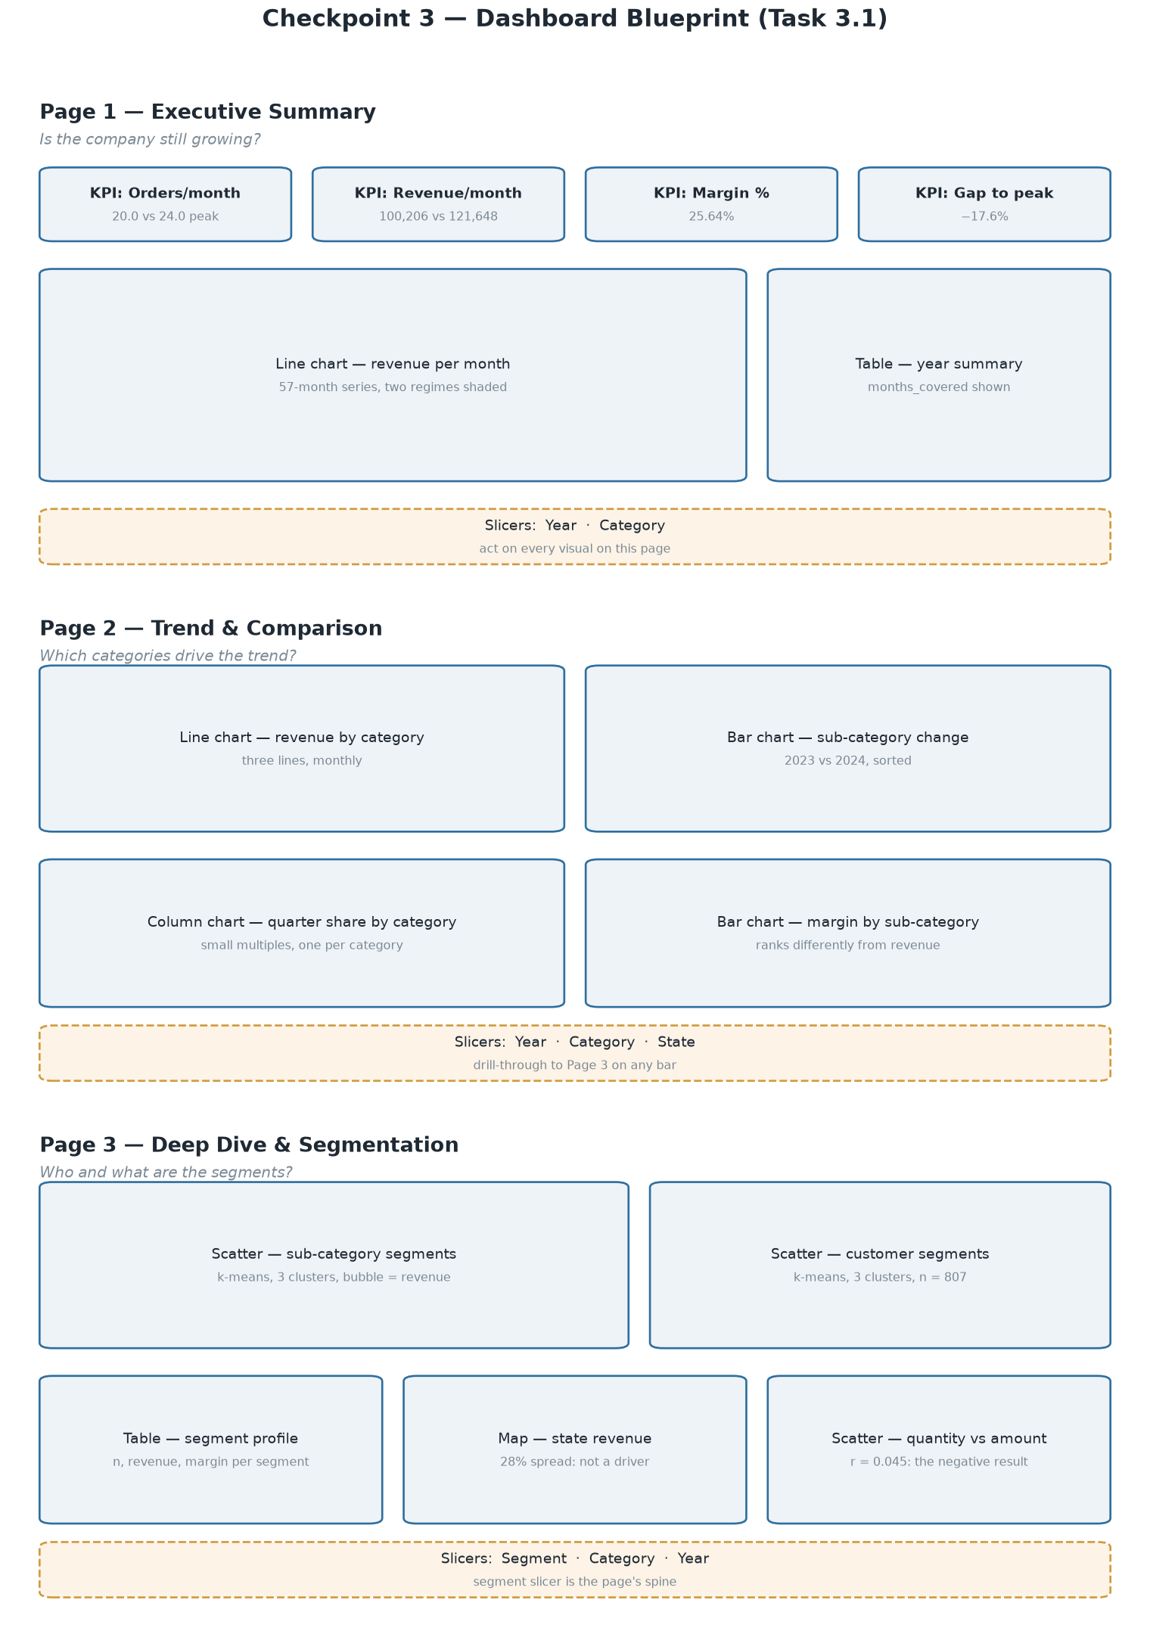
Figure 1. Dashboard blueprint. Three pages, their visuals, and the slicers acting on each.
Page | Title | Purpose — the question it answers
1 | Executive Summary | Is the company still growing, and by how much has it slipped?
2 | Trend & Comparison | Which categories and sub-categories drive the trend?
3 | Deep Dive & Segmentation | Who are the customers and what are the product segments?
Table 1. Task 3.1 — Dashboard Design Blueprint
Visual types planned
Page | Visual | Type | Shows
1 | Four KPI cards | Card | Orders/month, revenue/month, margin %, gap to peak
1 | Revenue per month | Line | The 57-month series with the two regimes
1 | Year summary | Table | Per-year figures with months_covered
2 | Revenue by category | Line | Three categories over time
2 | Sub-category change | Bar | 2023 against 2024, sorted
2 | Quarter share by category | Column, small multiples | Seasonality, split by category
2 | Margin by sub-category | Bar | Ranks differently from revenue
3 | Sub-category segments | Scatter, bubble | k-means clusters, Task 3.3
3 | Customer segments | Scatter | k-means clusters, Task 3.3
3 | Segment profile | Table | n, revenue and margin per segment
3 | State revenue | Map | The 28% spread — geography is not a driver
3 | Quantity against amount | Scatter | r = 0.045, the negative result
Table 2. Task 3.1 — Dashboard Design Blueprint
Interactive elements — the brief asks for at least two:
- Slicers on three dimensions — period (year and month), category and sub-category, and geography (state). Page 3 adds a segment slicer, which is that page's spine: selecting a segment refilters every visual on it
- Drill-through from Page 2 to Page 3 — right-clicking any sub-category bar opens Page 3 filtered to that sub-category
- Cross-filtering between visuals on the same page, left on by default

Task 3.2 — The data the dashboard reads
Five views in sql/06_dashboard_views.sql, exported to CSV in data/dashboard/ by scripts/build_dashboard_data.py. Connect Power BI to MySQL and use the views, or load the CSVs — they are the same rows.
View / file | Grain | Rows | Used by
v_sales_detail · sales_detail.csv | One transaction line, labelled | 1,194 | Page 3 scatter, anything ad hoc
v_monthly · monthly.csv | One complete calendar month | 59 | Page 1 line chart, KPI cards
v_category_month · category_month.csv | Month × sub-category | 562 | All of Page 2
v_geography · geography.csv | State × city | 18 | Page 3 map
v_annual · annual.csv | One year in the analysis window | 5 | Page 1 table
customer_segments.csv | One customer | 807 | Page 3, from build_segments.py
subcategory_segments.csv | One sub-category | 12 | Page 3, from build_segments.py
Table 3. Task 3.2 — The data the dashboard reads
Two things in the data layer are deliberate, and both are defensible.
v_monthly returns 59 rows, not 57. is_complete_month admits January and February 2025 — whole months that sit outside the window the Checkpoint 2 regression was fitted on, and which are the two holdout months the forecast was tested against. The in_analysis_window column marks the 57 months from April 2020 to December 2024. Default every trend visual to that filter, or the dashboard will disagree with the Checkpoint 2 report.
v_annual excludes 2025 outright, because two months of it would produce a revenue-per-month figure that looks comparable to a full year. That is the same class of mistake as the Checkpoint 1 correction, and the view is built so it cannot be made.
scripts/build_dashboard_data.py verifies ten published figures before writing anything and exits non-zero if any has drifted. Run it before every rebuild.

The measures, as DAX
Load monthly.csv as Monthly, category_month.csv as CategoryMonth, annual.csv as Annual, sales_detail.csv as Sales, and the two segment files as CustomerSegments and SubcategorySegments.
Revenue = SUM ( Sales[amount] )
Profit = SUM ( Sales[profit] )
Orders = COUNTROWS ( Sales )
Margin % = DIVIDE ( [Profit], [Revenue] ) * 100
Avg Line Value = DIVIDE ( [Revenue], [Orders] )
Months Covered = DISTINCTCOUNT ( Monthly[year_month] )
Revenue / Month = DIVIDE ( [Revenue], [Months Covered] )
Orders / Month = DIVIDE ( [Orders], [Months Covered] )
Peak Rev / Month =
CALCULATE ( [Revenue / Month], Annual[year_number] = 2022 )
Gap to Peak % =
DIVIDE ( [Revenue / Month] - [Peak Rev / Month], [Peak Rev / Month] ) * 100
-- The Checkpoint 2 regression slope, as a constant. Changing it means
-- refitting the model, not editing this line.
Gap Value / Year =
( [Peak Rev / Month] - [Revenue / Month] ) / 5224.25 * 5224.25 * 12
Always divide by Months Covered, never by 12. 2020 holds nine months.
Expected values, to check the KPI cards against — if a card disagrees with this table, the model is wrong, not the table:
Measure | 2024 | 2022 peak
Orders per month | 20.0 | 24.0
Revenue per month | 100,206.50 | 121,647.92
Margin % | 25.64 | 26.93
Average line value | 5,010.33 | 5,068.66
Gap to peak | −17.6% | —
Table 4. The measures, as DAX
ACTION for the group: build the three pages, title and label every visual, add a source note ("Source: sales_trend database, 1,194 transaction lines, March 2020 – March 2025"), export the .pbix and a PDF of all pages.

Task 3.3 — Clustering and segmentation
Two k-means segmentations, both reproducible from a fixed seed by scripts/build_segments.py. The brief allows Excel, Python or the built-in Power BI clustering; this uses Python.
How k was chosen. Silhouette score across k = 2 to 6, then selected within the 2–3 the brief asks for. The full scan is printed by the script rather than hidden:
k | Customers | Sub-categories
2 | 0.240 | 0.120
3 | 0.277 | 0.155
4 | 0.281 | 0.175
5 | 0.295 | 0.326
6 | 0.280 | 0.362
Table 5. Task 3.3 — Clustering and segmentation
Be ready to defend this. On customers, k=5 scores 0.295 against k=3's 0.277 — a difference too small to buy back the interpretability of five segments, two of which came out with the same profile. On twelve sub-categories, k=6 leaves two members per cluster, which is a partition rather than a segmentation.

Customer segments — 807 customers
Clustered on total revenue, margin and recency, each standardised.
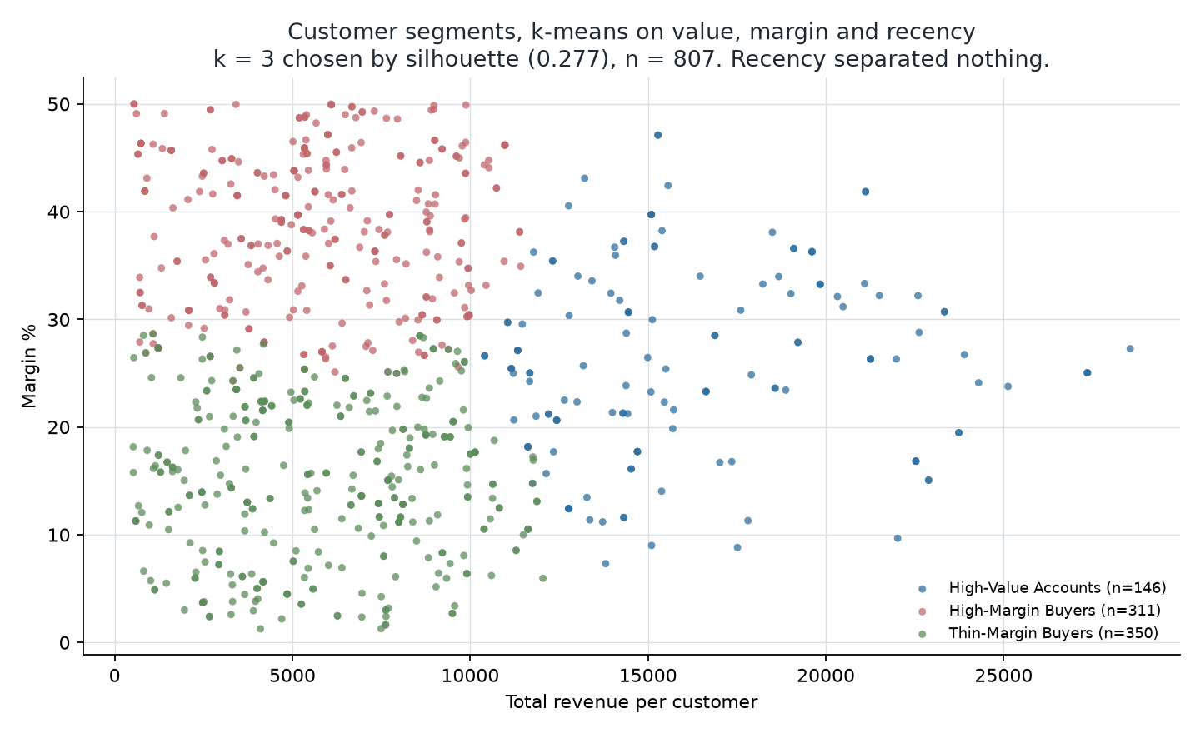
Figure 2. Customer segments. Value separates one cluster; margin separates the other two.
Segment | n | % of customers | % of revenue | % of profit | Margin
High-Value Accounts | 146 | 18.1% | 38.4% | 38.7% | 26.2%
High-Margin Buyers | 311 | 38.5% | 28.9% | 42.6% | 38.5%
Thin-Margin Buyers | 350 | 43.4% | 32.7% | 18.7% | 14.9%
Table 6. Customer segments — 807 customers
The business significance, and it is the finding of Checkpoint 3. Thin-Margin Buyers are the largest group — 43% of customers and a third of revenue — and they return 19% of the profit. High-Margin Buyers are a smaller group producing 43% of profit from less revenue. A sales effort aimed at revenue would chase the wrong group of the two. This is the customer-level form of the Checkpoint 2 finding that revenue is a poor proxy for profit, and it converts that statistic into a list of named accounts.
Two honest notes to carry into the defence. Recency separated nothing — every cluster centre sits within 0.11 standard deviations of the mean on it — so there are no "lapsed" or "active" segments to claim. And purchase frequency spans only 1 to 4 lines (510 customers bought once), too little spread to carry a segment boundary, which is why it was not clustered on. Both are consequences of the synthetic dataset documented in Checkpoint 1.

Sub-category segments — 12 sub-categories
Clustered on total revenue, 2023-to-2024 growth, and margin.
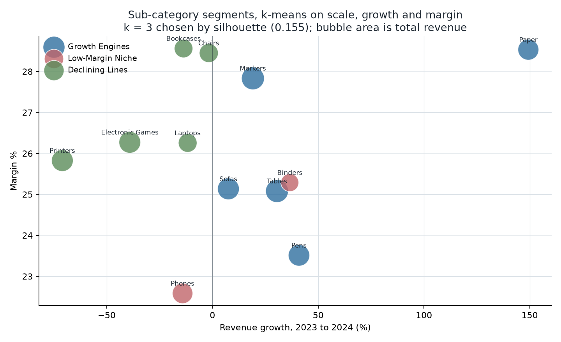
Figure 3. Sub-category segments. Growth separates the two ends; the middle cluster is defined by margin.
Segment | Members | 2023 → 2024
Growth Engines | Markers, Paper, Pens, Sofas, Tables | 452,521 → 634,777, +40.3%
Low-Margin Niche | Binders, Phones | 180,351 → 187,537, +4.0%
Declining Lines | Bookcases, Chairs, Electronic Games, Laptops, Printers | 596,851 → 380,164, −36.3%
Table 7. Sub-category segments — 12 sub-categories
The segmentation recovers Checkpoint 1's central finding without being told it: the two large clusters move in opposite directions, +40.3% against −36.3%, and the company-wide figure is their average. Printers sit at the far edge of Declining Lines at −71.0%.
The middle cluster is named for margin, not growth: Binders grew 36.6% and Phones fell 14.1%, so "stable" would be wrong. What its two members share is low margin and small scale.
ACTION for the group: put both scatter plots on Page 3, add the segment slicer, and write the business significance of each segment in your own words.

Task 3.4 — Presentation
Ten minutes, during Weeks 12–13. The brief requires all three pages walked through, at least one interactive feature demonstrated live, at least two questions answered, and every member speaking.
docs/dashboard_presentation_script.md is the script for this: ten minutes, all three speaking, every page walked, with the segment slicer demonstrated live and six prepared answers for the questions. The live demonstration should be the segment slicer on Page 3 — selecting Thin-Margin Buyers and showing the profit share collapse is the most persuasive thing on the dashboard.
Questions to expect: why order count rather than revenue as the headline KPI; why three clusters and not five; whether the segments would hold on real data. The answers to the first two are above; the answer to the third is no, and saying so is better than pretending otherwise.

Rubric map
Criterion | Points | Where
Dashboard Design & Usability | 30 | Blueprint above; ACTION: build it
Data Accuracy | 25 | Views verified against ten published figures; DAX and expected KPI values above
Insights & Storytelling | 25 | Page purposes above; ACTION: the narrative in your own words
Documentation | 20 | This document is the written report's spine; ACTION: wireframe printed, `.pbix` and PDF exported
Table 8. Rubric map

Submission checklist
- Printed report: blueprint wireframe plus the discussion of insights and segmentation
- Dashboard file: .pbix, submitted digitally
- Exported PDF of all three dashboard pages
- Updated signed Individual Contribution Form — reports/Form_A_Individual_Contribution.docx
- Live presentation, Week 12 or 13
- Deadline: beginning of Week 14

And the standing constraint
Section 3.2 still applies. The interpretation of every visual must be the group's own words. The segmentation numbers above are computed output and the DAX is tooling; what has to be yours is the reading of them.

