BA Capstone Project: Checkpoint 1

Data Fundamentals & SQL Querying
Group Name: _______________________ Course & Section: BED 108 — Business Analytics Date: _______________________
Team Members & Roles:
Member | Role
_______________________ | Project Lead / Analyst
_______________________ | Data Engineer
_______________________ | Statistician / Modeler
_______________________ | BI Developer / Visualizer

Project topic: Sales trend analysis for a multi-category US retailer, 2020–2025.

Task 1.1 — Business Problem Statement

Business Domain & Problem Investigation
Industry: Multi-category retail (consumer electronics, furniture and office supplies) operating across six US states — California, Florida, Illinois, New York, Ohio and Texas.
Core business problem. The company grew quickly out of 2020 and then stopped. Revenue rose 69.9% between 2020 and 2022, from 859,401 to 1,459,775, but has fallen in each of the two years since, ending 2024 at 1,202,478 — 17.6% below the 2022 peak. Overall margin has stayed flat in a narrow 23.97%–26.93% band throughout, so the problem is not that the company is selling at worse prices; it is that the volume and mix of what it sells have shifted in a way management has not yet diagnosed.
Because reporting to date has been a single company-wide revenue figure per year, nobody can say whether the plateau is a market-wide slowdown, a seasonal artefact, or a handful of specific product lines falling away. Those three explanations call for completely different responses, and the company currently cannot tell them apart.
What this project does. It rebuilds five years of transaction history into a queryable relational warehouse and decomposes the trend along three axes — time, product hierarchy, and geography — so that the plateau can be attributed to specific product lines and specific periods rather than described in aggregate.

Business Impact & Significance
- Revenue. The gap between the 2022 peak and 2024 actuals is 257,297 per year. Recovering even half of it is worth roughly 128,000 annually, which is material against a five-year total of 5.93 million.
- Inventory efficiency. Demand is heavily concentrated: October and December alone carry 21.7% of annual revenue, and Q4 as a whole carries 29.3%. Stocking to a flat monthly average guarantees both stockouts in the peak and dead capital in January, the weakest month at 4.72% of the year.
- Purchasing decisions. Category performance has diverged sharply. Knowing that Electronics fell 40.8% in 2024 while Office Supplies rose is the difference between an across-the-board purchasing cut and a targeted one.
- Reporting credibility. A documented, constraint-enforced schema replaces ad-hoc spreadsheet pivots, so every number in a management report can be traced back to a query and a source row.

Key Business Questions
- How have revenue and profit trended year over year from 2020 to 2024, and is the company still growing? (Answered by Q3, Figure 1.)
- Which product categories and sub-categories are driving the trend, and which ones reversed direction most recently? (Answered by Q5, Q7, Figure 3.)
- When during the year does demand concentrate, and is that seasonal pattern the same for every category? (Answered by Q4, Q8, Figure 2.)
Supporting questions: which cities return the most revenue per customer (Q6), and which bulk orders are being sold at the thinnest margins (Q2).

Data Source Overview
Historical point-of-sale transaction records — one row per product line on an order — obtained as a public CSV export in the Kaggle "Sales Dataset" format. The file covers 22 March 2020 to 15 March 2025 and carries order identifiers, dates, customer names, geography, a two-level product hierarchy, payment method, and the three measures: quantity, amount and profit.

Task 1.2 — Dataset Documentation

Data Source Report
Attribute | Details
Dataset Name | Sales Dataset (multi-category US retail transactions)
Source URL/File | archive.zip → Sales Dataset.csv, public Kaggle-format sales export. Stored in this repository as data/raw/sales_dataset_raw.csv
Date Accessed | 24 August 2026
License Type | Public/open dataset, used here for academic coursework only. _Confirm and record the exact licence shown on the source page before submission._
File Size | 1,194 data rows × 12 columns
Coverage | 22 March 2020 – 15 March 2025
Currency | Not stated in the source file. Amount and Profit are unitless integers; all figures in this report are quoted as currency units.

Data Dictionary
Column Name | Data Type | Description
Order ID | VARCHAR(20) | Order reference label, e.g. B-26776. Not unique — see quality notes.
Amount | INTEGER → DECIMAL(12,2) | Revenue for the transaction line. Range 508–9,992.
Profit | INTEGER → DECIMAL(12,2) | Gross profit for the line. Range 50–4,930.
Quantity | INTEGER | Units sold on the line. Range 1–20.
Category | VARCHAR(60) | Top product level: Electronics, Furniture, Office Supplies.
Sub-Category | VARCHAR(60) | Second product level, 12 values, e.g. Printers, Sofas, Paper.
PaymentMode | VARCHAR(40) | COD, Credit Card, Debit Card, EMI, UPI.
Order Date | DATE | Transaction date, ISO YYYY-MM-DD. 648 distinct dates.
CustomerName | VARCHAR(120) | Customer full name, 802 distinct values. Not a unique key.
State | VARCHAR(60) | One of 6 US states.
City | VARCHAR(60) | One of 18 cities, 3 per state.
Year-Month | CHAR(7) | YYYY-MM. Fully derivable from Order Date — dropped as redundant.

Preliminary Data Quality Assessment
Full evidence, regenerated from the raw file on every build, is in reports/data_quality_report.md.
Missing Values. None. All 12 columns are complete across all 1,194 rows, so no imputation or row-dropping was required.
Duplicates.
- Zero fully identical rows.
- 36 rows repeat the same (Order ID, Order Date, CustomerName, Sub-Category) combination. These were kept: one customer can legitimately buy two items from the same sub-category on one order, and the amounts differ between them.
- Order ID is not unique — 547 distinct values spread over 1,194 rows, and 194 of those values appear against more than one order date and a different customer name. It cannot function as a primary key.
Inconsistencies.
- Year-Month duplicates information already in Order Date (0 mismatches across 1,194 rows) — redundant storage and a future update anomaly.
- CustomerName is not a reliable identifier: 5 names appear in more than one city, so name alone cannot key a customer.
- The 2025 window is incomplete. Data stops on 15 March 2025, giving only 44 rows for that year. Read naively this looks like an 80% collapse in demand. It is a file cut-off, not a business event.
- Limitation worth stating. There are zero loss-making lines in five years, profit never exceeds amount, and the five payment methods are split almost evenly (206–260 lines each). Real retail data of this size would normally contain returns, discounts and loss-making orders. This dataset is very likely synthetic or pre-filtered, so the methodology here is sound but the specific figures should not be presented as a real company's results.
Cleaning Steps Applied.
- Trimmed whitespace and normalised casing on all text labels (State, City, Category, Sub-Category, CustomerName).
- Cast Amount, Profit, Quantity to numeric types and Order Date to a true DATE.
- Dropped the redundant Year-Month column; rebuilt year, quarter, month and month name in dim_date.
- Replaced Order ID as a key with the surrogate primary key sale_id, retaining the original value as the descriptive column order_ref.
- Keyed customers on (name, city) rather than name alone.
- Added dim_date.is_complete_year so every trend query can exclude the partial 2025 window explicitly.
- Split the flat file into six dimension tables and one fact table with enforced foreign keys; the build fails on any referential-integrity violation (PRAGMA foreign_key_check).
All steps are executable and repeatable: python3 scripts/clean_and_load.py.

Raw Dataset Preview — first 10 rows
Order ID | Amount | Profit | Qty | Category | Sub-Category | PaymentMode | Order Date | CustomerName | State | City | Year-Month
B-26776 | 9726 | 1275 | 5 | Electronics | Electronic Games | UPI | 2023-06-27 | David Padilla | Florida | Miami | 2023-06
B-26776 | 9726 | 1275 | 5 | Electronics | Electronic Games | UPI | 2024-12-27 | Connor Morgan | Illinois | Chicago | 2024-12
B-26776 | 9726 | 1275 | 5 | Electronics | Electronic Games | UPI | 2021-07-25 | Robert Stone | New York | Buffalo | 2021-07
B-26776 | 4975 | 1330 | 14 | Electronics | Printers | UPI | 2023-06-27 | David Padilla | Florida | Miami | 2023-06

_(Rows 1–3 above are exactly the evidence for the duplicate-key problem: one Order ID, three different dates, three different customers in three different states. Insert the full 10–20 row screenshot from your CSV viewer here.)_

Task 1.3 — Relational Database Design

Entity-Relationship Diagram (ERD)
The full diagram, in Mermaid source that renders directly on GitHub, is in docs/erd.md. Structure:
dim_state ──< dim_city ──< dim_customer ──┐
│
dim_category ──< dim_sub_category ────────┼──< fact_sales
│
dim_payment_mode ─────────────────────────┤
│
dim_date ─────────────────────────────────┘
Star schema, 7 tables. fact_sales sits at the centre at a grain of one transaction line, with six dimensions hanging off it.
Parent | Child | Cardinality
dim_state | dim_city | 1 : many
dim_city | dim_customer | 1 : many
dim_category | dim_sub_category | 1 : many
dim_customer | fact_sales | 1 : many
dim_sub_category | fact_sales | 1 : many
dim_payment_mode | fact_sales | 1 : many
dim_date | fact_sales | 1 : many

Why this design. Every key business question in Task 1.1 has the form "a measure, sliced by a dimension, over time" — which a star schema answers in one join hop. Geography and product are kept snowflaked (state → city → customer, category → sub_category) rather than flattened, so a city or category label lives in exactly one place and Task 1.4 has genuine multi-table joins to demonstrate.

Database Schema & Population
DDL: sql/01_schema_mysql.sql (MySQL 8, InnoDB, with PRIMARY KEY, FOREIGN KEY, UNIQUE and CHECK constraints plus four indexes on the columns the Task 1.4 queries filter and group by). Data: sql/03_insert_data.sql (generated, portable INSERT statements).
mysql -u root -p < sql/01_schema_mysql.sql
mysql -u root -p sales_trend < sql/03_insert_data.sql
mysql -u root -p sales_trend < sql/04_queries.sql
Populated row counts (verified after load):
Table | Rows
dim_state | 6
dim_city | 18
dim_category | 3
dim_sub_category | 12
dim_payment_mode | 5
dim_customer | 807
dim_date | 648
fact_sales | 1,194

fact_sales holds exactly the 1,194 rows of the raw file — no transaction was lost or invented in normalisation. dim_customer has 807 rows against 802 distinct names, the 5 extra rows being the names that appear in more than one city.
_(Insert your MySQL Workbench screenshots of SHOW TABLES; and SELECT COUNT(*) FROM fact_sales; here.)_

Task 1.4 — SQL Query Report
All eight queries are in sql/04_queries.sql; every result table below is machine-generated output from scripts/run_queries.py, reproduced in full in reports/query_results.md. Queries are written in portable SQL and run unchanged on MySQL 8 and SQLite 3.

1. Basic Data Retrieval

Q1 — Largest transaction lines of the most recent complete year
SELECT / WHERE / ORDER BY on fact_sales.
Business Interpretation. The 15 biggest lines of 2024 sit in a tight band from 9,380 to 9,914, against a dataset-wide maximum of 9,992 — so there is a hard ceiling near 10,000 rather than a long tail of outliers. This is a business of many mid-sized orders, not a few whales, which means no single lost account can explain the revenue decline.
Profit on those lines varies enormously, from 414 to 4,339 on near-identical revenue: sale 1008 returned 414 on 9,380 (4.4% margin) while sale 1092 returned 4,339 on 9,609 (45.2%). Order size alone is therefore a poor proxy for value, and any "top customer" report ranked on revenue would point management at exactly the wrong accounts.

Q2 — Bulk orders sold at thin margins
SELECT / WHERE / ORDER BY with a computed margin column.
Business Interpretation. These are lines of 15+ units returning under 15% margin — the company moving maximum stock for minimum return. The worst, sale 8, shipped 19 units for 7,702 in revenue and just 60 in profit, a 0.78% margin; all 15 lines shown return under 3.7%. They are the first candidates for a price-floor or volume-discount review, since a recovery of even two percentage points on high-quantity lines compounds quickly across the order book.
Note that these thin-margin bulk lines appear in every year from 2020 to 2024, not only the declining years, so they are a standing pricing issue rather than a cause of the trend break identified in Q3.

2. Aggregate Analysis

Q3 — Annual sales trend, 2020–2024
GROUP BY with COUNT, SUM and AVG.
year | lines | units | revenue | profit | avg_line_value | margin_pct
2020 | 171 | 1,695 | 859,401 | 224,103 | 5,025.74 | 26.08
2021 | 217 | 2,358 | 1,181,446 | 283,231 | 5,444.45 | 23.97
2022 | 288 | 3,234 | 1,459,775 | 393,113 | 5,068.66 | 26.93
2023 | 234 | 2,497 | 1,229,723 | 321,671 | 5,255.23 | 26.16
2024 | 240 | 2,523 | 1,202,478 | 308,336 | 5,010.32 | 25.64

Business Interpretation — answers Business Question 1. Growth stopped in 2022. Revenue climbed 69.9% over 2020–2022, then fell 15.8% in 2023 and a further 2.2% in 2024, finishing 17.6% below the peak. The decisive detail is that average line value barely moved across all five years (5,010–5,444, a 9% spread) while transaction count moved a lot (171 → 288 → 240). The company is not being forced into smaller or cheaper orders; it is simply writing fewer of them. That points the investigation at demand and product availability, not at pricing. Margin held between 23.97% and 26.93% throughout, confirming that profitability per sale was never the issue.
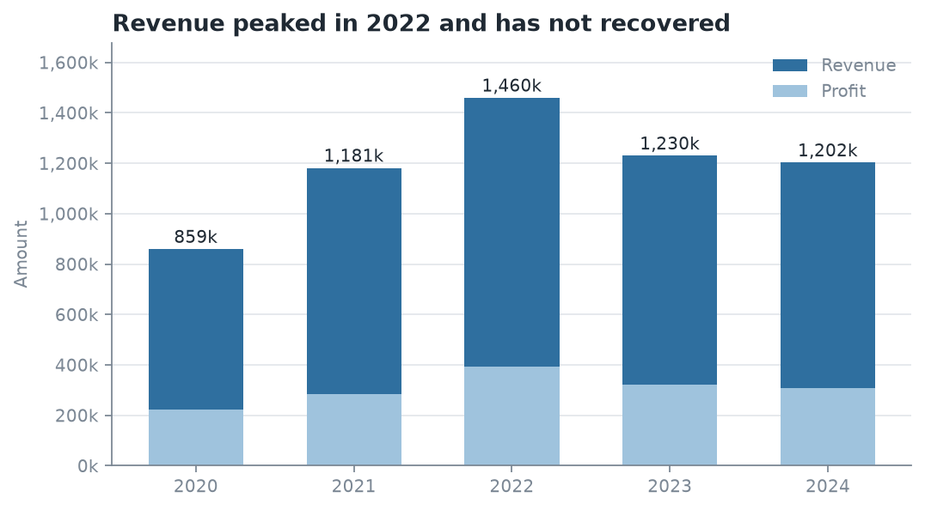
Figure 1 — annual revenue and profit

Q4 — Monthly seasonality, 2020–2024 pooled
GROUP BY month with a share-of-total subquery.
Business Interpretation — answers Business Question 3 (part 1). Demand is strongly seasonal and the peak is late. December (11.05% of annual revenue) and October (10.66%) are the two strongest months; Q4 as a whole carries 29.3% of the year against the 25% a flat distribution would give. January is the trough at 4.72% — barely 43% of a December. Notably the peak is driven by order count, not basket size: December records the most transaction lines of any month (133) on an average line value of 4,928 — below the 5,010–5,444 range of the annual averages in Q3. October is the same story, 120 lines at 5,271. The operational implication is that Q4 pressure is a throughput and fulfilment problem — more orders to pick, pack and ship — not a high-value-order problem, so the right response is staffing and warehouse capacity rather than premium stock.
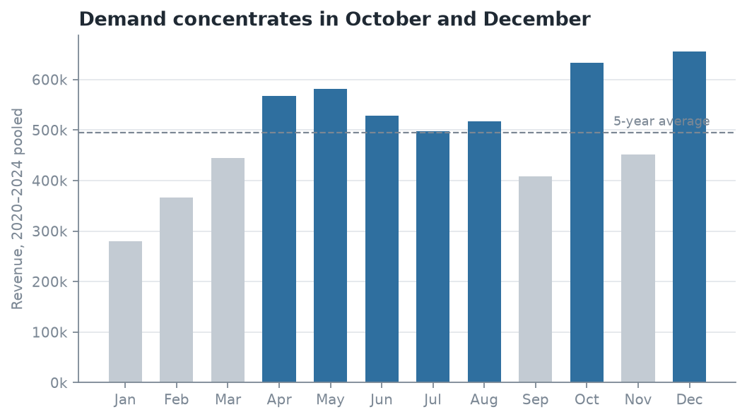
Figure 2 — monthly seasonality

3. Multi-Table Joins

Q5 — Revenue by category per year
Joins 4 tables: fact_sales → dim_date, dim_sub_category → dim_category.
category | 2020 | 2021 | 2022 | 2023 | 2024
Electronics | 233,178 | 387,757 | 478,451 | 538,319 | 318,630
Furniture | 299,708 | 391,342 | 496,353 | 385,893 | 415,878
Office Supplies | 326,515 | 402,347 | 484,971 | 305,511 | 467,970

Business Interpretation — answers Business Question 2 (part 1). The flat company-level total hides three different stories. Electronics kept growing a year longer than the others, peaking in 2023 at 538,319, then fell 40.8% to 318,630 in 2024 — the single largest movement anywhere in the dataset. Office Supplies did the opposite: it dropped to 305,511 in 2023 and rebounded 53% to 467,970 in 2024. Furniture is the stable one, recovering modestly after 2023. So the 2024 "plateau" is really an Electronics collapse very nearly offset by an Office Supplies recovery. Managing to the aggregate number would have missed both.
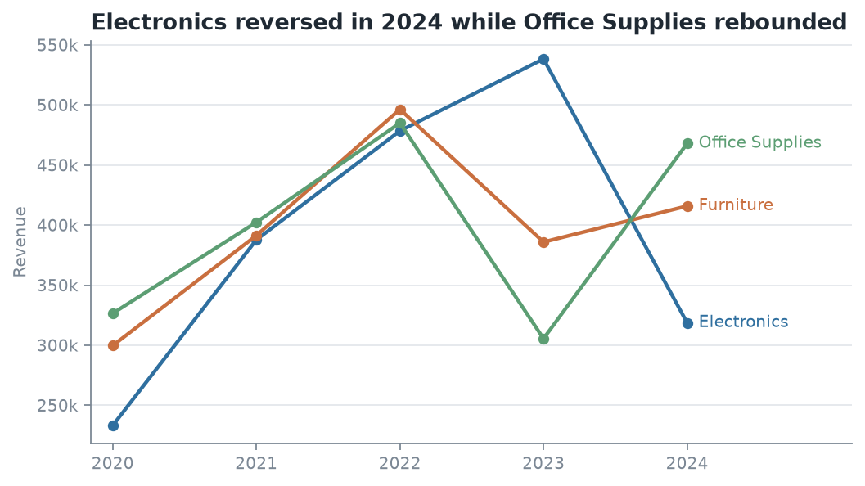
Figure 3 — category trend

Q6 — Top cities by revenue and revenue per customer
Joins 4 tables: fact_sales → dim_customer → dim_city → dim_state.
state | city | customers | revenue | revenue_per_customer | margin_pct
Florida | Orlando | 46 | 452,158 | 9,829.52 | 28.34
California | San Francisco | 53 | 440,000 | 8,301.89 | 24.57
New York | Buffalo | 58 | 418,514 | 7,215.76 | 26.72
New York | Rochester | 46 | 407,291 | 8,854.15 | 26.94
Texas | Dallas | 50 | 390,144 | 7,802.88 | 26.27

Business Interpretation. Geography is not where the problem lies. Total revenue across the six states spans only 884,768 (Ohio) to 1,130,048 (New York) — a 28% spread over five years, which is remarkably even. The more useful signal is per-customer value: Orlando returns 9,829 per customer at a 28.34% margin, while Buffalo generates comparable total revenue from 26% more customers at 7,216 each. Buffalo's revenue is bought with more customer relationships to service, so acquisition spend is better aimed at Orlando-like markets. This confirms the trend problem is national and product-driven, not regional — which is what makes Q7 the decisive query.

4. Business-Relevant Insights

Q7 — Which sub-categories turned growth into a plateau? (Business Question 2)
Conditional aggregation comparing 2023 with 2024 across all 12 sub-categories.
category | sub_category | revenue_2023 | revenue_2024 | change_abs | change_pct
Electronics | Printers | 192,817 | 55,952 | −136,865 | −71.0
Electronics | Electronic Games | 144,484 | 88,017 | −56,467 | −39.1
Electronics | Phones | 115,909 | 99,526 | −16,383 | −14.1
Furniture | Bookcases | 86,730 | 74,875 | −11,855 | −13.7
Electronics | Laptops | 85,109 | 75,135 | −9,974 | −11.7
Furniture | Chairs | 87,711 | 86,185 | −1,526 | −1.7
Furniture | Sofas | 92,052 | 98,984 | +6,932 | +7.5
Office Supplies | Markers | 100,742 | 120,002 | +19,260 | +19.1
Office Supplies | Binders | 64,442 | 88,011 | +23,569 | +36.6
Office Supplies | Pens | 82,959 | 116,900 | +33,941 | +40.9
Furniture | Tables | 119,400 | 155,834 | +36,434 | +30.5
Office Supplies | Paper | 57,368 | 143,057 | +85,689 | +149.4

Business Interpretation — the headline finding. The plateau is not broad weakness; it is concentrated in one sub-category. Printers alone lost 136,865 — more than half the entire 257,297 gap between the 2022 peak and 2024, and more than the next two decliners combined. Every one of the top four decliners is an Electronics line, and all four Electronics sub-categories fell. Meanwhile all four Office Supplies lines grew, led by Paper at +149.4%.
The pattern is coherent enough to name a hypothesis: consumables (Paper, Pens, Binders, Markers) are growing while durable electronics hardware is falling away. That is the signature of either a supply problem on the hardware side — stockouts, a lost supplier, a discontinued line — or a deliberate customer shift toward repeat consumable purchasing. The immediate action is to check 2024 Printer stock availability and supplier status before any demand-side conclusion is drawn, because a supply failure and a demand collapse look identical in a sales table and require opposite responses.

Q8 — Is the Q4 peak company-wide or category-specific? (Business Question 3)
Quarterly revenue per category with a window function giving each quarter's share of that category's own total.
category | Q1 | Q2 | Q3 | Q4
Electronics | 20.76% | 30.61% | 23.55% | 25.09%
Furniture | 16.96% | 29.46% | 22.74% | 30.84%
Office Supplies | 17.47% | 24.86% | 25.68% | 31.98%

Business Interpretation. The company-wide Q4 peak is not universal, and this is the finding most likely to change how the business plans. Furniture and Office Supplies both peak in Q4 (30.8% and 32.0% of their own annual revenue), consistent with holiday and new-fiscal-year buying. Electronics does not — it peaks in Q2 at 30.61% and Q4 is only its second-best quarter. Planning Electronics inventory against the blended company seasonal curve therefore over-stocks it in Q4 and under-stocks it in Q2, every year.
The recommendation is to replace the single company seasonal curve with per-category curves: Q4-weighted for Furniture and Office Supplies, Q2-weighted for Electronics. Q1 is the weakest quarter for all three (17–21%), so it is the natural window for clearance and maintenance.

Summary of Findings
- Growth stopped in 2022. Revenue is 17.6% below its peak, but margin never moved and average order value never moved — the company is writing fewer orders, not worse ones. (Q3)
- One sub-category explains most of it. Printers lost 136,865 between 2023 and 2024, over half the entire peak-to-2024 gap. All Electronics fell; all Office Supplies grew. (Q5, Q7)
- Seasonality is category-specific. Electronics peaks in Q2, Furniture and Office Supplies in Q4. The blended curve currently used for planning is wrong for all three. (Q4, Q8)
- Geography is not a factor. State revenue spans only 28% over five years; the problem is national and product-driven. (Q6)
Recommended next step for Checkpoint 2: verify the Printer supply hypothesis against stock and supplier records, then model monthly revenue with per-category seasonal terms rather than a single company-wide index.
Stated limitation. As noted in Task 1.2, the source file contains no loss-making transactions and an implausibly even payment-method split, so it is likely synthetic. The analysis method, schema and queries are valid; the specific figures should be presented as a modelling exercise rather than as a real company's trading results.

Reproducibility
python3 scripts/clean_and_load.py # clean, normalise, load, verify integrity
python3 scripts/run_queries.py # run all 8 queries, capture real results
python3 scripts/make_figures.py # regenerate Figures 1-3
Artefact | Path
Raw data | data/raw/sales_dataset_raw.csv
Cleaned tables | data/processed/*.csv
MySQL schema | sql/01_schema_mysql.sql
Generated INSERTs | sql/03_insert_data.sql
Query set | sql/04_queries.sql
Full query output | reports/query_results.md
Data quality evidence | reports/data_quality_report.md
ERD | docs/erd.md

