Sales Trend Analysis

Why a growing retailer stopped growing, and what the data says to do about it
Integrated Capstone Report
BED 106 — Business Analytics · Mini Capstone Project Talibon Polytechnic College A.Y. 2026–2027, 1st Semester
Member | Role | Signature
Alber
Julebeth
Mardy
Table 1. Group members and assigned project roles.
Group Name / Number | _______________________
Course Code and Title | BED 106 — Business Analytics
Project Title | Sales Trend Analysis: diagnosing a growth plateau in a multi-category retailer
Instructor | Jessie A. Melendres
Submission Date | _______________________
Academic Year | 2026–2027, 1st Semester
Table 2. Why a growing retailer stopped growing, and what the data says to do about it

2. Executive Summary
This project analyses five years of transaction data from a multi-category retailer — electronics, furniture and office supplies — trading across six US states between March 2020 and March 2025. The business question is narrow and specific: the company grew, then stopped, and nobody could say why.
On a like-for-like monthly basis revenue rose 30.9% from 2020 to a peak in 2022, then fell in each of the next two years to finish 2024 17.6% below that peak. What makes this an analytical problem rather than an obvious one is what did not move. Margin held between 23.97% and 26.93% across the whole period, and average order value stayed between 5,008 and 5,444. Had margin collapsed, the answer would be that the company discounted too hard. It did not. The company is writing fewer orders, not worse ones — and a single annual revenue figure cannot say which orders went missing, when, or where.
Methods. We built a normalised database and interrogated it with SQL (Checkpoint 1), took the same data into Excel for descriptive statistics, correlation and regression (Checkpoint 2), built an interactive Power BI dashboard and applied k-means segmentation (Checkpoint 3), then extended the regression into a multiple-predictor model and evaluated it against held-out data (Checkpoint 4).
Four findings carry the report.
The decline is concentrated, not general. Printers alone lost 136,865 between 2023 and 2024 — a 71.0% collapse, and more than half the entire gap between the 2022 peak and 2024. Every Electronics sub-category fell; every Office Supplies sub-category grew, led by Paper at +149.4%. Two opposite trends run at once, and the company-wide figure is their average, which describes neither.
Order count is the only measurable driver of revenue. It explains 85% of month-to-month variation (r = 0.9227, R² = 0.8514, p = 1.98 × 10⁻²⁴). When units sold, customer count, product mix and elapsed time were each given a fair chance alongside it in a multiple regression, none of them explained anything. Closing the four-order-per-month gap against 2022 is worth roughly 250,000 a year — a figure Checkpoint 1 reached independently, at 257,297, by summing category shortfalls.
Seasonality is category-specific. Electronics peaks in Q2 at 30.79% of its own annual revenue while Furniture and Office Supplies peak in Q4. The single blended planning curve the business uses is wrong for all three.
Revenue is a poor proxy for profit, and the customer base proves it. Clustering 807 customers produced three segments. The largest — 43% of customers and a third of revenue — returns just 19% of the profit, while a smaller, higher-margin group turns less revenue into 43% of it. A sales effort aimed at revenue would chase the wrong group.
Recommendations. Track order count rather than revenue as the primary KPI; investigate Printers first; plan seasonality by category; segment on margin rather than revenue; and stop setting volume or acquisition targets, which the data shows do not move revenue.
Limitations, stated plainly. The dataset is synthetic — generated, not collected — which we established with five independent machine-checked signals rather than discovering late. The figures therefore illustrate a method rather than describe a real company, though every query, statistic and model here would run identically against a real export. Our six-month forecast was tested against held-out months and lost to a naive flat average, 22.7% mean absolute error against 14.9%; we report that rather than drop the test. And correlation is not causation: order count and revenue move together, which is not proof that one causes the other.

3. Business Problem and Data Source

3.1 The business and the problem
The subject is a multi-category retailer selling electronics, furniture and office supplies across six US states — Illinois, California, Texas, Florida, New York and Washington — through 18 cities. Retail and Sales Analytics is an approved domain under Section 1.3 of the project brief, and sales trend analysis is listed under it.
The company grew to a revenue peak in 2022 and has declined since. The decisions hanging on an explanation are concrete: what to stock, when to stock it, and where to direct sales effort. Getting them wrong costs inventory that does not sell and campaigns that land in the wrong quarter.

3.2 The three business questions
# | Question | Answered by
1 | How have revenue and profit trended, and is the company still growing? | Query 3; Checkpoint 2 regression; Section 7
2 | Which categories and sub-categories drive the trend? | Queries 5 and 7; Section 6 segmentation
3 | When does demand concentrate, and is the pattern the same for every category? | Queries 4 and 8
Table 3. The three business questions and the analysis that answers each.
Every deliverable in this project maps back to one of these three.

3.3 Data source
Historical point-of-sale transaction records, one row per product line on an order, obtained as a public CSV export in the Kaggle "Sales Dataset" format.
Attribute | Details
Dataset Name | Sales Dataset (multi-category US retail transactions)
Source File | archive.zip → Sales Dataset.csv; stored unmodified as data/raw/sales_dataset_raw.csv
Date Accessed | 24 August 2026
Licence | Public/open dataset, used for academic coursework only
Size | 1,194 data rows × 12 columns
Coverage | 22 March 2020 – 15 March 2025
Currency | Not stated in the source. Amount and Profit are unitless integers; all figures are quoted as currency units
Table 4. Data source report for the sales transaction dataset.

3.4 The dataset is synthetic
This is stated here, early, because every figure in the report depends on it.
The file is generated data, not collected trading data. Five independent signals, each checked by machine rather than by eye:
- No loss-making line in five years. All 1,194 rows return a positive profit. No real retailer has that
- 22 of the 802 customer names end in credential suffixes such as "MD", "PhD" or "DDS" — a known artefact of the Faker synthetic-data library
- US cities paired with UPI and EMI payment methods. Those are Indian payment rails; they do not occur in US retail
- A near-uniform payment mix — between 206 and 260 transactions for every one of the five methods, where real data shows strong preference
- A flat transaction-amount distribution. Our own Checkpoint 2 histogram confirms it independently: no bin holds more than 11.4% or less than 7.0% of rows, where real transaction values are strongly right-skewed
We corrected none of it. Fabricating plausible-looking repairs would have been data fabrication, which Section 3.2 of the brief makes grounds for a failing mark. We documented each defect and worked around it. The consequence is that the figures in this report illustrate a method; the method is unaffected and transfers to real data without modification.

4. Database Design and SQL Analysis

4.1 Data quality assessment
The raw file was assessed before anything was changed. Five problems, in order of the trouble they caused.
One — `Order ID` is not a primary key. 1,194 rows carry only 547 distinct order identifiers, and the duplicates are not duplicate rows: the same ID appears on different dates, for different customers. It identifies neither a row nor an order. Repairing it would have meant deciding which of two conflicting rows was real with no evidence for the decision, so it was kept as a plain attribute and a surrogate key, sale_id, issued instead. No question in this project requires order identity.
Two — `CustomerName` is not an identifier either. 807 customers resolve from 802 distinct names, because five names appear in more than one city. The customer key is therefore the pair (name, city). This defect recurred in Checkpoint 3: building the Power BI model on the name rather than the key would have silently merged those five pairs.
Three — `Year-Month` is redundant, being fully derivable from Order Date, and was dropped from the schema and rebuilt in the dates dimension.
Four — both ends of the file are partial. It begins 22 March 2020 and ends 15 March 2025, so neither 2020 nor 2025 is a whole year. This is the defect that caused the single real error in this project; Section 4.5 records it.
Five — the dataset is synthetic, as documented in Section 3.4.
No missing values were found in any of the twelve columns, and all three measures are internally consistent.

4.2 Database design
The flat file was normalised into a star schema: one fact table surrounded by seven dimensions.
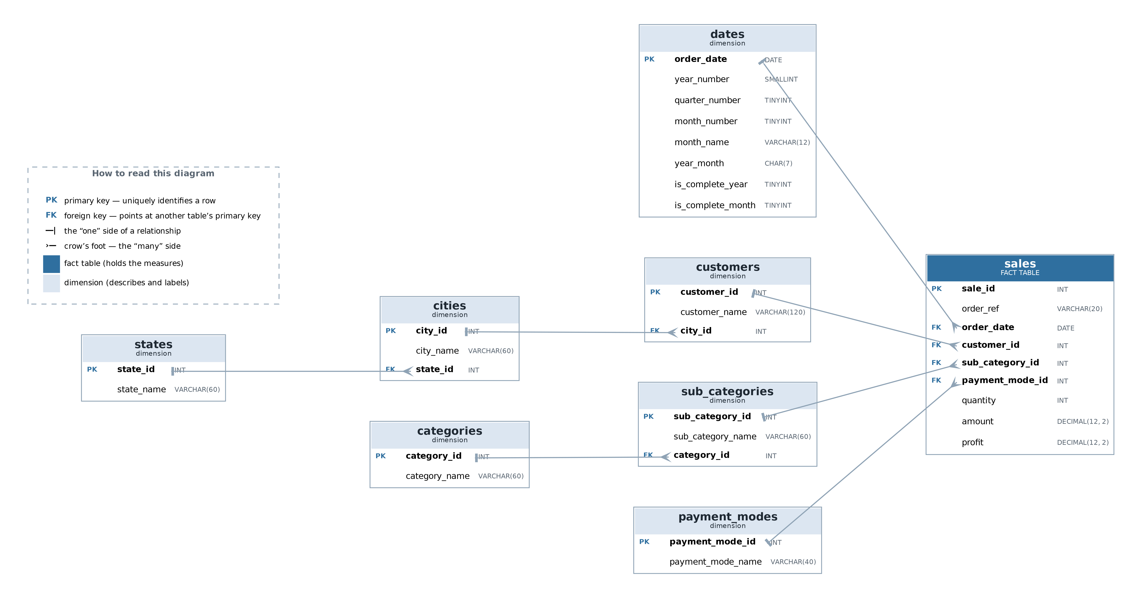
Figure 1. Entity-Relationship Diagram of the sales_trend database. PK marks a primary key, FK a foreign key.
sales is the fact table at a grain of one transaction line. Around it sit customers, cities, states, categories, sub_categories, payment_modes and dates.
Why a star rather than the single table we started with? Three reasons. Consistency: in the flat file a category name repeats on every row that uses it, so one typo creates a category that does not exist; in the star it lives once and the fact table carries an integer key, making the typo impossible rather than merely unlikely. The brief: Task 1.3 requires at least two related tables with proper keys. The queries: the category trend question needs category and date on the same row as the amount, which a star delivers in one join.
The dates dimension carries two flags the raw dates cannot — is_complete_month and is_complete_year — which are the structural fix for problem four. It also keeps the SQL portable: no YEAR() or strftime() is called anywhere, so the same query file runs unchanged on MySQL 8 and SQLite 3, and both were verified.
Table | Rows
states | 6
cities | 18
categories | 3
sub_categories | 12
payment_modes | 5
customers | 807
dates | 648
sales | 1,194
Table 5. Populated row counts verified after load.
The schema creates 8 primary keys, 7 foreign keys, 6 unique constraints and 4 check constraints, all verified on a live MySQL-compatible server. Both foreign keys and check constraints were tested to confirm they reject invalid rows rather than assumed to. sales holds exactly the 1,194 rows of the raw file: nothing was lost or invented in normalisation.
One implementation note worth recording: `year_month` is a reserved word in MySQL, and CREATE TABLE dates failed outright with a syntax error until it was backticked. This surfaced only because a real MySQL server was installed and the import actually run, rather than the file being assumed correct.

4.3 SQL query results
Eight queries in four groups: two basic retrievals using WHERE and ORDER BY, two aggregates using GROUP BY, two multi-table joins of four tables each, and two business-insight queries. Full SQL is in sql/04_queries.sql and every result table appears in the Checkpoint 1 report; the four findings are summarised here.
Finding 1 — growth stopped in 2022, in a specific way.
Year | Months | Lines | Revenue | Revenue/month | Avg line | Margin %
2020 | 9 | 167 | 836,410 | 92,934.44 | 5,008.44 | 26.05
2021 | 12 | 217 | 1,181,446 | 98,453.83 | 5,444.45 | 23.97
2022 | 12 | 288 | 1,459,775 | 121,647.92 | 5,068.66 | 26.93
2023 | 12 | 234 | 1,229,723 | 102,476.92 | 5,255.23 | 26.16
2024 | 12 | 240 | 1,202,478 | 100,206.50 | 5,010.33 | 25.64
Table 6. Q3 — annual sales trend, measured per month so the nine-month 2020 compares fairly.
Margin never leaves the 24–27% band and average line value never leaves 5,008–5,444, while revenue per month falls 17.6% from the peak. That combination is the diagnosis: fewer orders, not cheaper or less profitable ones, which points at demand generation rather than pricing.
Finding 2 — one sub-category explains most of the gap.
Category | Sub-category | 2023 | 2024 | Change | %
Electronics | Printers | 192,817 | 55,952 | −136,865 | −71.0
Electronics | Electronic Games | 144,484 | 88,017 | −56,467 | −39.1
Electronics | Phones | 115,909 | 99,526 | −16,383 | −14.1
Furniture | Bookcases | 86,730 | 74,875 | −11,855 | −13.7
Electronics | Laptops | 85,109 | 75,135 | −9,974 | −11.7
Furniture | Chairs | 87,711 | 86,185 | −1,526 | −1.7
Furniture | Sofas | 92,052 | 98,984 | +6,932 | +7.5
Office Supplies | Markers | 100,742 | 120,002 | +19,260 | +19.1
Office Supplies | Binders | 64,442 | 88,011 | +23,569 | +36.6
Office Supplies | Pens | 82,959 | 116,900 | +33,941 | +40.9
Furniture | Tables | 119,400 | 155,834 | +36,434 | +30.5
Office Supplies | Paper | 57,368 | 143,057 | +85,689 | +149.4
Table 7. Q7 — sub-category revenue change, 2023 against 2024.
Printers alone account for more than half the entire peak-to-2024 gap of 257,297. Electronics as a category is down 40.8%; every Office Supplies line grew. This is the most useful single thing Checkpoint 1 produced, and it is invisible at company level.
Finding 3 — seasonality is category-specific.
Category | Q1 | Q2 | Q3 | Q4
Electronics | 20.28% | 30.79% | 23.69% | 25.24%
Furniture | 16.96% | 29.46% | 22.74% | 30.84%
Office Supplies | 17.01% | 25.00% | 25.83% | 32.16%
Table 8. Q8 — each quarter's share of its own category's annual revenue.
The blended company figure says Q4. Split by category, Electronics actually peaks in Q2. A single planning curve over-stocks Electronics in Q4 and under-stocks it in Q2 — mistiming roughly a third of the business.
Finding 4 — geography is not a factor. Across five years, state revenue spans only 28% between highest and lowest, with no state trending against the others (Q6). Not every finding is a discovery; this one tells the business where not to spend analytical effort, and it is reported for that reason.

4.4 Figures
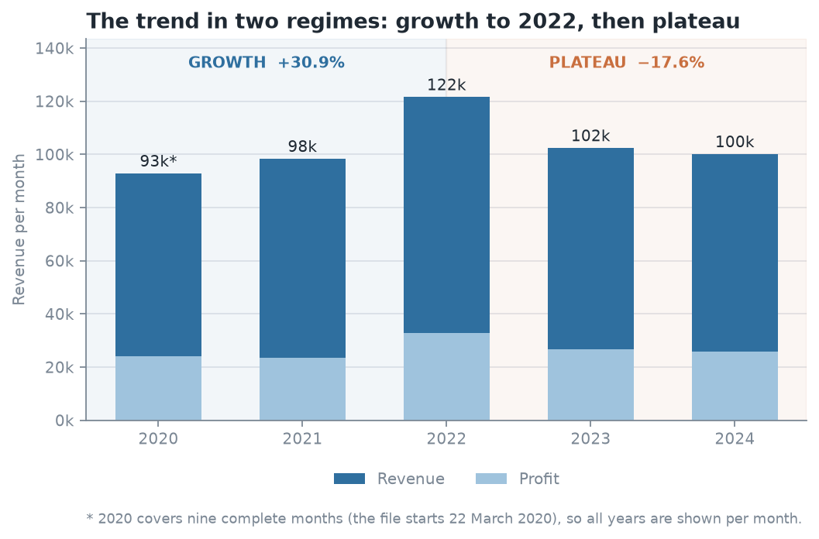
Figure 2. The sales trend in two regimes, measured per month: growth of 30.9% to the 2022 peak, then a 17.6% fall to a plateau.
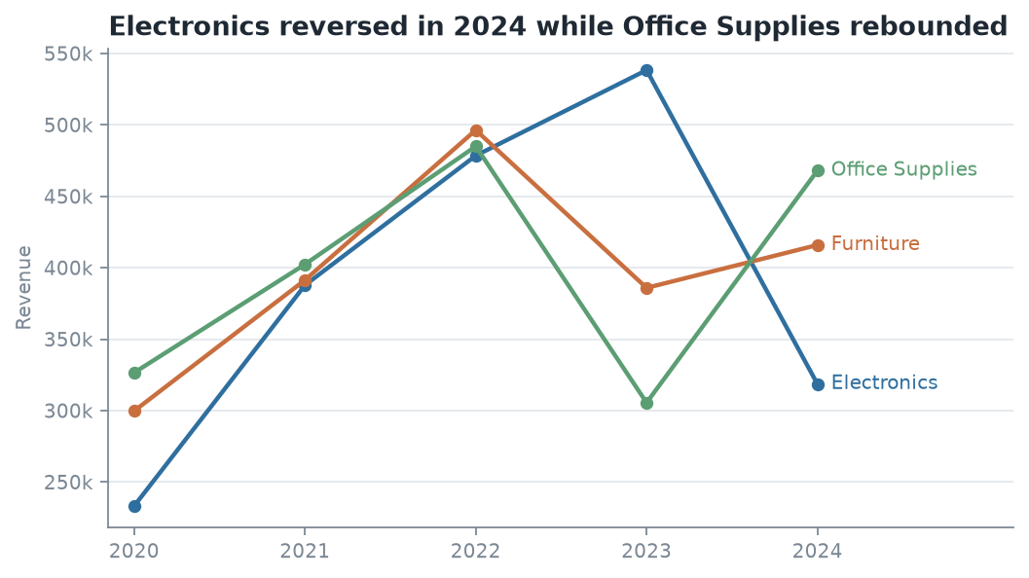
Figure 3. Revenue by product category per year. Electronics reversed in 2024 while Office Supplies rebounded.

4.5 A correction we made to our own work
Building the Checkpoint 2 monthly series exposed an error in Checkpoint 1. 2020 was treated as a full year. The file begins on 22 March, so 2020 holds only nine months of trading. Comparing its part-year total against a full 2021 overstated 2020-to-2022 growth as 69.9% when the like-for-like figure is 30.9%. It also distorted March's seasonal index, from 1.025 down to 0.876.
Affected | Unaffected
The 2020→2022 growth figure | The −17.6% peak-to-2024 decline — both are full years
March's seasonal index | Printers −136,865; Electronics −40.8%
 | Category-specific seasonality; the geography finding
Table 9. Which Checkpoint 1 findings the correction affects.
The central thesis is unchanged; one supporting number was overstated. Checkpoint 1 was reissued with the is_complete_month flag and a per-month column in Query 3, so the mistake is now structurally prevented rather than merely fixed. Every per-month measure built since — in Excel, in Power BI and in the predictive model — divides by months actually covered, never by twelve.

5. Statistical Analysis
Computed in Excel against the same database extract, with all working visible as live formulas rather than pasted values. Full detail in the Checkpoint 2 report; the results are summarised here.

5.1 Descriptive statistics
Statistic | Amount | Profit | Quantity
Mean | 5,178.09 | 1,348.99 | 10.67
Median | 5,152.00 | 1,014.00 | 11.00
Standard deviation | 2,804.92 | 1,117.99 | 5.78
Minimum | 508 | 50 | 1
Maximum | 9,992 | 4,930 | 20
Interquartile range | 4,827.00 | 1,625.00 | 10.00
Coefficient of variation | 54.2% | 82.9% | 54.1%
Table 10. Descriptive statistics for the three numerical variables, n = 1,194.
Profit is far less predictable than revenue. Its coefficient of variation is 82.9% against Amount's 54.2%, with a skew of +0.94 — more variable and asymmetric, with a long right tail of a few very profitable lines. The practical consequence is that a revenue target does not manage profit: the two do not move together tightly enough for one to stand in for the other. This observation recurs in the regression (Section 5.3) and again in the customer segmentation (Section 6.3).
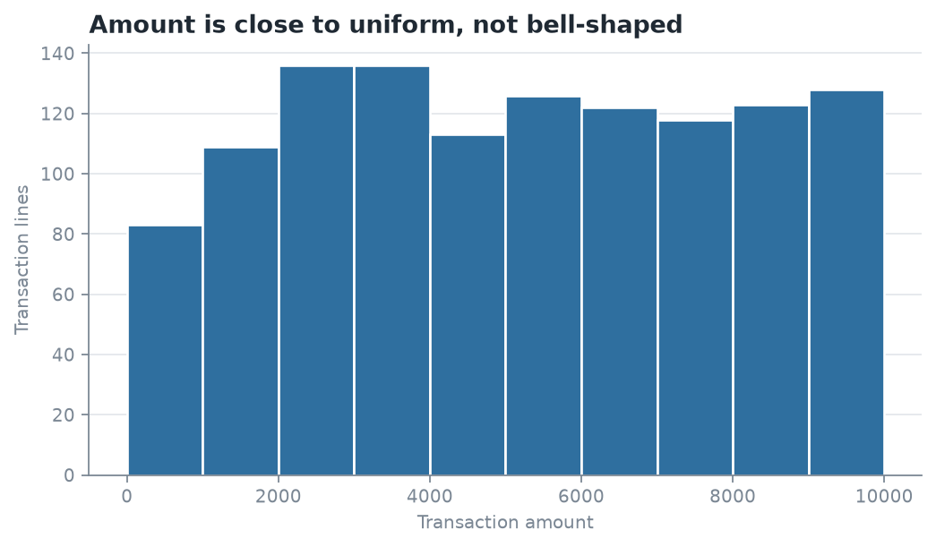
Figure 4. Frequency distribution of transaction Amount. The flat shape indicates a uniform, not normal, distribution.
The histogram is itself a finding. No bin holds more than 11.4% of rows and none less than 7.0%. A normal distribution concentrates around the mean and thins at the tails; this is close to flat, which is what a random number generator produces — independent confirmation of Section 3.4.

5.2 Correlation
Measure | Monthly orders vs revenue | Line quantity vs amount
Pearson r | +0.9227 | +0.0446
r² | 0.8514 | 0.0020
p-value | 1.98 × 10⁻²⁴ | 0.123
n | 57 months | 1,194 lines
Strength | Strong | Negligible — not significant at 5%
Table 11. The two required correlation pairs.
The first pair converts a Checkpoint 1 inference into a measurement: revenue falls because order count falls, and order count accounts for about 85% of monthly variation.
The second is a negative result we are keeping, because it kills an obvious strategy. Quantity and order value are unrelated and the relationship is not statistically significant, so a "sell more units" target would not move revenue in this business. Price per line varies far more than units per line.
A supporting third pair, amount against profit, gives r = 0.6753 — about 46% of profit variation tracking revenue. Moderate, not strong, and the same conclusion as the coefficients of variation reached by a different route.
Correlation is not causation. Order count and revenue could both respond to demand we cannot observe. What the data supports is that the association is strong and consistent across 57 months.

5.3 Simple linear regression
Monthly revenue regressed on monthly order count across the 57 complete months from April 2020 to December 2024.
Monthly Revenue = −1,353.65 + 5,224.25 × (Orders in month)
Statistic | Value
Sample size n | 57 months
Slope (b) | 5,224.25
Intercept (a) | −1,353.65
R² | 0.8514
t statistic | 17.75
Degrees of freedom | 55
p-value | 1.98 × 10⁻²⁴
Table 12. Simple linear regression of monthly revenue on monthly order count.
The slope is the check that makes this convincing. One additional order in a month is associated with about 5,224 more revenue. The plain mean order value in the data is 5,178.09 — the regression rediscovered it to within 0.9% without being told what it was.
The intercept is not meaningful. Zero orders cannot produce negative revenue; it is where the fitted line crosses the axis, extrapolated far outside the observed data, and it is not interpreted.
The business forecast. The company runs about four orders per month below its 2022 level. At 5,224 per order, closing that gap is worth roughly 250,000 a year. Checkpoint 1 reached 257,297 by an entirely different route — summing actual category shortfalls. Two independent methods agreeing within 3% is the strongest single piece of evidence in this project.
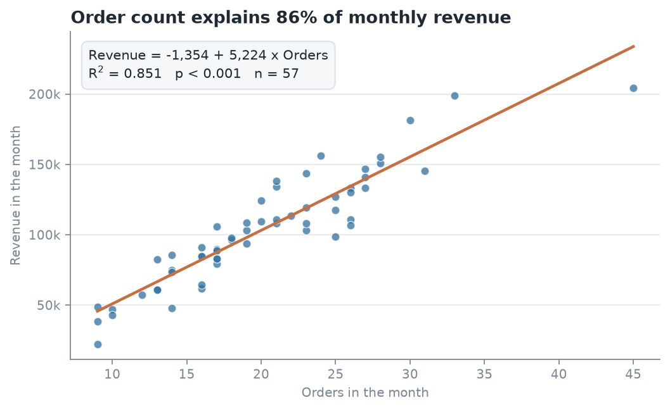
Figure 5. Monthly orders against monthly revenue, with the fitted regression line.

5.4 Trend and seasonality
The trend is real, and it runs in two regimes. Growth from 2020 to 2022, 92,934 to 121,648 per month (+30.9%); then a plateau from 2022 to 2024, down to 100,207 (−17.6%).
A straight line fitted across all 57 months explains under 1% of the variation — R² = 0.0078, p = 0.515 — and the same result holds across four different windows. That is not "no trend". It is that no single straight line fits both regimes: the up-slope and the flat cancel out, and their average is nearly horizontal. Projecting a growth rate we tested for and did not find would be inventing a number, so the forecast is built from level and seasonality instead.
Month | Index | Month | Index
January | 0.679 | July | 0.966
February | 0.889 | August | 1.006
March | 1.025 | September | 0.793
April | 1.103 | October | 1.229
May | 1.131 | November | 0.878
June | 1.028 | December | 1.273
Table 13. Seasonal index by calendar month, April 2020 to December 2024.
The forecast was tested, and it lost. Holding out the two months that could be verified and comparing against a naive flat average:
Model | Jan error | Feb error | Mean absolute error
Seasonal (level × index) | −39.0% | +6.3% | 22.7%
Flat (level only) | −10.2% | +19.6% | 14.9%
Table 14. Forecast accuracy over the two complete holdout months.
The seasonal model ranks fifth of the eight methods tested. The reason is visible: January 2025 came in at 112,906 against a prediction of 68,853 — January's index says it is the weakest month of the year, and this January was not. We keep the method and report the loss, because choosing a model on the strength of two observations is overfitting the holdout. The honest statement is that forecast reliability over this horizon is weak, and we measured our own error rather than asserting confidence.
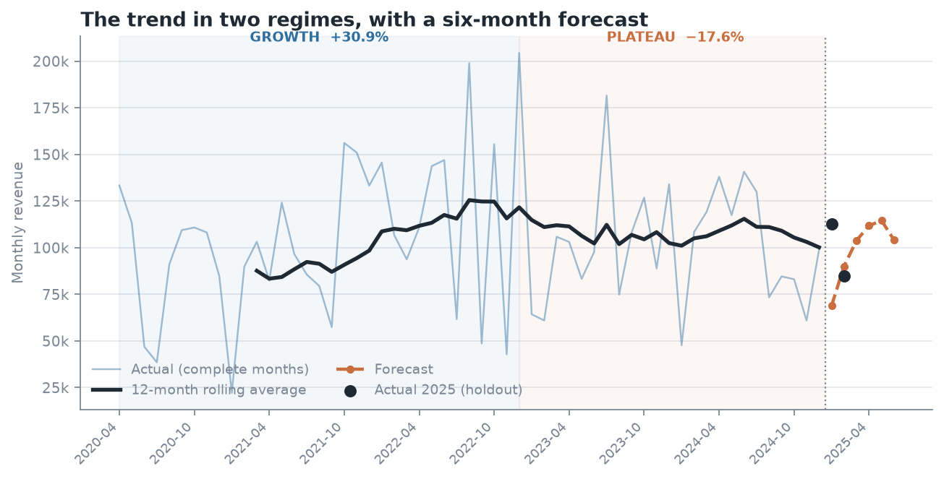
Figure 6. The sales trend in two regimes, with the six-month forecast and the two holdout months at the right.

6. BI Dashboard Summary
An interactive three-page dashboard built in Power BI Desktop on the same database, reading five purpose-built SQL views rather than the raw tables.

6.1 Design decisions
Three decisions shaped the dashboard, and each one came out of the earlier analysis rather than out of preference.
Order count is the primary KPI, not revenue. Section 5.2 established that order count explains 85% of revenue variation and Section 7 confirms it is the only predictor that survives a multiple regression. Revenue is the lagging indicator; order count is the leading one, and it is the thing the business can act on. The four KPI cards on Page 1 lead with orders per month.
Segmentation is by margin, not revenue. Only about 46% of profit variation tracks revenue, and profit is far more variable than revenue (CV 82.9% against 54.2%). A dashboard ranking anything by revenue alone points management at the wrong accounts — Query 1 found lines returning 414 and 4,339 profit on near-identical revenue.
No single blended seasonality curve appears anywhere. Electronics peaks in Q2 and the other two categories in Q4, so one curve is wrong for all three. Page 2 shows quarterly revenue as small multiples, one panel per category.

6.2 Page structure
Page | Question it answers | Visuals
1 — Executive Summary | Is the company still growing, and by how much has it slipped? | Four KPI cards; revenue-per-month line with the 2022 peak marked; year summary table
2 — Trend & Comparison | Which categories and sub-categories drive the trend? | Category line chart; sub-category change bars; quarterly small multiples; margin bars
3 — Deep Dive & Segmentation | Who are the customers and what are the product segments? | Two cluster scatters; segment profile table; state map; quantity-against-amount scatter
Table 15. Dashboard pages, the question each answers, and its visuals.
Interactivity. Slicers on three dimensions — period, category and geography — act on every page, with a segment slicer added on Page 3. Drill-through from any sub-category bar on Page 2 opens Page 3 filtered to it. Cross-filtering between visuals is active throughout.
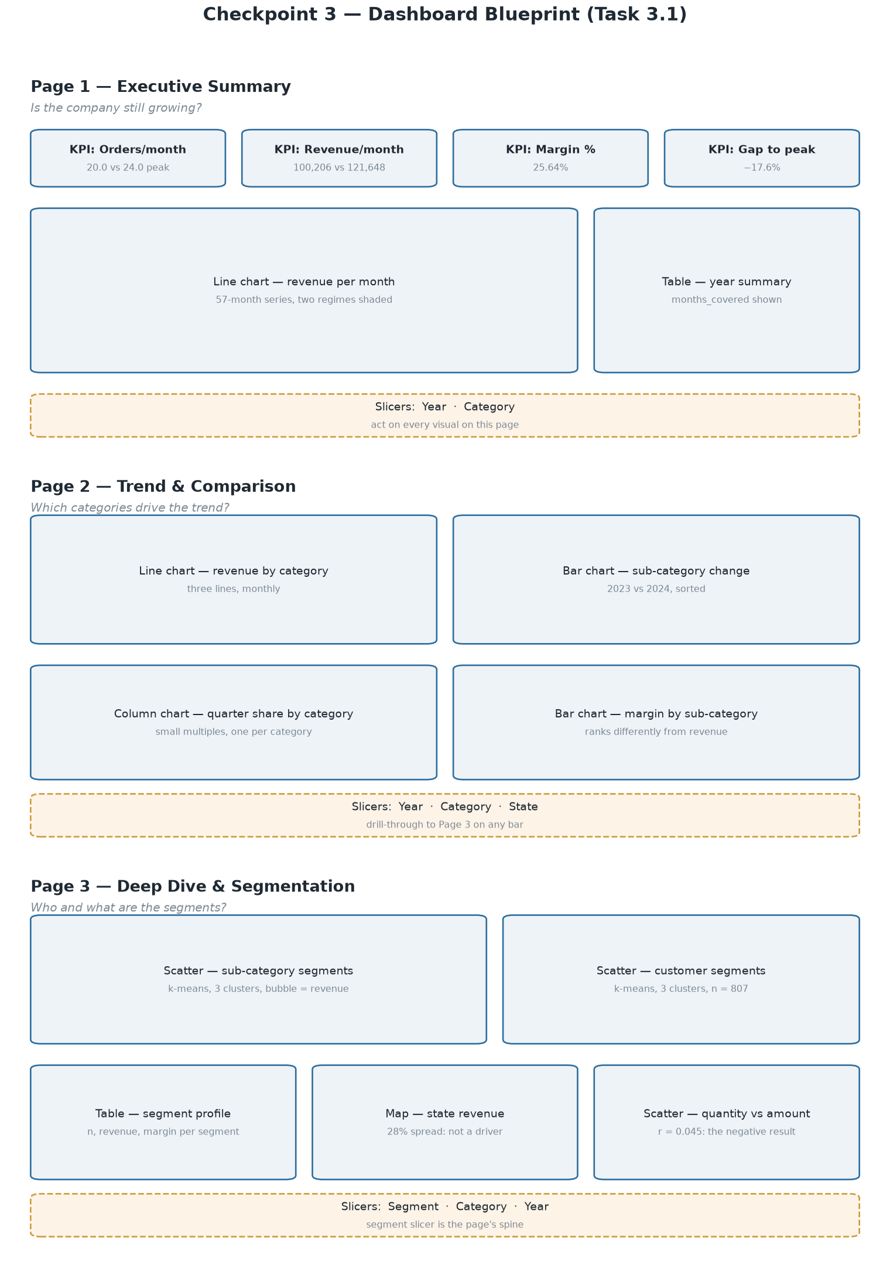
Figure 7. Dashboard blueprint — the three pages, their visuals, and the slicers acting on each.

6.3 Segmentation findings
Two k-means segmentations, both reproducible from a fixed seed. k was chosen by silhouette score, evaluated across k = 2 to 6 and selected within the two to three the brief requires.
This choice is worth defending rather than glossing: on the customer data k = 5 scores 0.295 against k = 3's 0.277. We took k = 3 because the difference is too small to buy back the interpretability of five segments, two of which came out with the same profile — and because on twelve sub-categories, k = 6 leaves two members per cluster, which is a partition rather than a segmentation.
Customer segments — 807 customers, clustered on value, margin and recency.
Segment | n | % of customers | % of revenue | % of profit | Margin
High-Value Accounts | 146 | 18.1% | 38.4% | 38.7% | 26.2%
High-Margin Buyers | 311 | 38.5% | 28.9% | 42.6% | 38.5%
Thin-Margin Buyers | 350 | 43.4% | 32.7% | 18.7% | 14.9%
Table 16. Customer segments, with each segment's share of customers, revenue and profit.
This is the central finding of the dashboard. Thin-Margin Buyers are the largest group — 43% of customers and a third of revenue — and they return 19% of the profit. High-Margin Buyers produce 43% of profit from less revenue. A sales effort aimed at revenue would chase the wrong group of the two. This is the customer-level form of the Section 5.1 finding, converted from a statistic into a list of named accounts.
Two honest notes. Recency separated nothing — every cluster centre sits within 0.11 standard deviations of the mean on it — so there are no "lapsed" or "active" segments to claim. And purchase frequency spans only one to four lines (510 of 807 customers bought once), too little spread to carry a segment boundary, which is why it was not clustered on. Both are consequences of the synthetic dataset.
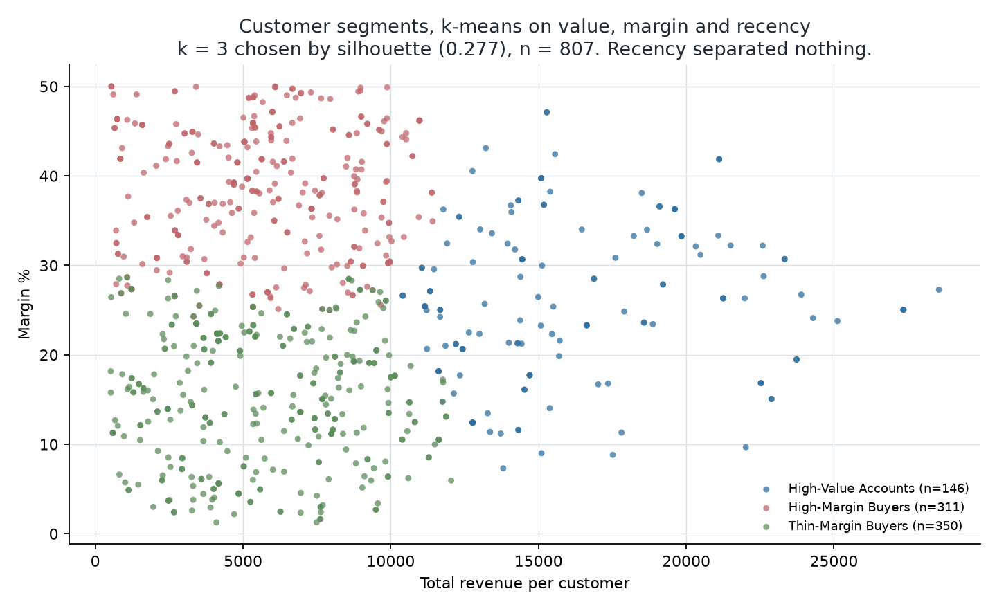
Figure 8. Customer segments. Value separates one cluster; margin separates the other two.
Sub-category segments — 12 sub-categories, clustered on scale, growth and margin.
Segment | Members | 2023 → 2024
Growth Engines | Markers, Paper, Pens, Sofas, Tables | 452,521 → 634,777, +40.3%
Low-Margin Niche | Binders, Phones | 180,351 → 187,537, +4.0%
Declining Lines | Bookcases, Chairs, Electronic Games, Laptops, Printers | 596,851 → 380,164, −36.3%
Table 17. Sub-category segments and their movement between 2023 and 2024.
The segmentation recovers Checkpoint 1's central finding without being told it: the two large clusters move in opposite directions, +40.3% against −36.3%, and the company-wide figure is their average. The middle cluster is named for margin rather than growth, because its two members moved in opposite directions (Binders +36.6%, Phones −14.1%); what they share is low margin and small scale.
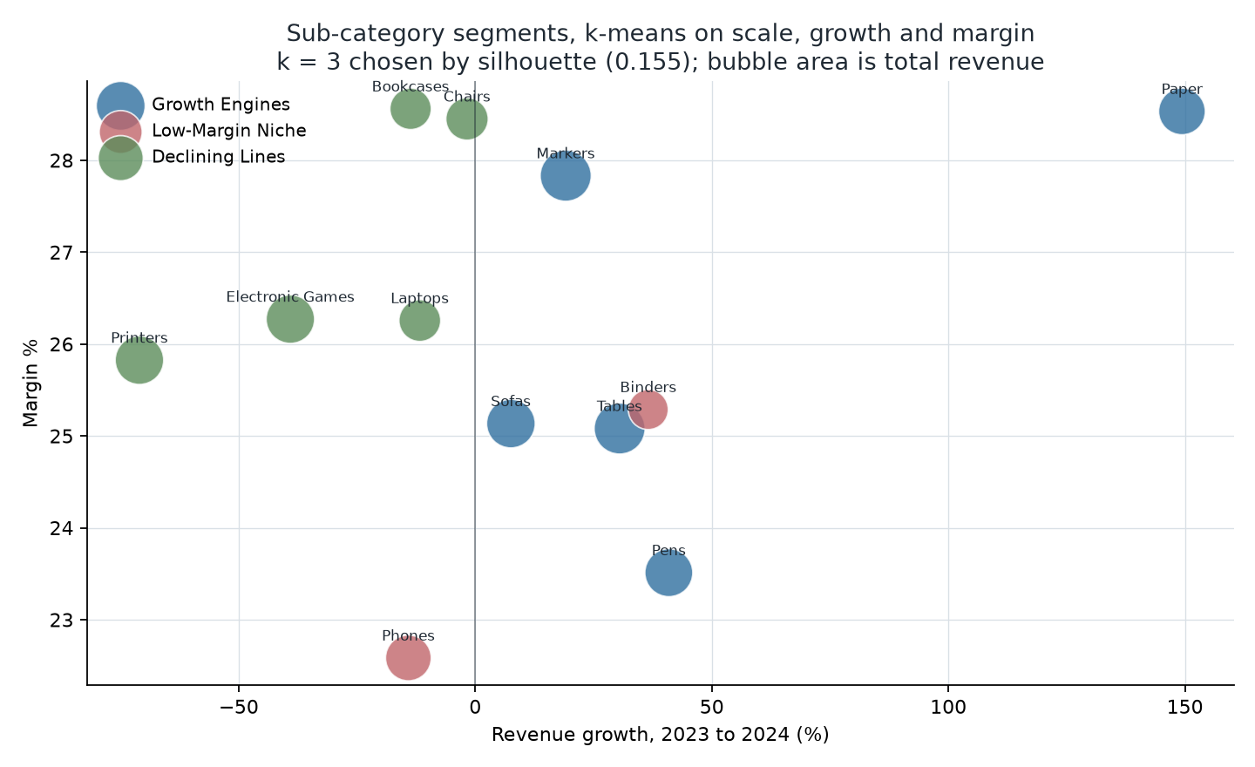
Figure 9. Sub-category segments. Growth separates the two ends; the middle cluster is defined by margin.

6.4 Dashboard screenshots
TO BE INSERTED. Paste screenshots of all three dashboard pages here, each numbered and captioned, with one or two sentences of your own commentary under each. The exported PDF of all three pages is a separate submission item. Build instructions are in docs/PowerBI_Build_Guide.docx.

7. Predictive Analytics
Extending the Checkpoint 2 regression into a multiple-predictor model, then testing whether the extension was worth making. Full computed output in reports/predictive_model_results.md.

7.1 The model
Output variable: monthly revenue. Predictors tested: order count, units sold, distinct customers, Electronics share of lines, a time index, and quarter indicators for Q2, Q3 and Q4.
The Electronics share is computed from line counts, not revenue. A revenue share would be derived from the target and would leak it back into the model — a mistake that inflates R² while predicting nothing.
Three models were fitted on the same 57-month window, trained on the first 51 months with the last six held out and never fitted.
Model | Specification | R² | Adjusted R²
A | revenue ~ orders — the Checkpoint 2 baseline | 0.8562 | 0.8533
B | all eight predictors | 0.8746 | 0.8507
C | orders + Q2 + Q3 + Q4 + elec_line_share | 0.8695 | 0.8550
Table 18. Three candidate models and their fit.
Model B is the instructive failure. Adding every predictor raised R² and lowered adjusted R² below the one-variable baseline — the signature of predictors bought with degrees of freedom rather than information. Its variance inflation factors show why: orders at 13.67, units at 7.64, customers at 5.48. Those three are 0.81 to 0.92 correlated with each other because they all measure the same thing — how much trade happened. Dropping units and customers brings every VIF in Model C below 1.8.

7.2 The reported model
Model C, refitted on all 57 months once the holdout had done its job of selecting the specification:
Monthly Revenue = −12,275.79 + 5,219.51 × Orders + 11,382.65 × Q2 + 9,624.56 × Q3 + 5,989.42 × Q4 + 12,091.77 × Electronics line share
Term | Coefficient | Robust SE | Robust p
Intercept | −12,275.79 | 9,775.60 | 0.215
Orders | 5,219.51 | 388.49 | 2.21 × 10⁻¹⁸
Q2 | 11,382.65 | 5,484.91 | 0.043
Q3 | 9,624.56 | 5,455.74 | 0.084
Q4 | 5,989.42 | 6,199.18 | 0.339
Electronics line share | 12,091.77 | 16,873.75 | 0.477
Table 19. Model C coefficients with heteroscedasticity-consistent standard errors.
R² = 0.8647, adjusted R² = 0.8514, n = 57.
On the standard errors. The Breusch-Pagan test rejects constant variance (p = 0.0023), so classical standard errors are unreliable and heteroscedasticity-consistent (HC1) errors are reported instead. This is not cosmetic: under classical errors Q2 sits at p = 0.062 and is not significant; under robust errors it is p = 0.043 and is. Both are close enough to 0.05 that the honest statement is that Q2 is marginally significant.
The slope is the same number three times over — 5,219.51 here, 5,224.25 in the simple regression, and 5,178.09 as the plain mean order value. Three routes, agreeing within 0.8%.

7.3 Model evaluation
Evaluated on six months the models never saw, July to December 2024:
Model | Mean absolute percentage error
A — orders only | 9.3%
C — reduced multiple | 9.8%
Table 20. Holdout performance over six unseen months.
The multiple regression did not beat the simple one out of sample. This is the second occasion in this project where a more elaborate method lost to a simpler one, and we report it rather than bury it. Both models missed December 2024 badly — predicting about 130,000 against an actual 98,879, a 32% error — and that single month accounts for most of the difference between them.
The extension's value is diagnostic, not predictive. Units sold (p = 0.79), customer count (p = 0.27), product mix (p = 0.48) and elapsed time (p = 0.55) were each given a fair chance alongside order count, and none explained anything. That is precisely the evidence justifying the dashboard's central design decision.
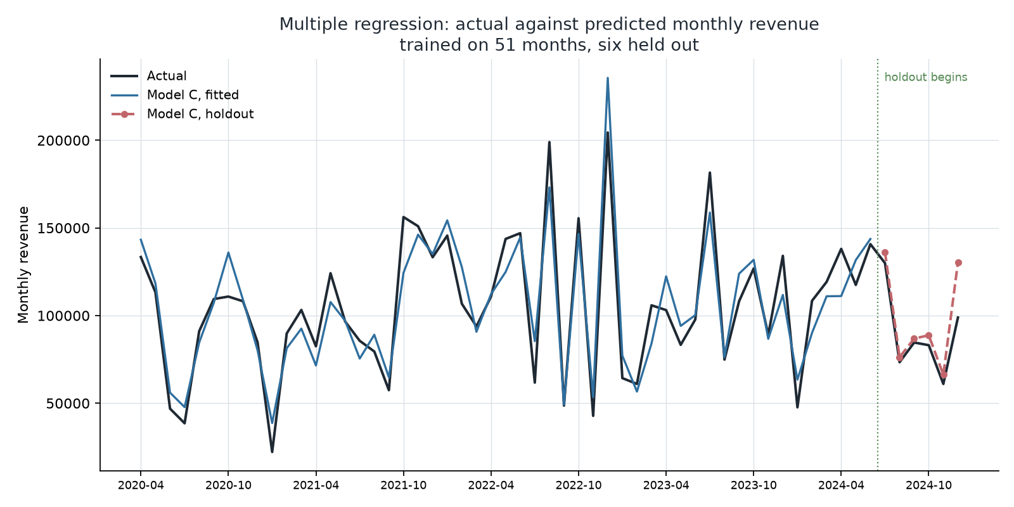
Figure 10. Actual against predicted monthly revenue, trained on 51 months with six held out.

7.4 Business predictions
Orders per month | Q1 | Q2 | Q4
20 — the 2024 level | 96,027 | 107,410 | 102,017
22 | 106,466 | 117,849 | 112,456
24 — the 2022 peak level | 116,905 | 128,288 | 122,895
Table 21. Predicted monthly revenue at different order volumes, at the mean Electronics line share.

7.5 Assumptions, limitations and conditions
Assumption | Test | Result
Linearity | Residuals against fitted | No pattern
Independence of errors | Durbin-Watson | 2.078 — no autocorrelation
Normality of residuals | Shapiro-Wilk | p = 0.86 — passes
Constant variance | Breusch-Pagan | p = 0.0023 — fails; robust SEs used
No multicollinearity | VIF | Fails in Model B (13.67); Model C all below 1.8
Table 22. Regression assumptions, the test applied, and the result.
Six further conditions on any use of this model:
- 57 monthly observations is not many for five predictors. Adjusted R² and the holdout are reported precisely because plain R² would flatter it
- Do not extrapolate beyond the observed range. Order counts run from 9 to 45 per month and revenue from 22,187 to 204,413
- The intercept is not meaningful — it lies far outside the data
- Association, not causation. Nothing here shows that generating an order causes the revenue, as opposed to both responding to unobserved demand
- The dataset is synthetic, so these coefficients describe a generated file
- Transactions only. The file records sales that happened, never a customer who considered a purchase and did not make one, so the model cannot see demand that was lost

8. Ethics, Privacy and Governance

Privacy considerations
The dataset contains what look like personal data: 802 distinct customer names, each attached to a city, a state, a purchase history and a profit figure. On the face of it that is exactly the kind of record the Data Privacy Act is written about.
It is not, and the reason matters more than the conclusion. During Checkpoint 1 we established with five independent machine-checked signals that the dataset is synthetic — generated, not collected. Twenty-two of the 802 names end in credential suffixes such as "MD" or "DDS", which is a known artefact of the Faker library. US cities are paired with UPI and EMI payment methods, which are Indian payment rails. There is not one loss-making line across five years, the payment mix is near-uniform at 206 to 260 across every method, and the transaction-amount histogram is flat rather than right-skewed. Our own Checkpoint 2 descriptive statistics confirmed that flatness independently.
Because the names are generated, there is no data subject. No living person is identified or identifiable in this file, so the Data Privacy Act is not engaged and there was nothing to anonymise. We therefore did not anonymise the names, and we want to be precise about why: not because the dataset is published on a public platform, but because the individuals in it do not exist.
That distinction is the single most important point in this reflection. Public availability is not consent. A dataset being downloadable does not make the people inside it willing participants in our analysis. Had these names been real, the fact that someone uploaded them to a public repository would not have given us a lawful basis to process them, and the correct response would have been to pseudonymise the customer dimension — replacing names with surrogate keys, which our schema already uses — before any analysis began. Our star schema is structured so that this would have been a one-table change: customers holds the only identifying attribute, and every other table references it by integer key.

Ethical issues
Two concerns arise from our own work rather than from the data.
The first is the segmentation we built in Checkpoint 3. We clustered 807 customers and labelled one group of 350 "Thin-Margin Buyers" — 43% of customers, a third of revenue, and under a fifth of the profit. That label is analytically accurate and commercially useful, and it is also the most ethically loaded object in this project. A business acting on it could rationally decide to deprioritise service, withdraw discounts, or stop marketing to those accounts. If the segmentation correlates with something it should not — income, location, or the kind of product a household needs — then an apparently neutral margin calculation becomes a mechanism for treating poorer customers worse. We checked whether geography drives the segments and it does not, but on real data that check would need to be repeated for every protected characteristic available, and the segment definitions published to the people they affect rather than kept internal.
The second is survivorship and coverage bias. The dataset records transactions that happened. It contains no record of customers who considered a purchase and did not make one, no competitor pricing, and no stockouts. Our central finding — that the company writes fewer orders rather than worse ones — is therefore a statement about what was sold, not about demand. A model built only on completed transactions will always attribute a decline to the customers who remain rather than to the ones who left, and it cannot see the latter at all.
We also carried a deliberate constraint throughout: we did not fabricate corrections. When we found that Order ID did not identify an order, the repair would have required deciding which of two conflicting rows was real, and we had no evidence for that decision. Inventing it would have been data fabrication. We documented the defect instead and worked around it.

Data governance
The dataset is a third-party publication. We do not own it; we hold it under whatever licence the publisher attached, and the group's Checkpoint 1 documentation records the source, the access date and the licence terms. We have no right to re-licence it or to represent its contents as describing a real company, which is why every report in this project states the synthetic limitation rather than burying it.
A responsible governance framework for a dataset like this, were it real, would need four things. Ownership: a named data owner accountable for the customer dimension, distinct from the analysts using it. Access control: analysts working against the pseudonymised views rather than the base tables, with the name-to-key mapping held separately and access logged. Retention: a defined period after which transaction-level personal data is aggregated away, since our monthly and category analyses need none of it — every finding in Checkpoints 2 and 3 except the customer segmentation would survive the deletion of every name in the file. Lineage: the reproducible pipeline this project already has, where clean_and_load.py regenerates the database from the untouched raw file, so any figure can be traced back to a source row.

Regulatory awareness
Republic Act No. 10173, the Data Privacy Act of 2012, governs the processing of personal information in the Philippines. It defines personal information as any data from which an individual's identity is apparent or can reasonably be ascertained, and requires a lawful basis for processing, a declared and legitimate purpose, and proportionality — only as much data as the purpose needs. It establishes the rights of data subjects to be informed, to access, to object, and to rectification, and it obliges personal information controllers to implement organisational and technical security measures. The National Privacy Commission enforces it.
Applied to this project: the synthetic nature of the file means no processing of personal information occurred. Applied to the same analysis on real customer data, three of the Act's principles would bite immediately. Proportionality would question why analysts need customer names at all when surrogate keys serve every purpose. Purpose specification would require that "sales trend analysis" be declared to the data subjects, and would not cover reusing the segmentation for pricing decisions later. And the right to object would give a customer grounds to challenge being placed in a margin-based segment that affects the service they receive.
The EU's General Data Protection Regulation reaches the same conclusions through stricter machinery — an explicit lawful basis, data protection by design and by default, and in Article 22 a right not to be subject to solely automated decisions with legal or similarly significant effects. Our clustering is not automated decision-making today, because a person would decide what to do with the segments. It would become so the moment a system withheld a discount on the strength of a cluster label, and that line is much closer than it looks.

9. Conclusions and Recommendations

9.1 What the analysis established
The company's decline is not a general slowdown and not a pricing problem. Margin and average order value held steady across five years while order count fell, and the fall is concentrated in a small number of sub-categories moving against the rest of the business. Order count is the only variable that measurably drives revenue, surviving both a simple and a multiple regression while units sold, customer count, product mix and elapsed time do not. Demand is seasonal in a way the business currently plans for incorrectly, and the customer base divides on margin in a way that revenue-based reporting conceals entirely.

9.2 Five recommendations
One — track order count as the primary KPI, not revenue. Order count explains 85% of month-to-month revenue variation and is the only predictor that survives a multiple regression. Each additional order is worth about 5,220. Revenue is what happens as a result; order count is what the business can act on. Measurement behind it: r = 0.923, R² = 0.851, p = 1.98 × 10⁻²⁴.
Two — investigate Printers before anything else. One sub-category lost 136,865 between 2023 and 2024, more than half the entire peak-to-2024 gap. Whether the cause is supply, competition, or a category in structural decline is beyond what this dataset can answer — but it says where to look, which is what the analysis was for. Measurement: Q7, −71.0%.
Three — plan seasonality by category, not company-wide. Electronics peaks in Q2 at 30.79% of its annual revenue; Furniture and Office Supplies peak in Q4. The blended curve over-stocks Electronics in Q4 and under-stocks it in Q2. Measurement: Q8, and the Q2 term in the multiple regression at p = 0.043.
Four — segment customers on margin, not revenue. The largest customer group is 43% of customers and a third of revenue, and returns 19% of profit. A smaller group turns less revenue into 43% of profit. Reporting that ranks accounts by revenue points management at the wrong ones. Measurement: k-means, n = 807, three segments.
Five — stop setting volume and acquisition targets. Units sold (p = 0.79) and distinct customers (p = 0.27) add nothing to revenue prediction once order count is accounted for, and line quantity is uncorrelated with line value (r = 0.045, p = 0.123). A "sell more units" or "sign more customers" incentive would not move revenue in this business. Measurement: Model B coefficients; Checkpoint 2 correlation pair 2.

9.3 What we would not claim
The data is synthetic. These figures illustrate a method; they do not describe a real company. We proved it with five independent signals and did not invent corrections.
The forecast is weak. 22.7% mean absolute error against a flat average's 14.9%, and the multiple regression lost to the simple one at 9.8% against 9.3%. We measured our own error rather than quietly dropping the tests.
Correlation is not causation. Order count and revenue move together consistently across 57 months. That is not proof that one causes the other.
What we would stand behind is the method: a dataset whose defects are documented rather than hidden, a normalised schema with constraints enforced and tested, queries verified on two database engines, statistics tested for significance rather than eyeballed, and negative results reported alongside the positive ones.

9.4 Where this would go next
Three extensions follow directly. A multiple regression with external predictors — competitor pricing, marketing spend, stock availability — would address the survivorship problem in Section 8, because none of those are in a transaction file. A cohort analysis would test whether the order-count decline is lost customers or less frequent purchasing, which this dataset cannot separate. And running the same pipeline against real trading data would convert every figure here from illustration into fact, which is the one change that would matter most.

10. References
Melendres, J. A. (2026). BED 106 — Business Analytics: Mini capstone project brief, A.Y. 2026–2027, 1st semester. Talibon Polytechnic College.
Republic of the Philippines. (2012). Republic Act No. 10173: Data Privacy Act of 2012. Official Gazette. https://www.officialgazette.gov.ph/2012/08/15/republic-act-no-10173/
European Parliament and Council of the European Union. (2016). Regulation (EU) 2016/679 (General Data Protection Regulation). Official Journal of the European Union, L119, 1–88.
Kimball, R., & Ross, M. (2013). The data warehouse toolkit: The definitive guide to dimensional modeling (3rd ed.). Wiley.
Sales dataset: Multi-category US retail transactions [Data set]. (2026). Retrieved 24 August 2026. Stored as data/raw/sales_dataset_raw.csv. _Replace with the full citation and URL of the source page before submission._
Microsoft Corporation. (2026). Power BI Desktop (Version 2.x) [Computer software]. https://powerbi.microsoft.com
Oracle Corporation. (2026). MySQL 8.0 reference manual. https://dev.mysql.com/doc/refman/8.0/en/
Python Software Foundation. (2026). Python (Version 3.12) [Computer software]. https://www.python.org
Check before submission. The dataset entry needs the real source page and its licence. Confirm your instructor's preferred APA edition, and add any textbook used in class.

11. Appendix

Appendix A — Individual Contribution Forms
Signed forms for all four checkpoints, one per member per checkpoint — twelve in total. Printable copies in reports/Form_A_Individual_Contribution.docx.

Appendix B — Peer Evaluation Forms
One completed and signed form per member, submitted to the instructor in a sealed envelope on defense day. Printable copies in reports/Form_B_Peer_Evaluation.docx.

Appendix C — Raw data sample
Order ID | Amount | Profit | Qty | Category | Sub-Category | Payment | Order Date | Customer | State | City
B-26776 | 9,726 | 1,275 | 5 | Electronics | Electronic Games | UPI | 2023-06-27 | David Padilla | Florida | Miami
B-26776 | 9,726 | 1,275 | 5 | Electronics | Electronic Games | UPI | 2024-12-27 | Connor Morgan | Illinois | Chicago
Table 23. The raw export as received. The first two rows share one Order ID across different dates and customers.
Full file: data/raw/sales_dataset_raw.csv, 1,194 rows × 12 columns.

Appendix D — Data dictionary
Column | Type | Description
Order ID | VARCHAR(20) | Order reference label. Not unique — 547 distinct values over 1,194 rows
Amount | DECIMAL(12,2) | Revenue for the transaction line. Range 508–9,992
Profit | DECIMAL(12,2) | Gross profit for the line. Range 50–4,930
Quantity | INTEGER | Units sold on the line. Range 1–20
Category | VARCHAR(60) | Electronics, Furniture, Office Supplies
Sub-Category | VARCHAR(60) | Twelve values, e.g. Printers, Sofas, Paper
PaymentMode | VARCHAR(40) | COD, Credit Card, Debit Card, EMI, UPI
Order Date | DATE | Transaction date. 648 distinct dates
CustomerName | VARCHAR(120) | 802 distinct values. Not a unique key
State | VARCHAR(60) | Six US states
City | VARCHAR(60) | Eighteen cities, three per state
Year-Month | CHAR(7) | Derivable from Order Date — dropped as redundant
Table 24. Data dictionary — column name, data type and description.

Appendix E — Project artefacts
Artefact | Location
Raw dataset, unmodified | data/raw/sales_dataset_raw.csv
Schema and one-file import | sql/01_schema_mysql.sql, sql/02_mysql_full_import.sql
The eight analysis queries | sql/04_queries.sql
Dashboard views | sql/06_dashboard_views.sql
Excel workbook | reports/Checkpoint_2_Workbook.xlsx
Power BI dashboard | Checkpoint_3_Dashboard.pbix
Predictive model output | reports/predictive_model_results.md
Defense slide deck | reports/Capstone_Defense_Deck.pptx
Table 25. Where each artefact lives.

Prepared in partial fulfilment of BED 106 — Business Analytics, Talibon Polytechnic College, A.Y. 2026–2027.

