Sales Trend Analysis for a Multi-Category Retailer

BA Capstone Project — Checkpoint 2: Spreadsheet & Statistical Analysis
Talibon Polytechnic College
Course Code & Title: BED 106 — Business Analytics
Academic Year / Semester: A.Y. 2026–2027 · 1st Semester
Instructor: Jessie A. Melendres
Business Domain: Retail & Sales Analytics
Group Name / Number: _______________________
Date of Submission: _______________________
Group Members & Roles
Member Name | Role
_______________________ | Project Lead / Analyst
_______________________ | Data Engineer
_______________________ | Statistician / Modeler
_______________________ | BI Developer / Visualizer
Table 1. Group members and assigned project roles.
Accompanying file: Checkpoint_2_Workbook.xlsx (submitted digitally). Dataset: unchanged from Checkpoint 1, as Section 2 of the brief requires.

Correction Carried Forward from Checkpoint 1
Building the monthly series for this checkpoint exposed an error in the Checkpoint 1 report, which is corrected here and in the reissued Checkpoint 1 document.
The dataset runs 22 March 2020 to 15 March 2025. Checkpoint 1 correctly excluded 2025 as a partial year, but treated 2020 as a full year when it holds only nine complete months. Comparing a nine-month total against a twelve-month total overstated growth: the reported "revenue rose 69.9% between 2020 and 2022" is, on a like-for-like monthly basis, 30.9%.
A second, smaller effect: March 2020 contains only ten days of trading. Leaving that ten-day month inside a monthly average pulled March's seasonal index down from 1.025 to 0.876 — a 15% distortion that would have made an average month look weak.
What changed. dim_date now carries a second flag, is_complete_month, alongside is_complete_year. The analysis window is the 57 whole months from April 2020 to December 2024. Query Q3 now reports months_covered and revenue_per_month so the short year is visible in the table rather than hidden inside a total.
What did not change. Every conclusion that compared two full years is unaffected:
Checkpoint 1 finding | Status
2024 revenue is 17.6% below the 2022 peak | Unchanged — both are full years
Printers lost 136,865 between 2023 and 2024 | Unchanged
Electronics fell 40.8% in 2024; Office Supplies rebounded | Unchanged
Seasonality is category-specific; Electronics peaks in Q2 | Unchanged (shares move by under 0.5pp)
Geography is not a factor | Unchanged
Growth from 2020 to 2022 was 69.9% | Corrected to 30.9% per month
Table 2. Which Checkpoint 1 findings the correction affects.
The central thesis — growth stalled after 2022, concentrated in one sub-category — stands. One supporting number was overstated.

Task 2.1 — Spreadsheet Analytics Report
The workbook Checkpoint_2_Workbook.xlsx contains ten sheets. Every computed cell is a live formula over named ranges, not a pasted value, so the workbook recalculates if the data changes.
Sheet | Task | Contents
Read Me | — | Sheet guide plus seven self-check formulas
Cleaned Data | 2.1 sheet 1 | All 1,194 transaction lines, 19 columns
Pivot Analysis | 2.1 sheet 2 | Four cross-tabs (SUMIFS / COUNTIFS / AVERAGEIFS)
Pivot Charts | 2.1 sheet 3 | Four charts drawn from those cross-tabs
Formulas Showcase | 2.1 sheet 4 | Eight Excel functions in business context
Descriptive Stats | 2.2 | 13 statistics × 3 variables
Frequency | 2.2 | Distribution table and histogram
Correlation | 2.3 | Two pairs plus a supporting third, with scatter plots
Regression | 2.4 | Equation, R², t, p-value, forecasts, limitations
Forecast | 2.5 | Trend test, seasonal index, forecast, holdout check
Table 3. Workbook structure and the task each sheet satisfies.

Sheet 1 — Cleaned Data
The 1,194 transaction lines exported from the Checkpoint 1 database, with the calendar and product-hierarchy columns joined on. MarginPct is a formula (=Profit/Amount), not a stored number.

Sheet 2 — Pivot Analysis (four cross-tabs)
The brief asks for at least three pivot tables. There are four:
- Revenue by Category × Year — SUMIFS(Amount, Category, …, Yr, …)
- Orders, revenue, average order value and margin by State — COUNTIFS, SUMIFS, AVERAGEIFS
- Orders, revenue and units by month — the series everything else is built on
- Revenue by Sub-Category, 2023 vs 2024 — two-criteria SUMIFS
Note on native PivotTables. These are formula-driven cross-tabs. They
compute exactly what a PivotTable computes and recalculate live, but they are
not PivotTable objects. docs/checkpoint2_excel_guide.md gives the two-minute
procedure to add native PivotTables from the Cleaned Data sheet if your
instructor wants the object itself.

Sheet 3 — Pivot Charts
Four charts, each titled, axis-labelled and annotated with what it shows: revenue by category and year; average order value by state; monthly revenue over time; and the 2023→2024 sub-category change.

Sheet 4 — Formulas Showcase
The brief asks for at least five functions. There are eight, each answering a real question rather than demonstrating syntax: SUMIF, COUNTIF, SUMIFS, AVERAGEIF, VLOOKUP, IF, TEXT, and MAX/MIN.

Task 2.2 — Descriptive Statistics Report
Three numerical variables, n = 1,194 transaction lines.
Statistic | Amount | Profit | Quantity
Mean | 5,178.09 | 1,348.99 | 10.67
Median | 5,152.00 | 1,014.00 | 11.00
Mode | 717 (×6) | 177 (×8) | 14 (×73)
Standard deviation | 2,804.92 | 1,117.99 | 5.78
Variance | 7,867,587.17 | 1,249,907.39 | 33.37
Minimum | 508 | 50 | 1
Maximum | 9,992 | 4,930 | 20
Range | 9,484 | 4,880 | 19
Q1 | 2,799.00 | 410.00 | 6.00
Q3 | 7,626.00 | 2,035.00 | 16.00
Interquartile range | 4,827.00 | 1,625.00 | 10.00
Coefficient of variation | 54.2% | 82.9% | 54.1%
Table 4. Descriptive statistics for the three numerical variables.

Amount — revenue per transaction line
Mean 5,178 and median 5,152 are almost identical, and the skewness is +0.05 — effectively zero. The distribution is symmetric, with no long tail of unusually large orders. The spread is wide (standard deviation 2,805, so a typical order sits about 54% of the mean away from it) and the interquartile range covers 2,799 to 7,626.
The histogram (Figure 1) is the important part: it is flat, not bell-shaped. A normal distribution would peak in the middle and thin at both ends. This one is close to uniform across the whole 508–9,992 span, which is what a random number generator produces and further evidence that the dataset is synthetic — consistent with the four signals documented in Checkpoint 1. For the business reading: there is no "typical order size" to design around, and no premium segment to separate out.

Profit — gross profit per transaction line
Profit behaves differently. Mean 1,349 sits well above median 1,014, and skewness is +0.94 — a clear right skew. Most lines earn a modest profit while a minority earn much more, and those pull the mean upward. The coefficient of variation is 82.9%, far higher than Amount's 54.2%: profit is much less predictable than revenue.
That gap matters. Two orders of the same value can return very different profits, because margin varies by product. Any target or forecast set on revenue alone will be a poor predictor of what the business actually earns. The median, not the mean, is the honest figure to quote for a "typical" order's profit.

Quantity — units per transaction line
Quantity runs 1 to 20 with a mean of 10.67 and a median of 11, skewness −0.04. Like Amount, it is flat rather than peaked: no preferred order size, no clustering at round numbers such as 5, 10 or 12, which real order data almost always shows. The mode is 14, appearing 73 times, but with 20 possible values and 1,194 rows that is close to what chance alone would produce.
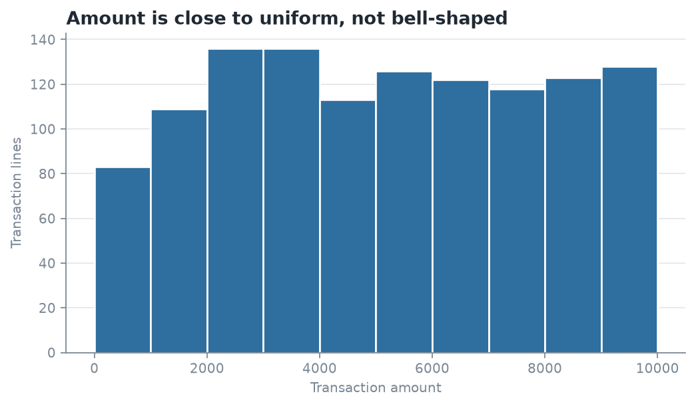
Figure 1.

Task 2.3 — Correlation Analysis

Pair 1 — Monthly orders vs monthly revenue
Measure | Value
Pearson r | +0.9227
r² | 0.8514
p-value | 1.98 × 10⁻²⁴
n | 57 months
Direction | Positive
Strength | Strong
Table 5. Correlation between monthly order count and monthly revenue.
Interpretation. A very strong positive relationship: months with more orders have proportionally more revenue, and order count alone accounts for about 85% of the variation in monthly revenue. The p-value is far below 0.05, so this is not chance.
This is the statistical form of the Checkpoint 1 finding. Checkpoint 1 observed that revenue fell while average order value stayed flat, and inferred that order count was doing the work. This tests that inference and confirms it. The business implication is direct: revenue is won by increasing the number of transactions, not the size of each one.

Pair 2 — Line quantity vs line amount
Measure | Value
Pearson r | +0.0446
r² | 0.0020
p-value | 0.123
n | 1,194 lines
Strength | Negligible — not significant at 5%
Table 6. Correlation between units sold and order value at the transaction-line level.
Interpretation. Essentially no relationship. Units sold explains 0.2% of the variation in order value, and at p = 0.123 we cannot reject the hypothesis that the true correlation is zero. A 20-unit order is worth no more, on average, than a 2-unit order.
This is a negative result, and it is the more useful of the two. The intuitive assumption — sell more units, earn more revenue — is false in this dataset, because unit price varies so widely across the twelve sub-categories that volume carries no information about value. Practically: a sales incentive built on units shifted would not raise revenue, and "units sold" should not be used as a performance measure here.

Supporting check — line amount vs line profit
r = +0.6753, r² = 0.456, p < 0.001, n = 1,194. A moderate-to-strong positive relationship, but notably not near 1.0: only 46% of profit variation tracks revenue. The remaining 54% is differences in margin between products. This supports the Task 2.2 observation that revenue is a weak proxy for profit.
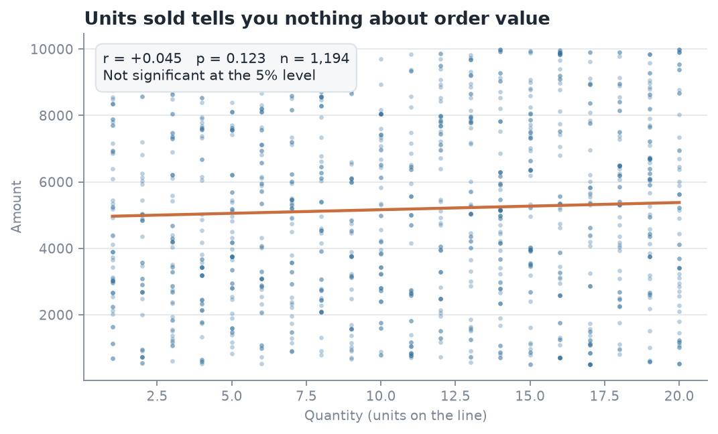
Figure 2.

Task 2.4 — Simple Linear Regression

Variables and why they were chosen
- Dependent variable (Y): monthly revenue
- Predictor (X): number of orders placed in that month
Chosen for three reasons: it tests the central Checkpoint 1 claim rather than asserting it; it had by far the strongest correlation of any pair examined; and it is actionable — a business can influence how many orders it wins far more readily than how large each one is.

Regression output
Statistic | Value
Sample size n | 57 months
Slope (b) | 5,224.25
Intercept (a) | −1,353.65
Correlation r | 0.9227
R² | 0.8514
Standard error of estimate | 15,099.14
Standard error of slope | 294.35
t statistic | 17.75
Degrees of freedom | 55
p-value | 1.98 × 10⁻²⁴
Significant at 5%? | Yes
Table 7. Simple linear regression of monthly revenue on monthly order count.

The regression equation
Monthly Revenue = −1,353.65 + 5,224.25 × (Orders in month)

Interpreting the output
The slope. Each additional order in a month is associated with about 5,224 more revenue. This figure is worth checking against something already known: the average transaction line is worth 5,178. The slope and the average order value agree to within 1%, which is exactly what should happen if revenue is simply order count multiplied by a stable average order size. The model is consistent with the data rather than merely fitted to it.
R² = 0.8514. Order count explains 85.1% of the month-to-month variation in revenue. The remaining 14.9% is product mix, seasonality and noise.
The p-value. At 1.98 × 10⁻²⁴ the slope is overwhelmingly significant. The null hypothesis is that the true slope is zero — that order count tells us nothing about revenue. With t = 17.75 on 55 degrees of freedom, we reject the null hypothesis: the relationship is real, not sampling noise.
The intercept. −1,353.65 is the predicted revenue at zero orders, which is both impossible and meaningless: no month in the data had fewer than 9 orders, so zero is far outside the observed range. The intercept is a mathematical artefact of fitting the line, not a business quantity.

Business forecasts from the model
Orders in month | Predicted revenue | Comment
15 | 77,010 | A weak month, below the historical average
20 | 103,131 | About the historical average (mean 20.1 orders)
25 | 129,253 | A strong month, near the 2022 peak rate
30 | 155,374 | Above almost anything observed — extrapolation
Table 8. Predicted monthly revenue at different order volumes.
The decision this supports. 2024 ran at 20.0 orders per month against 24.0 in 2022. The model puts the value of closing that four-order gap at roughly 20,900 per month, or 250,000 a year — which is very close to the 257,297 annual shortfall measured directly in Checkpoint 1. Two independent methods agreeing is a good sign the number is sound.
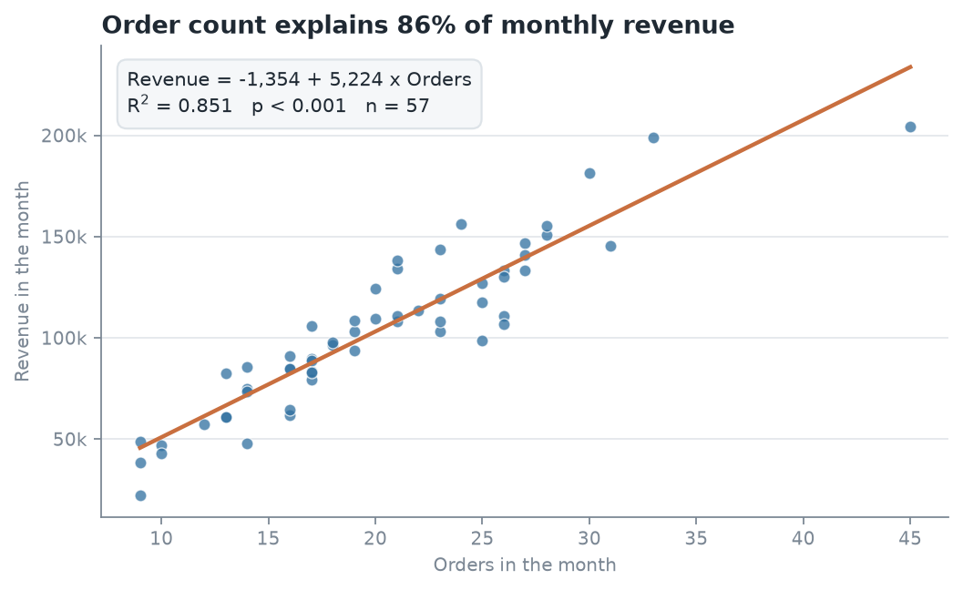
Figure 3.

Assumptions, limitations and conditions of use
- Linearity. The relationship is assumed to be a straight line. The scatter plot supports this across the observed range.
- Independence. Each month is assumed independent of the last. This is the weakest assumption here — monthly sales series are usually autocorrelated, and that inflates apparent significance. With t = 17.75 the conclusion survives comfortably, but the p-value should be read as "clearly significant", not as a precise probability.
- Range of validity. X was observed between 9 and 45 orders per month. Predictions outside that range, the intercept included, are extrapolation.
- Correlation is not causation. The model shows revenue and order count move together. It does not prove that forcing order count up would raise revenue by exactly 5,224 each time — if extra orders were won by discounting, the average order value would fall and the slope would not hold.
- One predictor only. A single variable cannot capture seasonality, product mix, or the Printer supply problem. Multiple regression in Checkpoint 4 is the natural extension.
- Synthetic data. The coefficients describe this file, not a real market.

Task 2.5 — Trend and Seasonality Analysis
The dataset is a time series, so this task applies. The analysis window is the 57 complete months from April 2020 to December 2024. January and February 2025 are held back and used to check the forecast.

Step 1 — Is there a linear trend to project?
Statistic | Value
Slope | +206.0 per month
R² | 0.0078
p-value | 0.515
Verdict | No significant trend
Table 9. Regression of monthly revenue on a simple time index.
Time explains less than 1% of the variation in monthly revenue, and at p = 0.515 the apparent upward slope is indistinguishable from noise.
This is a genuine finding, not a failure. The series is not a trend — it is a growth phase followed by a plateau. Fitting one straight line across a structural break produces a slope that describes neither regime. Projecting that slope forward would be the single easiest way to be badly wrong, so no growth rate is projected.

Step 2 — The seasonal index
Each calendar month's average revenue divided by the overall average month. 1.00 is an average month.
Month | Index | Reading | Month | Index | Reading
January | 0.679 | Weak | July | 0.966 | Average
February | 0.889 | Weak | August | 1.006 | Average
March | 1.025 | Average | September | 0.793 | Weak
April | 1.103 | Peak | October | 1.229 | Peak
May | 1.131 | Peak | November | 0.878 | Weak
June | 1.028 | Average | December | 1.273 | Peak
Table 10. Seasonal index by calendar month, April 2020 to December 2024.
December (1.273) and October (1.229) are the strongest months; January (0.679) is the weakest, at barely half a December.

Step 3 — The forecast
With no reliable trend, the forecast is recent level × seasonal index, where the level is the mean of the last 24 months (101,342).
Period | Index | Forecast | Actual | Error | Status
2025-01 | 0.679 | 68,853 | 112,906 | −39.0% | Complete — comparable
2025-02 | 0.889 | 90,064 | 84,712 | +6.3% | Complete — comparable
2025-03 | 1.025 | 103,870 | 52,198 | — | Partial month — not comparable
2025-04 | 1.103 | 111,806 | — | — | Future
2025-05 | 1.131 | 114,574 | — | — | Future
2025-06 | 1.028 | 104,156 | — | — | Future
Table 11. Six-period forecast with the two complete holdout months compared.
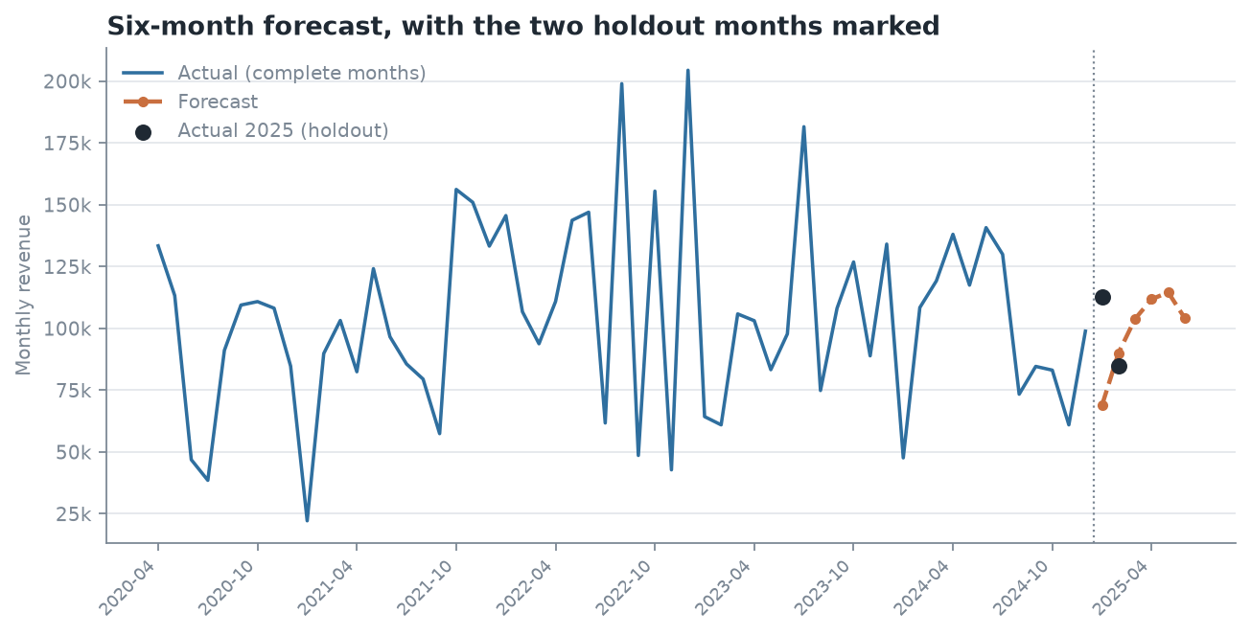
Figure 4.

Step 4 — How reliable is it? An honest assessment
Comparing the seasonal forecast against a naive alternative that ignores seasonality and predicts the recent average (101,342) every month:
Model | Jan error | Feb error | Mean absolute error
Seasonal (level × index) | −39.0% | +6.3% | 22.7%
Flat (level only) | −10.2% | +19.6% | 14.9%
Table 12. Forecast accuracy over the two complete holdout months.
The seasonal model did not win. It was better in February (6.3% against 19.6%) but much worse in January, and on average the simpler flat forecast was more accurate over these two months.
The cause is identifiable. January is historically the weakest month of the year at index 0.679, but January 2025 came in at 112,906 — above the recent average level, not 32% below it. Either the seasonal pattern has broken, or January 2025 is an unusual month. Two observations cannot distinguish those.
The honest conclusion: with two comparable months, no forecasting method can be validated here. This is reported as a sanity check, not as evidence the model works. What it does establish is that the seasonal adjustment is not obviously earning its extra complexity, which is worth knowing before anyone plans inventory on it.

Assumptions and conditions
- No trend is projected, because the trend test does not support one. If the business enters a new growth phase, the level must be re-estimated.
- The seasonal index assumes next year repeats the average shape of the last five. January 2025 shows that assumption failing in practice.
- The level is the mean of the last 24 months, chosen because the series is flat over that window.
- Two holdout months cannot validate a method. A meaningful test needs at least a full year.
- Nothing here models the Printer supply problem found in Checkpoint 1. If that is a supply failure and it is fixed, the forecast is too low; if it is lost demand, it may be too high.

Summary of Findings
- Order count drives revenue, and this is now proven, not inferred. r = 0.923, R² = 0.851, p < 0.001 across 57 months. The Checkpoint 1 inference holds up formally. (Tasks 2.3, 2.4)
- Units sold predicts nothing. r = 0.045, p = 0.123 — not significant. Volume-based targets and incentives would not move revenue. (Task 2.3)
- Revenue is a poor proxy for profit. Profit is right-skewed (+0.94) with a coefficient of variation of 82.9% against Amount's 54.2%, and only 46% of profit variation tracks revenue. (Tasks 2.2, 2.3)
- There is no linear trend to project. Time explains under 1% of variation (p = 0.515). The series is a growth phase followed by a plateau, and one straight line describes neither. (Task 2.5)
- The four-order-per-month gap is worth about 250,000 a year by the regression, independently corroborating the 257,297 shortfall measured directly in Checkpoint 1. (Task 2.4)
- The seasonal forecast did not beat a flat average over the two holdout months, and two months cannot settle the question. (Task 2.5)
Recommended next step for Checkpoint 3. Build the dashboard around order count as the primary KPI rather than revenue, since it is the leading indicator and the actionable one. Segment on margin rather than revenue, given how weakly the two are related.
Stated limitation. As established in Checkpoint 1, the dataset is synthetic — the flat, non-normal distributions of Amount and Quantity found in Task 2.2 are further evidence. The statistical methods and their interpretation are valid; the specific coefficients describe this file rather than a real market.

Reproducibility
python3 scripts/clean_and_load.py # rebuild the database
python3 scripts/build_workbook.py # build the Excel workbook
python3 scripts/make_figures_cp2.py # regenerate Figures 1-4
python3 scripts/build_docx.py # render this report to Word
Artefact | Path
Excel workbook | reports/Checkpoint_2_Workbook.xlsx
This report | reports/Checkpoint_2_Report.docx
Workbook builder | scripts/build_workbook.py
Figures | docs/figures/cp2_*.png
Native PivotTable guide | docs/checkpoint2_excel_guide.md
Individual Contribution Form | reports/Form_A_Individual_Contribution.md
Table 13. Checkpoint 2 artefacts and their locations.

