

**USER SENTIMENT TRACKING SYSTEM FOR A BRAND OR PRODUCT**

# SYSTEM DOCUMENTATION

# SUBMITTED BY,

# AGNES AHENDA

# DIT-01-8232/2023

**A SYSTEM DOCUMANTATION SUBMITTED IN PARTIAL FULFILMENT FOR THE AWARD OF DIPLOMA IN INFORMATION TECHNOLOGY BY ZETECH UNIVERSITY.**

# AUGUST, 2025

# DECLARATION

I declare that the contents of this document is my original work from my own research and study, The content is generated from absolute relevant external genuine information websites with no plagiarism.

AUGUST,2025

Agnes Ahenda

Student Name: ­­­­­­­­­­­­­­­­­­­_____________ Signature: _____________ Date: _____________

**DEDICATION**

**ABSTRACT**

# LIST OF TABLES

# LIST OF FIGURES

# DEFINATION OF KEY TERMS

# ABBREVIATIONS AND ACRONYMS

# 

# CHAPTER ONE: RESEARCH OVERVIEW

## 1.1 Statement of Problem

Many brands struggles to effectively monitor and analyze user sentiment across various platforms such as social media, review sites and customer feedback channels. The absence of a centralized, real-time sentiment tracking system often leads to delayed responses to negative feedback, missed opportunities to engage with customers, and inability to identify emerging trends or issues. For a specific brand of product, the lack of a robust sentiment tracking system results to challenges like, inability to gauge customer sentiment accurately, delay response to negative feedback, missed opportunities for positive engagement, difficulty in identifying trends and also manual analysis is time consuming and inefficient.

## 1.2 Study Justification

A User Sentiment Tracking System is vital for a brand to monitor and analyze customer feedback in real time. This study is justified as it enables the brand to improve customer satisfaction, proactively manage its reputation and make data driven decisions. By automating sentiment analysis, the brand can efficiently scale its efforts, stay ahead of competitors, and align with industry trends. Implementing such a system ensures the brand remains responsive to customer needs, enhances its products, and maintains a competitive edge in the market. The study will aim me with sufficient knowledge which will help me get prepare to develop the platform in the coming semester as my end of diploma project

## 1.3 Research Objectives

### 1.3.1 General Objective

(i)To develop a user sentiment tracking system for brand or product.

### 1.3.2 Specific Objectives

(i) To develop a system capable of tracking and analyzing user sentiment in real time across multiple platforms.

(ii) To implement algorithms to classify user feedback into positive, negative and neutral feedback to provide actionable insights for product improvement and marketing strategies.

(ii) To design the system to handle large volume of data and adapt new platforms, languages and evolving customer communication trends.

## 

## 1.4 FUCTIONAL REQUIREMENTS

|  |  |  |
| --- | --- | --- |
| User | User Activities | Features |
| **Product Managers** | * View real-time and historical sentiment trends for specific products or features. * Filter and analyze feedback by product, feature, or time period. * Receive alerts or summaries for significant changes in sentiment. * Export sentiment reports for product planning and review meetings | * Product filter dropdown in your Streamlit dashboard * Time range selector (daily, weekly, monthly views) * Sentiment trend charts for selected products * PDF report generation with product insights * Automated scheduled reports * Feature-level sentiment breakdown |
| **Marketing Teams** | * Monitor overall brand sentiment across platforms and campaigns * Visualize sentiment distribution and trends for marketing campaigns. * Identify and analyze positive/negative feedback for campaign effectiveness. * Download filtered sentiment data for further marketing analysis | * Campaign tagging system for feedback * Campaign comparison visualizations * Campaign performance reports * Competitor sentiment analysis * Marketing funnel sentiment tracking * User registration/login system * Role-based access control (RBAC) * User activity logging |
| **Administrators** | * Manage user accounts and assign roles (e.g., product manager, marketing team) * Configure data sources (add/remove datasets, connect APIs). * Oversee system health, data storage, and security * Generate and manage access to system-wide reports and dashboards | * **System health dashboard** * **Dataset upload/management system** |
| System | * Validating Sign up information * Calculate the payments to be made by the customer * Generate receipts * Track sales * Generate all feedbacks | * System health dashboard * Database management tools * Security audit logs |

**1.5 Breakdown of Tools and Resources to Be Used**

|  |  |  |  |
| --- | --- | --- | --- |
| **Tools** | **Purpose** | **Cost (ksh)** | **Alternatives** |
| Laptop | For developing host and website | 0 | N/A |
| Visual Studio Code | For developing website | Free open source | N/A |
| Pandas | For data manipulation and analysis. | Free open source | N/A |
| Scikit-learn | For machine learning models (sentiment classification) | Free open source | N/A |
| Streamlit | For building interactive web-based dashboards and visualizations | Free open source | N/A |
| Python | Main programming language for backend, data processing, and ML | Free open source | N/A |
| Matplotlib | For plotting charts and visualizations | Free open source | N/A |
| Wordcloud | For generating word cloud visualizations | Free open source | N/A |
| Joblib | For saving and loading trained models and vectorizers | Free open source | N/A |
| Kaggle CLI | For downloading datasets from Kaggle | Free tier | N/A |
| Local Data Storage | data folder for CSV datasets and SQLite database for structured storage | Free | N/A |
| Pre-trained Models | Sentiment analysis models and vectorizers saved as  .joblib files | Free open source | N/A |
| **Total** |  |  | 0 |

**1.6 Project Schedule Breakdown**

|  |  |  |  |  |  |  |
| --- | --- | --- | --- | --- | --- | --- |
|  | **PROJECT MILESTONES** | | | | | |
| **WEEKS** | **Project Planning & Analysis**  **(System Documentation: Cover page & Chapter One)** | **Project Design & Modeling**  **(System Documentation Chapter Two)** | **Project Development & Testing**  **(System Documentation Chapter Three)** | **Project Deployment**  **(System Documentation Chapter Three)** | **Final Touches of System Documentation**  **(Preliminary Pages, Chapter Four & References)** | **Project Presentation** |
| 18-23  May |  |  |  |  |  |  |
| 5-10  June |  |  |  |  |  |  |
| 19-23 June |  |  |  |  |  |  |
| 26-30 June |  |  |  |  |  |  |
| 2-6  July |  |  |  |  |  |  |
| 9-13 July |  |  |  |  |  |  |
| 16-20 July |  |  |  |  |  |  |
| 23-27 July |  |  |  |  |  |  |
| 30-4 July |  |  |  |  |  |  |
| 7-11 July |  |  |  |  |  |  |
| 14-18 July |  |  |  |  |  |  |
| 21-25 July |  |  |  |  |  |  |
| 11  Aug |  |  |  |  |  |  |

***Table 1.6 Project Schedule Gantt Chart***

**CHAPTER TWO: DESIGN AND MODELLING**

**2.1 Introduction to Modelling**

User sentiment tracking system use AI and NLP to analyze customer opinions from social media, reviews, and surveys. The sources reviewed are not older than 5 years in the past as of the time this paper was written (2025) and this ensures that only current and reliable data solutions are investigated. APA7 has been used to conduct in text citation for this paper and referencing at the end of this paper. The research findings shows that modern machine learning models improve accuracy, helping brands enhance reputation, customer satisfaction, and decision making. However, challenges like sarcasm detection and fake reviews persist. Advancements in big data and AI continue to refine sentiment analysis, making it crucial for brand success. The section has the following sub sections, empirical review deals with solutions, and conclusion which summarizes the contents of conceptual and empirical review.

**2.2 User Interface Model**

A user sentiment tracking system classifies sentiments as positive, negative or neutral helping brands improve reputation, customer engagement and product strategy. Key challenges include sarcasm detection, fake reviews and contextual misinterpretation. Advancements in AI and big data analytics continue to refine sentiment tracking, making it valuable tool for brand.

2.2.1 Sign up Form

This form will allow a new customer to fill in their details so that they can start using the system and it will look as follows:

First name

|  |
| --- |
|  |

Second name

|  |
| --- |
|  |

Email

|  |
| --- |
|  |

Password

|  |
| --- |
|  |

Confirm Password

|  |
| --- |
|  |

|  |
| --- |
| Register |

|  |
| --- |
| Cancel |

Already have an account. Login

2.2.2 Login Page

In this page, the customer will enter his/her login credentials to access the system, and shall look as pictured below:

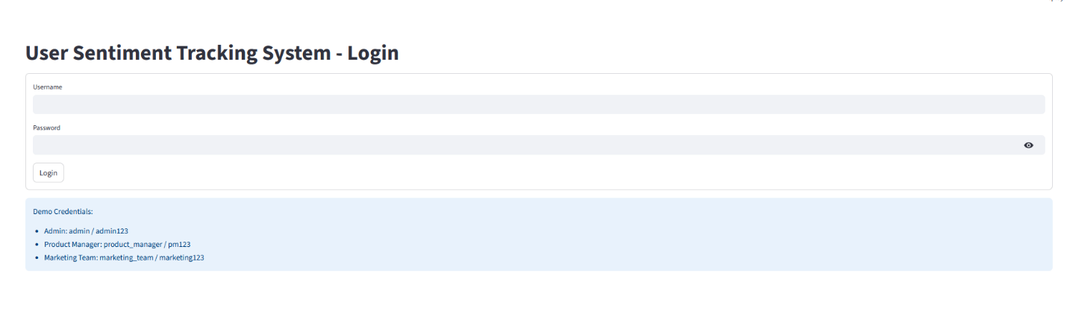

*Fig 2.2.1 Login page*

**2.2.3 Admin Page**

The Admin Page provides comprehensive system administration capabilities, enabling administrators to manage datasets, users, and monitor system health while maintaining full oversight of the sentiment tracking platform.

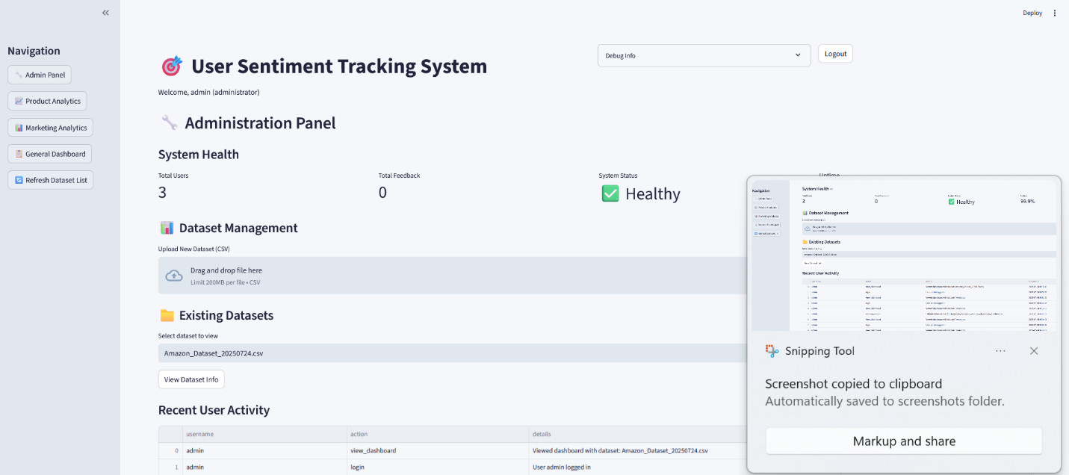

*Fig 2.2.3.1 Admin Page*

**2.2.3 Dashboard**

The General Dashboard serves as the universal interface accessible to all authenticated users, providing essential sentiment analysis visualizations and basic system functionality regardless of role permissions

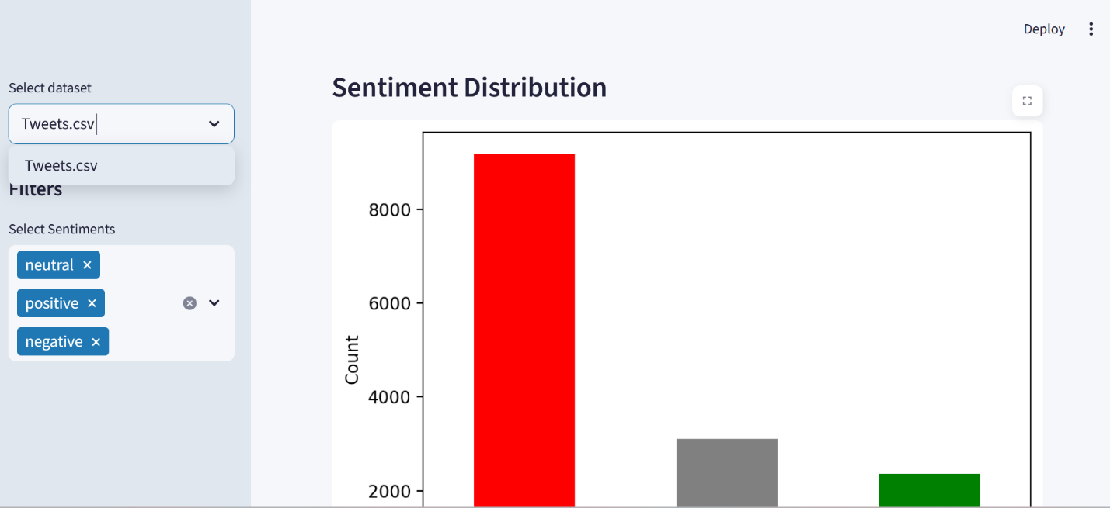

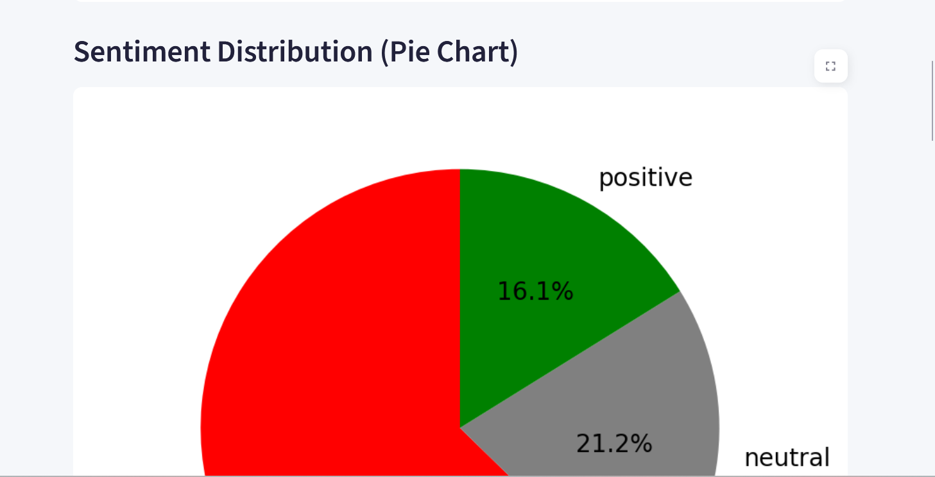

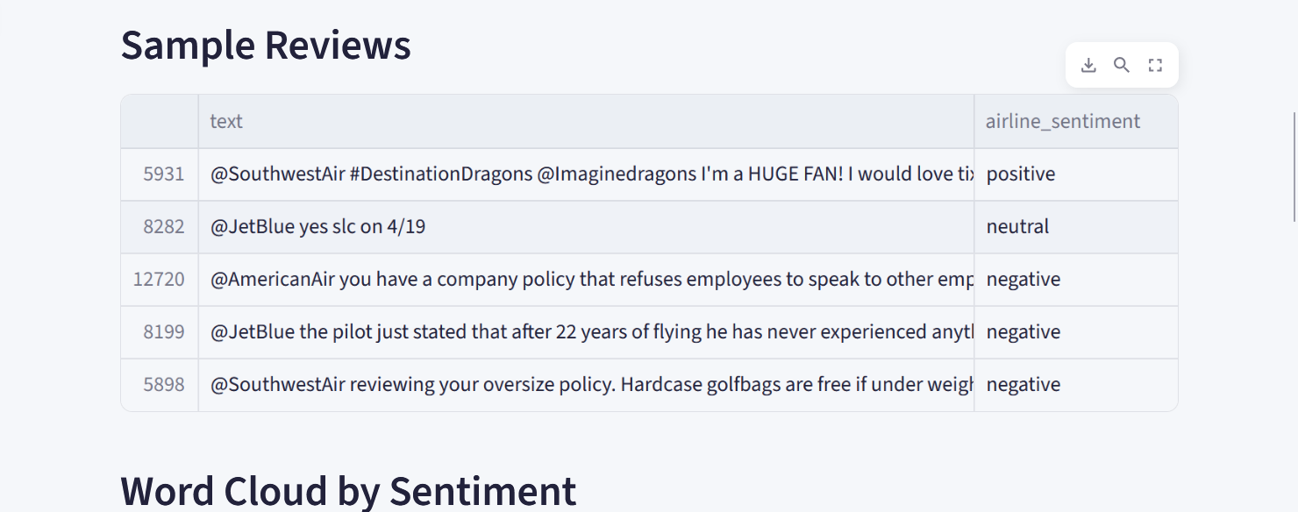

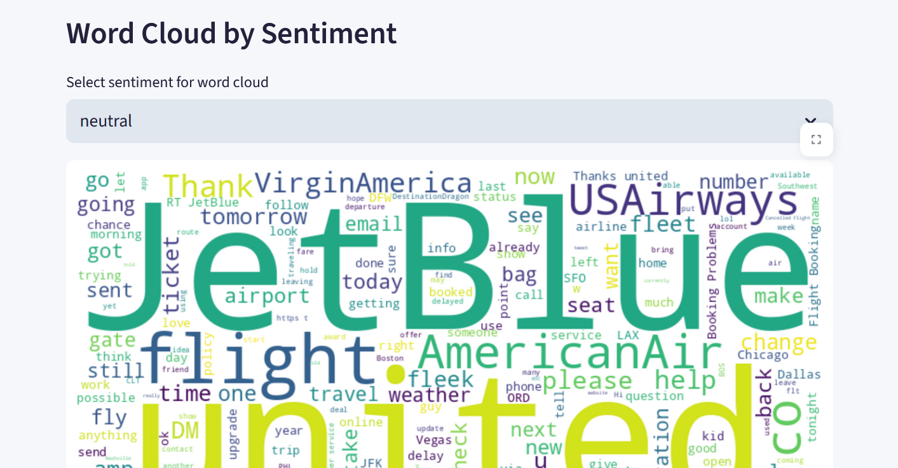

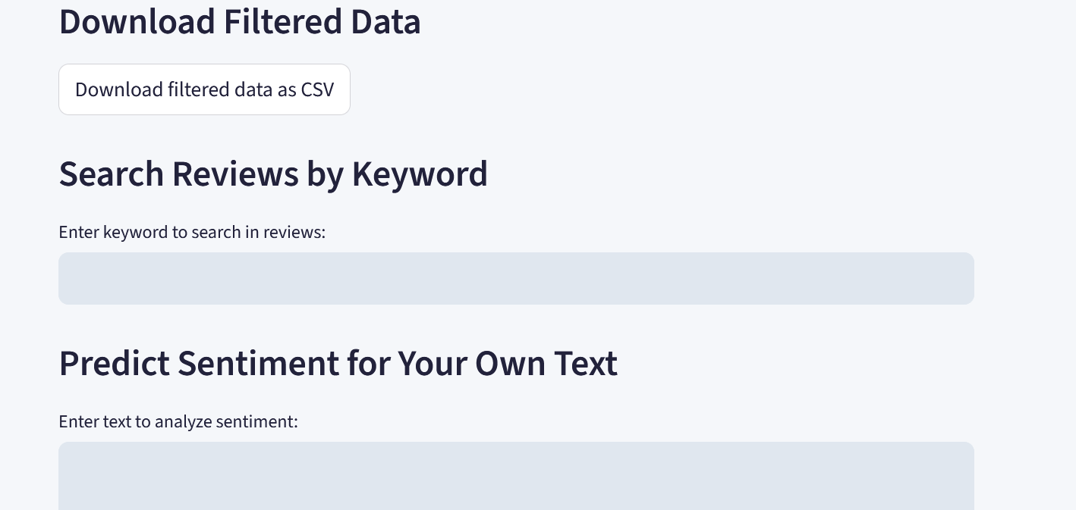

*Fig 2.2.3.1 User Dashboard*

**2.2.4 Product Manager Dashboard**

The Product Manager Dashboard provides specialized tools for product-focused sentiment analysis, root cause identification, and actionable business intelligence to improve product performance and customer satisfaction.

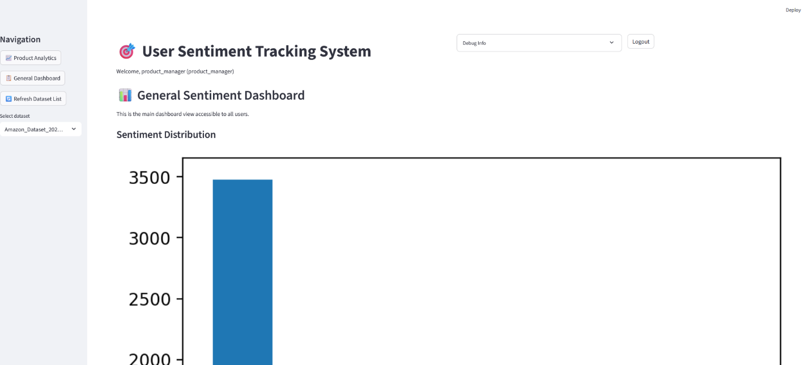

*Fig 2.2.4.1 Product manager dashboard*

**2.2.5 Marketing Team Page**

The Marketing Team Page focuses on brand sentiment monitoring, campaign performance analysis, and cross-platform sentiment tracking to support marketing strategy and brand management initiatives.

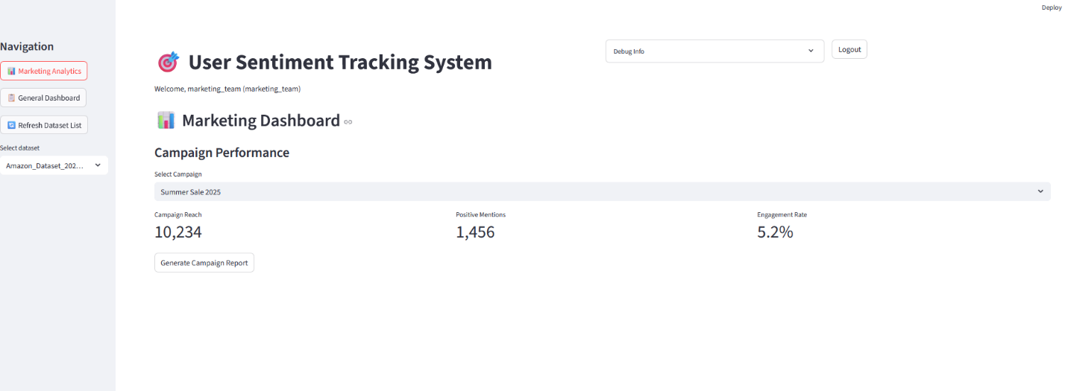

*Fig 2.2.5.1 Marketing Team page*

**2.3 Logic Model**

The Logic Model represents the systematic flow of data, processes, and decision-making within the User Sentiment Tracking System, illustrating how inputs are transformed into actionable business intelligence through structured workflows and data relationships.

**2.3.1 Flow Chart**

**Start**: The process begins when a user uploads data or connects an API.

**Ingest Feedback**: The system imports and stores feedback data.

**Preprocess and Clean Text**: The text is cleaned and prepared for analysis.

**Classify Sentiment**: The sentiment model analyzes the text and assigns a sentiment label.

**Store Results**: The results are saved in the database.

**Visualize and Report**: The system generates visualizations and reports for users.

**End**: The process completes

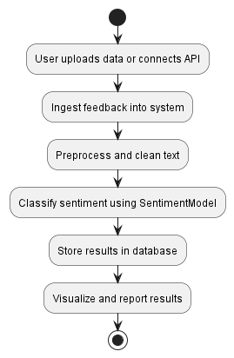

**2.3.2 Use Case Diagram**

* **Actors**:
  + **Admin**: Manages users, data sources, and sentiment models.
  + **ProductManager**: Views product sentiment and downloads reports.
  + **MarketingTeam**: Views brand sentiment and analyzes campaign feedback.
* **Use Cases**:
  + **Manage Users/Data Sources/Models**: Admin tasks for system configuration.
  + **View Product/Brand Sentiment**: Product managers and marketing teams analyze sentiment data.
  + **Analyze Campaign Feedback**: Marketing teams assess the impact of campaigns.
  + **Visualize Data**: All users can view dashboards and charts.
  + **Download Reports**: Users can export data for further analysis.

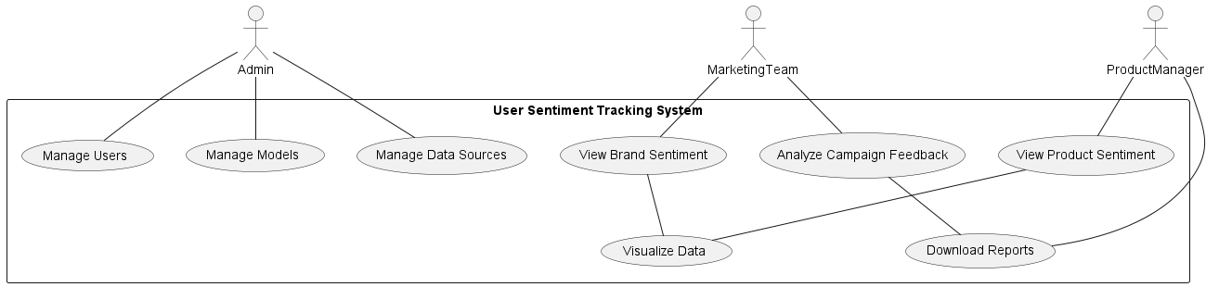

**2.3.3 ERD Diagram**

User: Represents people who interact with the system (admins, product managers, marketing team). Each user has a unique ID and role.

Product: Represents products being tracked for sentiment. Each product has a unique ID, name, and category.

Feedback: Stores individual feedback entries (reviews, tweets, etc.), linked to a user and a product. Contains the feedback text, platform, date, and sentiment label.

SentimentModel: Represents the machine learning model used for sentiment classification, including versioning and description.

Relationships:

* + A user can submit multiple feedback entries.
  + Each feedback can be associated with a product.
  + The sentiment model is used to classify feedback**.**

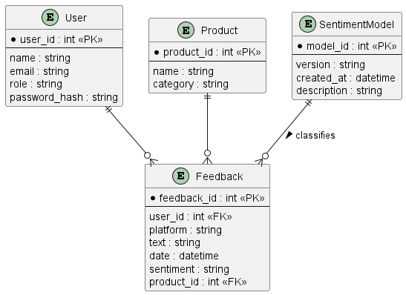

2.3.2 Package Diagram

Login

Password recovery

User registration

3.1 Validate Sign Up

SSSSSSSSSSSSSSSDDDDFSSASSSF

Start

User Info Input

Success Message if the details entered are correct

Error Message if the details entered are incorrect

Details entered are correct and all filled

Open login page

Stop

**CHAPTER THREE: SYSTEM IMPLEMENTATION**

**(DEVELOPMENT, TESTING AND DEPLOYMENT)**

**3.1 Introduction**