|  |
| --- |
| Group 2  Shawn Sabraw  Rob Bishop  Asma Javaid  Praveena Pinnika  Samira Saki |

|  |
| --- |
| COMP-6905 |
| Nature’s Palette |
| Assignment 1 |

Table of Contents

Vision Document 3

Introduction 3

Problem Statement 3

Stakeholders & Key Interests 3

Users & User-Level Goals 4

Summary of System Features 4

Project Risks 4

Use Cases 5

System Use Cases 5

Brief Descriptions 6

Detailed Descriptions of Use Cases 7

Use Case: Upload 7

Use Case: Search 8

Use Case: Download 9

Domain Model 10

Entities: 10

Boundaries: 10

Controls: 10

Sequence Diagrams 11

Upload File 11

Download File 11

Search 12

Design Goals 13

Logical Architecture 14

System Decomposition 15

Web Based Resources 16

# Vision Document

## Introduction

For this project, the aim is to design and implement a web application that will allow users to upload, search, and download spectral data that can be used in research and additional projects through useful search tools and data itself.

## Problem Statement

Research projects that require quantification of colours usually require thousands of spectral measurements. The issue in this; for researchers, is obtaining all that data. For example, comparative studies in birds have characterized the plumage colours for over 40% of described species of birds. However, less than 5% of that data is publicly available to other researchers. The applications that this data is available through are not designed in a way that makes them easy to use and/or provide the metadata that would allow that information to be used in other studies. Consequently, the possibilities for larger studies are very limited and lots of resources are being wasted in order to obtain (usually duplicating) the data for different research projects.

## Stakeholders & Key Interests

|  |  |
| --- | --- |
| Stakeholders | Key Interests |
| Researchers  (Professors/Students) | Using the data provided in their projects |
| Hobbyists/Users | Adding their data to be used in research projects |
| Establishments | Access to a large database of spectral information for R&D |

## Users & User-Level Goals

|  |  |
| --- | --- |
| User | Goals |
| General User  (Researchers/Hobbyists) | Login, Upload/edit/search/download spectral data, refine search through meta data/georeferencing/colour range, Upload many files … |
| Administrator | Login, Upload/edit/search/download/remove spectral data, edit user’s access rights, edit parts of the application, adding meta data tags … |

## Summary of System Features

* The application will allow users to upload spectral data with it’s meta data tags.
* The application will let users download the data as well as it’s meta data.
* The application will let users search through the data using georeferencing, meta data tags, and specifying a colour range.
* The application will allow users to edit their uploads in case of mistakes.

## Project Risks

* Utilizing and learning Node.js, MongoDB and other modules as a client -> server model.
* Mass uploading of thousands of files as well as storing them in a way to allow for scaling.
* Using a Python/R package in order to “clean” spectral data that is being uploaded.
* Using a polygon georeferencing tool to search meta data in a database.

# Use Cases

## System Use Cases

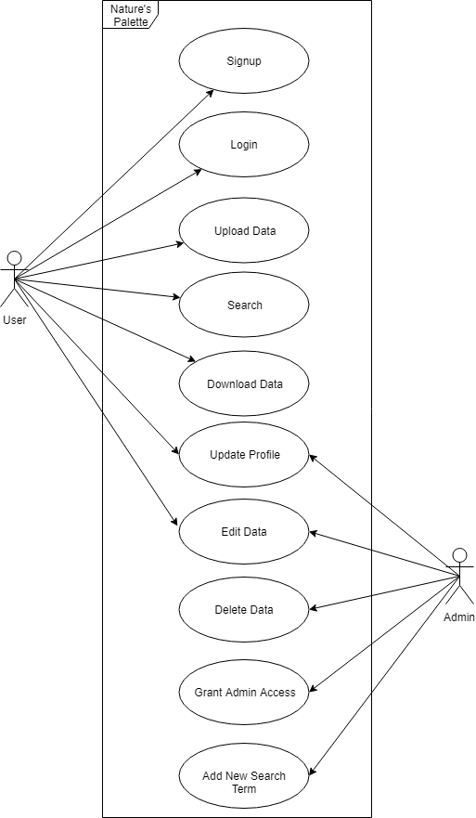

## Brief Descriptions

|  |  |
| --- | --- |
| **Use case** | **Description** |
| SignUp | User enters in the required information (username, password, etc.…) to create an account. |
| Login | User enters in the required information to gain access to their account. |
| Update Profile | User updates their profile details. Admins are also able to edit their own as well as other user’s details. |
| Upload | User uploads their spectral data accompanied with their meta data. |
| Search | User searches for spectral data giving metadata as input terms. |
| Download | User downloads the spectral and metadata provided. |
| AddNewSearch | Admin adds new search terms for users to search by. |
| AdvancedSearch | User searches for spectral data by providing multiple filters (regions, colour space, etc.…) given in the advanced search. |
| ChangeAccess | Admin changes a user’s access to ban, unban, or make them an admin. |
| Edit Data | User (with an account) can edit or delete their own data. Admins can edit and delete any data. |

# Detailed Descriptions of Use Cases

## Use Case: Upload

|  |  |
| --- | --- |
| Use Case Name | Upload |
| Participating Actors | User |
| Flow of Events | Main   1. User is prompted to upload the specified files. 2. User selects appropriate files to upload and continues. 3. After file upload, the spectral data will be compared to the metadata. 4. The data is confirmed with the metadata and is saved to the repository before displaying a success status message to the user. (**Alt1:** The metadata does not match)   **Alt1:** (The metadata does not match)   1. The data and metadata do not match. The data is not saved, and a failure status message is displayed to the user. |
| Entry Condition | * User clicks upload button |
| Exit Condition | * User clicks “x” or navigates away from the upload prompt |
| Quality Requirements | * Upload should be fast for the user; the server should do most of the work. |

## Use Case: Search

|  |  |
| --- | --- |
| Use Case Name | Search |
| Participating Actors | User |
| Flow of Events | Main   1. The user enters a query. 2. The webpage communicates the query to the server. 3. A series of entries that match the user’s query are displayed, each with some information about the entry. (**Alt1:** The query did not match)   **Alt1:** (The query did not match)   1. A status message is displayed saying that no data matched the user’s query. |
| Entry Condition | * User clicks on the search field |
| Exit Condition | * The user navigates away from the page |
| Quality Requirements | * Search should take place within a reasonable speed (To be determined by client) |

## Use Case: Download

|  |  |
| --- | --- |
| Use Case Name | Download |
| Participating Actors | User |
| Flow of Events | Main   1. The user is prompted for the download. 2. The user selects the type of files to download. 3. The server downloads the file data to the user. (**Alt1:** File Is Not Ready Yet)   **Alt1:** (File Is Not Ready Yet)   1. The data is not available yet for download. |
| Entry Condition | * Clicks download button |
| Exit Condition | * The download finishes or the user navigates away from the page |
| Quality Requirements | * Download should be available quickly |

# Domain Model

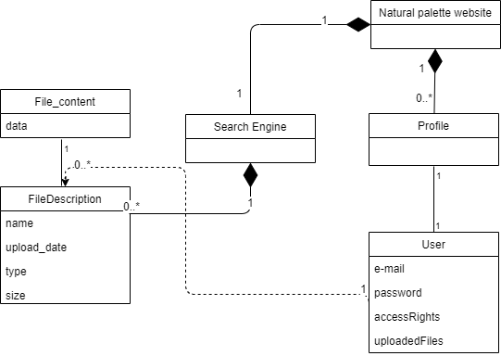

### Entities:

* Users
* FileDescription
* FileData

### Boundaries:

* Nature’s Palette website
* Search Engine
* Profile

### Controls:

* Upload manager
* Search manager
* Download manager
* Authentication manager
* Profile manager

# Sequence Diagrams

## Upload File

## Download File

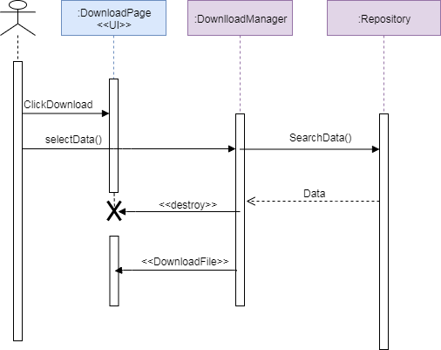

## Search

# Design Goals

* **Advanced search functions:** The search engine must allow users to query the database using three main approaches. Through Metadata (subset of Dublin Core and Darwin Core terms) using logical operators. Through georeferencing using polygon limits on a map. As well as regions within the color-spaces of key models.
* **Ease of use:** The interface should be intuitive and very easy to use for users of any skill level.
* **Flexibility:** Allow for the addition of search terms and visual model metrics as they may change over time.
* **Scalability:** Approximately 1 million files could be uploaded in the first year and the system should be able to support an additional 1-3 million files a year.

# Logical Architecture

The architecture for this application could potentially use the Client/Server architectural style. However, we need to use the repository style as well, so in order to do this we have chosen to use the Three-Layer Architectural Style.

* A user interface layer (Webpage), which will be allow for interaction with the second layer as well as displaying of any information.
* A middleware layer (NodeJS), which is responsible for accepting any requests and of processing of data before it is sent to the first(webpage) or third (MongoDB) layer.
* A database layer (MongoDB), which responds with data queried to/from the second (NodeJS) layer.

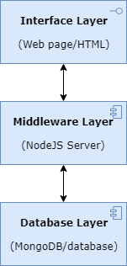

# Web Based Resources

As a proof of concept for the viability of the chosen technologies, a sample website has been created. It allows the uploading of files and displays a list of files that have been uploaded. It can be visited here:

[http://sc-2.cs.mun.ca](http://sc-2.cs.mun.ca/)

The Github repository for this project is available at:

<https://github.com/Zerocrossing/9605SEGroup2>

# Group Points

**(50 points):**

Shawn Sabraw – 10 points

Rob Bishop – 10 points

Asma Javaid – 10 points

Praveena Pinnika – 10 points

Samira Saki – 10 points