CST363 Spring 2018A Quiz 2 Name ________Christopher Holmes______________________________

1. From your reading of the article ***DataStructuresForDatabase*** which type of index (B-tree or hash) would be best for a **SELECT** statement that has a **WHERE** clause with the predicate ***salary between 30000 and 70000***? For full credit, you must explain your reasoning.

Because we are using a range of between 30000 and 70000, a tree will need to be used because on a hash table you cannot select a range like the predicate contains in this example.

Using the Art Course tables of course, enrollment and customer, (download and run the ***Art Course Tables .sql*** script) I want to find how many students are enrolled in each course. If no students are enrolled, I want the course to appear in the result with a count of 0.

I do the query

select *

from course c, enrollment e, customer s

where s.customernumber = e.customernumber and

e.coursenumber = c.coursenumber

group by c.CourseNumber

and get back the result

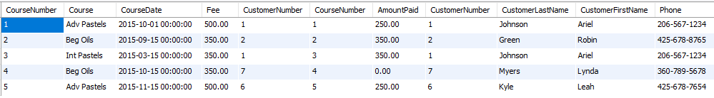

1. Explain the result that is returned by MySQL and why it is incorrect.

When running the query as is, we get an error because of the group by statement that is being included in the original query provided. We are not able to group by because we have more values in the select statement that are not allowed.

1. What would be the correct select statement to get the information?

To get the information as displayed in the picture above:

|  |
| --- |
| select *  from COURSE c, ENROLLMENT e, CUSTOMER s  where s.customernumber = e.customernumber and  e.coursenumber = c.coursenumber |

1. Explain in your own words what is the difference between an outer join and an inner join.

An inner join will return the intersection of the data from the queries that are run. An outer join will give you the union of the information.