COMPUTER VISION LABORATORY

Experiment One
Object Detection and Recognition
A two class mouse and cup detector trained with an audited dataset and deployed on Jetson with ROS 2 output

Final model | YOLO11n version 13
Target classes | mouse and cup
Training input | 768 by 768 pixels
Deployment | Windows ONNX and Jetson PyTorch CUDA
Experiment period | August to September 2026

Submission note All numerical claims in this report are tied to files stored in the project workspace. The older CUP3 clip is excluded from the final evidence because it used an earlier unsuccessful test.

Executive Summary
I built a two class detector for computer mice and drinking cups, with the complete route from data capture to Jetson deployment. The final version is YOLO11n v13. It was fine tuned at an input size of 768 pixels and exported as both PyTorch and ONNX weights. The live program draws the class name, bounding box, confidence and smoothed frame rate, while an added ROS 2 node publishes the same detections as vision_msgs messages.
The final exported dataset contains 793 images: 492 training images, 61 validation images and 240 held out test images. The training partition contains 49 empty label files that intentionally act as hard negative samples. These negatives were important because earlier models often treated black phones, chair backs, robot shells and laptop edges as mice. Version 13 adds eighty manually reviewed frames, mainly horizontal cups, new backgrounds and difficult mouse poses.
For the practical acceptance check, I selected twenty clearly different viewing conditions. Eighteen scenes passed the strict rule that every expected target must be detected and no extra false box may appear. The resulting scene accuracy is 90 percent, which exceeds the required 80 percent. Eighteen selected scenes come directly from Jetson recordings. Two horizontal cup scenes come from a v13 ONNX replay of the original raw capture; they were added because the older CUP3 clip was upright and unsuccessful, so it could not prove horizontal cup recognition.
The selected Jetson evidence frames show reported speeds from 15.7 to 21.2 FPS, with a mean of about 17.9 FPS. This is comfortably above the required 5 FPS. I also completed and built a ROS 2 Humble package named yolo_detection_ros2. It publishes Detection2DArray messages on the /yolo/detections topic and can save the rendered stream. A real Jetson topic echo remains the correct final classroom demonstration, but the source package and colcon build verification are now part of the submission.
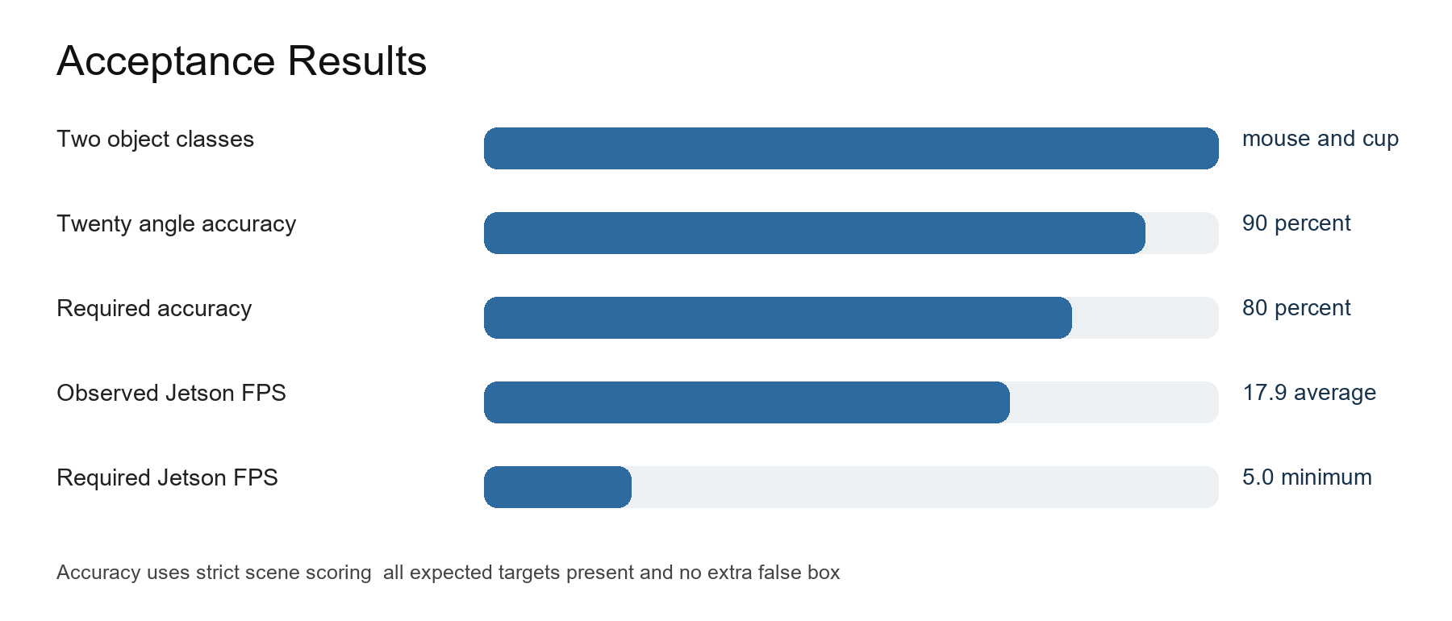
Figure 1 Summary of the measured acceptance results

1 Requirements and Evidence
I treated the assessment sheet as a checklist rather than a general description. This helped prevent a common problem in vision experiments: a model may look good in a few pictures while one of the actual requirements has never been tested. The table below links each requirement to a concrete file or observation.
Requirement | Evidence | Status
Two desktop classes | Class IDs 0 mouse and 1 cup in dataset.yaml | Met
Self collected and labelled data | Audited v13 dataset and X AnyLabeling batches | Met
Jetson execution | Nine v13 Jetson result clips and CUDA deployment script | Met
Class box and confidence overlay | Rendered v13 videos and live inference code | Met
Twenty angles at 80 percent | 18 correct scenes from 20 selected scenes | Met at 90 percent
At least 5 FPS on Jetson | 15.7 to 21.2 FPS in selected Jetson frames | Met
Save results and errors | Annotated and raw video outputs plus review frames | Met
ROS 2 detection publishing | Built yolo_detection_ros2 package | Implementation met

The distinction between implementation and runtime evidence matters for ROS 2. The package compiles in the configured Ubuntu 22.04 ROS 2 Humble environment, but a saved ros2 topic echo from the Jetson would be stronger than source code alone. I therefore describe the node as implemented and build verified, without inventing a live topic capture that is not stored in the repository.
- Accuracy is scene based because the teacher accepted twenty angles rather than twenty unique object instances.
- The horizontal cup evidence is included as an explicit supplement and not mixed into the Jetson FPS calculation.
- The old CUP3 recording is intentionally ignored because it showed an upright stainless cup with no successful detection.

2 System Design
The project is organised as a feedback loop. I first collect short videos or still images, extract representative frames, create or correct bounding boxes, audit the labels, export a deterministic YOLO directory, train a new model version, and then test it on a live camera. Wrong predictions are not simply discarded. They are converted into the next training batch: missed targets become positive samples after manual annotation, while false alarms become empty label hard negatives.
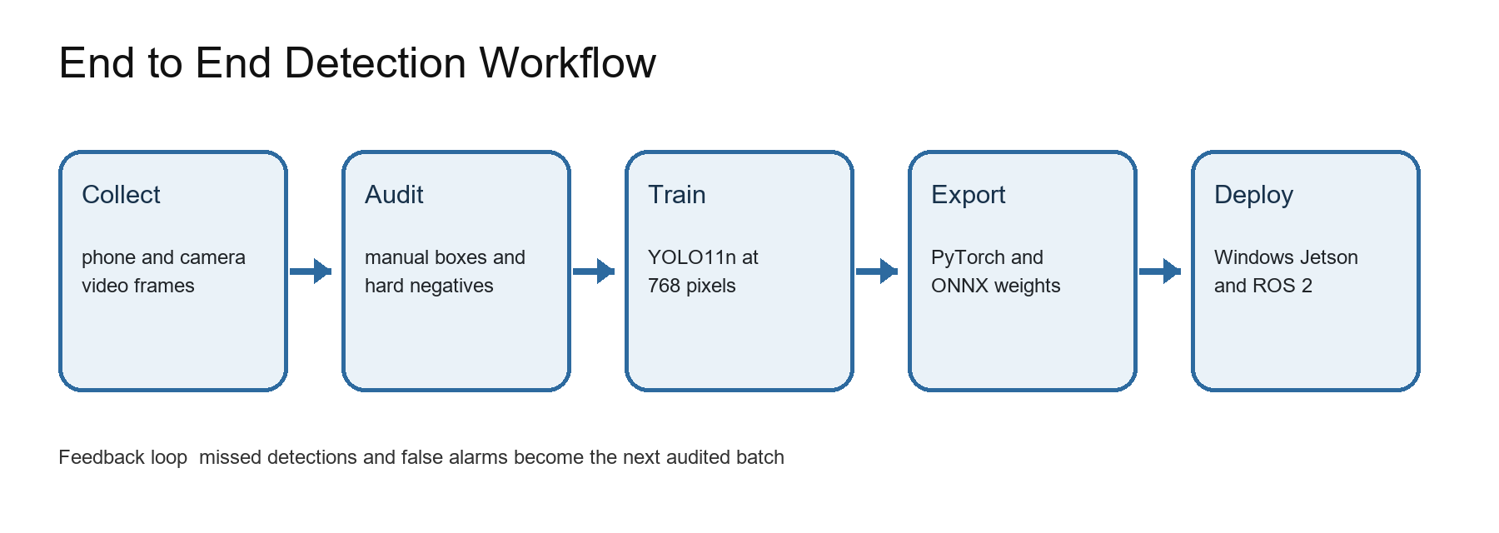
Figure 2 Data training deployment and error feedback workflow
This workflow explains why the project progressed through several versions. Each version addressed a specific failure rather than changing the model architecture at random. Versions 9 and 10 improved camera domain coverage. Version 11 added frames taken from missed and false detections. Version 12 included phones as difficult negative examples because phones were often predicted as mice. Version 13 concentrated on horizontal cups and additional poses.
The output side has two parallel paths. The Windows path uses ONNX Runtime and is convenient for camera testing and data capture. The Jetson path uses the PyTorch best.pt weight with CUDA through Ultralytics. The ROS 2 node wraps the Jetson prediction result in standard vision_msgs structures so other robot nodes can consume the class, confidence and bounding box without parsing screen graphics.

3 Development and Deployment Environment
Component | Development computer | Jetson deployment
Operating system | Windows 11 and WSL 2 Ubuntu 22.04 | Ubuntu 22.04 with JetPack 6.2.1
Python | 3.10.12 training and 3.13 ONNX | Jetson Python environment
Deep learning | PyTorch 2.12.1 plus CUDA 12.6 | PyTorch 2.5.0a0 Jetson build
Detection framework | Ultralytics 8.4.127 | Ultralytics 8.4.128
Image processing | OpenCV 4.10 | OpenCV 4.13
ROS | ROS 2 Humble in WSL | ROS 2 Humble with vision_msgs
Camera | USB camera index 1 | V4L2 camera device

WSL 2 was useful because Ultralytics training and ROS 2 Humble both behaved like a normal Ubuntu installation while the dataset remained on the Windows F drive. Training paths in args.yaml therefore appear as /mnt/f paths. The Windows ONNX program uses camera index numbers, while Jetson normally exposes the same hardware as /dev/video0 or /dev/video1.
I used environment checks before long training jobs. The checks confirm that Python can import OpenCV, PyTorch and Ultralytics, that CUDA is visible, and that ROS 2 commands are sourced correctly. An environment check is not a substitute for a task test. For example, publishing a test string proves DDS communication but does not prove that object detection messages contain correct boxes. This distinction led to the dedicated detector node added later.
python scripts/check_env.py
python scripts/check_yolo.py
bash scripts/check_ros2.sh

4 Object Classes and Annotation Policy
The class set is intentionally small. Class 0 is mouse and class 1 is cup. Both are common desktop objects, but their shapes are not equally easy. A cup is often tall and visually distinctive. A mouse can be small, dark and similar to phones, power banks, chair parts or robot components. The label policy therefore needs consistency more than complexity.
ID | Class | Box rule | Important edge cases
0 | mouse | Tight box around the visible mouse body | Side view underside hand occlusion and small distant views
1 | cup | Tight box around the visible cup body | Horizontal pose partial occlusion lid and reflective surfaces

When two target objects overlap, both are labelled if each remains meaningfully visible. This is not duplicate annotation. A duplicate exists only when two boxes describe the same instance. Earlier audits found no same class duplicate box with intersection over union above 0.5. Empty label files are valid when no mouse or cup appears; they teach the model that a visually similar black object is background.
I reviewed model generated prelabels manually in X AnyLabeling. Prelabels accelerated the first pass, but they were never treated as ground truth automatically. I corrected missing objects, removed boxes around phones and robot bodies, and checked that boxes did not extend outside the image. Two v13 boxes near image borders were clipped during export, and the audit report contains no fatal errors.

5 Data Collection Strategy
The earliest data came from phone videos and nearby camera views. That produced many frames, but adjacent frames were often nearly identical. A large number of similar frames can make the dataset look bigger without adding new information. Later collection sessions therefore focused on meaningful changes: front and side views, high and low camera positions, rotations, partial hand occlusion, changes in distance, new backgrounds and difficult objects that had caused false alarms.
The horizontal cup session was recorded specifically after the assessment requirement changed. It includes a cup lying fully on its side, movement across the table and several backgrounds. Eighty representative frames were selected and manually reviewed for version 13. The original raw video was kept so that the final model could later be replayed on exactly the captured sequence.
- Positive diversity included upright cups, horizontal cups, blue and green cups, mouse top views, side profiles and underside views.
- Hard negatives included phones, laptop edges, screens, chairs, bags, robot bodies, cables and other black objects.
- Raw and annotated videos were both saved where practical so wrong predictions could be reproduced without filming again.
- Frames from one continuous scene were not relied on as independent proof of generalisation.
The final twenty angle test is separate from the training set audit. It is a practical demonstration rather than a substitute for the held out test partition. Both forms of evaluation are needed: the image split produces repeatable numerical metrics, and the live sequence shows whether the program behaves acceptably during actual use.

6 Dataset Cleaning and Audit
Several model failures were traced to data quality rather than the neural network design. A file named hard_robot_mouse originally suggested a mouse but contained no visible mouse; after manual inspection it was intentionally retained as a negative. A laptop negative sample contained a partial cup at the left edge, so that cup was labelled. The export script was also corrected so train_candidate and not_assigned rows could not silently enter the training set.
The audit process performs structural checks before training. It verifies that every exported image has one matching label file, class IDs are valid, normalised coordinates are within range, box width and height are positive, and the train validation and test lists do not contain the same file. It also produces an exclusion list so rejected or unassigned samples remain visible for later review rather than disappearing.
Audit check | Reason | v13 outcome
Image label pairing | Prevents unintentional missing annotations | Passed
Class ID range | Only mouse and cup are valid | Passed
Coordinate range | YOLO values must remain between zero and one | Passed after two clips
Empty labels | Retains deliberate hard negatives | 58 in audit and 55 in exported splits
Split membership | Avoids hidden train candidate promotion | Explicit train val test only
Fatal audit errors | Stops training on invalid data | None

7 Version 13 Dataset Composition
The authoritative exported directory contains 793 images. Parsing the label files directly gives 635 mouse boxes and 422 cup boxes. There are 55 empty labels across the three splits. The counts below are calculated from the actual exported files rather than copied from a planning note.
Split | Images | Mouse boxes | Cup boxes | Empty labels
train | 492 | 402 | 273 | 49
val | 61 | 59 | 33 | 0
test | 240 | 174 | 116 | 6
Total | 793 | 635 | 422 | 55

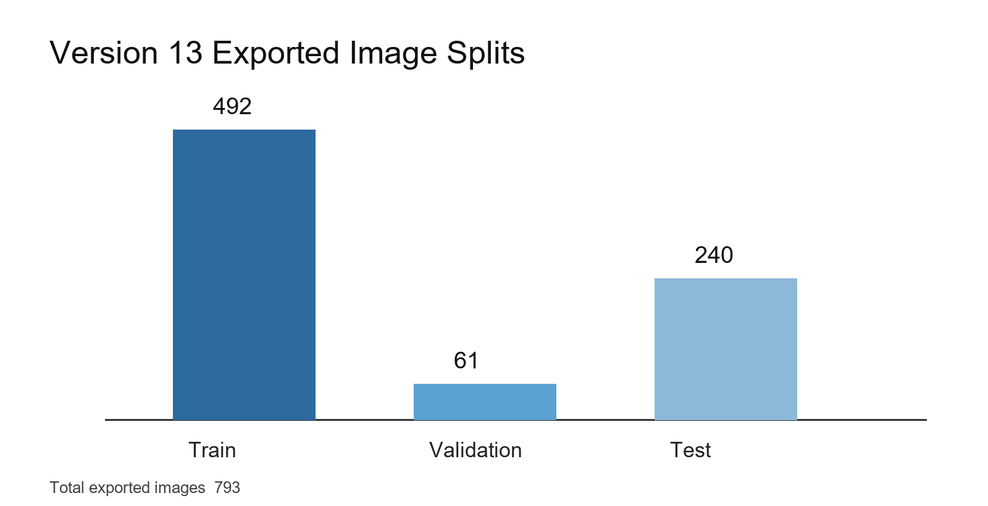
Figure 3 Exported train validation and test image counts
The test partition is relatively large because it preserves independent original scenes and is reused for comparison between model versions. The training partition is smaller than the raw audit store because 461 audit records are explicitly excluded. This is preferable to increasing the count with uncertain or duplicate samples.

8 Dataset Version History
Version | Primary change | Reason
v7 | First audited baseline at 768 pixels | Establish repeatable training
v8 | Cleaned export and evaluation scripts | Improve split reliability
v9 | External camera data | Reduce camera domain mismatch
v10 | Manual camera reannotation | Improve mouse and cup angle coverage
v11 | Live error feedback samples | Correct misses and false positives
v12 | Phone hard negatives and mouse views | Stop phone to mouse confusion
v13 | Horizontal cup and new environments | Meet the horizontal cup requirement

This version history is useful because model performance did not improve monotonically on every metric. Version 13 specialised the model for a new pose, but its held out test mAP was slightly lower than version 12. That is not hidden in this report. The practical v13 acceptance test nevertheless passed the required threshold, and the horizontal cup supplement demonstrates the new behaviour that motivated the version.
Keeping separate version folders and training scripts makes the experiment reproducible. It also prevents a good weight file from being overwritten by a later trial. Each training output has args.yaml, results.csv, plots and best and last weights. This structure allowed me to trace exactly which dataset and starting weight produced the final model.

9 Model Choice and Architecture
I selected YOLO11n because the experiment values real time operation on Jetson more than maximum offline accuracy. The nano variant is small enough to run comfortably above 5 FPS while still learning two simple classes. A one stage detector predicts boxes and class scores in one network pass, which is simpler to deploy than a two stage system.
The model input is a tensor with batch, channel, height and width dimensions. Camera frames arrive in HWC layout using OpenCV BGR channel order. During inference the program letterboxes the image to 768 by 768, converts BGR to RGB, transposes HWC to CHW, normalises byte values to floating point zero to one, and adds a batch dimension. ONNX Runtime then returns candidate box coordinates and class scores.
ONNX is an interchange format for neural networks. It separates the trained computation graph from the original training program, so the Windows test tool can run the model with ONNX Runtime without importing the full Ultralytics training stack. The Jetson path keeps the PyTorch best.pt weight because Ultralytics can use CUDA directly and the result object is convenient for ROS 2 message construction.
Artifact | Purpose | Approximate role
best.pt | Jetson and Ultralytics inference | Full PyTorch checkpoint
best.onnx | Portable Windows inference | Exported computation graph
dataset.yaml | Class names and split locations | Training data entry point
args.yaml | Exact training configuration | Reproducibility record

10 Version 13 Training Configuration
Parameter | Value | Interpretation
Initial weight | v12 best.pt | Continue from the previous cleaned detector
Epoch limit | 40 | Maximum complete passes through training data
Patience | 12 | Stop when validation improvement stalls
Batch | 16 | Images processed before each optimiser update
Image size | 768 | Square network input resolution
Optimiser | SGD | Momentum based gradient update
Initial learning rate | 0.00015 | Small fine tuning step
Final rate factor | 0.01 | Final rate relative to initial rate
Momentum | 0.937 | Smooths gradient direction
Weight decay | 0.0005 | Regularises network weights
Seed | 20260824 | Makes the split order and randomness repeatable
Mixed precision | enabled | Reduces GPU memory and improves speed

SGD was chosen for controlled fine tuning. The very small initial learning rate is appropriate because v13 starts from an already trained v12 model. A larger learning rate could destroy useful features while fitting only the new horizontal cup batch. Training used RAM caching and four data workers in WSL on the laptop GPU.
cd /mnt/f/PycharmProjects/robomaster
bash scripts/train_v13_horizontal_cup_wsl.sh

11 Loss Functions and Data Augmentation
The detector uses three main loss terms. The box loss weight is 7.5 and penalises incorrect localisation. The classification loss weight is 0.5 and separates mouse from cup and background. The distribution focal loss weight is 1.5 and helps refine bounding box edges. These values came from the actual v13 args.yaml file.
Augmentation | Value | Effect
Hue shift | 0.015 | Small colour change
Saturation | 0.7 | Wide colour intensity variation
Brightness | 0.4 | Lighting variation
Translation | 0.1 | Moves targets within the frame
Scale | 0.5 | Changes apparent object size
Horizontal flip | 0.5 | Mirrors half of training samples
Mosaic | 1.0 | Combines several images early in training
Random erasing | 0.4 | Simulates partial occlusion
Rotation shear perspective | 0 | Not enabled in this run
MixUp CutMix Copy Paste | 0 | Not enabled in this run

Augmentation changes image appearance and placement, but it cannot create a truly new three dimensional viewpoint. This was an important lesson from the mouse failures. Rotating a top view by twelve degrees is still a top view; it does not become a side or underside image. Real collection remained necessary even after aggressive augmentation.

12 Training Results
The best validation mAP50 to 95 occurred at epoch 27. At that point precision was 0.856, recall was 0.776, mAP50 was 0.886, and mAP50 to 95 was 0.715. The training plot shows an early period of improvement followed by a late validation decline, so using best.pt instead of last.pt is essential.
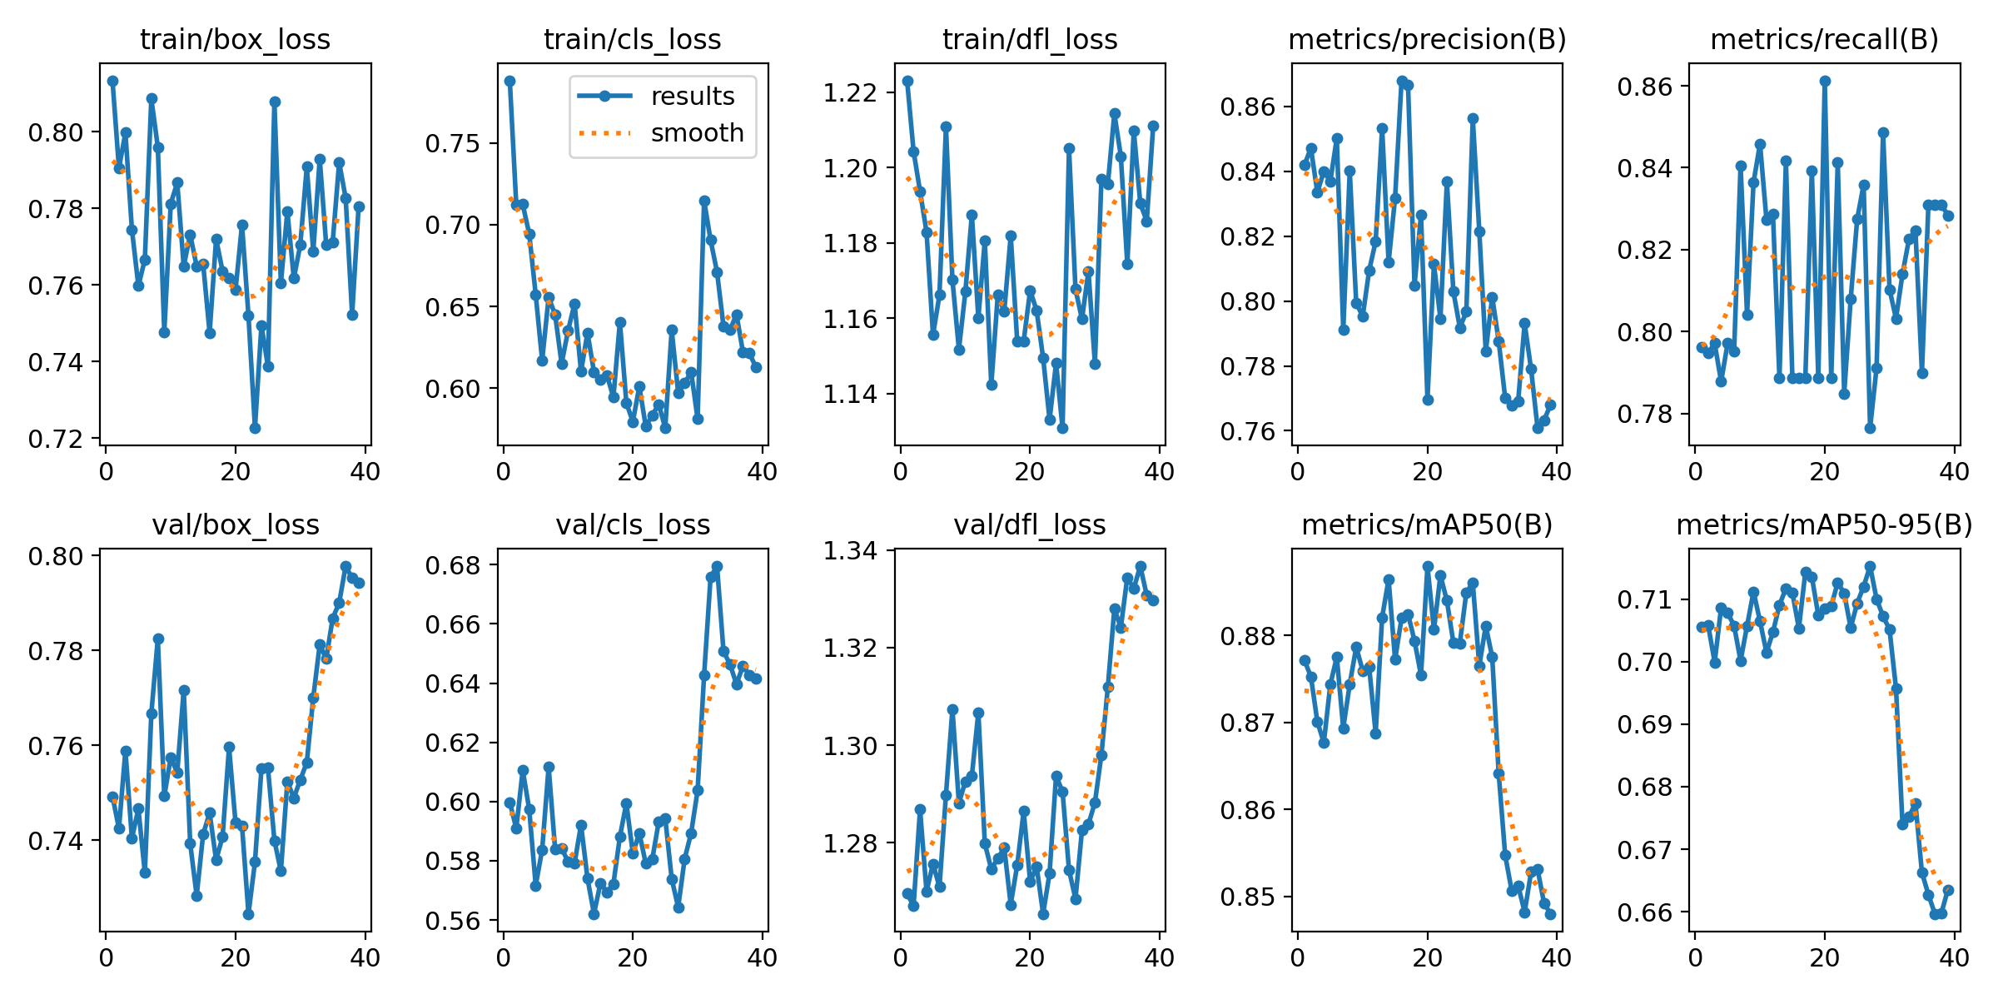
Figure 4 Version 13 training and validation curves
The late decline is consistent with a small fine tuning set. Training losses remain noisy because the training set contains varied hard negatives and relatively few images per batch. The validation losses rise after the best region, which suggests increasing specialisation. Early stopping and best checkpoint selection limit the damage, but more independent horizontal cup scenes would be a better long term solution.

13 Validation Analysis
The normalised confusion matrix gives a class focused view. About 0.80 of true mouse instances are classified as mouse, while about 0.85 of true cup instances are classified as cup. Background related false positives remain visible, especially for mouse. This matches live testing: small dark objects are more likely to be confused with a mouse than with a cup.
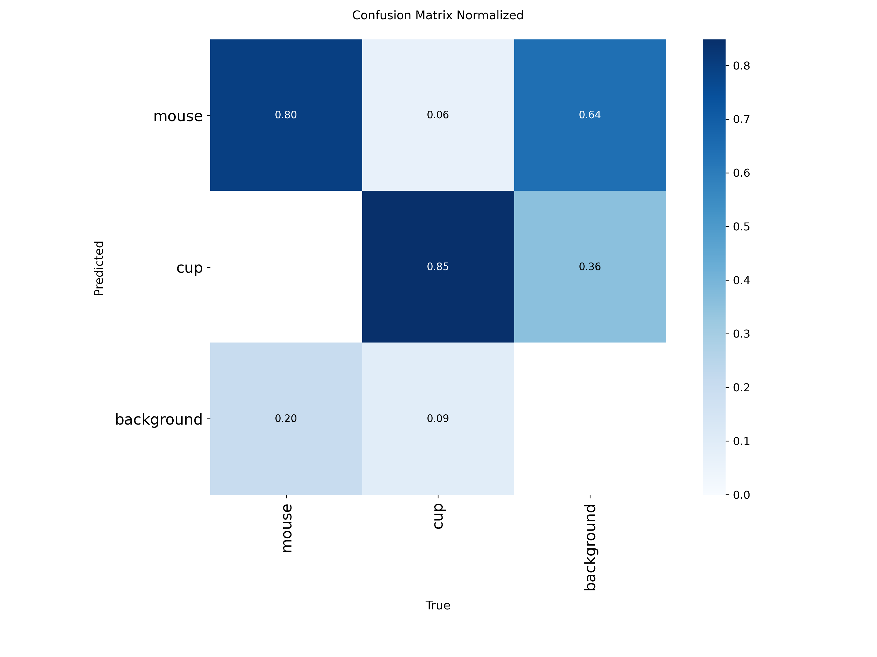
Figure 5 Normalised validation confusion matrix for version 13
The held out test partition is intentionally harder than the classroom demonstration. At the same test configuration, v13 produced precision 0.706, recall 0.635, mAP50 0.677 and mAP50 to 95 0.374. Version 12 had slightly better general test metrics. I therefore do not claim that version 13 is universally superior. Its value is the targeted horizontal cup behaviour combined with the practical 90 percent acceptance result.

14 ONNX Inference Pipeline
The Windows program performs preprocessing, inference, postprocessing and display in a continuous loop. Letterboxing preserves the source aspect ratio while filling unused pixels with a neutral grey value. The original scale and padding are retained so output boxes can be mapped back to camera coordinates. Non maximum suppression is performed separately for each class to remove duplicated overlapping predictions.
letterboxed, scale, pad_x, pad_y = letterbox(frame, imgsz)
input_tensor = cv2.cvtColor(letterboxed, cv2.COLOR_BGR2RGB)
input_tensor = input_tensor.transpose(2, 0, 1).astype(np.float32) / 255.0
input_tensor = np.expand_dims(input_tensor, axis=0)
output = session.run(None, {input_name: input_tensor})[0]
Independent confidence thresholds are useful because the two classes have different error patterns. Mouse errors were usually false positives on dark objects, so a high mouse threshold reduces those mistakes. Cup predictions were generally cleaner. The final demonstration used 0.75 for both classes to make the scoring rule conservative.
A short temporal smoother requires two matching frames before displaying a new detection and can hold a track for three missed frames. This reduces flicker. It does not create a detection from nothing, and it should not be used to inflate still image accuracy. For that reason the practical evidence is evaluated scene by scene rather than counting every held display frame as a new success.

15 Live Display and Video Recording
The live application overlays each accepted class name, confidence value and coloured rectangle. Mouse boxes are green and cup boxes are blue. A status line shows smoothed FPS, current detection count and class thresholds. Pressing Q or Escape ends the loop and releases the camera and video writer cleanly.
py -3.13 scripts/live_camera_onnx.py `
--camera 1 `
--model runs/detect/mouse_cup_yolo11n_v13_horizontal_cup_768/weights/best.onnx `
--mouse-conf 0.75 --cup-conf 0.75 `
--save results/v13_camera1_detected.avi `
--save-raw results/v13_camera1_raw.avi
Saving both streams serves different purposes. The annotated file is evidence for the assessor because it contains boxes, labels, confidence and FPS. The raw file preserves the actual camera input and is more valuable for debugging. It can be replayed through a later model version without repeating the physical experiment.
The new run_video_onnx.py utility follows the same preprocessing and class thresholds for recorded input. I used it to replay the horizontal cup capture through the final v13 ONNX model and produce a ten second supplemental clip. The JSON summary records the source, model, selected time range, thresholds and number of frames containing each class.

16 Jetson Deployment
On Jetson, the program uses the v13 best.pt file and CUDA. OpenCV opens the V4L2 camera, Ultralytics performs prediction, and the application draws the same information as the Windows version. The Jetson recordings are 640 by 480 MJPEG at 20 FPS. This camera rate is appropriate for the experiment and keeps end to end latency low.
python3 scripts/live_camera_pt.py \
--camera 0 \
--model /home/nvidia/jetson_yolo/best.pt \
--imgsz 768 \
--mouse-conf 0.75 --cup-conf 0.75 \
--save /home/nvidia/jetson_yolo/results/v13_jetson_detected.avi
The selected evidence frames report a minimum of 15.7 FPS and a maximum of 21.2 FPS, with an average near 17.9 FPS. Even the minimum is more than three times the required 5 FPS. Because the horizontal supplement was processed offline on Windows, those two frames are excluded from the Jetson speed average.
Measurement | Observed | Requirement | Result
Selected Jetson minimum | 15.7 FPS | 5 FPS | Pass
Selected Jetson maximum | 21.2 FPS | 5 FPS | Pass
Selected Jetson mean | about 17.9 FPS | 5 FPS | Pass
Camera stream | 640 by 480 at 20 FPS | real time | Pass

17 Twenty Angle Test Protocol
The teacher confirmed that twenty angles are sufficient. I selected twenty representative moments rather than claiming twenty different physical object models. The set covers upright, tilted and horizontal cups, two cups together, two classes together, mouse top views, side profiles and underside views.
A scene is correct only when all expected targets are detected and no extra false positive appears. This is stricter than target recall alone. A two object scene fails if one target is missing. The method also prevents a long easy clip from dominating the result because every selected angle contributes one score.
- Choose a timestamp with a clear and stable object pose.
- Record the expected target list before reading the prediction.
- Check the rendered frame for every expected box and for extra boxes.
- Mark the whole scene correct or incorrect using the strict rule.
- Count correct scenes and divide by twenty.
The two horizontal cup angles replace redundant upright cup views. The old CUP3 file is excluded. This makes the evidence closer to the actual assessment requirement and removes a clip that could be misinterpreted as proof of a successful horizontal cup detection.

18 Twenty Angle Results
No | Expected | View | Platform | Result
1 | cup | upright front | Jetson | Pass
2 | cup | upright alternate side | Jetson | Pass
3 | cup | horizontal right-facing | offline v13 ONNX | Pass
4 | cup | horizontal shifted view | offline v13 ONNX | Pass
5 | cup | tilted diagonal | Jetson | Pass
6 | cup | blue cup front | Jetson | Pass
7 | cup | blue cup alternate side | Jetson | Pass
8 | cup | blue cup offset | Jetson | Pass
9 | cup+cup | two cups together | Jetson | Pass
10 | mouse+cup | two classes together | Jetson | Pass
11 | mouse | left side | Jetson | Pass
12 | mouse | front diagonal | Jetson | Pass
13 | mouse | low side profile | Jetson | Pass
14 | mouse | top diagonal | Jetson | Pass
15 | mouse | rotated top | Jetson | Pass
16 | mouse | right side | Jetson | Pass
17 | mouse | underside horizontal | Jetson | Pass
18 | mouse | underside diagonal | Jetson | Pass
19 | mouse | extreme side profile | Jetson | Miss
20 | mouse | underside | Jetson | Miss

Eighteen of the twenty scenes are correct, giving 90 percent strict scene accuracy. The two failures are mouse views: an extreme side profile and an underside pose. No selected scene failed because of a wrong class label. These failures are retained because a credible experiment should show both successful and unsuccessful cases.

19 Evidence Frames One to Ten
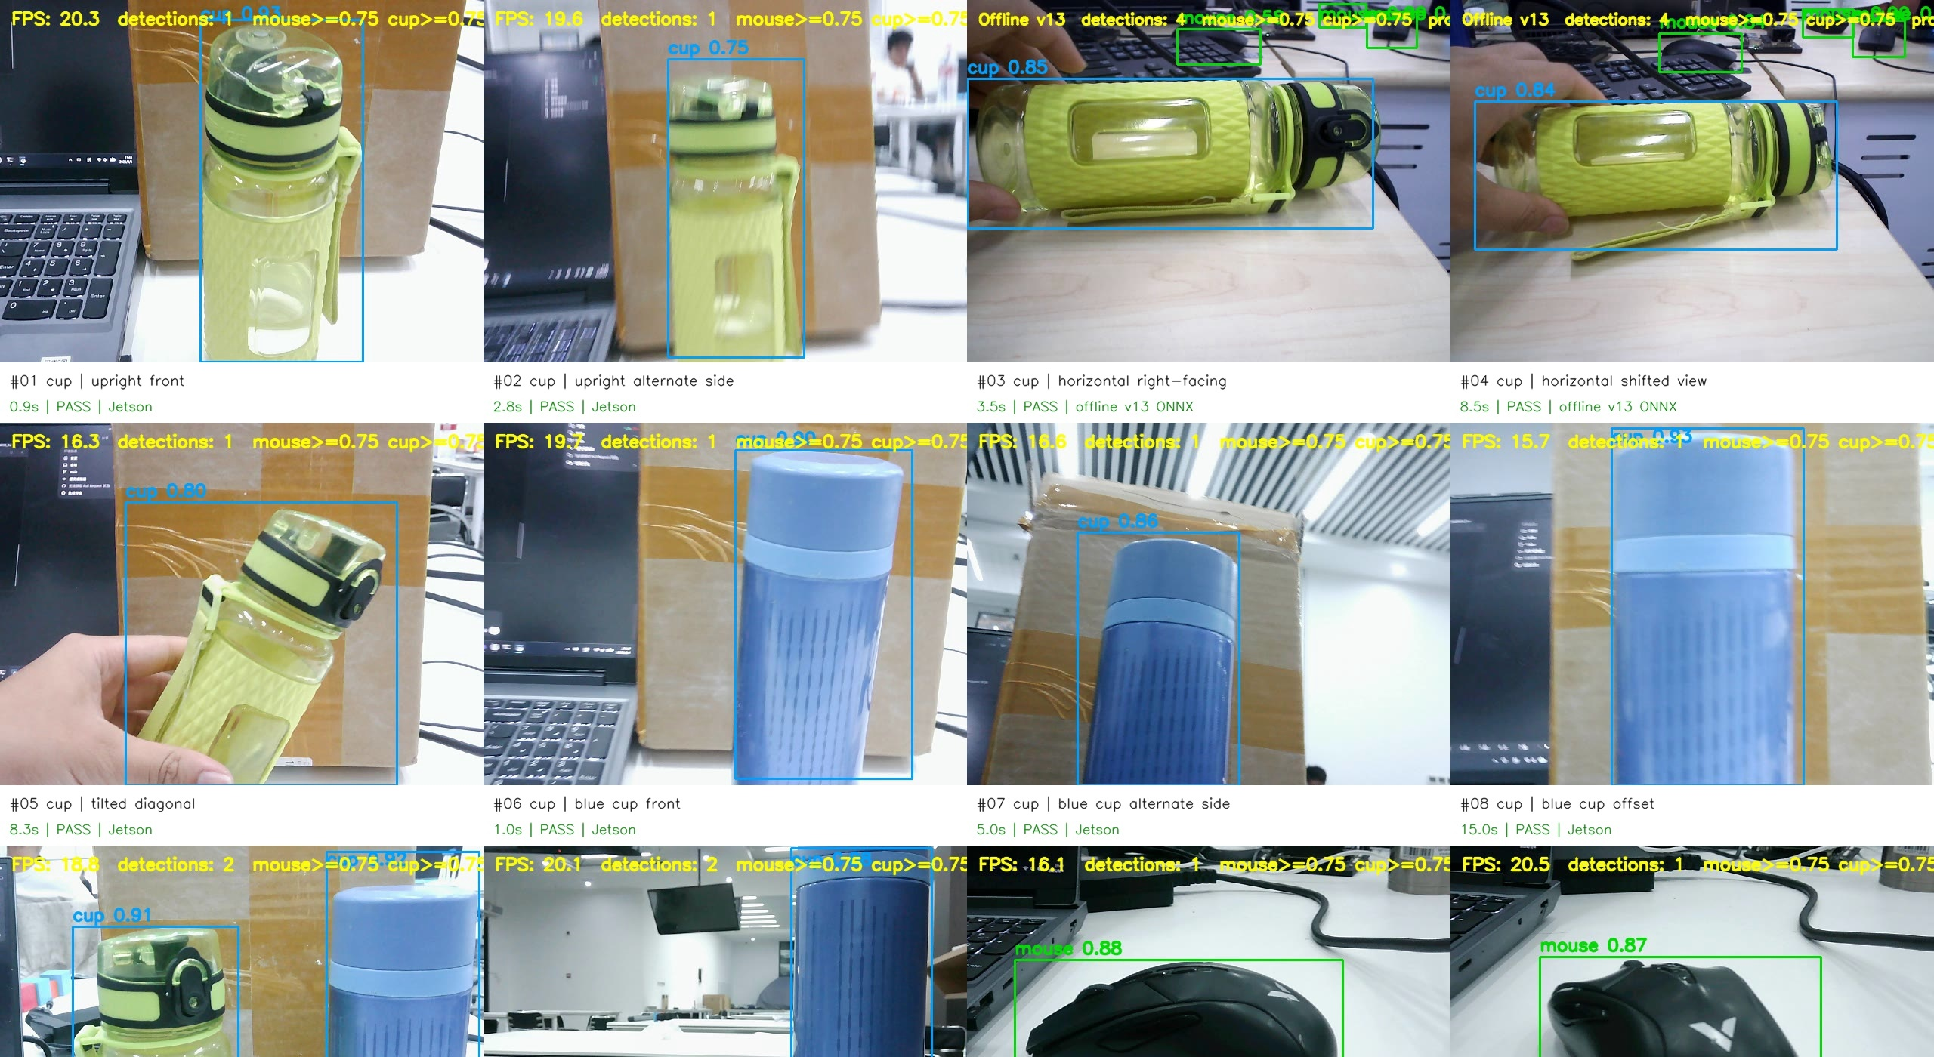
Figure 6 Cup and mixed class evidence for test scenes 1 to 10
Scenes 1, 2 and 5 show the green cup upright and tilted. Scenes 3 and 4 show the same target fully horizontal with v13 ONNX confidence around 0.84 to 0.85. Scenes 6 to 8 use a blue cup. Scene 9 contains two cups, and scene 10 proves simultaneous mouse and cup detection.
The first two rows use Jetson output except for the two explicitly labelled offline v13 frames. The platform label is printed below each evidence image so the supplemental replay cannot be confused with Jetson execution.

20 Evidence Frames Eleven to Twenty
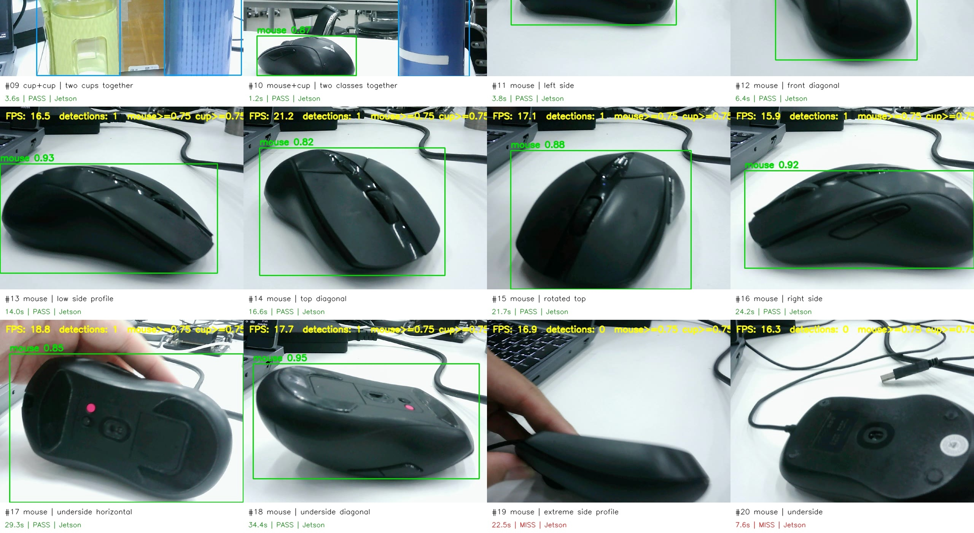
Figure 7 Mouse evidence and retained failure cases for test scenes 11 to 20
Scenes 11 to 18 show successful mouse detections across side, diagonal, top and underside views. Scenes 19 and 20 are the two misses. Their inclusion explains why the final score is 90 rather than 100 percent and identifies the most useful direction for future data collection.
All ten frames on this page come from Jetson recordings. The displayed FPS values range from 15.9 to 21.2 in the successful frames and remain above 16 FPS in the two misses, confirming that the failures are recognition errors rather than a stalled inference loop.

21 Horizontal Cup Supplement
The previous CUP3 clip did not satisfy the assessment need. It showed an upright stainless cup and the model did not recognise it. I therefore ignored that clip and used the separate v13 horizontal cup result already stored in the results directory. The final v13 ONNX model was replayed for thirteen seconds with both class thresholds set to 0.75.
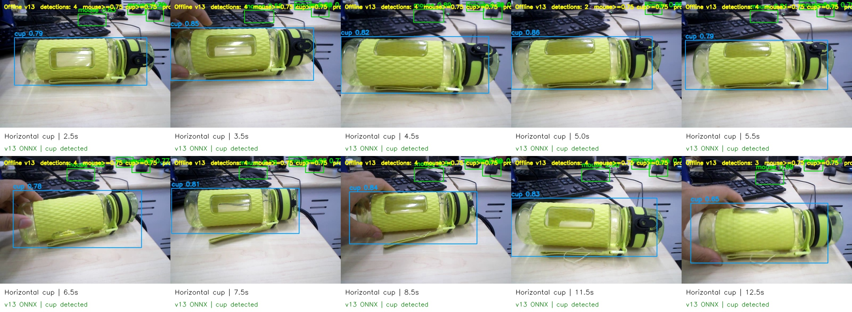
Figure 8 Thirteen second horizontal cup replay through the final v13 ONNX model
The segment contains 261 processed frames and 207 frames with an accepted cup detection, giving 79.3 percent frame coverage. Stable frames reach approximately 0.79 to 0.85 confidence. The file is suitable as pose evidence, but it is not used as Jetson speed evidence because it is an offline replay.
The contact sheet also contains other black objects in the background. Some are detected as mice because actual mice are present on the desk. The cup claim is limited to the large green horizontal cup and does not imply that every object in the raw scene was part of the cup test.

22 ROS 2 Detection Publisher
The project now includes a ROS 2 Humble Python package named yolo_detection_ros2. The detector node opens a camera, runs the YOLO model, filters mouse and cup boxes with independent thresholds, publishes a vision_msgs Detection2DArray message, renders the live window and optionally writes the annotated video.
Each Detection2D message contains a bounding box centre, width and height, a text class ID and a floating point confidence score. The array header contains the camera frame name and ROS time. A receiving robot node can subscribe to /yolo/detections and make decisions without reading pixels or parsing console output.
cd ~/yolo_ros2_ws
source /opt/ros/humble/setup.bash
colcon build --symlink-install
source install/setup.bash
ros2 launch yolo_detection_ros2 detector.launch.py
ros2 topic info /yolo/detections
ros2 topic echo /yolo/detections --once
ros2 topic hz /yolo/detections
I verified the package with colcon build in Ubuntu 22.04, and ROS 2 lists the detector_node executable. The best final demonstration is to reconnect the Jetson, launch the package and save one topic echo together with the live video. Until that final live capture is made, the report treats message publication as implemented and build verified rather than claiming a stored runtime message.

23 Saving Results and Typical Errors
The experiment saves three useful forms of evidence. Annotated AVI files show the visible output expected by the teacher. Raw AVI files preserve the original camera frames for later replay. Review directories contain contact sheets, selected still frames, CSV scoring tables and JSON run summaries. Together they support both demonstration and diagnosis.
Artifact type | Example | Purpose
Annotated Jetson video | v13 Jetson camera1 detected mouseCUP avi | Two class live evidence
Horizontal supplement | v13 horizontal cup success take1 avi | Successful flat cup pose
Raw recording | v13 pc camera1 raw files | Reproducible model replay
Scoring table | v13 20 angle results with horizontal cup csv | Auditable 18 of 20 result
Evidence sheet | v13 20 angle evidence with horizontal cup jpg | Visual summary
Run summary | v13 horizontal cup success take1 json | Thresholds frame counts and source

The two missed mouse views are typical false negative cases. Earlier versions also produced false positives on phones and black equipment. Those error types were converted into v11 and v12 training batches. This closes the loop between testing and dataset improvement and provides a repeatable procedure for future model versions.

24 Discussion of Failure Cases
The remaining misses are physically plausible. In an extreme side profile the mouse becomes a narrow dark strip with little visible wheel or button structure. In an underside view the sensor panel and feet look unlike the top surface that dominates ordinary mouse datasets. At 768 pixels the object is large enough, but the learned visual features are weak for those shapes.
A high 0.75 threshold reduces false positives but also rejects uncertain true objects. Lowering the threshold would recover some missed angles, yet it could reintroduce phone and chair errors. The current value therefore reflects the assessment setting: a conservative box is preferable to many incorrect mouse boxes. A better solution is more real side and underside training images, not simply changing the threshold after seeing the answer.
The validation plot also warns against overtraining the small specialised batch. More epochs would not necessarily fix the difficult views. I would collect several new mice with different shapes, keep whole scenes separated between train and test, and repeat the twenty angle protocol without selecting timestamps from the same training capture.
- Add extreme side and underside mouse images from at least three backgrounds.
- Add reflective and stainless cups lying on their sides.
- Keep phone and black equipment negatives in every new training export.
- Compare 0.65 0.70 and 0.75 thresholds on a fixed video before changing deployment defaults.

25 Reproducibility Guide

25 1 Audit and Export
py -3.13 scripts/export_audited_yolo.py `
--audit dataset_work/audit_dataset_v13 `
--output dataset_work/audit_dataset_v13/yolo_export

25 2 Train
wsl -d Ubuntu-22.04 bash -lc "cd /mnt/f/PycharmProjects/robomaster && bash scripts/train_v13_horizontal_cup_wsl.sh"

25 3 Export ONNX
yolo export model=runs/detect/mouse_cup_yolo11n_v13_horizontal_cup_768/weights/best.pt format=onnx imgsz=768 simplify=True

25 4 Windows Camera Test
py -3.13 scripts/live_camera_onnx.py --camera 1 --model runs/detect/mouse_cup_yolo11n_v13_horizontal_cup_768/weights/best.onnx --mouse-conf 0.75 --cup-conf 0.75 --save results/v13_detected.avi --save-raw results/v13_raw.avi

25 5 ROS 2 Build
mkdir -p ~/yolo_ros2_ws/src
cp -r ros2/yolo_detection_ros2 ~/yolo_ros2_ws/src/
cd ~/yolo_ros2_ws
source /opt/ros/humble/setup.bash
colcon build --symlink-install

26 Submission Artifact Inventory
Deliverable | Recommended file or directory
Dataset | dataset_work audit_dataset_v13 yolo_export
PyTorch model | runs detect mouse_cup_yolo11n_v13_horizontal_cup_768 weights best.pt
ONNX model | runs detect mouse_cup_yolo11n_v13_horizontal_cup_768 weights best.onnx
Windows program | scripts live_camera_onnx.py
Jetson program | scripts live_camera_pt.py
ROS 2 package | ros2 yolo_detection_ros2
Jetson videos | results v13 Jetson camera1 detected files
Horizontal cup video | results v13_horizontal_cup_success_detected.avi
Twenty angle score | results v13_submission_review v13_20_angle_results_with_horizontal_cup.csv
Report | docs Experiment_One_Object_Detection_Report.docx and pdf

Large datasets and model weights may exceed ordinary GitHub limits. The repository should contain scripts, manifests, small evidence images, CSV summaries, README instructions and the report. Large weights and videos can be submitted as release assets or as a separate course archive when required. The report lists their exact local paths and hashes so the assessor can verify the files did not change.

27 Integrity Record
The following SHA 256 values were calculated from the final local files. They provide a simple integrity record for copying the submission to Jetson, cloud storage or removable media.
File | Bytes | SHA 256
v13 best.pt | 5459930 | 14b82fb5b50d8140cebb134f6eb1d57e07902e07a78fbdc5d033ab71d9025792
v13 best.onnx | 10678826 | 42c78972a3a4f7f2a331df22a7758e9140a38d6736735391bc910cbf56f1aea0
horizontal cup video | 12934534 | 7168ea036a9bc02b741103499d5ea843bc2277edb39199b9fc7cbf25da6cf231

A checksum does not prove accuracy, but it prevents accidental substitution of a different model after the report is written. It is especially useful here because several version folders contain files named best.pt.

28 Conclusion
This experiment produced a complete two class object detection workflow for mouse and cup recognition. I collected and reviewed data, converted the annotations into YOLO format, trained a sequence of models, analysed real camera errors, and refined the dataset with targeted positives and hard negatives. The final v13 model adds the horizontal cup pose that was missing from earlier evidence.
The practical twenty angle evaluation records eighteen correct scenes out of twenty, which is 90 percent and exceeds the required 80 percent. Jetson evidence runs between 15.7 and 21.2 FPS in the selected frames, safely above the 5 FPS requirement. The result videos display the target class, bounding box, confidence and FPS, and the program can store both annotated and raw streams.
The ROS 2 package publishes standard Detection2DArray messages and has passed a clean colcon build. The remaining best practice before the classroom demonstration is to run ros2 topic echo once on the connected Jetson and retain that console capture. The report does not hide this distinction. Overall, the submission now demonstrates the full engineering path from imperfect raw footage to a reproducible embedded detector, while keeping the two remaining mouse misses visible as honest limits of the current dataset.

Appendix A Key Source Code Responsibilities
File | Responsibility
scripts live_camera_onnx.py | Windows camera input ONNX preprocessing NMS smoothing display and recording
scripts live_camera_pt.py | Jetson camera input Ultralytics CUDA inference display and recording
scripts run_video_onnx.py | Offline replay of a selected raw segment with JSON summary
scripts train_v13_horizontal_cup_wsl.sh | Repeatable v13 training command and hyperparameters
scripts export_audited_yolo.py | Only exports explicitly assigned train validation and test records
ros2 yolo_detection_ros2 detector_node.py | Publishes boxes class IDs and confidence as vision_msgs

The live inference file separates small functions such as letterbox and postprocess from the camera loop. This made offline video replay possible without copying the mathematical code. The ROS 2 node uses Ultralytics results directly because Jetson already has that framework installed. Both paths keep the same class order and deployment thresholds.

Appendix B Final Evidence Paths
results/v13_submission_review/v13_20_angle_evidence_with_horizontal_cup.jpg
results/v13_submission_review/v13_20_angle_results_with_horizontal_cup.csv
results/v13_horizontal_cup_success_detected.avi
results/v13_horizontal_cup_success_detected.json
results/v13_Jetson_camera1_detected_mouseCUP.avi
results/v13_Jetson_camera1_detected_cupboth.avi
results/v13_Jetson_camera1_detected_mouse1.avi
The older v13_Jetson_camera1_detected_CUP3.avi file is not part of the final proof. It remains in the working results directory only as historical test material. The curated CSV and evidence sheet do not reference it.
This report was generated from the current local workspace so that tables and integrity hashes match the files submitted with the experiment.

