**程序设计课程设计实验报告**



**学院： 计算机科学与教育软件学院**

**专业班级： 软件工程 174**

**姓名： 黎永杰**

**学号： 1706300154**

**2018.12.24**

**一、课程设计题目**

应用MFC应用程序实现学生信息管理系统

（1）、设计一个学生类Student,包括数据成员：姓名、学号、二门课程(面向对象程序设计、高等数学)的成绩。（2）、创建一个管理学生的类Management，包括实现学生的数据的增加、删除、修改、按课程成绩排序、保存学生数据到文件及加载文件中的数据等功能。（3）、创建一个基于对话框的MFC应用程序，程序窗口的标题上有你姓名、学号和应用程序名称。使用（1）和（2）中的类，实现对学生信息和成绩的输入和管理。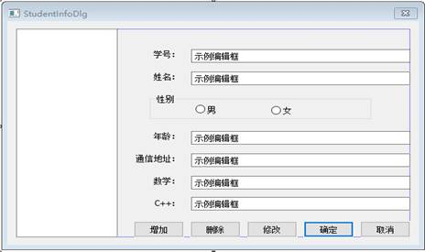

（4）、创建一个单文档的MFC应用程序，读取（3）中保存的文件中的学生成绩，分别用直方图和折线方式显示所有学生某课程的成绩分布图。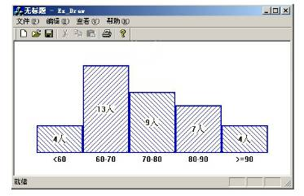

**二、程序设计基本步骤**

1.分析需求，了解程序所需的功能；

2.根据所需功能构思、设计相应算法；

3.创建工程，添加所需类、变量、函数等；

4.编写程序；

5.调试、测试；

6.生成、导出程序；

**三、自定义类及函数功能概括**

//学生管理系统

//StuMana.exe

Class Student{}; //储存学生信息

Class Management{}; //管理学生信息

bool Management::AddManaAdd(CString str_Name, CString str_Num, CString str_Sex, CString str_Math, CString str_Cpp, int i_KeyInd); //添加学生信息

int Management::FloorFull(Tree* p_Full);

//当节点key已满，执行该函数以分裂节点

Tree* Management::Search(Tree* p_Root, int i_fl, int key);

//查找该学生信息所在叶节点

Student* ManaSearch(int i_key); //查找并获取该学生地址

bool ManaDel(int i_DelKey, int i_DelInd, int KeyInd);

//删除学生信息

bool Unite(Tree* p_Unite);

//当删除操作后若节点、及其兄弟节点需要合并，执行该函数

Class About{}; //About窗口类

Class AddInfoDlg{}; //添加信息窗口类

afx_msg void AddInfoDlg ::OnBnClickedExit();

//添加并关闭的消息处理程序

afx_msg void AddInfoDlg ::OnBnClickedCancel();

//取消按钮的消息处理程序

afx_msg void AddInfoDlg ::OnBnClickedEmpty();

//清空按钮的消息处理程序

afx_msg void AddInfoDlg ::OnBnClickedAdd();

//添加按钮的消息处理程序

bool AddInfoDlg ::CheckInfo(); //检查信息是否填写规范

Class AddWaring{}; //添加时警告对话框类

afx_msg void AddWaring ::OnBnClickedCancel(); //取消按钮消息处理程序

afx_msg void AddWaring OnBnClickedContinue(); //继续按钮消息处理程序

Class AltDlg{}; //修改对话框类

afx_msg void AltDlg ::OnBnClickedAlter(); //修改按钮消息处理程序

afx_msg void AltDlg ::OnBnClickedCamcel(); //取消按钮消息处理程序

virtual BOOL AltDlg ::OnInitDialog(); //在此函数添加额外初始化

Class RankDlg{}; //排序对话框类

virtual BOOL RankDlg ::OnInitDialog(); //此函数添加额外初始化

afx_msg void RankDlg ::OnBnClickedRank(); //排序按钮消息处理程序

afx_msg void RankDlg ::OnBnClickedCancel(); //取消按钮消息处理程序

Class SearchDlg{}; //查找对话框类

afx_msg void SearchDlg ::OnBnClickedOnSearch(); //查找按钮消息处理

afx_msg void SearchDlg ::OnBnClickedSearchNext(); //查找下一个按钮

virtual BOOL SearchDlg ::OnInitDialog(); //添加额外的初始化

Class StuManaDlg{}; //主窗口

afx_msg void StuManaDlg ::OnBnClickedSearch(); //主对话框查找按钮

afx_msg void StuManaDlg ::OnBnClickedDel(); //主对话框删除按钮

afx_msg void StuManaDlg ::OnBnClickedRank(); //主对话框排序按钮

afx_msg void StuManaDlg ::OnBnClickedAlter(); //主对话框修改按钮

afx_msg void StuManaDlg ::OnBnClickedPic(); //主对话框绘图按钮

afx_msg void StuManaDlg ::OnBnClickedSave(); //主对话框保存按钮

afx_msg void StuManaDlg ::OnBnClickedLoad(); //主对话框打开按钮

afx_msg void StuManaDlg ::OnBnClickedAbout(); //主对话框作者按钮

afx_msg void StuManaDlg ::OnBnClickedOk(); //保存并关闭按钮

void CStuManaDlg::OnBnClickedReStart() //重置

INT_PTR StuMana ::OnSave(); //储存信息到文件

Class Tree{}; //B+树类，以B+树储存学生信息

int Tree ::AddKey(int i_AddKey); //添加关键字

void Tree ::Write(int index, int key, Tree* node, Tree* former = NULL);

//写入信息到叶节点对应位置

void Tree ::Del(int index); //删除某节点内某组数据

//绘图程序

//StuPic.exe

Class MainFrm{}; //框架

afx_msg void OnFileOpen(); //打开文件并读取

afx_msg void OnMathHis(); //绘制数学成绩直方图

afx_msg void OnMathLine(); //绘制数学成绩折线图

afx_msg void OnCppHis(); //绘制程设成绩直方图

afx_msg void OnCppLine(); //绘制程设成绩折线图

afx_msg void OnUpdateMathHis(CCmdUI *pCmdUI);

afx_msg void OnUpdateMathLine(CCmdUI *pCmdUI);

afx_msg void OnUpdateCppHis(CCmdUI *pCmdUI);

afx_msg void OnUpdateCppLine(CCmdUI *pCmdUI);

//以上四个函数均为 禁用/启用 菜单内选项

void GetCount(int i_Sub); //获取各分段人数

void DrawHis(bool b_Sub); //绘制直方图

void DrawLine(bool b_Sub); //绘制折线图

void ClearDraw(); //清除

afx_msg void OnViewOMH();

afx_msg void OnViewOCH();

afx_msg void OnViewOCL();

afx_msg void OnViewOML();

//以上四个函数均为工具栏中四个绘图按钮所对应函数

afx_msg void OnUpdateViewMl(CCmdUI *pCmdUI);

afx_msg void OnUpdateViewMh(CCmdUI *pCmdUI);

afx_msg void OnUpdateViewCl(CCmdUI *pCmdUI);

afx_msg void OnUpdateViewCh(CCmdUI *pCmdUI);

//以上四个函数均为 禁用/启用 工具栏选项

**四、实验代码**

//Student.h

#pragma once

#include "Tree.h"

class Student

:public Tree

{

public:

Student();

~Student();

CString str_Name; //姓名

CString str_Math; //数学

CString str_Sex; //性别

CString str_Num; //学号

CString str_Cpp; //程设

Student* p_Same; //用于指向相同数据特征的学生

int i_Rank;

};

//Student.cpp

#include "stdafx.h"

#include "Student.h"

Student::Student()

: str_Name(_T(""))

, str_Math(_T(""))

, str_Sex(_T(""))

, str_Num(_T(""))

, str_Cpp(_T(""))

, i_Rank(0)

, p_Same(NULL)

{

}

Student::~Student()

{

}

//Management.h

#pragma once

#include "Student.h"

#include "Tree.h"

class Management

{

public:

Management();

~Management();

int i_Total; //记录总数

int i_floor; //记录树的层数

Tree m_TreeHead; //头指针

Tree *p_TreeThis; //操作指针

Tree *p_TreeRoot; //树根指针

bool ManaAdd(CString str_Name, CString str_Num, CString str_Sex, CString str_Math, CString str_Cpp, int i_KeyInd); //向链表添加学生信息

int FloorFull(Tree* p_Full); //节点已满时的处理函数

Tree* Search(Tree* p_Root, int i_fl, int key); //查找叶节点函数

Student* ManaSearch(int i_key); //查找学生函数

bool ManaDel(int i_DelKey, int i_DelInd, int KeyInd); //删除学生函数

//bool Unite(Tree* p_Unite); //节点合并函数（功能未通过测试）

};

//Management.cpp

#include "stdafx.h"

#include "Management.h"

Management::Management() //初始化各个变量

: p_TreeThis(&m_TreeHead)

, p_TreeRoot(&m_TreeHead)

, i_floor(0)

, i_Total(0)

{

m_TreeHead.p_Node[0] = &m_TreeHead;

}

Management::~Management()

{

}

bool Management::ManaAdd(CString str_Name, CString str_Num, CString str_Sex, CString str_Math, CString str_Cpp, int i_KeyInd)

{

//本函数用于向树添加学生信息

i_Total++;

int i_AddKey;

Tree* p_ThisBefo = NULL;

switch (i_KeyInd) //将CString转为int

{

case 0:

{

int i_Len = str_Name.GetLength();

if (i_Len > 0)

{

i_AddKey = str_Name[0] - 19000;

i_AddKey = i_AddKey * 100000;

if (i_Len > 1)

i_AddKey = i_AddKey + str_Name[1] - 19000;

}

else return 0;

}; break;

case 1:i_AddKey = _ttoi(str_Num); break;

case 2:i_AddKey = _ttoi(str_Math); break;

case 3:i_AddKey = _ttoi(str_Cpp); break;

}

int i_Index = 0;

bool b_same = 1;

//查找叶节点

p_TreeThis = Search(p_TreeRoot, i_floor, i_AddKey);

for (; i_Index < p_TreeThis->i_count; i_Index++)

{

//查找叶节点内学生信息

int i_same;

switch (i_KeyInd)

{

case 0:

{

CString Name = ((Student*)(p_TreeThis->p_Node[i_Index]))->str_Name;

int i_Len = Name.GetLength();

if (i_Len > 0)

{

i_same = Name[0] - 19000;

i_same = i_same * 100000;

if (i_Len > 1)

i_same = i_same + Name[1] - 19000;

}

}; break;

case 1:i_same = _ttoi(((Student*)(p_TreeThis->p_Node[i_Index]))->str_Num); break;

case 2:i_same = _ttoi(((Student*)(p_TreeThis->p_Node[i_Index]))->str_Math); break;

case 3:i_same = _ttoi(((Student*)(p_TreeThis->p_Node[i_Index]))->str_Cpp); break;

}

if (i_same == i_AddKey)

{

//若找到相同的key，则判断是否有多个

//该key对应的信息，并获取正确的存放位置

p_ThisBefo = (Student*)(p_TreeThis->p_Node[i_Index]);

p_TreeThis = ((Student*)(p_TreeThis->p_Node[i_Index]))->p_Same;

while (p_TreeThis != NULL)

{

p_ThisBefo = p_TreeThis;

p_TreeThis = ((Student*)p_TreeThis)->p_Same;

}

b_same = 0;

break;

}

}

if (b_same)

{ //判断叶节点是否已满，已满则分裂节点

if (p_TreeThis->i_count == 4)

{

FloorFull(p_TreeThis);

p_TreeThis = p_TreeThis->p_Former;

p_TreeThis = Search(p_TreeThis, 1, i_AddKey);

if (p_TreeThis == NULL)

p_TreeThis = new Tree;

}

}

//添加学生信息至叶节点内

if (b_same)

{

i_Index = p_TreeThis->AddKey(i_AddKey);

p_TreeThis->p_Node[i_Index] = new Student;

((Student*)p_TreeThis->p_Node[i_Index])->str_Name = str_Name;

((Student*)p_TreeThis->p_Node[i_Index])->str_Math = str_Math;

((Student*)p_TreeThis->p_Node[i_Index])->str_Sex = str_Sex;

((Student*)p_TreeThis->p_Node[i_Index])->str_Num = str_Num;

((Student*)p_TreeThis->p_Node[i_Index])->str_Cpp = str_Cpp;

((Student*)p_TreeThis->p_Node[i_Index])->i_Rank = i_Total;

}

else

{

p_TreeThis = new Student;

((Student*)p_ThisBefo)->p_Same = (Student*)p_TreeThis;

((Student*)p_TreeThis)->str_Name = str_Name;

((Student*)p_TreeThis)->str_Math = str_Math;

((Student*)p_TreeThis)->str_Sex = str_Sex;

((Student*)p_TreeThis)->str_Num = str_Num;

((Student*)p_TreeThis)->str_Cpp = str_Cpp;

((Student*)p_TreeThis)->i_Rank = i_Total;

}

return 1;

}

int Management::FloorFull(Tree* p_Full)

{ //本函数用于节点已满时进行分裂操作

Tree* p_This; //操作指针

int i_Index = 0; //索引值

if (p_Full->p_Former != NULL) //若上一节点不为空

{

p_This = p_Full->p_Former; //操作指针移至上一节点

if (p_This->i_count == 4) //若上一节点已满

{

int i = 0, n = 0;

for (; p_Full != p_This->p_Node[i]; i++);

n = FloorFull(p_This); //则递归本函数

if (i > 3)

p_This = p_This->p_Former->p_Node[n];

p_Full->p_Former = p_This;

}

i_Index = p_This->AddKey(p_Full->i_key[2]) + 1; //向操作节点添加新关键字并获取索引值

p_This->p_Node[i_Index - 1] = p_This->p_Node[i_Index];

}

else

{

i_floor++;

p_This = new Tree; //建立新节点作为根节点

p_This->i_onfl = i_floor;

p_TreeRoot = p_This; //根节点指针指向新的根节点

p_Full->p_Former = p_This; //已满节点的上一节点指针指向新节点

i_Index = p_This->AddKey(p_Full->i_key[2]) + 1; //添加新关键字

p_This->p_Node[0] = p_Full; //将新节点首位指针指向原节点

}

p_This->p_Node[i_Index] = new Tree; //添加新子节点

p_This = p_This->p_Node[i_Index]; //操作指针指向新节点

p_This->p_Former = p_Full->p_Former; //写入上一节点

p_This->i_onfl = p_Full->i_onfl;

if (p_Full->i_onfl)

{

p_This->Write(0, p_Full->i_key[3], p_Full->p_Node[3], p_Full->p_Former); //将已满节点的后两组数据写入新节点

p_This->p_Node[1] = p_Full->p_Node[4];

Tree* p_Stay = p_Full->p_Node[2];

p_Full->Del(2);

p_Full->p_Node[2] = p_Stay;

}

else

{

p_This->p_Node[2] = p_Full->p_Node[4]; //将指向下一节点指针写入新节点

p_This->Write(0, p_Full->i_key[2], p_Full->p_Node[2]);

p_This->Write(1, p_Full->i_key[3], p_Full->p_Node[3]);

p_Full->Del(2);

p_Full->p_Node[2] = p_This;

}

p_Full->Del(3); //删除已满节点后两组数据

p_Full->Del(4);

return i_Index;

}

Tree* Management::Search(Tree* p_Root, int i_fl, int key)

{ //本函数用于查找key所在叶节点

//判断是否已在叶节点

if (i_fl == 0)

return p_Root;

Tree* p_This;

p_This = p_Root;

int i = 0;

int i_flag = 1;

for (int fl = i_fl; fl > 0; fl--)

{ //逐层查找

i_flag = 1;

for (i = 0; i < p_This->i_count; i++)

{

if (key < p_This->i_key[i])

{

p_This = p_This->p_Node[i];

i_flag = 0;

break;

}

}

if (i_flag)

p_This = p_This->p_Node[p_This->i_count];

}

return p_This;

}

Student* Management::ManaSearch(int i_key)

{ //查找key所对应的具体地址

Tree* p_Search;

//先查找key所在叶节点

p_Search = Search(p_TreeRoot, i_floor, i_key);

if (p_Search != NULL)

{ //若已找到叶节点，则查找具体地址

for (int i = 0; i < p_Search->i_count; i++)

{

if (p_Search->i_key[i] == i_key)

return (Student*)p_Search->p_Node[i];

}

return NULL;

}

return NULL;

}

bool Management::ManaDel(int i_DelKey, int i_DelInd, int i_KedInd)

{ //本函数用于删除key及其对应信息

Tree* p_Del;

int index = 0;

//先查找key所在叶节点

p_Del = Search(p_TreeRoot, i_floor, i_DelKey);

if (p_Del != NULL)

{

bool flag = 1;

for(; index < p_Del->i_count; index++) //查找该叶节点

{

int i_ThisDel;

switch (i_KedInd)

{

case 0:

{

CString str_Del = ((Student*)(p_Del->p_Node[index]))->str_Name;

int i_Len = str_Del.GetLength();

if (i_Len > 0)

{

i_ThisDel = str_Del[0] - 19000;

i_ThisDel = i_ThisDel * 100000;

if (i_Len > 1)

i_ThisDel = i_ThisDel + str_Del[1] - 19000;

}

}; break;

case 1:i_ThisDel = _ttoi(((Student*)(p_Del->p_Node[index]))->str_Num); break;

case 2:i_ThisDel = _ttoi(((Student*)(p_Del->p_Node[index]))->str_Math); break;

case 3:i_ThisDel = _ttoi(((Student*)(p_Del->p_Node[index]))->str_Cpp); break;

}

if (i_ThisDel == i_DelKey) //若已经找到相同的key

{

flag = 0;

if (((Student*)(p_Del->p_Node[index]))->i_Rank - 1 == i_DelInd) //判断是否为选中行所对应信息

{

if (((Student*)(p_Del->p_Node[index]))->p_Same) //判断该key是否有多个信息

{

Tree* p_DelSame= p_Del->p_Node[index];

p_Del->p_Node[index] = ((Student*)(p_Del->p_Node[index]))->p_Same;

delete p_DelSame;

}

else delete p_Del->p_Node[index]; //没有多个信息则直接删除

}

else

{ //不是选中行所对应信息

Tree* p_DelSame = p_Del->p_Node[index];

Tree* p_DelBefo = NULL;

while (p_DelSame)

{ //查找相同key的其它信息

p_DelBefo = p_DelSame;

if (((Student*)(p_DelSame))->i_Rank - 1 != i_DelInd)

p_DelSame = ((Student*)p_DelSame)->p_Same;

else break;

}

if (p_DelSame != NULL)

{

((Student*)p_DelBefo)->p_Same = ((Student*)p_DelSame)->p_Same;

delete p_DelSame;

}

else return 0;

}

break;

}

}

if (flag)

return 0;

}

for (; index < p_Del->i_count; index++)

{ //整理节点内信息

p_Del->i_key[index] = p_Del->i_key[index + 1];

p_Del->p_Node[index] = p_Del->p_Node[index + 1];

}

p_Del->p_Node[p_Del->i_count] = p_Del->p_Node[p_Del->i_count + 1];

p_Del->p_Node[p_Del->i_count + 1] = NULL;

p_Del->i_count--;

if (p_Del->i_count >= 2 || p_Del->p_Former == NULL)

return 1;

////如果该节点剩余key的个数大于等于2，或无父节点则返回1，否则继续执行以下代码

//Unite(p_Del);

////此处未通过测试

return 1;

}

/*bool Management::Unite(Tree* p_Unite)

{

int index = 0;

Tree* p_Brother;

if (p_Unite->p_Former == NULL)

return 0;

Tree* p_Former = p_Unite->p_Former;

for (; index < p_Unite->p_Former->i_count; index++)

{

if (p_Unite->i_key[0] < p_Former->i_key[index])

break;

}

index--;

if (index < 0)

return 0;

p_Brother = p_Former->p_Node[index];

if (p_Brother->i_count > 2)

{

//如果兄弟节点的key数量富余，则将最后一个key转移

int key = p_Brother->i_key[p_Brother->i_count - 1];

p_Former->i_key[index] = key;

p_Unite->AddKey(key);

if (p_Brother->i_onfl)

p_Unite->p_Node[0] = p_Brother->p_Node[p_Brother->i_count];

else

{

p_Unite->p_Node[0] = p_Brother->p_Node[p_Brother->i_count - 1];

p_Brother->p_Node[p_Brother->i_count - 1] = p_Brother->p_Node[p_Brother->i_count];

}

p_Brother->p_Node[p_Brother->i_count] = NULL;

p_Brother->i_key[p_Brother->i_count - 1] = 0;

p_Brother->i_count--;

}

else

{

//如果兄弟节点的key不足，则合并

int sum = p_Brother->i_count + p_Unite->i_count;

p_Brother->p_Node[sum] = p_Unite->p_Node[p_Unite->i_count];

for (int i = p_Brother->i_count; i < sum; i++)

p_Brother->Write(i, p_Unite->i_key[i - p_Brother->i_count], p_Unite->p_Node[i - p_Brother->i_count]);

p_Former->i_count--;

for (int i = index; i < p_Former->i_count - 1; i++)

{

p_Former->p_Node[i] = p_Former->p_Node[i + 1];

p_Former->i_key[i] = p_Former->i_key[i + 1];

}

p_Former->p_Node[p_Former->i_count] = p_Former->p_Node[p_Former->i_count + 1];

p_Former->p_Node[p_Former->i_count + 1] = NULL;

p_Former->i_key[p_Former->i_count] = 0;

if (p_Former->i_count < 2)

Unite(p_Former);

delete p_Unite;

}

return 1;

//本函数用于节点、及其兄弟节点内均key的数量不足时的合并处理，但由于考虑欠佳，也未能及时排除问题，限于时间精力暂时停用该函数；

}*/

//About.cpp

//此类用于弹出“关于”窗口，该窗口展示作者信息(static)及程序图标;

//AddInfoDlg.h

#pragma once

#include "AddWarning.h"

#define WM_ADDINFO WM_USER+1

// AddInfoDlg 对话框

class AddInfoDlg : public CDialogEx

{

DECLARE_DYNAMIC(AddInfoDlg)

public:

AddInfoDlg(CWnd* pParent = nullptr); // 标准构造函数

virtual ~AddInfoDlg();

// 对话框数据

#ifdef AFX_DESIGN_TIME

enum { IDD = IDD_DIALOG1 };

#endif

protected:

virtual void DoDataExchange(CDataExchange* pDX); // DDX/DDV 支持

DECLARE_MESSAGE_MAP()

public:

CString str_Name; //姓名

CString str_Num; //学号

CString str_Math; //数学

CString str_Sex; //性别

CString str_Cpp; //程序设计

virtual BOOL OnInitDialog(); //重写初始化函数，以初始化控件

CComboBox m_Sex; //控制性别的ComboBox控件的变量

afx_msg void OnBnClickedExit(); //添加并关闭的消息处理程序

afx_msg void OnBnClickedCancel(); //取消按钮的消息处理程序

afx_msg void OnBnClickedEmpty(); //清空按钮的消息处理程序

afx_msg void OnBnClickedAdd(); //添加按钮的消息处理程序

bool CheckInfo(); //检查信息是否已填写完整

CEdit m_Edit;

};

//AddInfoDlg.cpp

BOOL AddInfoDlg::OnInitDialog()

{

CDialogEx::OnInitDialog();

//初始化ComboBox，默认初始选择第一项

m_Sex.SetCurSel(0);

return TRUE;

}

void AddInfoDlg::OnBnClickedCancel()

{

//取消按钮的消息处理程序

CDialogEx::OnCancel();

}

void AddInfoDlg::OnBnClickedExit()

{

//添加并关闭的消息处理程序

UpdateData();

if (CheckInfo())

{

m_Sex.GetLBText(m_Sex.GetCurSel(), str_Sex);

CDialogEx::OnOK();

}

}

void AddInfoDlg::OnBnClickedEmpty()

{

//清空按钮的消息处理程序，清空编辑框内信息

str_Name.Empty();

str_Num.Empty();

str_Sex.Empty();

str_Cpp.Empty();

str_Math.Empty();

m_Edit.SetFocus();

UpdateData(0);

}

void AddInfoDlg::OnBnClickedAdd()

{

//添加按钮的消息处理程序

UpdateData();

if (CheckInfo())

{

m_Sex.GetLBText(m_Sex.GetCurSel(), str_Sex);

SendMessageA(AfxGetMainWnd()->m_hWnd, WM_ADDINFO, 0, 0);

OnBnClickedEmpty();

m_Edit.SetFocus();

}

}

bool AddInfoDlg::CheckInfo()

{

//检查信息是否填写完整、规范

if (str_Name == "")

{

MessageBox(_T("请填写姓名！"), _T("Error"));

return false;

}

if (str_Num.GetLength() > 10)

{

MessageBox(_T("学号的长度不能大于10！"), _T("Error"));

return false;

}

if (_ttoi(str_Math)>100)

{

MessageBox(_T("数学成绩不能大于100！"), _T("Error"));

return false;

}

if (_ttoi(str_Cpp) > 100)

{

MessageBox(_T("程序设计成绩不能大于100！"), _T("Error"));

return false;

}

if (str_Num == "" ||

str_Cpp == "" ||

str_Math == "")

{

//若信息不完整则弹出警告窗口，询问是否继续

AddWarning dlg;

if (dlg.DoModal() == IDOK)

return true;

else return false;

}

return true;

}

//AddWaring.cpp

void AddWarning::OnBnClickedCancel()

{

//取消按钮

CDialogEx::OnCancel();

}

void AddWarning::OnBnClickedContinue()

{

//继续按钮

CDialogEx::OnOK();

}

//AltDlg.h

#pragma once

class AltDlg : public CDialogEx

{

DECLARE_DYNAMIC(AltDlg)

public:

AltDlg(CWnd* pParent = nullptr); // 标准构造函数

virtual ~AltDlg();

#ifdef AFX_DESIGN_TIME

enum { IDD = IDD_DIALOG5 };

#endif

protected:

virtual void DoDataExchange(CDataExchange* pDX); // DDX/DDV 支持

DECLARE_MESSAGE_MAP()

public:

CComboBox m_AltSex; //性别

CString str_AltName; //名字

CString str_AltNum; //学号

CString str_AltMath; //数学

CString str_AltCpp; //程设

afx_msg void OnBnClickedAlter(); //修改按钮

afx_msg void OnBnClickedCamcel(); //取消按钮

virtual BOOL OnInitDialog(); //初始化按钮

bool b_Sex;

};

//AlgDlg.cpp

void AltDlg::OnBnClickedAlter()

{

UpdateData();

if (str_AltName == "")

MessageBox(_T("名字不能为空！"), _T("Error"));

else

{

if (str_AltNum.GetLength() > 10)

MessageBox(_T("学号不能大于10位！"), _T("Error"));

else

{

if (_ttoi(str_AltMath) > 100 || _ttoi(str_AltCpp) > 100)

MessageBox(_T("成绩不能大于100！"), _T("Error"));

else

{

b_Sex = m_AltSex.GetCurSel();

CDialogEx::OnOK();

}

}

}

}

void AltDlg::OnBnClickedCamcel()

{ //取消按钮

CDialogEx::OnCancel();

}

BOOL AltDlg::OnInitDialog()

{ //初始化

CDialogEx::OnInitDialog();

m_AltSex.SetCurSel(b_Sex);

UpdateData(0);

return TRUE;

}

//RankDlg.h

#pragma once

class RankDlg : public CDialogEx

{

DECLARE_DYNAMIC(RankDlg)

public:

RankDlg(CWnd* pParent = nullptr); // 标准构造函数

virtual ~RankDlg();

#ifdef AFX_DESIGN_TIME

enum { IDD = IDD_DIALOG4 };

#endif

protected:

virtual void DoDataExchange(CDataExchange* pDX); // DDX/DDV 支持

DECLARE_MESSAGE_MAP()

public:

CComboBox m_Accord; //排序依据

CComboBox m_UpDowm; //升倒序

virtual BOOL OnInitDialog();

afx_msg void OnBnClickedRank(); //排序按钮

afx_msg void OnBnClickedCancel(); //取消按钮

int i_Accord; //排序依据

bool b_UpDown; //升倒序

};

//RankDlg.cpp

BOOL RankDlg::OnInitDialog()

{ //初始化

CDialogEx::OnInitDialog();

m_Accord.SetCurSel(0);

m_UpDowm.SetCurSel(0);

return TRUE;

}

void RankDlg::OnBnClickedRank()

{ //排序按钮

i_Accord = m_Accord.GetCurSel();

b_UpDown = m_UpDowm.GetCurSel();

CDialog::OnOK();

}

void RankDlg::OnBnClickedCancel()

{ //取消按钮

CDialog::OnCancel();

}

//SearchDlg.h

#pragma once

#include "Tree.h"

class SearchDlg : public CDialogEx

{

DECLARE_DYNAMIC(SearchDlg)

public:

SearchDlg(CWnd* pParent = nullptr); // 标准构造函数

virtual ~SearchDlg();

#ifdef AFX_DESIGN_TIME

enum { IDD = IDD_DIALOG3 };

#endif

protected:

virtual void DoDataExchange(CDataExchange* pDX); // DDX/DDV 支持

DECLARE_MESSAGE_MAP()

public:

CString str_Search; //查找关键字

afx_msg void OnBnClickedOnSearch(); //查找按钮

afx_msg void OnBnClickedSearchNext(); //查找下一个按钮

CComboBox m_SearchKey; //查找依据

Tree* p_Search; //接收查找结果的指针

virtual BOOL OnInitDialog();

int i_key; //记录查找依据

CButton m_Next; //查找下一个按钮关联变量

bool Buttom; //判断查找还是查找下一个

};

//SearchDlg.cpp

void SearchDlg::OnBnClickedOnSearch()

{ //查找按钮

UpdateData(1);

Buttom = 1;

i_key = m_SearchKey.GetCurSel();

if (str_Search != "") //判断查找关键字是否为空

CDialogEx::OnOK();

else MessageBox(_T("关键字不能为空！"),_T("Error"));

}

void SearchDlg::OnBnClickedSearchNext()

{ //查找下一个按钮

UpdateData(1);

Buttom = 0;

i_key = m_SearchKey.GetCurSel();

if (str_Search != "")

CDialogEx::OnOK();

else MessageBox(_T("关键字不能为空！"), _T("Error"));

}

BOOL SearchDlg::OnInitDialog()

{

CDialogEx::OnInitDialog();

m_SearchKey.SetCurSel(0);

return TRUE;

}

//StuMana.h

public:

afx_msg void OnBnClickedAdd(); //该函数用于弹出添加信息窗口

void AddInfo(AddInfoDlg &dlg); //将信息写入表格并储存在链表中

SearchDlg m_SchDlg;

AddInfoDlg m_AddDlg; //“添加学生信息”窗口类

CListCtrl List_Ctrl; //该表格用于显示学生信息

Management m_MathStu;

Management m_NameStu;

Management m_NumStu;

Management m_CppStu;

protected:

afx_msg LRESULT OnAddinfo(WPARAM wParam, LPARAM lParam);

//处理来自“添加信息”子窗口的消息

public:

afx_msg void OnBnClickedSearch();

afx_msg void OnBnClickedDel();

afx_msg void OnBnClickedRank();

afx_msg void OnBnClickedAlter();

afx_msg void OnBnClickedPic();

afx_msg void OnBnClickedSave();

afx_msg void OnBnClickedLoad();

afx_msg void OnBnClickedAbout();

afx_msg void OnBnClickedOk();

INT_PTR OnSave();

};

//STuManaDlg.cpp

BOOL CStuManaDlg::OnInitDialog()

{

CDialogEx::OnInitDialog();

ASSERT((IDM_ABOUTBOX & 0xFFF0) == IDM_ABOUTBOX);

ASSERT(IDM_ABOUTBOX < 0xF000);

CMenu* pSysMenu = GetSystemMenu(FALSE);

if (pSysMenu != nullptr)

{

BOOL bNameValid;

CString strAboutMenu;

bNameValid = strAboutMenu.LoadString(IDS_ABOUTBOX);

ASSERT(bNameValid);

if (!strAboutMenu.IsEmpty())

{

pSysMenu->AppendMenu(MF_SEPARATOR);

pSysMenu->AppendMenu(MF_STRING, IDM_ABOUTBOX, strAboutMenu);

}

}

SetIcon(m_hIcon, TRUE); // 设置大图标

SetIcon(m_hIcon, FALSE); // 设置小图标

//初始化ListControl控件

DWORD dwListCtrl = List_Ctrl.GetExtendedStyle();

dwListCtrl |= LVS_EX_FULLROWSELECT;

dwListCtrl |= LVS_EX_GRIDLINES;

List_Ctrl.SetExtendedStyle(dwListCtrl);

List_Ctrl.InsertColumn(0, _T("姓名"), LVCFMT_CENTER, 70);

List_Ctrl.InsertColumn(1, _T("学号"), LVCFMT_CENTER, 100);

List_Ctrl.InsertColumn(2, _T("性别"), LVCFMT_CENTER, 70);

List_Ctrl.InsertColumn(3, _T("数学"), LVCFMT_CENTER, 70);

List_Ctrl.InsertColumn(4, _T("面向对象程序设计"), LVCFMT_CENTER, 120);

List_Ctrl.InsertColumn(5, _T("状态"), LVCFMT_CENTER, 70);

return TRUE; // 除非将焦点设置到控件，否则返回 TRUE

}

void CStuManaDlg::OnBnClickedAdd()

{

//该函数用于弹出添加信息窗口

if (IDOK == m_AddDlg.DoModal())

AddInfo(m_AddDlg);

}

void CStuManaDlg::AddInfo(AddInfoDlg &dlg)

{

//将信息写入表格并储存在链表中

int i_Count = List_Ctrl.GetItemCount();

List_Ctrl.InsertItem(i_Count, dlg.str_Name);

List_Ctrl.SetItemText(i_Count, 1, dlg.str_Num);

List_Ctrl.SetItemText(i_Count, 2, dlg.str_Sex);

List_Ctrl.SetItemText(i_Count, 3, dlg.str_Math);

List_Ctrl.SetItemText(i_Count, 4, dlg.str_Cpp);

m_MathStu.ManaAdd(dlg.str_Name, dlg.str_Num, dlg.str_Sex, dlg.str_Math, dlg.str_Cpp, 2);

m_NameStu.ManaAdd(dlg.str_Name, dlg.str_Num, dlg.str_Sex, dlg.str_Math, dlg.str_Cpp, 0);

m_NumStu.ManaAdd(dlg.str_Name, dlg.str_Num, dlg.str_Sex, dlg.str_Math, dlg.str_Cpp, 1);

m_CppStu.ManaAdd(dlg.str_Name, dlg.str_Num, dlg.str_Sex, dlg.str_Math, dlg.str_Cpp, 3);

List_Ctrl.EnsureVisible(i_Count, FALSE);

}

afx_msg LRESULT CStuManaDlg::OnAddinfo(WPARAM wParam, LPARAM lParam)

{

//本窗口接收 WM_ADDINFO 消息的处理函数

//用于不关闭子窗口的情况下添加学生信息

AddInfo(m_AddDlg);

return 0;

}

void CStuManaDlg::OnBnClickedSearch()

{

CString str_ForSearch = m_SchDlg.str_Search;

if (IDOK == m_SchDlg.DoModal())

{

int i_ForKey = m_SchDlg.i_key;

if (m_SchDlg.Buttom)

{

switch (i_ForKey)

{

case 0:

int i_SchKey;

{

int i_Len = m_SchDlg.str_Search.GetLength();

if (i_Len > 0)

{

i_SchKey = m_SchDlg.str_Search[0] - 19000;

i_SchKey = i_SchKey * 100000;

if (i_Len > 1)

i_SchKey = i_SchKey + m_SchDlg.str_Search[1] - 19000;

}

}; m_SchDlg.p_Search = m_NameStu.ManaSearch(i_SchKey); break;

case 1:m_SchDlg.p_Search = m_NumStu.ManaSearch(_ttoi(m_SchDlg.str_Search)); break;

case 2:m_SchDlg.p_Search = m_MathStu.ManaSearch(_ttoi(m_SchDlg.str_Search)); break;

case 3:m_SchDlg.p_Search = m_CppStu.ManaSearch(_ttoi(m_SchDlg.str_Search)); break;

}

CString str_Check;

if (m_SchDlg.p_Search != NULL)

{

while (((Student*)m_SchDlg.p_Search)->p_Same != NULL)

{

switch (i_ForKey)

{

case 0:str_Check = ((Student*)m_SchDlg.p_Search)->str_Name; break;

case 1:str_Check = ((Student*)m_SchDlg.p_Search)->str_Num; break;

case 2:str_Check = ((Student*)m_SchDlg.p_Search)->str_Math; break;

case 3:str_Check = ((Student*)m_SchDlg.p_Search)->str_Cpp; break;

}

if (str_Check == m_SchDlg.str_Search)

break;

else m_SchDlg.p_Search = ((Student*)m_SchDlg.p_Search)->p_Same;

}

}

}

else

{

if (m_SchDlg.i_key == i_ForKey && m_SchDlg.str_Search == str_ForSearch)

{

if (m_SchDlg.p_Search)

m_SchDlg.p_Search = ((Student*)m_SchDlg.p_Search)->p_Same;

else MessageBox(_T("已是最后一个"), NULL);

}

}

if (m_SchDlg.p_Search)

{ //若找到则选中该行并滚动列表至该行

List_Ctrl.SetFocus();

List_Ctrl.SetItemState(((Student*)m_SchDlg.p_Search)->i_Rank - 1, LVIS_SELECTED | LVIS_FOCUSED, LVIS_SELECTED | LVIS_FOCUSED);

List_Ctrl.EnsureVisible(((Student*)m_SchDlg.p_Search)->i_Rank - 1, FALSE);

} //没找到则提示

else MessageBox(_T("没有该记录或已删除"));

}

}

void CStuManaDlg::OnBnClickedDel()

{ //删除信息按钮

int i_select;

POSITION pos_sel;

pos_sel = List_Ctrl.GetFirstSelectedItemPosition();

if (pos_sel != NULL) //若有选中某行

{

i_select = List_Ctrl.GetNextSelectedItem(pos_sel);

while (1)

{

CString Name = List_Ctrl.GetItemText(i_select, 0);

int i_Len = Name.GetLength();

int i_DelKey = Name[0] - 19000;

i_DelKey = i_DelKey * 100000;

i_DelKey = i_DelKey + Name[1] - 19000;

m_NameStu.ManaDel(i_DelKey, i_select, 0);

m_MathStu.ManaDel(_ttoi(List_Ctrl.GetItemText(i_select, 3)), i_select, 2);

m_CppStu.ManaDel(_ttoi(List_Ctrl.GetItemText(i_select, 4)), i_select, 3);

m_NumStu.ManaDel(_ttoi(List_Ctrl.GetItemText(i_select, 1)), i_select, 1);

List_Ctrl.SetItemText(i_select, 5, _T("已删除"));

if (pos_sel == NULL)

break;

pos_sel = List_Ctrl.GetFirstSelectedItemPosition();

i_select = List_Ctrl.GetNextSelectedItem(pos_sel);

}

}

else MessageBox(_T("未选中任何信息！"), _T("Error"));

}

void CStuManaDlg::OnBnClickedRank()

{ //排序按钮

RankDlg m_RankDlg;

if (IDOK == m_RankDlg.DoModal())

{

Tree* p_Rank = NULL;

Tree* p_Ergodic = NULL;

Student* p_StuErg = NULL;

List_Ctrl.DeleteAllItems();

switch (m_RankDlg.i_Accord)

{

case 0:p_Rank = &m_NameStu.m_TreeHead; break;

case 1:p_Rank = &m_NumStu.m_TreeHead; break;

case 2:p_Rank = &m_MathStu.m_TreeHead; break;

case 3:p_Rank = &m_CppStu.m_TreeHead; break;

}

int i_Count = 0;

//重新将信息写入列表中

for (int i = 0; i < p_Rank->i_count; i++)

{

p_StuErg = (Student*)p_Rank->p_Node[i];

i_Count = List_Ctrl.GetItemCount();

List_Ctrl.InsertItem(i_Count, p_StuErg->str_Name);

List_Ctrl.SetItemText(i_Count, 1, p_StuErg->str_Num);

List_Ctrl.SetItemText(i_Count, 2, p_StuErg->str_Sex);

List_Ctrl.SetItemText(i_Count, 3, p_StuErg->str_Math);

List_Ctrl.SetItemText(i_Count, 4, p_StuErg->str_Cpp);

p_StuErg->i_Rank = i_Count + 1;

while (p_StuErg->p_Same != NULL)

{

p_StuErg = p_StuErg->p_Same;

i_Count = List_Ctrl.GetItemCount();

List_Ctrl.InsertItem(i_Count, p_StuErg->str_Name);

List_Ctrl.SetItemText(i_Count, 1, p_StuErg->str_Num);

List_Ctrl.SetItemText(i_Count, 2, p_StuErg->str_Sex);

List_Ctrl.SetItemText(i_Count, 3, p_StuErg->str_Math);

List_Ctrl.SetItemText(i_Count, 4, p_StuErg->str_Cpp);

p_StuErg->i_Rank = i_Count + 1;

}

}

p_Ergodic = p_Rank->p_Node[p_Rank->i_count];

for (; p_Ergodic != p_Rank; p_Ergodic = p_Ergodic->p_Node[p_Ergodic->i_count])

{

for (int i = 0; i < p_Ergodic->i_count; i++)

{

p_StuErg = (Student*)p_Ergodic->p_Node[i];

i_Count = List_Ctrl.GetItemCount();

List_Ctrl.InsertItem(i_Count, p_StuErg->str_Name);

List_Ctrl.SetItemText(i_Count, 1, p_StuErg->str_Num);

List_Ctrl.SetItemText(i_Count, 2, p_StuErg->str_Sex);

List_Ctrl.SetItemText(i_Count, 3, p_StuErg->str_Math);

List_Ctrl.SetItemText(i_Count, 4, p_StuErg->str_Cpp);

p_StuErg->i_Rank = i_Count + 1;

while (p_StuErg->p_Same != NULL)

{

p_StuErg = p_StuErg->p_Same;

i_Count = List_Ctrl.GetItemCount();

List_Ctrl.InsertItem(i_Count, p_StuErg->str_Name);

List_Ctrl.SetItemText(i_Count, 1, p_StuErg->str_Num);

List_Ctrl.SetItemText(i_Count, 2, p_StuErg->str_Sex);

List_Ctrl.SetItemText(i_Count, 3, p_StuErg->str_Math);

List_Ctrl.SetItemText(i_Count, 4, p_StuErg->str_Cpp);

p_StuErg->i_Rank = i_Count + 1;

}

}

}

}

if (m_RankDlg.b_UpDown)

{ //判断升降序

int i_Up = 0;

int i_Down = List_Ctrl.GetItemCount() - 1;

CString str_Info[5];

while (i_Up < i_Down)

{

for (int i = 0; i < 5; i++)

str_Info[i] = List_Ctrl.GetItemText(i_Up, i);

for (int i = 0; i < 5; i++)

List_Ctrl.SetItemText(i_Up, i, List_Ctrl.GetItemText(i_Down, i));

for (int i = 0; i < 5; i++)

List_Ctrl.SetItemText(i_Down, i, str_Info[i]);

i_Up++;

i_Down--;

}

}

}

void CStuManaDlg::OnBnClickedAlter()

{ //修改按钮

int i_select;

POSITION pos_sel;

pos_sel = List_Ctrl.GetFirstSelectedItemPosition();

if (pos_sel != NULL)

{

i_select = List_Ctrl.GetNextSelectedItem(pos_sel);

Student* p_Alt[4];

AltDlg dlg;

while (1)

{

CString Name = List_Ctrl.GetItemText(i_select, 0);

int i_Len = Name.GetLength();

int i_AltKey = 0;

if (i_Len > 0)

{

i_AltKey = Name[0] - 19000;

i_AltKey = i_AltKey * 100000;

if (i_Len > 1)

i_AltKey = i_AltKey + Name[1] - 19000;

} //查找信息

p_Alt[0] = m_NameStu.ManaSearch(i_AltKey);

p_Alt[1] = m_NumStu.ManaSearch(_ttoi(List_Ctrl.GetItemText(i_select, 1)));

p_Alt[2] = m_MathStu.ManaSearch(_ttoi(List_Ctrl.GetItemText(i_select, 3)));

p_Alt[3] = m_CppStu.ManaSearch(_ttoi(List_Ctrl.GetItemText(i_select, 4)));

dlg.str_AltName = Name;

dlg.str_AltNum = List_Ctrl.GetItemText(i_select, 1);

dlg.str_AltMath = List_Ctrl.GetItemText(i_select, 3);

dlg.str_AltCpp = List_Ctrl.GetItemText(i_select, 4);

if (List_Ctrl.GetItemText(i_select, 2) == "男")

dlg.b_Sex = 0;

else dlg.b_Sex = 1;

if (IDOK == dlg.DoModal())

{ //先删除信息

m_NameStu.ManaDel(i_AltKey, i_select, 0);

m_NumStu.ManaDel(_ttoi(List_Ctrl.GetItemText(i_select, 1)), i_select, 1);

m_MathStu.ManaDel(_ttoi(List_Ctrl.GetItemText(i_select, 3)), i_select, 2);

m_CppStu.ManaDel(_ttoi(List_Ctrl.GetItemText(i_select, 4)), i_select, 3);

CString str_AltSex;

if (dlg.b_Sex)

str_AltSex = "女";

else str_AltSex = "男";

//重新添加信息至树

m_NameStu.ManaAdd(dlg.str_AltName, dlg.str_AltNum, str_AltSex, dlg.str_AltMath, dlg.str_AltCpp, 0);

m_NumStu.ManaAdd(dlg.str_AltName, dlg.str_AltNum, str_AltSex, dlg.str_AltMath, dlg.str_AltCpp, 1);

m_MathStu.ManaAdd(dlg.str_AltName, dlg.str_AltNum, str_AltSex, dlg.str_AltMath, dlg.str_AltCpp, 2);

m_CppStu.ManaAdd(dlg.str_AltName, dlg.str_AltNum, str_AltSex, dlg.str_AltMath, dlg.str_AltCpp, 3);

List_Ctrl.SetItemText(i_select, 0, dlg.str_AltName);

List_Ctrl.SetItemText(i_select, 1, dlg.str_AltNum);

List_Ctrl.SetItemText(i_select, 2, str_AltSex);

List_Ctrl.SetItemText(i_select, 3, dlg.str_AltMath);

List_Ctrl.SetItemText(i_select, 4, dlg.str_AltCpp);

List_Ctrl.SetItemText(i_select, 5, _T("已修改"));

}

else

{

MessageBox(_T("已取消"), _T("Exit"));

break;

}

if (pos_sel == NULL)

break;

pos_sel = List_Ctrl.GetFirstSelectedItemPosition();

i_select = List_Ctrl.GetNextSelectedItem(pos_sel);

}

}

else MessageBox(_T("未选中任何信息！"), _T("Error"));

}

void CStuManaDlg::OnBnClickedPic()

{ //绘图按钮

CString str_Path = L"";

int nPos;

GetModuleFileName(NULL, str_Path.GetBufferSetLength(MAX_PATH + 1), MAX_PATH);

str_Path.ReleaseBuffer();

nPos = str_Path.ReverseFind(_T('\\'));

str_Path = str_Path.Left(nPos);

str_Path = str_Path + _T("\\StuPic.exe");

//获取路径

USES_CONVERSION;

LPCSTR lpstr = (LPCSTR)T2A(str_Path);

if (WinExec(lpstr, SW_SHOWNORMAL) < 32) //打开程序

MessageBox(_T("未能找到 StuPic.exe 请检查该文件是否与本程序在相同目录中！\n（注：暂不支持32位系统下运行！）"), _T("Error"));

}

void CStuManaDlg::OnBnClickedSave()

{ //保存按钮

OnSave();

}

void CStuManaDlg::OnBnClickedLoad()

{ //打开按钮

CStdioFile m_File;

BOOL isOpen = TRUE; //打开

CString str_Dir = L"";

CString str_FName = L"";

CString str_Filter = L"文件 (*.txt)|*.txt||";

CFileDialog m_LoadDlg(isOpen, str_Dir, str_FName, OFN_HIDEREADONLY | OFN_OVERWRITEPROMPT, str_Filter, NULL);

INT_PTR result = m_LoadDlg.DoModal();

CString str_FPath;

if (result == IDOK)

{

setlocale(LC_CTYPE, "chs"); //转换字符模式

str_FPath = m_LoadDlg.GetPathName();

m_File.Open(str_FPath, CFile::modeRead);

int i_count = List_Ctrl.GetItemCount();

CString str_Read;

CString str_Info[5];

int n = 0;

while (m_File.ReadString(str_Read))

{ //读入信息

n = 0;

for (int i = 0; i < 5; i++)

{

for (; n < str_Read.GetLength(); n++)

{

if (str_Read.GetAt(n) != '\t')

str_Info[i] = str_Info[i] + str_Read.GetAt(n);

else

{

n = n + 2;

break;

}

}

}

m_NameStu.ManaAdd(str_Info[0], str_Info[1], str_Info[2], str_Info[3], str_Info[4], 0);

m_NumStu.ManaAdd(str_Info[0], str_Info[1], str_Info[2], str_Info[3], str_Info[4], 1);

m_MathStu.ManaAdd(str_Info[0], str_Info[1], str_Info[2], str_Info[3], str_Info[4], 2);

m_CppStu.ManaAdd(str_Info[0], str_Info[1], str_Info[2], str_Info[3], str_Info[4], 3);

i_count = List_Ctrl.GetItemCount();

List_Ctrl.InsertItem(i_count, str_Info[0]);

List_Ctrl.SetItemText(i_count, 1, str_Info[1]);

List_Ctrl.SetItemText(i_count, 2, str_Info[2]);

List_Ctrl.SetItemText(i_count, 3, str_Info[3]);

List_Ctrl.SetItemText(i_count, 4, str_Info[4]);

for (int i = 0; i < 5; i++)

str_Info[i] = "";

}

}

}

void CStuManaDlg::OnBnClickedAbout()

{

About dlg;

dlg.DoModal();

}

void CStuManaDlg::OnBnClickedOk()

{ //保存并关闭

if (OnSave() == IDOK)

CDialogEx::OnOK();

}

INT_PTR CStuManaDlg::OnSave()

{ //保存文件处理函数

CStdioFile m_File;

BOOL isOpen = FALSE; //另存为

CString str_Dir = L""; //默认打开的文件路径

CString str_FName = L"Save"; //默认打开的文件名

CString str_Filter = L"文件 (*.txt)|*.txt||"; //文件类型

CFileDialog m_SaveDlg(isOpen, str_Dir, str_FName, OFN_HIDEREADONLY | OFN_OVERWRITEPROMPT, str_Filter, NULL);

INT_PTR result = m_SaveDlg.DoModal(); //弹出保存对话框

CString str_FPath;

if (result == IDOK)

{

setlocale(LC_CTYPE, "chs");

str_FPath = m_SaveDlg.GetPathName();

m_File.Open(str_FPath, CFile::modeCreate | CFile::modeWrite);

int i_count = List_Ctrl.GetItemCount();

CString str_Write;

CString str_Tab;

str_Tab = "\t\t";

for (int i = 0; i < i_count; i++)

{

for (int n = 0; n < 5; n++)

{

str_Write = List_Ctrl.GetItemText(i, n) + str_Tab;

m_File.WriteString(str_Write);

}

m_File.WriteString(_T("\n"));

}

}

return result;

}

void CStuManaDlg::OnBnClickedReStart()

{

//重置

::PostMessage(AfxGetMainWnd()->m_hWnd, WM_SYSCOMMAND, SC_CLOSE, NULL);

//获取exe程序当前路径

extern CStuManaApp theApp;

TCHAR szAppName[MAX_PATH];

::GetModuleFileName(theApp.m_hInstance, szAppName, MAX_PATH);

CString strAppFullName;

strAppFullName.Format(_T("%s"), szAppName);

//重启程序

STARTUPINFO StartInfo;

PROCESS_INFORMATION procStruct;

memset(&StartInfo, 0, sizeof(STARTUPINFO));

StartInfo.cb = sizeof(STARTUPINFO);

::CreateProcess(

(LPCTSTR)strAppFullName,

NULL,

NULL,

NULL,

FALSE,

NORMAL_PRIORITY_CLASS,

NULL,

NULL,

&StartInfo,

&procStruct);

}

//Tree.h

#pragma once

class Tree

{

public:

Tree();

~Tree();

Tree* p_Node[5]; //结点指针

Tree* p_Former; //上层指针

int i_key[4]; //关键字

int i_count; //计数

int i_onfl; //所在层数

int AddKey(int i_AddKey); //添加关键字

void Write(int index, int key, Tree* node, Tree* former = NULL);

void Del(int index);

};

//Tree.cpp

#include "stdafx.h"

#include "Tree.h"

Tree::Tree()

: i_count(0)

, p_Former(NULL)

, i_onfl(0)

{

for (int i = 0; i < 4; i++)

{

p_Node[i] = NULL;

i_key[i] = 0;

}

p_Node[4] = NULL;

}

int Tree::AddKey(int i_AddKey)

{

//添加关键字

int index = 0; //索引值

for (; index < i_count; index++) //遍历该节点关键字

{

if (i_AddKey < i_key[index]) //若参数小于该关键字

break; //则退出循环

}

p_Node[i_count + 1] = p_Node[i_count]; //将最后一位指针向后移动

for (int n = i_count; n >= index; n--) //将索引后所有指针与关键字后移

{

i_key[n] = i_key[n - 1];

p_Node[n] = p_Node[n - 1];

}

i_key[index] = i_AddKey; //写入至索引处

i_count++; //计数

return index;

}

void Tree::Write(int index, int key, Tree* node, Tree* former)

{

i_key[index] = key;

p_Node[index] = node;

if (former != NULL)

p_Former = former;

i_count++;

}

void Tree::Del(int index)

{

p_Node[index] = NULL;

if (index != 4)

{

i_key[index] = 0;

i_count--;

}

}

//MainFrm.h

public:

afx_msg void OnFileOpen();

CStdioFile m_File; //用于打开文件

CString str_FPath; //储存路径

afx_msg void OnMathHis();

afx_msg void OnMathLine();

afx_msg void OnCppHis();

afx_msg void OnCppLine();

afx_msg void OnUpdateMathHis(CCmdUI *pCmdUI);

afx_msg void OnUpdateMathLine(CCmdUI *pCmdUI);

afx_msg void OnUpdateCppHis(CCmdUI *pCmdUI);

afx_msg void OnUpdateCppLine(CCmdUI *pCmdUI);

void GetCount(int i_Sub);

void DrawHis(bool b_Sub);

void DrawLine(bool b_Sub);

void ClearDraw();

int i_Score[6]; //统计分段人数

afx_msg void OnViewOMH();

afx_msg void OnViewOCH();

afx_msg void OnViewOCL();

afx_msg void OnViewOML();

afx_msg void OnUpdateViewMl(CCmdUI *pCmdUI);

afx_msg void OnUpdateViewMh(CCmdUI *pCmdUI);

afx_msg void OnUpdateViewCl(CCmdUI *pCmdUI);

afx_msg void OnUpdateViewCh(CCmdUI *pCmdUI);

//MainFrm.cpp

void CMainFrame::OnFileOpen()

{

BOOL isOpen = TRUE; //打开

CString str_Dir = L"";

CString str_FName = L"";

CString str_Filter = L"文件 (*.txt)|*.txt||";

CFileDialog m_LoadDlg(isOpen, str_Dir, str_FName, OFN_HIDEREADONLY | OFN_OVERWRITEPROMPT, str_Filter, NULL);

INT_PTR result = m_LoadDlg.DoModal();

if (result == IDOK)

{

setlocale(LC_CTYPE, "chs");

str_FPath = m_LoadDlg.GetPathName();

GetCount(0);

DrawHis(1);

}

}

void CMainFrame::OnMathHis()

{ //绘制数学直方图

ClearDraw();

GetCount(0);

DrawHis(1);

}

void CMainFrame::OnMathLine()

{ //绘制数学折线图

ClearDraw();

GetCount(0);

DrawLine(1);

}

void CMainFrame::OnCppHis()

{ //绘制程设直方图

ClearDraw();

GetCount(2);

DrawHis(0);

}

void CMainFrame::OnCppLine()

{ //绘制程设折线图

ClearDraw();

GetCount(2);

DrawLine(0);

}

void CMainFrame::OnUpdateMathHis(CCmdUI *pCmdUI)

{ //判断是否启用该控件

if (!str_FPath.IsEmpty())

pCmdUI->Enable();

else pCmdUI->Enable(0);

}

void CMainFrame::OnUpdateMathLine(CCmdUI *pCmdUI)

{

if (!str_FPath.IsEmpty())

pCmdUI->Enable();

else pCmdUI->Enable(0);

}

void CMainFrame::OnUpdateCppHis(CCmdUI *pCmdUI)

{

if (!str_FPath.IsEmpty())

pCmdUI->Enable();

else pCmdUI->Enable(0);

}

void CMainFrame::OnUpdateCppLine(CCmdUI *pCmdUI)

{

if (!str_FPath.IsEmpty())

pCmdUI->Enable();

else pCmdUI->Enable(0);

}

void CMainFrame::GetCount(int i_Sub)

{ //获取各分段人数

CString str_Score;

CString str_Read;

int i_count = 0;

int n = 0;

m_File.Open(str_FPath, CFile::modeRead); //打开文件

for (int i = 0; i < 6; i++)

i_Score[i] = 0;

while (m_File.ReadString(str_Read))

{ //按行读取

for (n = 0; ; n++)

{

if (i_count == 6 + i_Sub)

break;

if (str_Read.GetAt(n) == '\t')

i_count++;

}

for (; str_Read.GetAt(n) != '\t'; n++)

str_Score = str_Score + str_Read.GetAt(n);

switch (_ttoi(str_Score) / 10)

{

case 10:

case 9:i_Score[0]++; break;

case 8:i_Score[1]++; break;

case 7:i_Score[2]++; break;

case 6:i_Score[3]++; break;

default:i_Score[4]++;

}

i_Score[5]++;

str_Score = "";

i_count = 0;

}

m_File.Close();

}

void CMainFrame::DrawHis(bool b_Sub)

{ //绘制直方图

CRect rectClient;

CBrush m_Brush;

CPen m_Pen;

CClientDC dc(this);

CString str_OutW;

if (b_Sub) //按科目设定画刷画笔

{

m_Brush.CreateHatchBrush(HS_BDIAGONAL, RGB(255, 100, 100));

m_Pen.CreatePen(PS_SOLID, 1, RGB(255, 100, 100));

str_OutW = "数学成绩直方图";

}

else

{

m_Brush.CreateHatchBrush(HS_FDIAGONAL, RGB(100, 100, 255));

m_Pen.CreatePen(PS_SOLID, 1, RGB(100, 100, 255));

str_OutW = "程序设计成绩直方图";

}

dc.SelectObject(&m_Brush);

dc.SelectObject(&m_Pen);

GetClientRect(rectClient); //获取客户区坐标

rectClient.DeflateRect(25, 25);

int i_wide = (rectClient.right - rectClient.left) / 7;

int i_totalH = (rectClient.bottom - rectClient.top) - 40;

int i_higt[5];

int i_xy[4];

for (int i = 0; i < 5; i++)

{

i_higt[i] = i_Score[i] * i_totalH * 6;

i_higt[i] = i_higt[i] / i_Score[5];

i_higt[i] = i_higt[i] / 7;

}

dc.TextOutW(rectClient.top + 10,rectClient.left + 40, str_OutW);

for (int i = 0; i < 5; i++)

{ //计算合理的绘图位置并绘图

i_xy[0] = i_wide * (i + 1);

i_xy[1] = rectClient.bottom - i_higt[i] - (i_totalH / 10) + 1;

i_xy[2] = i_xy[0] + i_wide - 5;

i_xy[3] = rectClient.bottom - (i_totalH / 10);

dc.Rectangle(i_xy[0], i_xy[1], i_xy[2], i_xy[3]);

str_OutW.Format(_T("%d人"), i_Score[i]);

dc.TextOutW(i_xy[0] + i_wide / 2.5, i_xy[1] - 25, str_OutW);

switch (i)

{

case 0:str_OutW = _T("0 - 59 分"); break;

case 1:str_OutW = _T("60 - 69 分"); break;

case 2:str_OutW = _T("70 - 79 分"); break;

case 3:str_OutW = _T("80 - 89 分"); break;

case 4:str_OutW = _T("90 - 100 分"); break;

} //输出相对应的文字

dc.TextOutW(i_xy[0] + i_wide / 4, i_xy[3] + 5, str_OutW);

}

}

void CMainFrame::DrawLine(bool b_Sub)

{

CRect rectClient;

CBrush m_Brush;

CPen m_Pen;

CClientDC dc(this);

CString str_OutW;

POINT m_Point[2];

if (b_Sub)

{

m_Brush.CreateSolidBrush(RGB(255, 100, 100));

m_Pen.CreatePen(PS_SOLID, 1, RGB(255, 0, 0));

str_OutW = "数学成绩折线图";

}

else

{

m_Brush.CreateSolidBrush(RGB(100, 100, 255));

m_Pen.CreatePen(PS_SOLID, 1, RGB(0, 0, 255));

str_OutW = "程序设计成绩折线图";

}

dc.SelectObject(&m_Brush);

dc.SelectObject(&m_Pen);

GetClientRect(rectClient); //获取客户区坐标

rectClient.DeflateRect(25, 25);

int i_wide = (rectClient.right - rectClient.left) / 7;

int i_totalH = (rectClient.bottom - rectClient.top);

int i_higt[5];

int i_xy[4];

for (int i = 0; i < 5; i++)

{

i_higt[i] = i_Score[i] * i_totalH * 6;

i_higt[i] = i_higt[i] / i_Score[5];

i_higt[i] = i_higt[i] / 7;

}

dc.TextOutW(rectClient.top + 10, rectClient.left + 40, str_OutW);

for (int i = 0; i < 5; i++)

{

i_xy[0] = i_wide * (i + 1);

i_xy[1] = rectClient.bottom - i_higt[i] - (i_totalH / 10) + 1;

dc.Rectangle(i_xy[0], i_xy[1], i_xy[0] + 5, i_xy[1] + 5);

str_OutW.Format(_T("%d人"), i_Score[i]);

dc.TextOutW(i_xy[0] - 5, i_xy[1] - 20, str_OutW);

switch (i)

{

case 0:str_OutW = _T("0 - 59 分"); break;

case 1:str_OutW = _T("60 - 69 分"); break;

case 2:str_OutW = _T("70 - 79 分"); break;

case 3:str_OutW = _T("80 - 89 分"); break;

case 4:str_OutW = _T("90 - 100 分"); break;

}

dc.TextOutW(i_xy[0] - 25, i_xy[1] + 10, str_OutW);

if (i > 0)

dc.LineTo(i_xy[0], i_xy[1] + 2);

dc.MoveTo(i_xy[0] + 5, i_xy[1] + 2);

}

}

void CMainFrame::ClearDraw()

{ //清除已绘制的图

CRect rectClient;

GetClientRect(rectClient);

CPen m_Pen(PS_SOLID, 1, RGB(255, 255, 255));

CClientDC dc(this);

dc.SelectObject(m_Pen);

int left = rectClient.top + 10;

int right = rectClient.right - rectClient.left;

int top = rectClient.left + 60;

int bottom = rectClient.bottom - 20;

dc.Rectangle(left, top, right, bottom);

}

void CMainFrame::OnViewOMH()

{

OnMathHis();

}

void CMainFrame::OnViewOCH()

{

OnCppHis();

}

void CMainFrame::OnViewOCL()

{

OnCppLine();

}

void CMainFrame::OnViewOML()

{

OnMathLine();

}

void CMainFrame::OnUpdateViewMl(CCmdUI *pCmdUI)

{

if (!str_FPath.IsEmpty())

pCmdUI->Enable();

else pCmdUI->Enable(0);

}

void CMainFrame::OnUpdateViewMh(CCmdUI *pCmdUI)

{

if (!str_FPath.IsEmpty())

pCmdUI->Enable();

else pCmdUI->Enable(0);

}

void CMainFrame::OnUpdateViewCl(CCmdUI *pCmdUI)

{

if (!str_FPath.IsEmpty())

pCmdUI->Enable();

else pCmdUI->Enable(0);

}

void CMainFrame::OnUpdateViewCh(CCmdUI *pCmdUI)

{

if (!str_FPath.IsEmpty())

pCmdUI->Enable();

else pCmdUI->Enable(0);

}

**五、实验结果**

1.添加信息功能

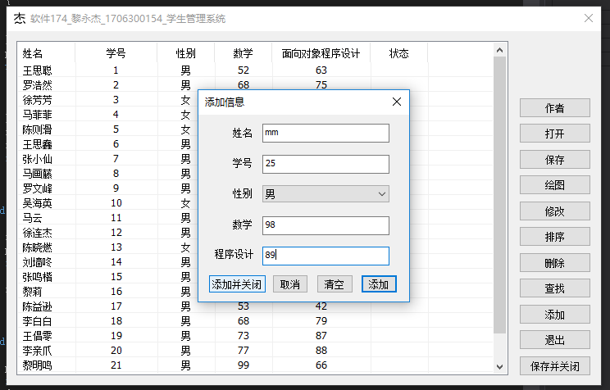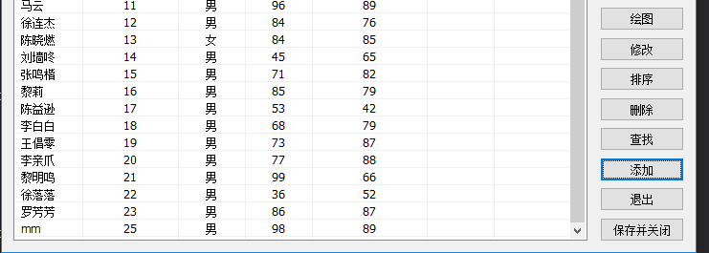

添加信息窗口中，点击“添加”键，可以将信息添加至列表但不关闭该窗口，并清空EDIT控件内的内容，使“姓名”的编辑框获得焦点；“清空”键可以清空所有编辑框的内容。

2.查找功能

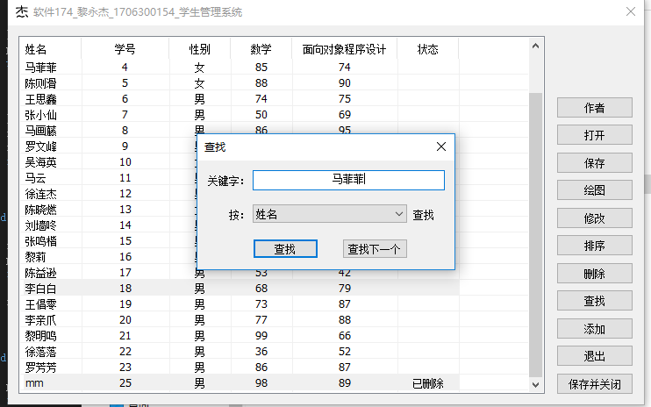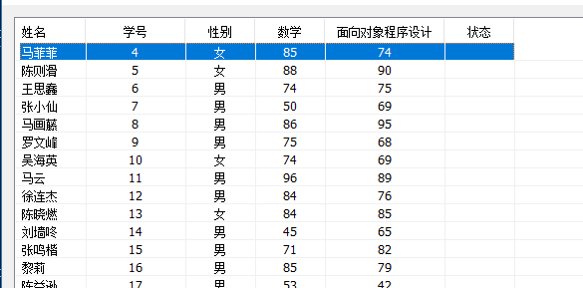

“查找”对话框内可选择以依据“姓名”、“学号”、“数学成绩”、“程序设计成绩”之一来查找信息；“查找下一个”可当在查找关键字不变的情况下，查找当前选中行的下一个与它关键字相同的信息；

3.删除

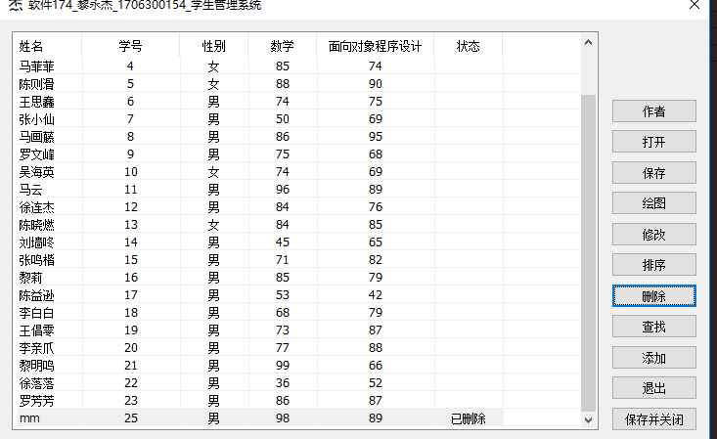

选中某一行后点击“删除”，可从内存删除该条信息，但不会从列表消失，取而代之的是“状态”出现“已删除”，以帮助误删恢复；删除后的信息经“排序”功能从而从列表消失；删除的信息不会被保存到文件。

4.排序

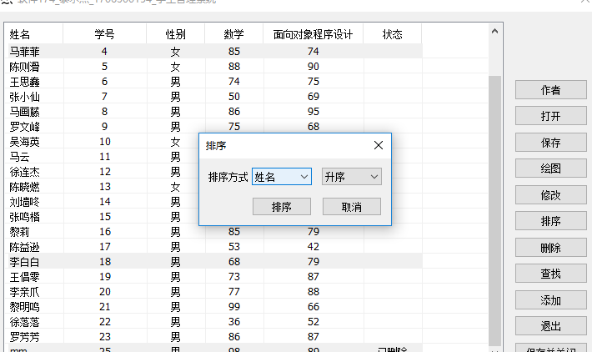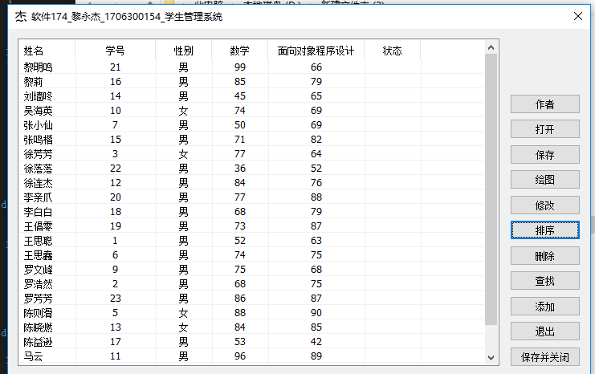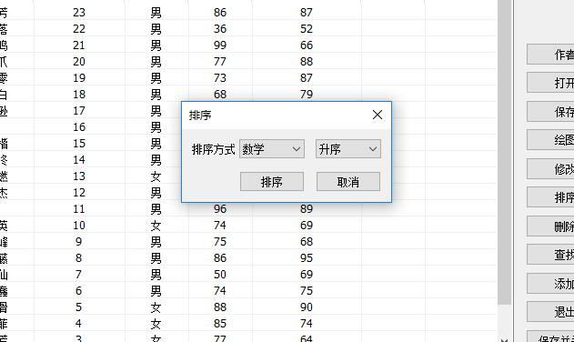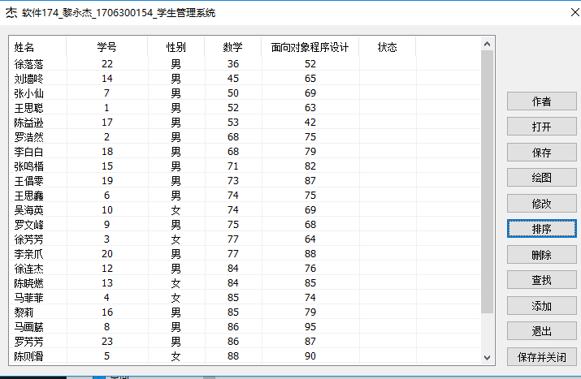

排序可将“姓名”、“学号”、“数学”、“程序设计”的其中之一项作为排序依据，

并可选择升序或降序，排序后“已删除”的信息将不会被显示

5.修改

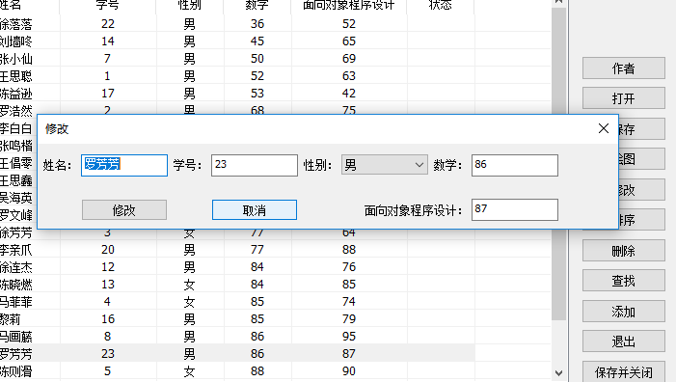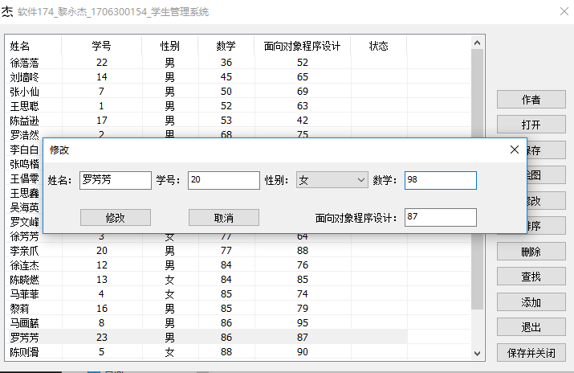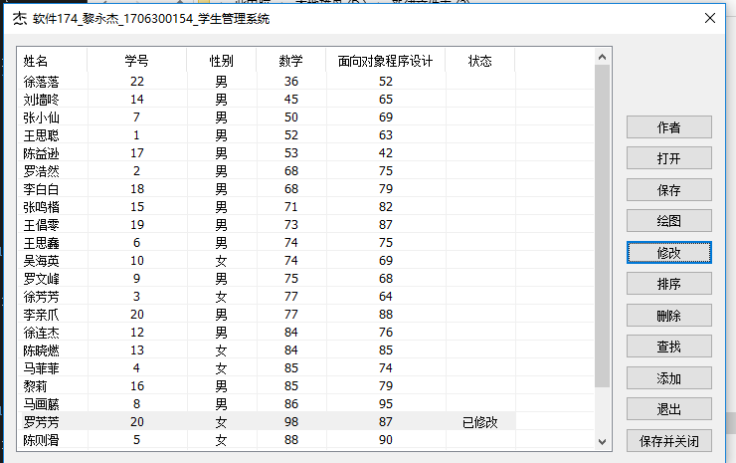

选中某一行后，点击修改按钮可以修改弹出的对话框内的信息，然后点击修改便可修改该行内容并刷新；修改功能支持多选并依次修改。

6.保存

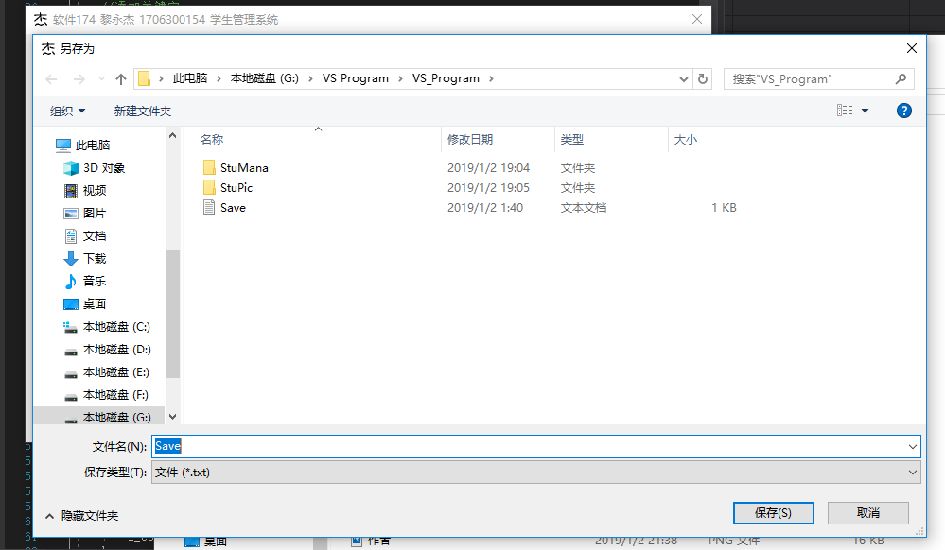

点击保存后可以将文件保存在自选的路径中，只能保存为.txt文件，文件内存有表格内“有效”的信息

7.打开

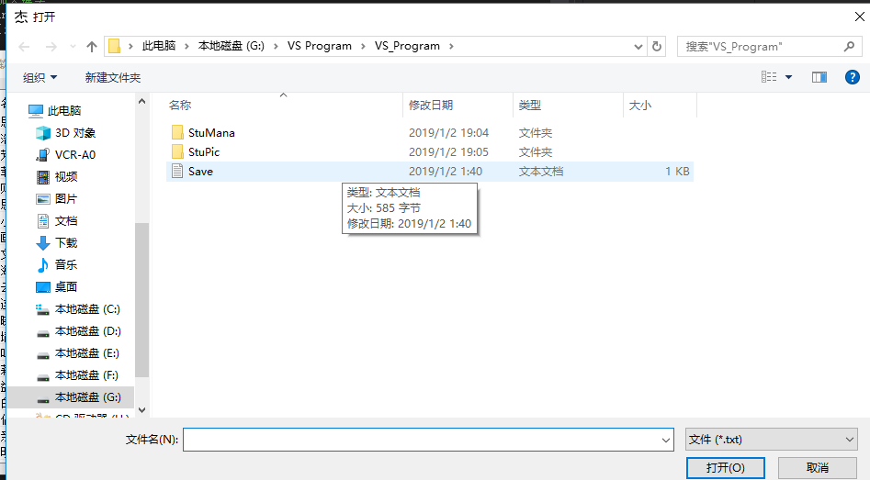

可打开以本程序储存的.txt文件，并录入到表格内，但若是打开未知的.txt可能会出问题。

8.绘图

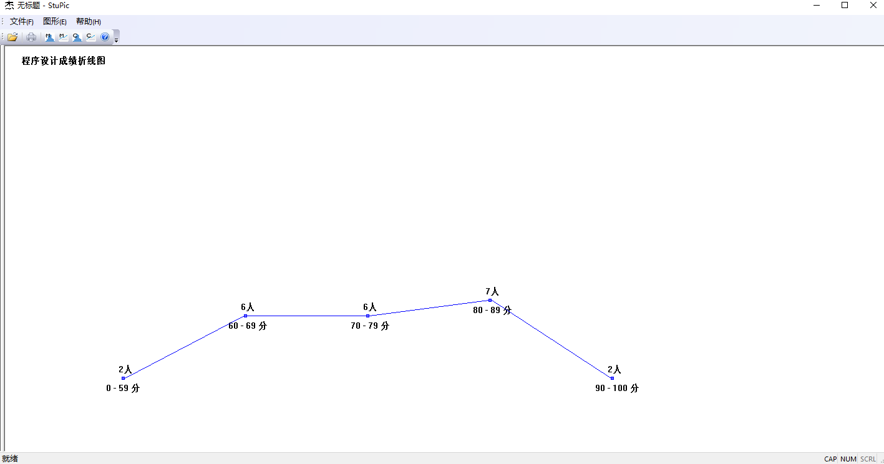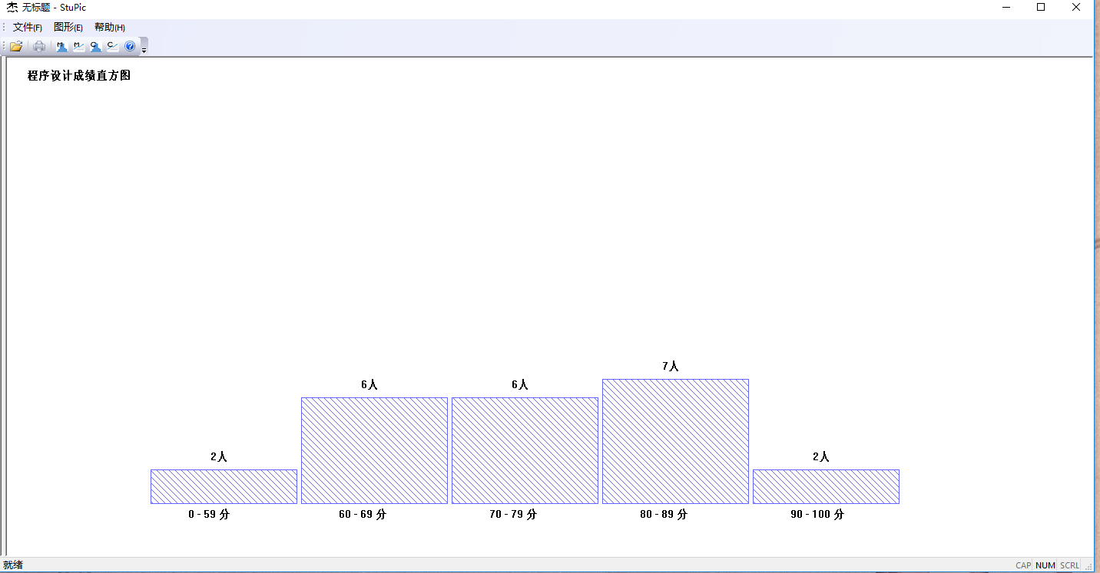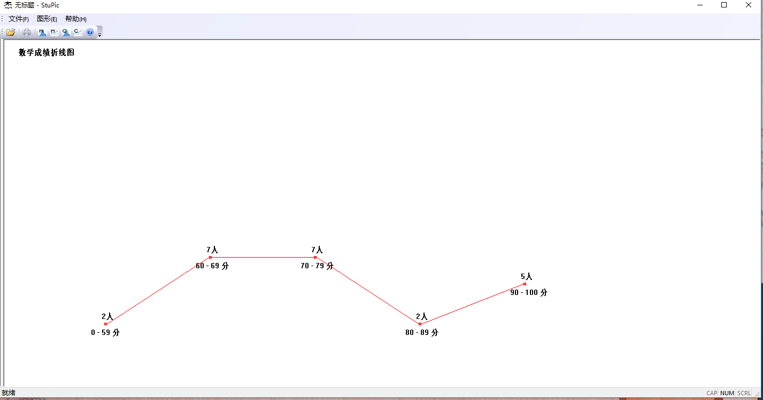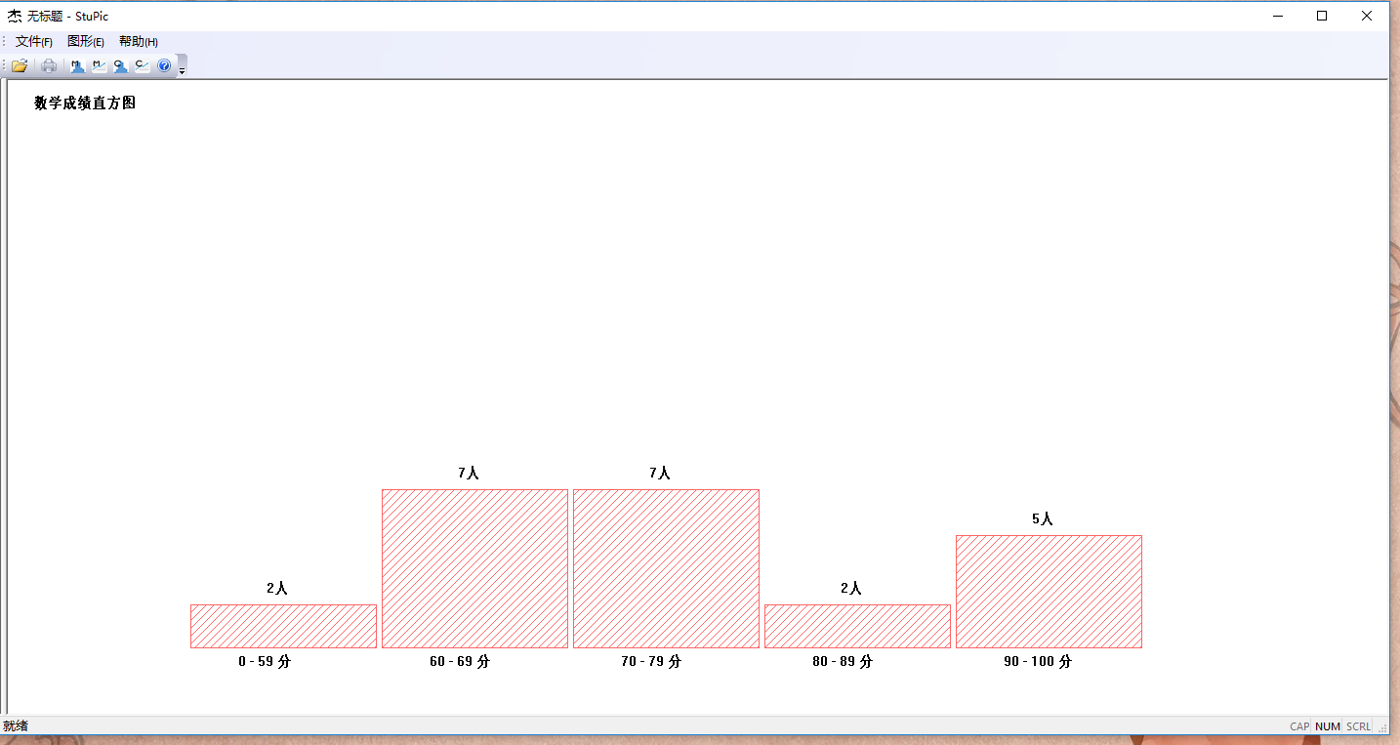

绘图的程序可由“学生管理系统”的“绘图”按钮自动搜索同目录下“StuPic.exe”打开，或者自行打开“StuPic.exe”；打开.txt文件将数据录入后，自动绘制“数学成绩直方图”，可以从“图形”内选择所需要的统计图，也可以从工具栏的四个按钮快速的切换统计图。

9.重置

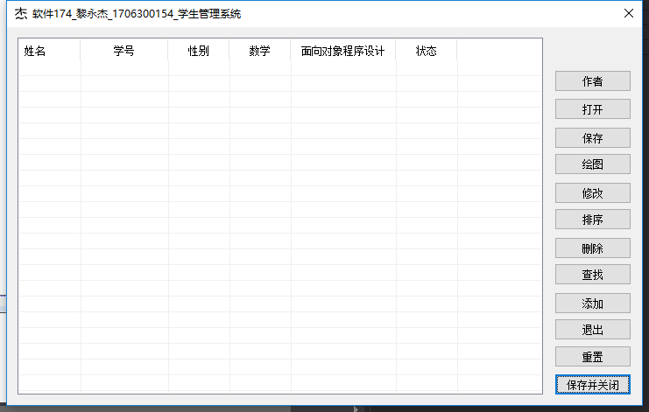

清空所有内容，并恢复至刚打开程序的状态

**六、实验疑难点分析**

1.本次实验操作数据的方式本应使用链表，但近期学习了B+树算法而且没有尝试过实现该算法，于是在本程序中首次使用了B+树 算法用以进行数据操作，但首次试验总是崎岖的，表面上该算法不难理解，但背地里却有许多小细节需要在实现的过程中注意，因此调试该算法耗费了大量的时间，同样也因为自身的考虑不周，导致了后续的其它函数与树的对接也出现了一些问题。

2.在代码展示中有一函数被注释了，该函数因考虑时不完善和未能及时分析出问题原因，从而不能通过测试，但由于函数其具有一定的独立性，可以暂时屏蔽掉该函数而不影响正常使用。

3.多个功能看似关联不大，但在实际的实现的过程中，功能间互相影响，互相制约，例如“添加”功能，若是添加信息时出现了错误，则“查找”、“删除”、“排序”等功能将会受到影响，若其它功能出现错误，错误本身未必在该功能上，也可能错误出现在“添加”功能上，这给测试调试添加了不少困难。

4.秉着“以人为本”的原则，总是心念着能有更人性化的设计，但这也增加了不少工作量和调试难度。

5.以本人的能力，考虑问题时不能面面俱到，大致的实现过程编写完成以后，调试的过程中会时不时遇到意想不到的情况，甚至有的情况出现的条件较为困难、复杂，给工作增加了不少难度。

6.合理的使用数组能有效的加强效率，但编写之初只考虑到数据并不多，故没有较多的使用数组，当发现数组能带来不少方便时，为时已晚。

7.编写“绘图”程序时，对界面的编辑比较困难，即使找到相关的初始化函数时，对其进行屏蔽、修改等操作时也会容易导致程序执行错误，对于“单文档”程序的学习有待加强。