Sumairu Dental Lab Task Management System

Installation, Network Configuration & User Deployment Manual

1. System Overview
This manual explains how to install, configure, and test the Sumairu Dental Lab Task Management System.
The system is designed for temporary internal clinic usage through a local network. The computer hosting the application acts as the local server, and other computers connected to the same Wi-Fi network can access it.

2. IMPORTANT Preparation Reminder
Before installing anything, create this folder:
C:\SumairuDentalLab
This folder should be used for application files, database files, uploaded photos, and backup files.
Do not install the application inside Desktop, Downloads, OneDrive, or USB drives.

3. Required Software
Required software:
- Windows 10/11
- Visual Studio 2022
- ASP.NET and Web Development workload
- .NET Framework 4.8 Developer Pack
- SQL Server LocalDB
- IIS Express or IIS
- Google Chrome or Microsoft Edge
Required package:
- iTextSharp for PDF generation

4. Visual Studio Installation
Install Visual Studio 2022.
Select workload:
ASP.NET and Web Development
Install components:
- .NET Framework 4.8 SDK
- .NET Framework 4.8 Targeting Pack
- SQL Server Express LocalDB

5. Application Folder Setup
Copy application files into:
C:\SumairuDentalLab
Ensure folder permissions include:
- Read
- Write
- Modify
The application requires permission to save photos and generate reports.

6. Database Setup
The application uses SQL Server LocalDB.
Just run the JoseTaskManager_Setup.sql files though the Visual Studio, it will automatically create the database for you.
Confirm LocalDB is installed and the JoseTaskManager database is available.
Connection target:
(localdb)\MSSQLLocalDB
Example:
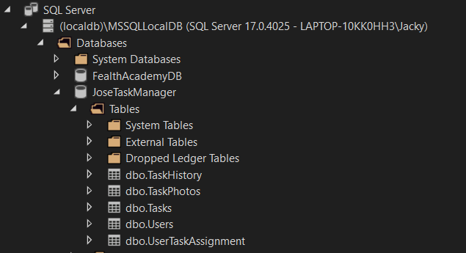

7. IP Address and TCP Port Configuration
To find the computer IP address:
1. Press Windows Key
2. Search CMD
3. Open Command Prompt
4. Type: ipconfig
Example:
IPv4 Address: 192.168.0.129
Access format:
https://192.168.0.129:44303
192.168.0.129 = computer IP address
44303 = application TCP port

8. Clinic Wi-Fi Setup
Connect all computers to the same clinic Wi-Fi network.
Example Wi-Fi:
Sumairu Dental Lab 5GHz@unifi
All devices must be inside the same local network.

9. Firewall Configuration
Allow the application TCP port through Windows Firewall.
Steps:
Windows Defender Firewall
→ Advanced Settings
→ Inbound Rules
→ New Rule
→ Port
→ TCP
→ Enter application port
→ Allow Connection

10. Testing Procedure
Test the following functions:
- Open application
- Admin login
- Staff login
- Create task
- Assign task
- Complete task
- Upload photo
- View photos
- Filter history
- Export PDF

11. Troubleshooting
Cannot access from another computer:
- Check Wi-Fi connection
- Verify IP address
- Check firewall
- Verify TCP port
Images cannot load:
- Check folder permission
- Check image storage path
PDF export problem:
- Check iTextSharp installation
- Rebuild application

Deployment Checklist
☐ Application opens successfully
☐ Admin account works
☐ Staff account works
☐ Task creation works
☐ Photo upload works
☐ History viewing works
☐ PDF export works

