Food Chains and Webs --- "What's for dinner?"

**Every organism needs to obtain energy in order to live.** For example, **plants get energy from the sun**, some animals eat plants, and some animals eat other animals.

A **FOOD CHAIN** is the sequence of **who eats whom** in a biological community (an ecosystem) to obtain nutrition. A food chain starts with the **primary energy source**, usually the **sun** or boiling-hot deep sea vents. The next link in the chain is an **organism that makes its own food** from the primary energy source -- an example is **photosynthetic plants** that make their own food from sunlight (using a process called **photosynthesis**) and **chemosynthetic bacteria** that obtain their food energy from chemicals in hydrothermal vents. These are called **autotrophs** or **primary producers**.

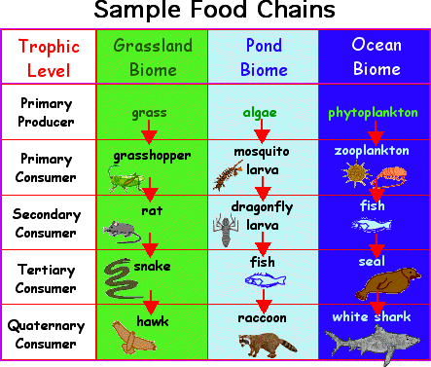

Next come organisms that eat the autotrophs; these organisms are called **herbivores** or **primary consumers** -- an example is a rabbit that eats grass. The next link in the chain is animals that eat herbivore - these are called **secondary consumers**

-- an example is a snake that eats rabbits. In turn, these animals are eaten by larger **predators** -- an example is an owl that eats snakes. The **tertiary consumers** are eaten by **quaternary consumers** -- an example is a hawk that eats owls. Each food

chain ends with a **top predator** and animal with **no natural enemies** (like an alligator, hawk, or polar bear).

**Food Chain Questions *(Refer to chapters 34-36 for help as needed)***

1. **What travels through a food chain or web?**

Energy

1. **What is the ultimate energy for all life on Earth?**

The sun

1. **Food chains start with what?**

Autotroph

1. **The 1st organism in a food chain must always be what type of organism?**

Primary Producer

1. **Name 2 food making processes.**

photosynthesis

1. **Where do chemosynthetic bacteria get their energy?**

chemicals in hydrothermal vents

1. **Define herbivore.**Something that doesn’t eat other animals
2. **Herbivores are also called** Primary Producers**.**
3. **What are animals called that feed on herbivores?**

secondary consumers

1. **Secondary consumers are eaten by larger** tertiary consumers **.**
2. primary consumers **consumers eat secondary consumers.**
3. **Draw your own real life food chain below (not one from above) with a producer and 3 consumers. Label all parts correctly using the terms you just reviewed.**

The **arrows** in a food chain show the **flow of energy**, from the sun or hydrothermal vent to a top predator. As the energy flows from organism to organism, **some energy is lost at each step**. This energy is lost to the environment as **HEAT**. **Energy,** unlike the atoms that make up the ions, minerals, and molecules of living systems, **cannot be recycled in the ecosystem. This is why food chains need a constant new input of energy from the sun.**

A network of many **food chains interacting together** is called a **FOOD WEB**. Food webs show more closely the complexity of feeding relationships in an ecosystem.

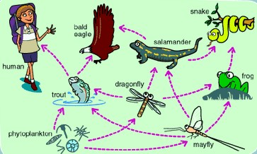

**Food Chain** versus **Food Web**

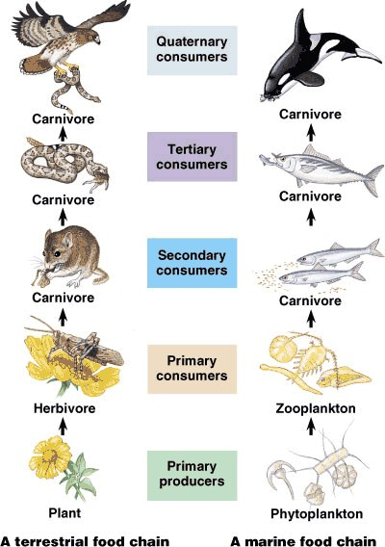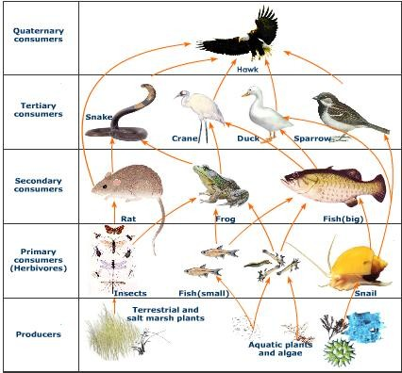

**TROPHIC LEVELS:**

**The trophic level of an organism is the position it holds in a food chain.**

## Primary producers (organisms that make their own food from sunlight and/or

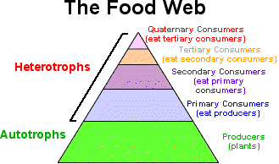**chemical energy from chemicals in deep sea vents)** are the base of every food chain - these organisms are called **autotrophs**.

* 1. **Primary consumers** are animals that eat primary producers; they are also called **herbivores (plant- eaters**).
  2. **Secondary consumers** eat primary consumers. They are **carnivores (meat- eaters)** and **omnivores (animals that eat both animals and plants).**
  3. **Tertiary consumers** eat secondary consumers.
  4. **Quaternary consumers** eat tertiary consumers.
  5. Food chains "end" with **top predators**, animals that have **little or no natural enemies.**

Some organisms' position in the food chain **can vary as their diet differs.** For example, when a bear eats berries, the bear is functioning as a **primary consumer**. When a bear eats a plant-eating rodent, the bear is functioning as a **secondary consumer**. When the bear eats salmon, the bear is functioning as a **tertiary consumer** (this is because salmon is a secondary consumer, since salmon eat herring that eat zooplankton that eat phytoplankton, that make their own energy from sunlight). Think about how **people's place in the food chain varies - often within a single meal!**

When any organism dies, it is eventually eaten by **detrivores** (like vultures, earthworms and crabs – **organisms that eat dead, decaying organisms**) and **decomposers (mostly bacteria and fungi that hydrolyze the dead organisms macromolecules back into monomers),** and the exchange of energy continues as these two groups of organisms take up the energy remaining in the dead organism’s chemicals and tissues and **help return essential nutrients to the soil.**

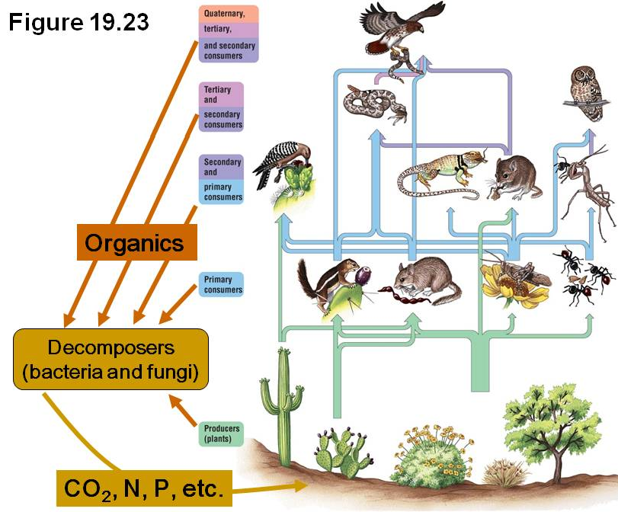

## Decomposers are CRITICAL in a food web for they return minerals and nutrients back to the soil for primary producers to use in order to grow and live (and support entire food webs). Remember, Remember, matter *(gray arrows)* is recycled in the environment while energy *(black arrows)* cannot be and so just flows through an ecosystem and is lost to outerspace.

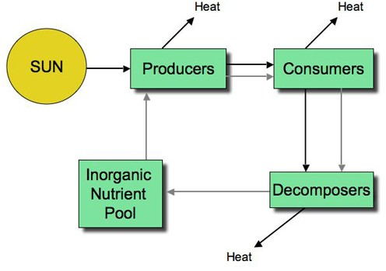

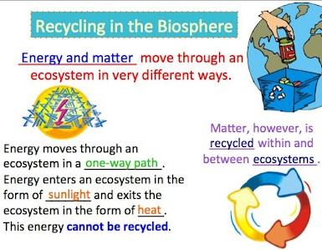

**Food Web Questions *(Refer to chapters 34-36 for help as needed)***

1. **What is used to indicate the flow of energy in a food chain or web?**
2. **What happens to energy as we move from step to step in a chain or web?**
3. **Define food web.**
4. **What is meant by trophic levels?**
5. **Define autotroph.**
6. **The 1st trophic level consists of consumers called**

.

1. **Name the 2nd trophic level (both names).**
2. **Secondary consumers may be eating meat or that eat both plants and animals.**
3. **What is the 3rd trophic level called?**
4. **What is the 4th trophic level called?**
5. **At the 5th trophic level would be consumers that eat consumers.**
6. **Give an example of 3 detrivores. On what do they feed?**
7. **What is the general name of an organism that feeds on dead plants and animals and helps recycle them by breaking down macromolecules and returning nutrients to the soil?**
8. **Both and act as decomposers.**
9. **Can an organism fill more than one trophic level --- yes or no? why? Give an example not mentioned in the text above.**

‘

## Numbers of Organisms & Trophic Levels:

In any food web, **energy is lost each time one organism eats another**. **Not all the energy used and stored by one organism in a lower trophic level is passed on to an organism in the next highest trophic level of a food web.**

Food chains can have as few as one link, or as many as six. **Very few food chains have more than five or six links.** Why? The food web consists of the transfer of energy from one species to another. Each level has about **10% less energy** available to be passed on to the next level because **some of the energy is lost as heat** at each level.

Plants utilize sun energy for primary production and can store only 10% of the utilized energy as net production available for the herbivores. When the plants are consumed by animal, about 10% of the energy in the food is fixed into animal flesh which is available for next trophic level (carnivores). When a carnivore consumes that animal, only about 10% of energy is fixed in its flesh for the higher level.

## So at each transfer 80 - 90% of potential energy is dissipated as heat (second law of thermodynamics) where only 10 - 20% of energy is available to the next trophic level. By the sixth trophic level, very little energy remains to be consumed.

Because of this, there have to be many **more plants than there are plant- eaters**. There are **more autotrophs than heterotrophs**, and more plant-eaters than meat-eaters. The animal at the top trophic level of a food chain faces no predators, but these species often face **the greatest chance of extinction,** since they depend on so many other species below them on the food chain.

Although there is **intense competition** between animals, there is also **interdependence**. When one **species goes extinct**, it can affect an entire chain of other species and have unpredictable consequences.

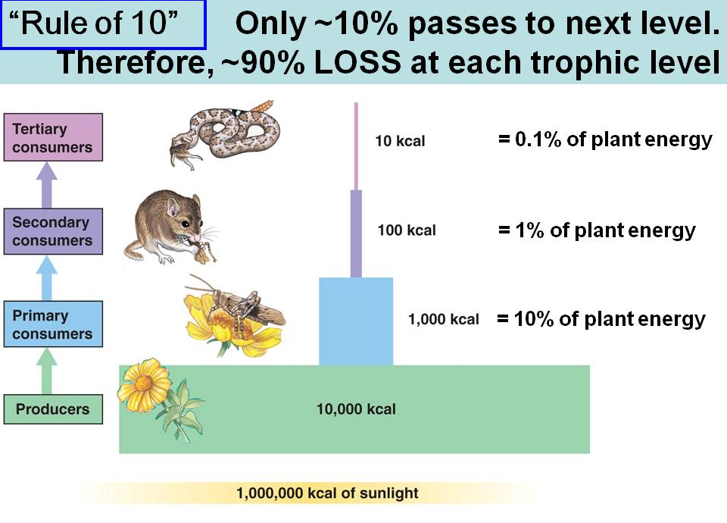

10

**Food Web Questions *(Refer to chapters 34-36 for help as needed)***

* 1. **In food chains and webs, what trophic level must you have more of than others? Why – in your own words?**
  2. **Each trophic level has how much LESS energy stored in the molecules of the organisms than the one below it?**
  3. **What may happen if a species goes extinct to the other organisms in a food web and why?**

# Equilibrium

As the number of **carnivores in a community increases**, they eat more and more of the herbivores, decreasing the herbivore population. It then becomes harder and harder for the carnivores to find herbivores to eat, and the population of carnivores decreases. In this way, the carnivores and herbivores stay in a **relatively stable equilibrium**, each limiting the other's population. A similar equilibrium exists between plants and plant-eaters.

# Complete the Food Chains Worksheet

Circle the organisms that complete the food chains below.

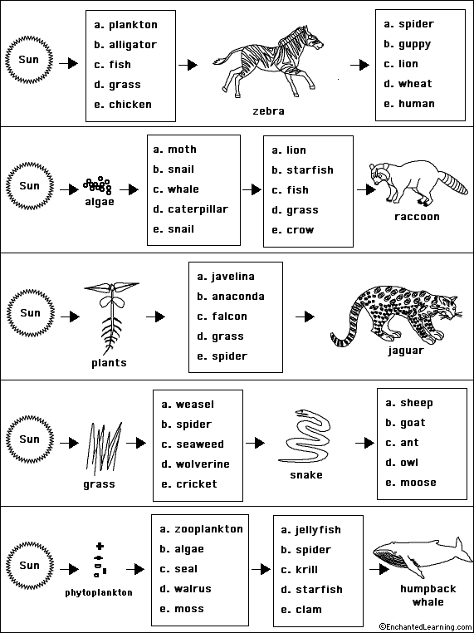

# Food Chain Worksheet

Read the passage then answer the questions below.

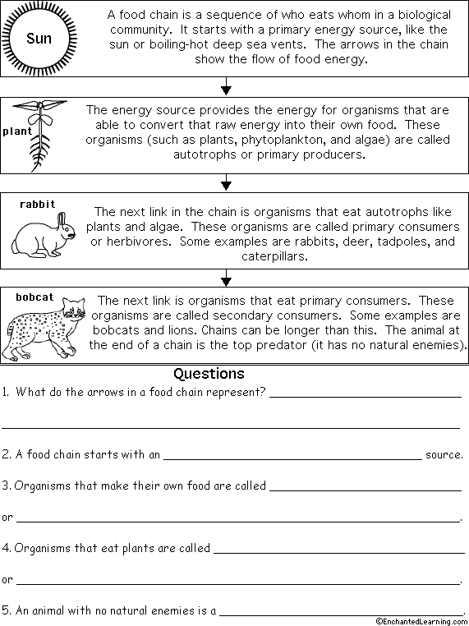

# Food Web Worksheet

Read the passage then answer the questions below.

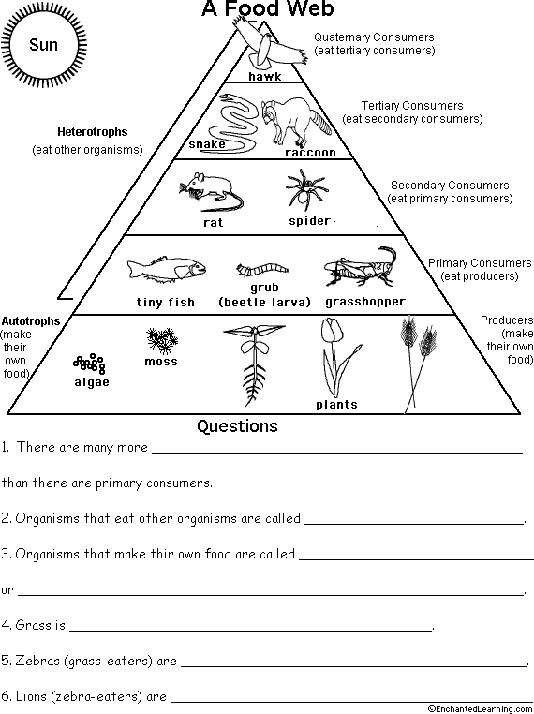

**Food Chain Quiz** - Multiple choice comprehension questions Color the circle by each correct answer.

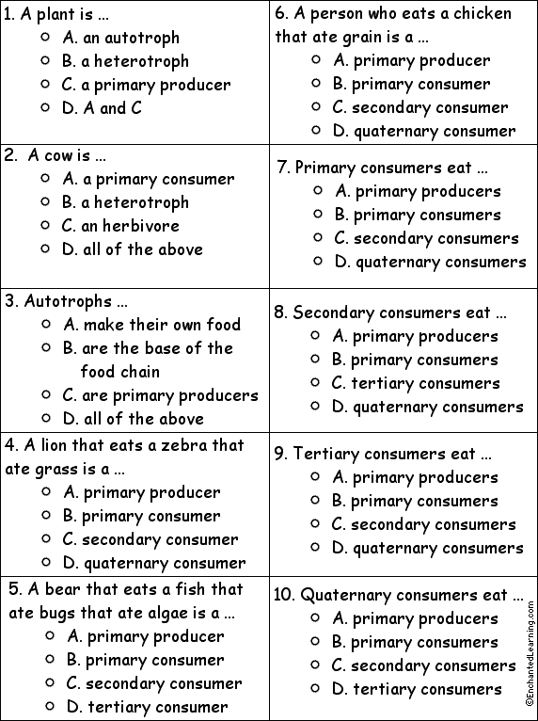

# Match each Food Chain Word to its Definition.

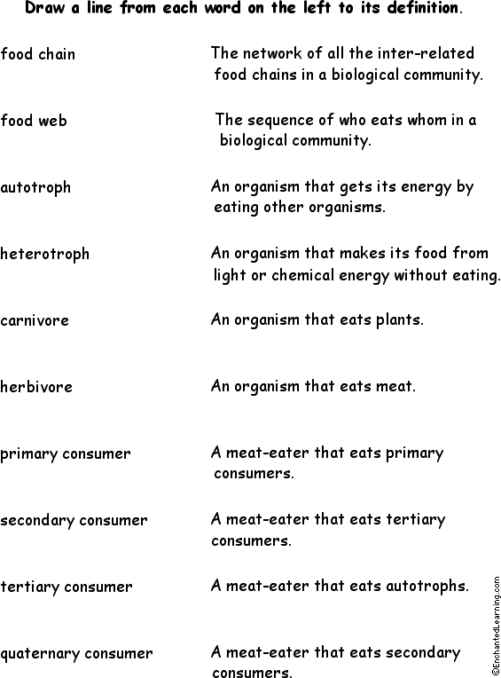

**Create Your Own Food Chain Trophic Levels - Worksheet**

