**Amoeba Sisters Video Recap: *Classification***

|  |  |  |
| --- | --- | --- |
| 1. First things first! Some important vocabulary: compare and contrast a **prokaryote** cell with an **eukaryote** cell.  ***No membrane-bound organelles, and no***  ***nucleus. (Prokaryotes)***  ***Membrane-bound organelles, Nucleus***  ***and DNA.*** | 2. Important vocabulary continued: label and *illustrate* an **autotroph** and a **heterotroph** organism. Underline the one that produces its own food. | 3. Important vocabulary continued: what is the difference between a **unicellular** organism and a **multicellular** organism?  ***Unicellular is only having one cell,***  ***Multicellular is having multiple cells.*** |
| 4. Classification is often changing! After introducing the domains, this video shows a 5 kingdom and 6 kingdom system. Why is classification subject to change?  ***Because what we know is always***  ***changing.*** | 5. Complete the diagram below to show all taxonomic levels from most inclusive (top in diagram) to least inclusive (bottom in diagram).    species  Genus  Family  Order  Class  Phylum  Kingdom | |

What’s in a Name?

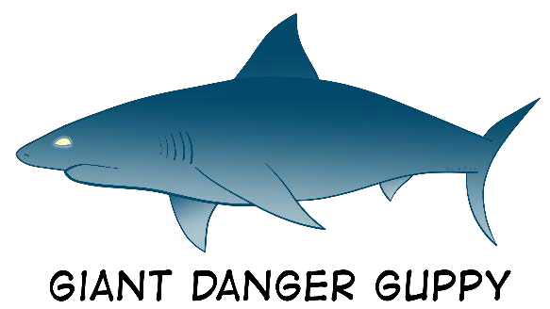

|  |  |
| --- | --- |
| 6. What is the benefit of a scientific name vs. a common name?  Scientific name allow don’t change and recognized everywhere, while common names can and differ depending on place. | 7. The video explains the two parts of a scientific name in **binomial nomenclature**. Label the parts of this scientific name below and write in any general facts about scientific names that you recall from the video.  They need to be italicized  *Hydra vulgaris*  The first part is uppercase no matter what |

Prokaryote Organisms



8. In the video, two different domains of prokaryotes were discussed. In a six kingdom system, these prokaryotes can also make up two of the six kingdoms. Describe these two separate prokaryote groups.

Eubacreria is the more common one and lives in place where it’s less extreme, and Archea live in more

Extreme places and are less common.

Eukaryote Organisms

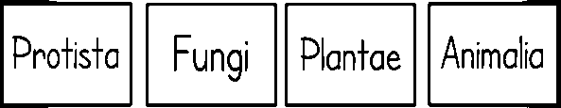

9. In the video, the domain Eukarya includes all eukaryote organisms. In a six kingdom system, these eukaryotes can make up four of the six kingdoms. Name these separate eukaryotic kingdoms and list descriptive words and examples for each. In your descriptions, use the bolded vocabulary words correctly from #1-3 on the previous page.

Protista can Autotrophs and Heterotrophs and most are unicellular, but

same are multicellular. Fungi, the are all heterotrophs, they can be both

multicellular and unicellular. Plante are autotrophs and are mostly

multicellular, with cell walls. Animalia are mostly multicellular

heterotrophs.