# Amoeba Sisters Video Recap of *Meiosis*

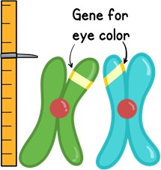

|  |  |  |
| --- | --- | --- |
| 1. The purpose of meiosis is to make **gametes**, also known as sperm and egg cells. In humans, your body cells have 46 chromosomes. How many chromosomes are in a sperm or egg cell if, when they come together to form a fertilized zygote, there are 46 chromosomes? **Write the correct number of chromosomes next to the sperm and egg.**  23 | 2. **Interphase** must occur once before meiosis can happen. (Same thing for mitosis). What would happen if interphase didn’t occur first?    ***The dna wouldn’t replicate.*** | 3. A cell that begins meiosis has 23 chromosomes inherited from the mother (shown in green in the cartoon below) and 23 chromosomes inherited from the father (shown in blue in the cartoon below). In the process of meiosis, chromosomes begin to match up in **homologous** pairs. How would you know if two chromosomes were **homologous**?  If they’re homologous chromosomes |
| 4. **Crossing over** is a very important event in Prophase I of meiosis! What happens during crossing over and what is the significance?  ***They exchange genetic information/*** | 5. Meiosis does PMAT twice! That means there is a prophase I and a prophase II. There is a metaphase I and a metaphase II. Etc… If the cartoon below has chromosomes in the middle of the cell, how would you know whether it was in metaphase I or metaphase II?  ***Because they meet in middle and it’s not single file so it’s metaphase I.*** | 6. Meiosis does not always occur without any difficulties. Describe what occurs during **nondisjunction** and the effect on the resulting cells.  ***The cell my have some genetic disorders.*** |



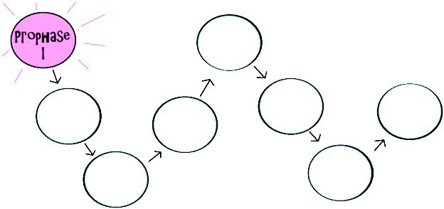**Can you finish the meiosis chain? Write the correct stage that comes next in each circle. Don’t forget the number that comes after the stage name! Then write any details about what this stage looks like next to it.**

Telophase II

Anaphase II

Metaphase II

Prophase II

Telophase I

Anaphase I

Metaphase I

# Now let’s play, “Which Clip Would That Be Said In?”

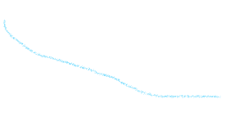Keeping mitosis and meiosis separate in your mind can be a bit tricky. Read the following speech bubbles. Determine whether they would be correctly placed in the mitosis clip, the meiosis clip, or both by drawing a line to the correct place in the Venn diagram.

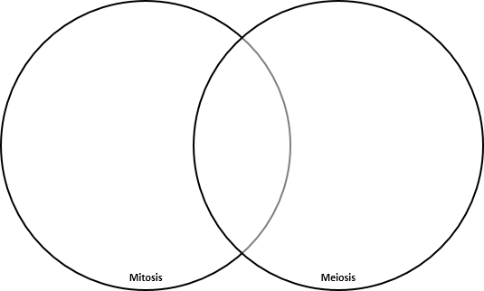

Produces

gametes.

Produces 4 cells

that each have 23 chromosomes.

Crossing

Over occurs.

Process is

important for growth and repair.

Interphase occurs once before the process begins.

Process ends with identical cells.