The Von Neumann model of a computer system

The model has the following basic features:

• There is a processor, a central processing unit.

• The processor has direct access to a memory.

• The memory contains a 'stored program' (which can be replaced by another at any time) and the data required by the program.

• The stored program consists of individual instructions.

• The processor executes instructions sequentially.

Components of the CPU

The two major components of the CPU are the arithmetic and logic unit (ALU) (or Arithmetic Logic Unit) and the control unit.

**Registers**: are storage components which, because of their proximity to the ALU, allow very short access times. Each register has limited storage capacity, typically 16, 32 or 64 bits. A register is either general purpose or special purpose.

**Accumulator**: a general-purpose register that stores a value before and after the execution of an instruction by the ALU

**Registers in a simple CPU** 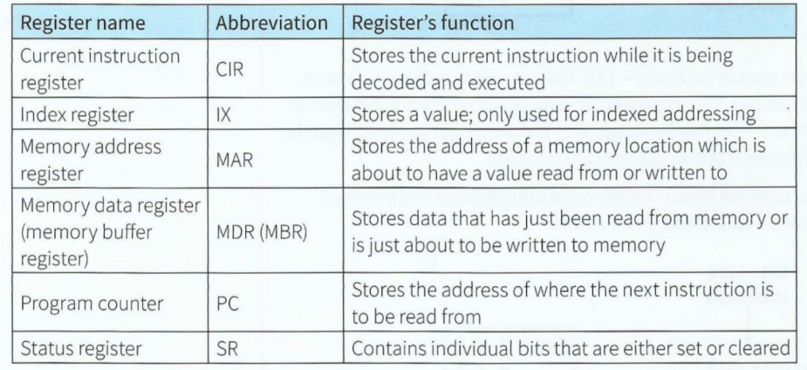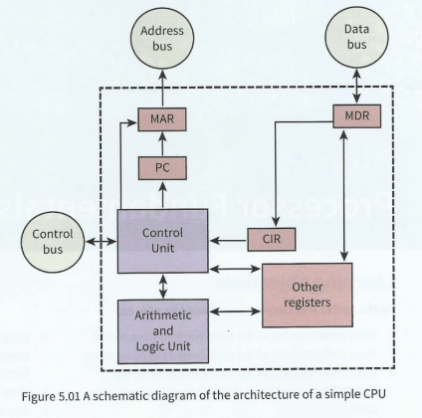

**Bus**: A bus is a parallel transmission component with each separate wire carrying a single bit, it is a mechanism for data to be transferred from one system component to another. The system bus allows data flow between the CPU, the memory, and input or output (I/O) devices.

**Address bus**: a component that carries an address to the memory controller to identify a location in memory which is to be read from or written to

**Data bus**: a component that carries data to and from the processor

**Control bus**: The control bus is another bidirectional bus which transmits a signal from the control unit to any other system component or transmits a signal to the control unit.

**Word**: a small number of bytes handled as a unit by the computer system

USB

Any computer user could connect a peripheral and start using it straight away by the USB standard.

Some information about the USB standard:

• A hierarchy of connections is supported.

• The computer is at the root of this hierarchy and can handle 127 attached devices.

• Devices can be attached while the computer is switched on and are automatically configured for use.

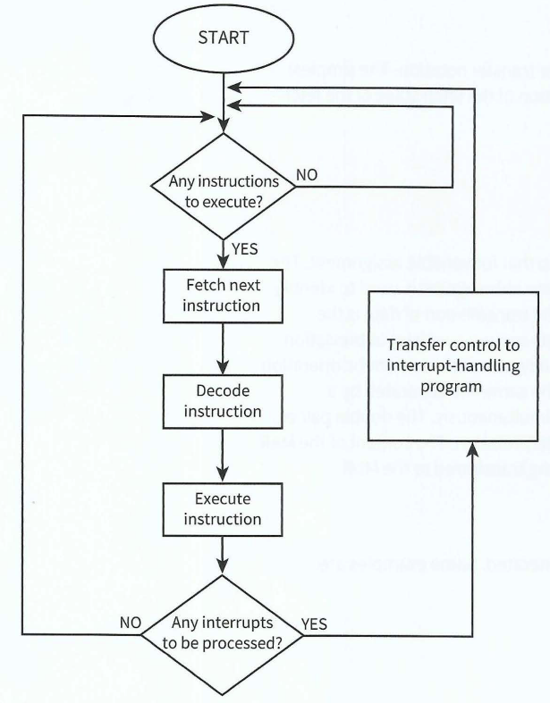• The standard has evolved, with USB 3.0 being the latest version.

Summary

• The von Neumann architecture for a computer system is based on the stored program concept.

• The CPU contains a control unit, an arithmetic and logic unit, and registers.

• Registers can be special purpose or general purpose.

• The status register has individual bits acting as condition flags.

• The system bus contains the data, address and control buses.

• A universal serial bus (USB) port can be used to attach peripheral devices.

• Instructions are handled by the fetch-execute cycle.

• Register transfer notation is used to describe data transfers.

• If an interrupt is detected, control passes to an interrupt-handling routine.