Contents
Get MobileDebug from GitHub.com 2
Option 1: Easy updates, not the best option for USB drives. 2
Option 2: Manual updates, more portable. 2

Get MobileDebug from GitHub.com

Option 1: Easy updates, not the best option for USB drives.

Install GitHub Desktop
Download: https://desktop.github.com/
Instructions: https://help.github.com/en/desktop/getting-started-with-github-desktop/installing-github-desktop
Search: https://www.google.com/search?q=download+github+desktop

Browse to: https://github.com/ZeroxCorbin/ReleaseBuilds

Select Clone or Download button and click Open in Desktop.
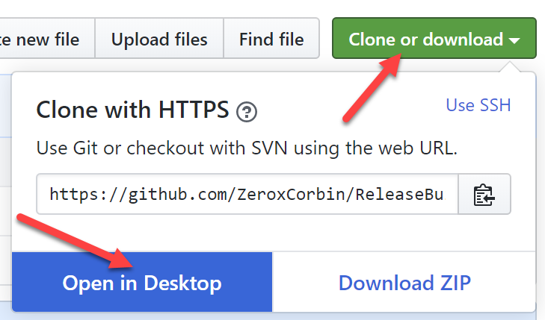

GitHub Desktop Will prompt you to select a directory to store the repository.
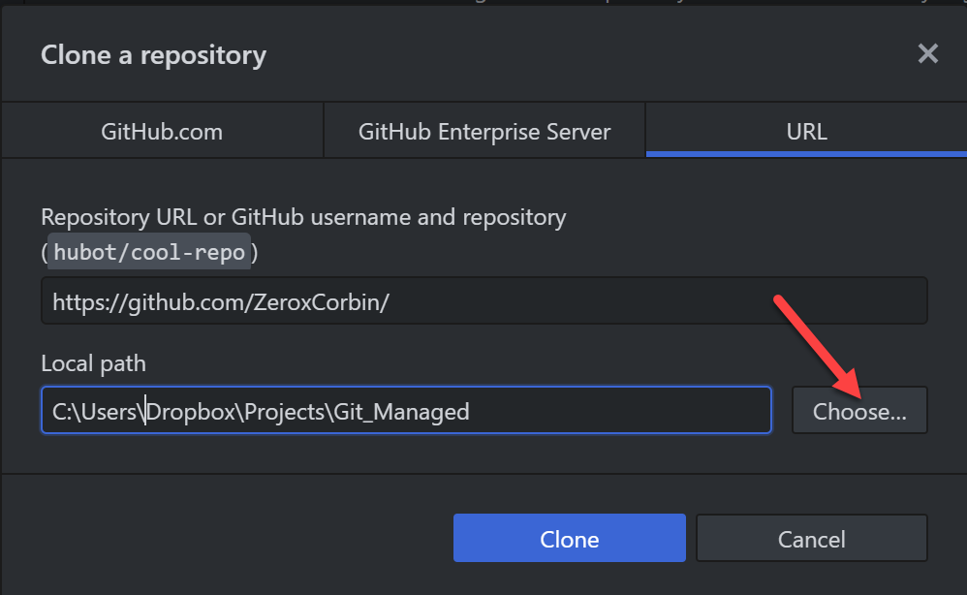

Click Pull Origin to download the repositiory to your system.
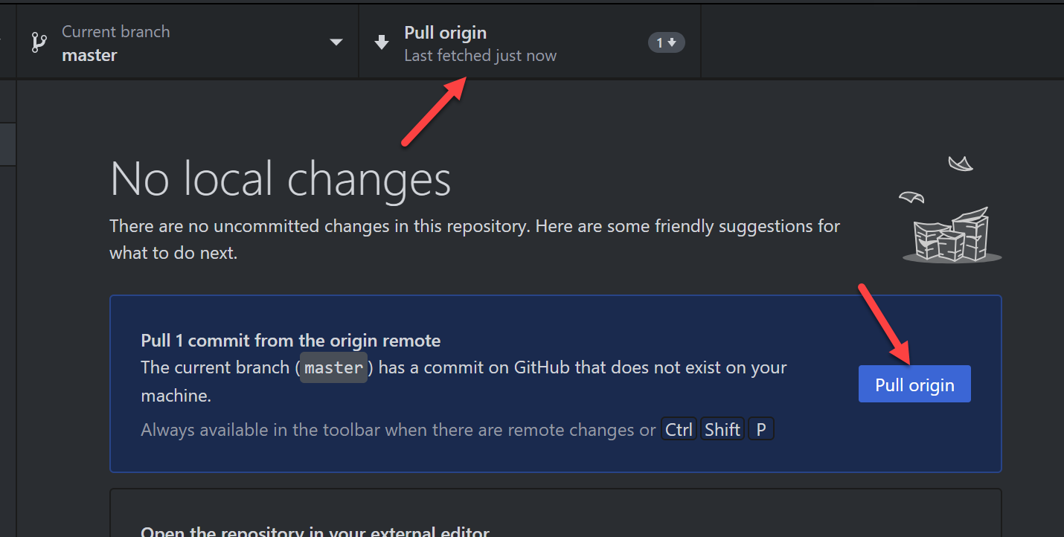

Option 2: Manual updates, more portable.

Browse to: https://github.com/ZeroxCorbin/ReleaseBuilds

Select Clone or Download button and click Download ZIP.
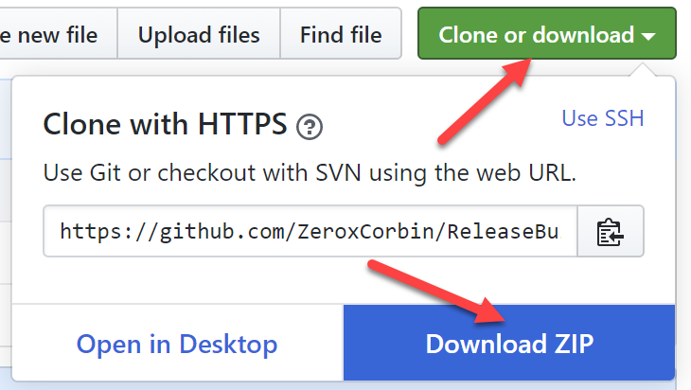

Save the zip file and extract it to a location you would like to run the program from.

Start MobileDebug

