An Analysis of NYS Tax Data to Determine Potential Tax Bracket Changes

Benjamin Sherman

CIS 512 Spring 2018

Draft 11-26-2018

Abstract

(Currently the same as my project proposal – will be updating it)

The wealth gap between Americans is continuing to grow with the average American owning far less wealth than those in the top one percent of the nation. The top 1% of the nation holds roughly 33.7% of the nation’s wealth while the bottom ninety percent holds only roughly 22.8% of the wealth in America (DePhillis, 2017). That means that the top ten percentile holds roughly 77.2% of all of America’s wealth, and since the top ten percentile of the top ten percentile owns almost half of that wealth, the average American has next to nothing compared to anyone who belongs in the top one percent of the nation.

My project is hoping to look at this disparity by looking over the open tax records to hopefully propose a new set of tax brackets meant to take advantage of this. Given the extreme disparity of wealth in America, a new set of tax brackets meant to tax the top ten percentile would at the least allow taxation of the lower tax brackets to be lowered, giving them more for their quality of life, and at the most it will allow for an increase in government income without further taxing the average American.

As ten million dollars means very little when lobbying for national law changes, if I were to invest the ten million dollars for this project in enacting the potential changes I come up with, I would need to start at a state or even local level, using the money to lobby for change in a more localized area where any individuals who would fall into the new tax brackets might have a hard time relocating and thus skewing any data that would be gathered on experimenting with the new brackets by simply leaving for somewhere that doesn’t use them.

Contents

1 Introduction and Topic Selection 1

2 Workflow – Obtaining the Data 1

3 Issues Encountered 3

4 Results 4

5 Conclusion and Discussion 6

6 CITATIONS 6

7 Appendix A 7

# Introduction and Topic Selection

There is an extreme economic disparity in our nation and among the states. Although federal taxes are implemented consistently, state taxes vary significantly from state to state.

****Need to expand more from what was in the abstract/project proposal.

# Workflow – Obtaining the Data

* 1. To do this analysis, Open Data for NYS is available at <http://data.ny.gov>
     1. Selecting the Government & Finance link results in <https://data.ny.gov/browse?category=Government+%26+Finance&utf8=%E2%9C%93>
     2. Using the menu options at the left side of the web page, select   
        Category = “Government & Finance” AND  
        Type = “Datasets” AND   
        Agencies & Authorities = “Taxation and Finance, Department of” AND   
        Tags = “income”  
        RESULTS in 6 datasets: The two original that I had previously found via a different search criteria deal with tax years 1999 to 2014, and 4 expanded datasets that deal with tax year 2015. I used Dataset 4 because of the expanded data fields and it being more recent. I have not been able to find open data for either 2016 or 2017.  
        <https://data.ny.gov/Government-Finance/Personal-Income-Tax-Filers-Summary-Dataset-4-Count/qjqv-zrwt>
  2. State Individual Income Tax Rates and Brackets for 2018  
     <http://www.tax-brackets.org> tax brackets for federal and states  
     <https://www.tax-brackets.org/newyorktaxtable> NYS income tax brackets 2017-2018  
     On this page, there is a link to VIEW PAST YEAR’s BRACKETS. I used this to get back to the 2015 brackets. See next item.
  3. State Individual Income Tax Rates and Brackets for 2015  
     <https://files.taxfoundation.org/20171101110528/TaxFoundation_FF462.pdf>
  4. Federal Income Tax Data  
     <https://taxfoundation.org/summary-federal-income-tax-data-2017/#_ftn1>
     1. This doesn’t only show 2017 data, it shows data from 1980 to 2015, in the form of 8 Tables. There are some things that do not make sense about the values in the table. It is unclear how they arrived at certain values.
     2. <https://en.wikipedia.org/wiki/Federal_tax_revenue_by_state>   
        Has a table of total federal tax revenue by state collected by the US Internal Revenue Service.
     3. <https://www.irs.gov/statistics/soi-tax-stats-historic-table-2>   
        SOI (Statistics of Income) Tax Stats Historic Table 2 – has a map of the US and by clicking on a state one can get the data about federal income tax by state. The map deals with the most recent year available, which currently is 2016. However, if one scrolls down, prior years are available. The file name for the 2015 NYS statistics is 15in33ny.xlsx

# Issues Encountered

* 1. The data that is available at the State Level and Federal Level are already aggregated. Due to privacy reasons and legal reasons, they do not make the individual data available. Given the income brackets reported in the available data sources, it is not possible to identify the top 1% wealth holders. However, for the NYS data, the incomes above $200,000 in 2015 represent approximately 7 % of the on-time tax returns, which is a significant proportion of the top ten percentile I planned on using. The federal data actually lists the Top 1% as an item.
  2. The income aggregations in the NYS data do not exactly match the tax brackets. However, the top bracket, $200,000 and higher, includes approximately 7% of the submitted returns, and is the actual range of the top tax bracket in NYS.
  3. The original data sources I suggested in the project proposal are problematic. They only have data between 1999-2014. In 2015, the open tax data format was modified to include more fields in the respective datasets. This now has 4 data sets:
* Personal Income Tax Filers, Summary Dataset 1 – Major Items by Liability Status and Place of Residence: Beginning Tax Year 2015
* Personal Income Tax Filers, Summary Dataset 2 – Major Items and Income & Deduction Components by Place of Residence and Broad Income Range: Beginning Tax Year 2015
* Personal Income Tax Filers, Summary Dataset 4 – County-level Major Items and Income & Deduction Components by Wide Income Range: Beginning Tax Year 2015 ** one I selected.
* Personal Income Tax Filers, Summary Dataset 3 – Statewide Major Items and Income & Deduction Components by Liability Status and Detail Income Range: Beginning Tax Year 2015.
  + 1. Personal Income Tax Filers, Summary Dataset 4 – County level Major Items and Income & Deduction Components by Wide Income Range: Beginning Tax Year 2015   
        <https://data.ny.gov/Government-Finance/Personal-Income-Tax-Filers-Summary-Dataset-4-Count/qjqv-zrwt>

NOTE: After reviewing the four 2015 datasets, I selected Dataset 4 because of the columns included.

I inserted two columns at the beginning of the spreadsheet, and copied the “Sort on Place” and “Sort on Income Range” values here to make it easier to adjust sorting for looking at the data. I named this file:   
Personal_Income_Tax_Filers_Summary_Dataset_4-_County-level_Beginning_Tax_Year_2015-v2.xlsx

* + 1. Had difficulties finding past year tax information on the NYS Taxation and Finance site. See appendix A.

# Results

* 1. Data Access and Use in Project

The data is with respect to individual tax returns that are aggregated by income levels. Unfortunately, these levels do not match the actual tax brackets

* 1. Subjects / Data Sources
     1. Subjects = taxpayers of New York State
     2. Data Sources

New York State <http://data.ny.gov>

Federal Government – IRS Tax Statistics by state   
<https://www.irs.gov/statistics/soi-tax-stats-historic-table-2>

* 1. Procedure
  2. Investment Plan
     1. Potential Plan 1: half of the 10,000,000 for advertising (possibly Super Bowl if there is a way to have an ad just for NYS) that asks constituents to contact the governor, speaker of the assembly and president pro tempore of the senate (as these individuals dominate the passing of legislation in NYS) to support the changing of tax brackets; and the other half to lobby the governor, speaker of the assembly and president pro tempore.
     2. Potential Plan 2: Use all of the 10,000,000 for lobbying, however, would need to further consider how to divide up this lobbying money. Since the top 3 (governor, speaker of assembly and president pro tempore) are so important with respect to the legislative agenda, they would still be targeted with a significant share, and the remainder to target representatives for the 62 senate districts (apparently one per county) and 150 assembly districts. Have not yet looked at ways to decide how to pick which ones to target. The state tax data is available to identify how much comes from each county. In terms of making a data driven decision, targeting the state senators is feasible.

# Conclusion and Discussion

A work in progress.

# CITATIONS

DePhillis, L. (November, 3, 2017). *America’s Wealth Gap is Bigger than Ever.* Retrieved from <https://money.cnn.com/2017/11/03/news/economy/wealth-gap-america/index.html>

# Appendix A

Datasets I have reviewed but not yet used:

* 1. (NYS) State Taxes and Fees Collected: Beginning Fiscal Year Ending March 31, 1995  
     <https://data.ny.gov/Government-Finance/State-Taxes-and-Fees-Collected-Beginning-Fiscal-Ye/cpjr-ezcj>   
     This is a place for future data analysis to see what other types of taxes might be adjusted in a fiscally and economically sound way to equitably distribute the tax burden across different entities beyond individual income taxes in NYS.
  2. State Individual Income Tax Rates and Brackets for 2018  
     <http://www.tax-brackets.org> tax brackets for federal and states - This data site is beneficial for future research to consider the impact of similar changes to potentially be made across the nation.

Click on the Download Data button on the right side. Gives you an excel spread sheet

<https://www.tax-brackets.org/newyorktaxtable> Specific tax brackets for NYS and an explanation on how income tax is computed.

### “**How do New York tax brackets work?**

Technically, you don't have just one "tax bracket" - you pay all of the New York marginal tax rates from the lowest tax bracket to the tax bracket in which you earned your last dollar. For comparison purposes, however, your **New York tax bracket** is the tax bracket in which your last earned dollar in any given tax period falls.

You can think of the bracketed income tax as a **flat amount** for all of the money you earned *up to your highest tax bracket*, plus a marginal percentage of any amount you earned over that.

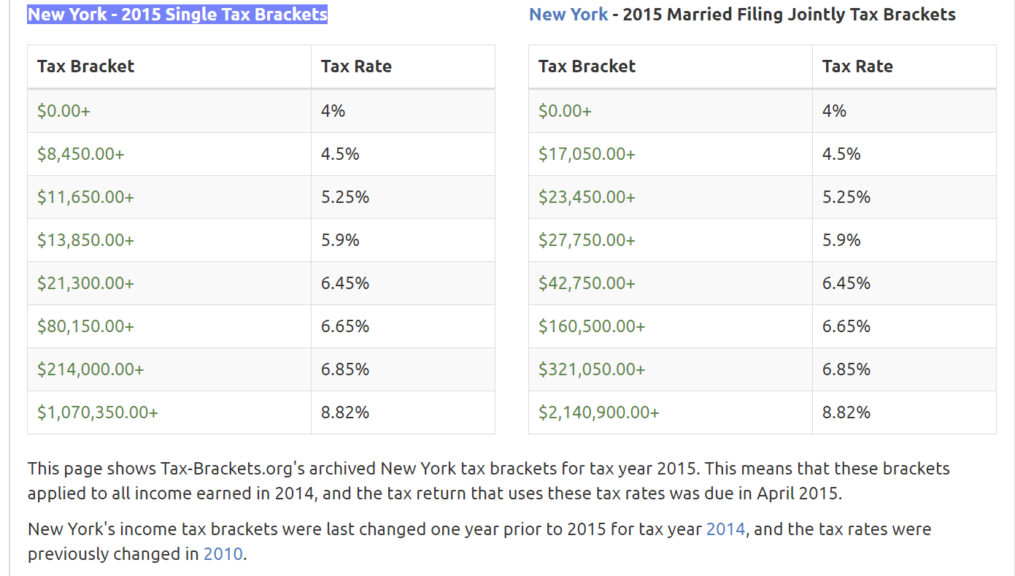

<https://www.tax-brackets.org/newyorktaxtable/2015>

The text brought something to my attention that I had not realized – it appears the tax year refers to when one pays the taxes, but actually reflects income earned in the prior year.

Yet in the NYS tax file, the data is aggregated by income using the following income ranges:

|  |
| --- |
| NY Adjusted Gross Income Range (Fed.Col) |
| $ 1 - 9,999 |
| $ 10,000 - 24,999 |
| $ 25,000 - 49,999 |
| $ 50,000 - 74,999 |
| $ 75,000 - 99,999 |
| $ 100,000 - 199,999 |
| $ 200,000 and Over |
| All Income Ranges |

This was on the 2017 page. The 2015 page did not provide similar breakdowns.

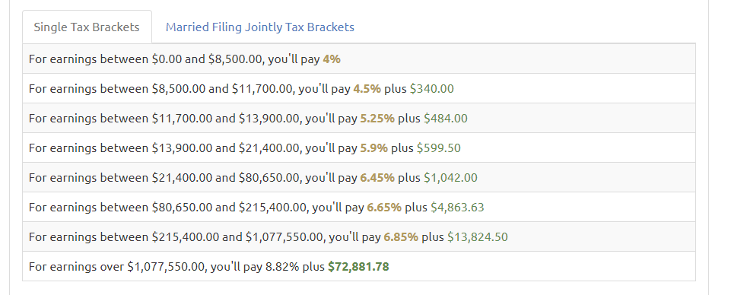

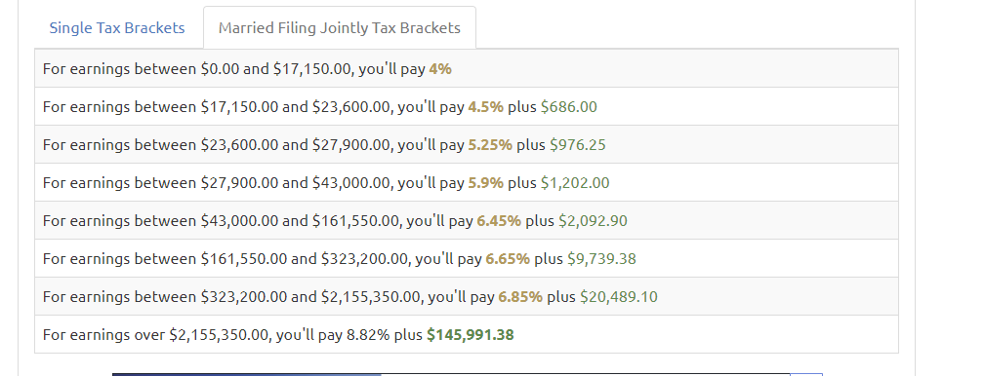

FINALLY FOUND IT online. <https://www.tax.ny.gov/pdf/2015/inc/it201i_2015.pdf>

I still have to figure out how to compute increasing the $200,000 and up income category to appropriately account for differences in the types of returns. To do this correctly, one cannot just multiply the tax liability by 1% given the way the actual tax amount is calculated.

Searching on the NYS department of taxation and finance is difficult and what I think are reasonable search strings did not give reasonable results. FINALLY found the 2015 tax forms and documentation on <https://www.tax.ny.gov/forms/prvforms/forms_2015.htm> Not exactly sure how to get here directly, as I was doing a number of searches to ultimately reach this point.

The following NYS tax rate schedule taken from the 2015 IT-201-I page 55

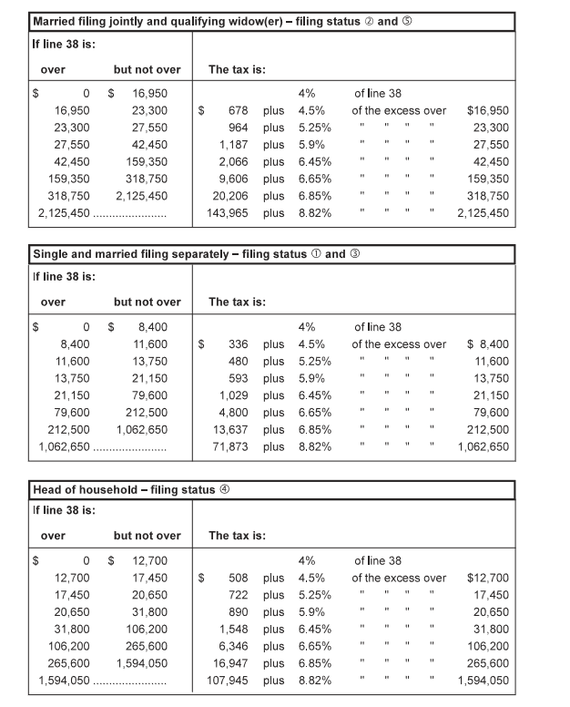

NYS tax rate schedule taken from the 2015 IT-201-I page 55