**Chapter 1 Introduction**

**1.1 Background of the Company**

QuickBiz Messenger is a delivery service firm that deliver packages and was established by Andrew Langston who obtained the idea after working for a local bicycle delivery service during his college years. After returning home, he set up QuickBiz Messenger as a business in his hometown Seattle which at that time only had a handful of small messenger services so there was not that much competition. In its early years, Andrew Langston worked alone and wrote every log sheet and customer slip by hand. QuickBiz Messenger used Bicycle as a means of service when delivering messages and packages to its clients. Opportunity came for QuickBiz Messenger in the 1990’s when the pace of business transactions skyrocketed and firms of all sizes needed additional services to carry out their day-to-day transactions so the number of deliveries required also increased. Traffic on the metropolitan area of Seattle also became heavier over time so delays were common for most of the other messenger services. With this situation, QuickBiz Messenger and through its model of using bicycle as a means to deliver which did not have much problems with the traffic meant that packages were always delivered safe and on time which allowed QuickBiz Messenger to obtain a reliable service and good reputation.

**1.2 Current System**

As business became bigger and more complex, Andrew hired Sarah Truesdale to be his bookkeeper and receptionist. Sarah organized an office and set up basic business applications such as word processing, spreadsheet, and database programs on the company’s first PC. When Andrew received a delivery request, Sarah typed it in her daily log sheet and Andrew went cycle and deliver. As the customer base grew, Andrew began hiring college students as part-time biker messengers and would be given instructions by dispatchers on new orders and delivery requests through the SMS. QuickBiz Messenger currently has more than 90 employees. Deliveries were kept track through No-Carbon-Required (NCR) Forms which were held by the couriers and would give them to the customers to fill out delivery information. Customers kept a copy of the form, and the couriers took the originals back to the main office. Sarah would then input the customer information such as order number, address, and type of service along with the facts of the delivery such as start and end times, courier name, and delivery address. Andrew recently expanded his services to car and truck deliveries which meant management of the messengers became more complex as these services do not work well with traffic which the company was known for not having problems with. Andrew is also planning to be able to evaluate the performance of his employees by tracking the number of deliveries and shortest delivery times for each messenger. He also plans to be able to evaluate the different delivery territories to determine which were the most profitable and to generate sales reports by region.

**1.3 Problems of the Current System**

Tracking the availability of the Employees

* The growth of messengers in the company is causing problems for Sarah Truesdale and Leslie Chen in manually managing the schedule for the messengers which became more complicated overtime. It should also be mentioned that most of the employees that were hired were part-time workers so certain individuals are only available while others are not in certain times. Most of these are College Students so their schedule would change every semester. Additionally, when some were suddenly unavailable in the moment such as calling-in sick or having emergencies, the managers would scramble in lining up a replacement which were available for the delivery.

No methods to assess the performance of the Employees

* Andrew wants to know which of the messengers in his company perform the best for them to receive a bonus from outside feedback and especially customers. Unfortunately, as of the moment, QuickBiz has no available method for it.

No methods to evaluate the Territories

* Andrew wants to have an idea on which of the territories they operate are the most profitable but as of the moment, QuickBiz has no available method for it.

Finding efficient routes for the Unfamiliar Messengers

* Most of the long-time messengers in QuickBiz Messenger already know the most efficient routes in Seattle with the exception for some of the few messengers who were not native to the area. This caused delays with some of the delivery. Customers and clients affected by this are beginning to complain and QuickBiz Messenger recognizes this problem as a threat to their reputation.

Outdated Tracking Delivery Data

* Problems arose for QuickBiz Messenger in using the NCR as a method to record delivery information when some of the handwritings were difficult to read and would often be damaged due to the weather. Because of this, inputting the data became tedious and was even worsened after the company expanded its service to cars and trucks. The number of NCRs required to review by Sarah became more unmanageable over time.

**1.4 Objectives of the System**

General Objective

* The main purpose of this study is to create and design a management system for QuickBiz Messenger that can help resolve most of the problems that were observed by the group.

Specific Objectives

Designing and developing a functional Database.

* This database must be able to store data regarding details about the employees of QuickBiz Messenger, details of the deliveries that were undertaken by QuickBiz Messenger, details regarding the customers that are using the services of QuickBiz Messenger, and data regarding the different territories the company operates in. This objective is important as this will be the component to be used by the company to store all of the data that the other systems will be using.

Designing and developing an Employee Management Program

* This program must be able to easily input and modify details about the employees including their schedules and availability in the database. This objective is also important as it will allow the managers to add and modify data in the proposed database which is vital for the functionality of the other programs.

Designing and developing an Available Employees Management Program

* This program should be able to produce a list of the available employees based on the conditions inputted. This objective should be able to offer a solution in challenges with tracking the availability of the employees.

Designing and developing an Employees Assessment Program

* This program should be able to list and assess the performance of the employees based on who has the shortest delivery time, has the most compliment, has the least complaints, and has the most deliveries. This program should be able to introduce a method that allows Andrew Langston to assess the performance of the employees.

Designing and developing a Territories Evaluation Program

* This program must be able to list and assess which of all the different territories has the most profits. This program should be able to introduce a method which will allow Andrew Langston to assess the performance of his employees and evaluate the profit of the different territories.

Designing and developing a Path-Finding Program

* This program must be able to recommend and suggest paths that are efficient and used by those familiar of the areas in Seattle. This objective aims to resolve the problem regarding some of the deliveries being delayed because of unfamiliar messengers.

Designing and developing an Application for the Customers

* This app must be able to register customers as official clients in order for them to use services offered by QuickBiz Messenger such as being able to fill-in the delivery form in their own device and have an overview list of the delivery services that were offered to them. This objective aims to resolve the problem regarding the outdated NCR Forms issue.

**1.5 Scope and Limitation of the System**

This system will be focusing on giving broad and general solutions based only on all of the five problems that was recognized by the group and may not be practically effective. The group will only be limited to using a Windows Form App (.NET Framework) using Visual Studio with a free MySQL Database Host to implement all of the possible solutions regarding the case. Most of the solutions in the system may also require some improvements especially regarding security and ease of use.

**1.6 Significance of the System**

The system to be designed and developed in this study will allow QuickBiz Messenger to hopefully offer some solutions in the problems recognized and more importantly, digitize most of its operations and methods especially regarding data and information which will allow it to catch up with technological progress and trendings as the company thrives in a digital age where most things are connected to the Internet.

**Chapter 2 System Analysis and Requirements Modeling**

**2.1 Users of the System**

Managers

* The managers include individuals such as Andrew Langston and Sarah Truesdale who will be using the Employee Management Program where they can add and update details regarding the employees working in the company.
* Managers specifically Sarah Truesdale and Leslie Chen will be using the Available Employees Management Program where they can input details such as Shift Start, Shift End, and which of the days after which the system will then automatically list all of the employees that are available who match the inputted criteria and their details from the database that meets the requirements of the entered settings.
* Manager Andrew Langston specifically will be using the Employees Assessment Program where he can sort a list of his employees in the company based on who has the shortest delivery time, has the most compliment, has the least complaints, and has the most deliveries. It should be noted that since this is determined every end of the month, the mentioned details regarding the employees must be reset to its default count which is none – in order to achieve this, this program also has a feature to reset the values for each employee.
* Manager Andrew Langston specifically will also be using the Territories Evaluation Program where he can sort a list of the territories QuickBiz Messenger operates in based on which are the most profitable.

Employees

* The employees are all of the messengers of the QuickBiz Messenger though it is likely that only the unfamiliar messengers would use the Path-Finding Program. In this program, employees can set the location that they are currently in and the location that they are heading to and with these settings, the program can then suggest paths that are efficient and used by those familiar of the areas in Seattle.

Unregistered Customers

* The Unregistered Customers are the potential clients of QuickBiz Messenger. They will be using an application in their own device where they can register for an account before they can use the services offered by QuickBiz Messenger.

Registered Customers

* The Registered Customers are the official clients of QuickBiz Messenger that can use the services offered by QuickBiz Messenger. A registered customer is able to fill-in the Delivery Form which contains Delivery Information from the application that sends it to the database. A registered customer will also be able to have an overview of all the deliveries that they have requested from the application which replaces and acts as their monthly hard-copy invoice.

**2.2 Proposed Data Flow Diagram**

|  |
| --- |
| **Path-Finding Program** |
|  |

|  |
| --- |
| **Employee Management Program** |
|  |

|  |
| --- |
| **Available Employees Management Program** |
|  |

|  |
| --- |
| **Employees Assessment Program** |
|  |

|  |
| --- |
| **Territories Evaluation Program** |
|  |

|  |
| --- |
| **Registration Program** |
|  |

|  |
| --- |
| **Delivery Form Program** |
|  |

|  |
| --- |
| **Invoice Program** |
|  |

**2.3 Entity Relationship Diagram**

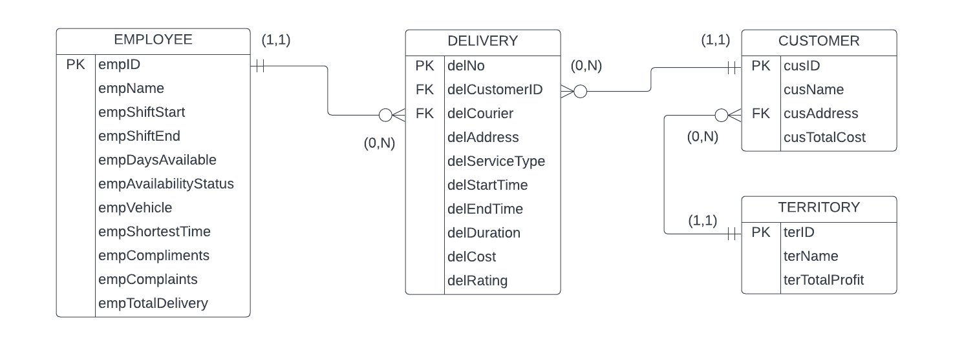

**2.4 Database Structure**

Database Name: QuickBiz

Table Name: EMPLOYEE

Table Number:

Primary Key: empID

Foreign Key: NA

Table Description: This table is used to store an employee’s data. This is to be used for the Employees Management Program, Available Employees Management Program, Employees Assessment Program, and Delivery Form Program.

|  |  |  |  |  |
| --- | --- | --- | --- | --- |
| Field | Attributes | Data Type | Size | Content/Description |
| 1 | empID | Int | 4 | Employee ID |
| 2 | empName | Varchar | 30 | Employee Name |
| 3 | empShiftStart | Int | 4 | Employee Shift Start |
| 4 | empShiftEnd | Int | 4 | Employee Shift End |
| 5 | empDaysAvailable | Varchar | 30 | Employee Days Available |
| 6 | empAvailabilityStatus | Varchar | 10 | Employee Availability Status |
| 7 | empVehicle | Varchar | 30 | Employee Vehicle |
| 8 | empShortestTime | Int | 4 | Employee Shortest Time |
| 9 | empCompliments | Int | 4 | Employee Compliments |
| 10 | empComplaints | Int | 4 | Employee Complaints |
| 11 | empTotalDelivery | Int | 4 | Employee Total Delivery |

Table Name: CUSTOMER

Table Number:

Primary Key: cusID

Foreign Key: cusAddress

Table Description: This table is used to store a registered customer’s data. This is to be used for the Registration Program, Delivery Form Program, and Invoice Program.

|  |  |  |  |  |
| --- | --- | --- | --- | --- |
| Field | Attributes | Data Type | Size | Content/Description |
| 1 | cusID | Int | 4 | Customer ID |
| 2 | cusName | Varchar | 30 | Customer Name |
| 3 | cusAddress | Int | 4 | Customer Address |
| 4 | cusTotalCost | Double | 7,2 | Customer Total Cost |

Table Name: DELIVERY

Table Number:

Primary Key: delID

Foreign Key: delCustomerAddress, delCourier

Table Description: This table is used to store a delivery data. This is to be used for the Delivery Form Program and Invoice Program.

|  |  |  |  |  |
| --- | --- | --- | --- | --- |
| Field | Attributes | Data Type | Size | Content/Description |
| 1 | delNo | Int | 4 | Delivery Number |
| 2 | delCustomerID | Varchar | 30 | Delivery Customer |
| 3 | delCourier | Int | 4 | Delivery Employee |
| 4 | delAddress | Int | 4 | Delivery Address |
| 5 | delServiceType | Varchar | 30 | Delivery Service Type |
| 6 | delStartTime | Varchar | 10 | Delivery Start Time |
| 7 | delEndTime | Varchar | 30 | Delivery End Time |
| 8 | delDuration | Int | 4 | Delivery Duration |
| 9 | delCost | Int | 4 | Delivery Cost |
| 10 | delRating | Int | 4 | Delivery Rating |

Table Name: TERRITORY

Table Number:

Primary Key: terID

Foreign Key: NA

Table Description: This table is used to store a territory data. This is to be used for the Territories Evaluation Program, Registration Program, and Delivery Form Program.

|  |  |  |  |  |
| --- | --- | --- | --- | --- |
| Field | Attributes | Data Type | Size | Content/Description |
| 1 | terID | Int | 4 | Territory ID |
| 2 | terName | Varchar | 10 | Territory Name |
| 3 | terTotalProfit | Double | 7,2 | Territory Total Profit |

**2.5 Use-case Diagram**

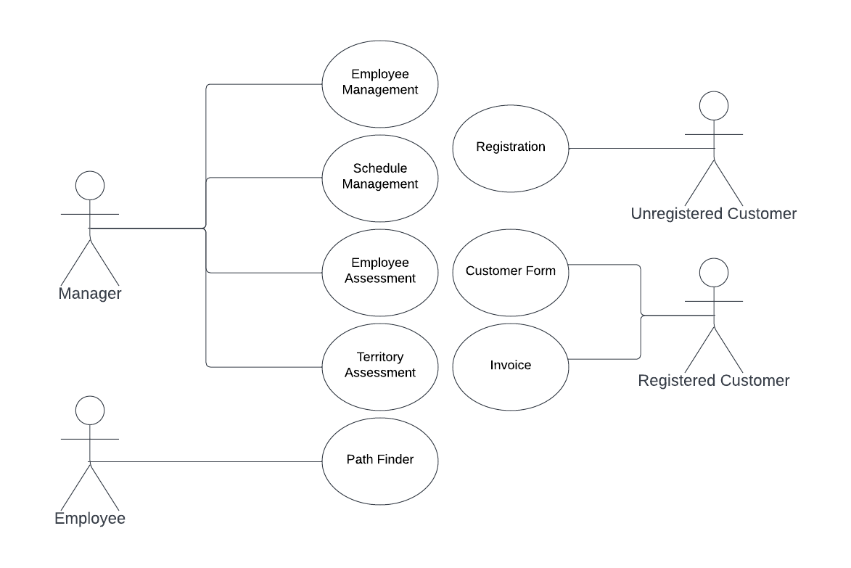

**2.6 Class Diagram**

**2.7 Sequence Diagram**

|  |
| --- |
| **Path-Finding Program** |
|  |

|  |
| --- |
| **Employee Management Program** |
|  |

|  |
| --- |
| **Available Employees Management Program** |
|  |

|  |
| --- |
| **Employees Assessment Program** |
|  |

|  |
| --- |
| **Territories Evaluation Program** |
|  |

|  |
| --- |
| **Registration Program** |
|  |

|  |
| --- |
| **Delivery Form Program** |
|  |

|  |
| --- |
| **Invoice Program** |
|  |

**2.8 Activity Diagram**

|  |
| --- |
| **Path-Finding Program** |
|  |

|  |
| --- |
| **Employee Management Program** |
|  |

|  |
| --- |
| **Available Employees Management Program** |
|  |

|  |
| --- |
| **Employees Assessment** |
|  |

|  |
| --- |
| **Territory Evaluation Program** |
|  |

|  |
| --- |
| **Registration Program** |
|  |

|  |
| --- |
| **Delivery Form Program** |
|  |

|  |
| --- |
| **Invoice Program** |
|  |

**Chapter 3 Methodology**

- Specific process model to use as a guide to be able to execute the different tasks and activities identified. Set of Procedures to be executed after following the basic stages of Systems Development Cycle.

**Chapter 4 Budget and Proposal**

- Make an estimation of how much would hardware and software cost. How much to develop the system. Calculate Yearly Depreciation (Sum up cost then divide by 5 / Hardware – 5 Years & Software – 10 Years)

**Appendices**

**Screen Shot**

**Gannt Chart**

**Work Breakdown Structure**

**Present Data Flow Diagram**