**Лабораторная работа №8**

# Сохранение настроек

**Цель работы:** Научиться сохранять настройки приложения с применение SharedPreferences.

**Задание:**

1. Модифицируйте приложение, созданное в лабораторной работе №7.
2. Добавьте пункт меню, позволяющий полностью отключить toast-уведомление.
3. Обеспечьте сохранение настроек с помощью SharedPreferences.

Ход работы:

public class MainActivity extends AppCompatActivity {  
 final int MENU_GROUP_TIME = 1;  
 final int MENU_ITEM_24H = 0;  
 final int MENU_ITEM_12H = 1;  
  
 final int MENU_GROUP_DATE = 2;  
 final int MENU_ITEM_ON = 0;  
 final int MENU_ITEM_OFF = 1;  
  
 final int MENU_GROUP_TOAST = 3;  
  
 private int OPTION_TIME_FORMAT = MENU_ITEM_12H;  
 final String TIME_FORMAT_PREF = "OPTION_TIME_FORMAT";  
 private int OPTION_DATE_STATE = MENU_ITEM_ON;  
 final String DATE_STATE_PREF = "OPTION_DATE_STATE";  
 private int OPTION_TOAST = MENU_ITEM_ON;  
 final String TOAST_PREF = "OPTION_TOAST";  
  
 SharedPreferences sPref;  
 final Handler handler=new Handler();  
 private boolean toasted = false;  
 private String datetime_format;  
  
  
 @Override  
 protected void onCreate(Bundle savedInstanceState) {  
 super.onCreate(savedInstanceState);  
 setContentView(R.layout.activity_main);  
 loadPreferences();  
  
 handler.postDelayed(updateTime,0);  
 handler.postDelayed(show_toast,0);  
  
 ConstraintLayout parentLayout = findViewById(R.id.rootLayout);  
  
 registerForContextMenu(parentLayout);  
 updateSettings();  
 }  
  
 private void updateSettings() {  
 String TIME_FORMAT="", DATE_STATE="";  
 switch (OPTION_TIME_FORMAT){  
 case MENU_ITEM_24H: TIME_FORMAT="HH:MM"; break;  
 case MENU_ITEM_12H: TIME_FORMAT="hh:MM aa"; break;  
 }  
 switch (OPTION_DATE_STATE){  
 case MENU_ITEM_ON: DATE_STATE=" dd/MM/YYYY"; break;  
 case MENU_ITEM_OFF: DATE_STATE=""; break;  
 }  
 datetime_format = TIME_FORMAT+DATE_STATE;  
 set_current_time();  
 }  
  
 @Override  
 public void onCreateContextMenu(ContextMenu menu, View v,  
 ContextMenu.ContextMenuInfo menuInfo) {  
 MenuItem saved_item;  
 SubMenu subMenuTime = menu.addSubMenu(R.string.subMenuTime);  
  
 subMenuTime.add(MENU_GROUP_TIME, MENU_ITEM_24H, Menu.NONE, R.string.MENU_ITEM_24H);  
 subMenuTime.add(MENU_GROUP_TIME, MENU_ITEM_12H, Menu.NONE, R.string.MENU_ITEM_12H);  
 subMenuTime.setGroupCheckable(MENU_GROUP_TIME, true, true);  
  
 saved_item = subMenuTime.getItem(OPTION_TIME_FORMAT);  
 saved_item.setChecked(true);  
  
 SubMenu subMenuDate = menu.addSubMenu(R.string.subMenuDate);  
 subMenuDate.add(MENU_GROUP_DATE, MENU_ITEM_ON, Menu.NONE, R.string.MENU_ITEM_ON);  
 subMenuDate.add(MENU_GROUP_DATE, MENU_ITEM_OFF, Menu.NONE, R.string.MENU_ITEM_OFF);  
 subMenuDate.setGroupCheckable(MENU_GROUP_DATE, true, true);  
  
 saved_item = subMenuDate.getItem(OPTION_DATE_STATE);  
 saved_item.setChecked(true);  
  
 SubMenu subMenuToast = menu.addSubMenu(R.string.subMenuToast);  
 subMenuToast.add(MENU_GROUP_TOAST, MENU_ITEM_ON, Menu.NONE, R.string.MENU_ITEM_ON);  
 subMenuToast.add(MENU_GROUP_TOAST, MENU_ITEM_OFF, Menu.NONE, R.string.MENU_ITEM_OFF);  
 subMenuToast.setGroupCheckable(MENU_GROUP_TOAST, true, true);  
  
 saved_item = subMenuToast.getItem(OPTION_TOAST);  
 saved_item.setChecked(true);  
 }  
  
  
 @Override  
 public boolean onContextItemSelected(MenuItem item)  
 {  
 if(item.getGroupId()!=Menu.NONE)  
 switch (item.getGroupId()){  
 case MENU_GROUP_TIME:  
 OPTION_TIME_FORMAT= item.getItemId();  
 break;  
 case MENU_GROUP_DATE:  
 OPTION_DATE_STATE = item.getItemId();  
 break;  
 case MENU_GROUP_TOAST:  
 OPTION_TOAST = item.getItemId();  
 break;  
 }  
 item.setChecked(true);  
 updateSettings();  
 return true;  
 }  
 final Runnable show_toast=new Runnable() {  
 @Override  
 public void run() {  
 if(OPTION_TOAST==MENU_ITEM_OFF){  
 toasted=true;  
 return;  
 }  
 if(toasted)  
 return;  
  
 toasted = true;  
 Toast.makeText(MainActivity.this, R.string.Toast,  
 Toast.LENGTH_LONG).show();  
 }  
 };  
  
 private void set_current_time() {  
 DateFormat df = new SimpleDateFormat(datetime_format);  
 TextView tv = findViewById(R.id.DateTime);  
 tv.setText(df.format(Calendar.getInstance().getTime()));  
 }  
 final Runnable updateTime=new Runnable() {  
 @Override  
 public void run() {  
 set_current_time();  
 handler.postDelayed(this,1000);  
 }  
 };  
  
 //Remembering Prefs  
 @Override  
 public void onSaveInstanceState(Bundle savedInstanceState) {  
  
 savedInstanceState.putBoolean("toasted", toasted);  
 super.onSaveInstanceState(savedInstanceState);  
  
 }  
 @Override  
 public void onRestoreInstanceState(Bundle savedInstanceState) {  
 super.onRestoreInstanceState(savedInstanceState);  
 toasted = savedInstanceState.getBoolean("toasted");  
 updateSettings();  
 }  
  
 //Saving Prefs  
 void savePreferences() {  
 sPref = getPreferences(MODE_PRIVATE);  
 SharedPreferences.Editor sPref_editor = sPref.edit();  
 sPref_editor.putInt(TIME_FORMAT_PREF, OPTION_TIME_FORMAT);  
 sPref_editor.putInt(DATE_STATE_PREF, OPTION_DATE_STATE);  
 sPref_editor.putInt(TOAST_PREF, OPTION_TOAST);  
 sPref_editor.apply();  
 }  
  
 void loadPreferences() {  
 sPref = getPreferences(MODE_PRIVATE);  
 OPTION_TIME_FORMAT = sPref.getInt(TIME_FORMAT_PREF, MENU_ITEM_12H);  
 OPTION_DATE_STATE= sPref.getInt(DATE_STATE_PREF, MENU_ITEM_ON);  
 OPTION_TOAST = sPref.getInt(TOAST_PREF, MENU_ITEM_ON);  
 updateSettings();  
 }  
  
 @Override  
 protected void onDestroy() {  
 super.onDestroy();  
 savePreferences();  
 }  
 @Override  
 protected void onPause() {  
 super.onPause();  
 savePreferences();  
 }  
  
  
}

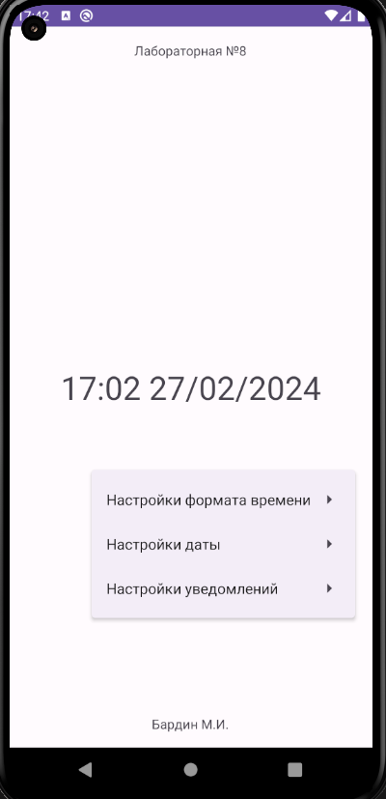

**Вывод:** в ходе работы мы научились сохранять настройки приложения с применение SharedPreferences