SIH26052
AI/ML Adaptive Noise Cancellation for Defence Speech Communication
Team Documentation — Project Explainer
Smart India Hackathon 2026
Sponsoring Organisation: DRDO (Defence Research and Development Organisation)

This document explains, in plain language, what our project is, what we're building, and every major decision we've made so far — hardware and software. Read this fully before jumping into any code. If something is unclear, ask before assuming.

1. What This Project Is
Soldiers, pilots, and vehicle crews often need to talk over radios and headsets in extremely loud environments — gunfire, artillery, helicopter rotors, tank/vehicle engines, sirens. That noise makes speech hard to understand, sometimes dangerously so.
Our job, as defined by DRDO's problem statement (SIH26052), is to build a system that:
- Takes in noisy speech (a person talking while battlefield noise is happening)
- Uses an AI model to clean it up in real time
- Outputs clear, understandable speech — with almost no delay
- Can eventually run on small embedded hardware (not just a full computer), so it fits inside real military equipment
In short: we are building a smart, AI-powered version of noise-cancelling headphones — but specifically trained to handle battlefield sounds like gunfire and rotor noise, which regular noise-cancelling tech is not built for.
Why this is hard
Regular noise cancellation (like in commercial headphones) is built for steady, predictable noise — traffic, fans, engines. Gunfire is the opposite: it's sudden, extremely loud, and over in a fraction of a second. Our system has to handle both steady noise AND these sudden bursts, without cutting out the person's voice.

2. Our Overall Process
We're building this in five stages. Each stage depends on the one before it, so they happen in this order:
- Data — Collect and prepare the audio our AI model will learn from
- Model — Train an AI model to remove noise from speech
- Validate — Measure whether the model is actually working well, using objective scores
- Optimize — Shrink the model so it can run fast, in real time
- Stream — Wrap the model in a live pipeline: mic in → cleaned audio out, continuously
We are currently working through stages 1 and 2. Stages 3–5 come after we have a trained model.
Deployment plan: we will demo the entire system running live on a laptop first. Moving it onto a Raspberry Pi (a small embedded computer) is a bonus goal we will attempt only if time remains — it is not required for the demo to be considered complete or working.

3. Hardware — What We're Using and Why
The hardware side of this project is intentionally simple. We are not building custom electronics — we are using off-the-shelf, easily available components.

3.1 The Components
Component | What It's For | Our Decision
Primary mic | Captures the person's voice (plus whatever noise is around them) | A standard USB mic (e.g. the kind used for vlogging/streaming), positioned near the mouth
Reference mic | Captures mostly noise, almost no voice — helps the system tell noise apart from speech | A second mic (a wired headphone's built-in mic works fine), pointed toward the noise source
Laptop | Runs the AI model and processes both mic signals in real time | Main development + demo machine (RTX 4060 laptop)
Output speaker/headphones | Plays the cleaned speech so judges can hear the result | Any standard speaker or headphones connected to the laptop
Noise-simulation speaker | Plays pre-recorded battlefield noise (gunfire, rotor, engine) near the mics during the live demo, since we can't bring real gunfire to a demo hall | A phone or small Bluetooth speaker
Raspberry Pi (stretch goal only) | The eventual small, embedded computer the system should run on in a real deployment | Attempted only if time remains after the laptop version works — not required for the main demo

3.2 Key Hardware Decisions
- Two mics, not one: one mic mainly hears the voice, the other mainly hears the noise. Having both makes it much easier for the system to tell the difference.
- No special/expensive equipment: everyday USB mics and a wired headphone mic are enough for our prototype. DRDO's mention of advanced hardware (like Jetson boards) describes their eventual real-world deployment target — not what our hackathon prototype needs.
- Laptop-first, Raspberry Pi later: the live demo will run entirely on a laptop. This removes a lot of hardware risk (driver issues, setup problems, board compatibility) from our critical path. The Raspberry Pi becomes a bonus — if we get it running, great; if not, it doesn't affect the core demo.
- For the Raspberry Pi stage specifically (later): a regular laptop mic jack won't work directly with a Raspberry Pi, because the Pi has no mic input built in. When we get there, we'll either use USB mics (which plug in directly and just work) or a purpose-built two-mic add-on board (a “2-Mic HAT”) designed exactly for this. This is not something we need to worry about yet.
- Hardware testing: we haven't physically tested the mics yet because we don't have them in hand. Testing (making sure the laptop actually detects both mics at once) will happen as soon as we have the physical mics — not before.

4. Software — Datasets, Model, and Training

4.1 What “Software” Means Here
There is no website involved in this project. The whole thing is one program that runs directly on our laptop — it listens to the mics, cleans the audio using our trained AI model, and plays the result out loud, continuously, in real time. For the visual screen judges will see, we're using a lightweight local dashboard (explained in Section 5) — that's the only “screen” involved, and it is not a hosted website.

4.2 The Dataset
An AI model like ours learns by example: we show it thousands of pairs of “noisy audio” and the matching “clean audio” it should have produced, and it gradually learns the pattern. No ready-made dataset of “clean speech + battlefield noise, already paired” exists publicly, so we are building our own by combining several existing audio sources and mixing them ourselves.
Our dataset is organized into categories, based on the type of noise. Here is the current breakdown of what we have collected so far:
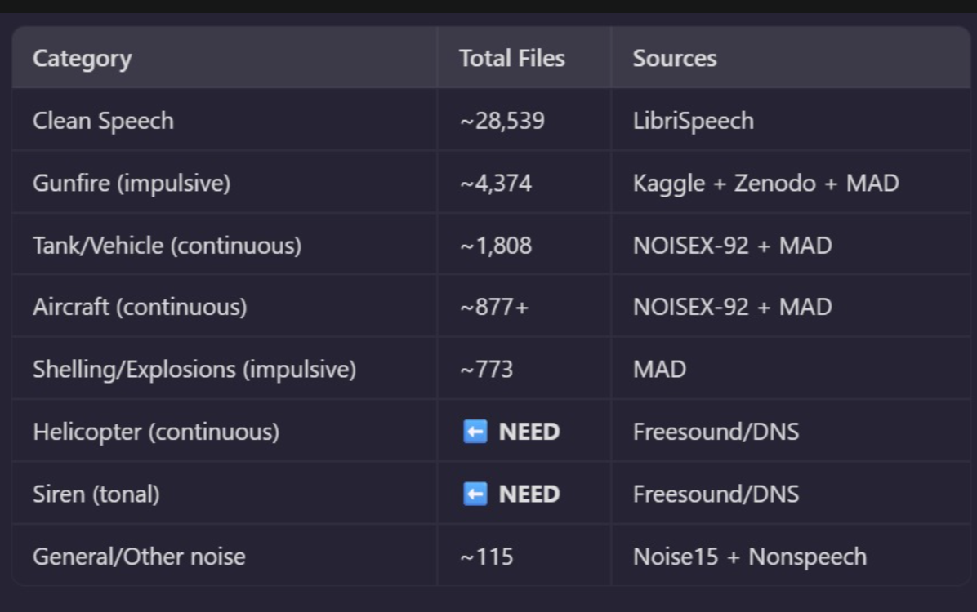
Current dataset breakdown by noise category
In plain terms:
- Clean Speech (~28,539 files, from LibriSpeech): this is the “correct answer” audio — clear human speech with no noise. The model is trained to reproduce this.
- Gunfire — impulsive noise (~4,374 files): sudden, short bursts of noise, sourced from Kaggle, Zenodo, and MAD (a military audio dataset).
- Tank/Vehicle noise — continuous (~1,808 files): engine and vehicle sounds, from NOISEX-92 and MAD.
- Aircraft noise — continuous (~877+ files): jet/aircraft sounds, from NOISEX-92 and MAD.
- Shelling/Explosions — impulsive (~773 files): artillery and explosion sounds, from MAD.
- Helicopter noise — continuous (still needed): rotor noise — we still need to source this, planned from Freesound/DNS.
- Siren — tonal (still needed): siren/alarm sounds — also still needed, planned from Freesound/DNS.
- General/Other noise (~115 files): miscellaneous background noise, for extra variety.
We deliberately split noise into “continuous” (steady, ongoing — engines, rotors) and “impulsive” (sudden, short — gunfire, explosions), because the model needs to handle both very differently, and mixing them into training data requires different math for each type.
Why so many different sources?
No single dataset has everything we need. We're combining multiple free, publicly available sources so the model sees a wide variety of voices and noise types — this is what stops the model from “memorizing” a handful of examples instead of genuinely learning to remove noise in general.

4.3 The Model — What We're Training
We are using an existing, proven AI architecture called DeepFilterNet3, rather than inventing a new one from scratch. We are fine-tuning it — meaning we start from a version that already knows general speech cleaning, and further train it specifically on our battlefield-noise dataset, so it gets good at our specific problem.

Why DeepFilterNet3, specifically
- It already handles both noise types well: it works in two stages internally — one stage is good at steady noise (engines, rotors), the other is specifically good at preserving speech quality through sudden noise bursts (gunfire). This matches our exact problem.
- It's light enough to run in real time: it's small and fast enough to run live on a normal laptop CPU, and is proven to also fit on small embedded boards like Raspberry Pi — which matters for our later stretch goal.
- It sounds significantly better than the alternatives we compared: in our research, it scored clearly higher on standard speech-quality tests than other lightweight options (RNNoise, NSNet2, Conv-TasNet, DTLN).
- The hard engineering part is already solved: getting a live microphone-to-model-to-speaker pipeline working smoothly is normally the most time-consuming part of a project like this. DeepFilterNet3 already has working example code for exactly this, which saves us significant time.
- Why fine-tuning instead of training from scratch: training a model from nothing would need far more data and far more time than we have. Fine-tuning an already-capable model onto our specific dataset gets us a working, specialized model in a realistic timeframe.
Backup plan: if DeepFilterNet3 turns out to be difficult to get running in our timeframe, we have a simpler fallback model (called DTLN) that is easier to set up, as a safety net. We are not planning to need it, but it's there if we do.

5. How the Demo Works in Front of Judges
This section covers exactly what will happen, and what judges will see and hear, during our presentation.

5.1 What Judges Will See on Screen
We are building a simple visual dashboard using a tool called Streamlit. It runs locally on our own laptop — nothing is uploaded to the internet, there's no login, and no separate server. It just uses a browser window on our own screen as a nice-looking display.
On screen, judges will see:
- A Start/Stop control for the live demo
- A live waveform of the incoming (noisy) audio
- A live waveform of the cleaned (output) audio, right next to it
- Our measured quality scores (SNR, STOI, PESQ) — numbers that show how much cleaner the output is

5.2 Why We Chose Streamlit Over Something Like React
React can look more custom/polished, but it requires splitting the project into two separate programs (a backend that runs the model, and a separate frontend that only handles the display) that then have to constantly communicate with each other. That's extra engineering work with no benefit to the actual noise-cancellation system we're being judged on.
Streamlit lets our mic-capture code, our AI model, and our on-screen display all live in one simple program. Given our limited time, this lets us spend our remaining hours improving the actual ANC system instead of plumbing together two separate programs. It can still look clean and professional — we are not using it because it's the bare-minimum option, but because it's the most efficient path to something that looks good and works reliably.

5.3 The Live Audio Demo — Before vs. After
Judges need to hear both the noisy version and the cleaned version, to appreciate the difference. Nothing gets saved as a file to do this. Instead, we use a live toggle:
- We start talking normally, with battlefield noise playing near the mics (Model: OFF) — judges hear the raw, noisy audio, live, exactly as picked up by the mic.
- We flip the model ON, live, without stopping.
- We keep talking with the same noise still playing — judges now hear the cleaned version, live, in real time.
This is the same idea used to demo real noise-cancelling headphones (“here it is off… now here it is on”). It proves the system works live, on the spot, with nothing pre-recorded or rehearsed.

5.4 How the Live Audio Processing Actually Works
This is the part that's easy to misunderstand, so here's the exact mechanism:
- Nothing is ever saved to a file during the live demo. Audio flows through continuously, like a phone call — never stored.
- Both mics are listened to at the same time, as two separate, independent audio streams.
- Every 20–40 milliseconds, a tiny slice of audio arrives from each mic. The model looks at both tiny slices together, decides what part is noise, and outputs a cleaned tiny slice.
- That cleaned slice is played out almost immediately, and the process repeats for the next slice — continuously, automatically, the entire time someone is talking.
- There is a small, unavoidable delay between speaking and hearing the cleaned result — roughly 10–40 milliseconds. For comparison, a single eye blink takes about 100–150 milliseconds. This delay is not something a human can consciously notice in normal conversation.
The one-line summary for anyone confused
Think of it like live sentence-by-sentence translation, but for 30-millisecond slices of sound instead of sentences: listen to a tiny piece, clean it, say it, move to the next piece — repeated continuously, automatically, many times per second.

Questions or disagreements about anything in this document should be raised with the team before we start building on top of these decisions — this is meant to be our shared reference point, not a final, unchangeable plan.

