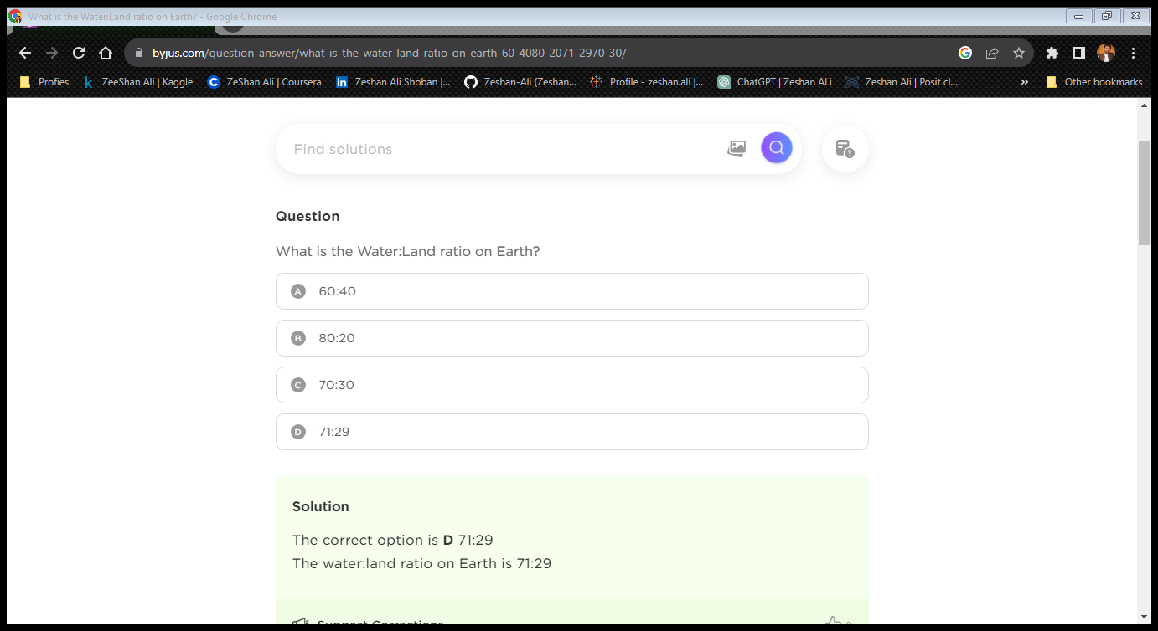

jjjjjjjjjjjjjjjjjjjjjjjjjjjjjjjjjjjjjjjjjjjjjjjjjjjjjjjjjjjjjjjjjjjjjjjjjjjjjjjjjjjjjjjjjjjjjjjjjjjjjjjjjjjjjjjjjjjjjjjjjjjjjjjjjjjjjjjjjjjjjjjjjjjjjjjjjjjjjjjjjjjjjjjjjjjjjjjjjjj

jjjjjjjjjjjjjjjjjjjjjjjjjjjjjjjjjjjjjjjjjjjjjjjjjjjjjjjjjjjjjjjjjjjjjjjjjjjjjjjjjjjjjjjjjjjjjjjjjjjjjjjjjjjjjjjjjjjjjjjjjjjjjjjjjjjjjjjjjjjjjjjjjjjjjjjjjjjjjjjjjjjjjjjjjjjjjjjjjjj

jjjjjjjjjjjjjjjjjjjjjjjjjjjjjjjjjjjjjjjjjjjjjjjjjjjjjjjjjjjjjjjjjjjjjjjjjjjjjjjjjjjjjjjjjjjjjjjjjjjjjjjjjjjjjjjjjjjjjjjjjjjjjjjjjjjjjjjjjjjjjjjjjjjjjjjjjjjjjjjjjjjjjjjjjjjjjjjjjjj

jjjjjjjjjjjjjjjjjjjjjjjjjjjjjjjjjjjjjjjjjjjjjjjjjjjjjjjjjjjjjjjjjjjjjjjjjjjjjjjjjjjjjjjjjjjjjjjjjjjjjjjjjjjjjjjjjjjjjjjjjjjjjjjjjjjjjjjjjjjjjjjjjjjjjjjjjjjjjjjjjjjjjjjjjjjjjjjjjjj

vvv jjjjjjjjjjjjjjjjjjjjjjjjjjjjjjjjjjjjjjjjjjjjjjjjjjjjjjjjjjjjjjjjjjjjjjjjjjjjjjjjjjjjjjjjjjjjjjjjjjjjjjjjjjjjjjjjjjjjjjjjjjjjjjjjjjjjjjjjjjjjjjjjjjjjjjjjjjjjjjjjjjjjjjjjjjjjjjjjjjj

vv jjjjjjjjjjjjjjjjjjjjjjjjjjjjjjjjjjjjjjjjjjjjjjjjjjjjjjjjjjjjjjjjjjjjjjjjjjjjjjjjjjjjjjjjjjjjjjjjjjjjjjjjjjjjjjjjjjjjjjjjjjjjjjjjjjjjjjjjjjjjjjjjjjjjjjjjjjjjjjjjjjjjjjjjjjjjjjjjjjj

jjjjjjjjjjjjjjjjjjjjjjjjjjjjjjjjjjjjjjjjjjjjjjjjjjjjjjjjjjjjjjjjjjjjjjjjjjjjjjjjjjjjjjjjjjjjjjjjjjjjjjjjjjjjjjjjjjjjjjjjjjjjjjjjjjjjjjjjjjjjjjjjjjjjjjjjjjjjjjjjjjjjjjjjjjjjjjjjjjj

jjjjjjjjjjjjjjjjjjjjjjjjjjjjjjjjjjjjjjjjjjjjjjjjjjjjjjjjjjjjjjjjjjjjjjjjjjjjjjjjjjjjjjjjjjjjjjjjjjjjjjjjjjjjjjjjjjjjjjjjjjjjjjjjjjjjjjjjjjjjjjjjjjjjjjjjjjjjjjjjjjjjjjjjjjjjjjjjjjj

jjjjjjjjjjjjjjjjjjjjjjjjjjjjjjjjjjjjjjjjjjjjjjjjjjjjjjjjjjjjjjjjjjjjjjjjjjjjjjjjjjjjjjjjjjjjjjjjjjjjjjjjjjjjjjjjjjjjjjjjjjjjjjjjjjjjjjjjjjjjjjjjjjjjjjjjjjjjjjjjjjjjjjjjjjjjjjjjjjj

jjjjjjjjjjjjjjjjjjjjjjjjjjjjjjjjjjjjjjjjjjjjjjjjjjjjjjjjjjjjjjjjjjjjjjjjjjjjjjjjjjjjjjjjjjjjjjjjjjjjjjjjjjjjjjjjjjjjjjjjjjjjjjjjjjjjjjjjjjjjjjjjjjjjjjjjjjjjjjjjjjjjjjjjjjjjjjjjjjj

jjjjjjjjjjjjjjjjjjjjjjjjjjjjjjjjjjjjjjjjjjjjjjjjjjjjjjjjjjjjjjjjjjjjjjjjjjjjjjjjjjjjjjjjjjjjjjjjjjjjjjjjjjjjjjjjjjjjjjjjjjjjjjjjjjjjjjjjjjjjjjjjjjjjjjjjjjjjjjjjjjjjjjjjjjjjjjjjjjj

jjjjjjjjjjjjjjjjjjjjjjjjjjjjjjjjjjjjjjjjjjjjjjjjjjjjjjjjjjjjjjjjjjjjjjjjjjjjjjjjjjjjjjjjjjjjjjjjjjjjjjjjjjjjjjjjjjjjjjjjjjjjjjjjjjjjjjjjjjjjjjjjjjjjjjjjjjjjjjjjjjjjjjjjjjjjjjjjjjj

jjjjjjjjjjjjjjjjjjjjjjjjjjjjjjjjjjjjjjjjjjjjjjjjjjjjjjjjjjjjjjjjjjjjjjjjjjjjjjjjjjjjjjjjjjjjjjjjjjjjjjjjjjjjjjjjjjjjjjjjjjjjjjjjjjjjjjjjjjjjjjjjjjjjjjjjjjjjjjjjjjjjjjjjjjjjjjjjjjj

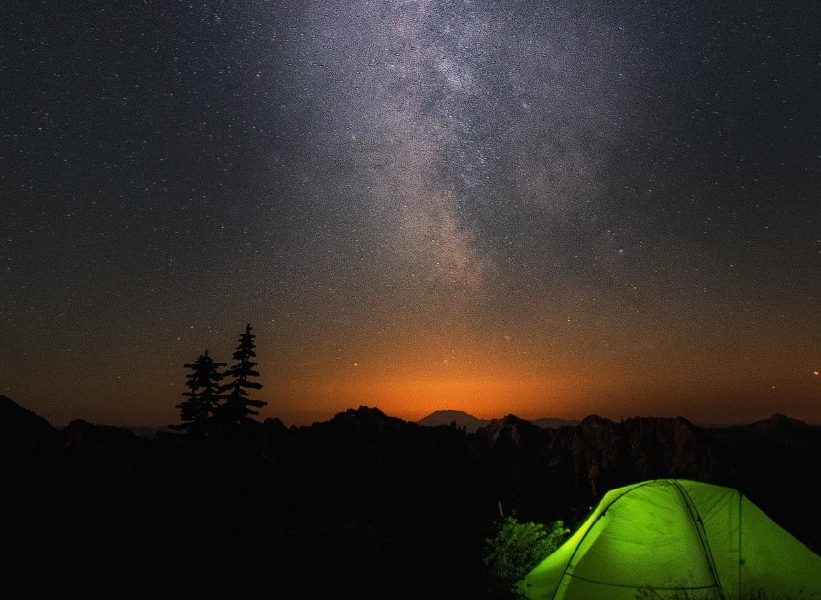

[D explorex](https://www.dexplorex.com)

Solve the equation $5/4{\left(x+a\right)}^{n}=\left[\begin{matrix}1 & 0 \\ 0 & 1\end{matrix}\right]\sum_{k=0}^{n}{\left({n \atop k}\right)x^{k}a^{n-k}}$