Zeeshan

Hjhjhjdmmmm

Mnakkgdkdkcghkcd

M

M

Mskkhdhksdhsssssssssssssssssssssssssssssssssssssssssssssssssssssssssssssssssssssssssssssssssss

Mjjjjjjjjjjjjjjjjjjjjjjjjjjjjjjjjjjjjjjjjjjjjjjjjjjjjjjjjjjjjjjjjjjjjjjjjjjjjjjjjjjjjjjjjjjjjjjjjjjjjjjjjjjjjjjjjjjjjjjjjjjjjjjjjjjjjjjjjjjjjjjjjjjjjjjjjjjjjjjjjj

Mm

M

M

Mm

Mm

M

Mm

M

Mm

M

M

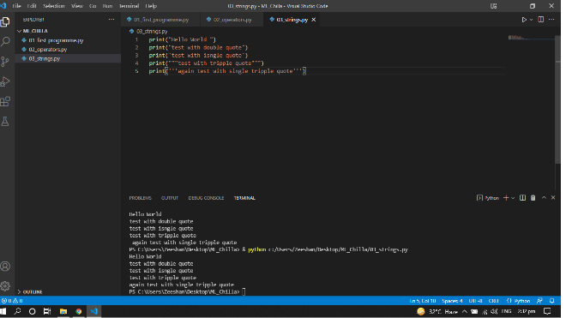Mnnnnnnnnnnnnnnnnnnnnnnnnnnnnnnnnnnnnnnnnnnnnnnnnnnnnnnnnnnnnnnnnnnnnnnnnnnnnnnnnnnnnnnnnnnnnnnnnnnnnnnnnbbbbbbbbbbbbbbbbbbbbbbbbbbbbbbb

bbbbnnnnnnnnnnnnnnnnnnnnnnnnnnnnnnnnnnnnnnnnnnnnnnnnnnnnnnnn

Mbbbbbbbbbbbbbbbbbbbbbbbbbbbbbbbbbbbbb

M

M

M

Mnnnnnnnnnnnnnnnnnnnnnnnnnnnnnnnnnnnnnnnnnnnnnnnnnnnnnnnnnnnnnnnnnnnnnnnnnnnnnnnnnnnnnnnnnnnnnnnnnnnnnnnnnnnnnnnnnnn

Mm

Mjk

fjhfjhfjh

M

m