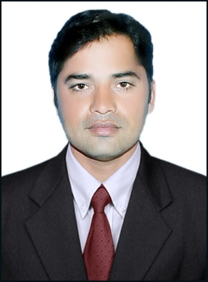**Zeshan Ali**

**Contact Info**: 0503725607 (UAE)

00923009531926 (Pakistan)

**Email:** zeshan_ali96@yahoo.com

**CAREER OBJECTIVE:**

A position in an organization that seeks an ambitious, social and a career conscious person, where acquired education and full skills will be utilized continued towards the growth and advancements in the field of Information Technology.



**PERSONAL INFORMATION:**

|  |  |  |  |
| --- | --- | --- | --- |
| **Father’s Name:** | Muhammad Siddique | **Martial Status:** | Single |
| **Gender:** | Male | **Date of Birth:** | 03 July 1983 |
| **Passport No:** | QT1806941 | **Nationality:** | Pakistani |
| **Visa Status:** | Visit | **Residence Country:** | UAE |
| **Career Level:** | Mid |  |  |

**EDUCATION:**

**BS (Computer Science)**

**VIRTUAL UNIVERSITY OF PAKISTAN Year 2007**

**Grade: 2.37 out of 4**

**Professional Education:**

**C# Developer (Training):**

**Training center: Global Tech Sialkot**

**Date attended: august 2009 ( 6 months)**

**PROFESSIONAL EXPERINCE:**

**PHP and C# Developer ( September 2009 to March 2017)**

**Govt. High School Charwa Sialkot (Pakistan)**

**Job Description:**

.

* To develop online result portal
* To develop students enrollment portal
* To create database using mysql
* To maintain the online portal
* To develop different education test for students of different classes
* To Code using Html and php with java scripts
* Gather and refine specifications and requirements based on technical needs
* Create and maintain software documentation
* Stay plugged into emerging technologies/industry trends and apply them into operations and activities

**Trainee of PHP and C# eveloper ( December 2007 to August 2009 )**

**Web solution sialkot (Pakistan)**

**Job Description:**

* + Create different website under the Project Manager
  + Develop different education website for school
  + Using my Sql creating database and its backup
  + Gather and refine specifications and requirements based on technical needs
  + Create and maintain software documentation
  + Stay plugged into emerging technologies/industry trends and apply them into operations and activities

**Specialties**

* PHP, MYSql
* C# , sql server, crystal reporting
* Coding using Dreamweaver and Php Editor
* Embedding Java script in Php Code
* Dedication to Problem Solving
* *Quick learner with desire to learn new tools and techniques*

**PERSONAL Skills:**

* Proficient Oral and interpersonal communication skills.
* Very quick at learning and adapting to new environment
* Courteous behavior toward customer & Team Members.

**Language Know:** Urdu, English