PROPOSAL

1. About Us  
   ZillionInfo specializes in providing products and services on GIS Consulting & Development, CAMA Geo-Sketch, Zoning & Redistrcting, and Location Intelligence. We received the NSF SBIR Award in 2013.

CAMA Geo-Sketch is a cross-platform sketch product which can be integrated into GIS and any CAMA system. It uses Open-Format simple sketch strings to store the sketch data in the database, which makes the data conversion much easier. The users can trace sketches on top of an aerial ortho-imagery and/or a map and geo-reference (by anchor and rotate) a sketch over the corresponding building in an aerial ortho-imagery.

Followings are some feedbacks from our clients:  
We easily integrated this sketching software into our new CAMA system.  Our users are enthusiastic about how friendly the tool is and the ability to use it with our GIS system.  It is a valuable addition to our system.

----Mike Prince, Project Manager, Richland County, SC

While looking for a sketch tool for buildings we demoed several software packages. We expected to find a server/database-based tool that doesn't use a proprietary file format. We also expected an easy integration into our CAMA system. ZillionInfo's software fits our needs the best.

----Lath Harris CAE, SRA, Sumter County, SC

We also provide software that is able to automatically geo-reference CAMA Sketch on top of GIS Imagery. This software takes a string, which presents a sketch, and a geo-referenced image as import and matches the sketch to the buildings in the image automatically (<http://www.youtube.com/watch?v=O6bgQeHwnYc>)   
  
ZillionInfo Contact Information:

Bonan Li

[info@zillioninfo.com](mailto:ella.li@zillioninfo.com)

(803) 386-8709

1225 Laurel Street, Suite 416

Columbia, SC 29201

<http://www.zillioninfo.com>

1. PDF Sketch Conversion  
   **2.1 Previous sketching experience**  
   We have used CAMA Geo-Sketch to sketch the properties for Richland County, Sumter County, Lexington County, and Anderson County.

Following are some screen shots for the CAMA Geo-Sketch:   
   
  


**2.2 Work load allocation**  
Based on the previous experience, work load is determined by the complexity of the plan. Sketch a plan like the sample you sent us may take about 2 hours. For example, if there are total 2500 folios to sketch, the total working hours is 5000 hours. It will take two people to work for about eleven months. Each person will finish 4 sketches per day. We will track the progress on daily basis and report to BC every two weeks. We can host a video conference to discuss the current progress and future plan.

1. GeoReferenced Sketches  
   We plan to utilize two software package (Manually and Automatically) to georeference sketches.  
     
   **3.1 Automated Geo-Referencing**   
   Automated Geo-Referencing is used to do the georeferencing automatically. It uses a set of formatted strings, each of which presents a sketch, and an ortho-imagery to match the sketch on the top of the image. Automated Geo-Referencing will export a matching report to show the metadata of the processing. It also exports a shapefile containing all the georeferenced sketches with the customized metadata (EX. Fit ranking) in its table.  
   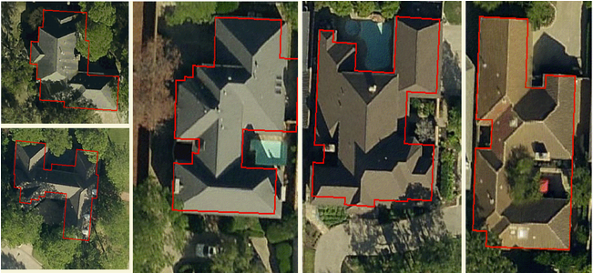**attach the metadata**

**3.2 CAMA Geo-Sketch**  
CAMA Geo-Sketch can be utilized to geo-reference a sketch over the corresponding building in an aerial ortho-imagery. This function allows the users to compare the sketch with the building boundary, change detections, and on-the-fly adjustment. After automatically georeferencing the sketch, we will pick those georeferenced sketches with poor fitting index and manually adjust them by using CAMA Geo-Sketch.  
  
**3.3 Work Flow of georeferencing**   
Automated Geo-Referencing accepts any readable data format including XML. The data conversion is done inside the software. The next step would be cut the ortho-imagery into a set of images with a proper size. It is easier to track the process in a small size. Third step would be importing the images and strings to Automated Geo-Referencing and get the shapefile and metadata. The last step would be select georeferenced sketches with poor fitting index out and adjust them in CAMA Geo-Sketch manually. Following is the work flow chart for the steps above mentioned:  
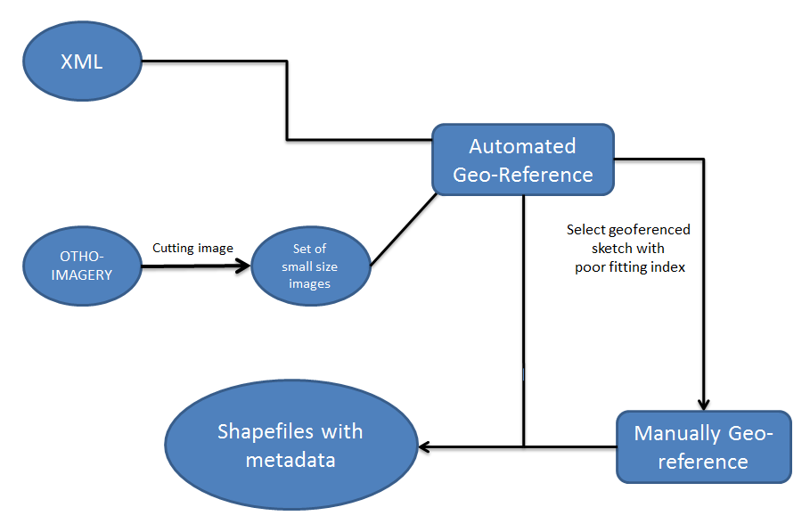

1. Key personnel  
   Project Manager  
   Backup Project Manager
2. Experience  
   projects of similar scope and complexity completed for two organizations in the last three years.  
   client reference, name, contact information for each project.
3. Proposed project management approach  
   timelines for the completion of the 2014 project  
   manage any issuses/risks

**Appendix A**

**Section 1: PDF Sketch Conversion**

|  |  |  |  |  |
| --- | --- | --- | --- | --- |
| **Quantity of Folios** | | | | |
| 0 – 2,000 | 2,001 – 4,000 | 4,001 – 6,000 | 6,001-8,000 | 8,001 - 10,000 |
| **$** | **$** | **$** | **$** | **$** |

**Section 2: Georeferenced Sketches**

|  |  |  |  |
| --- | --- | --- | --- |
| **Quantity of Folios** | | | |
| 0 – 2,000 | 2,001 – 4,000 | 4,001 – 6,000 | 6,001-8,000 |
| **$** | **$** | **$** | **$** |