**Java II - Group Project**

Members: Lee, Sharon

Zhong, Zeshi

Trinidad, Jeorge

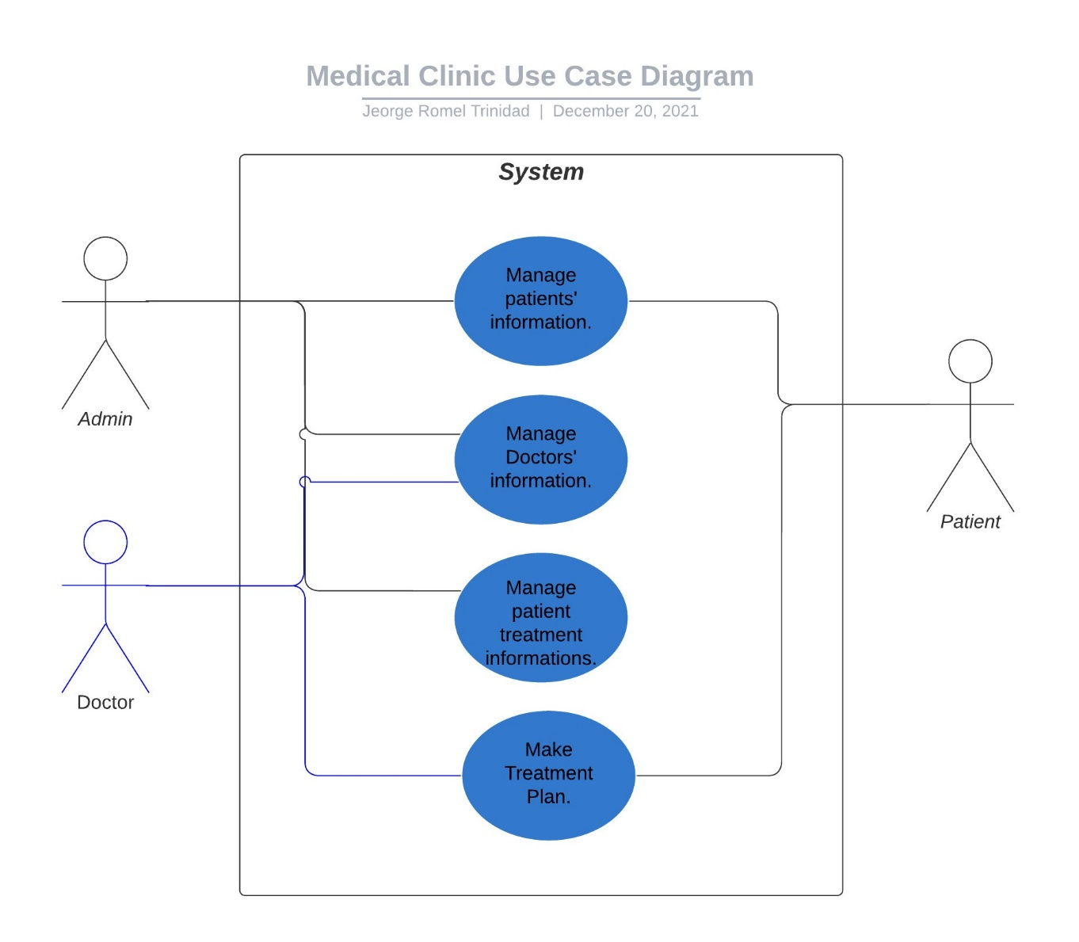

Figure . Use Case Diagram

1. Manage patients’ information. The admin will input and manage patients’ name, birthdate and insurance company based on the information the patient has given.
2. Manage doctors’ information. The admin will input and manage doctors’ name, birthdate and specialization based on information the doctors has provided.
3. Manage treatment plan. The admin manages the treatment information the doctors has made and the treatments received by the patients.
4. Make treatment plan. The doctors make treatment plans based on what each patients needs.

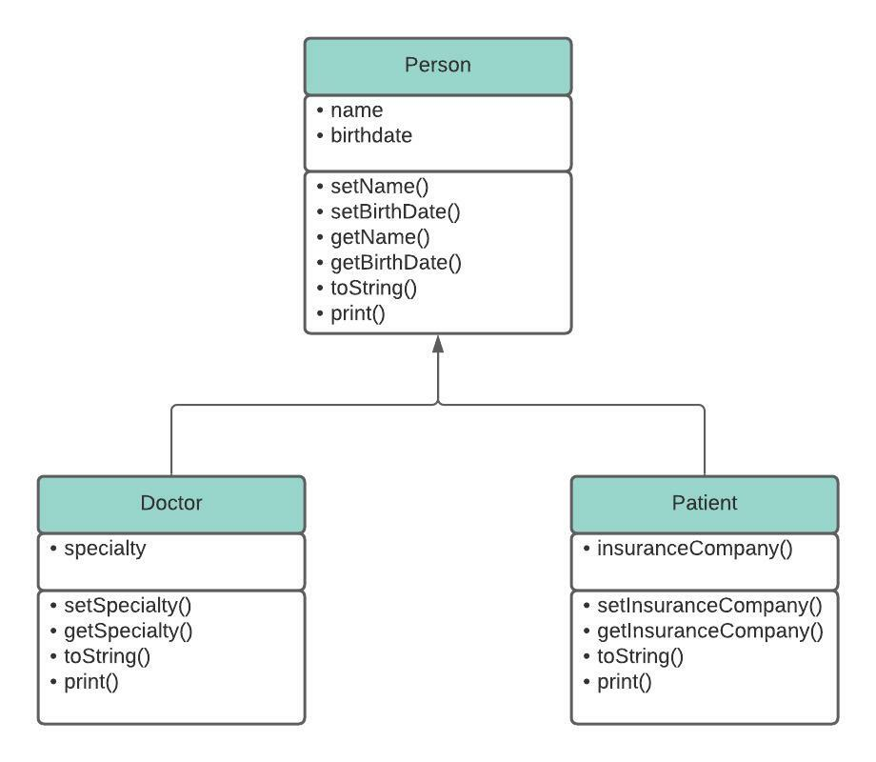

Figure . Class Diagram

Abstract Class: Person Class

Person Class is made abstract to prevent it to be instantiated or objects made from it.

Inherited Classes: Doctor and Patient Class

Doctor and Patient Class inherited variables from the parent class Person.

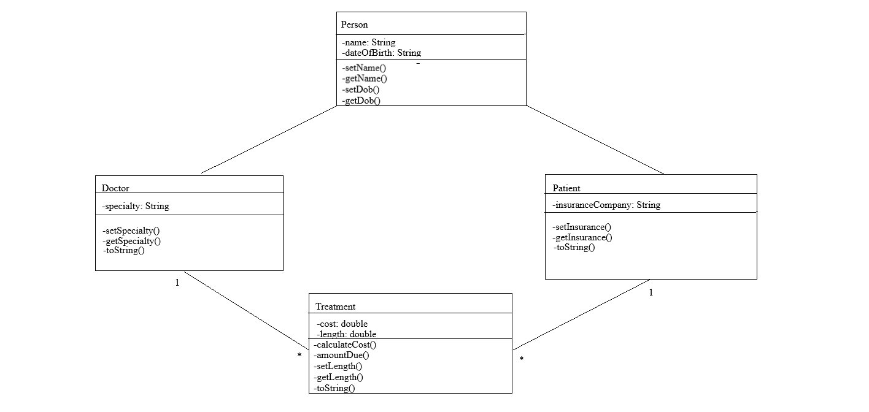

Figure . Class Diagram with Treatment Class

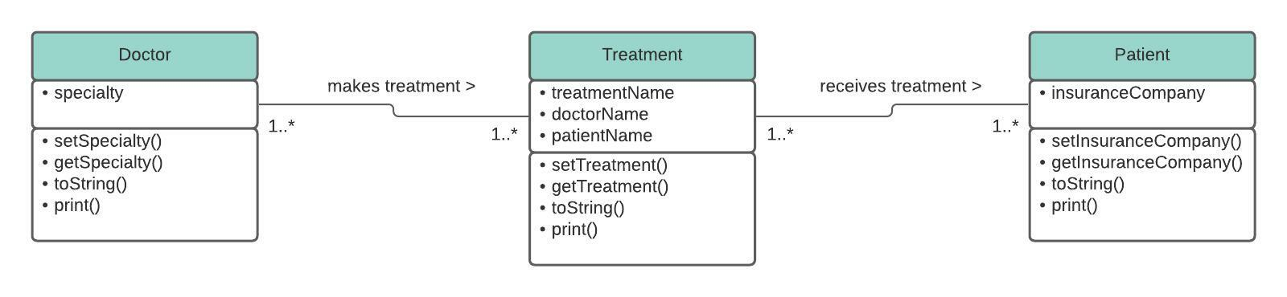

Figure . Class Diagram with Multiplicity Notation

The doctor makes one or more treatment plan. A treatment can be associated with one or more doctor. The patient can receive one or more treatment. A treatment can be applied to one or more patient.