BANK LOAN ANALYSIS PROJECT
SQL Script Specifications & Power BI Reconciliation Documentation
This technical specification document outlines the comprehensive SQL script infrastructure deployed to extract, calculate, and validate structural lending metrics from the database layer. Every metric defined here directly serves as the ground-truth benchmark for structural validation within the Power BI analytical dashboards, ensuring strict compliance across transactional processing data stores and client-facing reporting systems.

1. High-Level Performance Metrics (KPIs)

1.1 Total Loan Applications
Tracks the macro-volume of loan applications captured within the transactional infrastructure across historical data assets, along with operational Month-to-Date (MTD) and Previous Month-to-Date (PMTD) filters targeting December 2021 as the analytical anchor point.

Cumulative Historical Volume
SELECT COUNT(id) AS Total_Loan_Application
FROM Bank_Loan_data;

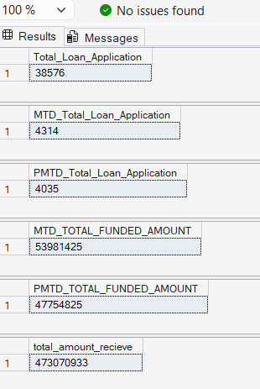

Month-to-Date (MTD) Volume
SELECT COUNT(id) AS MTD_Total_Loan_Application
FROM Bank_Loan_data
WHERE MONTH(issue_date) = 12 AND YEAR(issue_date) = 2021;

Previous Month-to-Date (PMTD) Volume
SELECT COUNT(id) AS PMTD_Total_Loan_Application
FROM Bank_Loan_data
WHERE MONTH(issue_date) = 11 AND YEAR(issue_date) = 2021;

1.2 Total Funded Amount
Aggregates capital allocation balances disbursed across the portfolio. Helps monitor capital outflow velocity and asset exposure over defined operational intervals.

Month-to-Date (MTD) Outflow
SELECT SUM(loan_amount) AS MTD_TOTAL_FUNDED_AMOUNT
FROM Bank_Loan_data
WHERE MONTH(issue_date) = 12 AND YEAR(issue_date) = 2021;



Previous Month-to-Date (PMTD) Outflow
SELECT SUM(loan_amount) AS PMTD_TOTAL_FUNDED_AMOUNT
FROM Bank_Loan_data
WHERE MONTH(issue_date) = 11 AND YEAR(issue_date) = 2021;

1.3 Total Amount Received (Cash Inflow)
Monitors cumulative collections, principal liquidations, and gross interest streams realized by servicing desks.

Cumulative Recovery
SELECT SUM(total_payment) AS total_amount_recieve
FROM Bank_Loan_data;

Month-to-Date (MTD) Cash Collections
SELECT SUM(total_payment) AS MTD_total_amount_recieve
FROM Bank_Loan_data
WHERE MONTH(issue_date) = 12 AND YEAR(issue_date) = 2021;

Previous Month-to-Date (PMTD) Cash Collections
SELECT SUM(total_payment) AS PMTD_total_amount_recieve
FROM Bank_Loan_data
WHERE MONTH(issue_date) = 11 AND YEAR(issue_date) = 2021;

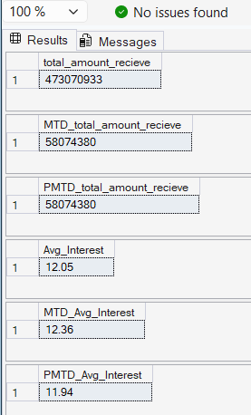

1.4 Weighted Financial Health Ratios
Calculates raw portfolio-level stress benchmarks spanning structural nominal interest rates alongside Debt-to-Income (DTI) metrics.

Portfolio-Wide Interest & Debt-to-Income Benchmarks
SELECT ROUND(AVG(int_rate), 4) * 100 AS Avg_Interest FROM Bank_Loan_data;
SELECT ROUND(AVG(dti), 4) * 100 AS AVG_DTI FROM Bank_Loan_data;

Month-to-Date (MTD) vs. Previous Month-to-Date (PMTD) Interest and DTI
-- MTD Interest & DTI Expressions
SELECT ROUND(AVG(int_rate), 4) * 100 AS MTD_Avg_Interest FROM Bank_Loan_data WHERE MONTH(issue_date) = 12 AND YEAR(issue_date) = 2021;
SELECT ROUND(AVG(dti), 4) * 100 AS Mtd_AVG_DTI FROM Bank_Loan_data WHERE MONTH(issue_date) = 12 AND YEAR(issue_date) = 2021;
-- PMTD Interest & DTI Expressions
SELECT ROUND(AVG(int_rate), 4) * 100 AS PMTD_Avg_Interest FROM Bank_Loan_data WHERE MONTH(issue_date) = 11 AND YEAR(issue_date) = 2021;
SELECT ROUND(AVG(dti), 4) * 100 AS PMTD_AVG_DTI FROM Bank_Loan_data WHERE MONTH(issue_date) = 11 AND YEAR(issue_date) = 2021;

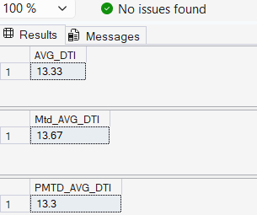

2. Credit Portfolio Quality Segregation
Loans are strictly partitioned into 'Good' vs 'Bad' categorical buckets based on risk profiles to assess portfolio resilience and net write-off exposures.

2.1 Good Loans Portfolio Performance
Covers accounts marked as 'Fully Paid' or 'Current'. Represents the high-performing, non-defaulting core of the loan portfolio.

-- KPI 1: Good Loan Application Percentage Allocation
SELECT (COUNT(CASE WHEN loan_status = 'Fully Paid' OR loan_status = 'Current' THEN id END) * 100.0) / COUNT(id) AS Good_loan_percent
FROM Bank_Loan_data;
-- KPI 2: Absolute Application Accounts
SELECT COUNT(id) AS Good_Loan_Application FROM Bank_Loan_data WHERE loan_status = 'Fully Paid' OR loan_status = 'Current';
-- KPI 3: Total Capital Allocated (Funded Asset Base)
SELECT SUM(loan_amount) AS GOOD_LOAN_FUNDED_AMOUNT FROM Bank_Loan_data WHERE loan_status = 'Fully Paid' OR loan_status = 'Current';
-- KPI 4: Total Revenue Recieved (Collected Principal + Interest)
SELECT SUM(total_payment) AS GOOD_LOAN_Recieved_AMOUNT FROM Bank_Loan_data WHERE loan_status = 'Fully Paid' OR loan_status = 'Current';

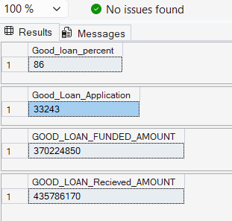

2.2 Bad Loans Portfolio Performance (Impaired Exposure)
Isolates toxic and distressed debt exposures classified under the 'Charged Off' state. This metric acts as the primary baseline for tracking write-offs and default losses.
-- KPI 1: Bad Loan Write-Off Percentage Allocation
SELECT (COUNT(CASE WHEN loan_status = 'Charged Off' THEN id END) * 100.0) / COUNT(id) AS Bad_loan_percent
FROM Bank_Loan_data;
-- KPI 2: Distressed Accounts Volume
SELECT COUNT(id) AS Bad_Loan_Application FROM Bank_Loan_data WHERE loan_status = 'Charged Off';
-- KPI 3: Principal Value Forfeited (Gross Defaulted Outflow)
SELECT SUM(loan_amount) AS BAD_LOAN_FUNDED_AMOUNT FROM Bank_Loan_data WHERE loan_status = 'Charged Off';
-- KPI 4: Recovered Revenue Over Bad Debt Assets
SELECT SUM(total_payment) AS BAD_LOAN_Recieved_AMOUNT FROM Bank_Loan_data WHERE loan_status = 'Charged Off';

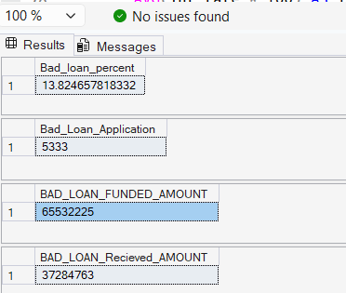

3. Multidimensional Analytical Segregations
The following centralized multi-dimensional analytical matrices group metrics to build visual drill-down layers inside Power BI reports.

3.1 Core Loan Status Categorical Summary Table
Consolidates application volumes, principal outlays, liquid cash collection records, historical nominal yields, and transactional risk profiles across all core loan states.
SELECT
loan_status,
COUNT(id) AS Total_Loan_Applications,
SUM(total_payment) AS Total_Amount_Recieved,
SUM(loan_amount) AS Total_Funded_Amount,
AVG(int_rate * 100) AS INTEREST_RATE,
AVG(dti * 100) as DTI
FROM Bank_Loan_data
GROUP BY loan_status;
Verified SQL Engine Core Compilation Metadata Output:
Loan Status | Total Applications | Total Amount Received | Total Funded Amount | Interest Rate (%) | DTI (%)
Fully Paid | 32,145 | 411,586,256 | 351,358,350 | 11.64% | 13.17%
Charged Off | 5,333 | 37,284,763 | 65,532,225 | 13.88% | 14.00%
Current | 1,098 | 24,199,914 | 18,866,500 | 15.09% | 14.72%
💡 Verification Note: The metrics shown above exactly mirror the baseline validation figures for the primary Power BI KPI Matrix block. Ensure that any DAX aggregations for 'Total Amount Received' match the numbers in this table before moving the report to production.

3.2 Advanced Segmentation Matrices
These targeted analytical queries break down portfolio distribution across time, geography, and borrower demographics to support granular slicing within the reporting layer.

Monthly Timeline Breakdown
Groups loan volumes and capital movement by calendar month to feed trend graphs and spot seasonal borrowing patterns.
SELECT
MONTH(issue_date) as Month_Num,
DATENAME(MONTH, issue_date) as Month_Name,
COUNT(id) AS Total_Loan_Application,
SUM(loan_amount) AS Total_Funded_Amount,
SUM(total_payment) AS Total_Amount_Recieved
FROM Bank_Loan_data
GROUP BY MONTH(issue_date), DATENAME(MONTH, issue_date)
ORDER BY MONTH(issue_date);

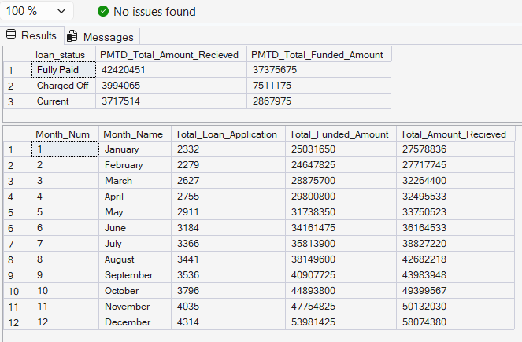

Geographic (State-Level) Dispersion
Exposes localized market concentration risk profiles across different geographical regions.
SELECT
address_state,
COUNT(id) AS Total_Loan_Application,
SUM(loan_amount) AS Total_Funded_Amount,
SUM(total_payment) AS Total_Amount_Recieved
FROM Bank_Loan_data
GROUP BY address_state
ORDER BY COUNT(id) DESC;

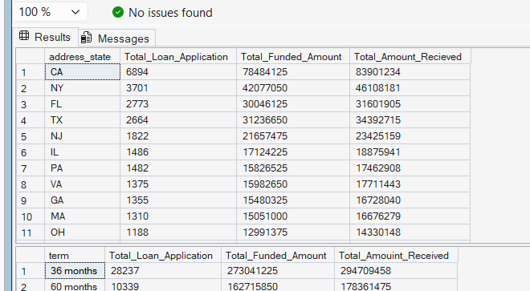

Structural Term Horizon Matrix
Segments risk profiles and structural cash flows by short-term (36 months) vs long-term (60 months) contract horizons.
SELECT
term,
COUNT(id) AS Total_Loan_Application,
SUM(loan_amount) AS Total_Funded_Amount,
SUM(total_payment) AS Total_Amouint_Received
FROM Bank_Loan_data
GROUP BY term
ORDER BY term;



Employment Tenure Exposure Summary
Correlates professional stability with overall default probabilities to refine risk-assessment models.
SELECT
emp_length,
COUNT(id) AS Total_Loan_Application,
SUM(loan_amount) AS Total_Funded_Amount,
SUM(total_payment) AS Total_Amouint_Received
FROM Bank_Loan_data
GROUP BY emp_length
ORDER BY COUNT(id) DESC;

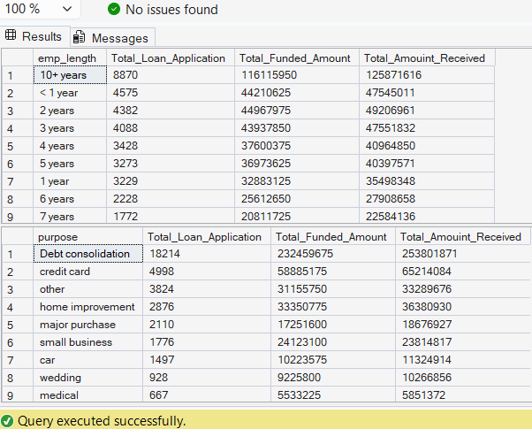

Loan Purpose Credit Concentrations
Classifies portfolio distribution by borrower intent (e.g., debt consolidation, credit card payoff, small business loans) to identify use-case performance patterns.
SELECT
purpose,
COUNT(id) AS Total_Loan_Application,
SUM(loan_amount) AS Total_Funded_Amount,
SUM(total_payment) AS Total_Amouint_Received
FROM Bank_Loan_data
GROUP BY purpose
ORDER BY COUNT(id) DESC;



Home Ownership Classification Analysis
Analyzes the impact of residential asset status (Mortgage, Rent, Own) on a borrower's overall credit performance.
SELECT
home_ownership,
COUNT(id) AS Total_Loan_Application,
SUM(loan_amount) AS Total_Funded_Amount,
SUM(total_payment) AS Total_Amouint_Received
FROM Bank_Loan_data
GROUP BY home_ownership
ORDER BY COUNT(id) DESC;

