Proposal 1: Delicious Crumbs Bakery.


Student Name: Zethembiso Mpanza

Student Number: ST10518561

Module: WEDE5020

Submissions Date: 31/07/2026

1. ORGANISATION OVERVIEW
Organization Name: Zee’s Delicious Crumbs Bakery
Background: A modest, fictitious bakery called Delicious Bakery is situated in Nongoma, KwaZulu-Natal. Freshly baked bread, cakes, cupcakes, pastries, cookies, and specially designed celebration cakes for weddings, birthdays, and business gatherings are the bakery's specialties. The bakery was founded in 2025 and currently serves clients through its physical location. It mostly depends on word-of-mouth and walk-in clients. By building a polished website where clients can browse merchandise, ask questions about personalized cakes, and get in touch with the bakery online, the owner hopes to grow the company.
Mission: To offer fresh, reasonably priced, and superior baked goods while providing outstanding customer service and making each customer's experience unforgettable.
Vision: To become one of the top local bakeries in Nongoma by providing top-notch goods and first-rate online client experience.
Target Audience: The website is intended for families, students, workers, event planners, schools, small businesses and those ordering for birthdays, weddings and all.
2. WEBSITE GOALS AND OBJECTIVES
The website's primary objective is to boost Delicious Bakery's online visibility and enhance customer connection. Customers will be able to inquire about custom cake orders, view available products, and access business information on the website.
Objectives
- Increase online visibility
- Display bakery products professionally
- Increase customer enquiries
- Promote seasonal specials
- Allow customers to request custom cakes
- Improve customer communication.
KPI | Target
Monthly visitors | 1000+
Online enquiries | 35 per month
Customer satisfaction | 90%
Contact form submissions | 60 per month

4. PROPOSED WEBSITE FEATURES AND FUNCTIONALITY
The proposed websites will include the following pages:
Home: The homepage will include visitors to the bakery using an attractive banner image and highlight featured products and promotions.
About us: Provides information about bakery, its history, mission and values.
Products: Displays all bakery products including bread, cakes, cupcakes, pastries and biscuits including their image, name, description and price.
Custom cake orders: Customers will complete an online enquiry form including name, email, phone number, event date, cake flavor, cake size, theme and additional notes.
Gallery: Displays photographs of complete cakes and bakery products.
Contact: location, business hours, WhatsApp, email and contact form.
Bakery Homepage inspiration
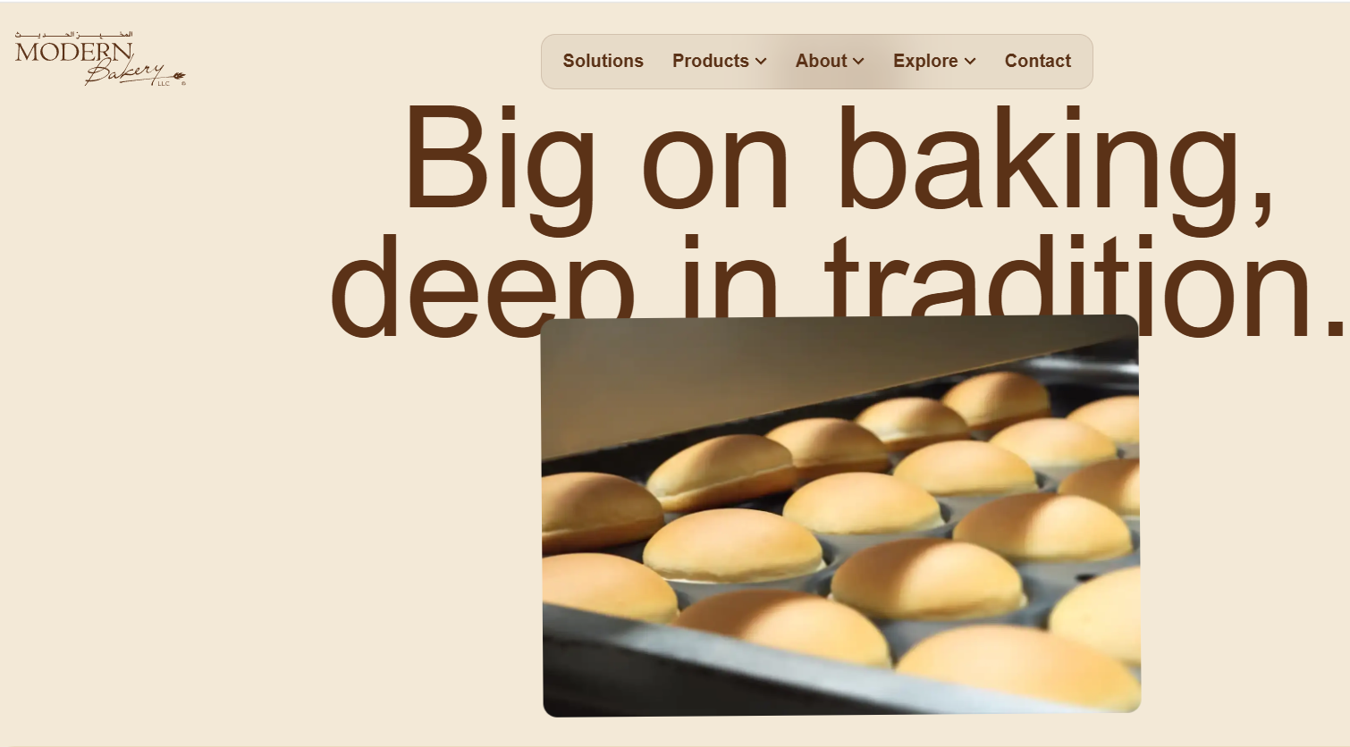
Bakery products display.
This image demonstrates a clean product layout and variety which will inspire the products page design
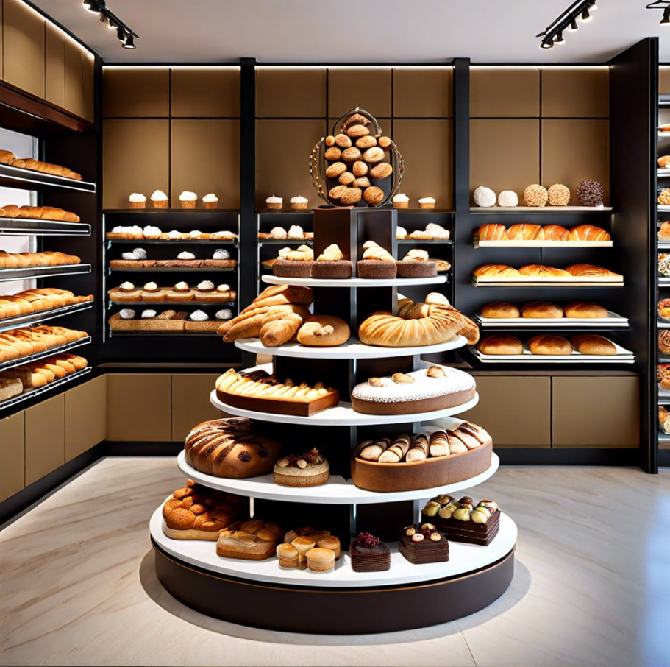
Cake Gallery/ Custom Cake Inspiration.
This image shows the type of custom decorated cakes that will be featured in the online gallery.
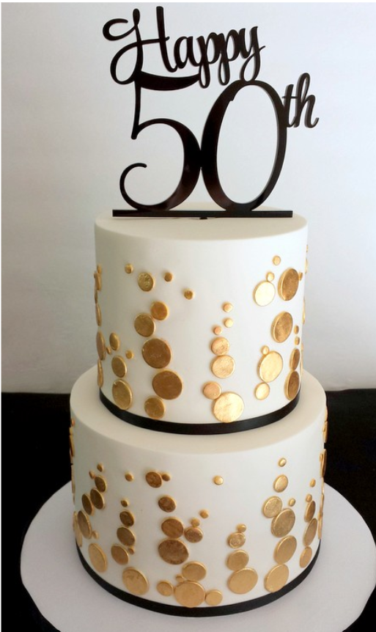
5. DESIGN AND USER EXPERIENCE
The website will have a contemporary rustic look that is cozy and welcoming. In order to attract clients who want daily bread and custom cakes, it will seem professional while reflecting the homey atmosphere of a local bakery. To build appetite appeal, the branding will make use of natural textures and excellent food imagery.

Color Scheme: Warm Bakery Palette
1. Cream: #FOEBD7 – Background, makes site feel clean.
2. Warm brown: #C87640– Headings, represents bread/coffee.
3. Gold Accents: #D1AE68 – Buttons, highlights, represents pastries.
4. Soft Black: #2D2D2D – Body text for readability
Typography
1. Headings: Playfair Display – Elegant serif font for “Bakery Name” and page tittles. Feels premium.
2. Body Text: Montserrat – Clean sans-serif font for product descriptions and paragraphs. Easy to read on mobile. Hierarchy: H1 = 36px Bold, H2 = 24PX Bold, Body =16px Regular.
Layout and Design
The website will have logical divisions and a single page scroll structure. A sizable hero banner will open the homepage, followed by Feature Products, About Us, Testimonials, and Contact. For convenience, a sticky navigation bar will remain at the top. Images, names, and prices will be arranged in a grid format on product pages.
User Experience Considerations
1. Navigation; Clear menu with Home, Products, About, Contact. Mobile-friendly hamburger menu.
2. Layout: Lots of white space so images of cakes/bread stand out.
3. Color Scheme: Warm colors to create comfort and make food look more appealing.
4. Accessibility: Lage buttons for “Order Now” and “WhatsApp Us” for easy mobile use.
Bakery color palette
These warm tones reflect a rustic, artisanal bakery brand.
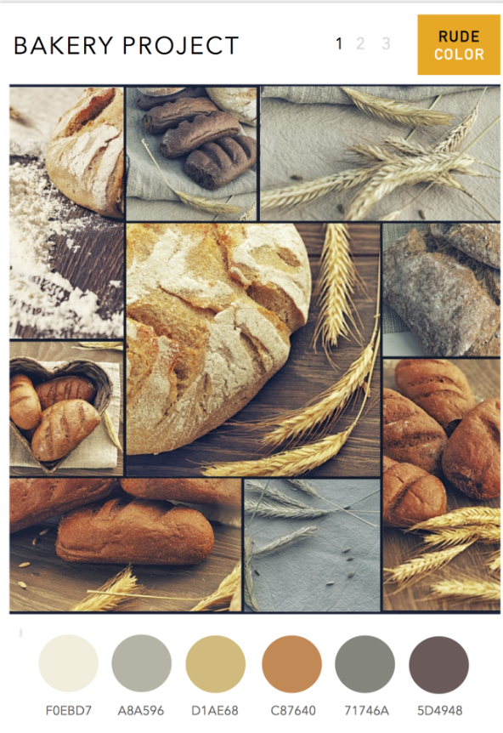
Bakery Logo inspiration.
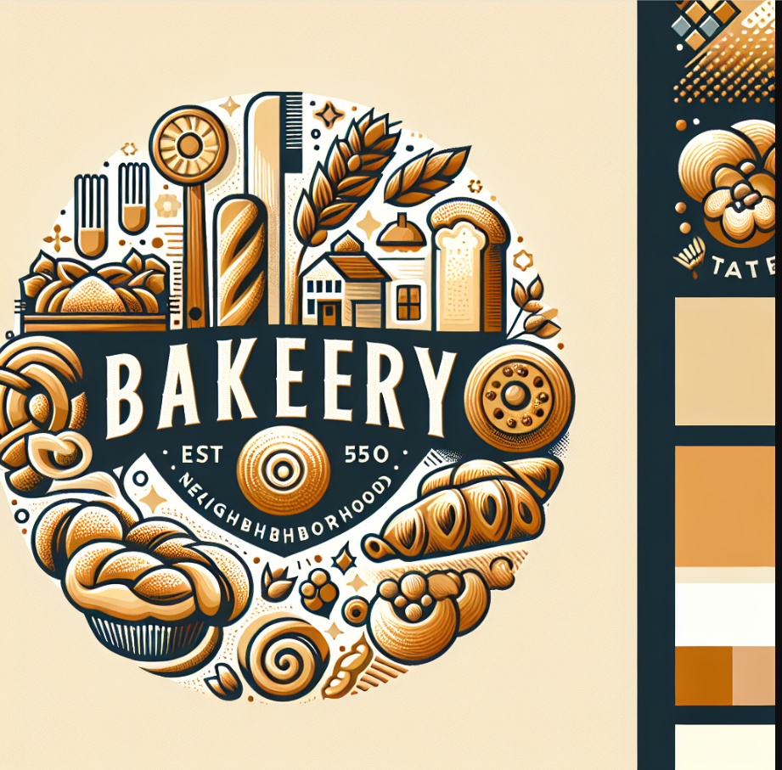
Low-Fidelity Wireframe.
The site layout employing bakery brand colours is depicted in the wireframe below. The navigation and company name are located in the dark brown header. "Freshly Baked Every Day" is promoted with call-to-action buttons in a sizable cream hero part. Bread, cakes, cupcakes, and pastries are represented by four gold boxes. The "About" and "Customer Reviews" sections are cream. Contact information and social media accounts are located in the dark brown footer. The product list is highlighted, and simple navigation is given priority in this layout.

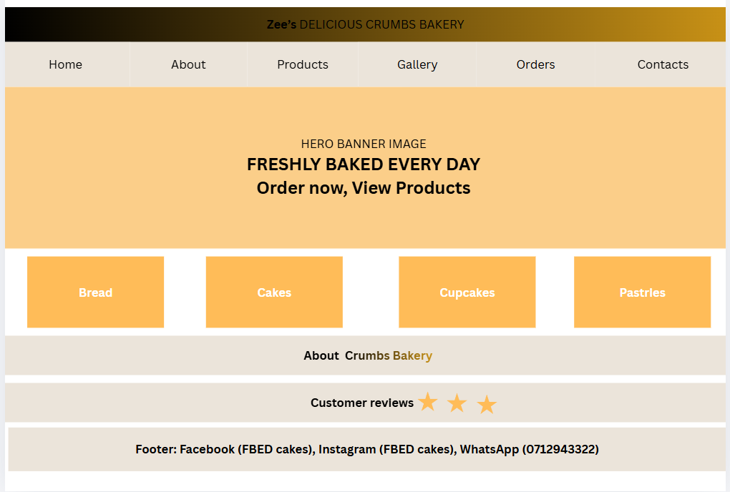
6 TECHNICAL REQUIREMENTS
1. Hosting and Domain Name Requirements
- Domain Name: www.zeesdeliciouscrumbs.co.za . A .co.za domain is recommended to target South African customers and build local trust.
-Web Hosting; Shared hosting plan at least 10GB storage and SSL certificate
Recommended providers: Hostinger, Afrihost, or Xneelo. SSL is needed for secure online orders and payments.
-Email Hosting: 2 business email accounts e.g. order2zeesdeliciouscrumbs.co.za
2. Programming Languages and Frameworks
For a small bakery website, we will use beginner-friendly technologies:
-HTML5: To structure all web pages and content
-CSS3: To style the website with the brank colors, fonts, and layout
-JavaScript: To add interactivity like the “Order Now” button and product gallery
-Content Management System: WordPress with WooCommerce.
Reason: Easy for the owner to update products, prices, and photos without coding. A lso handles online orders.
3. Additional tools
-Payment Gateway: Payfast for secure online payments
-Google Analytics: To track website visitors and orders
-Responsive Design: Website must work on mobile, tablet and desktop.
7. Timeline and Milestones
Task | Description | Duration | Status
Planning | Gather requirements | 29-30 June | Completed
Research | Collect Content | 29-30 June | Completed
Wireframe | Design Layout | 30 June | Completed
Java, CSS, HTML | Create, Apply and Add | 30-31 June | Pending
Final review | Final edits | 31 June | Pending
Submission | Submit Project | 31 June | Pending

8. Budget
Item | Estimated Costs
Domain Registration | R150/year
Logo Design | R400
Photography | R800
Testing | R300
Maintenance | R1500/year
Web hosting | R1000
Website development | R4000
Total Estimated Budget: R8150

References
Bakery, M., 2025. Big on baking, deep in tradition. [Online]
Available at: https://modernbakery.com
[Accessed 30 July 2026].
Cakes, B., 2025. Delight in Creative Celebrations with Stunning cake with your picture. [Online]
Available at: https://birthday cakes.co.za
[Accessed 30 July 2026].
Canva, 2026. Wireframe Layout. www.canva.com
Display, B., 2024. 15 Bakery Display Ideas. [Online]
Available at: https://Bakery Display Ideas
[Accessed 30 July 2026].

Proposal 2: Urban Choice Retail Store
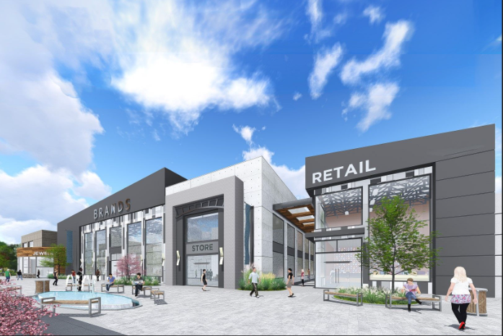

1. ORGANISATION OVERVIEW
Name: Zee’s Urban Choice Retail Store.
In Johannesburg, South Africa, there is a fictitious small clothes and accessory store called Urban Choice Retail Store. The business sells reasonably priced apparel, accessories, purses, and shoes for men, women, and kids. The company was founded in 2024 and does not currently have an official website; instead, it services clients through its physical store and social media accounts. Fashion-conscious consumers searching for stylish, yet reasonably priced goods make up the target market. The owner intends to create a polished website where clients may peruse merchandise, take advantage of specials, and get in touch with the company with questions in order to broaden its market reach and enhance customer convenience.
Mission: To provide affordable, fashionable and high-quality clothing while delivering excellent customer service and convenient shopping experience
Vision: To become a trusted local fashion retailer by offering quality products and an engaging online presence.
Target audience: Teenagers, young adults, working professionals, families, and local shoppers looking for affordable fashion and accessories.

2. WEBSITE GOALS AND OBJECTIVES
Establishing an online presence and raising brand awareness for Zee's Urban Choice Retail Store is the website's main objective. The website will display products that are available, promote sales, and give clients quick access to business details. Additionally, it will enhance online contact forms for communication. Increased website traffic, client inquiries, the conversion rate from visitors to purchases, and interaction with promotional content will all be used to gauge the success of the website.
Key Performance Indicators
-Increase monthly website to 1200
-Receive at least 50 customers enquiries per month
-Achieve at least 90% of customer satisfaction through online feedback
-Ensure the website is fully responsive on desktop and mobile devices
4. PROPOSED WEBSITE FEATURES AND FUNCTIONALITY
The Urban Choice Retail Store website will be designed to provide a smooth shopping experience and improve customer engagement. The website will include the following pages and features.
Home Page: Will include a hero banner with current promotions and new arrivals, featured product categories and quick links to Shop and Specials.
About Us: Will provide information about the store history, mission, vision, and team.
Products: Will display all clothing categories with filters for Men, Women, and Children. Each product will have an image, name, prize, size options, and “Add to Cart” button.
Contact: Will include a contact form, store location with embedded map, operating hours, phone number and email address.
Gallery: Will showcase customer photos wearing store outfits and behind the scenes images.
Checkout Page: Will include secure form for customer details, delivery address and payment options.
Retail Website Inspiration.
The homepage layout is inspired by ASOS, with a hero banner and clear category buttons for Men and Women.
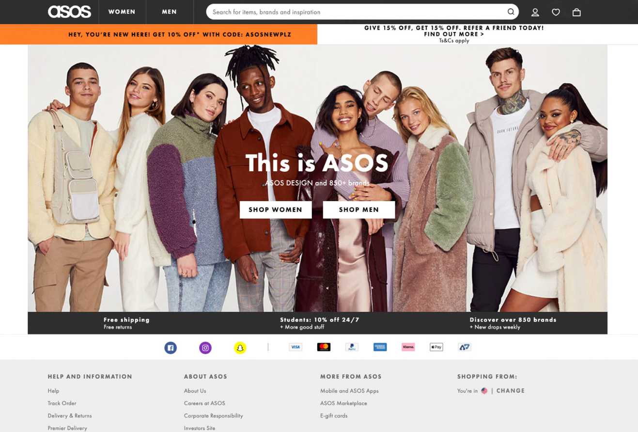
5 DESIGN AND USER EXPERIENCE.
The website will use modern and professional design that reflects a fashion retail brand.
Color Palette
The website will use black, white, grey and gold.
-Black #000000: Represents elegance and sophistication.
-White #FFFFFF: Creates a clean and spacious look.
-Grey #808080: Used for backgrounds and secondary text
-Gold #FFD700: Used for buttons and highlights to create a premium feel.
Typography
-Headings: Poppins – Bold and modern for tittles and banners.
-Body Text: Open Sans – Clear and easy to read for product descriptions
Layout and Navigation
The layout will be clean with plenty of white space. The navigation menu will be at the top and include Home, Shop, Specials, About us, Gallery, Contact.
The homepage will have: Hero banner, featured categories, Promotional section, Customer reviews, and footer with Contact details

Low-Fidelity Wireframe.
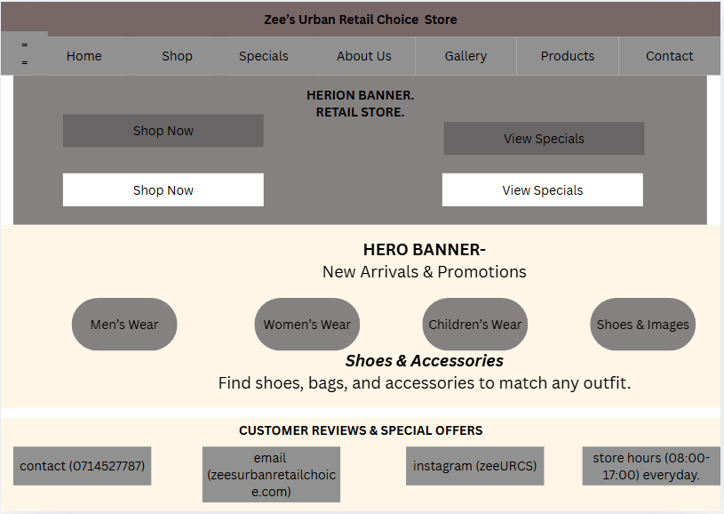

6. TECHNICAL REQUIREMENTS.
To develop and host the Urban Choice Retail Store website, the following technical requirements are needed:
Development tools: HTML5, CSS3 and JavaScript will be used to build the website structure, styling and interactivity. Visual Studio Code will be used as the code editor.
Frameworks: Bootstraps will be used to ensure the website is responsive on all devices
Hosting: A shared web hosting service will be used to store website files.
Domain Name: A. co.za domain name will be registered, eg www.zeesurbanchoice.co.za
Database: MySQL will be used to store product information, customer details, and orders
7. Timeline and Milestones.
Task | Duration | Status
Planning | 29-30 July | Completed
Research | 29-30 July | Completed
Wireframe | 30 July | Completed
HTML, CSS3, JavaScript | 30 July | Pending
Database | 31 July | Pending
Submission | 31 July | Submitted

8. Budget
Items | Estimated Cost
Domain Registration | R180
Logo Design | R500
Product Photography | R1000
Shared Web Hosting | R1000
Website Development | R1200
Testing | R300
Annual Maintenance | R1500
Total Estimated Budget R5680

References
Canva, 2026. Wireframe Layout. www.canva.com
DESIGN, A., 2024. Retail Homepage Inspiration. [Online]
Available at: https://blog.boxmode.com
[Accessed 30 July 2026].

