SITEMAP

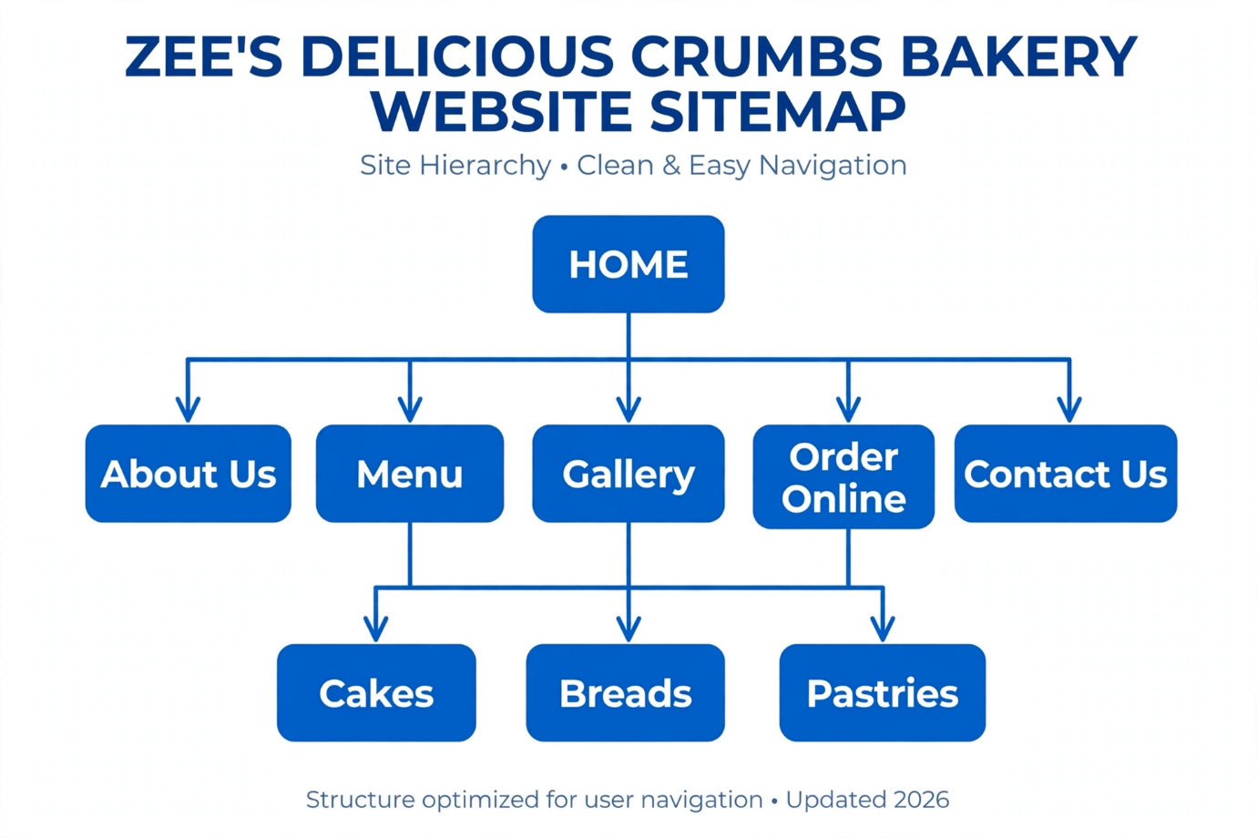
Page | Purpose | Content/Features
Home | First impression, attract customers | Hero image, slogan "Freshly Baked Daily", 3 featured products, CTA button "Order Now"
About Us | Build trust | Our story, founder Zee's bio, mission, team photos
Menu | Show Products | Main category page linking to sub-pages
-Cakes | Detailed Products | 5 cake types with original descriptions + prices + images
-Breads | Detailed Products | 4 bread types + ingredients
-Pastries | Detailed Products | Muffins, croissants etc.
Gallery | Visual proof | 12 images of bakery, customers, process (from Pexels + original)
Order Online | Conversion | Order form: Name, Product, Quantity, Delivery date, Payment method
Contact Us | Support | Map, Address, Phone, Email, Opening Hours, Contact Form

The website uses a top horizontal navigation bar present on all pages. Users can navigate from Home to any main page in one click. The journey Home > Menu > Cakes > Order Online takes 3 clicks. The footer contains contact details and social media links on every page to ensure easy access and good user experience.

