BOND RISK & KEY RATE DURATION ANALYSIS

Internship Project Report

Submitted by: Kanaparthi Gayathri

Internship Organization: Zetheta

Under the Guidance of: Varalakshmi

Academic Year: 2025–2026

Table of Contents

1. Executive Summary

2. Introduction

3. Problem Statement

4. Project Objectives

5. Bond Mathematics & Risk Framework

6. Bond Risk Analysis

7. Key Rate Duration Analysis

8. Scenario Analysis

9. Machine Learning Analysis

10. Results & Findings

11. Validation

12. Tools & Technologies

13. Day-by-Day Project Journal

14. Conclusion

15. Future Scope

16. References

17. Appendix

1. Executive Summary
This project focuses on bond risk analysis with particular emphasis on Key Rate Duration (KRD), interest-rate sensitivity, scenario analysis, and quantitative risk assessment. The project uses financial and analytical techniques to examine how changes in interest rates across different maturity buckets can affect bond portfolio risk and profit and loss. The analysis includes data preparation, KRD analysis, risk measurement, scenario-based assessment, machine learning analysis, feature importance, and visualization of results. The final outputs provide a structured view of the major risk drivers and the sensitivity of the bond portfolio to changes in the yield curve.

2. Introduction
Bond investments are exposed to changes in market interest rates, and the sensitivity of a bond portfolio can vary across different maturity points of the yield curve. Key Rate Duration provides a useful framework for measuring this sensitivity by examining the impact of changes in specific maturity segments. This project applies bond-risk concepts and quantitative analysis techniques to understand interest-rate exposure, identify important risk buckets, and evaluate potential portfolio impacts under different scenarios.

3. Problem Statement
The objective of this project is to analyse bond interest-rate risk
and identify the maturity buckets that contribute most significantly
to portfolio sensitivity. The project also aims to quantify the
potential impact of yield changes and use quantitative and machine
learning techniques to support bond-risk analysis.

4. Project Objectives
• Analyse bond and interest-rate risk.
• Calculate and interpret Key Rate Duration.
• Identify important maturity buckets.
• Evaluate portfolio sensitivity under yield shocks.
• Analyse potential P&L impact.
• Apply machine learning techniques to the available bond-risk data.
• Identify important risk-driving features.• Present the results through tables and visualizations.

5. Bond Mathematics & Risk Framework
This section presents the fundamental fixed-income concepts used in the project. Bond price, yield to maturity, Macaulay Duration, Modified Duration, Convexity and DV01 form the foundation of the risk-analysis framework. Bond price represents the present value of the future coupon and principal cash flows discounted at the required yield. Macaulay Duration measures the weighted-average time to receive the bond's cash flows. Modified Duration measures the approximate percentage change in bond price for a change in yield. Convexity improves the duration-based approximation for larger interest-rate movements by accounting for the curvature of the price-yield relationship. DV01 measures the approximate change in bond value resulting from a one-basis-point change in yield. These measures are used together to understand and quantify the interest-rate sensitivity of fixed-income investments.
5.1 formulas
Bond Price:
P = Σ [CFt / (1 + y/m)^(mt)]
Modified Duration:
Dmod = DMac / (1 + y/m)
Approximate Price Change:
ΔP/P ≈ -Dmod × Δy + 0.5 × Convexity × (Δy)^2
DV01:
DV01 ≈ Price × Modified Duration × 0.0001
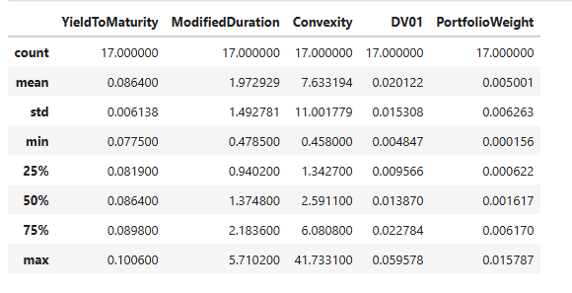Table 5.1: Bond Risk Measure Summary Statistics
The summary statistics show the distribution of yield-to-maturity, modified duration, convexity, DV01, and portfolio weight across the bond dataset. Modified duration ranges from 0.4785 to 5.7102, while DV01 ranges from 0.004847 to 0.059578.

6. Bond Risk Analysis
Bond risk analysis evaluates how changes in market variables can affect the value of fixed-income investments. The analysis considers interest-rate sensitivity, duration, convexity, DV01 and potential profit-and-loss impact under yield shocks.At the portfolio level, individual bond-level risk measures can be aggregated to understand the overall exposure. This allows the analysis to identify concentrations of risk and maturity segments that may contribute more significantly to portfolio sensitivity.The project also uses visual analysis to make the risk contribution and scenario results easier to interpret.
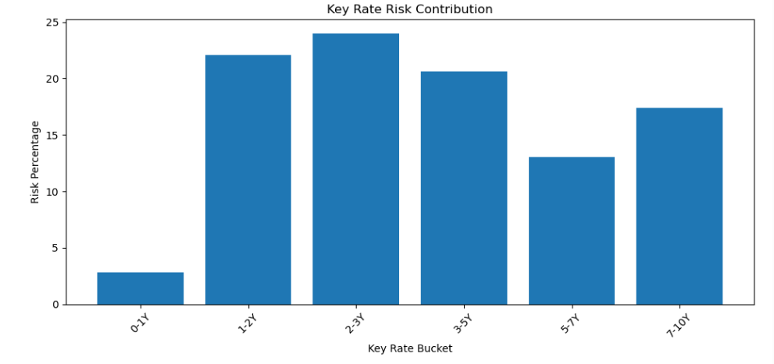Table 6.1: Bond Portfolio Risk Measures

7. Key Rate Duration Analysis
Key Rate Duration (KRD) decomposes interest-rate sensitivity across specific maturity points of the yield curve. Unlike Modified Duration,which generally assumes a parallel movement in yields, KRD allows different parts of the yield curve to move independently.The project analyses key-rate buckets including 3M, 6M, 1Y, 2Y, 3Y,5Y, 7Y, 10Y, 20Y and 30Y. A one-basis-point yield movement is applied to individual tenor points and the corresponding price sensitivity is used to estimate the KRD contribution. The KRD analysis helps identify whether portfolio exposure is concentrated at the short, intermediate or long end of the yield curve.

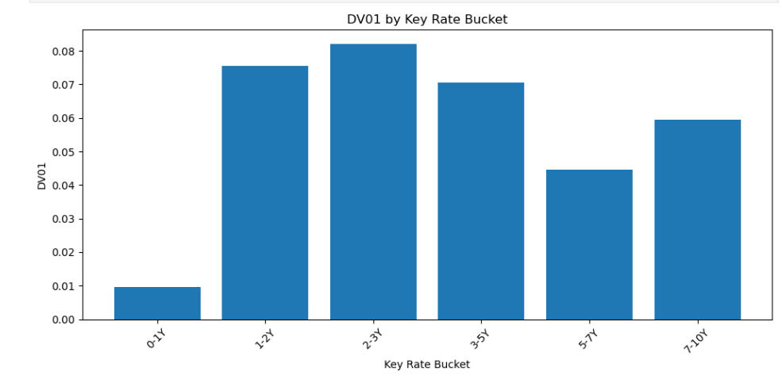7.1: Key Rate Duration Risk by Maturity Bucket

8. Scenario Analysis
Scenario analysis evaluates the potential impact of changes in interest rates under different market conditions. It is particularly important for non-parallel yield-curve movements because a single Modified Duration measure may not adequately capture the effect. In this project, Key Rate Duration is used to estimate the portfolio impact of maturity-specific yield shocks. The analysis examines the resulting P&L impact for the affected key-rate buckets.The scenario framework can be extended to include parallel shifts,steepening, flattening, inversion and other yield-curve movements.
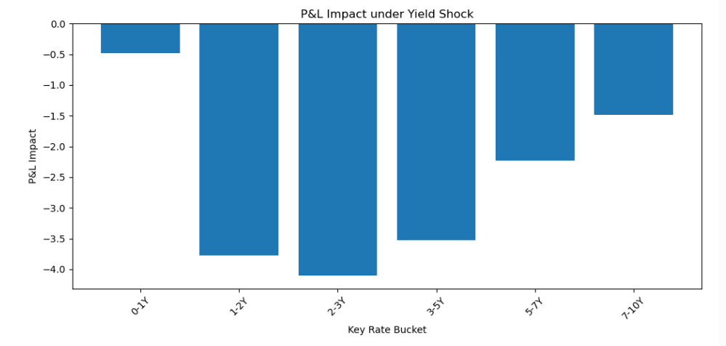Table 8.1: Interest Rate Shock Scenario P&L

9. Machine Learning Analysis
Machine learning was incorporated into the project to explore the use of predictive analytics in bond-risk analysis. The workflow includes data preparation, model analysis, prediction outputs and feature-importance interpretation. The machine-learning results are used as a complementary analytical approach rather than as a replacement for established fixed-income risk measures such as Duration, Convexity and Key Rate Duration. Model performance should be reported using the actual held-out test metrics generated during the project. Feature importance is used to identify variables that contribute relatively more to the model's predictions.
Table 9.2: Actual versus Predicted Risk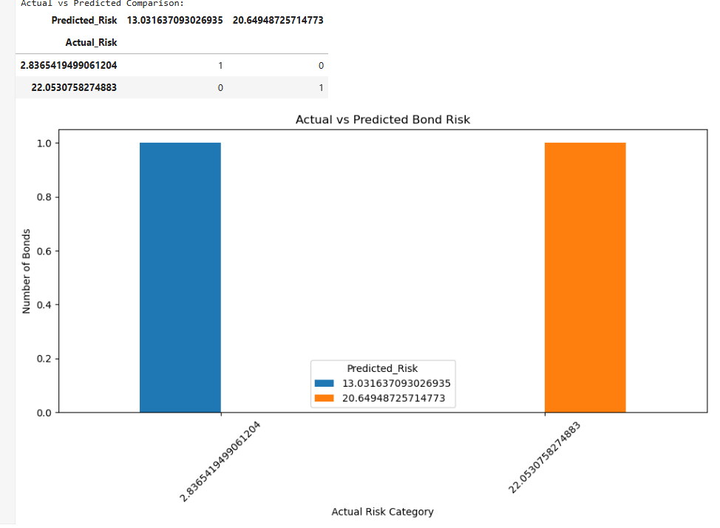Table 9.2: Actual versus Predicted Risk

10. Results & Findings
The project analysis was performed using bond risk and Key Rate Duration data. The analysis examined the contribution of different maturity buckets to interest-rate risk and evaluated the corresponding P&L impact under the applied yield shock. Data validation, descriptive analysis, risk analysis, visualizations, feature importance analysis and prediction outputs were generated using Python.
10.1 Key Rate Duration Results
The Key Rate Duration analysis provides a maturity-bucket-level view of interest-rate sensitivity. Instead of treating the entire yield curve as a single movement, the analysis identifies the contribution of individual key-rate buckets. This helps determine which maturity segments are relatively more sensitive to changes in interest rates.

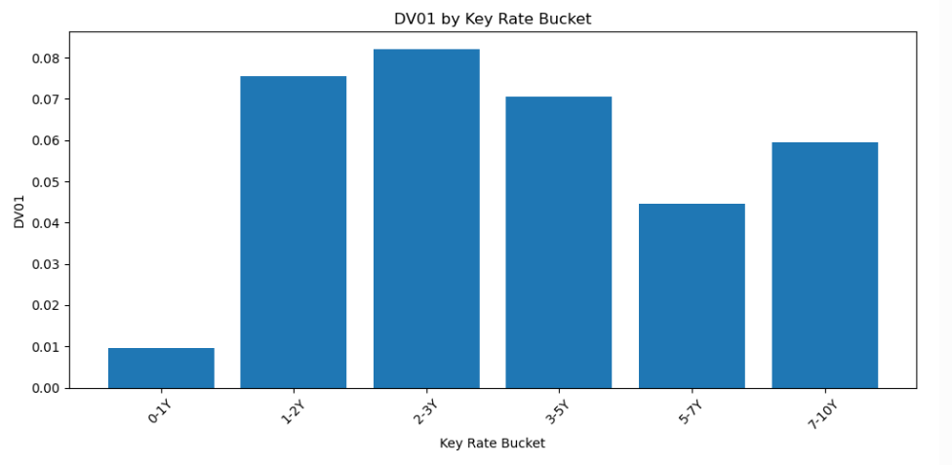Figure 1: DV01 by Key Rate Bucket
10.2 Risk Contribution Analysis
The risk contribution analysis compares the relative importance of the key-rate buckets. The bucket-level results help identify the areas where interest-rate movements may have a larger effect on the portfolio. This provides a more detailed risk view than a single portfolio-duration measure.

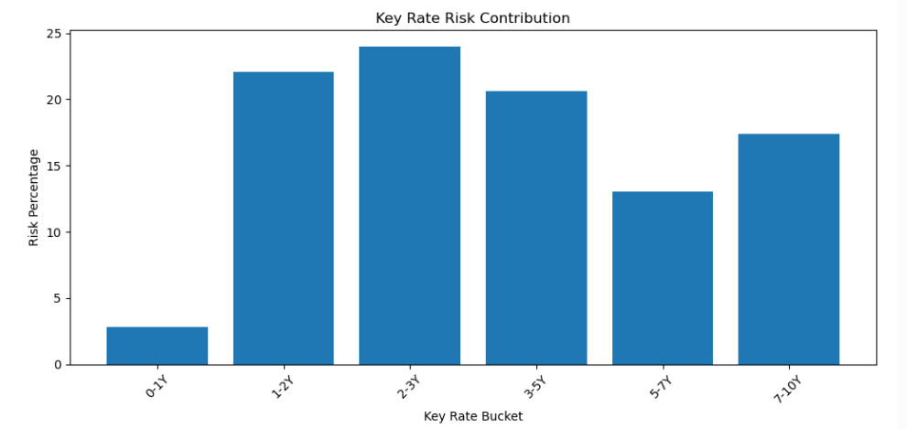
Figure 2: Key Rate Risk Contribution
10.3 Scenario P&L Analysis
Scenario analysis was used to evaluate the potential P&L impact resulting from the applied yield shock. The analysis provides a maturity-bucket-level view of the estimated impact and helps identify the areas contributing most to the overall scenario result.
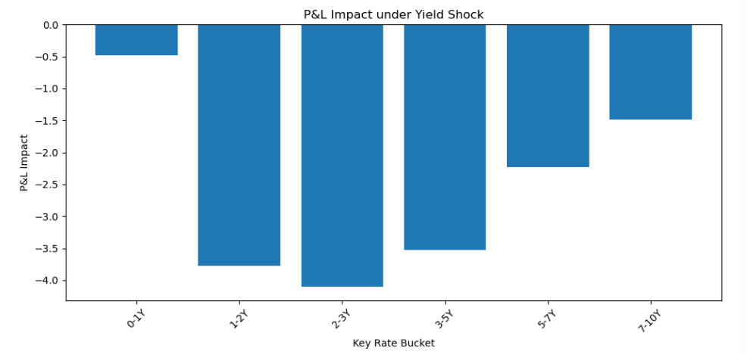
Figure 3: P&L Impact by Key Rate Bucket
10.4 Key Findings
• Key Rate Duration provides a granular measure of interest-rate sensitivity across maturity buckets.
• The analysis identifies the maturity segments contributing relatively more to risk.
• Yield shocks can generate different P&L impacts across different key-rate buckets.
• Visual analysis makes the concentration of interest-rate risk easier to interpret.
• The generated analytical outputs can support portfolio risk monitoring and decision-making.

11. Validation
Validation is an important part of the project to ensure that the analytical outputs are reliable and consistent with established financial methods. The project requirements specify independent validation of bond calculations, machine learning results, risk measures, dashboard calculations and case-study information.
11.1 Bond Calculation Validation
Bond pricing, duration, convexity and DV01 calculations were developed using standard fixed-income methodology. The project specification requires these calculations to be cross-checked against Excel financial functions such as PRICE(), DURATION() and MDURATION(). Any final validation claim should be supported by the corresponding Excel comparison evidence.
11.2 Key Rate Duration Validation
Key Rate Duration was used to decompose interest-rate sensitivity across maturity buckets. The project methodology requires the sum of the KRD contributions to be approximately consistent with portfolio Modified Duration, within the specified tolerance. This provides an important consistency check on the KRD implementation.
11.3 Machine Learning Validation
Machine learning outputs should be evaluated using a held-out test dataset. The project specification requires reporting RMSE for every machine learning model. Therefore, model performance should be reported only using the actual test-set metrics generated during the project.
11.4 Risk Measure Validation
Risk estimates should be independently checked against an analytical benchmark wherever applicable. In particular, the project specification requires VaR calculations to be compared with Parametric VaR as a sanity check. This helps identify unreasonable or inconsistent risk estimates.
Validation status table
Validation Item | Requirement | Status
Bond Pricing | Excel PRICE() cross-check | To be evidenced
Duration | Excel DURATION()/MDURATION() cross-check | To be evidenced
KRD | KRD sum vs Modified Duration | Analysis completed
ML | Held-out RMSE | Check actual output
VaR | Parametric VaR comparison | Check evidence
DAX | DAX Studio profiling | Separate validation
Case Studies | Primary-source verification | Separate validation

12. Tools & Technologies
The project was developed using a combination of programming, analytical, visualization and research tools. Python was used for bond-risk calculations, Key Rate Duration analysis, scenario analysis, machine learning and data visualization. Jupyter Notebook was used as the primary development environment. Excel-based financial functions were specified as an independent validation benchmark. Power BI, R, SQL and other supporting tools form part of the broader project methodology.
12.1 Python & Jupyter Notebook
Python was used to implement the quantitative bond-risk analysis. The Jupyter Notebook provided an interactive environment for data preparation, calculations, visualizations, machine learning and generation of final analytical outputs.

13. Day-by-Day Project Journal
13.1 Day 1 — Domain Orientation
The first phase focused on understanding fixed-income markets, bond risk management, Indian government securities and yield-curve concepts. The key objective was to build familiarity with duration, convexity, interest-rate risk and Key Rate Duration.
13.2 Day 2 — Bond Pricing From First Principles The second phase focused on implementing core bond mathematics, including bond pricing, Macaulay Duration, Modified Duration, Convexity and DV01. The calculations were designed to support subsequent portfolio and interest-rate risk analysis.
13.3 Day 3 — Portfolio Analytics
The portfolio analytics phase focused on aggregating bond-level risk measures into portfolio-level measures. Duration, convexity,DV01 and risk contributions were analysed across relevant dimensions and visualizations were generated.
13.4 Day 4 — Key Rate Duration
The Key Rate Duration phase decomposed interest-rate sensitivity across maturity buckets. The analysis examined the contribution of individual tenor points and evaluated the impact of yield-curve scenarios on portfolio P&L.
13.5 Day 5–6 — Monte Carlo Risk Analysis
The Monte Carlo phase focused on simulating interest-rate scenarios and evaluating portfolio risk under multiple possible market conditions. VaR, CVaR and yield-curve scenarios were considered as part of the quantitative risk framework.
13.6 Day 7 — Quantitative Case Studies
The case-study phase applied bond-risk concepts to practical financial situations. The objective was to connect theoretical duration and convexity concepts with real-world portfolio risk-management decisions.
13.7 Day 8 — Machine Learning Analysis
The machine learning phase introduced predictive analytics into the bond-risk workflow. The available risk dataset was prepared for model-based analysis, followed by model evaluation and feature-importance analysis. The objective was to investigate whether quantitative relationships within the available bond-risk variables could support risk prediction and interpretation.
13.8 Day 9 — ML Sensitivity Analysis
The sensitivity-analysis phase focused on understanding how model outputs can respond to changes in interest-rate assumptions. The analysis was considered alongside traditional duration and convexity based approaches to understand the relationship between market shocks and estimated bond-risk outcomes.
13.9 Day 10 — Yield Curve Analysis
The yield-curve phase focused on understanding the term structure of interest rates and the relationship between maturity and yield. Yield-curve modelling provides an important foundation for analysing parallel and non-parallel interest-rate movements and their effect on fixed-income portfolios.
13.10 Day 11 — R Implementation
R was included in the project methodology as a complementary analytical environment for fixed-income calculations and yield-curve analysis. The purpose was to demonstrate reproducibility of selected quantitative methods across analytical platforms.
13.11 Day 12 — Power BI Dashboard
The Power BI phase focused on transforming analytical results into an interactive reporting format. The dashboard concept was designed to present portfolio risk, KRD contributions, scenario results and other important risk indicators in a decision-oriented format.
13.12 Day 13 — Gamification & Risk Lab
The Bond Risk Lab concept introduced a gamified approach to fixed-income risk learning. The framework uses levels, scenarios, achievements and risk-management challenges to make bond-risk concepts more practical and engaging.
13.13 Day 14 — Validation & Review
The validation phase focused on reviewing analytical outputs, checking data quality and identifying areas requiring independent verification. Validation is particularly important because the project requires independent checks for bond calculations, machine-learning metrics, VaR, DAX performance and case-study facts.
13.14 Day 15 — Final Submission
The final phase consolidated the project outputs into a structured technical report and presentation. The deliverables include the analytical notebook converted into appropriate source files, supporting datasets, visualizations, documentation and final project findings.

14. Conclusion
This project provided a structured approach to analysing bond interest-rate risk using Key Rate Duration, scenario analysis, quantitative techniques and machine learning. The analysis demonstrated the importance of examining interest-rate sensitivity across individual maturity buckets rather than relying only on a single duration measure. The resulting risk views and visualizations provide useful support for identifying important risk concentrations and understanding potential portfolio impacts under yield-curve movements.

15. Future Scope
Future development can include richer market datasets, real-time yield-curve integration, more advanced machine-learning models, robust out-of-sample validation, automated Power BI reporting, hedging optimisation and expanded stress-testing scenarios. Integration with reliable Indian fixed-income data sources could further improve the practical usefulness of the risk-management framework.

16. References
1. Reserve Bank of India (RBI) — Government Securities, monetary policy and auction-related information. 2. Clearing Corporation of India Limited (CCIL) — Government securities prices, yields and market data. 3. Fixed Income Money Market and Derivatives Association of India (FIMMDA) — Fixed-income valuation information. 4. National Stock Exchange of India (NSE) — benchmark yields and fixed-income market information. 5. Association of Mutual Funds in India (AMFI) —mutual-fund and fixed-income related information. 6. Project-provided Bond Risk & Key Rate Duration project specification document. 7. Python / Jupyter Notebook documentation used for analytical implementation.

17. Appendix
Appendix A — Jupyter Notebook Final notebook: Bond_Risk_KRD_Final.ipynb
Appendix B — HTML Notebook Bond_Risk_KRD_Final.html
Appendix C — Data Outputs Final_KRD_Analysis.csv Final_Bond_Risk_Dataset.csv Final_Project_Summary.csv
Appendix D — Analytical Outputs Final_Correlation_Matrix.csv Final_Feature_Importance.csv Final_Risk_Predictions.csv
Appendix E — Final Excel Workbook Bond_Risk_KRD_Final_Report.xlsx
17.1 Limitations
The analysis is dependent on the quality and scope of the available dataset. Some project requirements, including independent Excel validation, full machine-learning test-set validation, VaR sanity checks, DAX Studio profiling and primary-source verification, require separate supporting evidence. Therefore, these items should be completed and documented before final submission wherever applicable.

