FOREX MARKET
ANALYSIS DASHBOARD
Power BI Project Report
Dataset shown: EUR/USD price data | Tool: Microsoft Power BI Desktop
Prepared: October 2026

1. Executive Summary
This project presents an interactive Power BI dashboard for exploring EUR/USD price behaviour and trading activity. The screenshot shows a closing-price trend chart, high-versus-low price comparison, trading-volume time series, KPI cards, a moving-average comparison, a market-trend indicator, and currency-pair and date-range slicers. The displayed KPIs are filter-dependent and should be interpreted in the context of the selected date range and pair.

2. Project Objectives
- Visualize EUR/USD closing-price movement over time.
- Compare observed high and low prices.
- Explore trading-volume variation and spikes.
- Compare closing price with a moving-average line.
- Provide KPI cards and slicers for interactive exploration.

3. Dataset Overview
The dashboard displays EUR/USD observations across the date range 1 January 2023 to 21 January 2023. The project’s earlier report described 500 rows in the model; the screenshot itself does not independently establish the complete row count or the original data source.
Field | Description
DateTime | Timestamp used on the time axis and date-range slicer.
PairName | Currency-pair label; EUR/USD is displayed.
Open | Opening price.
High | Highest price in the observation.
Low | Lowest price in the observation.
Close | Closing price.
Volume | Trading-volume value.
Spread | Recorded spread value.
MA_5 / moving average | Moving-average line shown alongside the closing-price series.

4. Dashboard Components and Displayed Values
- Average EUR/USD Closing Price: Approximately 1.09.
- Average Trading Volume: Approximately 3.37K.
- Highest Price: Approximately 1.12.
- Lowest Price: Approximately 1.06.
- Price Change: Approximately 0.03; the exact DAX definition and comparison period are not visible in the screenshot.
- Closing Price Trend: The plotted series rises overall after an early decline, then fluctuates near the end.
- Average High and Average Low: Both lines show the observed price range over time.
- Trading Volume Over Time: The chart shows frequent variation and several volume spikes.
- Closing Price vs. Moving Average: The moving-average line is smoother than the more variable price series.
- Market Trend: The card displays “Downtrend”; its precise meaning depends on the underlying DAX measure.
- Currency-pair slicer: EUR/USD is listed as the selectable pair.
- Date-range slicer: The visible range is 1/1/2023 to 1/21/2023.

5. Key Observations
- The closing-price chart trends upward overall across most of the displayed period, with short-term dips and a pullback near the end.
- The visible price range is approximately 1.06 to 1.12.
- Trading volume varies substantially, with several pronounced spikes.
- The moving-average line is smoother than the closing-price line.
- The Market Trend card says “Downtrend,” but this label should not be treated as a forecast or trading recommendation without reviewing its DAX definition.

6. Measures and Interpretation Notes

Moving average
The earlier project documentation describes the MA_5 measure as averaging Close over a DateTime window from CurrentDate minus five days through CurrentDate. If that is the measure still used in this dashboard, it is a five-day time-window average, not necessarily the average of exactly five hourly observations. Confirm the DAX definition in Power BI Desktop before describing it as a five-observation moving average.

Market Trend
The screenshot displays “Downtrend,” but the screenshot alone does not reveal the measure formula. If the measure compares the latest Close with the latest moving-average value, the label describes that latest comparison only, not necessarily the direction of the entire displayed period.

Price Change
The card displays 0.03. The screenshot does not show whether this is a difference between the first and last close, a change against a prior period, or another calculation. Confirm the measure definition before interpreting it.

7. Data Validation and Limitations
The screenshot documents the visible dashboard layout and displayed values, but it does not prove the source data’s quality or the complete Power Query transformation history. Before submission, verify the following in Power BI Desktop:
- DateTime is typed as Date/Time and sorts chronologically.
- Open, High, Low, Close, Volume, and Spread have appropriate numeric types.
- There are no unexpected blank timestamps, duplicate observations, or null values.
- High is not below Low, and OHLC values are plausible.
- The date and currency-pair slicers filter the intended visuals.
- The Price Change and Market Trend measures match their titles and intended definitions.
- The moving-average definition is documented accurately.
- The source dataset and actual data-cleaning steps are recorded.
Scope limitation: the visible dashboard focuses on EUR/USD and a limited period in January 2023. It does not establish performance across other currency pairs or support reliable trading predictions.

8. Conclusion
The dashboard provides a clear visual summary of EUR/USD price movement, high/low values, trading volume, KPI values, and a moving-average comparison. The screenshot is suitable as a visual appendix for the project report. Final submission should follow a Power BI Desktop check of the measures, slicer interactions, data quality, and saved PBIX file.

Appendix A — Dashboard Screenshot
The following screenshot records the dashboard layout and values visible at the time of capture.
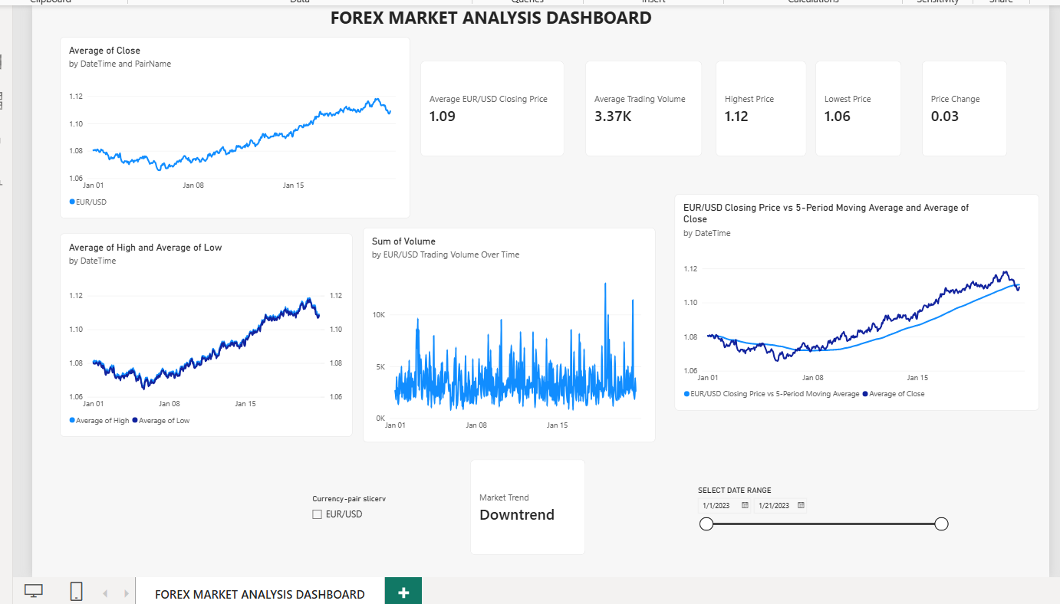
Figure 1. Forex Market Analysis Dashboard in Power BI.

Appendix B — Submission Checklist
- Open the PBIX in Power BI Desktop and confirm it loads without errors.
- Test the date-range and currency-pair slicers against every relevant visual.
- Verify the Price Change DAX formula and comparison period.
- Verify whether MA_5 means a five-day window or five observations.
- Confirm the Market Trend formula and explain its meaning accurately.
- Check source data types, blanks, duplicates, and OHLC consistency.
- Save the final PBIX after any corrections and capture a fresh screenshot.

