DATA ANALYST FOREX TRADING SIGNAL AI AGENT
Project Report

Prepared by: Suvasini
Computer Science & Engineering
CMR University, Bengaluru

Organization: Zetheta Algorithms Private Limited
Project: Project 1C
Duration: 15 Days

Abstract
The objective of this project was to develop an AI-assisted Forex Trading Signal Analysis system capable of analyzing historical foreign exchange market data and generating meaningful trading insights. The project combines data preprocessing, feature engineering, machine learning, technical indicators, and business intelligence visualization to support data-driven trading decisions.
Python was used for data preparation, feature engineering and model development, while Microsoft Power BI was used to create interactive dashboards for trading analysis.

1. Introduction
The foreign exchange (Forex) market is the largest financial market in the world. This project builds an AI-powered trading analytics system using historical Forex data, technical indicators and Power BI dashboards.

2. Objectives
- Analyze Forex data
- Perform preprocessing and feature engineering
- Generate technical indicators
- Build ML model
- Create Power BI dashboards
- Evaluate trading performance

3. Problem Statement
Raw Forex data is difficult to interpret. This project transforms raw market data into actionable insights using machine learning and interactive dashboards.

4. Technologies Used
Technology | Purpose
Python | Data Processing
Pandas | Data Manipulation
NumPy | Numerical Computation
Scikit-learn | Machine Learning
Matplotlib | Visualization
Jupyter Notebook | Development
Power BI | Dashboard Creation

5. Dataset
- Date and Time
- Open
- High
- Low
- Close
- Volume
- Currency Pair

6. Data Preprocessing
- Handled missing values
- Removed duplicates
- Formatted DateTime
- Converted data types
- Prepared structured dataset

7. Feature Engineering
- MA5
- MA20
- RSI
- MACD
- MACD Signal
- MACD Histogram
- Bollinger Bands
- Price Change
- Return
- High-Low Range

8. Machine Learning
A machine learning workflow was implemented to generate trading signals from engineered features.
- Feature Selection
- Model Training
- Prediction
- Trade Signal Generation

Model Performance
Classification Accuracy: 55.32%
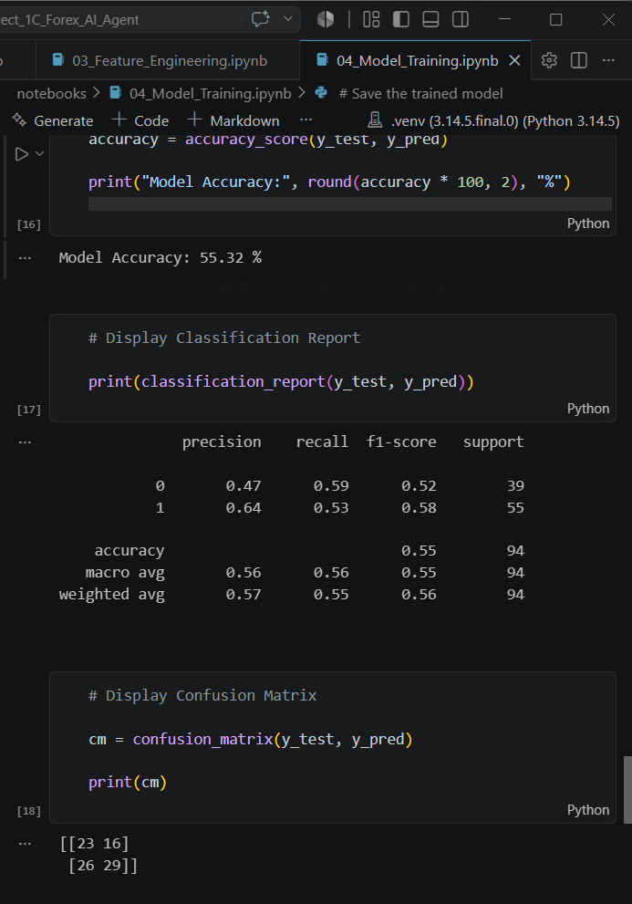
Figure 1. Machine Learning Classification Report and Confusion Matrix

Feature Engineering Output
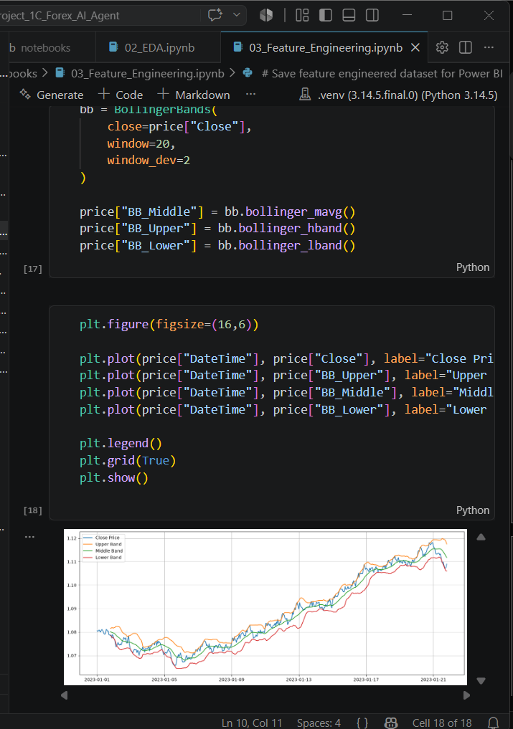
Figure 2. Bollinger Band Feature Engineering

9. Power BI Dashboard
Two dashboard pages were created to analyze trading performance and technical indicators.
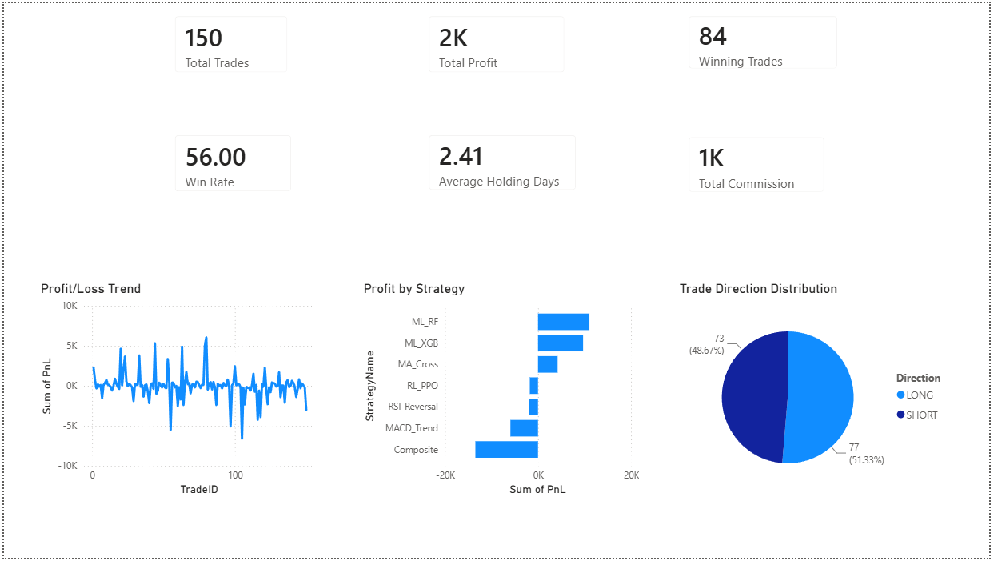
Figure 3. Executive Dashboard
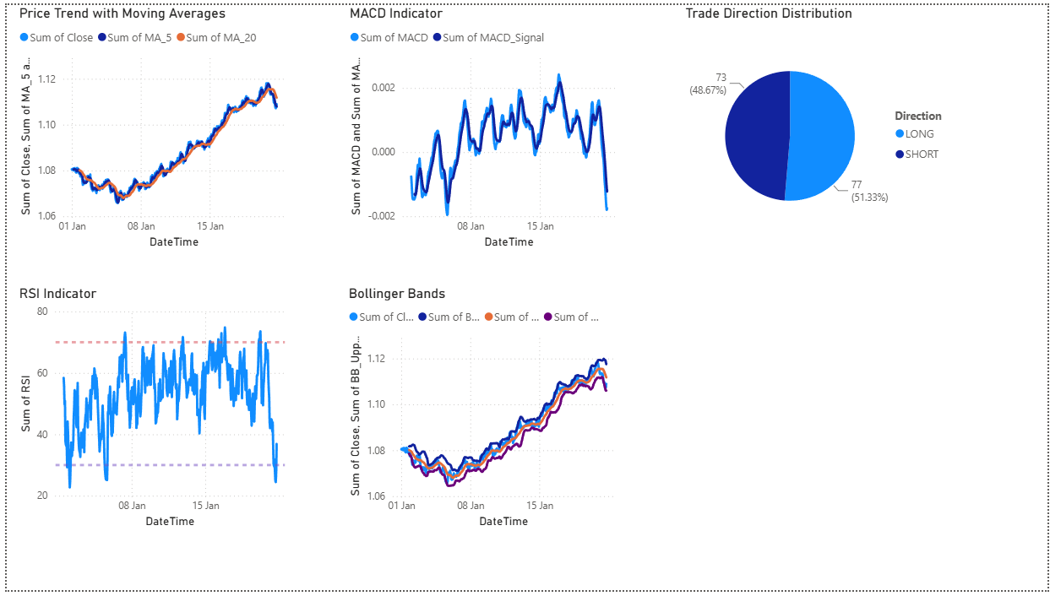
Figure 4. Technical Indicators Dashboard

10. Results
- Automated feature engineering
- Technical indicator calculation
- Interactive dashboards
- Trading performance visualization
- Strategy comparison

11. Challenges Faced
- Cleaning financial data
- Generating indicators
- Dashboard design
- Python-Power BI integration
- Performance optimization

12. Future Scope
- Real-time Forex API
- LSTM models
- Reinforcement Learning
- Cloud deployment
- Automated reporting

13. Conclusion
This project demonstrates an end-to-end AI-driven Forex Trading Analytics workflow using Python, machine learning and Power BI. The solution provides meaningful trading insights through interactive dashboards.

References
- Microsoft Power BI Documentation
- Scikit-learn Documentation
- Pandas Documentation
- NumPy Documentation
- Investopedia
- Yahoo Finance
- Python Documentation

