**Name – Akshat Jaiswal**

**Roll No. – 21052646**

**Section – CSE 15**

**WT LAB 3**

1. Create a webpage to display the following student table:

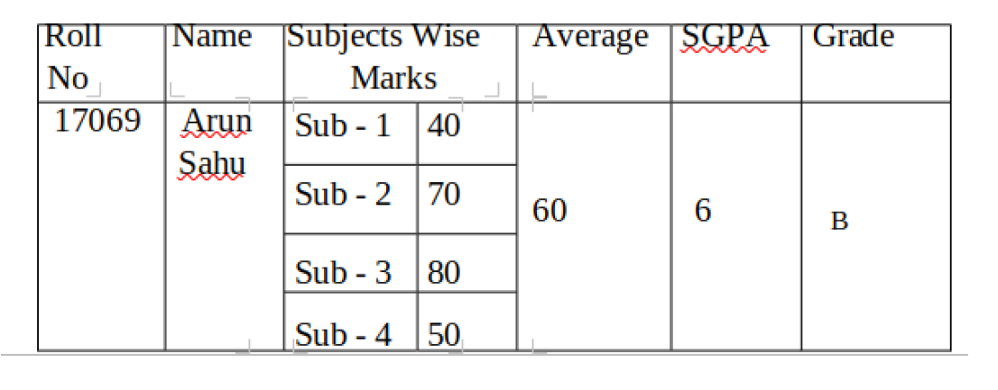

Code:

<!DOCTYPE html>

<html lang="en">

<head>

<meta name="viewport" content="width=device-width, initial-scale=1.0">

    <title>Student Table</title>

</head>

<style>

    *{

*font-size*: 20px;

*font-family*: Arial, Helvetica, sans-serif ;

    }

</style>

<body>

    <table border="1" width="70%" cellpadding="20px" align="center">

        <tr align="center">

            <td>Roll No</td>

            <td>Name</td>

            <td colspan="2">Subject Wise Marks</td>

            <td>Average</td>

            <td>SGPA</td>

            <td>Grade</td>

        </tr>

        <tr align="center">

            <td rowspan="4">21052646</td>

            <td rowspan="4">Akshat Jaiswal</td>

            <td>OS</td>

            <td>89</td>

            <td rowspan="4">91</td>

            <td rowspan="4">8.9</td>

            <td rowspan="4">A</td>

        </tr>

        <tr align="center">

            <td>DBMS</td>

            <td>89</td>

        </tr>

        <tr align="center">

            <td>WT</td>

            <td>99</td>

        </tr>

        <tr align="center">

            <td>PDC</td>

            <td>77</td>

        </tr>

    </table>

</body>

</html>

Screenshot:

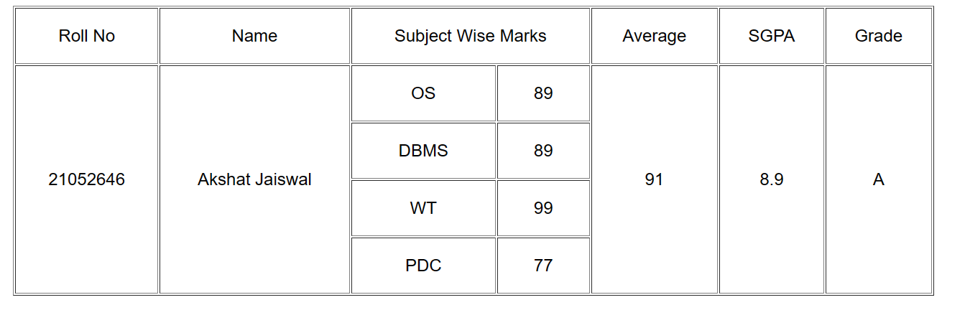

1. Design the following table using colspan and row span

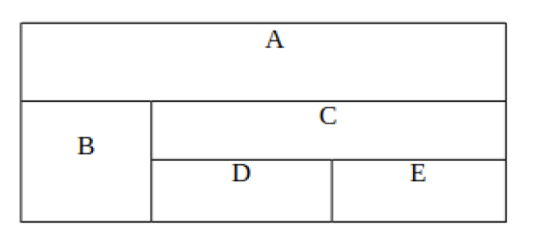

Code:

<!DOCTYPE html>

<html lang="en">

<head>

    <meta charset="UTF-8">

    <meta http-equiv="X-UA-Compatible" content="IE=edge">

    <meta name="viewport" content="width=device-width, initial-scale=1.0">

    <title>Table</title>

</head>

<style>

 p{

*transform*: translateY(-35px);

 }

</style>

<body>

    <table border="2" width="40%" cellpadding="20px" align="center">

        <tr align="center">

            <td colspan="4" valign="top"><p>A</p></td>

        </tr>

        <tr align="center" >

            <td rowspan="2" >B</td>

            <td colspan="2"><p>C</p></td>

        </tr>

        <tr align="center" >

            <td><p>D</p></td>

            <td><p>E</p></td>

        </tr>

    </table>

</body>

</html>

Screenshot:

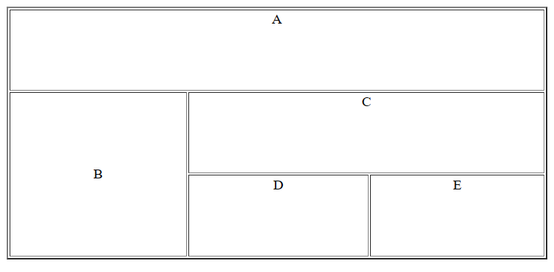

1. Create a registration form and generate the following output.

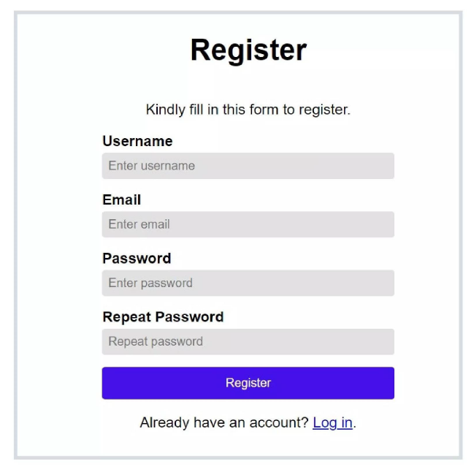

Code: File: form.html

<!DOCTYPE html>

<html lang="en">

<head>

    <meta charset="UTF-8">

    <meta http-equiv="X-UA-Compatible" content="IE=edge">

    <meta name="viewport" content="width=device-width, initial-scale=1.0">

    <title>Registration</title>

    <link rel="stylesheet" href="style.css">

    <link rel="icon" href="favicon.ico">

    <link href="https://fonts.googleapis.com/css2?family=Kanit&display=swap" rel="stylesheet">

    <link rel="stylesheet" href= "https://cdnjs.cloudflare.com/ajax/libs/font-awesome/6.1.2/css/all.min.css"/>

</head>

<body>

    <div class="containerB">

        <!-- <h1>REGISTER</h1> -->

        <div  class="photo">

          <div class="glow-wrap">

            <img src="SS.png" />

            <i class="glow"></i>

          </div>

        </div>

        <br>

        <div class="box">

            <p id="kind">Kindly fill in this form to register</p>

        </div>

        <div class="user_box">

           <label for="username">Username

            <input type="text" id="username" required placeholder="Enter username">

           </label>

        </div>

        <div class="user_box">

            <label for="email">Email

                <input type="email" id="email" placeholder="Enter Email">

            </label>

        </div>

        <div class="user_box">

            <label for="pwd">Password

                <input type="password" id="pwd" placeholder="Enter Password">

            </label>

        </div>

        <div class="user_box">

            <label for="rpwd">Repeat Password

                <input type="password" id="rpwd" placeholder="Repeat password">

            </label>

        </div>

         <button class="btn-hover color-3">Register</button>

        <div class="sign_in">Already have an account? <a href="#">&nbsp;Log in</a>&nbsp;<i class="fa-brands fa-google"></i></div>

    </div>

</body>

</html>

File: style.css

*{

*margin*: 0;

*padding*: 0;

*box-sizing*: border-box;

*font-family*: 'Kanit', sans-serif;

}

@import url('https://fonts.googleapis.com/css2?family=Montserrat:wght@500&display=swap');

@import url('https://fonts.googleapis.com/css2?family=Raleway:wght@500&display=swap');

@font-face {

*font-family*: Ethnocentric;

*src*: url(*ethnocentric* *rg.otf*);

}

body{

*display*: flex;

*justify-content*: center;

}

.containerB{

*display*: flex;

*flex-direction*: column;

*align-items*: center;

*justify-content*: center;

*background-color*: white;

*color*: rgb(61, 59, 59);

*font-family*: Helvetica, Arial;

*font-size*: 1.15vw;

*width*: 60vw;

*height*: 90vh;

*margin*: 30px;

*padding*: 30px;

*box-shadow*: 0 4px 8px 0 rgb(173 202 230), 0 6px 20px 0 rgb(173 202 230);

*border-radius*: 15px;

*box-sizing*: border-box;

*overflow*: hidden;

}

.containerB h1{

*font-family*: Ethnocentric;

*font-size*: 4vw;

*text-align*: center;

*color*: black;

}

#kind{

*font-size*: 1.2vw;

}

.Name{

*display*: flex;

*flex-direction*: row;

*padding-left*: 30px;

*padding-top*: 20px;

*width*: 80%;

*height*: 19%;

*justify-content*: space-around;

}

.Name input{

    /* text-align: center; */

*padding-left*: 10px;

*border-radius*: 5px;

*border*: 0;

*background-color*: rgb(244, 244, 244);

*height*: 5.9vh;

*width*: 18vw;

*accent-color*: #0066ff;

}

.Name label{

*display*: flex;

*flex-direction*: column;

*height*: 100%;

*width*: 40%;

*justify-content*: center;

*font-size*: 1.2vw;

*line-height*: 30px;

}

.user_box input{

*border-radius*: 5px;

*border*: 0;

*background-color*: rgb(229, 228, 228);

*height*: 5.9vh;

*width*: 39vw;

*accent-color*: #0066ff;

*padding-left*: 10px;

}

input:hover{

*border*: 1.4px solid #0066ff;

}

.user_box{

*display*: flex;

*flex-direction*: row;

*justify-content*: space-around;

*height*: 17%;

*width*: 80%;

}

.user_box label{

*display*: flex;

*flex-direction*: column;

*height*: 100%;

*width*: 80%;

*justify-content*: center;

*font-size*: 1.2vw;

*line-height*: 30px;

}

.btn{

*background-color*:rgb(131, 22, 233);

*color*: white;

*border*: 0;

*border-radius*: 5px;

*height*: 6vh;

*width*: 39vw;

*cursor*: pointer;

*margin*: 10px auto;

*transform*: translate(20px, 10px);

}

.btn:hover{

*box-shadow*: 0 0 5px blueviolet,0 0 15px blueviolet;

}

.term{

*display*: flex;

*flex-direction*: row;

*align-items*: center;

*height*: 4vh;

*width*: 55vw;

*justify-content*: center;

*transform*: translate(5px,10px);

}

a{

*color*: #0099ff;

*text-decoration*: none;

}

.sign_in{

*display*: flex;

*text-align*: center;

*align-items*: center;

*justify-content*: center;

*transform*: translateY(15px);

*font-size*: 1.05vw;

}

.sign_in a:hover{

*color*: #ea4335;

}

.fa-google{

*background*: conic-gradient(from -45deg, #ea4335 110deg, #4285f4 90deg 180deg, #34a853 180deg 270deg, #fbbc05 270deg) 73% 55%/150% 150% no-repeat;

*-webkit-background-clip*: text;

*background-clip*: text;

*color*: transparent;

*-webkit-text-fill-color*: transparent;

}

.photo{

*display*: block;

  }

  .photo img{

*width*: 300px;

*height*: 52px;

*object-fit*:fill;

    /* filter: grayscale(100%) contrast(120%); */

*display*: block;

  }

  .photo .glow-wrap{

    /* visibility: hidden; */

*overflow*: hidden;

    /* position: absolute; */

*width*: 100%;

*height*: 100%;

*top*: 0;

  }

  .photo .glow{

*display*: block;

  /* position: absolute; */

*width*: 10%;

*height*: 910%;

*background*: white;

*top*: 0;

*filter*: blur(7px);

*transform*: rotate(45deg) translate(-1883%, -986px);

  /* transition: all .5s cubic-bezier(0.645, 0.045, 0.355, 1); */

  }

  .photo:hover .glow{

*transform*: rotate(45deg) translate(290%, 0);

*transition*: all 0.6s cubic-bezier(0.645, 0.045, 0.355, 1);

  }

  .photo:hover .glow-wrap{

*margin-top*: 0;

 }

.buttons {

*margin*: 10%;

*text-align*: center;

    /* letter-spacing: 4px; */

}

.btn-hover {

*width*: 300px;

*font-size*: 16px;

*font-weight*: 600;

*color*: #fff;

*cursor*: pointer;

*margin*: 20px;

*height*: 55px;

*text-align*:center;

*border*: none;

*background-size*: 300% 100%;

*border-radius*: 50px;

*transition*: all .4s ease-in-out;

*-o-transition*: all .4s ease-in-out;

*-webkit-transition*: all .4s ease-in-out;

*transition*: all .4s ease-in-out;

}

.btn-hover.color-3 {

*background-image*: linear-gradient(to right, #667eea, #764ba2, #6B8DD6, #8E37D7);

*box-shadow*: 0 4px 15px 0 rgba(116, 79, 168, 0.75);

}

.btn-hover:focus {

*outline*: none;

}

.btn-hover:hover {

*background-position*: 100% 0;

*transition*: all .4s ease-in-out;

*-o-transition*: all .4s ease-in-out;

*-webkit-transition*: all .4s ease-in-out;

*transition*: all .4s ease-in-out;

}

Screenshot:

