#### Theory

1. What are the six principles of DevOps? Please describe each of them briefly.

* Continuous updates
* Automate everything
* Fully responsible teams, selvstendige teams
* End to end responsibility
* Brukerene I focus, feedback and improvements
* fokus på endproduktet

1. In your own words describe what continuous integration is.

Det er å automatisere testing og merging av de forskjellige commitsa fra forskjellige utviklere og ledd.

Og hvor dette gjøres oftere slik prosjektet beveger seg i en mer sømløs metode.

1. What is the difference between DevOps and Agile teams?

Dev ops er mer bredt enn det agilie teams er, I den forstand at devops også inkluderer ops I prosessen.

1. What is project automation?

Project automation er å automatisere ting om kan automatiseres og er gjort flere ganger. Hvor der er tid som er vesentlig nokk til at det ville være nytte av å invistere tid i å lage oppsettet til automatiskeringen.

1. List three tools that you can use for project automation.

* Grunt
* Gulp
* Webpack

**Case Study**

Your company has just implemented DevOps and has tasked you to set up the process with the development team and the operations teams. You have been asked to create a mobile application which records a person giving a speech. This should convert the speech to text and then upload it to a website.

#### Questions

1. Draw up your own process flow of the DevOps cycle which will be used in your company. Remember to include all the steps as well as the tools you will use.

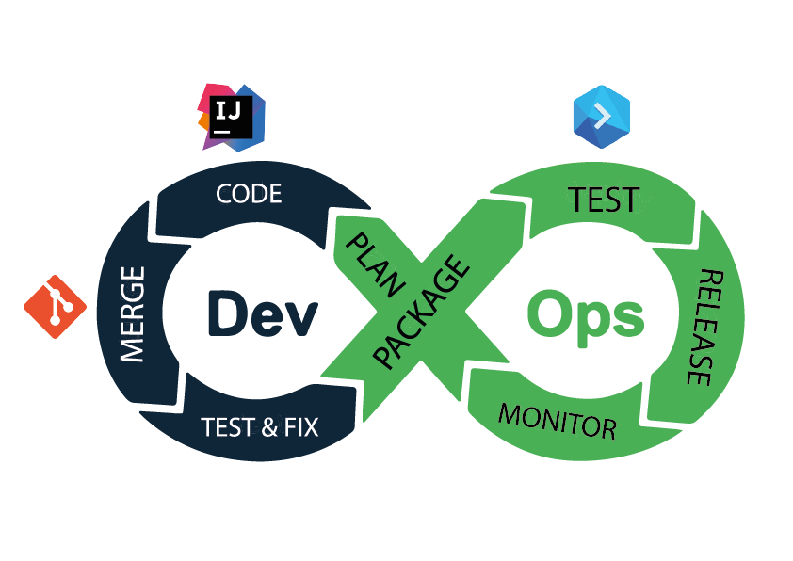

Plan => code => merge => test, (fix) => package => test => release & deploy => monitor

intellij, git, buddy

1. Discuss 2 of these tools which you would use.

* I would use intellij as my idea where it has most the tools I would need, server integration git integration, linters, filewatchers, packagemanagers and so on.
* I would use git to work co-operative with other co-workers, and a form for version control to make devOps work like it should where ppl can work on separate stuff and merge in to master when stuff is done.
* Ville brukt buddy som er en unittester og minotoring som vil gjøre at jeg kunne automatisere mye av feilsøking og testing, samt den kan settes opp til continous deployment eller continious integration. Men hvor jeg ville gått for integration.

<https://github.com/Zettrex/FEU2-Workflow-CA>