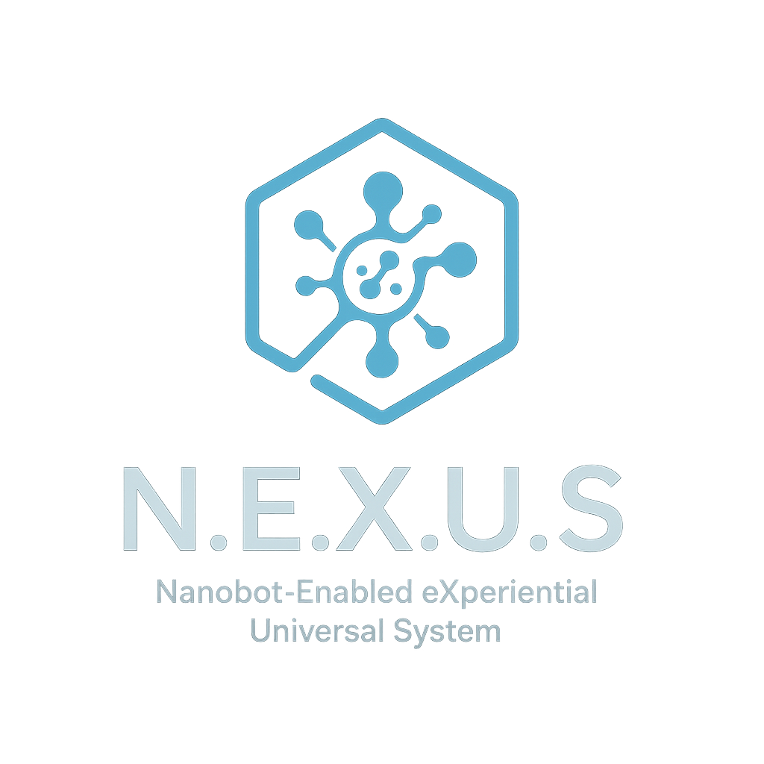

Project N.E.X.U.S.

## Nanobot-Enabled eXperiential Universal System

“A new frontier in human evolution — where technology serves consciousness, not the other way around.”

Prepared by: Joshua Robert Matney  
Founder & Visionary Architect

Email: joshuarmatney@gmail.com

Date: August 1, 2025

© 2025 Joshua Robert Matney. All rights reserved.  
This document and its contents are protected under applicable intellectual property laws. No reproduction, distribution, or use is permitted without express written consent from the creator, except under approved collaboration agreements or licensing terms.

🧠 Project N.E.X.U.S. – Nanobot-Enabled eXperiential Universal System  
  
VISION  
N.E.X.U.S. is a human-centered, AI-integrated nanotechnology framework designed to enhance health, cognition, and perception without compromising free will, individuality, or consciousness.  
  
SYSTEM ARCHITECTURE  
1. Nanobot Layer – internal hardware for health monitoring and neural interfacing  
2. Neural Interface Layer – secure BCI for brain-data translation  
3. AI Layer – adaptive, personalized assistant  
4. User Experience Layer – augmented perception, overlays, regulation tools  
5. Ethics & Security Layer – autonomy-first, transparent, user-controlled  
  
USE CASES  
- Mental health support  
- Cognitive enhancement  
- Medical monitoring  
- Sensory augmentation  
- Consciousness exploration  
  
DOCUMENTS  
- White Paper (conceptual + ethical framework)  
- README (summary + collaboration info)  
- Collaboration Agreement (IP, ethics, NDA)  
- System Diagram (5-layer layout)  
- Logo Design (uploaded)  
- Patent + publication goals  
  
CONTACT  
Joshua Robert Matney  
Email: joshuarmatney@gmail.com  
Date: August 1, 2025  
  
LOGO USE  
Used on cover, footer, and README for identity consistency.