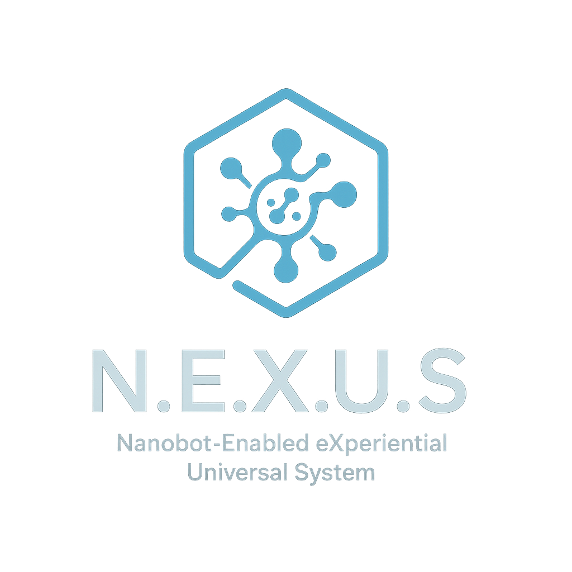

N.E.X.U.S. Project Documentation

Nanobot-Enabled eXperiential Universal System

Project Owner: Joshua Robert Matney

Email: joshuarmatney@gmail.com

© 2025 Joshua Robert Matney. All rights reserved.

# Project Summary

N.E.X.U.S. (Nanobot-Enabled eXperiential Universal System) is a visionary integration of ethical artificial intelligence, neural interfaces, and nanobot technologies to enhance human health, cognition, and autonomy. The project includes advanced features such as real-time neural feedback, an intuitive UI, adaptive AI responses, privacy-first architecture, and nanobot-assisted physiological regulation. It is rooted in ethical design principles to ensure safety, transparency, and user consent.

# White Paper

See full white paper included in prior content dump. (Full content can be inserted here manually or attached externally if too long)

# Component Breakdown

1. User Interface Layer: AR/VR + BCI control for intuitive engagement.  
2. Neural Interpretation Module: Brainwave decoding to understand user intent.  
3. AI Ethical Core: Decision-making aligned with consent, emotion, and context.  
4. Nanobot Swarm: In-body programmable network for real-time body regulation.  
5. Privacy Layer: Zero-knowledge proofs, encrypted identity, and user-overridden permissions.  
6. Learning Module: Evolves with user needs over time through feedback loops.

# System Diagram

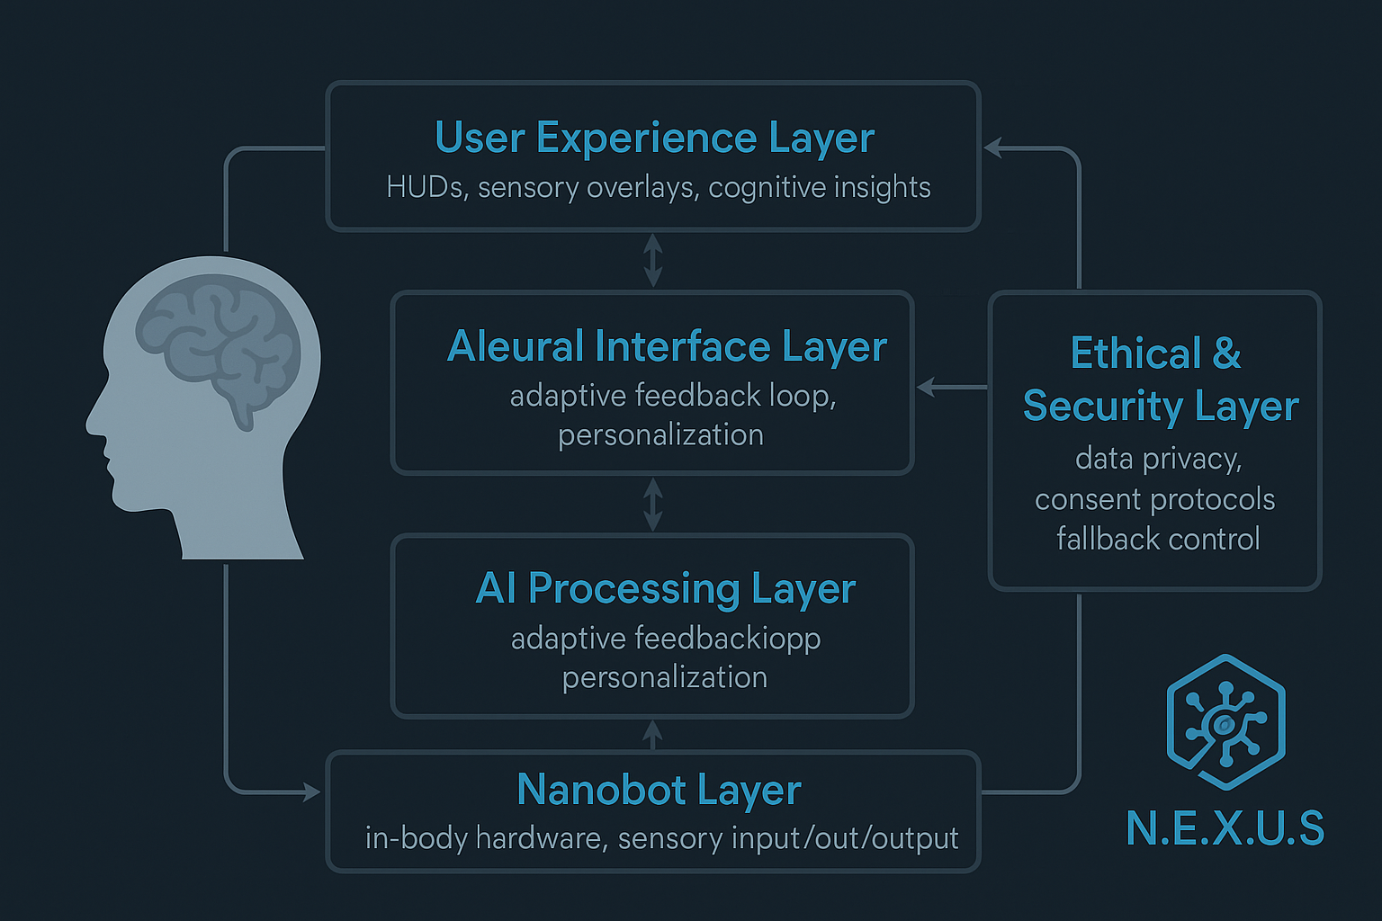

# Augmented Human Bill of Rights (Draft)

1. Right to Neural Privacy: No external entity may read, manipulate, or store neural data without explicit and revocable consent.  
2. Right to Full Autonomy: Augmentation must never override user will.  
3. Right to System Transparency: All AI decisions must be explainable.  
4. Right to Consent-Based Modification: No system updates without permission.  
5. Right to Emergency Shutdown: Users retain final control.

# Prototype Planning + Build Notes

- Mockup in progress with layered UX, AI, and nanobot architecture.  
- Code for nanobot console and adaptive UI to be modular.  
- Collaboration invites to ethical tech and bioengineering communities.