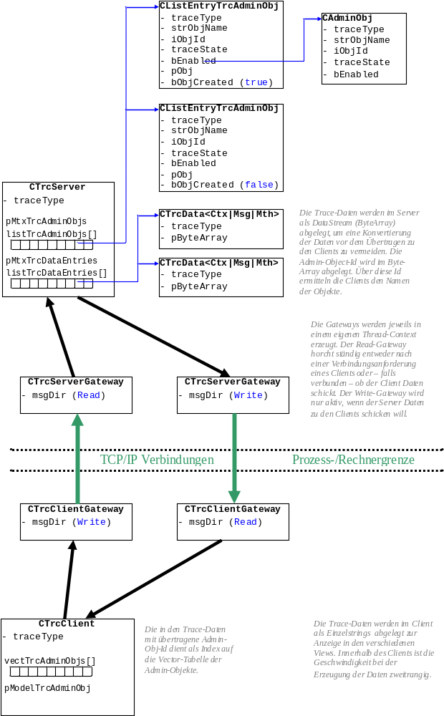

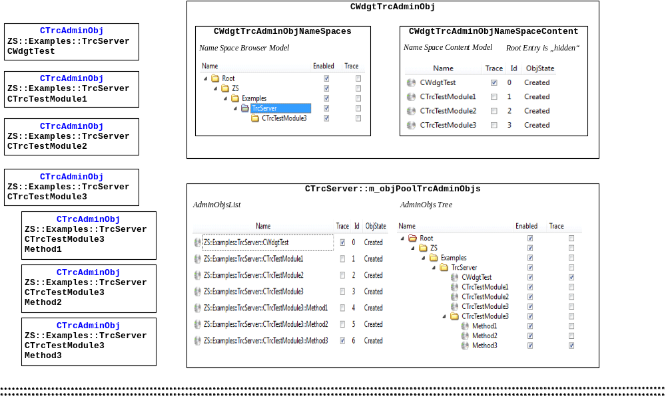

WdgtNameSpaceContent::TableView::mouseReleaseEvent(ZS::Examples::TrcServer,CTrcTestModule3,State=On)
----------------------------------------------------------------------------------------------------
WdgtNameSpaceContent::ObjPool::setData(ZS::Examples::TrcServer,CTrcTestModule3,State=On)
Emit dataChanged
Emit objectChanged
WdgtObjPool::objectChanged(ZS::Examples::TrcServer,CTrcTestModule3,State=On)
TrcServer::ObjPool::updateObj(ZS::Examples::TrcServer,CTrcTestModule3,State=On)
TrcServer::ObjPool::updateListEntry(ZS::Examples::TrcServer,CTrcTestModule3,State=On)
Emit objectChanged
TrcServer::adminObjectChanged(ZS::Examples::TrcServer,CTrcTestModule3,State=On)
TrcAdminObj::setState(State=On)
WdgtObjPool::objectChanged(ZS::Examples::TrcServer,CTrcTestModule3,State=On)
WdgtNameSpaceContent::ObjPool::updateObj(ZS::Examples::TrcServer,CTrcTestModule3,State=On)
WdgtNameSpaceContent::ObjPool::updateListEntry(ZS::Examples::TrcServer,CTrcTestModule3,State=On)
No data changed
WdgtNameSpaceContent::ObjPool::updateTreeEntry(ZS::Examples::TrcServer,CTrcTestModule3,State=On)
No data changed
TrcServer::ObjPool::updateTreeEntry(ZS::Examples::TrcServer,CTrcTestModule3,State=On)
Emit dataChanged

WdgtNameSpaces::TreeView::mouseReleaseEvent(ZS::Examples,TrcServer,State=Off)
----------------------------------------------------------------------------------------------------
Emit nameSpaceChanging
WdgtObjPool::nameSpaceChanging(ZS::Examples,TrcServer,State=Off,Recursive=true)
// First step: set the "inProcess" flag
EntryChangingInProcess=true
// Second step: update the model (and list) within the object pool
TrcServer::ObjPool::updateNameSpace(ZS::Examples,TrcServer,State=Off,Recursive=true)
TrcServer::ObjPool::updateTreeEntry(ZS::Examples,TrcServer,State=Off,Recursive=true)
Emit dataChanged
Emit nameSpaceChanged
WdgtObjPool::nameSpaceChanged(ZS::Examples,TrcServer,State=Off,Recursive=true)
EntryChangingInProcess
TrcServer::ObjPool::updateListEntry(ZS::Examples::TrcServer,CWdgtTest,State=Off)
Emit objectChanged
TrcServer::adminObjectChanged(ZS::Examples::TrcServer,CWdgtTest,State=Off)
TrcAdminObj::setState(State=Off)
WdgtObjPool::objectChanged(ZS::Examples::TrcServer,CWdgtTest,State=Off)
EntryChangingInProcess
TrcServer::ObjPool::updateListEntry(ZS::Examples::TrcServer,CTrcTestModule1,State=Off)
Emit objectChanged
TrcServer::adminObjectChanged(ZS::Examples::TrcServer,CTrcTestModule1,State=Off)
TrcAdminObj::setState(State=Off)
WdgtObjPool::objectChanged(ZS::Examples::TrcServer,CTrcTestModule1,State=Off)
EntryChangingInProcess
TrcServer::ObjPool::updateListEntry(ZS::Examples::TrcServer,CTrcTestModule2,State=Off)
Emit objectChanged
TrcServer::adminObjectChanged(ZS::Examples::TrcServer,CTrcTestModule2,State=Off)
TrcAdminObj::setState(State=Off)
WdgtObjPool::objectChanged(ZS::Examples::TrcServer,CTrcTestModule2,State=Off)
EntryChangingInProcess
TrcServer::ObjPool::updateListEntry(ZS::Examples::TrcServer,CTrcTestModule3,State=Off)
Emit objectChanged
TrcServer::adminObjectChanged(ZS::Examples::TrcServer,CTrcTestModule3,State=Off)
TrcAdminObj::setState(State=Off)
WdgtObjPool::objectChanged(ZS::Examples::TrcServer,CTrcTestModule3,State=Off)
EntryChangingInProcess
TrcServer::ObjPool::updateTreeEntry(ZS::Examples::TrcServer,CTrcTestModule3,State=Off,Recursive=true)
Emit dataChanged
Emit nameSpaceChanged
WdgtObjPool::nameSpaceChanged(ZS::Examples,TrcServer,State=Off,Recursive=true)
EntryChangingInProcess
TrcServer::ObjPool::updateListEntry(ZS::Examples::TrcServer::CTrcTestModule3,Method1,State=Off)
Emit objectChanged
TrcServer::adminObjectChanged(ZS::Examples::TrcServer::CTrcTestModule3,Method1,State=Off)
TrcAdminObj::setState(State=Off)
WdgtObjPool::objectChanged(ZS::Examples::TrcServer::CTrcTestModule3,Method1,State=Off)
EntryChangingInProcess
TrcServer::ObjPool::updateListEntry(ZS::Examples::TrcServer::CTrcTestModule3,Method2,State=Off)
Emit objectChanged
TrcServer::adminObjectChanged(ZS::Examples::TrcServer::CTrcTestModule3,Method2,State=Off)
TrcAdminObj::setState(State=Off)
WdgtObjPool::objectChanged(ZS::Examples::TrcServer::CTrcTestModule3,Method2,State=Off)
EntryChangingInProcess
TrcServer::ObjPool::updateListEntry(ZS::Examples::TrcServer::CTrcTestModule3,Method3,State=Off)
Emit objectChanged
TrcServer::adminObjectChanged(ZS::Examples::TrcServer::CTrcTestModule3,Method3,State=Off)
TrcAdminObj::setState(State=Off)
WdgtObjPool::objectChanged(ZS::Examples::TrcServer::CTrcTestModule3,Method3,State=Off)
EntryChangingInProcess
// Third step: update the model within the name space content widget
WdgtNameSpaceContent::ObjPool::updateObj(ZS::Examples::TrcServer,CWdgtTest,State=Off)
WdgtNameSpaceContent::ObjPool::updateListEntry(ZS::Examples::TrcServer,CWdgtTest,State=Off)
Emit objectChanged
WdgtObjPool::objectChanged(ZS::Examples::TrcServer,CWdgtTest,State=Off)
EntryChangingInProcess
WdgtNameSpaceContent::ObjPool::updateTreeEntry(ZS::Examples::TrcServer,CWdgtTest,State=Off)
Emit dataChanged
WdgtNameSpaceContent::ObjPool::updateObj(ZS::Examples::TrcServer,CTrcTestModule1,State=Off)
WdgtNameSpaceContent::ObjPool::updateListEntry(ZS::Examples::TrcServer,CTrcTestModule1,State=Off)
Emit objectChanged
WdgtObjPool::objectChanged(ZS::Examples::TrcServer, CTrcTestModule1,State=Off)
EntryChangingInProcess
WdgtNameSpaceContent::ObjPool::updateTreeEntry(ZS::Examples::TrcServer, CTrcTestModule1,State=Off)
Emit dataChanged
WdgtNameSpaceContent::ObjPool::updateObj(ZS::Examples::TrcServer,CTrcTestModule2,State=Off)
WdgtNameSpaceContent::ObjPool::updateListEntry(ZS::Examples::TrcServer,CTrcTestModule2,State=Off)
Emit objectChanged
WdgtObjPool::objectChanged(ZS::Examples::TrcServer, CTrcTestModule2,State=Off)
EntryChangingInProcess
WdgtNameSpaceContent::ObjPool::updateTreeEntry(ZS::Examples::TrcServer,CTrcTestModule2,State=Off)
Emit dataChanged
WdgtNameSpaceContent::ObjPool::updateObj(ZS::Examples::TrcServer,CTrcTestModule3,State=Off)
WdgtNameSpaceContent::ObjPool::updateListEntry(ZS::Examples::TrcServer,CTrcTestModule3,State=Off)
Emit objectChanged
WdgtObjPool::objectChanged(ZS::Examples::TrcServer, CTrcTestModule3,State=Off)
EntryChangingInProcess
WdgtNameSpaceContent::ObjPool::updateTreeEntry(ZS::Examples::TrcServer,CTrcTestModule3,State=Off)
Emit dataChanged
// Fourth step: update the model within the name space browser widget
WdgtNameSpaces::ObjPool::updateNameSpace(ZS::Examples,TrcServer,State=Off)
WdgtNameSpaces::ObjPool::updateTreeEntry(ZS::Examples,TrcServer,State=Off)
Emit dataChanged
Emit nameSpaceChanged
WdgtObjPool::nameSpaceChanged(ZS::Examples,TrcServer,State=Off)
EntryChangingInProcess
WdgtNameSpaceContent::ObjPool::updateTreeEntry(ZS::Examples::TrcServer,CTrcTestModule3,State=Off)
Emit dataChanged
Emit nameSpaceChanged
WdgtObjPool::nameSpaceChanged(ZS::Examples,TrcServer,State=Off)
EntryChangingInProcess
// Fifth step: reset the "inProcess" flag
EntryChangingInProcess=false

