

Geschäftsbereich / Division
Überwachungs- und Ortungstechnik /
Radio monitoring and Radiolocation
Software Design Description (SDD)
This document and all parts thereof are protected by copyright and may not be used without the permission of Rohde & Schwarz. This especially applies to reproduction, translation and the transfer of contents to microfilm as well as storage and processing in electronic systems.
Copyright © All rights reserved by Rohde & Schwarz GmbH & Co. KG.
Analysis Center - GSA


Contents
1 Introduction 3
1.1 Scope of Application 3
1.2 Document Overview 3
1.3 Abbreviations and Definitions 3
1.4 Naming conventions 3
1.5 Revision List 3
1.6 References 3
2 System Design 4
3 Behavioral Concepts 7
3.1 Asynchronous Requests 7
3.1.1 Executing Asynchronous Requests 7
3.1.2 Implementing Classes Providing Asynchronous Requests 10
3.2 System Startup 10
3.3 System Shutdown 11
4 Class Model 12

Introduction

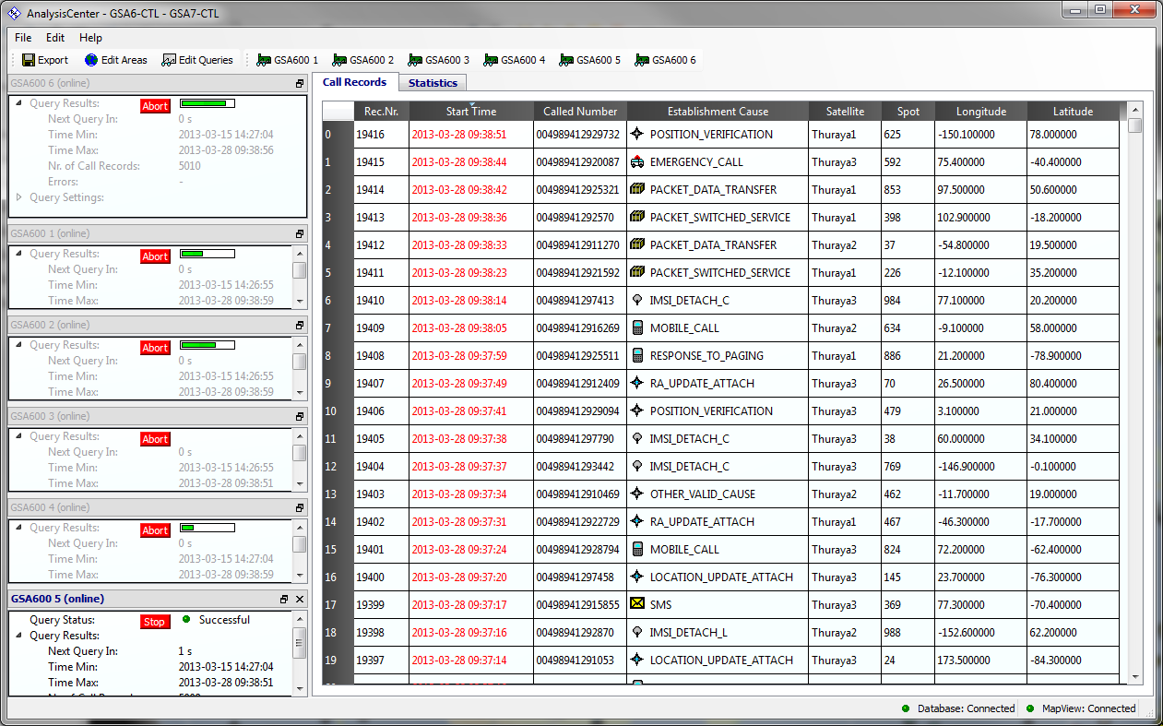

Scope of Application
This document is the software design description (SDD) of the application “AnalysisCenter-GSA”. The purpose of the SDD is to describe the software architecture of the application.

Document Overview
After a rough overview of the packages belonging to the application the behavioural concepts to frequently used and/or important tasks are explained. Studying those concepts and sequences you should get familiar with the classes and their relationships building up the application. After the description of the sequences UML class models and class specifications complete the system design description.

Abbreviations and Definitions
Abbreviation/term | Description

Naming conventions
Most of the naming is based on the R&S coding rules according to standard TVR264 and Hungarian notation is used wherever appropriate.

Slot methods are named like “on<ObjectName><SignalName>” where “<ObjectName>” and “<SignalName>” may be shortened or omitted if appropriate. E.g. the application’s slot method connected to the signal “destroyed” of the object “DlgProgressBar” is named “onDlgProgressBarDestroyed” whereas the application’s slot method connected to the signal “connected” fo the object “MapViewConnector” is named “onMapViewConnected”.

Revision List
Version | Date | Author | Comments
01.00 | 2013.03.13 | Christian Bauer

References
ID | Title | Version | Date

System Design
Classes and modules are organized in packages. Each package may be divided in further sub packages. The modules and classes of a package are summarized in source directories with the same name as the package. C++ source and header files are separated into the directories “Include” and “Source”.

All modules belonging to the GSA6 control application are named starting with the prefix “ACGSA”. This is useful to distinguish several modules within different applications (each ISAR application may define modules named “App”, “MainWindow”, “CentralWidget” or so. All classes, structures, functions and data types are implemented within the namespace AC::GSA.

The following figure illustrates the packages and their dependencies.

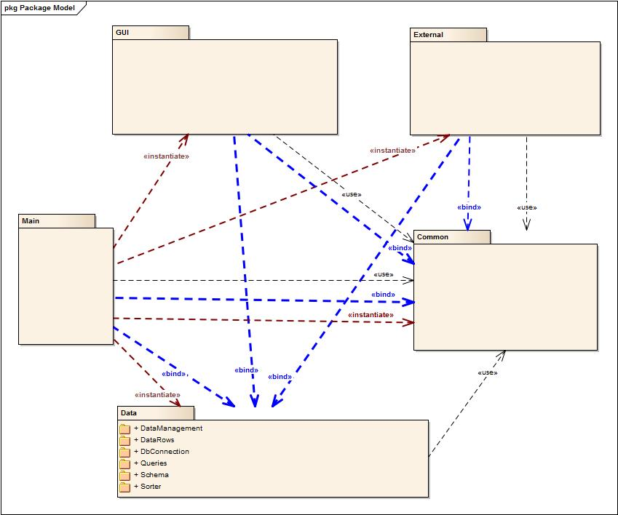

Package | Subpackage | Usage
Main |  | Here you find the main class controlling the creation of objects depending on the program flow and user interactions. The “main controller” is also responsible for system startup and system shutdown. Classes (there is just one) within this package can also be considered as belonging to the “application layer”.
Common |  | This is a collection of commonly used auxiliary classes and may be considered as an application specific library. All other packages may use the auxiliary classes and methods defined in this package. Also the application’s settings class is implemented in this package. Other packages may bind slots to signals of the settings class to get informed of any configuration changes during runtime.
Data |  | Modules and classes within this package are summarizing the data model of the application. This data model is designed as an offline data cache as a collection of data tables. Data tables themselves are a collection of data rows. The data tables may be filled with data (data rows) from the database using select queries. Data rows modified by the user in the data tables will be saved in the database using modify queries. All classes within the data package do not directly reference any classes in the GUI, External or Main package (all classes within the data package can be compiled without including any header file from the GUI, External or Main package). But the classes provide a lot of Qt signals to which observers (like objects in the GUI or External packages) may connect to.  What’s missing are packages named “DataColumns” and “DataRelations” encapsulating the schema definition of a database (data types, ranges, keys, constraints, parent/child relations, etc.).
 | Schema | Within this package the schema of the used database data tables is defined providing methods to convert table and column ids into strings and vice versa. Also a schema model class is defined which will be filled during system startup providing information about existing data tables and columns in the database.
 | DataManagement | A better name for this package would have been “DataTables”. But for historical reasons the package name “DataManagement” has been kept. Also the “DataSet” module as a collection of all instantiated data tables is found within this package.
 | DataRows | A data table is a collection of data rows. Data rows may be added, deleted and modified during runtime and the changes made in the offline data cache must be adjusted with the database when appropriate.
 | Sorter | This package contains a helper class to sort the data rows within a data table according to the content of data columns.
 | Queries | Queries can be considered as command objects. Information will be set at creation time and the query objects will be transferred to the database gateway object to be executed at a suitable time. While executed a result data set may be stored within the query object and sent back as an answer to the sender of the query.
 | DbConnection | The singleton database connection class encapsulates the functionality necessary to connect with the Oracle SQL database. The database connection object receives queries as command objects and executes the queries in the context of a database gateway thread. This way querying a huge result set does not block the applications main thread and it is possible to provide and process intermediate results. Several queries may be executed in parallel. For each of them an own gateway thread is created and administered by the database connection instance.
External |  | Here modules and classes are found linking the data to external applications. This time only classes to render data from the area data table and session data tables on map view can be found. The external layer objects bind slot methods to signals of the data objects to get informed about changes to data rows within data tables. External objects are also getting events from the external application and may therefore themselves modify data within the offline data cache.
GUI |  | In the GUI package modules and classes are summarized building up the user interface of the application. The GUI layer objects bind slot methods to signals of the data objects to get informed about changes to data rows within data tables. GUI objects are receiving user events and may therefore themselves modify data within the offline data cache or may receive triggers for executing methods (e.g. saving modified data and so on). GUI objects may also trigger the main controller to execute some tasks (e.g. shutdown).

Development Environment

To build the application a visual studio project is used. The application is implemented as a plugin to the ISAR framework. The following indicates the ISAR projects (ISAR-Dlls) the AnalysisCenter-GSA depends on:

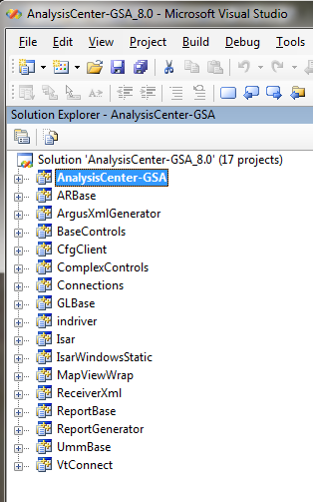

To setup the build environment several tools have to be installed correctly. Which version of those tools have to be installed depend on the development branch of ISAR. The following table shows some important tools and their versions needed in development branch 5.6 of ISAR.

Boost | Version 1.47.0
Corba | Omni Version 4.1.4
Qt | Version 4.7.0 with libinfix Isar built with VS 2005
Python | Version 2.5

Installing the tools requires setting some environment variables correspondingly (e.g. PATH, QTDIR, etc.). Also the environment variable “OutputDir” must be defined.

As this document should describe the software design of the analysis center and not how to setup an environment for building ISAR plugins please refer to the corresponding manuals as provided by the ISAR development team.

To start the analysis center from within the visual studio project the following settings may be used (OutputDir was set to “C:\RSOutputDir\AC-GSA-Qt4.7.0-vs2005-Isar”):

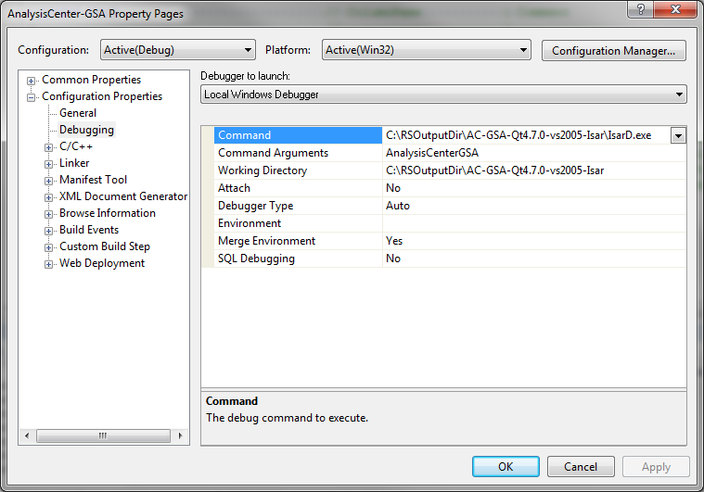

Basic Concepts

Design Patterns
The design of the Analysis Center classes is object oriented and therefore several patterns are used throughout the whole application. Most of the patterns are more or less modified (e.g. the command pattern as used for database SQL queries).

Just for the sake of clarification some notes are given on two important patterns and how they are used in the application modules.

Observer Pattern
In contrary to the original Analysis Center (COBAnalyzer) the observer pattern is completely realized by signals and slots provided by Qt objects. The “ObjectOrientedObserver” classes have been removed.

Model View Controller Pattern
This pattern is used in several layers. The overall system design could be considered as follows:

Model
Oracle Database
Controller
Analysis
Center
View
GUI Controls
(Pie Charts, TableView, LineEdits, ComboBoxes, etc.)
MapView
MapViewOverlays
MapViewConnection

The Model of the overall system is the database. The view and the controller objects onto the data within the database are implemented in the classes of the AnalysisCenter application. The classes and objects within the AnalysisCenter application cannot be uniquely assigned to the View or to the Controller layer. E.g. if you just consider the ComboBox class of Qt. This class is a viewer onto the items in the pull down list, a controller to select an item and a model as a data container for the items.

And the AnalysisCenter itself uses a data model which is implemented in subsystem data:

Model
Controller
Analysis
Center
View
GUI Controls
(Pie Charts, TableView, LineEdits, ComboBoxes, etc.)
MapView
MapViewOverlays
MapViewConnection
Subsystem Data
(DataSet, DataTables, DataRows, etc.)

State Machines and Asynchronous Requests
Some methods trigger asynchronous requests (like querying data from a database). Executing requests asynchronously means that the response to a request is received sometimes later by a callback or response message and that the execution of the application code is not blocked while the application is waiting for the callback or response message.

Most of the state machines are realized using an instance member for the current state (“m_state”) and an instance member for the currently executed request (“m_pReqItemInProgress”). Each request may be assembled by several sub requests and sub requests may also be assembled by other sub requests and so on. If a request is in progress the instance is “busy”. In busy state instances may not be able to immediately execute further requests but may have to postpone those requests. In this case the requests will be queued in a list of postponed requests. After the current request has been executed the first entry in the list of postponed requests will be executed.

As the GSA6 control application communicates with external applications and with a SQL database asynchronous requests are a common use case within the application. On executing asynchronous requests the following demands have to be met:

- Executing an asynchronous request should not block the main thread.
- For long duration requests it should be possible to report intermediate results.
- For long duration requests it should be possible to indicate a progress bar (or progress dialog with additional information).
- It should also be possible to abort requests (the user may start requests which take too much time as e.g. he forgot to set an appropriate filter for querying data from the database).
- While an instance is busy (executing the request) other objects may still request the instance to execute other jobs. But depending on the requested job and the current internal state of the instance:
  - It should be possible to postpone the new requests and execute them after the current request has been finished.
  - Abort the current request in progress and execute the new request immediately.
  - Refuse the new request with an error message or just simply ignore the new request.
- It should be possible to split an asynchronous request into several asynchronous sub requests. E.g. the application startup request includes the sub requests querying permissions, connecting with the database, reading the schema from the database and read some system data tables. The sub request of reading some system data tables again consists of several sub requests as reading each data table is an asynchronous request which has to be executed one after another.

State A
State B
Request_1
Execute(Request_1)
Waiting for Request 1_1 to be finished
request_1_1_Executed
executeRequest_1_2
Waiting for Request 1_2 to be finished
request_1_2_Executed
executeRequest_1_2
Waiting for Requests 1_3_1, 1_3_2 and 1_3_3 to be finished
request_1_3_1_Executed
request_1_3_2_Executed
request_1_3_3_Executed
Request_2
Postpone(Request_2)
executePostponedRequests
State C
Execute(Request_2)
executeRequest_1_1

Reentries

On emitting a signal a slot method of another class is called. This slot method may again call a method of the instance just emitting the signal. This is called a reentry into the signal emitting class.

The possibility of reentries has to be taken into account on designing asynchronous request classes. In general it is good practice to keep the signal emitting instance in a busy state and postpone the reentry method.

On emitting a signal the signal receiving class may also want to delete or shutdown the signal emitting instance immediately (synchronously). In this case this reentry request must not be postponed even if the instance is in a busy state.

On executing the reentry immediately you have to consider that further signals may be emitted leading to further reentries and so on. This may deadlock the application because of stack overflows or that instance A is waiting for instance B to execute a request while instance B is waiting for instance A to execute a request – and both instances will wait forever.

Providing data

If data should be queried from an external data source this data must be handed over on emitting the “requestExecuted” signal. To allow a generic signature of the “requestExecuted” signal the data is provided by the means of a void data pointer. The signal emitting object must take care of deleting the data block at a suitable time – in most cases right after the signal has been emitted.

This section describes the basic algorithms how asynchronous requests are handled within the GSA6 control source code modules.

Executing Asynchronous Requests

The following figure shows the basic principle on how asynchronous requests are processed within the GSA6 control application. On starting a new query a new session data table has to be created and will be added to the offline data cache (an instance of class CDMSessions is added to the singleton class CDataSet). To fill the session data table with data from the database a query has to be executed and “execQuery” is applied to the CDMSessions table. The data table forwards this request to the database connector (the singleton instance of class CDbConnector). The database connector needs to forward this request to the database – which is an asynchronous request. If the query has been executed the database connector emits the signal “requestExecuted” whereupon the slot “onDbConnectorRequestExecuted” of the DMSession table instance is invoked copying the result set into the data table’s collection of data rows. If the data tables has been filled the DMSession instance again emits the “requestExecuted” signal whereupon the “onDMSessionsQueryExecuted” slot method of the data set instance is called.

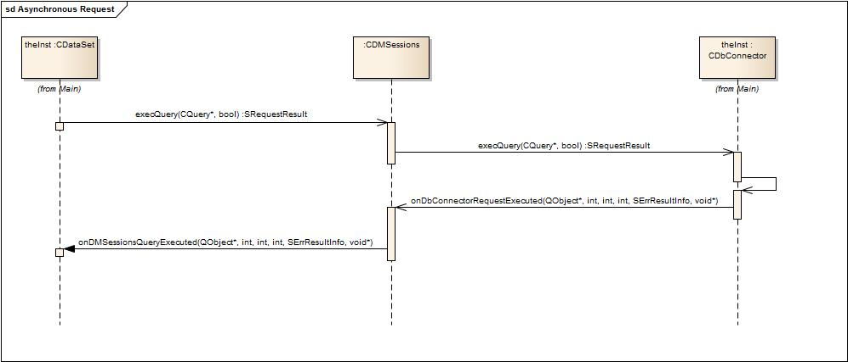

class CRequestItem

To handle the requirements above the return value of a request method as well as the result parameter provided with the “requestExecuted” signal is a pointer to an object of type “CRequestItem”. Please note that request methods may also return a NULL pointer as a result indicating that the method has been executed synchronously with no error. In case the method returns a valid request item object and if method has been executed synchronously (result == Success or result == Error) the caller of the method must delete the request item object.

Protected Instance Members

int m_iLockCount
Range [0..N]
If a child request has been executed completely also the main request may have been finished. In this case the creator of the main request item may delete the main request item. As default on deleting a request item also all child items will be deleted – if the item is not locked. As the child request item is still needed (the “requestExecuted” signal may not have been received yet by all observers of the signal) it must not be deleted together the main request item but has to be deleted after the signal has been emitted. For this the request item has to be locked before and has to be unlocked after emitting the “requestExecuted” signal. After emitting the signal the child request item has to be deleted – if it no longer has a parent item and is not locked anymore (the method “canBeDeleted” checks whether the item may be deleted).

QObject* m_pObjCreator
Range [valid address]
Usually the object executing the request creates the request item object and deletes the item object if the request has been executed completely (by emitting the signal “requestExecuted” with Progress = 100%).

int m_iId
Range [0..N]
This Id was created on calling the request method and was returned to the caller of the request method as the “PendingRequestId”. If the caller of the request method wants to be informed about progress of the request the caller must at least store this Id as the “PendingRequestId”. On receiving the “requestExecuted” signal (if the “on<ObjectName>RequestExecuted” slot method is called) the signal receiver must compare the “RequestId” provided with the signal with the originally stored “PendignRequestId” to decide whether it was “his” request which has been executed. This is important as requests may have been postponed and it may be the request initiated by another object whose execution is signaled. In addition some classes may execute several asynchronous requests at a time (in parallel).

int m_request
Range [<ClassName>::ERequest<RequestName>]
Classes providing asynchronous request define an enumeration specifying the executed request method. E.g. the database connector may execute the requests “Shutdown”, “Connect”, “Disconnect”, “ChangeSettings” and “ExecQuery”.

QString m_strRequest
Range [0..N]
Name of the request item (mainly used for trace and debugging purposes).

QString m_strDscr
Range [0..N]
If the request item should be indicated in a progress dialog a descriptive text may be set.

QString m_strToolTip
Range [0..N]
If the request item should be indicated in a progress dialog a descriptive tool tip may be set.

int m_iProgress_perCEntry
Range [0..100]
Requests which may take a long time may report intermediate results. The progress is indicated by this signal argument.
Please note that the values 0 and 100 are reserved to indicate the start and the end of a request. This way it was not necessary to additionally provide signals like “requestStarted” and “requestFinished”.
Range [0..100]

SErrResultInfo m_errResultInfo
This structure provides information about the success of the executed request. If executing the request failed you should be able to get additional information why the request failed (e.g. the severity of the error). The result may also be set to “RequestAborted” to indicate that the request has not been executed but has been aborted. This way it was not necessary to additionally provide a signal like “requestAborted”.
The following result codes have a particular meaning:
EResultUndefined The result is not yet known (yet undefined). In case this result is returned by a method the method is executed asynchronously providing the final result by means of a callback (slot method) on emitting the “requestExecuted” signal.
EResultSuccessIntermediateResults The request has been partially executed.
EResultSuccess The request has been successfully executed. In case this result is returned by the request method the method has been executed synchronously and the request has been immediately finished. The request item must be deleted by the caller of the request method.
EResult<Error> The request has been executed with an error. In case this result is returned by the request method the method has been executed synchronously and the request has been immediately finished. . The request item must be deleted by the caller of the request method.

void* m_pvData
Range [NULL, pointer to any data block]
Some requests need to provide results which are specific for the executed request. E.g. the result set of an executed query need to be provided to the initiator of the request.

CRequestItem* m_pParent
Range [NULL, pointer to parent request item]

QList<CRequestItem*> m_arpChilds
List of child request items.

Examples and Test Scenarios
Example code has been provided in the “AsynchRequests” project. This example code is available as a standalone application and is also used to test the asynchronous request pattern as described in this document.

If you understand the implementation details within the example code you will also understand most of the code within the GSA6 control application.

The “AsynchrRequests” example application simulates some kind of a radio which is assembled by the following components:

Radio
Power Supply
RF Receiver
RF Tuner
RF Amplifier
Frontpanel
Audio Board

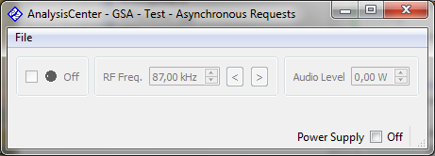

The whole radio is reflected by the singleton class “CApplication”.

The logical layer of the front panel is reflected by the singleton class “CFrontpanel” whereas the GUI layer of the front panel is reflected by the singleton “CMainWindow”. The front panel is the only object providing GUI components to control the radio application.

The RF receiver is reflected by class “CRFReceiver”. The RF receiver is assembled by two sub components which are reflected by classes “CRFAmplifier” and “CRFTuner”.

The audio board is reflected by class “CAudioBoard”.

The power supply is reflected by class “CPowerSupply”.

The front panel, the audio board and the RF receiver are the “radio components”.

The RF amplifier and the RF tuner are the “RF components” of the radio.

Any request in progress can be aborted at any time as the power supply may be switched off at any time (the Power Supply check box may be clicked at any time).

Each component as well as the whole radio (the application) are emitting a “stateChanged” signal providing the current state, the previous state, whether the instance is busy and, if the instance is busy, the estimated time for the busy state. The “stateChanged” signal is also emitted if just the busy state changes and if the previous and current states are still the same.

The radio (the application) is connected to the “requestExecuted” and to the “stateChanged” signals of the frontpanel, the RF receiver, the audio board and the power supply.

The frontpanel, the RF receiver and the audio board are connected to the “stateChanged” signal of the power supply.

The RF receiver is connected to the “stateChanged” and “requestExecuted” signals of the RF amplifier and the RF tuner.

Each request in progress can be aborted at any time if the power supply is switched off (on deselecting the “Power Supply” check box).

Test Sequence 1: System Startup
This test sequence is used to simulate the startup sequence of the Analysis Center:

- As long as the startup sequence is executed most of the GUI controls of the application are disabled.
- As long as the application is not connected to the database most of the functionality of the application is disabled.
- The request can be aborted at any time passing the application into a stable state (initialized but disconnected from database).
- The request triggers further requests (query permissions, connect to database).
- Changing the state of a certain component triggers further requests (after establishing the connection to the database system data will be queried from the database).

Starting up the analysis center is simulated on clicking the “Power Supply” check box in the following state of the test application:

- The application (the radio) delegates the request to the power supply.
- After a while the power supply changes its state from “Off” to “On” and emits the signal “stateChanged”.
- The “onPowerSupplyStateChanged” slot methods of the RF receiver, the audio board and the front panel components are called.
- After a while the front panel and the audio board are changing their states from “Off” to “StandBy” emitting the signal “stateChanged”.
- The RF receiver requests his sub components “RF amplifier” and “RF tuner” to switch their power supply unit on and waits until both sub components have reported execution of those requests..
- Both the RF amplifier and the RF tuner are changing their states from “Off” to “StandBy” after a while emitting both the “requestExecuted” and “stateChanged” signals.
- If both RF components have signaling execution of the “SwitchOnPowerSupply” requests the RF receiver enters the “StandBy” state and emits the “stateChanged” signal.
- If any radio component is changing its state from “Off” to “StandBy” the “on<Component>StateChanged” slot of the application is called. If all of those radio components are in “StandBy” state the whole application (the whole radio) is in “StandBy” mode.

If the “System Startup” request has not been aborted by deselecting the “Power Supply” check box again the application (radio) enters the following state where only the “StandBy” check box and the “Power Supply” check boxes are enabled. This state simulates the analysis center in a state disconnected from the database.

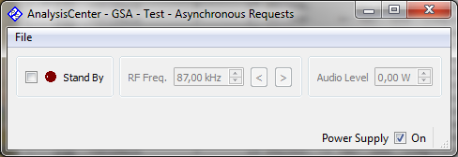

If the request to switch the radio into “StandBy” mode is aborted by clicking the Power Supply check box again:

Implementing Classes Providing Asynchronous Requests

Each class within the GSA6 control application communicating with external applications like a database or map view must provide asynchronous request methods and must be able to queue requests and/or execute requests in parallel.

Each of those classes has different requirements to fulfill. But the basic principle on how those classes provide the functionality for administering asynchronous requests is very similar. To illustrate the basic concept an asynchronous example class has been introduced which can be used as a template for all classes providing asynchronous request methods. But of course this template class needs to be modified and adapted to the concrete use cases and some code snippets are not necessary and some others need to be added.

First of all the terms “main” and “sub” requests are introduced and how those type of requests are distinguished in the context of asynchronous request methods within the GSA6 control application. Please note that those terms are not based on any common design pattern or any other official documentation. Those terms are simply an invention of the software developer of the GSA6 control application.

Within the GSA6 control’s application main requests have to be executed one after another (serialized) whereas sub requests can be executed in parallel. But sub requests can only be executed if no main request is in progress and if the object is in a state which allows to execute sub requests. In practice the database connector considers the “connect”, “disconnect” and “changeSettings” requests as main requests and “execQuery” requests as sub requests. In addition it might be necessary to delete all sub requests if a main request is started.

“Our” asynchronous example class is designed to execute the main requests in the context of the applications main thread and the asynchronous behavior for the main requests is simulated by using a timer. On invoking a main request method first it will be checked if no other main request is in progress postponing the request into the list of pending requests if necessary. If the main request can be executed a timer is started. Intermediate results are simulated in the way that the timer elapses after e.g. 10 seconds but its timeout signal is emitted in an interval of 1 second.

Sub requests are simulated in the way that for each sub request a “sub request executer” thread is created and a “sub request executer” object is created in the context of this thread (in the run method of the QThread class). The “sub request executer” class is designed as an “active” object class. This means that the class is able to receive messages in order to execute commands and to send messages in order to signal execution of commands. For this the “sub request executer” thread starts his own event loop and the executer object class implements the “event” method of the QObject base class. In addition message classes have been implemented whose objects are sent between the base object and its sub request executer objects. Mainly four different types of message classes are used:

- Request Messages
Request messages can be considered as wrapper classes for command objects which are sent from the command creator to the command executer.
- Confirmation Messages
Confirmation messages are sent as answers to request messages and may contain results of the executed command. Confirmation messages may be used to provide intermediate results if there is enough time for the main thread to process the results before receiving the next confirmation messages. Otherwise indicating and generating intermediate results must be synchronized using indication and acknowledge messages.
- Indication Messages
While executing a command the executer may provide intermediate results. If intermediate results are available they will be indicated to the command creator using indication messages. To allow the creator to process and indicate the intermediate results it might be necessary that the command executer defers executing the command until he receives an acknowledge message for the indication message.
- Acknowledge Messages
Acknowledge messages are sent as answers to indication messages to indicate that the results provided with the indication messages have been processed.

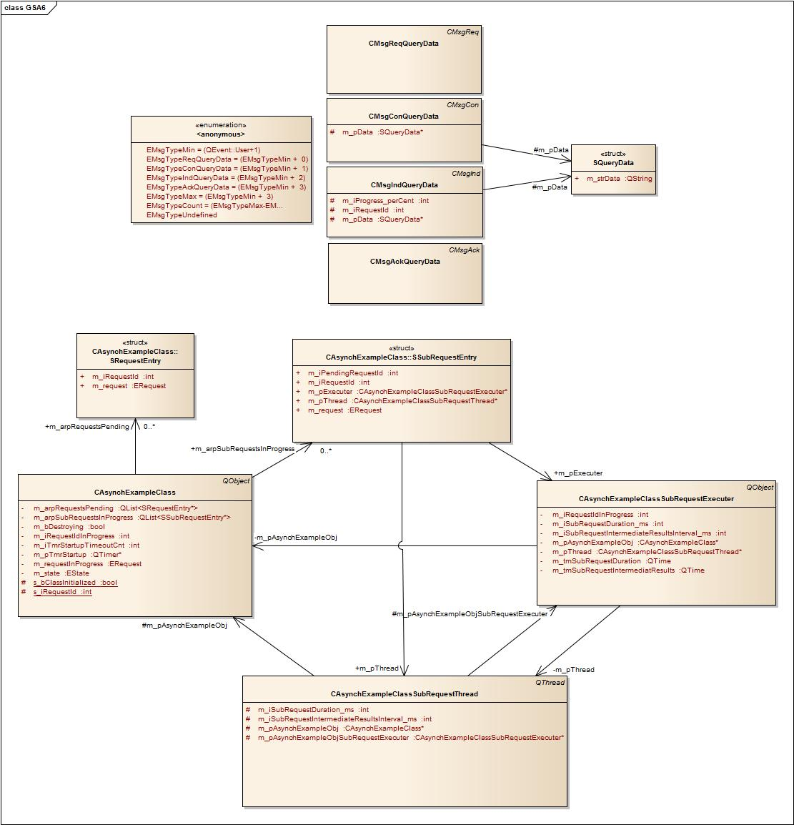

Protected Class Members
static bool s_bClassInitialized
Range [true, false], Default: false
Indicates whether the constructor has been called at once.

static int s_iRequestId
Range [-1, 0..INT_MAX], Default: -1
Will be incremented each time a request method is called to generate a unique request id. If INT_MAX is exceeded the next request id is 0 assuming that requests are only temporarily postponed.

Protected Instance Members
EState m_state
Range [Error: Reference source not found Error: Reference source not found]

QTimer* m_pTmrStartup
Range [valid addres]
Timer to simulate asynchronous behavior of the startup request method.

int m_iTmrStartupTimeoutCnt
Range [0..10]
This variable will be set to 0 if the startup request is started and will be incremented by one each time a startup timeout occurs (each second). After the startup timeout occurred for ten times the startup request is finished.

bool m_bDestroying
Range [true, false], Default: false
Indicates that the "abortAllRequests" method has been called by the destructor and that it is not necessary to call “executeNextPendingRequest”.

ERequest m_requestInProgress
Range [see Error: Reference source not found Error: Reference source not found], Default: ERequestNone
Main request in progress (may not be set to ERequestQueryData).

int m_iRequestIdInProgress
Range [-1, 0..INT_MAX]
Unique Id of the request in progress (request id the caller of an asynchronous request method is waiting for). To signal progress of a main request the parameter “RequestId” of the “requestExecuted” signal is set to this request id.

QList<SRequestEntry*> m_arpRequestsPending
List of pending (postponed) requests. Please note that also sub requests may have been postponed and may be found in this list.

QList<SSubRequestEntry*> m_arpSubRequestsInProgress
List of sub requests which are currently executed. Several sub requests may be executed at the same time.

Constructor(s)

CAsynchExampleClass

Parameters
const QString& i_strObjName
Range [valid string]
Name of the object (for debugging and trace purposes)

Destructor

virtual ~CAsynchExampleClass

Signals

void requestExecuted
This signal is emitted to indicate the current progress of a request (for further information and the signature of the signal please refer to Error: Reference source not found Error: Reference source not found).

Public Main Request Methods

SRequestResult startup (public)
Main request method triggering transition from state “Init” to “Running”. Only in running state sub requests may be executed.

Result
struct SRequestResult
See 4.4.2 class CRequestItem for further details.

SRequestResult shutdown (public)
Main request method triggering transition from state “Running” to “Init”.

Result
struct SRequestResult
See 4.4.2 class CRequestItem for further details.

Public Sub Request Methods

SRequestResult queryData (public)
Sub request which may only be executed in state “Running”.

Result
struct SRequestResult
See 4.4.2 class CRequestItem for further details.

Checking for Requests in Progress

bool isMainRequestInProgress (public, const)
Checks whether a main request is currently in progress or has been postponed (by comparing the request type using the enum values “..Main_MIN” and “..Main_MAX”).

Parameters
int i_iRequestId
Range [-1, 0..INT_MAX], Default -1
Use -1 to check whether any main request is in progress.

ERequest i_request
Range [see Error: Reference source not found Error: Reference source not found], Default: ERequestUndefined
Use Undefined to check whether any main request is in progress.

bool isSubRequestInProgress (public, const)
Checks whether a sub request is currently in progress or has been postponed (by comparing the request type using the enum values “..Sub_MIN” and “..Sub_MAX”).

Parameters
int i_iRequestId
Range [-1, 0..INT_MAX], Default -1
Use -1 to check whether any sub request is in progress.

ERequest i_request
Range [see Error: Reference source not found Error: Reference source not found], Default: ERequestUndefined
Use Undefined to check whether any sub request is in progress.

bool isRequestInProgress (public, const)
Checks whether main and sub requests are in progress or have been postponed.

Parameters
int i_iRequestId
Range [-1, 0..INT_MAX], Default -1
Use -1 to check whether any request is in progress.

ERequest i_request
Range [see Error: Reference source not found Error: Reference source not found], Default: ERequestUndefined
Use Undefined to check whether any request is in progress.

Aborting Requests

void abortRequest (public)
Immediately aborts the specified request. The “requestExecuted” signal with “errResultlInfo.result = EResultRequestAborted” is emitted if the request has been found by the specified id.

Parameters
int i_iRequestId
Range [0..INT_MAX]
“External” request Id of the request to be aborted.

void abortAllSubRequests (public)
Immediately aborts all sub requests. For each aborted request the “requestExecuted” signal with “errResultlInfo.result = EResultRequestAborted” is emitted.

void abortAllRequests (public)
Immediately aborts all requests (main and sub requests). For each aborted request the “requestExecuted” signal with “errResultlInfo.result = EResultRequestAborted” is emitted.

Protected Main Request Methods
External requests may be executed immediately or have to be postponed and executed later. To avoid duplicated code a protected request method has been implemented which is called in both scenarios. The name of the protected request method just starts with an underscore to explicitly point to the originally initiated public request method.

SRequestResult _startup (protected)

Parameters
CAsynchExampleClass::SRequestEntry* i_pReqEntry
Range [NULL, pointer to entry in list of postponed requests]
NULL, if executed immediately by the public request method
!= NULL, if executed as a postponed request

SRequestResult _shutdown (protected)

Parameters
CAsynchExampleClass::SRequestEntry* i_pReqEntry
Range [NULL, pointer to entry in list of postponed requests]
NULL, if executed immediately by the public request method
!= NULL, if executed as a postponed request

Protected Sub Request Methods
External requests may be executed immediately or have to be postponed and executed later. To avoid duplicated code a protected request method has been implemented which is called in both scenarios. The name of the protected request method just starts with an underscore to explicitly point to the originally initiated public request method.

SRequestResult _queryData (protected)

Parameters
CAsynchExampleClass::SRequestEntry* i_pReqEntry
Range [NULL, pointer to entry in list of postponed requests]
NULL, if executed immediately by the public request method
!= NULL, if executed as a postponed request

Protected State Machine Methods

void onSubRequestExecuterCreated (protected, slot)
Each sub request is executed in an own thread. If the thread has been started and if the sub request’s executer object has been created in the context of this thread the “objectCreated” signal is emitted by the thread and this slot method is called.

Please note that the thread object belongs to the same main thread of the application and that the signal is not queued.

Parameters
QObject* i_pThread
Range [valid address]
Pointer to the thread instance emitting the signal.

QObject* i_pExecuter
Range [valid address]
Pointer to the sub request’s executer object which has been created in the context of the thread.

void executeNextPendingRequest (protected)
This method is called internally each time a request has been executed or aborted or if for any other reason during program execution a postponed request may be started.

virtual bool event (protected)
Command messages are posted between objects using Qt events. To receive those events the event method of base class QObject has been reimplemented.

Parameters
QEvent* i_pMsg
Range [valid address]
Will be dynamically casted to AC::GSA::CMsg. If the cast is successful a message type for handling request has been received.

void onTmrStartupTimeout (protected, slot)
To simulate asynchronous behavior of the startup method a timer is used. The timeout is generated each second simulating only partial progress of the request by emitting the “requestExecuted” signal with “Progress_perCent” in the range of [10..90]. After the timeout has been occurred for ten times (so after 10 seconds) the startup is finished and the “requestExecuted” signal is triggered with “Progress_perCent = 100”.

Class CAsynchExampleClassSubRequestThread
As the class need to provide signals and slots it must be derived from QObject (QThread is derived from QObject) and the macro “Q_OBJECT” must be stated.

//******************************************************************************
class CAsynchExampleClassSubRequestThread : public QThread
//******************************************************************************
{
Q_OBJECT

Protected Instance Members
CAsynchExampleClass* m_pAsynchExampleObj
Range [valid address]
The reference to the command creator object must have been provided with the constructor. This reference is forwarded to the constructor of the request executer object.

CAsynchExampleClassSubRequestExecuter* m_pAsynchExampleObjSubRequestExecuter
Range [NULL, valid address], Default NULL
If the thread has been started the request executer object is created in the thread’s run method and the reference to the created object is stored in this member variable.

int m_iSubRequestIntermediateResultsInterval_ms
Range [1..N]
Specifies the interval the request executer object should provide intermediate results.

int m_iSubRequestDuration_ms
Range [1..N]
Specifies the duration of the request.

Constructor(s)

CAsynchExampleClassSubRequestThread (public)

Parameters
CAsynchExampleClass* i_pAsynchExampleObj
Range [valid address]
Reference to the command creator object.

int i_iSubRequestIntermediateResultsInterval_ms
Range [1..N]
Specifies the interval the request executer object should provide intermediate results.

int i_iSubRequestDuration_ms
Range [1..N]
Specifies the duration of the request.

Destructor

virtual ~CAsynchExampleClassSubRequestThread()

Signals

void executerCreated

This signal is emitted right after the command executer object has been created in the run method of the thread. Please note that this signal is not queued as the thread object belongs to the main execution thread.

Parameters
QObject* i_pThread
Range [valid address]
Reference to the thread emitting the signal.

QObject* i_pObjRequestExecuter
Range [valid address]
Reference to the request executer object created in the context of the executer thread.

Aborting Requests

void abortRequest (public)
This method may be used to immediately abort a sub request in progress. E.g. the method call may be forwarded to the command executer object setting a “quit” flag to true forcing the command executer object to break a while loop or so.

Overridables of Base Class QThread

virtual void run (public)
This method is the starting point of the thread. The request executer object is created within the run method and therefore in the context of this thread. After creating the executer object the thread event loop is started. Communication between the command executer and the command creator object is achieved by the means of messages and the command executer is implemented as an active object.

virtual void msleep (public)
To simulate time consuming requests the msleep method is used to pause execution of the thread.

Parameters
unsigned long i_iDuration_ms
Range [1..N]
Number of milliseconds the thread should sleep.

Class CAsynchExampleClassSubRequestExecuter (Command Executer)
As the class need to provide signals and slots it must be derived from QObject and the macro “Q_OBJECT” must be stated.

//******************************************************************************
class CAsynchExampleClassSubRequestExecuter : public QObject
//******************************************************************************
{
Q_OBJECT

Protected Instance Members
CAsynchExampleClass* m_pAsynchExampleObj
Range [valid address]
The reference to the command creator object must have been provided with the constructor. Events (messages) are only accepted from the command creator object.

CAsynchExampleClassSubRequestThread* m_pThread
Range [valid address]
The reference to the thread object is provided with the constructor.

int m_iSubRequestIntermediateResultsInterval_ms
Range [1..N]
Specifies the interval the request executer object should provide intermediate results.

int m_iSubRequestDuration_ms
Range [1..N]
Specifies the duration of the request.

QTime m_tmSubRequestDuration
Used to measure the duration of the request. On starting the request the start method of this time object is called. In the requests executions loop the current time is compared with the start time and if the request duration time has been exceeded the request is considered to be finished.

QTime m_tmSubRequestIntermediatResults
Used to measure the duration of the request. On receiving an acknowledge message (which is the “continue request” message) the start method of this time object is called. In the requests executions loop the current time is compared with the start time and if the requests intermediate result time has been exceeded an intermediate results indication message is sent to the command creator and the request is paused until an acknowledge message is received.

int m_iRequestIdInProgress
Range [0..INT_MAX]
On receiving the start request message the provided request id is stored and is further on used to indicate intermediate results and the final confirmation message.

Constructor(s)

CAsynchExampleClassSubRequestExecuter

Parameters
CAsynchExampleClass* i_pAsynchExampleObj
Range [valid address]
Reference to the command creator object.

CAsynchExampleClassSubRequestThread* i_pSubRequestThread
Range [valid address]
Reference to the thread in which context this object is created.

int i_iSubRequestIntermediateResultsInterval_ms
Range [1..N]
Specifies the interval the request executer object should provide intermediate results.

int i_iSubRequestDuration_ms
Range [1..N]
Specifies the duration of the request.

Destructor

virtual ~CAsynchExampleClassSubRequestExecuter

Aborting Requests

void abortRequest (public)
This method may be used to immediately abort a sub request in progress. E.g. the method call may be forwarded to the command executer object setting a “quit” flag to true forcing the command executer object to break a while loop or so. In this example scenario this method does nothing.

Protected State Machine Methods

virtual bool event (protected)
Command messages are posted between objects using Qt events. To receive those events the event method of base class QObject has been reimplemented.

Parameters
QEvent* i_pMsg
Range [valid address]
Will be dynamically casted to AC::GSA::CMsg. If the cast is successful a message type for handling request has been received.

State Machine Methods Simulating Asynchronous Requests

void executeRequest (protected)
This method is called on receiving the initial start request and each time an acknowledge message is received to resume a paused request.

Subsystem Data

As mentioned the subsystem Data encapsulates the data model classes of the application and none of the classes contain any GUI related code. But some classes (still) contain Controller related code like the DataSet class. For a real object oriented design the Data subsystem would have to be extended by additional abstract classes like DataProvider, DataCommands, DataColumns, DataRelations, etc..

You may consider the subsystem Data as a collection of classes to realize an offline database as a collection of data tables containing a snapshot of the database content. Some data tables have to be completely filled to provide the user with a selection of the available items (e.g. to fill the Areas-Combo-Box with all possible defined areas). Other data tables are only filled if explicitly requested during runtime (e.g. the result of session queries).

The link to the database is realized by class CDbConnection. This singleton class may be connected or disconnected with the database. If connected SQL-Query-Command objects are passed to the connection object to be executed in a separate ExecQuery-Thread. As several queries can be executed at a time for each query command object an own ExecQuery-Thread is created.

SQL-Query-Command objects are either created by assigning a SQL command string or by adding a subset of a data set containing the changes of the applications data set which have to be adjusted with the database. The command objects are able to convert either the result set of a SELECT command into data rows or to generate the SQL command for modified data rows.

By applying the “save” or “fill” methods to data table objects the data tables will create a data row collection of all changed data rows and pass a clone of this data row collection to the query command object. The query command internally keeps a data set object to store the changed data rows.

On receiving the results of the “save” and “fill” requests the data set of the query need to be merged into the data set of the application.

Program Flow

System Startup
The GSA6 control is an application running on the ISAR platform. This means that the GSA6 control is loaded as a plugin by the ISAR main application. The ISAR executable retrieves information about important parameters (name of the Dll to be loaded, user rights, configuration parameters) from a global XML file (“CfgRamon.xml”). On loading the Dll (here “AnalysisCenter-GSA.dll”) the ISAR executable tries to resolve the symbols “ARCreate” and “ARDestroy” which must therefore be implemented and exported by the “AnalysisCenter-GSA” dll. Those two methods are implemented in the main module “ACGSAApp”.

On loading the Dll ISAR calls the “ARCreate” method. This method creates the singleton class “AC::GSA::CApplication” which again creates the applications global objects as shown in the figure below (the global objects are created in clockwise order starting at one o’clock).

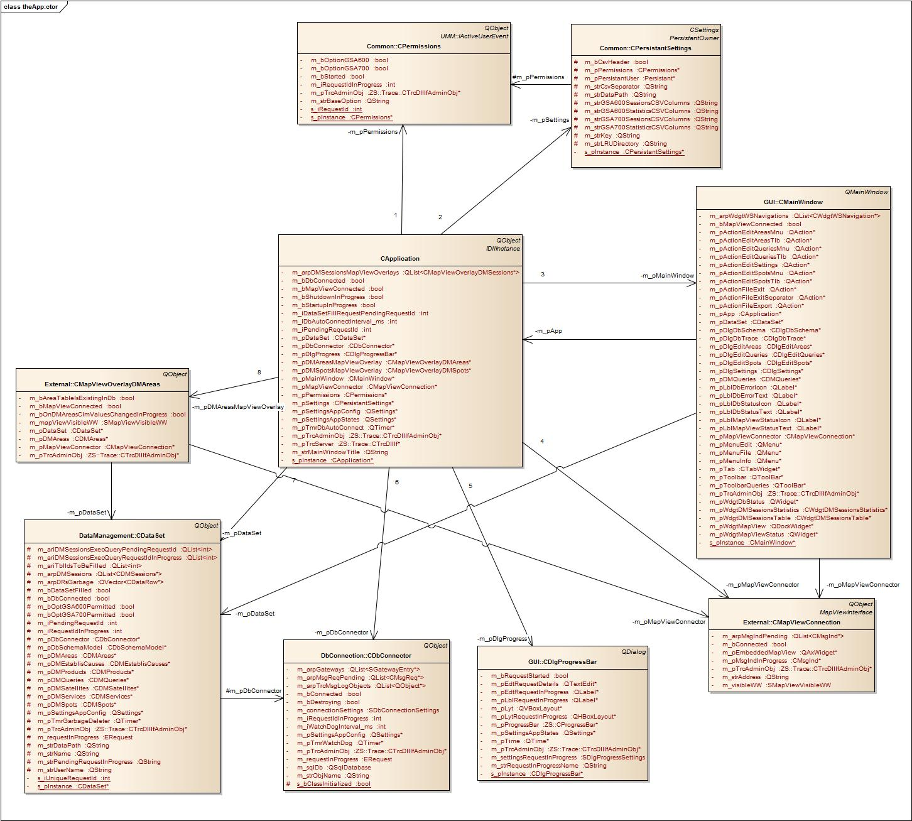
After the global objects have been created the asynchronous system startup process is started by querying the permissions from the external RAMON application “user manager”.

Note: Unfortunately the ownership of the main window is passed to the ISAR framework. The ISAR framework will show the main window and restores the geometry of the main window. Querying user rights is an asynchronous process (which may take some time if the user manager server runs on a remote PC) and should be indicated in the dialog indicating the progress of the system startup. But the main windows geometry is only restored after the permissions have been queried and therefore the system startup progress dialog may not be indicated centered on the main window.

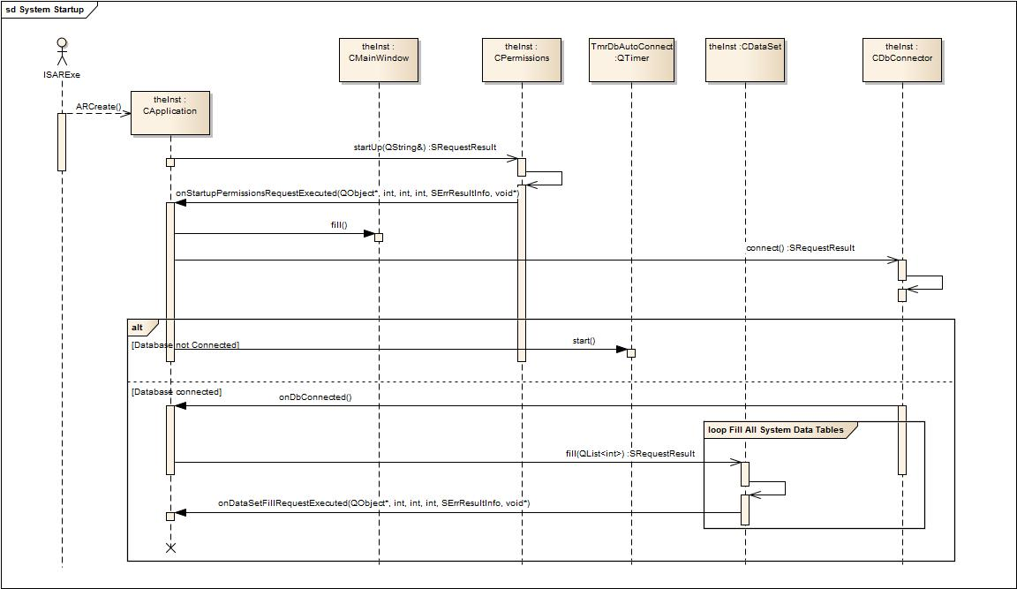

First of all the permissions are queries from the user manager. After receiving the permissions the main window is filled with the controls (actions, menu bar items, etc.) depending on certain permissions.

After system startup has been finished the following signal/slot connections are established:

Observer | Slot | Observable | Signal
 | Action perfomed by the slot method
theInst:CApplication | onDlgProgressDestroyed | theInst:CDlgProgress | destroyed
 | Invalidates (NULLs) the reference to the destroyed object.
 | onMapViewDestroyed | theInst:CMapViewConnection | destroyed
 | Invalidates (NULLs) the reference to the destroyed object.
 | onDbAutoConnectTimeout | TmrDbAutoConnect | timeout
 | Tries to connect to the database if the connection has not yet been established and if the database connector is idle. The timer of this timeout slot is started on receiving disconnected signal and is stopped on receiving the connected signal from the database connector.
 | onDbDestroyed | theInst:CDbConnector | destroyed
 | Invalidates (NULLs) the reference to the destroyed object. The data set is cleared (the data row collections of all data tables are cleared). The corresponding slots are disconnected from the data set signals “requestExecuted”, “subRequestStarted“, “subRequestFinished”, “dmInserted” and “dmRemoving”.
 | onDbConnected
 | Stops the auto connection timer and triggers the request to fill the data set.
 | onDbDisconnected
 | The data set is cleared (the data row collections of all data tables are cleared). The corresponding slots are disconnected from the data set signals “requestExecuted”, “subRequestStarted“, “subRequestFinished”, “dmInserted” and “dmRemoving”. The auto connect timer is started.
theInst:CMainWindow | onDbConnected | theInst::CDbConnector | connected
 | Updates the connection status in the status bar.
 | onDbDisconnected |  | disconnected
 | Updates the connection status in the status bar.
 | onDbRequestExecuted |  | requestExecuted
 | Each time the database connector signals execution of a request the error result is provided with the signal. The last error result is retrieved and indicated in the status bar.
 | onDataSetRequestExecuted | theInst:CDataSet | requestExecuted
 | Each time the data set signals execution of a request the progress is examined. If the request is in progress all controls are disabled. If the request has been finished the controls are enabled.
 | onDataSetSubRequestStarted |  | subRequestStarted
 | Indicates a message text in the status bar.
 | onDataSetSubRequestFinished |  | subRequestFinished
 | Does nothing yet.
 | onDataSetDMInserted |  | dmInserted
 | If a new session table has been created (usually on starting a new query) the main window creates a new dock able workspace widget and adds it to the list of workspace widgets. If not yet done the sessions table and sessions statistics tabs are created. The newly created workspace widget is “activated” by the means that the sessions table and sessions statistics widget indicate the content of this workspace widget.
 | onDataSetDMRemoving |  | dmRemoving
 | On deleting a session table the corresponding workspace widget will be deleted and removed from the list of workspace widgets. If other workspace widgets still exist another workspace widget is “activated”.
 | onDMQueriesRowsInserted | theInst:CDMQueries | rowsInserted
 | Updates the query tool bar by deleting all buttons and newly creating a button for each data row of the query data table.
 | onDMQueriesRowsRemoving |  | rowsRemoving
 | Does nothing yet.
 | onDMQueriesRowsRemoved |  | rowsRemoved
 | Updates the query tool bar by deleting all buttons and newly creating a button for each data row of the query data table.
 | onDMQueriesClmValuesChanged |  | clmValuesChanged
 | Updates the query tool bar by deleting all buttons and newly creating a button for each data row of the query data table.
 | onMapViewDestroyed | theInst:CMapViewConnection | destroyed
 | Invalidates (NULLs) the reference to the destroyed object and updates the map view connection status in the status bar.
 | onMapViewConnected |  | connected
 | Updates the map view connection status in the status bar.
 | onMapViewDisconnected |  | disconnected
 | Updates the map view connection status in the status bar.
 | onActionFileExportTriggered | ActionFileExport | triggered
 | Opens the export dialog for the current active workspace.
 | onActionEditSettingsTriggered | ActionEditSettings | triggered
 | Creates the settings dialog if not yet created and opens the dialog.
 | onActionEditAreasTriggered | ActionEditAreas | triggered
 | Creates the edit areas dialog if not yet created and opens the dialog.
 | onActionEditQueriesTriggered | ActionEditQueries | triggered
 | Creates the edit queries dialog if not yet created and opens the dialog.
 | onAppPermissionsChanged | theInst:CPermissions | permissionsChanged
 | Enables or disables the actions according to the changed permissions.
 | onAppSettingsChanged | theInst:CPersistantSettings | settingsChanged
 | The main window evaluates the kind map view should be embedded.
 | onTabCurrentChanged |  | currentChanged
 | Delegates the activation of the tab to either the sessions table or sessions statistics tab.
 | onDlgDbSchemaDestroyed |  | destroyed
 | Invalidates (NULLs) the reference to the destroyed object.
 | onDlgDbTraceDestroyed |  | destroyed
 | Invalidates (NULLs) the reference to the destroyed object.

System Shutdown

To shut down the application the “quit” slot method of the application is connected with the “lastWindowClosed” signal of the application. On closing the application the destructor of the singleton class “CApplication” is called (which is the main controller of the whole application). The “CApplication” destructor destroys all instances. No asynchronous methods are called but the shutdown method of each asynchronous object is called. Those shutdown methods are aborting requests in progress blocking the main thread until the objects are idle and ready to be destroyed.

Filling System Data Tables
On receiving the “connected” signal the application slot “onDbConnected” applies the “fill” method to the data set whereupon the data set reads the schema from the database and the content of all system data tables. Schema information (which tables and which columns exist) is stored in a schema model within the data set instance and is further on used to decide which table and column may be filled with data from the database. System data tables are those tables whose content is permanently needed during program execution. Those system data tables are:

Class Name | Database Table Name | Remarks
CDMProducts | GSA_QPROD_FLAGS_REL_TBL
CMEstablisCauses | GSA_QESTABLIS_CAUSE_TBL
CDMServices | GSA700_SERVICE_TBL
CDMAreas | COUNTRY_NAME_TBL | Areas (Countries)
CDMSatellites |  | There is no satellites data table in the database. The table is filled by querying DISTINCT values from the session data tables.
CDMSpots |  | There is no spots data table in the database and the data table is not needed at the moment (for future use?). Filled with dummy data.
CDMQueries | GSA_QUERIES_TBL

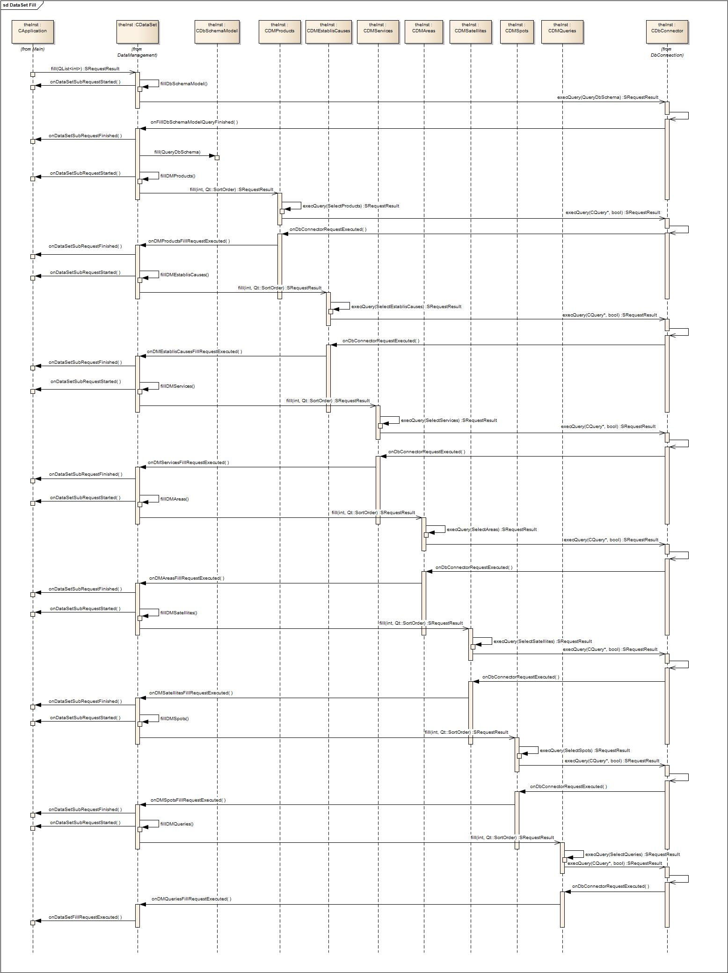

Saving Changes in the Database
On opening the area or the query dialog a data row of the corresponding data table is selected and the user may edit this data row. On clicking the “Save” button, selecting another data row or closing the dialog the changes need to be saved in the database.

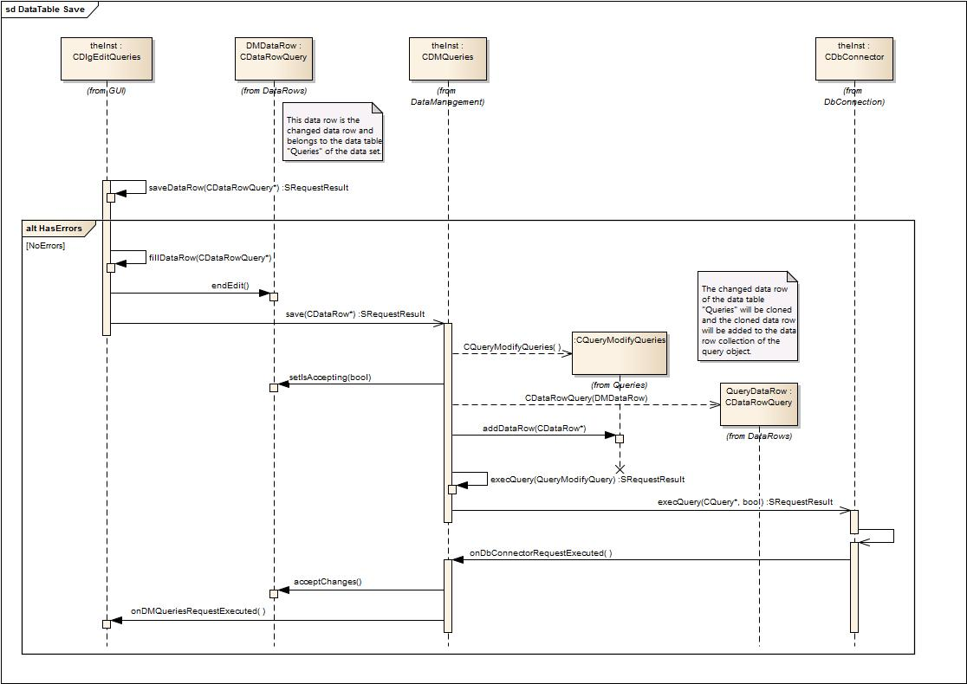

To save the changes the method “saveDataRow” is called internally by the dialog classes. On calling “saveDataRow” the content of the edit controls will be checked for constraint violations (unique key). In case the data row would violate database constraints an error message is reported to the user and the data row will not be saved in the database.

Executing Session Queries
Session queries may be executed on clicking the tool bar button or from within the query dialog on clicking either on the Check or Run button. If the user changed data in the query dialog the changes will first be saved in the database before the session query is executed.

On clicking the Check button the result of the query (which is the number of data rows which will be returned on clicking the “Run” button) should be indicated in a small message box.

On clicking the Run or tool bar button the result of the query should be stored in a session data table and should indicated in the session data table widget. For each different query (for each query with an own name) an own session data table should be created. For each of those session data tables a dock able workspace widget is created allowing to select (activate) the session table and indicate the content of the table in the session table widget.

Depending on the selected query type (GSA600 or GSA700) different query classes are involved and either the class CGSA600QuerySelectSessionsRowCount or class CGSA700QuerySelectSessionsRowCount is instantiated as the query command object.

Executing a Check Query Request
The result of the Check Query request has to be indicated by the query dialog in a small “Check Result Dialog” and the query dialog can therefore directly delegate the query to the database connector.

As mentioned different query classes addressing different session tables in the database need to be instantiated depending on the selected type of query. But after creating the query command object the same code sequences will be processed.

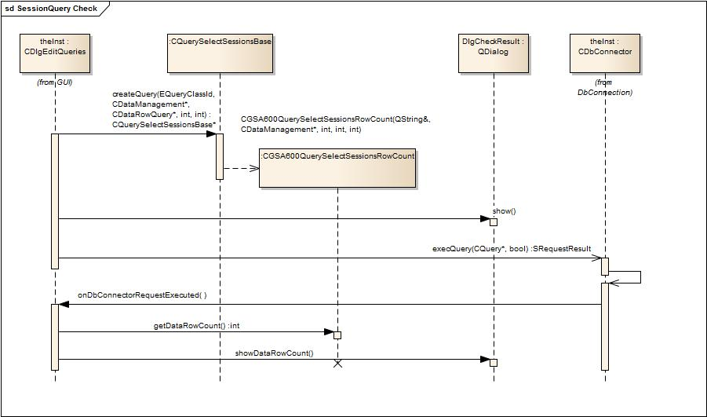

Executing a Run Query Request
The result of the Run Query request has to be indicated in a session data table. If a corresponding session data table does not yet exist a new session data table object and a new dock able workspace has to be created. As the data set is the container of all data tables the data set is responsible for creating session data tables. The main window is the container of dock able workspace widgets and is therefore responsible for creating workspace widgets. For this the main window observes the signal “dmInserted” of the data set object and each time the data set creates a new session data table the main window is triggered and creates the corresponding workspace widget. Vice versa if a workspace widget is closed the main window is informed by Qt’s widget system by emitting the widget closed signal whereupon the main window destroys the session data table and the workspace widget.

As mentioned different query classes addressing different session tables in the database need to be instantiated depending on the selected type of query. But after creating the query command object the same code sequences will be processed.

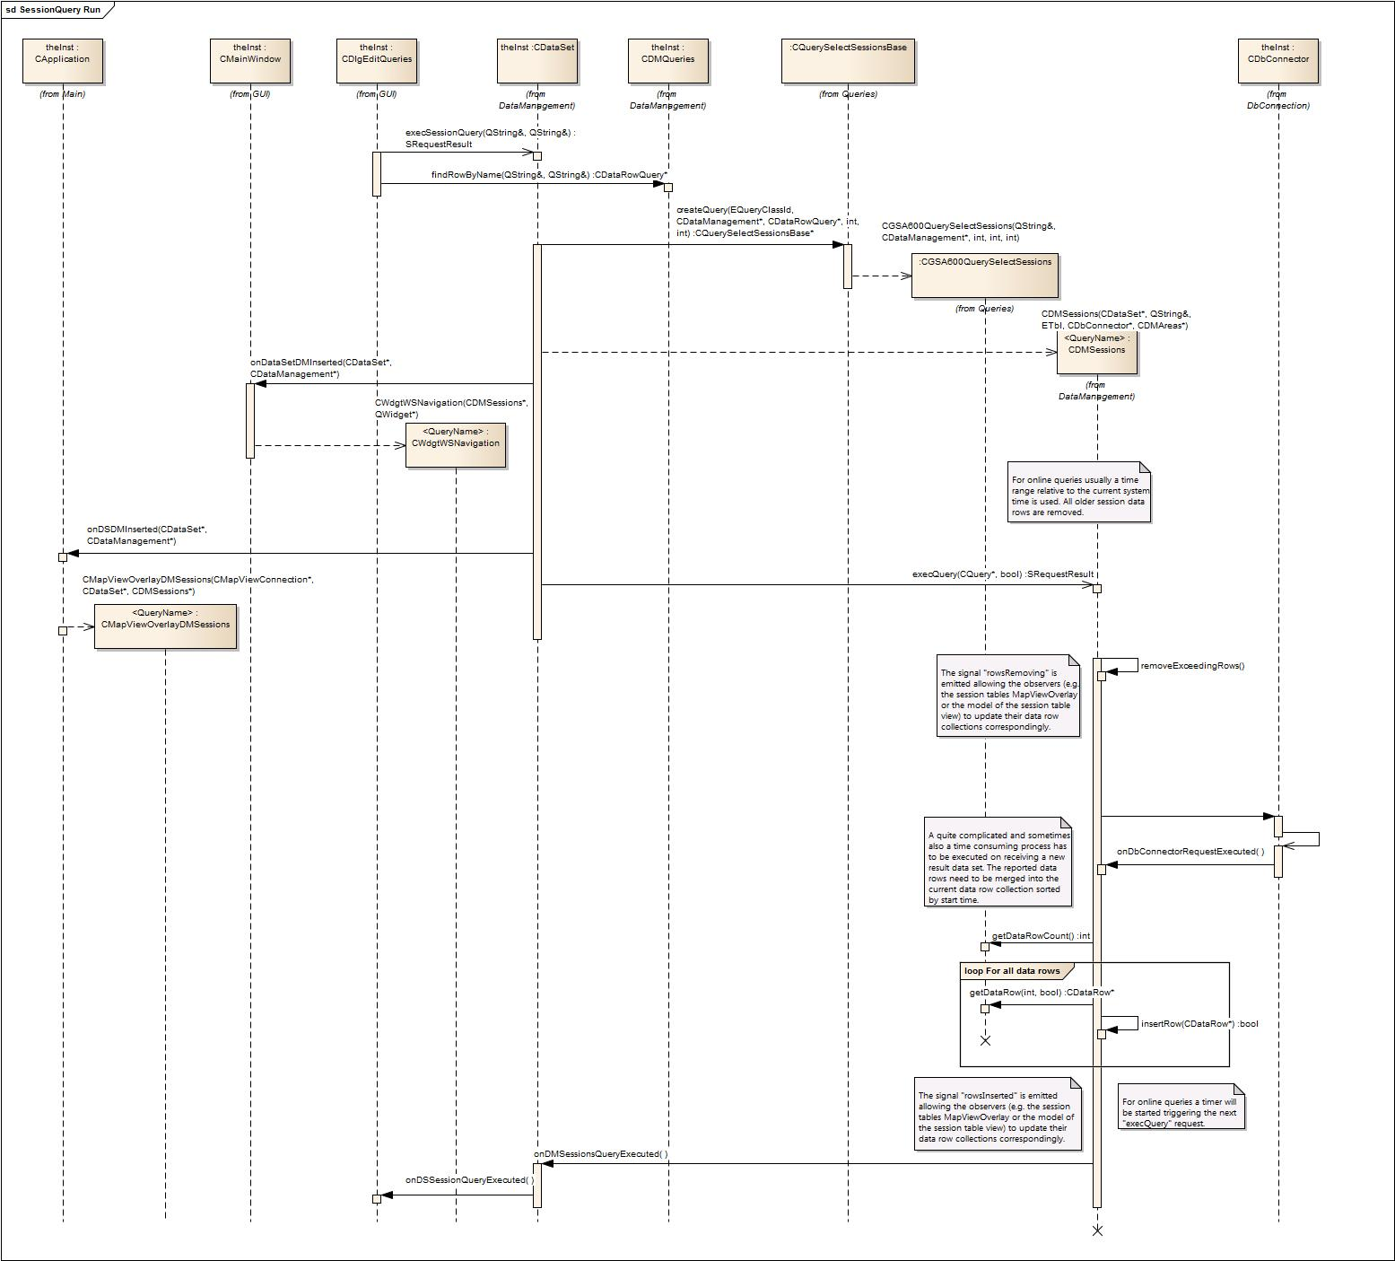

Class Model

Subsystem Main
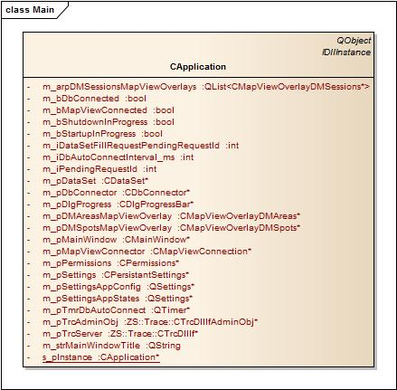

Subsystem Data

Subsystem Data::Schema
For each table and each column which should be handled by the application corresponding C++ constants are defined. Auxiliary methods are provided to convert table and column ids into table and column names and vice versa. Also for some enumerated column data types constants (e.g. establishment causes) are defined together with their corresponding conversion routines.

Class CDbSchemaModel
In addition a model class is provided which may be instantiated and filled by the application to store information about existing tables and columns. This allows downward compatibility of the application.

On system startup it will be checked which tables and which columns exist by reading the schema of the database on calling “SqlDb::record” and filling this model with the retrieved information.

To check whether a table or column exist in the database the model provides the methods “isTableExistingInDb” and “isColumnExistingInDb”.

To allow indicating the implemented database schema the model is derived from Qt’s class QAbstractItemModel. The corresponding tree view object is created in the dialog “CDlgDbSchema” which is accessible through the database tab of the global settings dialog – if “ShowDbSchema” is set in the ini file of the application.

Subsystem Data::DbConnection

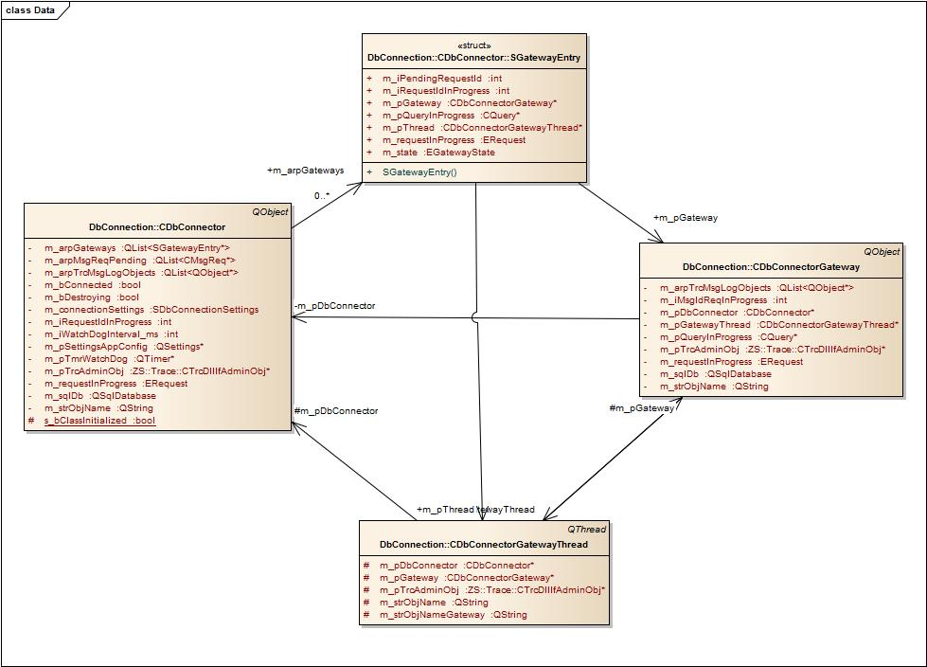

Class CDbConnector

The class CDbConnector provides asynchronous request methods and is used as a gateway to a database instance.

Use the “connect” method to connect with a database. If connected you may pass query command objects to be executed by the database connector. On executing a query the database connector creates and starts a gateway thread. A gateway object is created in the context of the gateway thread and the thread’s command loop is started. The database connector communicates with the gateway object using messages (objects derived from QEvent which are sent from one object to another using the method “QCoreApplication::postEvent”).

Queries are started by sending the ExecQuery Request Message. Execution of the query (either successful or with error result) is reported by sending the ExecQuery Confirmation Message. Intermediate results are reported by the query gateway object by sending ExecQuery Indication Messages. Before the gateway continues executing the query and indicating further results the gateway waits for the ExecQuery Acknowledge Message.

Type Definitions and Constants

enum ERequest (public)
Requests are divided into "main" requests and "ExecQuery" requests. "Main" requests are executed one after another (serialized). "ExecQueries" can only be executed if no "main" request is in progress. Several "ExecQuery" requests can be executed at a time (in parallel) and each query is executed in the context of a query gateway thread. On starting a "main" request all "ExecQuery" requests in progress will be aborted.

The method request2Str” is provided to convert the request into its string representation. In addition to the almost mandatory entries Count and Undefined the enum provides the following values:

None | Used to indicate that no request is in progress.
Shutdown | Used to indicate that the connection is shutting down and that all requests are aborted.
Connect | Reflects the request method “connect”.
Disconnect | Reflects the request method “disconnect”.
ChangeSettings | Reflects the request method “changeSettings”.
ExecQuery | Reflects the request method “execQuery”.

enum EGatewayState (public)
This enum reflects the different states of the gateway object during execution of a query.

The method “gatewayState2Str” is provided to convert the request into its string representation. In addition to the almost mandatory entries Count and Undefined the enum provides the following values:

Creating | The gateway thread is created but the gateway object has not yet been created in the context of the gateway thread and the thread’s event loop is not yet running.
Deleting | If the query has been executed the gateway object can be deleted. That’s been done on quitting the thread.
QueryRunning | The gateway object is created and is currently executing the query. Intermediate results are provided sending indication message. The complete execution of the query is confirmed by a Confirmation message with progress = 100%.

struct SGatewayEntry (protected)
For each query a gateway object is created in the context of a gateway thread. The lifetime of the gateway objects is administered in a list of gateway entries. This struct is almost the same as the struct for sub requests as described in Error: Reference source not found Error: Reference source not found. In addition a reference to the query command object is stored.

Protected Instance Members
QString m_strObjName
Range [Unicode string]
Name of the object (for tracing and debugging).

QSettings m_pSettingsAppConfig
Range [valid address]
Reference to parameters in the ini file of the application. Parameters of the ini file are reserved for “experts use” only and cannot be changed via the GUI of the application.

SDbConnectionSettings m_connectionSettings
Holds the parameters of the database connection (driver type, host name, database name, port number, user name and password).

QSqlDatabase m_sqlDb
Qt class used to communicate with the database.

Int m_iWatchDogInterval_ms
QTimer* m_pTmrWatchDog
To be able to recognize if the database connection has been lost (e.g. on stopping the service or on disconnection a network cable or so on) the connection will be observed by a watch dog whose timeout method is executed in a specified interval. To check the connection a “record” command will be sent to the database to query whether mandatory tables exist. If the “record” command fails something is certainly wrong with the connection to the database and the disconnected signal is emitted.

bool m_bConnected
Indicates whether the connection to the database is established.

bool m_bDestroying
Is set to true if the destructor is called before all requests are aborted.

ERequest m_requestInProgress
Range [see enum ERequest, but may not be set to ERequestExecQuery]
Indicates the current main request in progress.

int m_iRequestIdInProgress
Range [-1, 0..INT_MAX], Default: -1 (for no request in progress)
Unique Id of the request in progress. This Id is returned to the caller of the external request methods and is therefore the request id the caller of the asynchronous request method is waiting for. If the request has been executed (but also to indicate intermediate results) the signal “requestExecuted” is emitted by the database connector providing this request id.

QList<CMsgReq*> m_arpMsgReqPending
List of postponed external requests. If on calling one of the asynchronous request methods currently a main request is in progress (e.g. on calling “execQuery” while the connector tries to establish the connection to the database) the new request cannot be immediately executed but must be postponed in this list. After the current request is executed this list is checked whether there are postponed request and the first entry is taken from this list to be executed.

QList<SGatewayEntry*> m_arpGateways
Several queries are executed in parallel. Each one in an own database gateway thread. For each of those “execQuery” gateway thread objects states and references to involved objects are stored in an entry of this list.

QList<QObject*> m_arpTrcMsgLogObjects
For trace and debugging purposes objects may register themselves at the connector for receiving trace output messages. Within the AnalysisCenter application a DbTrace widget may be registered which is accessible through the database tab of the global settings dialog if this option is activated via the ini file.

Constructors

CDbConnector
The constructor of the database connector creates the following objects:

- An instance of Qt’s database class QSqlDatabase.
- A watch dog timer.

The following signal/slot connections are established:

Observer | Slot | Observable | Signal
 | Action perfomed by the slot method
this | onTmrWatchDogTimeout | m_pTmrWatchDog | timeout
 | If the connection to the database is established it the connection will be continuously observed by checking whether either the GSA600 or the GSA700 session table is accessible.
this | onDbSettingsChanged | CSettings::instance | dbSettingsChanged
 | If any of the connection parameters is changed all ExecQuery requests in progress are aborted and the connector tries to establish a new connection using the changed settings.

Parameters
QString i_strObjName (IN)
Range [Unicode string]
Name of the object (for tracing and debugging).

QSettings i_pSettingsAppConfig
Range [valid address]
Reference to parameters in the ini file of the application. Parameters of the ini file are reserved for “experts use” only and cannot be changed via the GUI of the application.

Destructor
Aborts all requests in progress.

Signals

connected
This signal is emitted if the connection to the database is established.

connecting
This signal is emitted if the connector starts connecting with the database.

disconnected
This signal is emitted if the connection to the database was established but has been lost.

requestExecuted
This signal is emitted to report the current state of a request in progress. See Error: Reference source not found Error: Reference source not found for further details.

In case the execution of the request “ExecQuery” is reported the parameter “pvData” provided with the signal may point to the executed query command object (pointer to CQuery*) and the receiver of the signal may retrieve the result set (data rows) from that query.

Aborting Requests

abortRequest
Aborts the request specified by Id. On aborting the request the signal “requestExecuted” with Progress = 100% and Result = RequestAborted is emitted.

Parameters
Int i_iRequestId (IN)
Range [0..INT_MAX]
Id of the request which should be aborted which can be the current request in progress, a postponed request or an executed query.

abortAllExecQueryRequests
Aborts all ExecQuery requests. For each aborted query the signal “requestExecuted” with Progress = 100% and Result = RequestAborted is emitted. Please note that also postponed queries (queries which have not been started yet) are aborted.

abortAllRequests
Aborts all requests.

Database Connection

Connect
Asynchronous request method.

Tries to connect with the database using the connection settings as provided by the global CSettings instance. All “ExecQuery” requests are aborted. The progress of the request is indicated by emitting the signal “requestExecuted”.

Result
struct SRequestResult
See 4.4.2 class CRequestItem for further details.

disconnect
Asynchronous request method.

Disconnects from the database. All “ExecQuery” requests are aborted. The progress of the request is indicated by emitting the signal “requestExecuted”.

Result
struct SRequestResult
See 4.4.2 class CRequestItem for further details.

Executing Queries

execQuery
Asynchronous request method.

Queries may only be executed if the connection to the database is established. On calling this method if the connection is not established the method returns immediately with result = RequestRefused. In any other case the progress of the request is indicated by emitting the signal “requestExecuted”.

On executing the request a gateway thread is created and the query is executed in the context of this gateway thread. Several queries may be executed in parallel and therefore several gateway threads may be running at the same time.

Parameters
CQuery* i_pQuery
Range [valid addres]
Reference to the query command object which should be forwarded to the gateway object. The database connector creates a clone of the query object and takes ownership of the clone but not of the passed query object. Therefore the creator of the query has to delete the query object themselves. After the query has been finished the clone will be deleted by the database.

Result
struct SRequestResult
See 4.4.2 class CRequestItem for further details.

Internal State Machine

onCreatedGateway
If the ExecQuery gateway thread is started and has created the gateway object the signal “gatewayCreated” is emitted by the thread right before the thread’s event loop is started. This slot is connected to this signal and continues the ExecQuery request by sending the ExecQuery request message to the gateway object.

Parameters
QObject* i_pThread
Range [valid addres]
Thread emitting the signal.

QObject* i_pGateway
Range [valid addres]
The address of the thread object emitting the signal is searched in the list of gateways. This list entry is used to store the address of the gateway object to which the request message has to be sent.

event
ExecQuery gateway objects are so called active objects meaning that the object is controlled by receiving messages and returns results by sending messages. All messages within the Qt event driven system are handled by the event methods of the QObject class. So all messages sent from the gateway object to the database connector object are handled by this event method.

Postponed requests are also executed via messages posted to this event method. One reason for this is that the requests are stored as message objects in the list of postponed requests. Another reason is to avoid duplicating code on starting a request and to decouple the request method from the call considering the stack call depth.

The following messages are handled by the event method:

ReqConnect | Request to establish the connection with the database. If the connection parameters passed with the request message are different from the current connection parameters the current connection is closed, the signal “disconnected” is emitted and it will be tried to open the new connection. If successful the signal “connected” is emitted. After executing the request the signal “requestExecuted” is emitted and the next pending request (if any) will be started.
ReqDisconnect | Request to close the connection to the database. The signal “disconnected” is emitted. After executing the request the signal “requestExecuted” is emitted and the next pending request (if any) will be started.
ReqChangeSettings | Request to change the connection settings. This may include closing the current database connection and opening another one whereupon the signals “disconnected” and “connected” are emitted before the signal “requestExecuted” is emitted and the next pending request (if any) will be started.
ReqExecQuery | On receiving this message a gateway thread will be created and started and the slot “onCreatedGateway” will be connected with the signal “gatewayCreated” of the thread. The request will be continued if the slot method is invoked by sending the ReqExecQuery message to the gateway object.
ConExecQuery | This message is sent by the gateway object if the query has been finished – successful or because of an error. The result set provided with the confirmation message is dispatched by emitting the requestExecuted signal providing a pointer to the executed query command object as “pvData”. The gateway thread will be destroyed.
IndExecQueryIntermediateResults | For long duration queries intermediate results are reported by the gateway object. The result set provided with the indication message is dispatched by the requestExecuted signal providing a pointer to the executed query command object as “pvData”.

Class CDbConnectorGatewayThread

Protected Instance Members
QString m_strObjName
Range [Unicode string]
Name of the object (for tracing and debugging).

QString m_strObjNameGateway
Range [Unicode string]
Name of the gateway object (for tracing and debugging). Has to be provided on creating the thread and will be forwarded by the thread to the constructor of the gateway object.

CDbConnector* m_pDbConnector
Range [valid address]
Reference to the database connector creating the thread. Has to be provided on creating the thread and will be forwarded by the thread to the constructor of the gateway object.

CDbConnectorGateway* m_pGateway
Range [NULL, valid address], Default: NULL
Reference to the gateway object. The gateway object is created in the “run” method of the thread before starting the thread’s event loop.

Contructor(s)

CDbConnectorGatewayThread

Parameters
QString i_strObjName (IN)
Range [Unicode string]
Name of the object (for tracing and debugging).

QString i_strObjNameGateway (IN)
Range [Unicode string]
Name of the gateway object (for tracing and debugging).

CDbConnector* i_pDbConnector (IN)
Range [valid address]
Reference to the database connector creating the thread. Will be forwarded by the thread to the constructor of the gateway object.

Destructor
Destroys the gateway object (if not yet done).

Signals

createdGateway
This signal is emitted if the gateway object has been created in the context of the thread (within the threads run method) right before starting the event loop of the thread.

Class CDbConnectorGateway

Type Definitions and Constants

enum ERequest (public)
Request currently in progress by the gateway object.

The method request2Str” is provided to convert the request into its string representation. In addition to the almost mandatory entries Count and Undefined the enum provides the following values:

None | Used to indicate that no request is in progress.
ExecQuery | Reflects the request method “execQuery”.

Protected Instance Members

QString m_strObjName
Range [Unicode string]
Name of the object (for tracing and debugging).

CDbConnector m_pDbConnector
Range [valid address]
Reference to the database connector creating the gateway thread and therefore also creating this gateway object. Has to be provided on creating the thread and will be forwarded by the thread to the constructor of the gateway object. The gateway object receives and sends messages to this object only.

CDbConnectorGatewayThread m_pGatewayThread
Range [valid address]
Reference to the gateway thread creating this object.

QSqlDatabase m_sqlDb
Qt’s database class used to communicate via the Qt-SQL-Driver with the Oracle database. Please note that the Qt-SQL drivers themselves require OCI drivers to communicate with the Oracle database. As the QSqlDatabase class is not thread safe the database object of the database connector is cloned and is furthor on used to execute queries.

CQuery* m_pQueryInProgress
Range [NULL, valid address]
Reference to the query which is executed by this gateway object. The query object is provided by the ExecQuery request message. To execute the query the gateway object applies the method “exec” on the query command object. On initially starting the query a QSqlQuery object is created by the query command object in the context of the gateway thread.

ERequest m_requestInProgress
Range [see enum CDbConnectorGateway::ERequest]

int m_iMsgIdReqInProgress
Range [-1, 0..INT_MAX], Default: -1 (for no request in progress)
This request id is provided with the ExecQuery Request Message and is further on used by the gateway object on sending Confirmation and Indication Messages ot the database connector object. The database connector object again keeps this request id as the PendingRequestId within the list of administered gateways executing queries.

QList<QObject*> m_arpTrcMsgLogObjects
For trace and debugging purposes objects may register themselves at the connector for receiving trace output messages. Within the AnalysisCenter application a DbTrace widget may be registered which is accessible through the database tab of the global settings dialog if this option is activated via the ini file.

Contructor(s)

CDbConnectorGateway

Parameters
QString i_strObjName (IN)
Range [Unicode string]
Name of the object (for tracing and debugging).

CDbConnector* i_pDbConnector (IN)
Range [valid address]
Reference to the database connector.

CDbConnectorGatewayThread* i_pGatewayThread (IN)
Range [valid address]
Reference to the thread creating this object.

Destructor
Destroys the query command object (if not yet done).

Aborting Requests

abortRequestInProgress
Aborts the executed query by applying the method “abortExec” to the query object.

Internal State Machine

event
ExecQuery gateway objects are so called active objects meaning that the object is controlled by receiving messages and returns results by sending messages. All messages within the Qt event driven system are handled by the event methods of the QObject class. So all messages sent from the database connector object to this gateway object are handled by this event method.

The following messages are handled by the event method:

ReqExecQuery | This is the request message to start executing the query. As the QSqlDatabase object is not thread safe the database object will be cloned and the cloned database object will be opened. On failure or if the query has been finished immediately a confirmation message with Progress = 100% is posted to the database connector. If executing the query takes more time than the specified IntermediateResultsInterval intermediate results are reported by sending indication messages to the database connector. The query is paused.
AckExecQueryIntermediateResults | For long duration queries intermediate results are reported by the gateway object and the query is paused. The database connector indicates that the result set provided with the indication message is dispatched by the requestExecuted signal by sending this acknowledge messages whereupon the gateway object resumes the paused query.

Subsystem Data::DataManagement
For historical reasons the term “DataManagement” has been kept. But as a matter of fact “DataTables” would have been a better name for this subsystem. In addition also an own subsystem “DataSet” should have been invented for class “CDataSet”.

The data set can be considered as an offline data cache of the database content and is a container for data tables whereas data tables are containers for data rows.

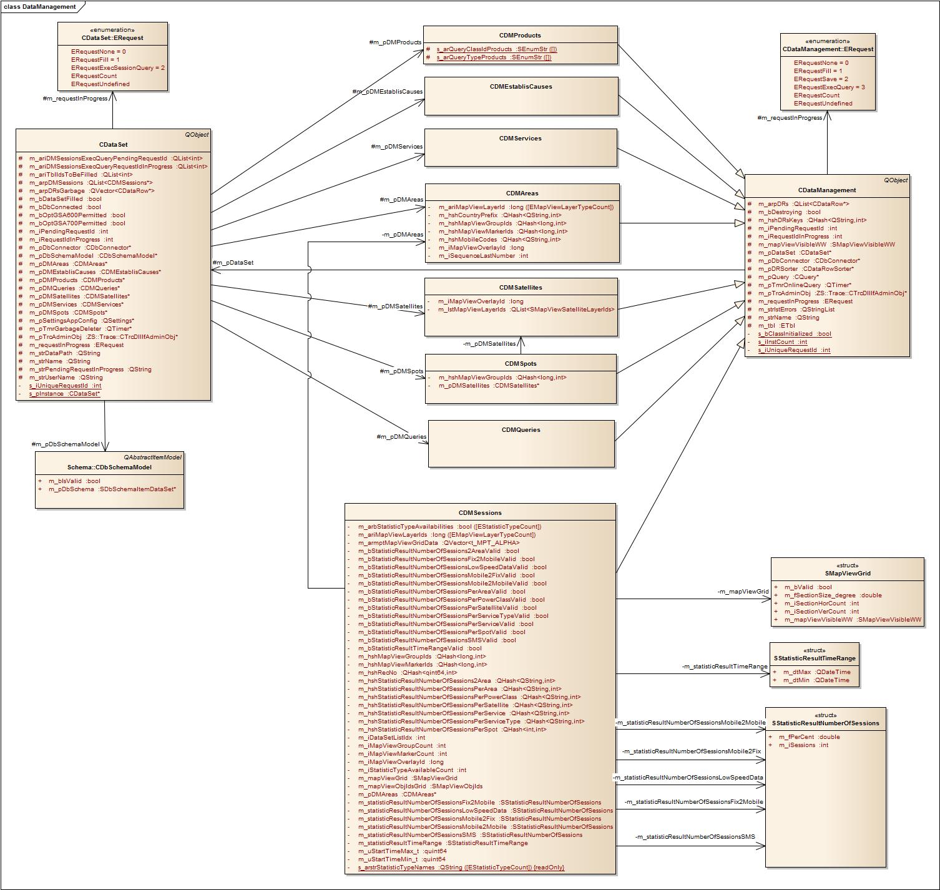

All DataManagement (DataTable) classes (instead of CDMSessions) are singletons and are created and filled during system startup. Session data tables are created during runtime each time the user “runs” a session query. In addition for each session data table statistics are evaluated if requested. And as also the content of a session table has to be indicated on map view as a density grid the corresponding grid data is calculated and is stored together with the session data table.

Class CDataSet

Type Definitions and Constants

enum ERequest (public)
Enum to reflect the different asynchronous request methods which may be executed.

The method request2Str” is provided to convert the request into its string representation. In addition to the almost mandatory entries Count and Undefined the enum provides the following values:

None | Used to indicate that no request is in progress.
ReadDbSchema | Reflects the request method “readDbSchema”.
Fill | Reflects the request method “fill”.
ExecSessionQuery | Reflects the request method “execSessionQuery”.

Protected Instance Members

QString m_strName
Range [unicode string]
Name of the data set (mainly used for debugging and trace outputs)

QSettings* m_pSettingsAppConfig
Range [valid address]
Reference to parameters in the ini file of the application. Parameters of the ini file are reserved for “experts use” only and cannot be changed via the GUI of the application.

QString m_strDataPath
Range [empty string or existing path]
Path where the content of data tables will be saved (exported to XML files). This is usually the directory “AnalysisCenterGSA” below the Ramon data directory (so very likely “D:\RamonData\AnalysisCenterGSA”). Set by the application during startup.

QString m_strUserName
Range [valid user name]
Name of the logged in user. Queries are stored per user in the database. The user name is set by the application during startup.

bool m_bOptGSA600Permitted
true, if both the GSA600 option is licensed and if the GSA600 option is activated by the user manager. Used e.g. to detect which query to load. Set by the application during startup.

bool m_bOptGSA700Permitted
true, if both the GSA700 option is licensed and if the GSA700 option is activated by the user manager. Used e.g. to detect which query to load. Set by the application during startup.

ERequest m_requestInProgress
Range [see enum ERequest, bot not ERequestExecSessionQuery]
Indicates the current request in progress. As several queries may be executed in parallel and as the queries don’t really belong to the data set but to the sesssion table created on starting the query the request in progress flag is never been set to ExecSessionQuery. Instead the request is forwarded to the session data table and also the “requestExecuted” signal is just forwarded after adapting the parameters correspondingly.

int m_iRequestIdInProgress
Range [-1, 0..INT_MAX]
Unique Id of the request in progress (request id the caller of an asynchronous request method is waiting for).

int m_iPendingRequestId
Range [-1, 0..INT_MAX]
On calling a request method (e.g. “fill”) the data set itself may need to call an asynchronous request method of aggregated objects (e.g. the “fill” method of the system data tables). The request id as returned by the aggregated object is stored as the “pending request id”. Before continuing the request in progress (the data sets fill request) the data set waits until the aggregated object has finished the request (the data tables fill request) by emitting the “requestExecuted” signal providing this “pending request id”.

QString m_strPendingRequestInProgress
Range [unicode string]
The data set fill request is divided into several data table fill request. Or in other words the data set request may be considered is a parent request which is divided into several child requests. To indicate the current child request in progress (e.g. in a progress bar) this variable is set correspondingly (e.g. set to “Reading Areas”, “Reading Services”, etc.

bool m_bDbConnected
Reflects the state of the database connector and is updated via the connectors “connected” and “disconnected” signals.

CDbConnector* m_pDbConnector
Range [valid address]
Reference to the database connector the data set used to execute queries.

QVector<CDataRow*> m_arpDRsGarbage
QTimer* m_pTmrGarbageDeleter
In Debug mode deleting data rows is a time consuming process which may noticeably slow down destroying session tables and therefore closing workspaces. If a session table is destroyed it hands over its data row collection to the data set to be deleted in a background process realized by a timer e.g. deleted a certain amount of rows in specified time intervals. If the data set is destroyed (during shutdown) all not yet deleted garbaged data rows will be deleted at once.

bool m_bDbSchemaRead
Indicates whether the schema has been successfully read from database.

QList<int> m_ariTblIdsToBeFilled
The tables which should be filled by the fill request may be limited. If this list is not empty only the tables as defined via this list are filled.

bool m_bDataSetFilled
Indicates whether the system data tables (Products, Establishment Causes, Queries, etc.) have been successfully read from database.

CDbSchemaModel* m_pDbSchemaModel
Range [valid address]
Reference to the schema model object created by the data set. The model will be filled on calling the “readDbSchema” request method.

CDMProducts* m_pDMProducts
Range [valid address]
Reference to the products data table created by the data set. The data table will be filled as a child request of the data tables fill request. If the data table is not existing in the database the table will be filled with default data (with an internal set of predefined data rows).

CDMEstablisCauses* m_pDMEstablisCauses
Range [valid address]
Reference to the establishment causes data table created by the data set. The data table will be filled as a child request of the data tables fill request. If the data table is not existing in the database the table will be filled with default data (with an internal set of predefined data rows).

CDMServices* m_pDMServices
Range [valid address]
Reference to the services data table created by the data set. The data table will be filled as a child request of the data tables fill request. If the data table is not existing in the database the table will be filled with default data (with an internal set of predefined data rows).

CDMAreas* m_pDMAreas
Range [valid address]
Reference to the areas data table created by the data set. The data table will be filled as a child request of the data tables fill request.

CDMSatellites* m_pDMSatellites
Range [valid address]
Reference to the satellites data table created by the data set. The data table will be filled as a child request of the data tables fill request. If the data table is not existing in the database the table will be filled either with the distinct values from column “SAT_NAME” of the GSA600 and GSA700 session tables or – if the columns don’t exist in database - with default data (with an internal set of predefined data rows).

CDMSpots* m_pDMSpots
Range [valid address]
Reference to the spots data table created by the data set. This time (March 2013) this data table is not used and will not be filled.

CDMQueries* m_pDMQueries
Range [valid address]
Reference to the queries data table created by the data set. The data table will be filled as a child request of the data tables fill request. If the Queries data table does not exist in database the data source is an XML file stored in the data path of the application (see m_strDataPath above).

QList<CDMSessions*> m_arpDMSessions
Range [list of valid pointers]
The data set is the container of the application’s data tables and therefore the data set is responsible for creating and destroying session data tables. For this the request to run a session query is delegated to the data set object by calling the data set’s request method “execSessionQuery”. The data set created a new session table, adds the reference to the session table in this list of session tables and emits the “dmInserted” (data management object inserted) signal.

QList<int> m_ariDMSessionsExecQueryPendingRequestId
This list must be of same size as the list of session data tables (“m_arpDMSessions” above). The “execQuery” request is forwarded to the session table object and the data sets waits for the “requestExecuted” signal with this pending request id to recognize that for the session table the query has been finished.

QList<int> m_ariDMSessionsExecQueryRequestIdInProgress
This list must be of same size as the list of session data tables (“m_arpDMSessions” above). The “execQuery” request is forwarded to the session table object. If the session table object finished the query the data set forwards the data tables “requestExecuted” signal by emitting the “requestExecuted” signal providing the request id in progress.

Contructor(s)
The constructor of CDataSet instantiates the schema model object, the global system data tables (Products, Establishment Causes, etc.) and the timer for the garbage collector of the data table’s data row collections.

CDataSet

Parameters
Const QString& i_strName (IN)
Range [Unicode string]
Name of the data set (mainly for tracing and debugging).

QSettings* i_pSettingsAppConfig (IN)
Range [valid address]
Reference to parameters in the ini file of the application. Parameters of the ini file are reserved for “experts use” only and cannot be changed via the GUI of the application.

CDbConnector* i_pDbConnector (IN)
Range [valid address]
Reference to the database connector.

Destructor
The destructor clears all data tables (including any session data tables which have been created during runtime) and destroys the data rows which have not yet been deleted by the garbage collector.

Signals

requestExecuted
This signal is emitted to report the current state of a request in progress. See Error: Reference source not found Error: Reference source not found for further details.

subRequestStarted
On calling “DataSet.fill” several data tables have to be filled one after another. Filling each of those tables is a sub request. On starting such a sub request this signal is emitted and e.g. a progress dialog may be filled correspondingly.

Parameters
QObject* i_pDS (IN)
Range [valid address]
Address of the object emitting the signal (this data set).

Const QString& i_strRequest (IN)
Range [Unicode string]
Description of the sub request.

subRequestFinished
On calling “DataSet.fill” several data tables have to be filled one after another. Filling each of those tables is a sub request. If such a sub request has been executed this signal is emitted and e.g. a progress dialog may be filled correspondingly.

Parameters
QObject* i_pDS (IN)
Range [valid address]
Address of the object emitting the signal (this data set).

Const QString& i_strRequest (IN)
Range [Unicode string]
Description of the sub request.

dmInserted
This signal is emitted if a new data table has been added to the data set. On running a new query a new session data table will be created and added to the data set’s collection of data tables whereupon the main window has to create a workspace widget and the application has to create a DM session overlay object linked to the session data table.

Parameters
CDataSet* i_pDS (IN)
Range [valid address]
Address of the object emitting the signal (this data set).

CDataManagement* i_pDM (IN)
Range [valid address]
Address of the newly created data table.

dmRemoving
This signal is emitted right before a data table is going to be deleted. On deleting a session data table the main window has to delete the corresponding workspace widget and the application has to delete the corresponding DM session overlay object.

Parameters
CDataSet* i_pDS (IN)
Range [valid address]
Address of the object emitting the signal (this data set).

CDataManagement* i_pDM (IN)
Range [valid address]
Address of the data table which will be deleted.

dmRemoved
This signal is emitted after a data table has been deleted.

Parameters
CDataSet* i_pDS (IN)
Range [valid address]
Address of the object emitting the signal (this data set).

Common

setDataPath
The data path is used to store configuration settings of the application. The data path is used by the data set if the queries data table is not existing in the database to store the queries in a XML file within the data path of the application.

Parameters
QString i_strDataPath (IN)
Range [valid path]
Usually the data path is set to “D:\RamonData\AnalysisCenterGSA”.

setUserName
The user name is used by the data set if the queries data table is not existing in the database to store the queries in a XML file within the data path of the application. The queries are stored for each user separately by adding the name of the user to the XML file name (“AnalysisCenter-GSA-Queries-<UserName>.xml”).

Parameters
QString i_strUserName (IN)
Range [valid user name]

Clearing

clear
Clears the data set by clearing all system data tables and deleting all session data tables. The data set will be cleared if the connection to the database is closed.

addGarbageDataRows
Clearing huge data row collections may be a time consuming process as the destructor of each data row has to be called. The result of a session query might be a huge data row collection within a session data table. On closing a workspace widget the session data table has to be deleted. This might block the main thread and would therefore freeze the GUI for a while. This effect is not expected and desired by the user who just wanted to close a widget. To avoid this freezing effect the data table’s data row collection will be cleared but the data rows will be deleted later by the garbage collector of the data set. For this the data table hands over the data row collection to the garbage collector of the data set.

Class Parameters
Const QVector<CDataRow*> i_arpDRs (IN)
Reference to the data row collection which has to be deleted.

Aborting Requests

abortRequest
Aborts the request specified by Id. On aborting the request the signal “requestExecuted” with Progress = 100% and Result = RequestAborted is emitted.

Parameters
Int i_iRequestId (IN)
Range [0..INT_MAX]
Id of the request which should be aborted which can be the current request in progress, a postponed request or an executed query.

abortRequestInProgress
Aborts the current request in progress. On aborting the request the signal “requestExecuted” with Progress = 100% and Result = RequestAborted is emitted.

Retrieving Data from Database

readDbSchema
Asynchronous request method.

Reads schema information from the database. The schema information is stored in the schema model object of the data set.

The schema has to be read right after the connection to the database has been established before reading (SELECTing) the content of data tables.

fill
Asynchronous request method.

Reads the content of the global system data tables. The tables are read one after another by calling the fill methods of the corresponding table objects.

The fill request of each data table is introduced by the data set by calling the corresponding slot method “fill<DataTable>” emitting the signal “subRequestStarted”.

The fill request of each data table is completed if the data base connector emits the “requestExecuted” signal and the data set’s slot method “on<DataTable>FillRequestExecuted” slot method is called emitting the signal “subRequestFinished”.

The system data tables have to be read right after the schema has been read.

Parameters
QList<int> i_ariTblIds (IN)
Here the list of tables to be filled may be defined. As default this list is empty and all system data tables will be filled (Products, Establishment Causes, Services, Areas, Satellites, Queries).

Executing Queries

execSessionQuery
Asynchronous request method.

Queries may only be executed if the connection to the database is established. On calling this method if the connection is not established the method returns immediately with result = RequestRefused. In any other case the progress of the request is indicated by emitting the signal “requestExecuted”.

The method starts by searching for the corresponding query data row in the Query data table (the key for query data rows is assembled by the user name and the name of the query). If the query data row has been found the query command object will be created passing the query data row as argument to the constructor of the query object (the query data row stores all query filter settings which are used to build the WHERE clause of the SQL command).

If a valid query command object has been created it will be checked whether a session data table is already available for the query (the name of the query is used to uniquely identify the session data table within the session data table collection of the data set). If a session data table has not been defined a new data table will be created and added to the data set’s collection of session data tables and the signal “dmInserted” is emitted.

Finally the “execQuery” method is delegated to the data session table. If the query has been executed the data table emits the “requestExecuted” signal and the data set’s slot method “onDMSessionsQueryExecuted” is called.

Parameters
Const QString& i_strUser
Range [valid user name]
Name of the currently logged in user.

Const QString& i_strQueryName
Range [valid name]
Descriptive name of the query.

Result
struct SRequestResult
See 4.4.2 class CRequestItem for further details.

CDataManagement
As a matter of fact the data management classes functionality is very similar to a data table keeping a list of data rows and hashes to find data rows using keys. The content of the data tables may be indicated using the
model/view subsystem of Qt each of them may use its own sorter. Keep in mind that several model/view pairs with different sorters may be used to indicate the same data. The data rows within the data management class may be sorted or not. It could be meaningful to presort the data rows within the data management class to speed up the indication of data rows.

Within the Analysis Center GSA modules the CDataManagement class is an abstract base class for typed data table classes and acts as a data row factory. The derived classes must overwrite the pure virtual methods “createRow”, “fill”, “save”, “execQuery” and “onDbConnectorRequestExecuted”. In other words all methods must be implemented by the type data table classes which need access to specific column information as the data subsystem does not (yet) provide generic “DataColumn” classes.

Type Definitions and Constants

enum ERequest (public)
Enum to reflect the different asynchronous request methods which may be executed.

The method request2Str” is provided to convert the request into its string representation. In addition to the almost mandatory entries Count and Undefined the enum provides the following values:

None | Used to indicate that no request is in progress.
Fill | Reflects the request method “fill”.
Save | Reflects the request method “save”.
ExecQuery | Reflects the request method “execQuery”.

Protected Instance Members
CDataSet* m_pDataSet
Range [valid address]
Reference to the data set creating the data table. The data set is the parent object of the data table.

QString m_strName
Range [unicode string]
Name of the data table. This name may also be used to label the table in the GUI.

ETbl m_tbl
Range [0..ETblCount]
Id of the data table (see enum ETbl within the schema definition).

bool m_bDestroying
Indicates that the table is currentyl beeing destroyed. On clearing the table the signal “clearing” is emitted. Observers of the signal (e.g. map view overlay object) may need to know whether the table is beeing destroyed to not access the session table anymore.

ERequest m_requestInProgress
Range [see enum ERequest above]
Indicates the current request in progress.

int m_iRequestIdInProgress
Range [-1, 0..INT_MAX]
Unique Id of the request in progress (request id the caller of an asynchronous request method is waiting for).

int m_iPendingRequestId
Range [-1, 0..INT_MAX]
Request Id of the request which has been started by the data table (Id of the request the data table is waiting for to be executed).

CDbConnector* m_pDbConnector
Range [valid address]
Reference to the database connector used to execute queries.

CQuery* m_pQuery
Range [NULL, valid address]
Reference to query command object currently being executed.

QTimer* m_pTmrOnlineQuery
Range [valid address]
Timer for triggering timeouts to continuosly execute online queries.

QList<CDataRow*> m_arpDRs
Collection of data rows. The data rows may be sorted or not.

QHash<QString,int> m_hshDRsKeys
The key may be composed of several columns separated by "\n", the value is the index into m_arpDRs. The key may be changed during runtime e.g. if the user edits the key (e.g. the name of areas or queries). On changing the key the corrsponding hash entry has to be corrected. For this the table connects to the “clmValuesChanging” signal of the data rows and corrects the key if changed.

CDataRowSorter* m_pDRSorter
Range [NULL, valid address]
Sorter object used to sort the table using “std::stable_sort” (could be replaced in the future by QMultiMap to simplify and shorten code lines).

SMapViewVisibleWW m_mapViewVisibleWW
The visible area on map view

QStringList m_strlstErrors
List of error messages. Error messages may be added and removed during runtime. E.g. on receiving a result set from the database the rows may be checked for constraint violations (duplicated rows if the database schema is not ok). The corresponding error message may be stored in this list and may later on be indicated in the GUI. After indicating the error the error message should be removed.

Contructor(s)

CDataManagement
Creates an instance of the data table class.

Parameters
CDataSet* i_pDataSet (IN)
Range [valid address]
Address of the data set the data table belongs to (the parent of the data table).

Const QString& i_strName (IN)
Range [Unicode string]
Name of the data table.

ETbl i_tblId (IN)
Range [0..ETblCount] (see enum of in DbSchema definition)
Id of the data table.

CDbConnector* i_pDbConnector (IN)
Range [valid address]
Reference to the database connector.

Destructor
Clears the data row collection, deletes the query command object and aborts the request in progress.

Signals

requestExecuted
This signal is emitted to report the current state of a request in progress. See Error: Reference source not found Error: Reference source not found for further details.

rowsInserted
This signal is emitted if a single data row or a collection of data rows have been added to the data table.

Parameters
CDataManagement* i_pDM (IN)
Range [valid address]
Address of the object emitting the signal (this data table).

Const QList<CDataRow*>& i_arpDRs (IN)
Collection of newly added data rows.

rowsRemoving
This signal is emitted right before a single data row or a collection of data rows is going to be removed from the data table.

Parameters
CDataManagement* i_pDM (IN)
Range [valid address]
Address of the object emitting the signal (this data table).

Const QList<CDataRow*>& i_arpDRs (IN)
Collection of data rows which will be removed from the data table.

rowsRemoved
This signal is emitted after a single data row or a collection of data has been removed from the data table.

Parameters
CDataManagement* i_pDM (IN)
Range [valid address]
Address of the object emitting the signal (this data table).

clmValuesChanging
The data table’s slot method “onDRClmValuesChanging” is connected with the “clmValuesChanging” signal of each data row in its data row collection.

On the one hand the data table needs to correct the hash entry if the primary key of the data row is going to be changed.

On the other hand the number of signal/slot connections can be significantly reduced if there are several observers for data row change events. Those observers should not connect to the “clmValuesChanging” signal of the data rows but to the “clmValuesChanging” signal of the data table.

On emitting this signal the “old” column values are still available at the data row. The “new” values of the changing data rows are provided with parameter “i_ararClmValues”.

Parameters
CDataManagement* i_pDM (IN)
Range [valid address]
Address of the object emitting the signal (this data table).

Const QList<CDataRow*>& i_arpDRs (IN)
Collection of data rows for which column values will be changed. The data rows still contain the current values (the proposed values have not yet been accepted).

Const QList<QList<QVaraint>>& i_ararClmValues (IN)
Collection of column values containing the new values which will be set at the data rows. There must be a list of changed column values for each changed data row (i_arpDRs.size() == i_ararClmValues.size()). If the primary key is changed the corresponding hash entry must be corrected.

int i_rowVersion (IN)
Range [see enum EDataRowVersion]
Specifies the row version which will be changed.

clmValuesChanged
The data table’s slot method “onDRClmValuesChanged” is connected with the “clmValuesChanged” signal of each data row in its data row collection.

The number of signal/slot connections can be significantly reduced if there are several observers for data row change events. Those observers should not connect to the “clmValuesChanged” signal of the data rows but to the “clmValuesChanged” signal of the data table.

On emitting this signal the “old” column values are no longer available at the data row but the changes have been accepted.

Parameters
CDataManagement* i_pDM (IN)
Range [valid address]
Address of the object emitting the signal (this data table).

Const QList<CDataRow*>& i_arpDRs (IN)
Collection of data rows for which column values have been changed.

int i_rowVersion (IN)
Range [see enum EDataRowVersion]
Specifies the row version which has been changed.

mapViewObjIdsChanging
The data table’s slot method “onDRMapViewObjIdsChanging” is connected with the “mapViewObjIdsChanging” signal of each data row in its data row collection.

The number of signal/slot connections can be significantly reduced if there are several observers for data row change events. Those observers should not connect to the “mapViewObjIdsChanging” signal of the data rows but to the “mapViewObjIdsChanging” signal of the data table.

On emitting this signal the “old” object ids are still available at the data row. The “new” values of the changing data rows are provided with parameter “i_arMapViewObjIds”.

Parameters
CDataManagement* i_pDM (IN)
Range [valid address]
Address of the object emitting the signal (this data table).

Const QList<CDataRow*>& i_arpDRs (IN)
Collection of data rows for which map view object ids will be changed. The data rows still contain the current values.

Const QList<int> i_aridxObj (IN)
List with map view object indices which will be changed. The object index must be specified for each changed data row (i_arpDRs.size() == i_aridxObj.size()).

Const QList<SMapViewObjIds>& i_arMapViewObjIds (IN)
Collection of map view object ids containing the new ids which will be set at the data rows. The new object ids must be provided for each changed data row (i_arpDRs.size() == i_arMapViewObjIds.size()).

mapViewObjIdsChanged
The data table’s slot method “onDRMapViewObjIdsChanged” is connected with the “mapViewObjIdsChanged” signal of each data row in its data row collection.

The number of signal/slot connections can be significantly reduced if there are several observers for data row change events. Those observers should not connect to the “mapViewObjIdsChanged” signal of the data rows but to the “mapViewObjIdsChanged” signal of the data table.

On emitting this signal the “old” object ids are no longer available at the data row.

Parameters
CDataManagement* i_pDM (IN)
Range [valid address]
Address of the object emitting the signal (this data table).

Const QList<CDataRow*>& i_arpDRs (IN)
Collection of data rows for which map view object ids have been changed.

Const QList<int> i_aridxObj (IN)
List with map view object indices which have been changed. The object index must be specified for each changed data row (i_arpDRs.size() == i_aridxObj.size()).

rowStateChanged
The data table’s slot method “onDRRowStateChanged” is connected with the “rowStateChanged” signal of each data row in its data row collection.

The number of signal/slot connections can be significantly reduced if there are several observers for data row change events. Those observers should not connect to the “rowStateChanged” signal of the data rows but to the “rowStateChanged” signal of the data table.

On emitting this signal the “old” row state is no longer available at the data row.

Parameters
CDataManagement* i_pDM (IN)
Range [valid address]
Address of the object emitting the signal (this data table).

CDataRow* i_pDR (IN)
Address of the changed data row.

int i_rowState (IN)
Range [see enum EDataRowState]
New row state of the data row (could also be retrieved by calling “i_pDR->getRowState()”).

selectStateChanged
The data table’s slot method “onDRSelectStateChanged” is connected with the “selectStateChanged” signal of each data row in its data row collection.

The number of signal/slot connections can be significantly reduced if there are several observers for data row change events. Those observers should not connect to the “selectStateChanged” signal of the data rows but to the “selectStateChanged” signal of the data table.

On emitting this signal the “old” select state is no longer available at the data row.

Parameters
CDataManagement* i_pDM (IN)
Range [valid address]
Address of the object emitting the signal (this data table).

CDataRow* i_pDR (IN)
Address of the changed data row.

bool i_bSelected (IN)
New select state of the data row (could also be retrieved by calling “i_pDR->isSelected()”).

editStateChanged
The data table’s slot method “onDREditStateChanged” is connected with the “editStateChanged” signal of each data row in its data row collection.

The number of signal/slot connections can be significantly reduced if there are several observers for data row change events. Those observers should not connect to the “editStateChanged” signal of the data rows but to the “editStateChanged” signal of the data table.

On emitting this signal the “old” edit state is no longer available at the data row.

Parameters
CDataManagement* i_pDM (IN)
Range [valid address]
Address of the object emitting the signal (this data table).

CDataRow* i_pDR (IN)
Address of the changed data row.

bool i_bEditing (IN)
New edit state of the data row (could also be retrieved by calling “i_pDR->isEditing()”).

Clearing
This signal is emitted right before the data table is cleared (before the row collection is cleared).

Parameters
CDataManagement* i_pDM (IN)
Range [valid address]
Address of the object emitting the signal (this data table).

Cleared
This signal is emitted after the data table has been cleared (after the row collection is cleared).

Parameters
CDataManagement* i_pDM (IN)
Range [valid address]
Address of the object emitting the signal (this data table).

Sorting
This signal is emitted right before the data table is sorted.

Parameters
CDataManagement* i_pDM (IN)
Range [valid address]
Address of the object emitting the signal (this data table).

Sorted
This signal is emitted after the data table has been sorted.

Parameters
CDataManagement* i_pDM (IN)
Range [valid address]
Address of the object emitting the signal (this data table).

errorListChanged
The data table administers a list of errors. On adding or removing entries to the error list this signal is emitted.

Parameters
CDataManagement* i_pDM (IN)
Range [valid address]
Address of the object emitting the signal (this data table).

errorReported
This signal is emitted each time a new error string is added to the list of errors (each time “appendError” is called).

Parameters
CDataManagement* i_pDM (IN)
Range [valid address]
Address of the object emitting the signal (this data table).

Const QString& i_strError (IN)
Range [Unicode string]
String describing the error.

Clearing

clear
Clears the data table by clearing the error list and disconnecting from all data row changed signals. As already mentioned the data row will be handed over to the data row garbage collector of the data set before the data table’s row collection will be cleared.

Aborting Requests

abortRequest
Aborts the request specified by Id. On aborting the request the signal “requestExecuted” with Progress = 100% and Result = RequestAborted is emitted.

Parameters
Int i_iRequestId (IN)
Range [0..INT_MAX]
Id of the request which should be aborted which can be the current request in progress, a postponed request or an executed query.

abortRequestInProgress
Aborts the current request in progress. On aborting the request the signal “requestExecuted” with Progress = 100% and Result = RequestAborted is emitted.

Data Row Factory

createRow
Pure virtual method which must be overwritten be derived classes (by typed data tables) to create a typed data row. A typed data row is a data row with the schema according to the typed data table (containing all columns of the data table).

E.g. the data table “Products” must return a pointer to a data row of type “CDataRowProduct”.

After creating the data row the row state is “Detached” (the data row is created but not yet added to the data table’s row collection).

This method is necessary as long as the data sub system does not contain DataColumn classes.

Result
CDataRow*
Range [valid addres]
Address of the newly created data row.

Fill and Save from XML Files

Fill
Fills the data table with data from a XML file. The format of the XML file is defined by the implementations of the “fill” and “save” methods. But in general the format should look like this:

<?xml version="1.0" encoding="UTF-8"?>
<DTName>
<DataRow>
<ClmName0>Value</ClmName0>
..
<ClmNameN>Value</ClmNameN>
</DataRow>
..
</DTName>

With:

DTName | Name of the data table.
DataRow .. | One entry for each data row.
ClmName0 .. ClmNameN | One entry for each column of the data row with the corresponding value. For enumerations the value should be converted into its string representation.

Parameters
Const QString& i_strXmlFileName
Range [valid file name]
XML file containing data of the data table.

Result
EResult
Range [EResultSuccess, ..] see enum EResult

Save
Saves the data of the data table in a XML file. The format of the XML file is defined by the implementations of the “fill” and “save” methods (see “fill” method above).

Parameters
Const QString& i_strXmlFileName
Range [valid file name]
XML file to be created.

Result
EResult
Range [EResultSuccess, ..] see enum EResult

Fill and Save from Database

Fill
Asynchronous request method which must be overwritten.

Derived classes must create a typed SELECT query command object (an instance of class CQuerySelect<DataTableName>) and call the internal “execQuery” method providing the query as parameter.

This time the fill method cannot be used if filter criteria need to be applied. In this case the query command object needs to be created outside the data table object. Within the Analysis Center filter criteria must be set to query data rows from the session data tables, the query command objects are created by the data set’s method “execSessionQuery” using the filter settings as provided by the selected query data row and the “fill” method of class CDMSessions does nothing.

On querying data from the database the result record set may be presorted via the SQL command (“SORT BY ClmName ASC/DESC”).

Parameters
int i_iSortClm
Range [0..N]
Index of the column which should be used for presorting.

Qt::SortOrder
Range [Ascending, Descending]
Sort order which should be used for presorting.

Result
struct SRequestResult
See 4.4.2 class CRequestItem for further details.

Save
Asynchronous request method which must be overwritten.

Derived classes must create a typed MODIFY query command object (an instance of class CQueryModify<DataTableName>), scan the data row collection for changed data rows, make a copy of the changed data rows, add those copies to the data row collection of the query command object and finally call the internal “execQuery” method providing the query as parameter.

Parameters
CDataRow* i_pDR
Range [NULL, valid address] Default: NULL
Provide a valid address to just save the specified data row in the database.
If NULL the complete data row collection will be checked for changes and all changed data rows will be saved in the database.

Result
struct SRequestResult
See 4.4.2 class CRequestItem for further details.

Executing Queries

execQuery
Asynchronous request method which must be overwritten.

The data table takes ownership of the query and delegates the “execQuery” call to the database connector.

Results of the query (intermediate or final results) are reported by the database’s “requestExecuted” signal triggering the “onDbConnecterRequestExecuted” slot method of the data table.

The query command object provided with the “pvData” parameter of the “requestExecuted” signal from the database connector may contain a data row collection as a result from executing the query. E.g. the result of SELECT queries or the data rows originally passed to the MODIFY queries. The result sets got to be merged to the data table. Newly received data rows need to be cloned.

The data rows are created within the context of the DbConnectorThread and stored within the query instance. The ownership of the data rows will be moved from the query to the data management instance (the data set). Further on the data rows belong to the data set. For this the thread affinity of the data rows must be moved to the same thread as the data set belongs (which is the GUI main thread). Otherwise signals emitted by the data row would be queued from the DbConnectorThread to the data sets thread. And this is bad as the content of the data row might be changed within the data sets thread and might be deleted right afterwards. A queued signal will reach the signal receiver object after the data row has already been deleted ... Unfortunately the "moveToThread" call is not thread safe and the current thread must be the same as the current thread affinity. In other words, the "moveToThread" function can only "push" an object from the current thread to another thread, it cannot "pull" an object from any arbitrary thread to the current thread. So the data rows must be copied (cloned) from the query to the data set.

Parameters
CQuery* i_pQuery
Range [valid address]
Pointer to the query command object to be executed. The data table takes ownership of the query.

Bool i_bInternalCall
Set to true if “execQuery” is called by the data table class itself (e.g. by the “fill” or “save” method). For internal calls the request in progress is already set and must not be set to “ExecQuery”.

Result
struct SRequestResult
See 4.4.2 class CRequestItem for further details.

Data Row Collection

findRow

insertRow

removeRow

Subsystem Data::DataRows

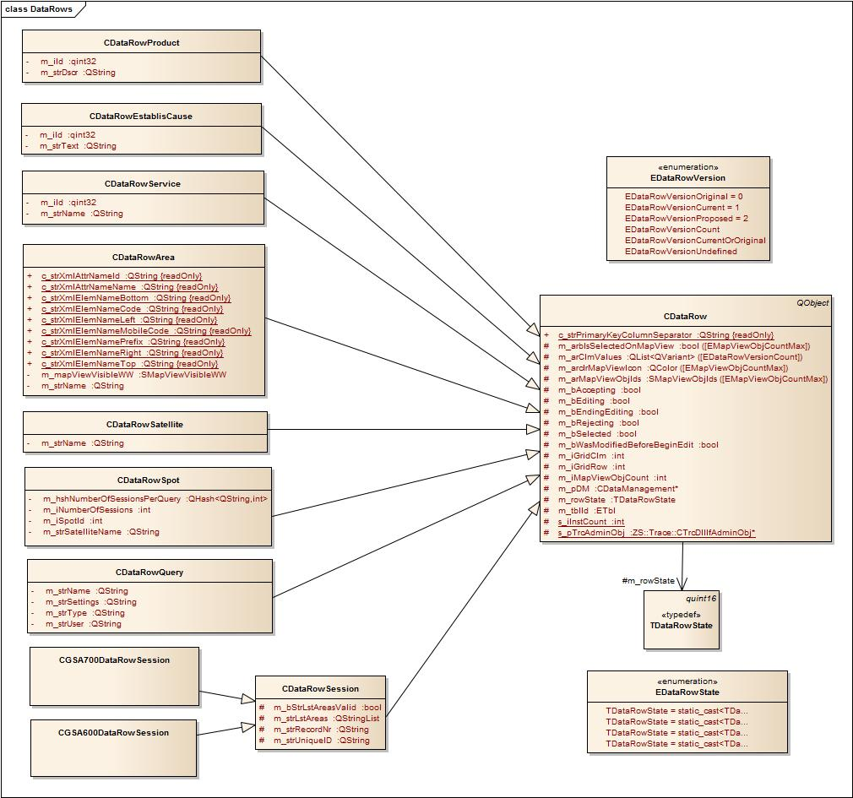

Class CDataRow

Type Definitions and Constants

enum EDataRowState (public)
This enumeration allows a bitwise combination. But not all combinations are possible. E.g. a detached row is not added to its data row collection whereas an added row is not detached from its data row collection.

Detached  (0x0001) | The row has been created but is not part of any DataRowCollection. A DataRow is in this state immediately after it has been created and before it is added to a collection, or if it has been removed from a collection.
Added  (0x0002) | The row has been added to a DataRowCollection and acceptChanges has not been called. Data rows are marked as "Added" to indicate that they have not yet been inserted in the database.
Deleted  (0x0004) | The row is marked to be deleted and the row is still part of a DataRowCollection. "acceptChanges" does not reset the Deleted state. To accept the deletion of a data row the row must be removed from its data row collection and destroyed afterwards. Data rows are marked as "Deleted" to indicate that they are still inserted in the database but got to be deleted on updating the table in the database.
Modified  (0x0008) | The row has been modified and acceptChanges has not been called.

enum EDataRowVersion (public)
The DataRowVersion values are used when retrieving the value found in a DataRow using getClmValue.

The DataRowVersion informs you what version of a DataRow exists. Versions change under the following circumstances:

- After calling the DataRow's beginEdit method, if you change the value, the Current and Proposed values become available.
- After calling the DataRow's cancelEdit method, the Proposed value is deleted.
- After calling the DataRow's endEdit method, the Proposed value becomes the Current value.
- After calling the DataRow's acceptChanges method, the Original value becomes identical to the Current value.
- After calling the DataRow's rejectChanges method, the Proposed value is discarded, and the version becomes Current.

EDataRowVersionOriginal | The row contains its original values (accepted by database).
EDataRowVersionCurrent | The current column value of a data row depend on the state of the data row (row state, edit mode).
EDataRowVersionProposed | The row contains a proposed value.
EDataRowVersionCurrentOrOriginal | If the proposed value in edit mode should not be returned. The current value is preferred before the Original value.

Protected Instance Members
ETbl m_tblId
Range [0..ETblCount]
Id of the data table (see enum ETbl within the schema definition).

CDataManagement* m_pDM
Range [NULL, valid address]
If added to the data table this variable will be set to the parent data table.

TDataRowState m_rowState
Range [see enum EDataRowState above]
The row state indicates the current state of the data row (see enum EDataRowState above for details about the live cycle of a data row).

bool m_bSelected
As a matter of fact this is a user defined flag. But very often a single flag is sufficient and can be used to select or deselect a row. But note that this flag cannot be used if the data row is indicated in different table views with different selections. In those cases the select flag has to be kept and administered by the views (or selection objects assigned to the views).

bool m_bAccepting
This flag indicates that the method “acceptChanges” is currently in progress. On executing “acceptChanges” the current and proposed values of several columns may be changed in a loop by calling “setClmValue”. In this case it is not desired that the “clmValueChanged” signal is emitted for each “setClmValue” call but instead after applying “acceptChanges” one signal “clmValuesChanged” should be emitted. This flag is also used to indicate that the data rows current values are synchronized with the database and that the data row has been added to the corresponding “Modify” query.

bool m_bRejecting
This flag indicates that the method call "rejectChanges" is in progress. On executing “rejectChanges” the proposed value of several columns may be changed in a loop by calling “setClmValue” but that its not desired that the signal “clmValueChanged” is emitted for each column.

bool m_bEditing
Indicates that the data row is currently being edited. “setClmValue” calls as default modify the proposed column values.

bool m_bWasModifiedBeforeBeginEdit
This flag is set if “beginEdit” is called and is used to restore the data row state correspondingly if the edit session ends.

bool m_bEndingEditing
This flag indicates that the method call "endEdit" is in progress. On executing “endEdit” the proposed value of several columns may be changed in a loop by calling “setClmValue” but that its not desired that the signal “clmValueChanged” is emitted for each column.

QList<QVariant> m_arClmValues[EDataRowVersionCount]
A data row consists of several column values. Each of the is stored as a QVariant object in three different versions:
A proposed value if the data row is beeing edited. Proposed values become the current values if the edit session ends.
A current value if the data row has changes which are not yet snynchronized with the database.
An original value if the data row has been synchronized with the database.

Please note that all map view variables don’t really belong to data row class but should be kept and administered by a corresponding map view data object which is assigned to the data row if the object is indicated on map view. This implies that the map view variables are only used by those data rows which may be indicated on map view (Areas and Sessions). So the data row class is not generic but a specific implementation for the AnalysisCenterGSA application.

int m_iMapViewObjCount
Range [0..EMapViewobjCountMax]
Some objects may be composed of several graphical objects to be indicated on mapview. E.g. in former map view version it was necessary to draw two objects if the object to be shown on mapview has parts on the left and right side of the Antimeridian (date line).

SMapViewObjIds m_arMapViewObjIds[EMapViewObjCountMax]
If the data row is indicated on map view the id of the different graphical objects is stored in this struct.

bool m_arbIsSelectedOnMapView[EMapViewObjCountMax]
Indicates whether the object is selected on map view.

QColor m_arclrMapViewIcon[EMapViewObjCountMax]
Only used for session data rows.

int m_iGridRow
int m_iGridClm
Range [0..N]
If session data rows are indicated on mapview using a density grid the Row and Clm variables define the grid cell of the data row.

Contructor(s)

Destructor

Subsystem Data::Queries

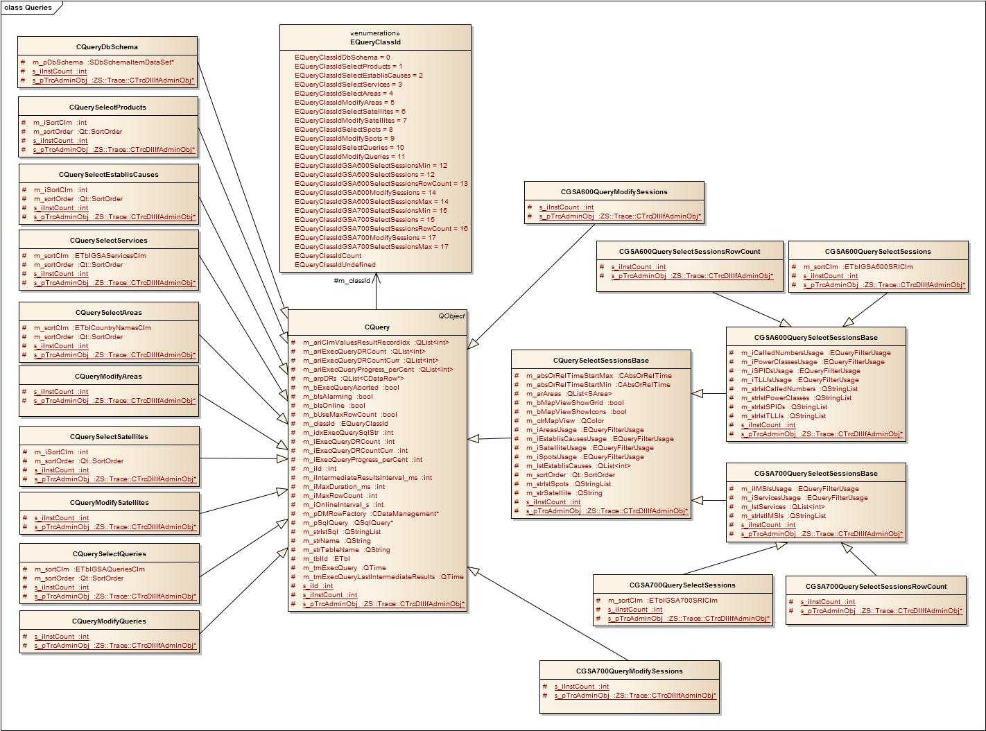

Class CQuery

Protected Instance Members
EQueryClassId m_classId
Range [0..EQueryClassIdCount]
Each class derived from CQuery gets its own class id. Some other classes executing queries may need to detect the type of executed queries during runtime.

ETbl m_tblId
Range [ETblUndefined, 0..ETblCount]
Id of the data table (see enum ETbl within the schema definition) for which the query has been executed. May also be set to ETblUndefined (e.g. for DbSchema-Query or queries to execute a SQL command which have not created by data tables or the data set).

QString m_strTableName
Range [empty string, name of the data table]
Name of the data table (mainly used for debugging and trace).

QString m_strName
Range [0..N]
Name of the query. Usually the class name of the query. But for session queries names are assigned by the user.

int m_iId
Range [0..INT_MAX]
Each query gets its own unique Id. This Id may also be used as a request id.

CDataManagement* m_pDMRowFactory
Range [NULL, valid address to data table object]
On receiving the results for a select query for each reported record a data row is created and the reported values are stored in those data rows as column values. The data tables are designed as data row factories and in order to create the correct data row classes a valid reference to the corresponding data table object must be provided.

int m_iIntermediateResultsInterval_ms
Range [-1, 0..N]
If set to a value greater than 0 long duration queries may report intermediate results in the specified interval.

int m_iMaxDuration_ms
Range [-1, 0..N]
If set to a value greater than 0 a query is aborted if its duration exceeds this maximum time.

bool m_bIsOnline
true for online queries. Online queries are repeated in a specfied interval.

bool m_bIsAlarming
true if an alarm should be triggered (a sound played by the PC speaker) if a query reports new data rows.

bool m_bUseMaxRowCount
Specifies whether the number of reported data records (data rows) should be limited.

int m_iMaxRowCount
Range [-1, 0..N]
If UseMaxRowCount is set to true this variable defines the maximum number of data records (data rows) which should be reported by a query.

int m_iOnlineInterval_s
Range [-1, 0..N]
If IsOnline is set to true this variable defines the interval in which online queries are repeated. As a matter of fact this is not the real interval but the distance between two queries (a query may take longer than the specfied online interval).

QStringList m_strlstSql
Query objects are designed to execute several SQL commands. E.g. for Modify queries it may be necessary to insert several records (data rows) at once. For each of those records an own INSERT SQL statement is generated (as a matter of fact the query command object internally sends the SQL commands one after another to the database).

QList<int> m_ariClmValuesResultRecordIdx
Data rows contain a collection of column values and each column may be accessed using an index. As some table columns may not exist in the database the column index of the data rows column value collection may be different from the column id as defined in the schema header file. The resulting index is stored in this list. Example:
Schema definition in header file | Schema of the table in the database
ClmName = 0 | NAME = 0
ClmDscr = 1 | DSCR = 1
ClmStrange = 2 | TYPE = 2
ClmType = 3 | ANY = 3
ClmAny = 4
As Column “Strange” is not existing in the database the SQL statement
SELECT NAME, DSCR, TYPE, ANY FROM ….
is created an the ClmValuesResultRecordIdx contains the values [0, 1, -1, 2, 3]. This means that the column value for column “Strange” is not available and that the column value for column “Type” is found at index 2 of the result record set of the SQL query:
idxClmValDataRow = 3 (ClmType)
idxClmValSqlRecord = 2 (TYPE)
DataRow.setClmValue( 3, sqlRecord.getVal(2) )

QSqlQuery* m_pSqlQuery
Range [NULL, valid address]
Qt’s query object which will be created on starting the query.

bool m_bExecQueryAborted
To abort a long duration query this flag is set to true by method “abortExec”. The result of the query is evaluted in a while loop (“while m_pSqlQuery->next”). This while loop is aborted if this flag is set to true.

int m_idxExecQuerySqlStr
Range [0..N]
As mentioned query objects are designed to execute several SQL commands. Here the current index of the executed SQL command in list “m_strlstSql” is stored.

int m_iExecQueryProgress_perCent
Range [0..100]
Queries may provide intermediate results and are paused if they have sent an indication message to report the intermediate results. This variable keeps the current progress over all SQL commands.

int m_iExecQueryDRCount
Range [0..N]
Before executing a SELECT query the number of expected records will be queries from the database (using SELECT COUNT(*) statement). The number of expected result records (data rows) is stored here.

int m_iExecQueryDRCountCurr
Range [0..N]
Number of currently processed result records.

QList<int> m_ariExecQueryProgress_perCent
Range [0..N]
As mentioned query objects may execute several SQL commands. Each of those commands may provide intermediate results and therefore has its own progress.

QList<int> m_ariExecQueryDRCount
Range [0..N]
As mentioned query objects may execute several SQL commands. Each of those commands may provide intermediate results and therefore has its own number of expected result records.

QList<int> m_ariExecQueryDRCountCurr
Range [0..N]
As mentioned query objects may execute several SQL commands. Each of those commands may provide intermediate results and therefore has its own number of curently processed result records.

QTime m_tmExecQuery
Range [0..N]
Time object to measure the total time elapsed since the query has been initially started.

QTime m_tmExecQueryLastIntermediateResults
Range [0..N]
Time object to measure the time elapsed since the last time a paused query has been restarted.

QList<CDataRow*> m_arpDRs
Range [0..N]
Results Set. Empty array for SELECT COUNT(*) queries. Result array for SELECT queries. Rows to be modified for UPDATE, INSERT or DELETE queries.

Contructor(s)

Destructor

Subsystem External

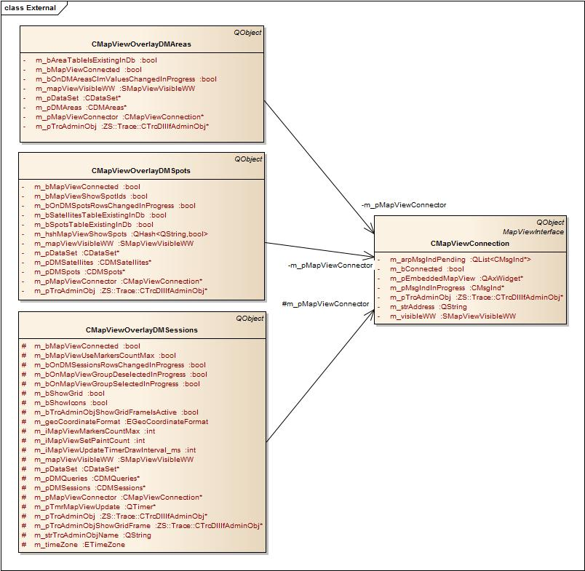

Subsystem GUI

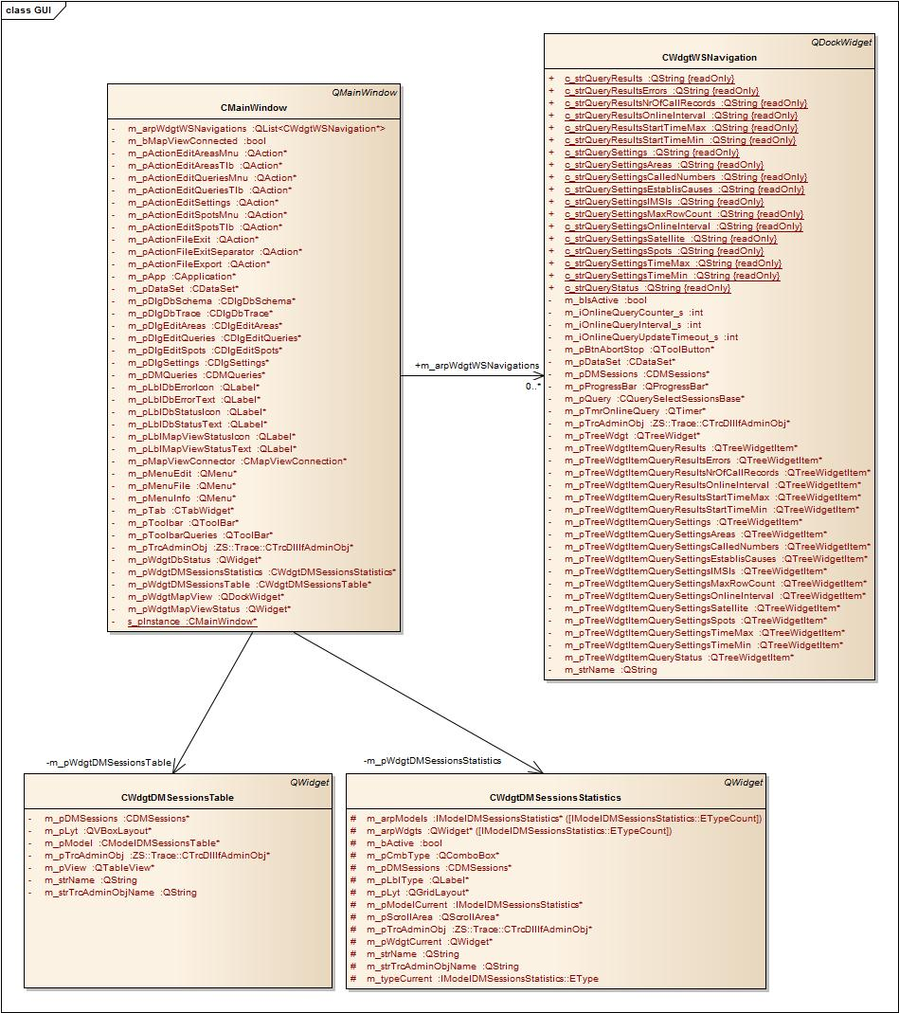

Subsystem Common

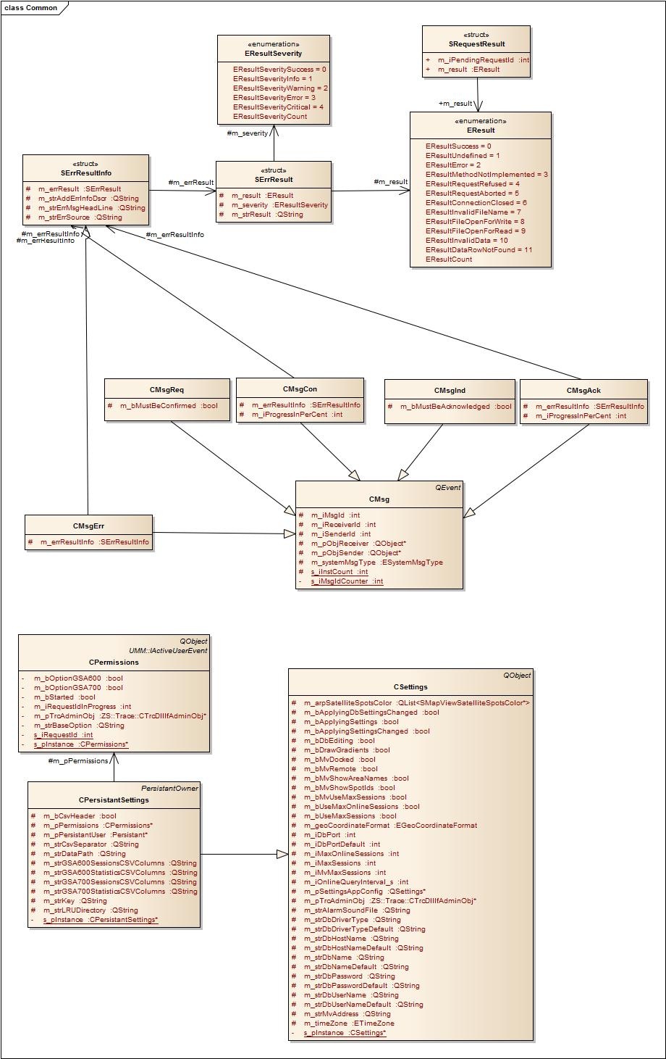

How-To Manual
The How-To Manual section should help developers adding new features.

Supporting an Additional Session Table Data Column
One of the most common features which have to be added is extended the GSA session tables with an addition column.

The code is not that generic that by simply defining the column in the database’s session table the application adapts itself automatically to support the new column.

Assuming the GSA700 Session Table has to be extended by column SPID (Service Provider ID) the following tasks would have to be performed:

Add the Column to the Schema Definition of the Application
Insert a column id in the corresponding enumeration (changes are marked in red color).

File: “Include\Data\Schema\ACGSASchema.h”

// Table ETblGSA700SRI (GSA700_SRI_TBL):
//------------------------------------------------------------------------------

typedef enum // ColumnName | Comment
{ //----------------------+-------------------------------
ETblGSA700SRIClmId = 0, // GSA700_ID | Primary key
ETblGSA700SRIClmRecNo = 1, // GSA700_RECNO | Record number
ETblGSA700SRIClmStartTime = 2, // STARTTIME | Time of interception
ETblGSA700SRIClmIMSI = 3, // IMSI | IMSI
ETblGSA700SRIClmGPSPosLat = 4, // GPS_LATITUDE | GPS position latitude
ETblGSA700SRIClmGPSPosLon = 5, // GPS_LONGITUDE | GPS position longitude
ETblGSA700SRIClmEstablisCause = 6, // ESTABLISHMENT_CAUSE | Refers to table GSA_QESTABLIS_CAU..
ETblGSA700SRIClmSatName = 7, // SAT_NAME | Refers to table GSA_SATELLITES_TBL
ETblGSA700SRIClmSpot = 8, // SPOT | Refers to table GSA_SPOTS_TBL
ETblGSA700SRIClmSPID = 9, // SPID | Service provider ID
ETblGSA700SRIClmServiceId = 10, // SERVICE_ID | Refers to table GSA700_SERVICE_TBL
ETblGSA700SRIClmCount,
ETblGSA700SRIClmUndefined
} ETblGSA700SRIClm;

For the next steps to be taken you can simply search for ETblGSA700SRIClmSpot in all files belonging to the visual studio project. You will get a list of files which very likely need to be changed.

Next step is to provide the strings (column names) in the Schema.

File: “Source\Data\Schema\ACGSASchema.cpp”

/* Table GSA700_SRI_TBL: Column Names
------------------------------------------------------------------------------*/

const QString s_arstrTblGSA700SRIDbClmNames[ETblGSA700SRIClmCount] = {
/* 0: ETblGSA700SRIClmId */ "GSA700_ID",
/* 1: ETblGSA700SRIClmRecNo */ "GSA700_RECNO",
/* 2: ETblGSA700SRIClmStartTime */ "STARTTIME",
/* 3: ETblGSA700SRIClmIMSI */ "IMSI",
/* 4: ETblGSA700SRIClmGPSPosLat */ "GPS_LATITUDE",
/* 5: ETblGSA700SRIClmGPSPosLon */ "GPS_LONGITUDE",
/* 6: ETblGSA700SRIClmEstablisCause */ "ESTABLISHMENT_CAUSE",
/* 7: ETblGSA700SRIClmSatName */ "SAT_NAME",
/* 8: ETblGSA700SRIClmSpot */ "SPOT",
/* 9: ETblGSA700SRIClmSPID */ "SPID",
/* 10: ETblGSA700SRIClmServiceId */ "SERVICE_ID"
};

const QString s_arstrTblGSA700SRIViewClmNames[ETblGSA700SRIClmCount] = {
/* 0: ETblGSA700SRIClmId */ "Id",
/* 1: ETblGSA700SRIClmRecNo */ "Record Number",
/* 2: ETblGSA700SRIClmStartTime */ "Start Time",
/* 3: ETblGSA700SRIClmIMSI */ "IMSI",
/* 4: ETblGSA700SRIClmGPSPosLat */ "Latitude",
/* 5: ETblGSA700SRIClmGPSPosLon */ "Longitude",
/* 6: ETblGSA700SRIClmEstablisCause */ "Establishment Cause",
/* 7: ETblGSA700SRIClmSatName */ "Satellite",
/* 8: ETblGSA700SRIClmSpot */ "Spot",
/* 9: ETblGSA700SRIClmSPID */ "Provider ID",
/* 10: ETblGSA700SRIClmServiceId */ "Service"
};

If you recompile and start the analysis center and run a GSA700 query the column “Provider ID” is – not yet visible in the session table view.

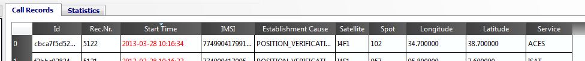

But if you open the schema dialog via “Edit – Settings – Database – Schema” (requires that “ShowDbSchema=true” is set in the ini file) you will see the newly defined column and a flag whether this column is defined in the database.

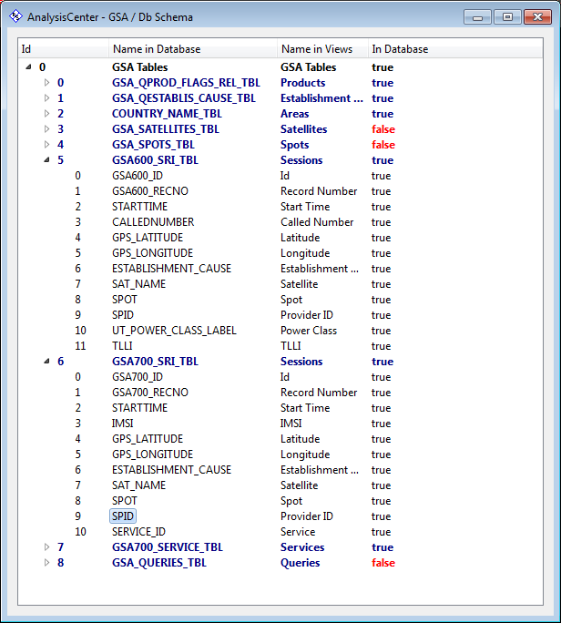

Indicate the Column in the Session’s Table View
Session tables are indicated using Qt’s model view architecture. Which columns are indicated by the table view must be defined in the model class. Both for GSA600 as well as for GSA700 sessions the model class “CModelDMSessionsTable” is used. Very similar to the enumeration in the database schema usually you would have to add e enum value within the model class. But in our example the column SPID is already existing in the GSA600 session table and column 9 was used to indicate either GSA600:SPID or GSA700:SERVICE_ID. This has to be changed now as follows:

File: “Include\GUI\ACGSAModelDMSessionsTable.h”

typedef enum // Database ColumnName
{ //-----------------------------------------
EClmId = 0, // GSA600_ID | GSA700_ID
EClmRecNo = 1, // GSA600_RECNO | GSA700_RECNO
EClmStartTime = 2, // STARTTIME
EClmCalledNumberOrIMSI = 3, // CALLEDNUMBER | IMSI
EClmEstablisCause = 4, // ESTABLISHMENT_CAUSE
EClmSatellite = 5, // SAT_NAME
EClmSpot = 6, // SPOT
EClmGPSPosLon = 7, // GPS_LONGITUDE
EClmGPSPosLat = 8, // GPS_LATITUDE
EClmSPID = 9, // SPID
EClmPowerClassOrServiceId = 10, // UT_POWER_CLASS_LABEL | SERVICE_ID
EClmTLLI = 11, // TLLI
EClmCount,
EClmUndefined
} EClm;

Also the conversion tables for GSA700 have to be adapted to the new columns (for GSA600 only the comments have been changed):

File: “Source\GUI\ACGSAModelDMSessionsTable.cpp”

const QString s_arstrGSA600ClmNames[CModelDMSessionsTable::EClmCount] = {
/* 0 EClmId */ "Id",
/* 1 EClmRecNo */ "Rec.Nr.",
/* 2 EClmStartTime */ "Start Time",
/* 3 EClmCalledNumberOrIMSI */ "Called Number",
/* 4 EClmEstablisCause */ "Establishment Cause",
/* 5 EClmSatellite */ "Satellite",
/* 6 EClmSpot */ "Spot",
/* 7 EClmGPSPosLon */ "Longitude",
/* 8 EClmGPSPosLat */ "Latitude",
/* 9 EClmSPID */ "Serv.Prov.Id",
/* 10 EClmPowerClassOrServiceId */ "Power Class",
/* 11 EClmTLLI */ "TLLI"
};

const ETblGSA600SRIClm s_ariGSA600DbClmIds[CModelDMSessionsTable::EClmCount] = {
/* 0 EClmId */ ETblGSA600SRIClmId,
/* 1 EClmRecNo */ ETblGSA600SRIClmRecNo,
/* 2 EClmStartTime */ ETblGSA600SRIClmStartTime,
/* 3 EClmCalledNumberOrIMSI */ ETblGSA600SRIClmCalledNumber,
/* 4 EClmEstablisCause */ ETblGSA600SRIClmEstablisCause,
/* 5 EClmSatellite */ ETblGSA600SRIClmSatName,
/* 6 EClmSpot */ ETblGSA600SRIClmSpot,
/* 7 EClmGPSPosLon */ ETblGSA600SRIClmGPSPosLon,
/* 8 EClmGPSPosLat */ ETblGSA600SRIClmGPSPosLat,
/* 9 EClmSPID */ ETblGSA600SRIClmSPID,
/* 10 EClmPowerClassOrServiceId */ ETblGSA600SRIClmPowerClass,
/* 11 EClmTLLI */ ETblGSA600SRIClmTLLI
};

const QString s_arstrGSA700ClmNames[CModelDMSessionsTable::EClmCount] = {
/* 0 EClmId */ "Id",
/* 1 EClmRecNo */ "Rec.Nr.",
/* 2 EClmStartTime */ "Start Time",
/* 3 EClmCalledNumberOrIMSI */ "IMSI",
/* 4 EClmEstablisCause */ "Establishment Cause",
/* 5 EClmSatellite */ "Satellite",
/* 6 EClmSpot */ "Spot",
/* 7 EClmGPSPosLon */ "Longitude",
/* 8 EClmGPSPosLat */ "Latitude",
/* 9 EClmSPID */ "Serv.Prov.Id",
/* 10 EClmPowerClassOrServiceId */ "Service",
/* 11 EClmTLLI */ ""
};

const ETblGSA700SRIClm s_ariGSA700DbClmIds[CModelDMSessionsTable::EClmCount] = {
/* 0 EClmId */ ETblGSA700SRIClmId,
/* 1 EClmRecNo */ ETblGSA700SRIClmRecNo,
/* 2 EClmStartTime */ ETblGSA700SRIClmStartTime,
/* 3 EClmCalledNumberOrIMSI */ ETblGSA700SRIClmIMSI,
/* 4 EClmEstablisCause */ ETblGSA700SRIClmEstablisCause,
/* 5 EClmSatellite */ ETblGSA700SRIClmSatName,
/* 6 EClmSpot */ ETblGSA700SRIClmSpot,
/* 7 EClmGPSPosLon */ ETblGSA700SRIClmGPSPosLon,
/* 8 EClmGPSPosLat */ ETblGSA700SRIClmGPSPosLat,
/* 9 EClmSPID */ ETblGSA700SRIClmSPID,
/* 10 EClmPowerClassOrServiceId */ ETblGSA700SRIClmServiceId,
/* 11 EClmTLLI */ ETblGSA700SRIClmUndefined
};

As SPID now belongs to both GSA600 and GSA700 session data rows the column value access method “getSPID” has to be declared pure virtual in base class “CDataRowSession” and has to be implemented in both derived classes ( “CGSA600SessionDataRow” and “CGSA700SessionDataRow”). The data method of the model must look like:

//------------------------------------------------------------------------------
QVariant CModelDMSessionsTable::data( const QModelIndex& i_modelIdx, int i_iRole ) const
//------------------------------------------------------------------------------
{
..
case EClmSPID:
{
if( i_iRole == SortRole || i_iRole == Qt::DisplayRole
|| i_iRole == Qt::UserRole || i_iRole == Qt::EditRole )
{
if( pDRSession != NULL )
{
varData = pDRSession->getSPID();
}
}
break;
}
case EClmPowerClassOrServiceId:
{
if( i_iRole == SortRole || i_iRole == Qt::DisplayRole || i_iRole == Qt::UserRole )
{
if( pDRSession600 != NULL )
{
varData = pDRSession600->getPowerClass();
}
else if( pDRSession700 != NULL )
{
CDMServices* pDMServices = CDataSet::instance()->getDMServices();

if( pDMServices != NULL )
{
varData = pDMServices->serviceId2Str(pDRSession700->getServiceId());
}
else
{
varData = pDRSession700->getServiceId();
}
}
}
break;
}

..

} // data

Also the “flags” method has to be changed a little bit:

//------------------------------------------------------------------------------
Qt::ItemFlags CModelDMSessionsTable::flags( const QModelIndex& i_modelIdx ) const
//------------------------------------------------------------------------------
{
..
case EClmSPID:
{
flags = Qt::ItemIsEnabled | Qt::ItemIsSelectable | Qt::ItemIsEditable;
break;
}
case EClmPowerClassOrServiceId:
{
break;
}
..

} // flags

As already mentioned SPID now belongs to both GSA600 and GSA700 session data rows and the access method “getSPID” has to be declared pure virtual in base class “CSessionDataRow” and has to be implemented in the derived classes “CGSA600SessionDataRow” and “CGSA700SessionDataRow”:

File: “Include\GUI\ACGSASessionDataRow.h”

Pure virtual method “getSPID” has to be added.

File: “Include\GUI\ACGSA600SessionDataRow.h”

Method “getSPID” has to be declared “virtual”.

File: “Source\GUI\ACGSA600SessionDataRow.cpp”

Method “getSPID” has to be removed.

File: “Include\GUI\ACGSA700SessionDataRow.h”

Virtual method “getSPID” has to be added..

File: “Source\GUI\ACGSA600SessionDataRow.cpp”

Method “getSPID” has to be implemented..

If you recompile and start the analysis center and run a GSA700 query the column “Serv. Prov. Id.” is visible in the session table view.

Provide Statistic for the Column.
It doesn’t really make sense to add a statistic “Activities per Service Provider Id” as this is very likely not needed. But it makes sense to show you how such a statistic would have to be implemented if it would be needed. So we are going to implement a pie chart in the General statistics view and the output of the new statistic should look similar to the statistics “Activities per Service Type” and “Activities per Power Class”.

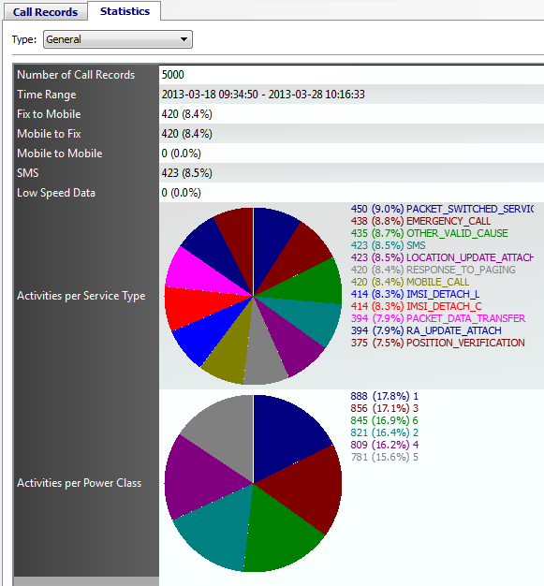

Statistics are made over the results of a session query and therefore belong to the corresponding session data table.

File: “Include\Data\DataManagement\ACGSADMSessions.h”

The name of the statistic has to be defined as follows:

static const QString& c_strNameStatisticActivitiesPerArea = "Activities per Area";
static const QString& c_strNameStatisticActivitiesPerSPID = "Activities per Serv.Prov.Id";
static const QString& c_strNameStatisticActivitiesPerService = "Activities per Service";

Add the new statistic type to the enumeration in class CDMSessions:

typedef enum
{ // following statistics will be exported in the same csv file (general statistics)
EStatisticTypeGeneralMin = 0, // !! MUST REMAIN 0 !!
EStatisticTypeGeneralExportMin = 0, // !! MUST REMAIN 0 !!
EStatisticTypeNumberOfCallRecords = 0, // Single numeric value in general tab
EStatisticTypeTimeRange = 1, // Single numeric value in general tab
EStatisticTypeFix2Mobile = 2, // Single numeric value in general tab
EStatisticTypeMobile2Fix = 3, // Single numeric value in general tab
EStatisticTypeMobile2Mobile = 4, // Single numeric value in general tab
EStatisticTypeSMS = 5, // Single numeric value in general tab
EStatisticTypeLowSpeedData = 6, // Single numeric value in general tab
EStatisticTypeGeneralExportMax = 6,
// following statistics will be exported in a separated csv file (graphical statistics)
EStatisticTypeActivitiesPerEstablisCause = 7, // Pie chart shown in general statistic tab
EStatisticTypeActivitiesPerPowerClass = 8, // Pie chart shown in general statistic tab
EStatisticTypeActivitiesPerService = 9, // Pie chart shown in general statistic tab
EStatisticTypeActivitiesPerSPID = 10, // Pie chart shown in general statistic tab
EStatisticTypeGeneralMax = 10,
EStatisticTypeGeneralCount = (EStatisticTypeGeneralMax-EStatisticTypeGeneralMin+1),
EStatisticTypeActivitiesPerSatellite = 11, // Diagram only
EStatisticTypeActivitiesPerSpot = 12, // Diagram only
EStatisticTypeActivitiesPerTimeSlice = 13, // Diagram only
EStatisticTypeActivitiesPerArea = 14, // Diagram only
EStatisticTypeCalls2Areas = 15, // not yet implemented
EStatisticTypeCount,
EStatisticTypeUndefined
} EStatisticType;

Add method declaration to get the results of the new statistic type:

QHash<QString,int> getNumberOfSessionsPerService();
QHash<QString,int> getNumberOfSessionsPerSPID();

And the necessary instance members to store the results of the statistic:

QHash<QString,int> m_hshStatisticResultNumberOfSessions2Area;
bool m_bStatisticResultNumberOfSessionsPerServiceValid;
QHash<QString,int> m_hshStatisticResultNumberOfSessionsPerService;
bool m_bStatisticResultNumberOfSessionsPerSPIDValid;
QHash<QString,int> m_hshStatisticResultNumberOfSessionsPerSPID;

File: “Source\Data\DataManagement\ACGSADMSessions.cpp”

Add the defined statistic name to the list of names:

const QString CDMSessions::s_arstrStatisticTypeNames[EStatisticTypeCount] =
{
/* 0: NumberOfCallRecords */ c_strNameStatisticNumberOfCallRecords,
/* 1: TimeRange */ c_strNameStatisticTimeRange,
/* 2: Fix2Mobile */ c_strNameStatisticFix2Mobile,
/* 3: Mobile2Fix */ c_strNameStatisticMobile2Fix,
/* 4: Mobile2Mobile */ c_strNameStatisticMobile2Mobile,
/* 5: SMS */ c_strNameStatisticSMS,
/* 6: LowSpeedData */ c_strNameStatisticLowSpeedData,
/* 7: ActivitiesPerEstablisCause */ c_strNameStatisticActivitiesPerEstablisCause,
/* 8: ActivitiesPerPowerClass */ c_strNameStatisticActivitiesPerPowerClass,
/* 9: ActivitiesPerService */ c_strNameStatisticActivitiesPerService,
/* 10: ActivitiesPerSPID */ c_strNameStatisticActivitiesPerSPID,
/* 11: ActivitiesPerSatellite */ c_strNameStatisticActivitiesPerSatellite,
/* 12: ActivitiesPerSpot */ c_strNameStatisticActivitiesPerSpot,
/* 13: ActivitiesPerArea */ c_strNameStatisticActivitiesPerArea,
/* 14: Calls2Areas */ c_strNameStatisticCalls2Areas,
/* 15: ActivitiesPerTimeSlice */ c_strNameStatisticActivitiesPerTimeSlice
};

Initialization of the new instance members in the ctor:

m_hshStatisticResultNumberOfSessions2Area(),
m_bStatisticResultNumberOfSessionsPerServiceValid(true),
m_hshStatisticResultNumberOfSessionsPerService(),
m_bStatisticResultNumberOfSessionsPerSPIDValid(true),
m_hshStatisticResultNumberOfSessionsPerSPID()

During runtime the instance member “m_arbStatisticTypesAvailabilities” of class “CDMSessions” indicates whether a specific statistic type is available or not. The elements of this array are set according to whether necessary tables or columns exist in the database. This array is initialized by method “initStatisticsAvailabilities” and we have to add a flag for our new statistic type as follows:

//------------------------------------------------------------------------------
void CDMSessions::initStatisticsAvailabilities()
//------------------------------------------------------------------------------
{
ETbl tblSession = ETblUndefined;
int clmEstablisCause = -1;
int clmPowerClass = -1;
int clmSatName = -1;
int clmSpot = -1;
int clmLatitude = -1;
int clmLongitude = -1;
int clmServiceId = -1;
int clmSPID = -1;

if( CDataSet::instance()->isDataSetFilled() )
{
tblSession = m_tbl;

if( tblSession == ETblGSA600SRI )
{
clmEstablisCause = GSA::ETblGSA600SRIClmEstablisCause;
clmPowerClass = GSA::ETblGSA600SRIClmPowerClass;
clmSatName = GSA::ETblGSA600SRIClmSatName;
clmSpot = GSA::ETblGSA600SRIClmSpot;
clmLatitude = GSA::ETblGSA600SRIClmGPSPosLat;
clmLongitude = GSA::ETblGSA600SRIClmGPSPosLon;
clmServiceId = -1;
clmSPID = GSA::ETblGSA600SRIClmSPID;
}
else if( tblSession == ETblGSA700SRI )
{
clmEstablisCause = GSA::ETblGSA700SRIClmEstablisCause;
clmPowerClass = -1;
clmSatName = GSA::ETblGSA700SRIClmSatName;
clmSpot = GSA::ETblGSA700SRIClmSpot;
clmLatitude = GSA::ETblGSA700SRIClmGPSPosLat;
clmLongitude = GSA::ETblGSA700SRIClmGPSPosLon;
clmServiceId = GSA::ETblGSA700SRIClmServiceId;
clmSPID = GSA::ETblGSA700SRIClmSPID;
}
}

if( tblSession == ETblUndefined )
{
memset( m_arbStatisticTypeAvailabilities, false, sizeof(m_arbStatisticTypeAv..) );
m_iStatisticTypeAvailableCount = -1;
}
else
{
if( m_iStatisticTypeAvailableCount < 0 )
{
bool bTblCountriesExist = false;
int idx;

if( CDataSet::instance()->getDbSchemaModel()->isTab..InDb(GSA::ETblCountryNames) )
{
bTblCountriesExist = true;
}

m_arbStatisticTypeAv..ties[EStatisticTypeNumberOfCallRecords] = true;
..
m_arbStatisticTypeAv..ties[EStatisticTypeActivitiesPerService] = false;
m_arbStatisticTypeAv..ties[EStatisticTypeActivitiesPerSPID] = false;
m_arbStatisticTypeAv..ties[EStatisticTypeActivitiesPerSatellite] = false;
..
m_arbStatisticTypeAv..ties[EStatisticTypeCalls2Areas] = false;

..
if( CDataSet::instance()->getDbSchemaModel()->isCol..(tblSession,clmServiceId) )
{
m_arbStatisticTypeAvailabilities[EStatisticTypeActivitiesPerService] = true;
}
if( CDataSet::instance()->getDbSchemaModel()->isCol..(tblSession,clmSPID) )
{
m_arbStatisticTypeAvailabilities[EStatisticTypeActivitiesPerSPID] = true;
}

m_iStatisticTypeAvailableCount = 0;

for( idx = 0; idx < _ZSArrLen(m_arbStatisticTypeAvailabilities); idx++ )
{
if( m_arbStatisticTypeAvailabilities[idx] )
{
m_iStatisticTypeAvailableCount++;
}
}
}
}

} // initStatisticsAvailabilities

Reset the validity flag in method “invalidateStatisticResults”:

//------------------------------------------------------------------------------
void CDMSessions::invalidateStatisticResults()
//------------------------------------------------------------------------------
{
m_bStatisticResultTimeRangeValid = false;
..
m_bStatisticResultNumberOfSessionsPerServiceValid = false;
m_bStatisticResultNumberOfSessionsPerSPIDValid = false;

} // invalidateStatisticResults

Implement the algorithm to provide the result of the statistic in method “getNumberOfSessionsPerSPID” very similar as implemented for “getNumberOfSessionsPerService”. First it will be checked whether the last results are still valid (if in the meantime new session rows have been received the statistic results are invalidated by calling the method “invalidateStatisticResults”). If the statistic results need to be updated the result array (a hash) will be cleared. For each different Service Provider Id an entry in this hash table is created (if not yet added to the hash) and incremented (the key is the Service Provider Id, the value is the number of sessions per Provider Id). After the results have been calculated the validity flag is set to true.

//------------------------------------------------------------------------------
QHash<QString,int> CDMSessions::getNumberOfSessionsPerSPID()
//------------------------------------------------------------------------------
{
if( !m_bStatisticResultNumberOfSessionsPerSPIDValid )
{
m_hshStatisticResultNumberOfSessionsPerSPID.clear();

if( getRowCount() > 0 )
{
QString strSPID;
int iClmId = ETblGSA600SRIClmSPID;

if( m_tbl == ETblGSA700SRI )
{
iClmId = ETblGSA700SRIClmSPID;
}

for( idxSession = 0; idxSession < m_arpDRs.size(); idxSession++ )
{
pDRSession = dynamic_cast<CDataRowSession*>(m_arpDRs[idxSession]);

if( pDRSession != NULL )
{
if( pDRSession->isClmValueNull(iClmId) )
{
strSPID = "(null)";
}
else
{
strSPID = pDRSession->getSPID();
}
m_hshStatisticResultNumberOfSessionsPerSPID[strSPID]++;
}
}
}

m_bStatisticResultNumberOfSessionsPerSPIDValid = true;
}

return m_hshStatisticResultNumberOfSessionsPerSPID;

} // getNumberOfSessionsPerSPID

File: “Source\GUI\ACGSAModelDMSessionsStatisticsGeneral.cpp”

The result of general statistics is indicated in a table view and we need to add a row to the underlying model. For this we need to extend the method “setDMSessions” of class “CModelDMSessionsStatisticsGeneral” as follows:

//------------------------------------------------------------------------------
void CModelDMSessionsStatisticsGeneral::setDMSessions( CDMSessions* i_pDMSessions )
//------------------------------------------------------------------------------
{
..
case CDMSessions::EStatisticTypeActivitiesPerService:
{
addStatistic( c_strNameStatisticActivitiesPerService, activitiesPerService );
break;
}
case CDMSessions::EStatisticTypeActivitiesPerSPID:
{
addStatistic( c_strNameStatisticActivitiesPerSPID, activitiesPerSPID );
break;
}
..
}

The method “addStatistic” is called to add the new statistic. The first parameter is the name of the statistic and the second parameter is a pointer to a method which converts the result of the statistic from the session tables class hash table into a pixmap. The prototype of this function has to be declared as follows:

namespace AC
{
namespace GSA
{
static int numberOfSessions( ..AdminObj* i_pTrcAdminObj, CDMSessions* i_pDMSessions );
..
static QPixmap activitiesPerService( ..AdminObj* i_pTrcAdminObj, CDMSessions* i_pDMSessions );
static QPixmap activitiesPerSPID( ..AdminObj* i_pTrcAdminObj, CDMSessions* i_pDMSessions );

static QPixmap createPieChartSortedByQuantities( int i_iSessions_100_percent, .. );
..
} // namespace GSA

} // namespace AC

Implement the method “activitiesPerSPID” which is pretty much a copy of method “activitesPerService”:

//------------------------------------------------------------------------------
static QPixmap AC::GSA::activitiesPerSPID( ..Obj* i_pTrcAdminObj, CDMSessions* i_pDMSessions )
//------------------------------------------------------------------------------
{
..

QPixmap pxm;

QHash<QString,int> arSPIDs;

if( i_pDMSessions != NULL )
{
arSPIDs = i_pDMSessions->getNumberOfSessionsPerSPID();

if( arSPIDs.size() > 0 )
{
pxm = createPieChartSortedByQuantities( i_pDMSessions->getRowCount(), arSPIDs );
}
}

return pxm;

} // activitiesPerSPID

If you recompile and start the analysis center and run a GSA700 query the new statistic is available as a pie chart in the General statistics. In our example the column SPID is not

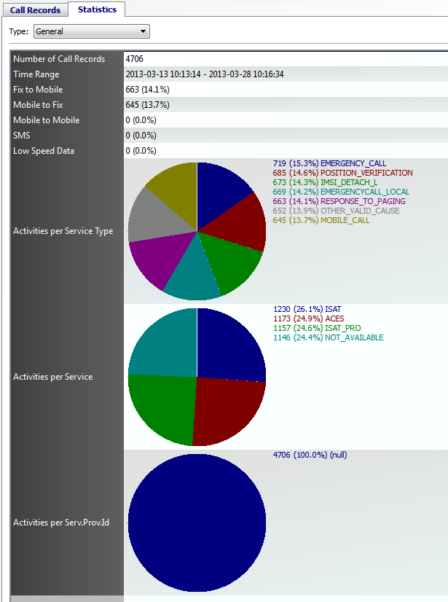

Export the result of the statistic

Opening the Export dialog you’ll see that the new column “Provider ID” is already indicated and supported for exporting the session data table (Data: “Call Records”).

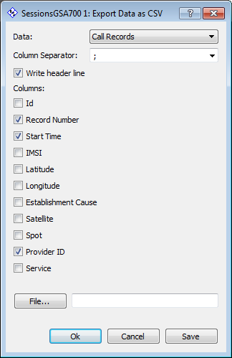

But on choosing Data: “Statistics” the new statistic type “Activities per Service Provider” is not yet available.

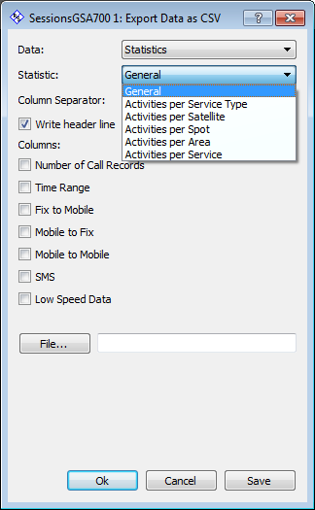

To support exporting the new statistic type we need to modify the Export Dialog. This is necessary as there is no 1 to 1 relation from the statistic types as defined in class “CDMSessions” and to the resulting export files. Part of the statistic results of the general statistics are stored in one file other general statistic results are stored in an own file. Generally speaking all statistic results creating an array of values (like the pie charts or the diagrams) are stored in an own file while the results with a single value (like “Fix to Mobile”, SMS”, etc.) are summarized in the same file.

File: “Include\GUI\ACGSADlgExport.h”

The new statistic type got to be added to the enumeration of statistic types in class “CDlgExport”:

typedef enum {
EStatisticTypeGeneral = 0,
EStatisticTypeActivitiesPerEstablisCause = 1,
EStatisticTypeActivitiesPerPowerClass = 2,
EStatisticTypeActivitiesPerSPID = 3,
EStatisticTypeActivitiesPerTimeSlice = 4,
EStatisticTypeActivitiesPerSatellite = 5,
EStatisticTypeActivitiesPerSpot = 6,
EStatisticTypeActivitiesPerArea = 7,
EStatisticTypeCalls2Areas = 8,
EStatisticTypeActivitiesPerService = 9,
EStatisticTypeCount,
EStatisticTypeUndefined
} EStatisticType;

File: “Source\GUI\ACGSADlgExport.cpp”

Add an entry to the conversion table between the dialogs statistic types and the session tables statistic types:

static const CDMSessions::EStatisticType s_ariDMStatisticTypes[CDlgExport::EStatisticTypeCount] = {
/* 0: General */ CDMSessions::EStatisticTypeNumberOfCallRecords,
/* 1: ActivitiesPerEstablisCause */ CDMSessions::EStatisticTypeActivitiesPerEstabl..,
/* 2: ActivitiesPerPowerClass */ CDMSessions::EStatisticTypeActivitiesPerPowerClass,
/* 3: ActivitiesPerSPID */ CDMSessions::EStatisticTypeActivitiesPerSPID,
#pragma message(__TODO__"Export of time slice statistic not yet supported. Need ...
/* 4: ActivitiesPerTimeSlice */ CDMSessions::EStatisticTypeUndefined,
/* 5: ActivitiesPerSatellite */ CDMSessions::EStatisticTypeActivitiesPerSatellite,
/* 6: ActivitiesPerSpot */ CDMSessions::EStatisticTypeActivitiesPerSpot,
/* 7: ActivitiesPerArea */ CDMSessions::EStatisticTypeActivitiesPerArea,
/* 8: Calls2Areas */ CDMSessions::EStatisticTypeCalls2Areas,
/* 9: ActivitiesPerService */ CDMSessions::EStatisticTypeActivitiesPerService
};

Add an entry for the combo box pull down list to select the statistic for being exported:

static QString s_arstrStatisticTypes[CDlgExport::EStatisticTypeCount] = {
/* 0: General */ c_strNameStatisticGeneral,
/* 1: ActivitiesPerEstablisCause */ c_strNameStatisticActivitiesPerEstablisCause,
/* 2: ActivitiesPerPowerClass */ c_strNameStatisticActivitiesPerPowerClass,
/* 3: ActivitiesPerSPID */ c_strNameStatisticActivitiesPerSPID,
/* 4: ActivitiesPerTimeSlice */ c_strNameStatisticActivitiesPerTimeSlice,
/* 5: ActivitiesPerSatellite */ c_strNameStatisticActivitiesPerSatellite,
/* 6: ActivitiesPerSpot */ c_strNameStatisticActivitiesPerSpot,
/* 7: ActivitiesPerArea */ c_strNameStatisticActivitiesPerArea,
/* 8: Calls2Areas */ c_strNameStatisticCalls2Areas,
/* 9: ActivitiesPerService */ c_strNameStatisticActivitiesPerService
};

In method “createCheckBoxesSelectColumn” add code lines to create a check box for selecting the column value:

//------------------------------------------------------------------------------
void CDlgExport::createCheckBoxesSelectColumns()
//------------------------------------------------------------------------------
{
..
else if( m_iStatisticTypeCurrent == EStatisticTypeActivitiesPerPowerClass )
{
pChkSelectColumn = new QCheckBox("Power Class");
}
else if( m_iStatisticTypeCurrent == EStatisticTypeActivitiesPerSPID )
{
pChkSelectColumn = new QCheckBox("Provider Id");
}
else if( m_iStatisticTypeCurrent == EStatisticTypeActivitiesPerTimeSlice )
..

} // createCheckBoxesSelectColumns

And add a case in the slot method of the save button:

//------------------------------------------------------------------------------
void CDlgExport::onBtnSaveClicked( bool )
//------------------------------------------------------------------------------
{
QString strSeparator = getSeparator();
bool bWithHeaders = getWithHeaders();
QStringList strlstColumns;
int idx;

CPersistantSettings::instance()->setCsvSeparator(strSeparator);
CPersistantSettings::instance()->setCsvHeader(bWithHeaders);

bool bSaveExportedColumns = false;

..
case EStatisticTypeActivitiesPerPowerClass:
{
result = m_pDMSessions->saveGraphicalStatistic(
/* statisticType */ CDMSessions::EStatisticTypeActivitiesPerPowerClass,
/* strFileName */ m_strFileName,
/* strlstColumns */ strlstColumns,
/* strSeparator */ strSeparator,
/* bWithHeaders */ bWithHeaders );
break;
}
case EStatisticTypeActivitiesPerSPID:
{
result = m_pDMSessions->saveGraphicalStatistic(
/* statisticType */ CDMSessions::EStatisticTypeActivitiesPerSPID,
/* strFileName */ m_strFileName,
/* strlstColumns */ strlstColumns,
/* strSeparator */ strSeparator,
/* bWithHeaders */ bWithHeaders );
break;
}
case EStatisticTypeActivitiesPerTimeSlice:
{
result = m_pDMSessions->saveGraphicalStatistic(
/* statisticType */ CDMSessions::EStatisticTypeActivitiesPerTimeSlice,
/* strFileName */ m_strFileName,
/* strlstColumns */ strlstColumns,
/* strSeparator */ strSeparator,
/* bWithHeaders */ bWithHeaders );
break;
}
..
} // onBtnSaveClicked

Now you can export the statistic into a csv file.

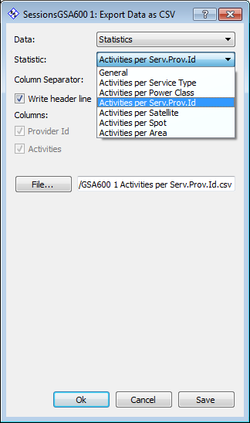

But the csv file is - empty !!!

File: “Source\Data\DataManagement\ACGSADMSessions.cpp”

There is one thing left to do. We need to add the new statistic type in the method “saveGraphicalStatistic” of class CDMSessions:

//------------------------------------------------------------------------------
EResult CDMSessions::saveGraphicalStatistic(
EStatisticType i_statisticType,
const QString& i_strFileName,
const QStringList& i_strlstColumns,
const QString& i_strSeparator,
bool i_bWithHeaders )
//------------------------------------------------------------------------------
{
..
case EStatisticTypeActivitiesPerPowerClass:
{
txtstream << "Power Class" << i_strSeparator;
txtstream << "Activities" << i_strSeparator;
txtstream << "\n";
break;
}
case EStatisticTypeActivitiesPerSPID:
{
txtstream << "Provider Id" << i_strSeparator;
txtstream << "Activities" << i_strSeparator;
txtstream << "\n";
break;
}
case EStatisticTypeActivitiesPerTimeSlice:
{
txtstream << "Start Time" << i_strSeparator;
//txtstream << "End Time" << i_strSeparator;
txtstream << "Activities" << i_strSeparator;
txtstream << "\n";
break;
}
..

else
{
switch( i_statisticType )
{
case EStatisticTypeActivitiesPerEstablisCause:
{
arActivities = getNumberOfSessionsPerEstablisCause();
break;
}
case EStatisticTypeActivitiesPerPowerClass:
{
arActivities = getNumberOfSessionsPerPowerClass();
break;
}
case EStatisticTypeActivitiesPerSPID:
{
arActivities = getNumberOfSessionsPerSPID();
break;
}
..

} // saveGraphicalStatistic

If you recompile and start the analysis center and run a GSA700 query the new statistic is available in the export dialog and the exported csv file contains the expected values.

Add Filter Criteria
There is still one thing left to do to completely support the new column in the AnalysisCenter-GSA application. If there is a new column in the session table it is very likely that it should also be possible to add a filter criteria using this column. For this we have to add a corresponding line edit field to the “Edit Queries” dialog.

In our scenario there is already a SPID line edit for the SPID column in the query dialog. But only for GSA600. What we have to do now is just enabling this line edit also for GSA700 queries.

File: “Include\GUI\ACGSADlgEditQueries.h”

The corresponding comment should be corrected:

..
QFrame* m_pSeparatorCalledNumbersOrIMSIs;
// General Tab - SPIDs (GSA600 and GSA700):
QLabel* m_pLblSPIDs;
..

File: “Source\GUI\ACGSADlgEditQueries.cpp”

Search for “m_pWdgtSPIDs” and correct the comment correspondingly (also used for GSA700).

In method “createDestroyOptionalEditControls” take into account that column SPID may now also be available in table GSA700 (see variable “bClmSPIDExist”).

//------------------------------------------------------------------------------
void CDlgEditQueries::createDestroyOptionalEditControls()
//------------------------------------------------------------------------------
{
..
if( (m_iQueryType == EQueryTypeGSA600 && m_pDataSet->getDbSchemaModel()
->isColumnExistingInDb(ETblGSA600SRI,ETblGSA600SRIClmSPID))
|| (m_iQueryType == EQueryTypeGSA700 && m_pDataSet->getDbSchemaModel()
->isColumnExistingInDb(ETblGSA700SRI,ETblGSA700SRIClmSPID)) )
{
bClmSPIDExist = true;
}
..

} // createDestroyOptionalEditControls

In our case that’s almost all we have to do and on opening the query dialog and selecting the query type GSA 700 Call Records” we also see a line to add filter criteria for column SPID:

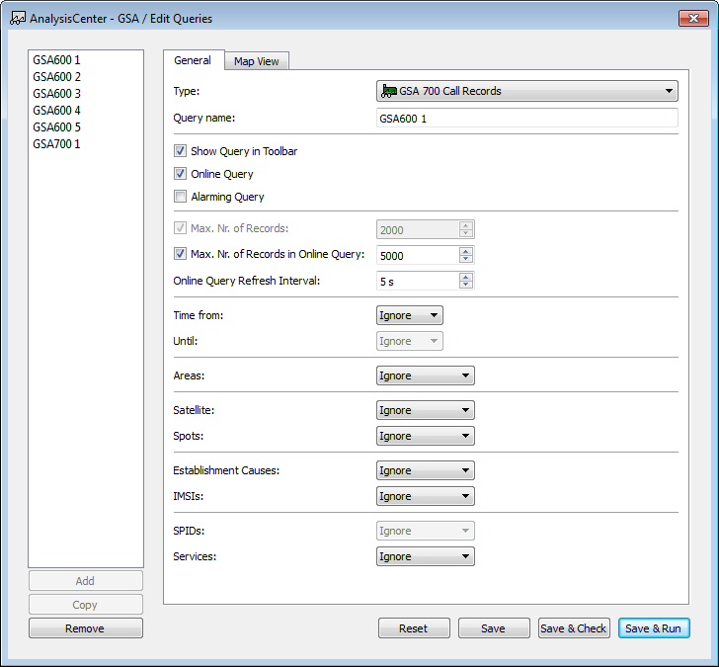

But the SPIDs combo box is – disabled !! We have something forgotten.

The edit controls are enabled or disabled in method “enableDisableEditControls” depending on the selected query type and whether specific columns exist or not. In method “enableDisableEditControls” we also have to take into account that column SPID may now also be available in table GSA700 (see variable “bClmSPIDExist”).

//------------------------------------------------------------------------------
void CDlgEditQueries::enableDisableEditControls()
//------------------------------------------------------------------------------
{
..
if( (m_iQueryType == EQueryTypeGSA600 && m_pDataSet->getDbSchemaModel()
->isColumnExistingInDb(ETblGSA600SRI,ETblGSA600SRIClmSPID))
|| (m_iQueryType == EQueryTypeGSA700 && m_pDataSet->getDbSchemaModel()
->isColumnExistingInDb(ETblGSA700SRI,ETblGSA700SRIClmSPID)) )
{
bClmSPIDExist = true;
}
..

} // enableDisableEditControls

Now if we recompile and start the application we can set a SPID filter criteria also for GSA 700 Call Records.

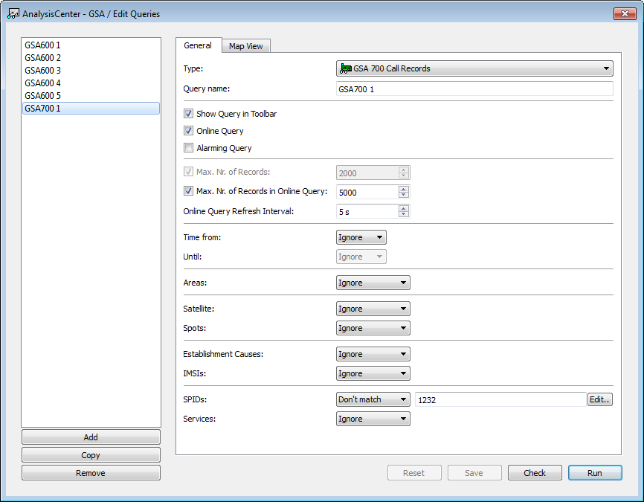

But no matter which filter criteria we set for SPIDs, the result is always the same. The point is that we still need to add code to support the filter criteria to the query command objects creating the SQL statements for selecting the session records from the database.

As we (or better I) have chosen column SPID which is already available in GSA600 session tables, the only thing we need to do is moving the filter criteria for column SPID from class “CGSA600QuerySelectSessionsBase” into the base class “CQuerySelectSessionsBase” (which is the base class for GSA600 and GSA700 SELECT queries).

Files: “Include\Data\Queries\ACGSA600SessionQueries.h” and “Include\Data\Queries\ACGSASessionQueries.h”

Move the declaration for the SPID filter criteria from class CGSA600QuerySelectSessionsBase to CQuerySelectSessionsBase:

//******************************************************************************
class CQuerySelectSessionsBase : public CQuery
//******************************************************************************
{
..
public: // instance methods (filter for SPIDs)
void setSPIDs( EQueryFilterUsage i_usage, const QStringList& i_strlst );
EQueryFilterUsage getSPIDsUsage() const;
QStringList getSPIDs() const;
int getSPIDsCount() const;
..
protected: // instance methods
..
QString getSqlSubStringSPIDs() const;
..
protected: // instance members
..
EQueryFilterUsage m_iSPIDsUsage;
QStringList m_strlstSPIDs;

}; // class CQuerySelectSessionsBase

Files: “Source\Data\Queries\ACGSA600SessionQueries.cpp” and “Source\Data\Queries\ACGSASessionQueries.cpp”

Move the implementation for the SPID filter criteria from class CGSA600QuerySelectSessionsBase to CQuerySelectSessionsBase.

Session queries are created during runtime by the static class method “createQuery” of class CQuerySelectSessions. We need to modify this method by taking into account that column SPID may now also be available in table GSA700 (see variable “bClmSPIDExist”) and we need to set the SPIDs filter criteria for both types of session queries:

//------------------------------------------------------------------------------
CQuerySelectSessionsBase* CQuerySelectSessionsBase::createQuery(
EQueryClassId i_classId,
CDataManagement* i_pDM,
CDataRowQuery* i_pDRQuery,
int i_iIntermediateResultsInterval_ms,
int i_iMaxDuration_ms )
//------------------------------------------------------------------------------
{
..
if( iQueryType == EQueryTypeGSA600 || iQueryType == EQueryTypeGSA700 )
{
if( pDbSchemaModel->isColumnExistingInDb(ETblGSA600SRI,ETblGSA600SRIClmSPID)
|| pDbSchemaModel->isColumnExistingInDb(ETblGSA700SRI,ETblGSA700SRIClmSPID) )
{
bClmSPIDExist = true;
}
}
..
if( bClmSPIDExist )
{
pQuery->setSPIDs( querySettings.getSPIDsUsage(), querySettings.getSPIDs() );
}
..

} // createQuery

The WHERE clause of the SELECT statement is assembled in method “getSqlString” of the specialized classes (“CGSA600QuerySelectSessions”, “CGSA600QuerySelectSessionsRowCount”, (“CGSA700QuerySelectSessions”, “CGSA700QuerySelectSessionsRowCount”). But so far inserting the SQL sub string for SPIDS is only implemented in the “getSqlString” methods of the GSA600 query classes. We need to add the “getSqlSubStringSPIDs” calls also at the GSA700 query classes:

//------------------------------------------------------------------------------
QStringList CGSA700QuerySelectSessions::getSqlString(
bool i_bForceUpdate, bool i_bTemporaryForRowCount )
//------------------------------------------------------------------------------
{
..
// IMSIs
//------

strFilterIMSIs = getSqlSubStringIMSIs();

if( !strFilterIMSIs.isEmpty() )
{
bAddWhereClause = true;
}

// SPIDs
//--------------------

strFilterSPIDs = getSqlSubStringSPIDs();

if( !strFilterSPIDs.isEmpty() )
{
bAddWhereClause = true;
}

// Services
//---------
..

// Add resulting WHERE clause
//---------------------------

if( bAddWhereClause )
{
..
if( !strSPIDs.isEmpty() )
{
if( !strFilter.isEmpty() )
{
strFilter += " AND ";
}
strFilter += "(" + strSPIDs + ")";
}
..

} // getSqlString

//------------------------------------------------------------------------------
QStringList CGSA700QuerySelectSessionsRowCount::getSqlString(
bool i_bForceUpdate, bool i_bTemporaryForRowCount )
//------------------------------------------------------------------------------
{
..
// IMSIs
//------

strFilterIMSIs = getSqlSubStringIMSIs();

if( !strFilterIMSIs.isEmpty() )
{
bAddWhereClause = true;
}

// SPIDs
//--------------------

strFilterSPIDs = getSqlSubStringSPIDs();

if( !strFilterSPIDs.isEmpty() )
{
bAddWhereClause = true;
}

// Services
//---------
..
// Add resulting WHERE clause
//---------------------------

if( bAddWhereClause )
{
..
if( !strSPIDs.isEmpty() )
{
if( !strFilter.isEmpty() )
{
strFilter += " AND ";
}
strFilter += "(" + strSPIDs + ")";
}
..

} // getSqlString

Test Tools
Below the directory “SatMon_dev\AnalysisCenter-GSA” you find a directory name “Test”. There you can find scripts to create the schema (tables, columns, keys, indexes, etc.) in the oracle database. But you can also find projects to create test tools.

Creating Sessions Using the Sensor Server Simulation
Below the directory “SensorServer-Sim” you find a project which is used to create a test tool application to simulate the “in time” creation of sessions. This is important to test the functionality of “Online” queries within the AnalysisCenter-GSA.

Most of the classes and module of the AnalysisCenter-GSA are reused within the Sensor Server Simulation project. Especially the classes from subsystem Data are used again. This had two advantages:

- On the one hand it was easy and fast to create the simulation.
- On the other hand the data subsystem classes have been used in a different use case than within the AnalysisCenter-GSA and have therefore been better tested.

It was only necessary to:

- Replace the main controller CApplication, as not all of the global instances from the AnalysisCenter-GSA are needed (e.g. there is no need to connect with Map View).
- Replace the MainWindow as no dynamic creation of Workspace Widgets are needed but in instead tabs to indicate and control creation of GSA600 and GSA700 sessions are permanently needed.
- Implement a new session table widget class providing the buttons to control the simulation and indicating the created sessions in a table view.
- Add a main module, as the Sensor Server Simulation is not a plugin to the ISAR framework.

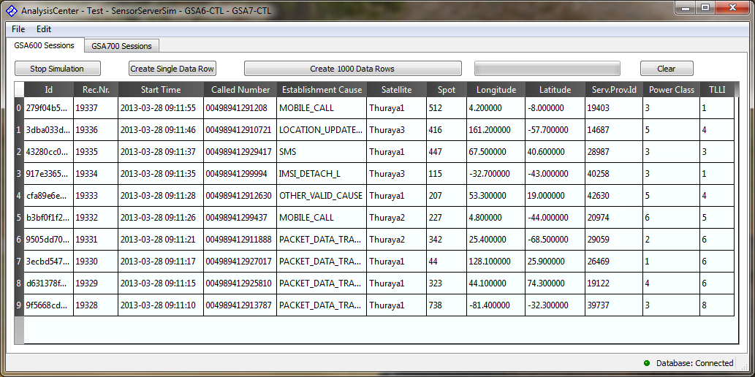

Via the ini file “AnalysisCenter-GSA-Test-SensorServerSim.ini” (usually located in the startup directory of the application) the behavior of the simulation can be modified. Parameters of the simulation can be found below the sections “[SessionsGSA600SessionsSimValues]” and “[SessionsGSA700SessionsSimValues]”.

Mainly it is possible to set a range in which values for each session table column are randomly generated. The following is an extract from the ini file:

Satellites | List of satellites each separated with a blank (e.g. “Thuraya1 Thuraya2 Thuraya3”).
StartTimeIntervalMin_ms  StartTimeIntervalMax_ms | Distance between two start times.
CalledNumberPostfixMin  CalledNumberPostfixMax | Called numbers start with “0049894129” by adding a postfix in the specified range.
Area_LTRB_0  Area_LTRB_1  ..  Area_LTRB_N | Area coordinates by defining Left, Top, Right and Border in Degrees The last number is used to simulate several areas.  E.g. to simulate sessions in the areas Afghanistan and Albania use:  Area_LTRB_0=60 38 75 29  Area_LTRB_1=19 42 21 40

Sessions will be randomly created by methods “createGSA600SessionDataRow” and “createGSA700SessionDataRow” of class CApplication.

