**COMP 6231 Assignment 3 Report**

**Group Member:**

**Zexin Peng**

**Student number: 40166520**

1. **Architecture Design:**

DDOServer, LVLServer and MTLServer are inherited from the same superclass “ServerImpl”, which implements the Interface “CenterServer”. IDServer is responsible for assigning RecordID when creating new records. We should indicate the managerID and location of the client at first. The responsibility of “Configuration” is to store some configuration information like ports and directory names. “Tool” provides basic support to other classes. The java classes generated by command **wsimport** are in package WebService. ConfigurationFactory in package factory can return the instance of Configuration.

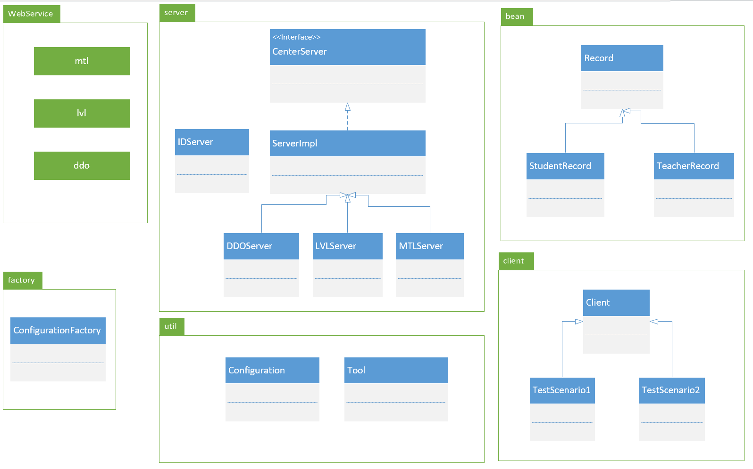

1. **Techniques：**
   1. **WebService:**

We need to define the interface at first.

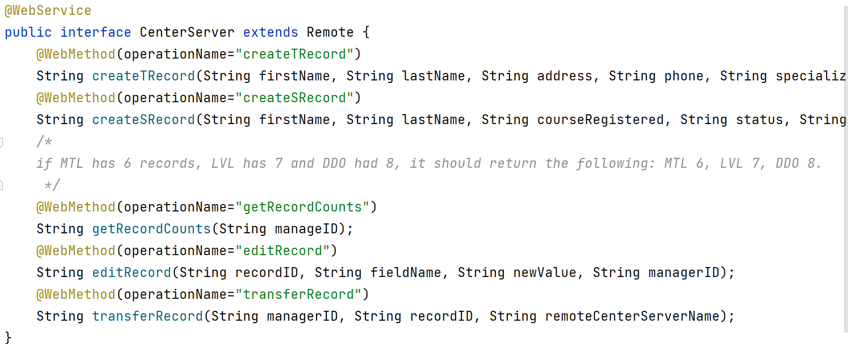

And then, we use command **wsgen** to generate the wsdl file.

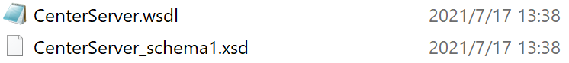

At the next step, we start IDServer, LVLServer, MTLServer and DDOServer and use command wsimport to generate WebService codes for clients respectively.

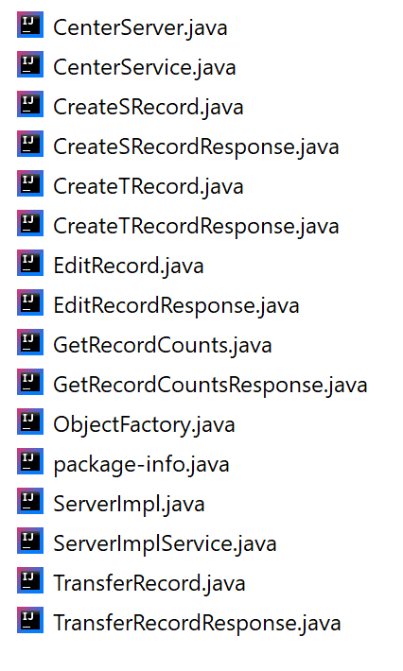

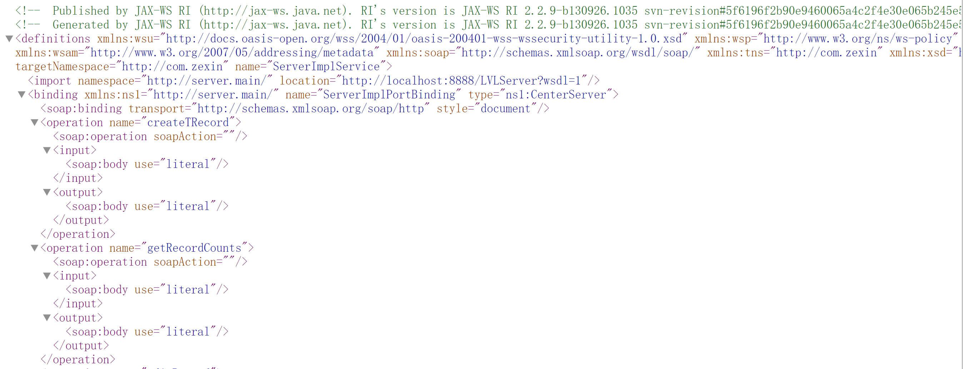

* 1. **UDP/TCP Socket:**

I use UDP socket to get the quantity of records in other servers.

The recordID should be unique in the system, so I create a new server named “IDServer” to assign recordID, and it uses TCP to communicate with other servers. Another usage of TCP programming in my assignment is in method transferRecord().

* 1. **synchronized:**

I use ‘synchronized’ in my code to avoid synchronization problem, because some shared data cannot be modified concurrently. By the way, to maximize concurrency, I do not maintain strong consistency in my assignment. In other word, if a server has 10 records, and a client will get 10 and will not be blocked when it wants to know the quantity of records in this server even if another client is creating new records in this server at the same time. If a system has strong consistency, the client will be blocked and get 11 after another client creates a new record, but it will reduce the concurrency.

1. **Data Structure:**

I encapsulate student records and teacher records as Bean classes with bunches of getter and setter method.

* 1. **StudentRecord:**

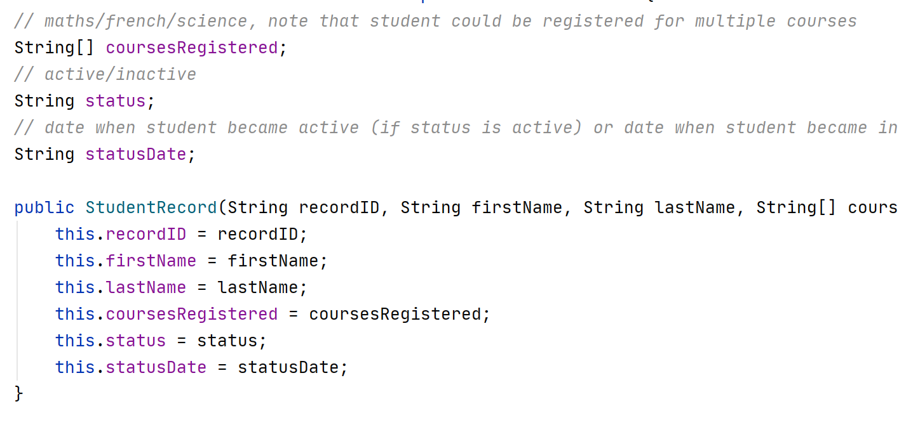

* 1. **TeacherRecord:**

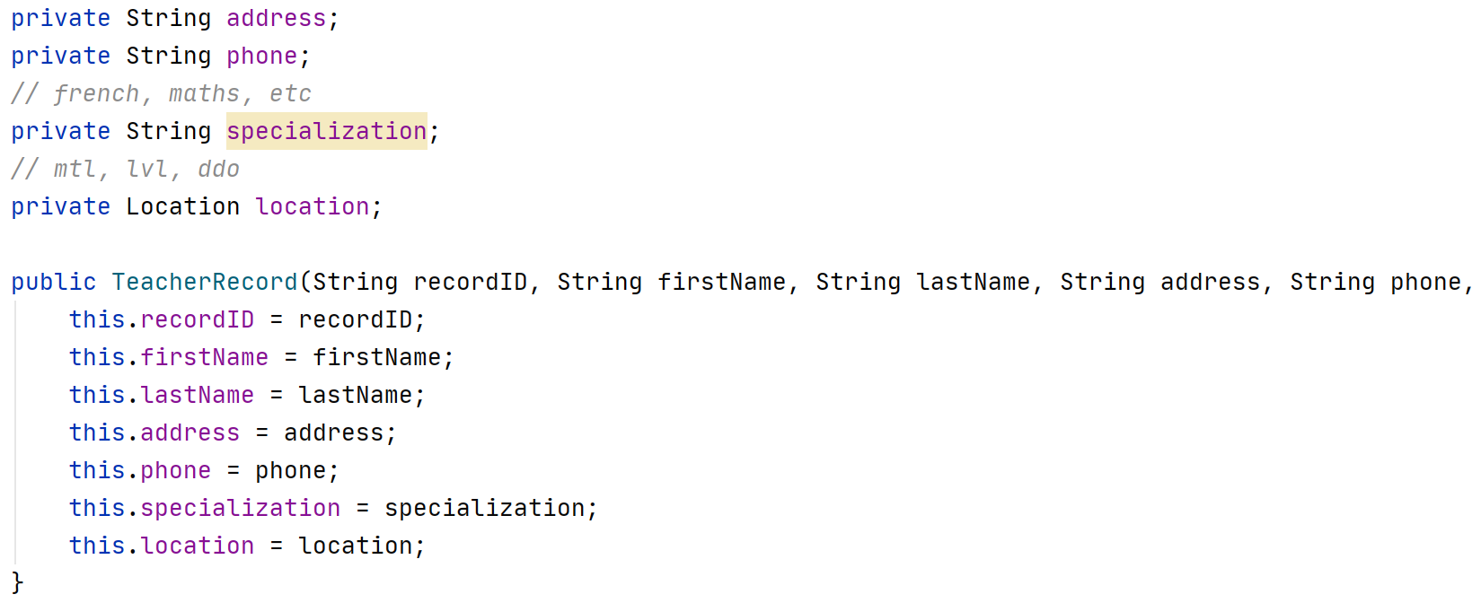

* 1. **RecordMap:**

All records are stored in the RecordMap, whose type definition is HashMap<Character, List<Record>>. The key of this map is the first letter of the last name indicated in the records.



1. **Test scenarios**

Each server initially has a few records except scenario 4.1. We have two records in MTL Server, three records in LVL Server and four records in DDO Server after startup of all servers. The correctness of methods createTeacherRecord(), createStudentRecord(), getRecordCounts() and editRecord() are already tested in the report of assignment 1, so I focus on concurrency of my system in this report. All codes can be found in package test.client named TestScenario1, TestScenario2 and so on.

* 1. **Scenario 1:**

**Description:** I start three threads representing three clients “LVL0001”, “DDO0001” and “MTL0001” respectively and create 300 student records and 300 teacher records concurrently to test the uniqueness of recordID and correctness of createRecords. You can see the code in test.client.TestScenario1.java.

Firstly, I create three threads and run them.

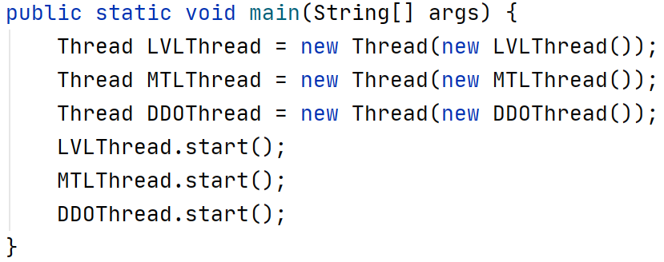

In the IDServer, I got the following logs.

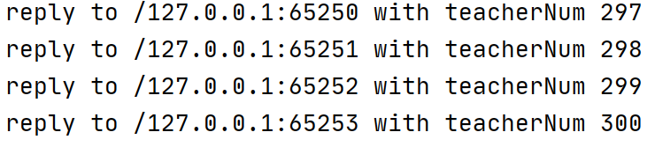

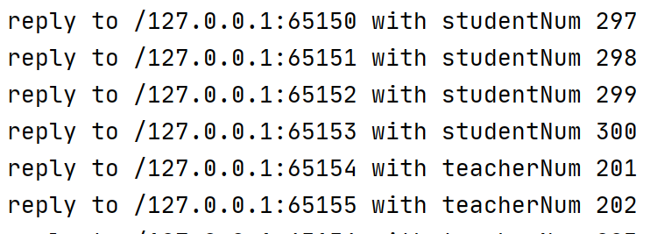

Logs in three servers are below.







At last, I invoke the method getRecordCounts(), I got the result as below. The last student recordID is SR00300, and the last teacher recordID is TR00300. After analysis, we got a conclusion that all recordIDs are unique in the system.



* 1. **Scenario 2:**

**Description:** this test scenario focus on transferRecord() method in the server. I will edit all field in student record and teacher record by three managers “LVL0001”, “MTL0001” and “DDO0001”. By this test scenario, we will know the correctness of editRecordCounts method and log function.

Firstly, we will try some invalid input.

1. **The recordID that does not exist. We try it in LVL client.**



We will get log message as below, and messages are stored in the log files LVL0001 in the client side and LVL in the server side.



1. **I try the invalid location name in MTL client.**



We will get log message as below, and messages are stored in the log files MTL0001 and MTL. 

Secondly, we will test the correctness of the method, which focuses on atomicity and concurrency.

1. **I test the atomicity of the method in DDO Server. I start three threads with client managers “DDO0001”, “DDO0002” and “DDO0003”, and the record can only be transferred once.**

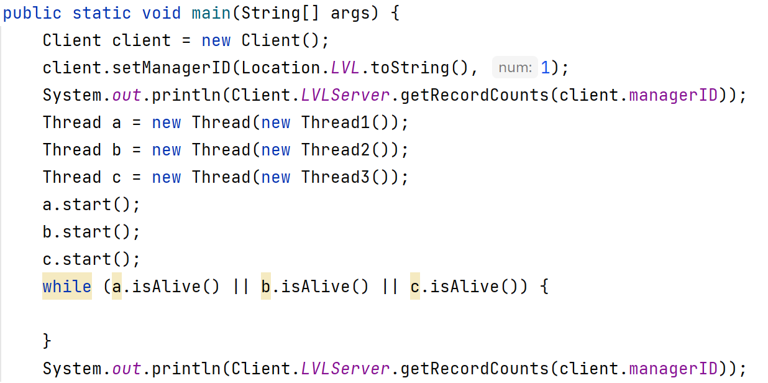

We got log messages as below, and the quantity of records in the server is also consistent.



We can see that the record “TR0004” is only transferred once. Then we will see the correctness of log function. We got three new log files.

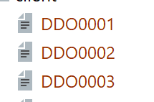

Contents in DDO0001, DDO0002 and DDO003 are showed in order as below, and the log messages are consistent with that in the client console.







We can see the log message in LVL Server.



Contents in DDO Server.



1. **This case tests the atomicity of the method in LVL Server. I start three threads to edit the field in the record, at the same time, I start a thread to transfer it. We can analysis the result whether is consistent through logs.**

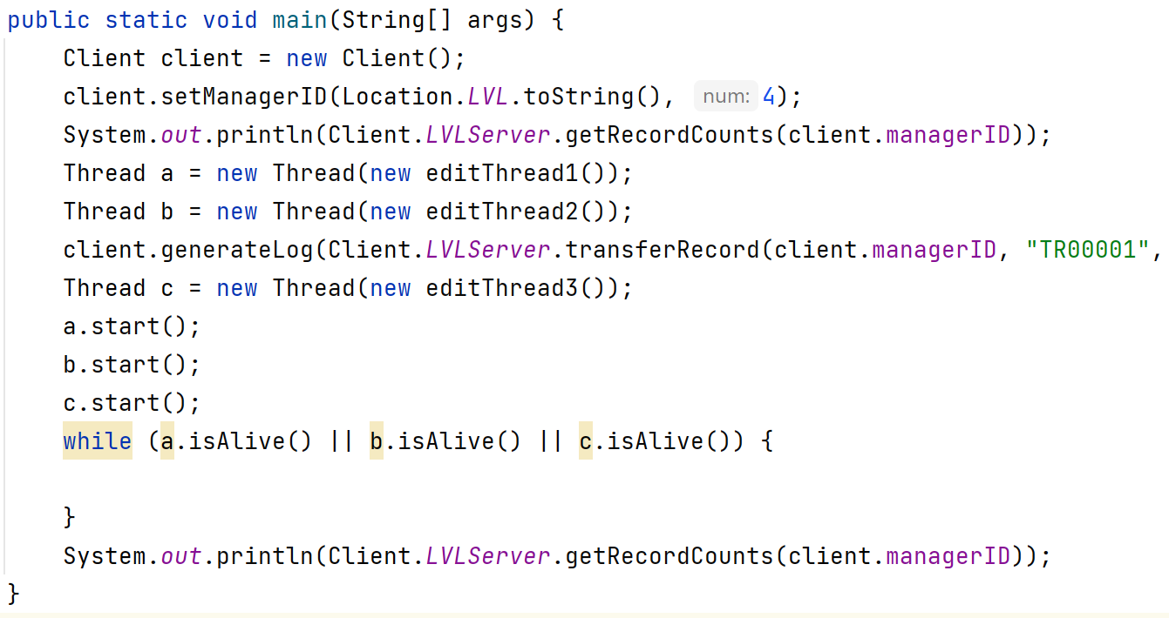

We can see the log messages as below.

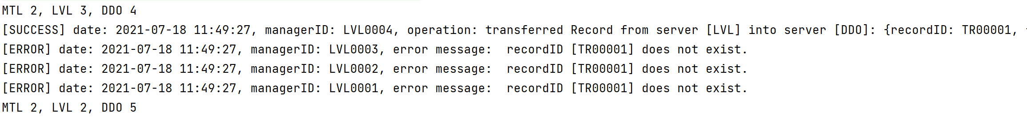

Log messages in LVL Server:

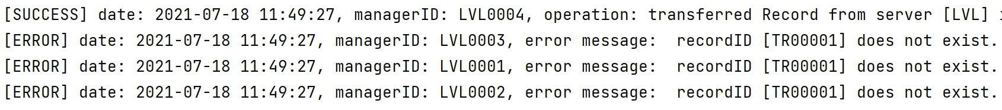

Log messages in DDO Server:



The content is consistent in the system.

1. **This case tests the atomicity of the method transferRecord and editRecord in LVL Server. I start three threads to edit the field in the record, after this, I start a new thread to transfer it. We can analysis the result whether is consistent through logs.**

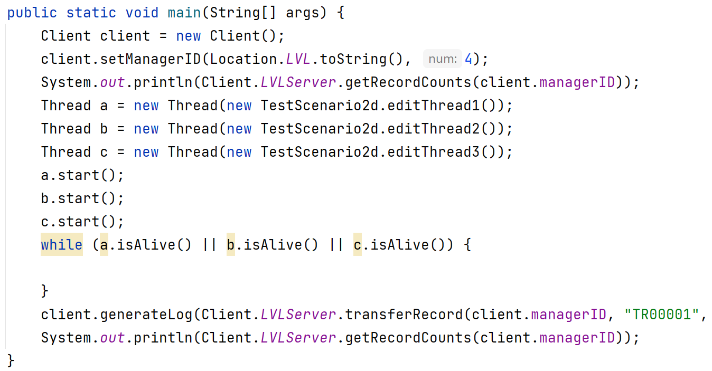

We can see the log messages as below.

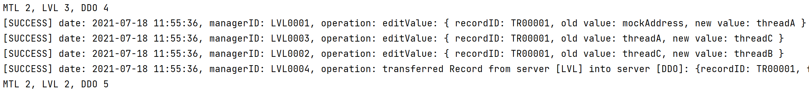

Log messages in LVL Server:

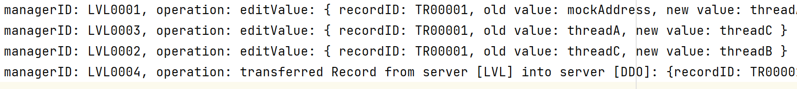

Log messages in DDO Server:



As we can see, the value of the field is changed in order, and the record is transferred at last. The content of the record is consistent in the whole system.

1. **Important parts:**

The implementation of configuration and log function is introduced in the last report, so I focus on the new part in this assginment.

* 1. **IDServer**

I set up a new server to create unique recordIDs for new records. LVL, MTL and DDO Server have to communicate with IDServer to get the unique recordID when they want to create new StudentRecord or TeacherRecord. In IDServer, I use AtomicInteger class, which uses CompareAndSwap mechanism, to ensure the consistency of unique records. Compared with traditional synchronized methods, AtomicInteger has better performance. As we know, blocking and waking up threads are very time-consuming, and when some threads share the same AtomicInteger, they will operate its value in the memory directly and not be blocked. I use it to maximize the concurrency while ensuring the uniqueness of recordIDs.



**5.2 implementation of transferRecord():**

I use TCP programming to send the records to the target server for its reliability. The sequence diagram of transferRecord shown as below.

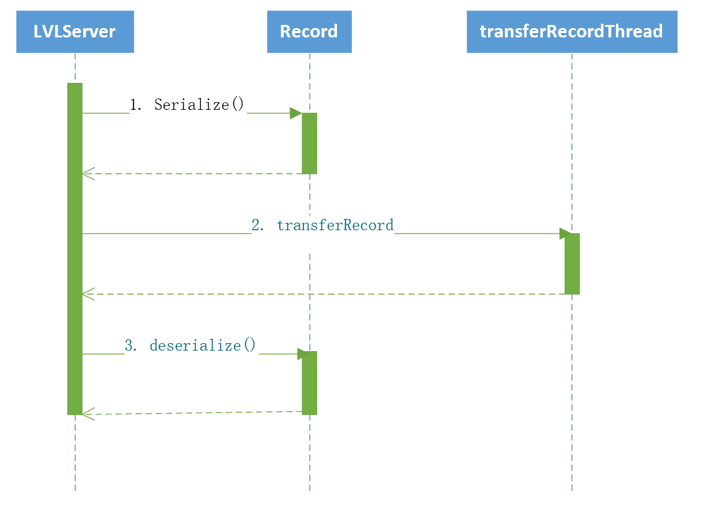

The first step is to find the record by its recordID. If the record exists in the server, we need to serialize it. The serialization method for Student is shown as below.

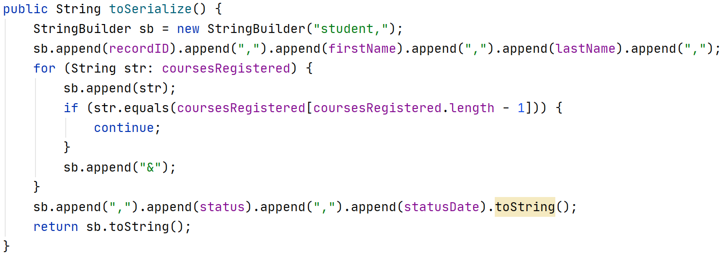

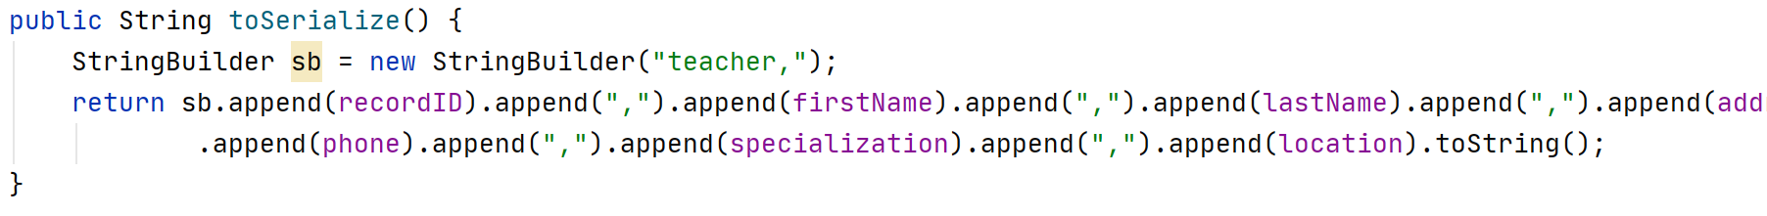

After serialization, I use TCP to transfer the record to another server for its reliability, and the address of the server is stored in the configuration file. I also start a new thread in each server to listen on the port.

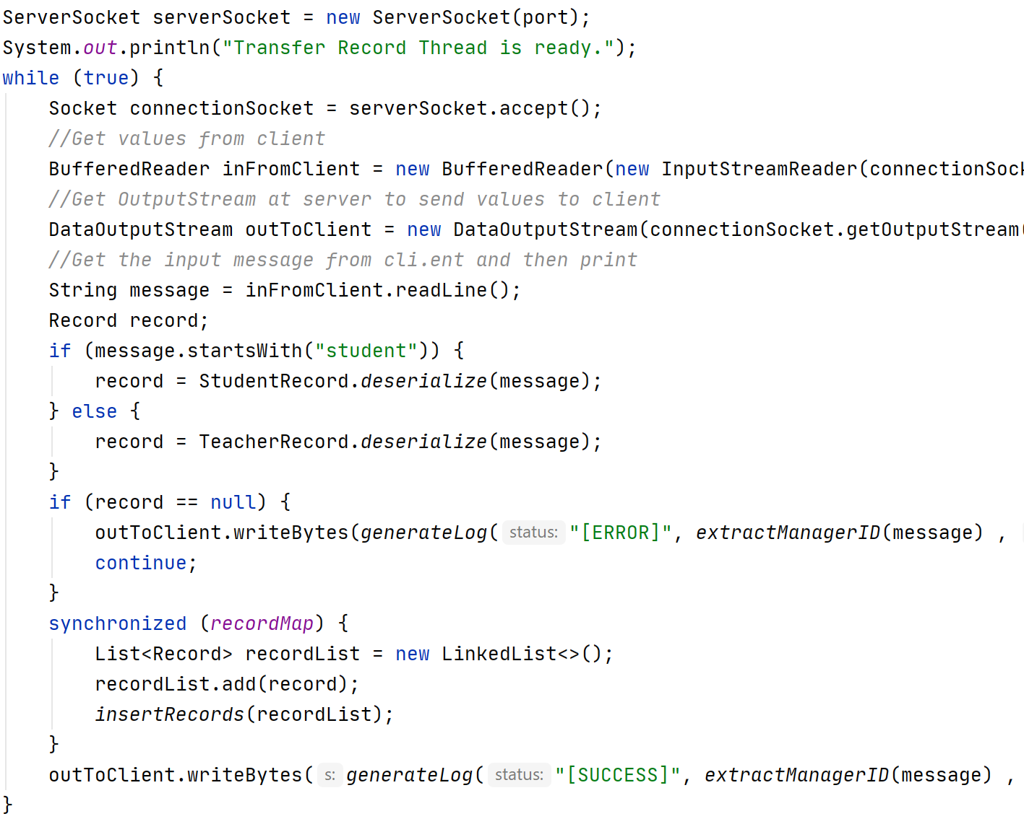

When a thread accepts a new record transferred from another server, it will check the format of the record and deserialize it to the object in the current Java Virtual Machine. Then it will try to get the access of shared data structure ‘recordMap’, and add the record into it if successes. Finally, it will generate the log message according to the result and return it. The server invoking the method will get the log message and write it into its log file.

**5.3 server startup method:**

The sequence graph of the startup of the server shown as below.

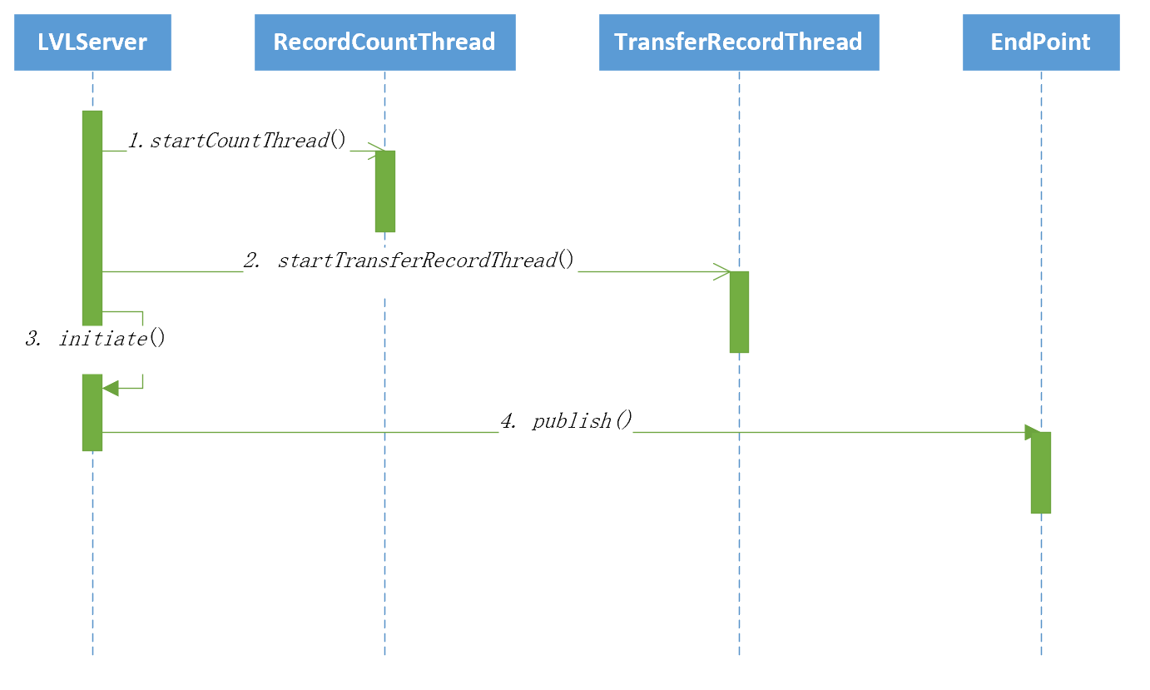

We should indicate the location of the server as parameters.

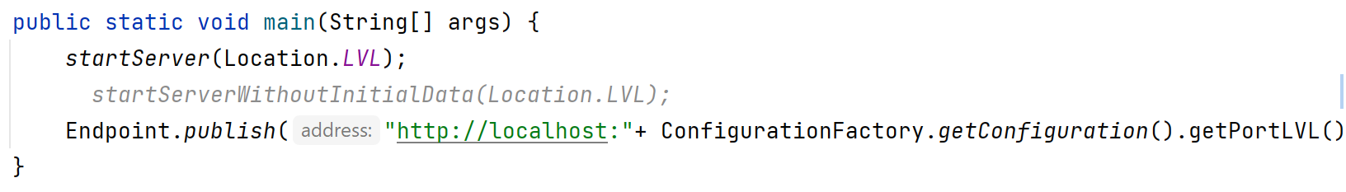

Then the server will start Count Thread and Transfer Record Thread which is introduced in my report. At the next step, the server will set up some initial data and the context in the method initiate().

