BREWW TO HIVED
Daily Packing Tool
STANDARD OPERATING PROCEDURE
Daily courier order processing and preparation of sorted Hived label-upload files

Document status | Working draft
Version | 0.6
Date | 5 August 2026
Document owner | Operations / Packing
This SOP will be completed section by section and updated as the workflow develops.

1. Introduction
Purpose of this SOP
This document explains how to use the Breww to Hived Daily Packing Tool to prepare courier orders and generate the files needed for Hived. It is intended to give packing and operations staff a clear, repeatable process that can be followed without needing to understand the underlying Python code.

1.1 What the app does
The app takes two CSV files exported from Breww: one containing delivery and customer information, and one containing the products included in each order. It matches the two files using the invoice number, interprets the order contents, separates multi-carton orders into individual parcel rows, and sorts the final label-upload file by carton size and flavour.
The app also separates orders that need human attention—such as gifting orders, Build Your Own Box orders, special delivery instructions, blank product records, or unrecognised items—into a manual-processing file. This allows normal orders to be processed quickly while ensuring unusual orders are visible and are not accidentally left out.

1.2 Inputs and outputs at a glance
Stage | File / action | Purpose
Input 1 | Breww delivery export | Provides invoice, customer, address, contact and total-order-weight information.
Input 2 | Breww order-content export | Provides the products, quantities, delivery notes and order type for each invoice.
Output 1 | Hived upload CSV | Contains one sorted row per parcel or label for automated processing.
Output 2 | Manual-processing CSV | Lists orders that require a person to review or complete manually.
Output 3 | Validation and audit files | Confirm that invoices are represented, weights reconcile and exceptions are visible.
Important: The Hived upload file must not be used on its own without checking the manual-processing and validation outputs. These files are part of the control process and ensure that special or unrecognised orders are not missed.

2. Installation
Installation only needs to be completed once on each computer. Follow the steps below to download and extract the app.
Download page
https://github.com/ZeyBau/Breww-to-Hived

1 | Open the download page  Open the GitHub page shown above in your web browser.

2 | Download the latest ZIP file  Find the newest version of the app and download the file ending in .zip.

3 | Open your Downloads folder  Locate the ZIP file after the download has finished.

4 | Extract the ZIP file  Right-click the ZIP file, select “Extract All…”, and follow the on-screen instructions.

5 | Choose a useful location  Extract the folder somewhere easy to find, such as the Desktop.

6 | Keep the folder together  Open the extracted folder and leave all files inside it. The app is now ready for use.

Important: Do not run the app from inside the ZIP file. Always extract it first, and do not remove individual files from the extracted app folder.
Installation is complete when the extracted app folder is saved in a permanent, easy-to-find location.

3. Getting the Breww CSV files
The app needs two CSV files from Breww for the same delivery date. Download both files before opening the app.
Before you begin: Make sure you are working on the correct delivery date. Do not edit either CSV after downloading it.

Open the correct delivery day

1 | Open Deliveries  In Breww, select Deliveries from the menu on the left-hand side.

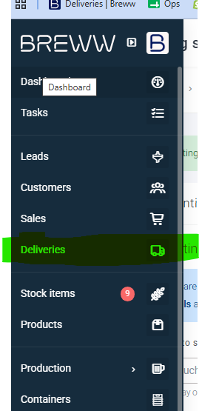
Select Deliveries from the Breww menu.
2 | Open the correct date  Find the delivery date being prepared and open that day.

CSV 1 — Courier delivery list

3 | Open Deliveries (courier)  On the delivery-day page, select the Deliveries (courier) tab.

4 | Export the full courier list  Click Export as CSV file and export the whole courier-delivery list. This is the first file required by the app.

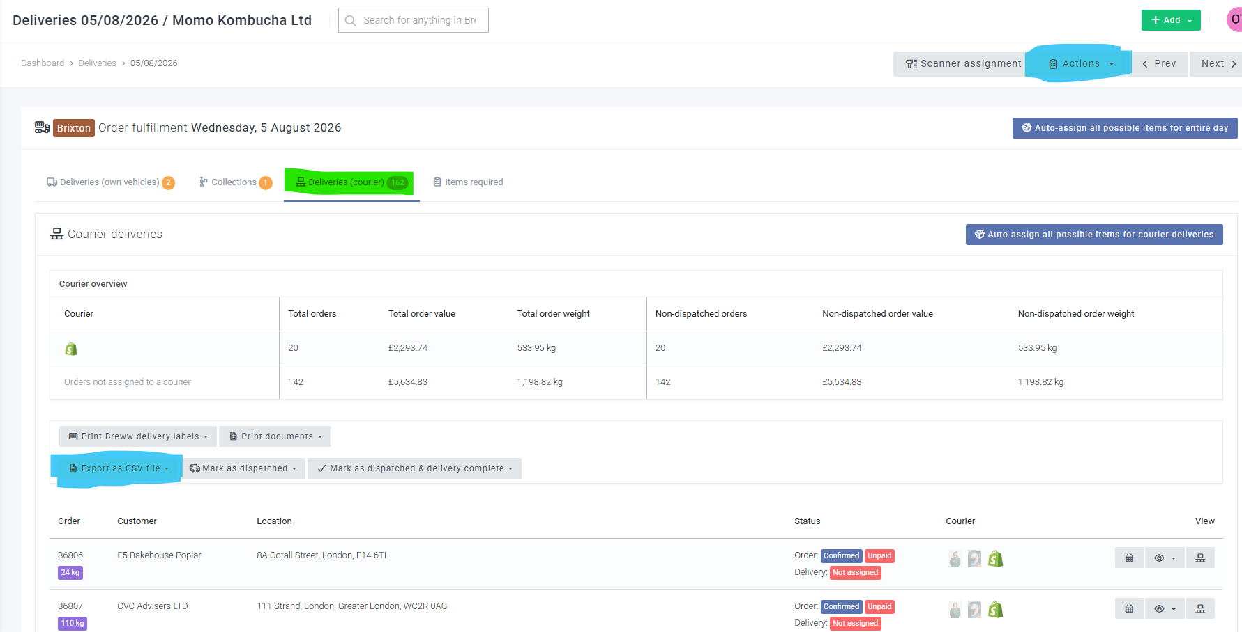
Open Deliveries (courier), then export the full list as a CSV file.
CSV 1 contains: Customer and delivery information, including invoice number, address and total order weight.

CSV 2 — Full order-content list

5 | Open Actions  Stay on the same delivery-day page and select Actions in the top-right corner.

6 | Select List/export all  From the Actions menu, select List/export all. A new page will open.

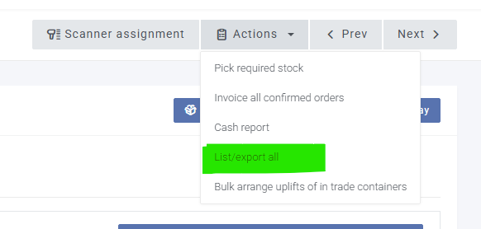
Select Actions, then List/export all.
7 | Export the second CSV  On the page that opens, export the displayed list as a CSV file. This is the second file required by the app.

CSV 2 contains: The products, quantities and order details linked to each invoice.

Final check

CSV 1 | Full Deliveries (courier) export
CSV 2 | List/export all order-content export
Date | Both files are for the same delivery day
Ready for the app: Once both CSV files have downloaded, leave them unchanged. They can now be selected in the Breww to Hived app.

4. Using the app
Use the two Breww CSV files downloaded in the previous section to create the processed Hived files.
Open the app

1 | Open the app folder  Open the extracted Breww to Hived tool folder that was saved during installation.

2 | Start the app  Windows: double-click RUN_TOOL_WINDOWS.bat. Mac: open RUN_TOOL_MAC.command. The app window will appear.

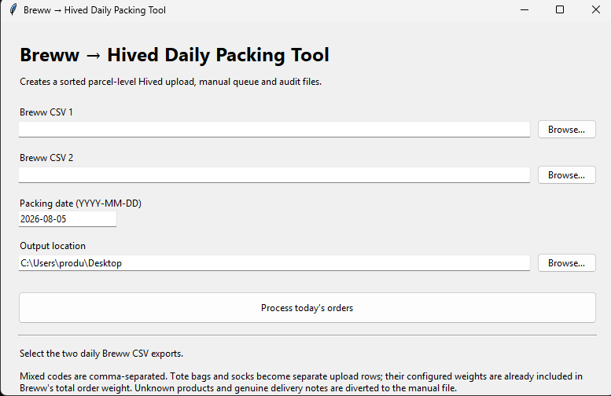
The Breww to Hived app window.
Important: Run the launcher from the extracted app folder. Do not run the app from inside the ZIP file.

Enter the files and process the orders

3 | Select the two Breww CSV files  Use the Browse buttons beside Breww CSV 1 and Breww CSV 2. Select the two files downloaded from Breww. The order does not matter.

4 | Check the packing date  Confirm that the packing date matches the delivery date of the two CSV files. Change it if necessary.

5 | Choose the output location  Select a permanent, easy-to-find folder where all processed outputs will be stored. Use the same location each day so previous outputs are easy to find.

Recommended location: Create a folder such as Documents\Breww to Hived Outputs. Avoid using Downloads, as files there are easier to lose or delete.

6 | Process today's orders  Click Process today's orders. Wait while the app checks the files and creates the output folder.

7 | Open the processed files  When the success message appears, click OK. The newly created dated output folder will open automatically.

Complete: The processed Hived upload, manual-processing file, validation report and supporting audit files are now ready for review.

Before clicking Process

CSV 1 | One of the two Breww CSV exports
CSV 2 | The other Breww CSV export
Packing date | Matches the delivery date in Breww
Output location | A permanent folder that is easy to find again

5. Understanding the output files
The app creates six files in the dated output folder. Always review the manual-processing and validation files before uploading anything to Hived.
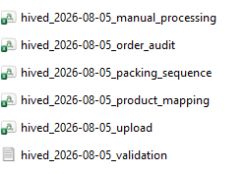
The six files created by the app.
Files that must be checked

1 | manual_processing — Orders that need manual handling  Contains BYOB orders, gifting orders, genuine delivery instructions and any unrecognised products or orders. Check every row before finishing, as these orders must be corrected or processed manually.

2 | upload — Main Hived upload file  This is the main processed file that is uploaded to Hived after the manual-processing and validation checks have been completed.

3 | validation — Final sanity check  Confirms that the generated output weights match the Breww input weights and that no orders were lost. Check that Overall weight difference is 0.0000 kg.

Do not upload yet: If the overall weight difference is not 0.0000 kg, stop and investigate the manual-processing and validation files before continuing.

Supporting files

4 | packing_sequence — Packing totals  Shows the total number of labels for each box-size and flavour combination. This can help the packing team prepare boxes and organise the run.

5 | order_audit — Invoice-level record  Shows how each original invoice was converted into one or more output rows. It is mainly useful for checking a specific order if something looks wrong.

6 | product_mapping — Product recognition record  Shows how the app interpreted each Breww product description and which product code it assigned. It is mainly useful when investigating an unrecognised or incorrectly mapped item.

Final check before Hived

Manual processing | All listed orders have been reviewed and dealt with.
Validation | Overall weight difference is 0.0000 kg.
Upload file | The correct packing date is shown in the filename.
Ready | The upload CSV is almost ready for upload.
Complete: Once the manual-processing file has been handled and the validation difference is 0.0000 kg, the upload file is ready for Hived.

6. Preparing the file for Hived
Complete these steps after the app has created the output folder. The upload file needs one additional column before it can be uploaded to Hived.
Recommended workflow

1 | Check manual_processing  Open the manual-processing file and deal with every listed order, including BYOB, gifting, delivery instructions and unrecognised items.

2 | Confirm validation is correct  Open the validation file and check that Overall weight difference is 0.0000 kg. Do not continue if it is not zero.

3 | Open the upload file  Open the file ending in _upload.csv in Excel or another spreadsheet program.

4 | Add the Shipping class column  Add a new column to the sheet. Enter the header exactly as: Shipping class

5 | Enter next_day for every row  Type next_day under Shipping class for every invoice or parcel row. Fill the value down the whole column and make sure there are no blanks.

6 | Save the completed file as CSV  Save the file in CSV format. If Excel warns that some features may be lost, choose to keep or use the CSV format.

7 | Upload the file to Hived  The completed upload CSV is now ready to be uploaded to Hived.

Important: The header must be written exactly as Shipping class, and every data row must contain exactly next_day. Save the finished file as .csv, not .xlsx.
Complete: The checked and updated CSV can now be uploaded to Hived.

