Stock VS Modified Car Classification

Zeyad Ahmed - 231000010
AI - ITCS
Nile University
Giza, Egypt
z.ahmed2310@nu.edu.eg
Youssef ElDeeb
AI - ITCS
Nile University
Giza, Egypt
Y.Ahmed2364@nu.edu.eg
Mohamed Abdellatif - 231000119
AI - ITCS
Nile University
Giza, Egypt
M.Abdellatif2319@nu.edu.eg
Abdalsalam AlZaqzouq
AI - ITCS
Nile University
Giza, Egypt
A.E2208@nu.edu.eg
Mark Hany
AI - ITCS
Nile University
Giza, Egypt
M.Hany2374@nu.edu.eg

Abstract—This project focuses on building multiple machine learning models capable of classifying whether a vehicle is stock or modified. The models rely on visual (image) information and text information to learn and extract features that will aid them in classifying the vehicle. The workflow includes data cleaning, label encoding, feature extraction, model training, and performance/accuracy evaluation.
Keywords—Web Scraping, Machine Learning, Multi-Modal Learning, Late Fusion, XGBoost, CNN, Linear Regression, SVM, ANN.

Introduction
Our Project’s objective, originally, was to tackle the problem of classifying stock VS modified cars by using images and audio. We would do so by web scraping the internet for the data, then we would clean the data to ensure that there are no null values or duplicates, then we would encode and standardize the data, then we would split the data to use as train and test data, and finally, we would train the models and calculate their accuracies.

Problems Faced

Difficulty of extracting audio data
Firstly, we had a problem extracting (web scraping) audio data from the internet. Many websites had heavy restrictions placed that disabled us from extracting audio data from them; other websites that had fewer restrictions had sparse data that wouldn’t have helped us in training the models.

Generated AI data
Secondly, some of our data was AI-generated to compensate for the sparsity of some data types. The AI generated data caused problems with the models during their training.

Solving The Problems

Audio Data Problem
To accommodate for the audio data problem, we extracted the range of the stock engine decibel sounds to use for our dataset, and we generated the decibel range for the modified cars using AI.

Generated AI data problem
Since the engine decibel data generated by the AI caused the models memorize and not learn the difference between both, because the range between both were very far apart, we fixed the decibel reading data by decreasing the range of the modified. This is logical since not all modified cars have a modified engine with a different decibel sound.

Findings
After running all models in our project, we have concluded that the tabular data is too simple since almost all our models end with a prediction score of 1.0. The images in our dataset were sufficient and complex enough to yield logical prediction score.

XGBoost Models (Zeyad Ahmed)
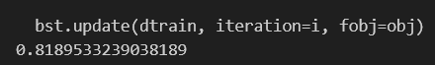

For the image model the outcome was 0.81

For the text model the outcome was 0.57

The Late Fusion outcome was 0.84

SVM and Logistic Regression (Abdulsalam Zaqzouq)


The image model (Linear Regression )gave an accuracy of 0.58

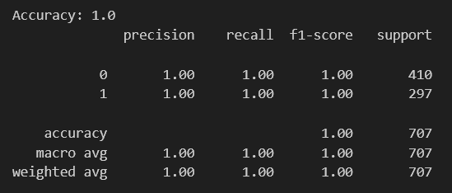
2) The text model (SVM) gave an accuracy of 1.0

CNN and Logistic Regression (Youssef ElDeeb)
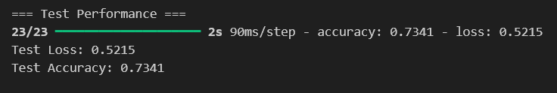

The image model (CNN) gave an accuracy of 0.73
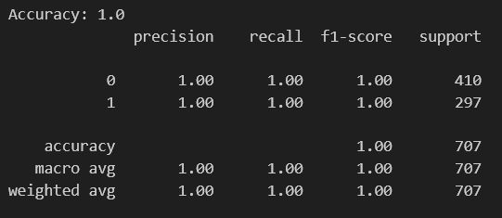

The text model (Logistic Regression) gave an accuracy of 1.0

CNN and Linear Regression (Mark Hany)

The image (CNN) model gave an accuracy of 0.72

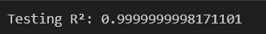

The Text (Linear Regression) model gave an accuracy of 0.99

ANN and RNN (Mohamed Abdellatif)

1)The image (ANN) model gave an accuracy of 0.58

2) The text (RNN) model gave an accuracy of 1.0

