

Module :

4FTC2030 – Introduction to Manufacturing Technology

Students :

Gana Ahmed Sheraky

Hamza Bassem Fathy

Jana Moustafa Abdelsalam

Mohamed Medhat Ali

Youssef Hussein Salah

Youssef Mohamed Saber

Zeyad Alaaeldin Ali

Introduction to Manufacturing and Assembly

Manufacturing is a fundamental part of modern engineering, involving the conversion of raw materials into functional products using a variety of production processes. These processes include machining, manufacturing, forming, and assembly techniques that allow engineers to create complex components efficiently and accurately. Manufacturing technology is widely used in many industries such as automotive, aerospace, electronics, and robotics.
This project aims to provide practical experience in manufacturing methods and engineering design through the development of two main tasks. The first task was the design and fabrication of a hydraulic powered robotic arm capable of lifting and transferring marshmallows into a cup of water. The robotic arm demonstrates the principles of mechanical design, machining, and assembly of structural components.
The second task focused on machining a mechanical axle component using workshop equipment and CAD/CAM tools. The project aimed to demonstrate practical manufacturing skills, engineering design principles, and safe workshop practices.
Additionally, the project required the application of project management tools such as a Work Breakdown Structure (WBS) and a Gantt chart to plan and organize the manufacturing process efficiently. These tools helped ensure that tasks were completed within the allocated time while maintaining quality and safety standards.

Project Management planning

Work Breakdown Structure (WBS)
To manage the project effectively, the work was divided into smaller tasks using a Work Breakdown Structure (WBS). This allowed the group to organize the project into manageable activities such as design, material preparation, fabrication, machining, and testing. The WBS for our project is shown in Figure 1.

Figure 1 Work Breakdown Structure for the project

Gantt Chart
A Gantt Chart was used to schedule the project tasks and ensure that the work was completed within the available workshop sessions. Each stage of the project was assigned a time frame based on the estimated difficulty and the resources required.

Task | Week 1 | Week 2 | Week 3 | Week 4 | Week 5
Project planning

RObotic arm design

MACHINING AXLE
ROBOTIC ARM MANUFACTURING

ASSEMBLY AND HYDRUALIC SETUP

tESTING AND INSEPECTION
Figure 2 Gantt Chart Showing the Project Timeline

The chart helped our team coordinate responsibilities and track progress throughout the manufacturing process. The overall project timeline is shown in Figure 2.Figure 2

Part 1 – Design and Fabrication of the Hydraulic Robotic Arm

Overview of the Robotic Arm Design
The objective of Part 1 was to design and fabricate a hydraulic powered robotic arm capable of lifting and transferring marshmallows into a cup of water. The arm needed to be able to fully demonstrate controlled motion, hydraulic actuation, and structural stability.
The structure of the robotic arm consisted of a base platform, multiple arm segments, and a gripper mechanism. Movement of the arm was controlled using a hydraulic system composed of syringes connected through flexible tubes filled with water, allowing pressure to be transferred between the control syringes and the actuating syringes attached to the arm.
The overall dimensions were designed according to the project requirements, ensuring that the base did not exceed 25 cm and the arm reach remained within 200-300 mm.

Bill of Materials
The following materials and components were used in the construction of the robotic arm :
(put BOM here)

Manufacturing Process and Software
The manufacturing process of the robotic arm began with the design stage using CATIA CAD software. During this stage, the overall structure of the robotic arm was modelled, including the base, arm segments, and clamp gripper.
Using CATIA, the team first created a sketch of the hydraulic arm and then converted them into 3D parts using the specified dimensions to ensure that the arm did not exceed the size limits allowed. The initial design was a prototype intended to identify areas that required improvement, such as positioning of the joints. The initial prototype can be seen in Figure 3
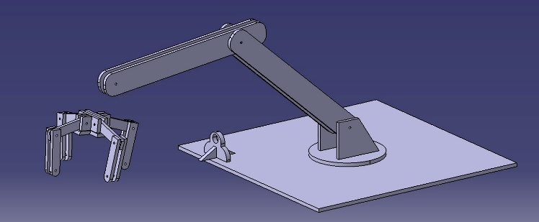
Figure 3 Initial Prototype of the Robotic Arm
Based on the evaluation of the prototype, we refined the design in CATIA to improve the functionality of the robotic arm. After finalizing the improved design, the files were exported and used for the laser cutting process in the university workshop. The final parts as seen in Figure 4 and Figure 5 were then laser cut to assemble the final working arm.
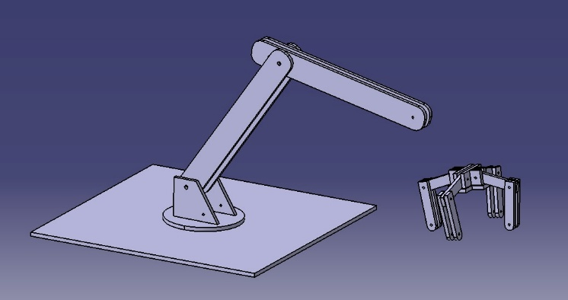
Figure 4 Final CATIA design
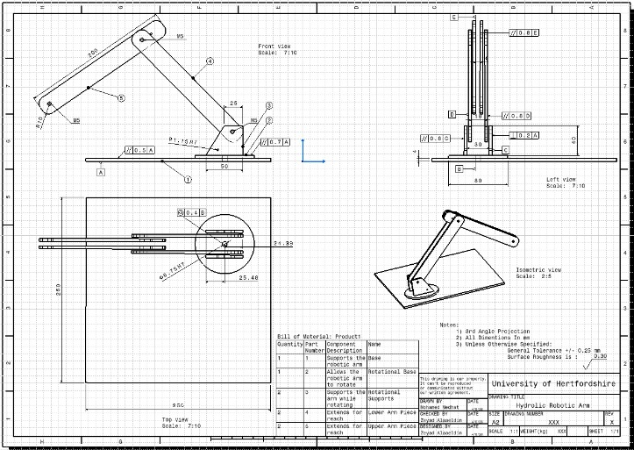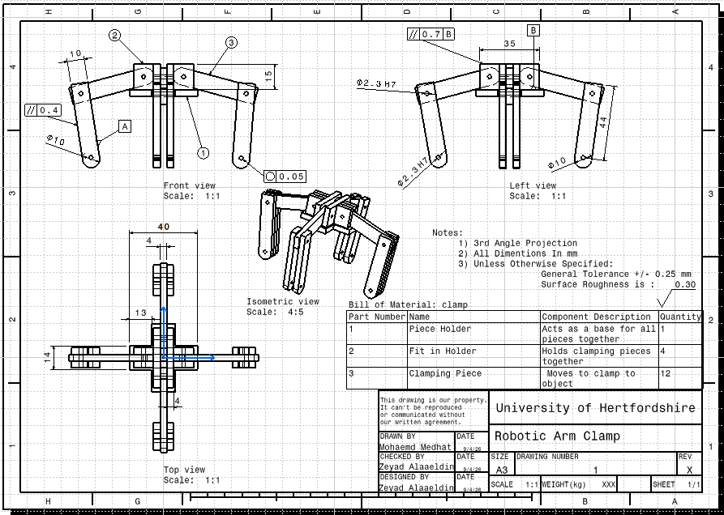

Figure 5 Drafting of the final CATIA Design

Assembly Process
After manufacturing the individual components, the robotic arm was assembled by connecting the laser cut parts to form the arm structure.
The arm segments were connected using a combination of mechanical fasteners such as nails and bolts. The nails and bolts were used to provide structural stability at the hinges to allow for flexible movements. Wooden sticks were specifically used to hold and secure the syringes in place. Additionally hot glue and zip ties were used to secure some of the syringes in place and to attach the wooden sticks to the laser cut parts. Additionally, zip ties were used to fasten smaller components and provide extra stability where needed. The assembly process is shown in Figure 6
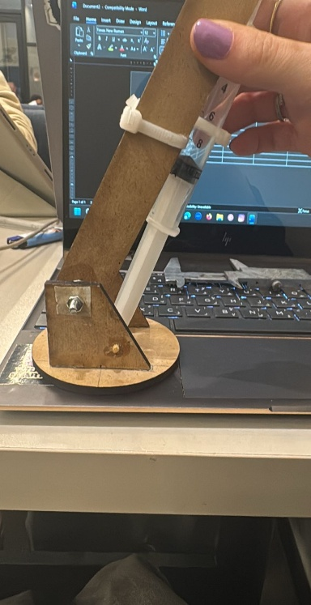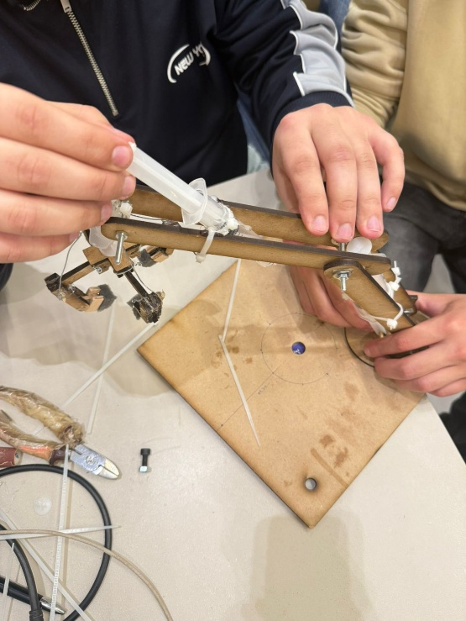
Figure 6 Assembly Process

Manufacturing and Software Settings
The design was developed using CATIA, afterward the sketches were turned into 3D models with defines dimensions and constraints. The final designs were exported for laser cutting. The manufacturing process was carried out using a laser cutting machine on cardboard material of thickness 4 mm, with appropriate power and speed settings selected to ensure clean and accurate cuts.

Part 2 – Machining the Axle Component

Component Overview
The second part of the project involved the machining of an axle component using workshop manufacturing processes and Inventor CAM simulation. The component represents a mechanical axle designed to support the front wheels of a radio controlled car, requiring accurate dimensions and a good surface finish to ensure proper functionality.

Machining Process and Software
The machining of the axle component was carried out using conventional workshop machines in combination with CAM software simulation. The process began with understanding the full dimensions of the technical drawing, including diameters, length, and threading dimensions.
A cylindrical bar of low carbon steel was used as the raw material. First, a Vernier caliper was used to determine the required length of 160 mm, after which the material was cut to the required length using a saw. The workpiece was then mounted on a lathe machine, where it was held by a 3 jaw chuck on one side, and supported by a tail-stock on the other to ensure stability while machining. Afterwards, facing and turning operations were preformed to reduce the diameter from the original 23 mm to the required 19 mm. The same machine was used to machine grooves along the shaft using a grooving tool. These grooves are essential for accommodating components such as retaining rings for assembly purposes.
Additional features such as holes were produced using a drilling machine, ensuring accurate positioning and depth as seen in Figure 7. The central hole was located 65 mm from one end of the workpiece. 2 smaller holes were positioned 75 mm apart from each other and 14.5 mm from the end of the piece. Milling operations were also carried out using a milling machine to create flat surfaces of depth 1 mm on both ends of the workpiece.
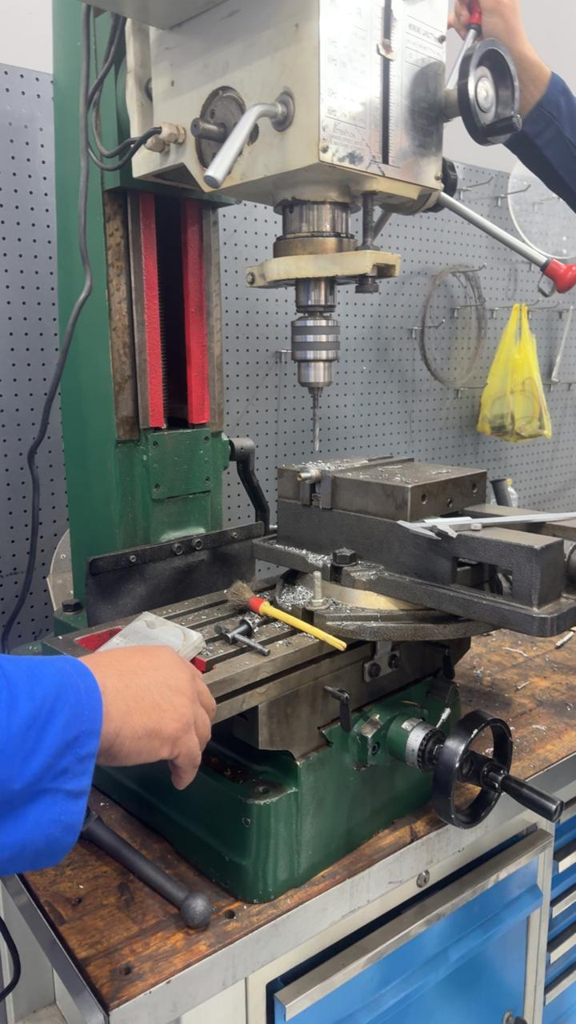
Figure 7 Photo of the Drilling Operation
In parallel, the machining process was simulated using Inventor CAM, where the part geometry was modelled, and machining operations such as turning, drilling, and milling were defined. Toolpaths were generated to represent CNC machining operations, allowing verification of the process before actual manufacturing.

Routing Sheet
The machining process was planned using a simplified routing sheet to outline the sequence of operations required to manufacture the axle component. This ensured an organized and efficient workflow during the machining process.
Op No. | Operation | Description | Machine Tool
1 | Cutting | Cut raw material to 160 mm | Saw
2 | Facing | Create flat reference surface | Lathe
3 | Turning | Reduce diameter from 23mm to 19 mm | Lathe
4 | Grooving | Machining grooves for retaining rings | Lathe
5 | Drilling | Drill central and side holes | Drilling Machine
6 | Milling | Creating flat surfaces (1mm depth) | Drilling Machine (Milling Tool)

  - Setup Sheet from CAM
The CAM setup sheet was created using Inventor CAM to simulate the machining of the axle component. First, a 2D sketch was created within the CAM software, and the required dimensions were defined. The sketch was then revolved to generate the 3D model of the shaft.
Additional features were incorporated into the model, including holes created using reference planes positioned on the surface of the workpiece. The central hole was produced using a tapping operation, while threading was applied to both ends of the shaft. Grooves were also included in the design, followed by chamfering to remove sharp edges and improve final finish.
The work coordinate system (WCS) was set appropriately to ensure accurate alignment of the toolpaths. Both the initial and final dimensions of the workpiece were specified, and tool clearances were defined to prevent collisions during machining.
The machining sequence began with a facing operation, where a light cut of approximately 1 mm was applied to create a flat reference surface. A centering operation was then preformed to allow support from the tailstock. This was followed by a rough turning process to reduce the diameter of the workpiece, and a finishing pass to achieve the required surface quality.
Grooving operations were carried out on one side of the shaft, followed by drilling operations where hole positions were first centered before machining. Tapping was then preformed for the threaded hole, and threading operations were applied to the ends of the shaft. Milling operations were also included where necessary to produce flat surfaces.
After completing the operations on one side, the workpiece was reoriented, partial grooving was then moved sideways to completely cut the extra length of the workpiece, and then the same sequence of operations was repeated on the opposite side to ensure symmetry. The simulation was then run to visualize the toolpaths, verify the machining process, and estimate the machining time.
In conclusion, this project provided valuable practical experience in both manufacturing and assembly processes. The design and fabrication of the hydraulic robotic arm demonstrated key principles of mechanical design, structural stability, and hydraulic actuation, while also highlighting the importance of careful planning and teamwork.
The machining of the axle component further developed essential workshop skills, including the use of machines such as the lathe, drilling machine, and milling machine. It also emphasized the importance of precision, accuracy, and proper sequencing of operations in manufacturing.
The integration of CAD/CAM software, particularly Inventor CAM, enhanced understanding of modern manufacturing techniques by allowing simulation of machining processes, toolpath generation, and process verification before actual production.
Although some minor inaccuracies were observed in the final machined component due to limited prior experience with the equipment, the project provided a valuable learning opportunity and improved our confidence in using engineering tools and machinery.
Overall, the project successfully met its objectives and strengthened our understanding of manufacturing technology, project planning, and safe workshop practices.

Measurement and Inspection
After machining, the axle component was inspected to ensure it met the required dimensions and specifications. A Vernier caliper was used to measure key dimensions such as the overall length and the diameter of the shaft.
The measured values were compared with those specified in the technical drawing to evaluate accuracy. Minor deviations were observed between the measured and expected values. These inaccuracies were mainly due to the challenges encountered during machining, as this was our first experience using the workshop machines. As a result, some difficulties in handling the equipment and maintaining precision affected the final dimensions.
The measurements recorded as seen in Figure 8 :
Body length : 130.5 mm
Body width : 18.65 mm
External threading : 9.65 mm
Central hole : 8.5 mm
Smaller holes : 6.25 mm
Distance between smaller holes and end of the workpiece : 14.4 mm
Distance between central hole and end of the workpiece : 65 mmm
Milling : 0.34 mm

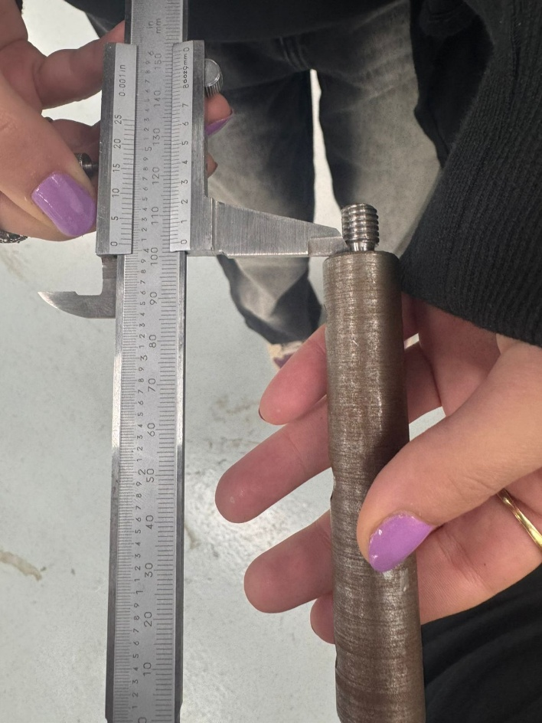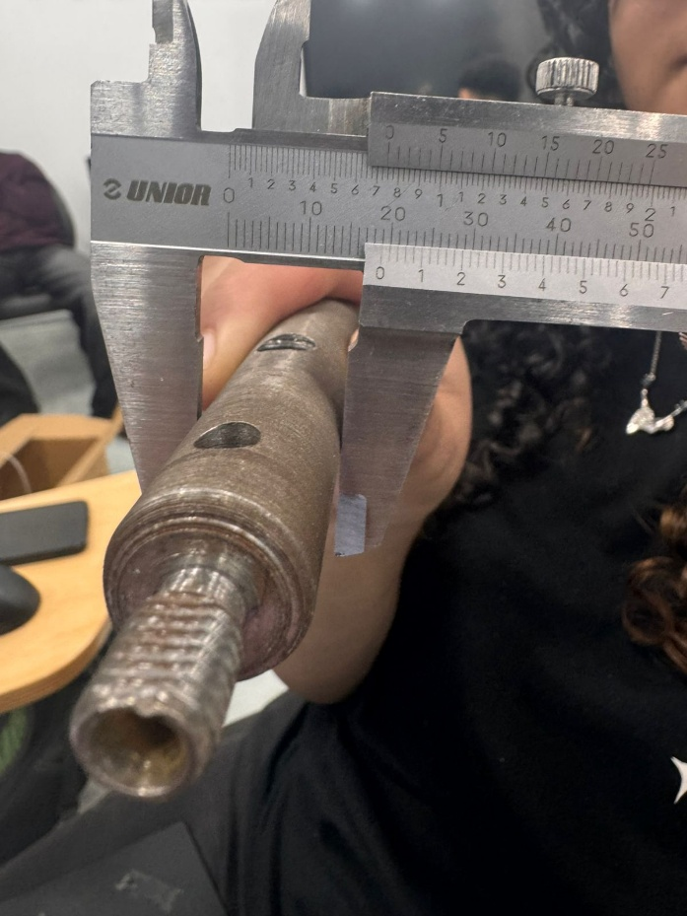
Figure 8 Taken Measurments

Additionally, the machining time for a turning operation was estimated using the CAM simulation, providing insight into the efficiency of the process.

Conclusion
In conclusion, this project provided valuable practical experience in both manufacturing and assembly processes. The design and fabrication of the hydraulic robotic arm demonstrated key principles of mechanical design, structural stability, and hydraulic actuation, while also highlighting the importance of careful planning and teamwork.

The machining of the axle component further developed essential workshop skills, including the use of machines such as the lathe, drilling machine, and milling machine. It also emphasized the importance of precision, accuracy, and proper sequencing of operations in manufacturing.

The integration of CAD/CAM software, particularly Inventor CAM, enhanced understanding of modern manufacturing techniques by allowing simulation of machining processes, toolpath generation, and process verification before actual production.

Although some minor inaccuracies were observed in the final machined component due to limited prior experience with the equipment, the project provided a valuable learning opportunity and improved our confidence in using engineering tools and machinery.

Overall, the project successfully met its objectives and strengthened our understanding of manufacturing technology, project planning, and safe workshop practices.

