🔐
Security Lab
RBAC · ServiceAccounts · SecurityContext · NetworkPolicy
⏱ 60 minutes 📊 100 points 📋 6 tasks 🎯 CKA Level
Session: S09

🔑 Part 1 — RBAC | 40 pts

1 | Create a Role and RoleBinding — Read-only Access | Easy ⭐

Give a user read-only access to Pods in the dev namespace.

Field | Value
Namespace | dev
Role name | pod-reader
Verbs allowed | get, list, watch
Resource | pods
RoleBinding name | read-pods
Subject user | alice

Requirements:
a | Create namespace dev

kubectl create namespace dev

b | Create the Role imperatively

kubectl create role pod-reader --verb=get,list,watch --resource=pods -n dev

c | Create the RoleBinding

kubectl create rolebinding read-pods --role=pod-reader --user=alice -n dev

d | Verify the permissions using auth can-i

kubectl auth can-i get pods -n dev --as=alice

kubectl auth can-i delete pods -n dev --as=alice

✅ Verify:
First should return: yes
Second should return: no
✍️ Why is alice allowed to get pods but not delete them?
because the Role only allows specific verbs get, list, watch

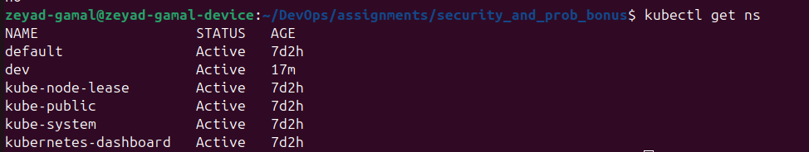

2 | ClusterRole and ClusterRoleBinding — Cluster-wide Access | Medium ⭐⭐

Field | Value
ClusterRole name | node-viewer
Resource | nodes
Verbs | get, list
ClusterRoleBinding name | view-nodes
Subject user | bob

Requirements:
a | Create ClusterRole — nodes are cluster-scoped, not namespaced

kubectl create clusterrole node-viewer --verb=get,list --resource=nodes

b | Create ClusterRoleBinding

kubectl create clusterrolebinding view-nodes --clusterrole=node-viewer --user=bob

c | Test bob's access

kubectl auth can-i list nodes --as=bob

kubectl auth can-i list pods --as=bob

✍️ Can bob list pods? Why / why not?
No, Because the ClusterRole node-viewer only grants access to nodes, not pods.

✍️ What is the difference between Role and ClusterRole?

- Role is namespace-scoped, meaning it only applies to resources within a specific namespace.
- ClusterRole is cluster-scoped, meaning it can grant permissions across the whole cluster or even to resources that are not namespaced (like nodes).
- You bind a Role with a RoleBinding, which is limited to a namespace.
- You bind a ClusterRole with a ClusterRoleBinding, which can apply cluster-wide or to multiple namespaces.
- Use Role for controlling access inside a single namespace, and ClusterRole when you need cluster-wide permissions or access to cluster-scoped resources.
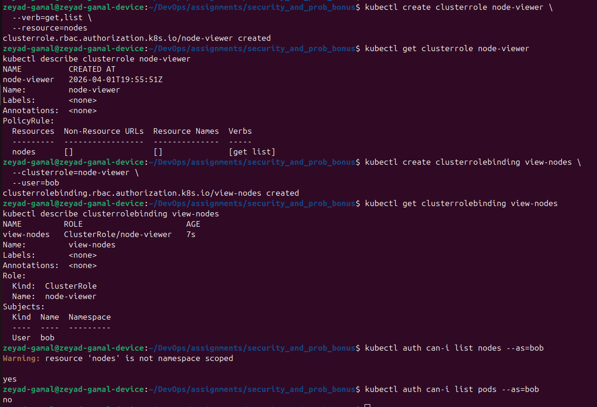

3 | ServiceAccount — Attach to a Pod | Medium ⭐⭐

Field | Value
Namespace | dev
ServiceAccount name | app-sa
Role | pod-reader (from Task 1)
Pod | uses app-sa as its identity

Requirements:
a | Create the ServiceAccount

kubectl create serviceaccount app-sa -n dev

b | Bind pod-reader role to the ServiceAccount

kubectl create rolebinding sa-read-pods --role=pod-reader --serviceaccount=dev:app-sa -n dev

c | Create a pod that uses this ServiceAccount
apiVersion: v1
kind: Pod
metadata:
name: sa-demo
namespace: dev
spec:
serviceAccountName: app-sa # attach the SA
containers:
- name: app
image: nginx:latest

d | Verify the pod has the SA token mounted

kubectl exec sa-demo -n dev -- ls /var/run/secrets/kubernetes.io/serviceaccount/

✍️ What files are inside /var/run/secrets/kubernetes.io/serviceaccount/?
ca.crt namespace token

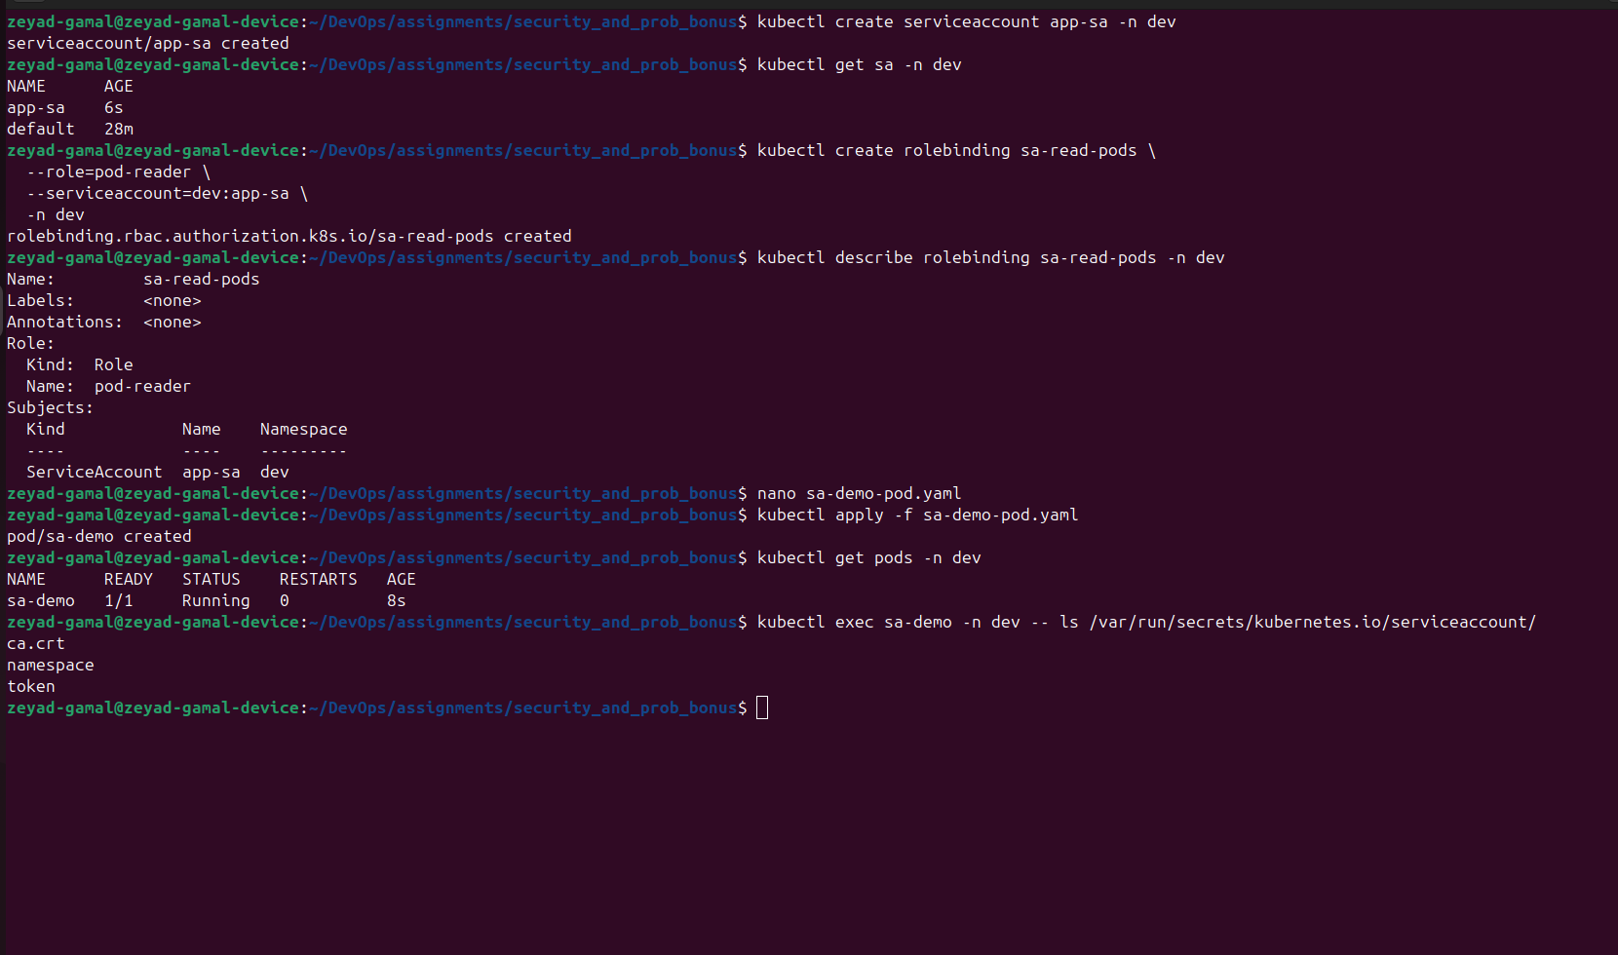
🛡️ Part 2 — SecurityContext & NetworkPolicy | 60 pts

4 | SecurityContext — Run as Non-Root | Medium ⭐⭐

Field | Value
Pod name | secure-pod
runAsNonRoot | true
runAsUser | 1000
readOnlyRootFilesystem | true
Drop capabilities | ALL

spec:
securityContext:
runAsNonRoot: true
runAsUser: 1000
containers:
- name: app
image: nginx:latest
securityContext:
readOnlyRootFilesystem: true
capabilities:
drop: [ALL]

💡 Hint:
Note: nginx:latest may fail with readOnlyRootFilesystem — use image: busybox with command: ['sleep','3600'] instead for this task.

Requirements:
a | Apply the pod with SecurityContext
b | Verify the user ID inside the container

kubectl exec secure-pod -- id

c | Try writing to the root filesystem — should be denied

kubectl exec secure-pod -- sh -c 'echo test > /test.txt'

✍️ What uid/gid does the container run as?
UID/GID: 1000 / 0 (non-root user, primary group root)
✍️ What error do you get when writing to the root filesystem?

sh: can't create /test.txt: Read-only file system

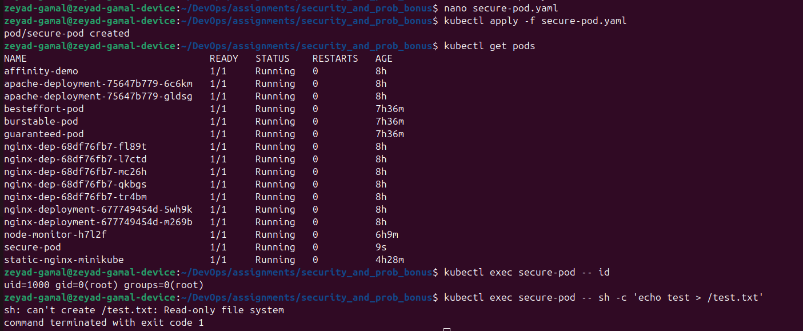

5 | NetworkPolicy — Deny All Ingress | Hard ⭐⭐⭐

Create a Deny All policy, verify pods cannot communicate, then add a specific Allow rule.

Field | Value
Namespace | dev
Step 1 | Deploy 2 pods: frontend and backend
Step 2 | Apply deny-all NetworkPolicy
Step 3 | Confirm frontend cannot reach backend
Step 4 | Add allow policy — frontend → backend on port 80
Step 5 | Confirm frontend CAN reach backend now

Step 1 — Deploy pods:

kubectl run frontend --image=nginx -n dev --labels=app=frontend

kubectl run backend --image=nginx -n dev --labels=app=backend

Step 2 — Deny All Ingress policy:
apiVersion: networking.k8s.io/v1
kind: NetworkPolicy
metadata:
name: deny-all
namespace: dev
spec:
podSelector: {} # applies to ALL pods in namespace
policyTypes: [Ingress] # deny all incoming traffic

Step 3 — Test connectivity (should FAIL):

kubectl exec frontend -n dev -- curl -s --max-time 3 <backend-pod-ip>

Step 4 — Allow frontend to reach backend:
apiVersion: networking.k8s.io/v1
kind: NetworkPolicy
metadata:
name: allow-frontend
namespace: dev
spec:
podSelector:
matchLabels: { app: backend }
policyTypes: [Ingress]
ingress:
- from:
- podSelector:
matchLabels: { app: frontend }
ports:
- protocol: TCP
port: 80

e | Test again after allow policy — should now succeed

kubectl exec frontend -n dev -- curl -s --max-time 3 <backend-pod-ip>

✍️ What happened in Step 3 vs Step 5? Explain why.
In step 3 failed after applying deny all policy
In step 5 success after adding the allow policy

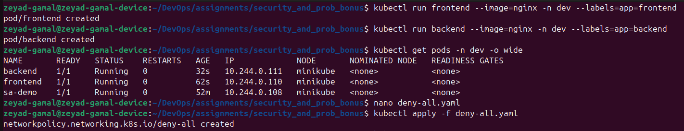

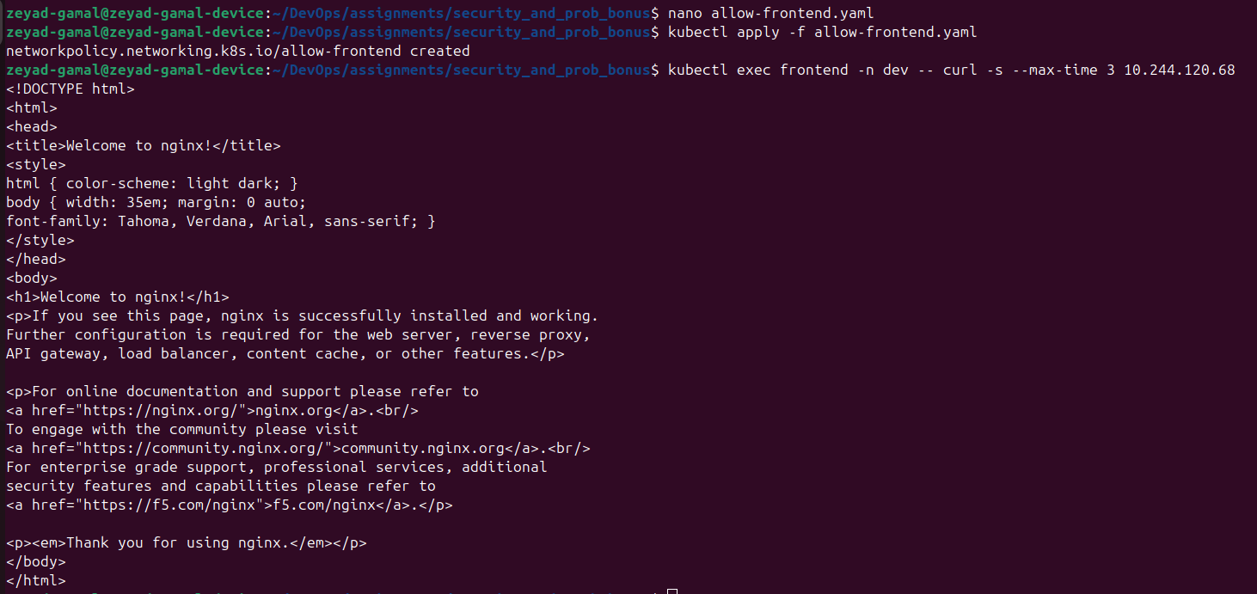

6 | kubeconfig — Inspect and Switch Contexts | Easy ⭐

Requirements:
a | View current context

kubectl config current-context

b | List all contexts in kubeconfig

kubectl config get-contexts

c | View full kubeconfig

kubectl config view

d | Inspect what kubeconfig contains

cat ~/.kube/config | grep -E 'cluster|user|namespace'

✍️ What are the 3 main sections in a kubeconfig file?
clusters , users , contexts

✍️ What does a 'context' tie together in kubeconfig?
a cluster
a user
a namespace (optionally)
