

Sprints Devops

Task 1



nAME: zEYAD mAGDY iBRAHIM moHAMED

*Under supervision of*

**Dr. Mohamed Fakhruldeen**

# what is a docker:

The Docker technology uses the [Linux kernel](https://www.redhat.com/en/topics/linux/what-is-the-linux-kernel) and features of the kernel, like [Cgroups](https://www.redhat.com/en/blog/world-domination-cgroups-rhel-8-welcome-cgroups-v2) and [namespaces](https://lwn.net/Articles/528078/), to segregate processes so they can run independently. This independence is the intention of containers—the ability to run multiple processes and apps separately from one another to make better use of your infrastructure while [retaining the security](https://www.redhat.com/en/topics/security) you would have with separate systems.

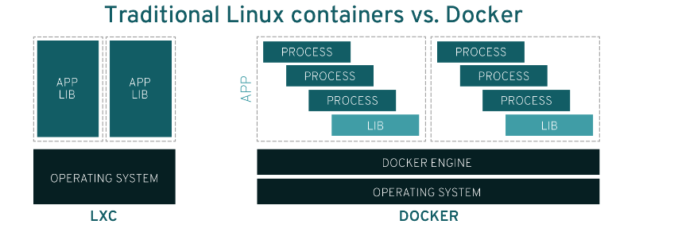

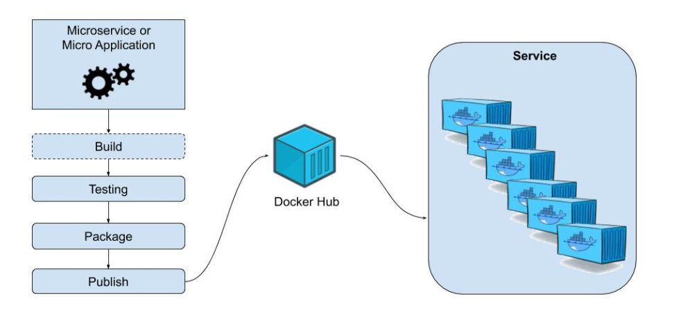

# To run docker file and create docker image:

## Docker file

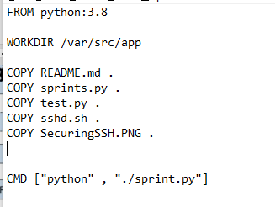

## Running docker file to create docker image

### In shell:

#### **Docker build -t ‘NLM’ // to build file and install needed packages**

#### **Docker images // to see the images of our docker listed**

#### **Docker run -ti sprints // to run our docker image file**

